cyberSentinel
Technical Documentation
Machine Learning-Based Network Intrusion Detection System

1. Project Overview
cyberSentinel is a machine-learning-based Network Intrusion Detection System (NIDS) designed to classify network traffic into two classes: normal, representing legitimate traffic, and attack, representing potentially malicious or intrusive traffic.
The project uses network-flow statistics as input features and applies targeted feature engineering followed by a calibrated gradient boosting classifier. The trained model can be reused for inference and can generate both class predictions and confidence scores.
The implementation is organized as a modular Python project so that data loading, feature analysis, feature engineering, model training, prediction generation, and evaluation are handled independently.

2. Problem Statement
Network traffic contains measurable characteristics such as packet counts, byte counts, traffic rates, timing information, TCP state information, and connection statistics. Manually identifying malicious traffic from these characteristics is difficult because normal and attack traffic can have overlapping patterns and different attacks can produce substantially different flow characteristics.
- Normal and attack traffic can have overlapping network characteristics.
- Different attack types can produce different traffic patterns.
- Individual network features may not be sufficient to distinguish traffic classes.
- Relationships between packet counts, traffic volume, and flow rates can provide additional information.
- The distribution of some traffic characteristics may differ between training and validation data.
The objective of cyberSentinel is to learn traffic patterns from labeled network-flow data and automatically classify validation records as either normal or attack.

3. Dataset
The project uses separate training and validation CSV files stored in the data directory.
data/
├── train.csv
└── validation.csv
The training dataset contains 24,000 records and 21 columns. The validation dataset contains 5,000 records and uses the same feature schema. Each dataset contains 20 network-flow features and a label column.

3.1 Input Features
Feature | Description
dur | Flow duration
spkts | Source-to-destination packet count
dpkts | Destination-to-source packet count
sbytes | Source-to-destination byte count
dbytes | Destination-to-source byte count
rate | Traffic rate
sttl | Source TTL value
dttl | Destination TTL value
sload | Source traffic load
dload | Destination traffic load
sinpkt | Source inter-packet timing
dinpkt | Destination inter-packet timing
sjit | Source jitter
djit | Destination jitter
swin | Source TCP window information
stcpb | Source TCP base sequence information
dtcpb | Destination TCP base sequence information
ct_state_ttl | Connection-state/TTL feature
ct_dst_ltm | Destination connection statistics
ct_src_dport_ltm | Source/destination-port connection statistics
label | Traffic classification label

4. Repository Architecture
cyberSentinel/
│
├── data/
│ ├── train.csv
│ └── validation.csv
│
├── model_training/
│ ├── __init__.py
│ ├── data_loader.py
│ ├── feature_audit.py
│ ├── feature_engineering.py
│ ├── train_model.py
│ ├── generate_submission.py
│ └── evaluate_model.py
│
├── models/
│ └── calibrated_model.joblib
│
├── confusion_matrix.png
├── submission.csv
├── requirements.txt
├── .gitignore
└── README.md
data_loader.py loads the training and validation data. feature_audit.py performs statistical feature analysis. feature_engineering.py contains feature selection and derived-feature generation. train_model.py trains, calibrates, evaluates, and serializes the model. generate_submission.py performs inference and creates submission.csv. evaluate_model.py evaluates predictions against validation labels.

5. Data Preprocessing and Target Construction
The original label field is converted into a binary target. The project treats normal traffic as class 0 and every non-normal label as class 1.
y = (label != "normal").astype(int)
0 → normal
1 → attack
The same transformation is applied to validation labels during evaluation.

6. Feature Engineering
The implementation does not train directly on every available input column. It focuses on network-flow characteristics representing packet behavior, traffic load, and connection state, and adds derived features that explicitly represent relationships between traffic directions and volumes.

6.1 Selected Raw Features
spkts
dpkts
sload
dload
ct_state_ttl

6.2 Derived Features
Packet Ratio:
pkt_ratio = spkts / (dpkts + 1)
Total Packets:
total_pkts = spkts + dpkts
Load Ratio:
load_ratio = sload / (dload + 1)
Total Load:
total_load = sload + dload
The value 1 in the denominators prevents division by zero.

6.3 Final Feature Set
spkts
dpkts
sload
dload
ct_state_ttl
pkt_ratio
total_pkts
load_ratio
total_load

7. Feature Audit
The project includes a statistical feature-audit stage implemented in feature_audit.py. Two techniques are used: the ANOVA F-test and mutual information.

7.1 ANOVA F-Test
The ANOVA F-test measures how strongly the distribution of a feature differs between the two target classes. Its scores provide an indication of class-separation strength.

7.2 Mutual Information
Mutual information estimates statistical dependency between an input feature and the target. It can capture dependencies that are not limited to a simple linear relationship.

8. Machine Learning Model
The main classifier is sklearn's HistGradientBoostingClassifier with the following configuration:
HistGradientBoostingClassifier(
max_iter=150,
learning_rate=0.03,
max_leaf_nodes=15,
min_samples_leaf=25,
l2_regularization=3.0,
random_state=42
)

8.1 Model Parameters
- max_iter=150: number of boosting iterations.
- learning_rate=0.03: contribution of each boosting stage.
- max_leaf_nodes=15: limits individual tree complexity.
- min_samples_leaf=25: requires a minimum number of samples per leaf.
- l2_regularization=3.0: applies L2 regularization.
- random_state=42: provides reproducible training behavior.
HistGradientBoostingClassifier builds a sequence of decision trees, where later stages improve errors made by earlier stages. The histogram-based implementation is suitable for numerical datasets of this size.

9. Probability Calibration
The gradient boosting classifier is wrapped in CalibratedClassifierCV using five-fold cross-validation and sigmoid calibration.
CalibratedClassifierCV(
...,
method="sigmoid",
cv=5
)
Calibration is important because the model's probability is used as the confidence value in the generated submission. The objective is to make the predicted probabilities more meaningful as confidence estimates.

10. Classification Threshold
After calibration, the attack probability is converted into a binary prediction using a threshold of 0.74.
probability >= 0.74 → attack
probability < 0.74 → normal
This threshold is explicitly part of the prediction pipeline and changes the decision boundary from the default 0.50 threshold.

11. Model Training Pipeline
train.csv
│
▼
Load training data
│
▼
Convert labels to binary target
│
▼
Select raw features
│
▼
Generate engineered features
│
▼
HistGradientBoostingClassifier
│
▼
5-fold sigmoid probability calibration
│
▼
Save calibrated_model.joblib

12. Model Serialization
After training, the calibrated classifier is serialized using joblib. The resulting artifact is stored at:
models/calibrated_model.joblib
The serialized model allows inference to be performed without retraining the classifier.

13. Prediction and Submission Generation
generate_submission.py loads the saved calibrated model, applies the same feature-engineering logic to validation data, and generates predictions and confidence values.
validation.csv
│
▼
Feature engineering
│
▼
Saved calibrated model
│
▼
Attack probability
│
├──→ confidence
│
▼
Threshold = 0.74
│
▼
predicted_class
│
▼
submission.csv
Each record receives a generated sample identifier using the CSHT_#### format. The submission contains sample_id, predicted_class, and confidence.

14. Evaluation
The evaluation script compares the predicted class in submission.csv with the binary labels derived from validation.csv.
y_val_binary = (validation["label"] != "normal").astype(int)
preds_binary = (submission["predicted_class"] == "attack").astype(int)
The implementation calculates accuracy, a confusion matrix, and a classification report containing precision, recall, F1-score, and support.

14.1 Validation Result
For the supplied validation.csv and submission.csv files, the calculated accuracy is 0.9132 (91.32%).

14.2 Confusion Matrix
 | Predicted Normal | Predicted Attack
Actual Normal | 140 | 360
Actual Attack | 74 | 4426
The matrix contains 140 correctly classified normal records, 360 normal records classified as attack, 74 attack records classified as normal, and 4,426 correctly classified attack records.
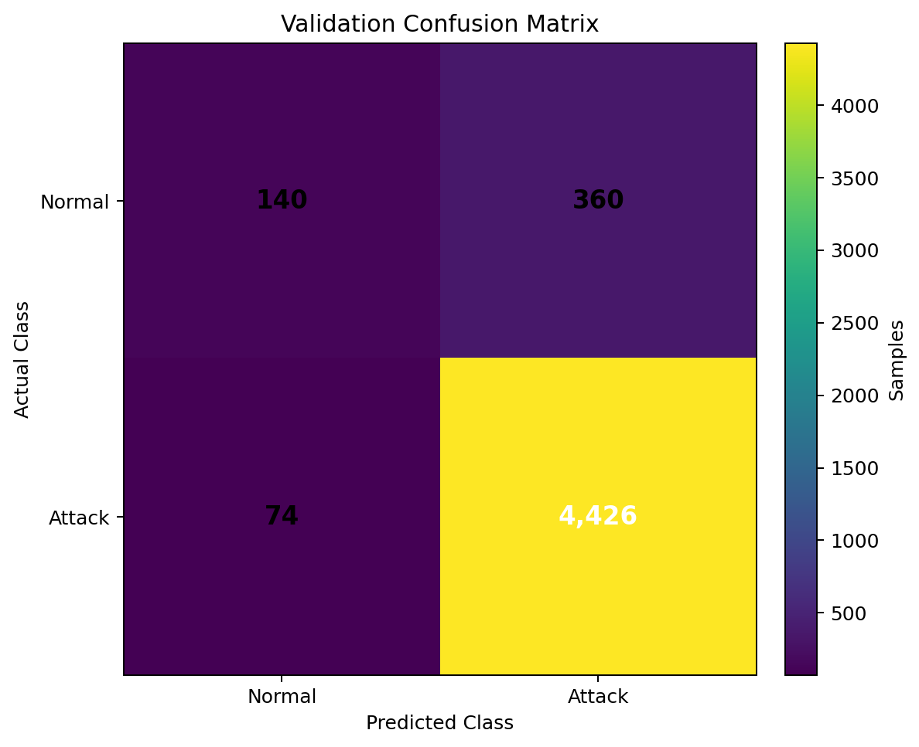
Figure 1. Confusion matrix for the supplied validation predictions.

15. Error Analysis
The supplied confusion matrix shows that the larger class-specific error is normal traffic being classified as attack: 360 normal-to-attack cases versus 74 attack-to-normal cases.
A false positive occurs when normal traffic is classified as attack. This can increase the number of alerts requiring investigation. A false negative occurs when attack traffic is classified as normal. In an intrusion-detection setting, false negatives are security-sensitive because malicious traffic can pass without being flagged.
The classification threshold of 0.74 directly influences this precision/recall trade-off.

16. Reproducing the Project

16.1 Install Dependencies
pip install -r requirements.txt
The project dependencies are numpy, pandas, scikit-learn, joblib, and matplotlib.

16.2 Run Feature Audit
python model_training/feature_audit.py

16.3 Train the Model
python model_training/train_model.py
The trained model is saved to models/calibrated_model.joblib.

16.4 Generate Predictions
python model_training/generate_submission.py
This creates submission.csv.

16.5 Evaluate Predictions
python model_training/evaluate_model.py

17. End-to-End Execution
pip install -r requirements.txt
python model_training/feature_audit.py
python model_training/train_model.py
python model_training/generate_submission.py
python model_training/evaluate_model.py

18. Reproducibility
The training configuration uses random_state=42. The selected features, engineered features, calibration method, and classification threshold are explicitly defined in the project source code. The saved joblib model preserves the trained classifier for direct inference.

19. Limitations
- The current implementation focuses on binary classification: normal versus attack.
- It does not identify the specific attack category in the final prediction output.
- It operates on the network-flow features available in the supplied CSV files.
- It does not directly inspect packet payloads, raw packets, network logs, or live network interfaces.
- The repository represents the machine-learning classification component of an intrusion-detection workflow rather than a complete real-time network monitoring platform.

20. Future Extensions
- Multi-class attack classification to identify specific attack categories.
- Real-time inference connected to a network-flow collection pipeline.
- Automated alerting based on configurable attack-probability thresholds.
- Model and data-drift monitoring.
- Threshold optimization based on an explicit security objective.
- Comparison with alternative machine-learning classifiers.
- Explainability methods to help analysts understand suspicious predictions.

21. Conclusion
cyberSentinel implements a modular machine-learning pipeline for binary network intrusion detection. It combines targeted network-flow feature selection, derived traffic-ratio and aggregate features, histogram-based gradient boosting, five-fold sigmoid probability calibration, a configurable attack threshold, serialized model inference, and validation using accuracy, confusion matrix, and classification-report metrics.
The separation of data processing, feature engineering, training, prediction, and evaluation makes the project easier to reproduce, maintain, and extend into a larger intrusion-detection system.

