**D1. UNCERTAINTY AND THE PENDULUM**

**SUBMISSION TEMPLATE**

|  |
| --- |
| **NAME: Borna Sadeghi**  **STUDENT No.: 400315188**  **LAB/TUTORIAL SECTION: L20/T20**  **LECTURE SECTION: C01** |

***COMPLETE ALL SECTIONS OF THIS TEMPLATE AND SUBMIT AS ONE SINGLE DOCUMENT. SOME INSTRUCTIONS HAVE BEEN INCLUDED HERE. SEE LAB MANUAL FOR FULL DIRECTIONS.***

The following shows the value of all the questions in this lab:

|  |  |  |  |  |  |  |
| --- | --- | --- | --- | --- | --- | --- |
| **Laboratory 1 Grading Scheme** | | | | | | |
| **Part 1** | | | | | | |
| **Part 1** | **Q1** | **Q2** | **Q3** | **Q4** | **Tables (3)** | **Totals** |
| **Points** | /1 | /1 | /1 | /1 | /2 | **/6** |
| **Part 2** | | | | | | |
| **Part 2 A** | **Q1** | **Q2** | **Q3** | **Q4** | **Table (1)** | **Totals** |
| **Points** | /1 | /1 | /1 | /1 | /1 | **/5** |
| **Part 2 B** | **Q5** | **Q6** | **Table (1)** | | **Plot (1)** |  |
| **Points** | /1 | /1 | /1 | | /2 | **/5** |
| **Part 2 C** | **Q7** | **Table (1)** | | | **Plot (1)** |  |
| **Points** | /1 | /1 | | | /2 | **/4** |
| **TOTAL** | | | | | | **/20** |

**Part 1: Measurements and Uncertainties**

**Procedure** (a chart has been provided below to help organize your data, please provide sample calculations in addition to the chart):

1. Using the first measuring device, measure the length and width of your calculator including the associated uncertainty for each measurement.
2. Repeat these measurements 4 more times. Note: you should randomize your measurements by starting at random ruler positions (i.e. don’t always start on a mark or the same mark).
3. Determine the mean length and width of your calculator
4. Calculate the error in the mean in two ways:
   1. Using error propagation rules
   2. By determining the greatest difference between a data point and the average value

**Question 1. Why do the values for the uncertainty calculated by these two methods differ? Which is a more accurate reflection of the measurement uncertainty in this case? Why? Suggest ways in which you might be able to minimize the uncertainty.**

|  |
| --- |
| For a single measurement, the measurement uncertainty is ± half of the smallest scale unit. Since device #2 goes down to the millimeter and device #1 goes down to the centimeter, the measurement uncertainties would be different (for device #2 it’d be half a millimeter while for device #1 it’d be half a centimeter). Device #2 demonstrates a more accurate reflection of the measurement uncertainty, because with a lower value of uncertainty, the measurement is more accurate. To minimize the uncertainty in the measurements, one must use a more precise measuring device because the uncertainty in the measurement is completely based on the tool one uses to measure. |

Note that it is not just the measuring instrument that contributes to the uncertainty, but also the conditions under which the device is being used (e.g. rounded edges, viewing angle, etc.)

1. Repeat steps 1-4 using the other measuring device.
2. Using your values for the length and width (and uncertainty) determined using the second measuring device calculate the area of your calculator with its associated uncertainty (using error propagation).

**Question 2. Does your value agree with the accepted value of 120.5 cm2 (1st ed) or 124.4 cm2 (2nd ed) within uncertainty? If not, can you suggest a reason why not?**

|  |
| --- |
| No it does not, because even though the measurements have a small statistical error, they have a large systematic error (they are consistent measurements, but all are far off of the accepted value). This is because of the inaccurate size of the rulers (each centimeter marking is larger than an actual centimeter). |

1. Now measure the length and width of your calculator using a ruler or measuring tape (include the associated error of this single measurement). Compare these values to the ones you obtained with the 2nd measuring device.
2. Determine a correction factor for your measurement device and correct for the systematic error in your scale. Re-calculate the area of your calculator and its associated uncertainty.

**Question 3. Does your area now agree with the accepted value of 120.5 cm2 (1st ed) or 124.4 cm2 (2nd ed) within uncertainty?**

|  |
| --- |
| Yes it does (at approximately 125.0 cm2). The ruler is more accurate (centimeters are scaled properly) and more precise (goes down to the millimeter), hence, causing less overall error. |

**Question 4. What were sources of error in this exercise? Where these random or systematic errors?**

|  |
| --- |
| The distance between markings on each ruler was different, leading to systematic error (measurements with each ruler were consistent, but not consistent with measurements of other rulers)  It was not specified whether the calculator should have the case on or not. This would lead to systematic error in all of the results because the case adds a few millimeters in both length and width. |

|  |  |  |  |
| --- | --- | --- | --- |
| **Device #1** | | Width (mm) | Length (mm) |
| Trial | | Uncertainty = 5 | Uncertainty = 5 |
| 1 | | 55 | 117 |
| 2 | | 56 | 118 |
| 3 | | 56 | 117 |
| 4 | | 56 | 118 |
| 5 | | 56 | 117 | AREA (mm^2) |
| AVERAGE | | 55.8 | 117.4 | 6600 |
| Uncertainty Method | Error Propagation | 5 | 5 | 866 |
| Data Spread | 0.8 | 0.6 | 0 |

|  |  |  |  |
| --- | --- | --- | --- |
| **Device #2** | | Width (mm) | Length (mm) |
| Trial | | Uncertainty = 0.5 | Uncertainty = 0.5 |
| 1 | | 67 | 142 |
| 2 | | 67 | 141 |
| 3 | | 67 | 142 |
| 4 | | 67 | 142 |
| 5 | | 67 | 141 | AREA (mm^2) |
| AVERAGE | | 67.0 | 141.6 | 9500 |
| Uncertainty Method | Error Propagation | 0.5 | 0.5 | 100 |
| Data Spread | 0 | 0.6 | 0 |

|  |  |  |  |
| --- | --- | --- | --- |
| Ruler | Width = 77 | Length = 162 | Area = 12500 |
| (include units) | Uncertainty = 0.5______ | Uncertainty = 0.5__ | Uncertainty = 100 |

|  |
| --- |
| **BEFORE CONTINUING, BE SURE YOU HAVE COMPLETED 4 DISCUSSION QUESTIONS, AND 3 TABLEs.** |

**Part 2: The Pendulum**

**THEORY**

According to the theory of a simple pendulum, the period T (the time for one complete swing) is given by

$T = 2 π \sqrt{\frac{l}{g}}$ (1)

where *l* is the length of the pendulum and g is the gravitational field. In deriving this result certain **assumptions** are made:

1) the pendulum consists of a point mass suspended by a massless string of length *l* from a fixed support;

2) the amplitude of the swing is **small**, i.e., sin θ ~ θ (measured as the angle between the vertical and the string at the maximum of its swing).

Squaring Eq. (1) yields the following relation, which will be used for analysis of your data.

$T^{2}=4π^{2}\frac{l}{g}$ (2)

**PROCEDURE**

In this lab you will need:

* 1 meter of string or cord (for pendulum)
* small object with some mass (a few hundred grams is fine, it doesn’t have to be exact and you don’t need to know its mass)
* stopwatch (consider using your phone, or Google “stopwatch”)
* ruler or measuring tape

You will tie the small object to your string to make the pendulum, so choose an object that is easy to attach to your string.

**PART A**

Verify that relation (2) is approximately true by measuring the period for two values of *l*, 20 cm and 80 cm. It is useful to measure the time for 20 cycles in order to get an accurate measurement. Repeat the measurements several times to determine the precision, and ensure you are counting 20 swings. Check that if *l* is increased by a factor of 4 (as in your experiment), T doubles. From these measurements calculate the value of *g*. You will encounter difficulties in making the measurements, so choose procedures that will make your measurements as accurate as possible. To determine errors from a set of measured values refer to the introductory section (pp. vi to x).

Part A: Preliminary Study Amplitude =15cm (approx.)

|  |  |  |  |
| --- | --- | --- | --- |
| Length | Time for 20 swings (several measurements at each length) ± *δ t*  (sec ) | *T*(period) ± *δ T*  (sec) | (ms-2) |
| 20 cm (approx.) | 18.78 ± 0.25 | 0.94 ± 0.02 | 8.95 ± 0.01 |
|  | 18.57 ± 0.25 | 0.93 ± 0.02 | 9.17 ± 0.01 |
|  | 18.44 ± 0.25 | 0.92 ± 0.02 | 9.29 ± 0.01 |
|  | 18.38 ± 0.25 | 0.92 ± 0.02 | 9.35 ± 0.01 |
| 80 cm (approx.) | 36.13 ± 0.25 | 1.81 ± 0.02 | 9.7 ± 0.02 |
|  | 35.83 ± 0.25 | 1.79 ± 0.02 | 9.8 ± 0.02 |
|  | 36.40 ± 0.25 | 1.82 ± 0.02 | 9.5 ± 0.02 |
|  | 35.93 ± 0.25 | 1.80 ± 0.02 | 9.8 ± 0.02 |

**Ratio of lengths = 80 / 20 = 4 / 1**

**Ratio of periods squared = 1.804 / 0.927 ≈ 2**

Note that the uncertainty is determined from the *measured* values of total time (20 *T*), and that the error in *T* is *calculated* from this result. In this instance the calculation is simplified in that the integer 20 has no error. The error in *g* is determined from uncertainties in length *t* and time *T* by successive use of the rules for error propagation (multiplication and division).

**Question 1. To what point on the mass do you measure *l*? (The theory assumes a point mass, but does it make any difference which point is used?)**

|  |
| --- |
| l must be measured as close to the center of mass of the object as possible. The theory does assume a point mass, and this point mass is referring to the object’s center of mass. It does make a difference in which point is used if the distance to the center of mass changes. Since l is measured from the top of the pendulum to the center of mass, measuring l from any other point will lead to a discrepancy in the true l value. |

**Question 2. Is it better to start and stop the stopwatch at the end of the swing or at the center? You may wish to check this by doing a short experiment.**

|  |
| --- |
| It’s better to start and stop the stopwatch at the end of the swing. It’s easier to tell exactly when the velocity of the pendulum is zero than to tell when the pendulum is at the center of its swing. |

**Question 3. Can you eliminate your reaction time between the moment you see the pendulum and the moment you press the stop watch? Does it help if two different people do the timing?**

|  |
| --- |
| You can try to account for it or make up for it, but ultimately, there will always be error caused by reaction time in time measurements performed by humans. Having two different people is unlikely to help as both people will have reaction time error. However, it can help with collecting multiple trials and reducing statistical error. |

**Question 4. Does the non-rigidity of the pendulum support affect the measurement?**

|  |
| --- |
| Having a rigid pendulum support can decrease minor discrepancies in l caused by the force of tension, and the changing tangential velocity of the pendulum but the effect is negligible unless the support is very non-rigid. |

|  |
| --- |
| **BEFORE CONTINUING, BE SURE YOU HAVE COMPLETED 4 DISCUSSION QUESTIONS, AND 1 TABLE.** |

**PART B**

In this part we check the variation of period with the amplitude of swing. Select a convenient length for your pendulum (this will be kept constant), and measure *N* periods (choose *N* for a reasonable precision. A protractor is not necessary for measuring the angle: measure the length of the string and the horizontal displacement, and use trigonometry. Measure the period for a small (~5°) and a large amplitude. The largest angle that can be used is about 60°.

Part B: Variation with Amplitude Length = 80 cm

|  |  |  |
| --- | --- | --- |
| Amplitude (degrees) | Time for 20 swings ± 0.05 (sec) | Period ± 0.002(sec) |
| 7 | 37.98 ± 0.25 | 1.899 ± 0.02 |
| 15 | 38.15 ± 0.25 | 1.908 ± 0.02 |
| 20 | 38.16 ± 0.25 | 1.908 ± 0.02 |
| 30 | 38.90 ± 0.25 | 1.945 ± 0.02 |
| 45 | 39.05 ± 0.25 | 1.952 ± 0.02 |
| 60 | 39.43 ± 0.25 | 1.972 ± 0.02 |

|  |
| --- |
|  |

**Before making any further measurements, prepare a graph** (you may graph by hand or using a program like Excel, Numbers etc.) for the data points. The horizontal scale on which you plot the amplitude should run from 0 on the left to 60° on the right, with a scale that allows you to use as much of the graph paper as possible. Select a vertical scale that allows you to see the uncertainty ranges and the variation of the period clearly. The upper plot on the right, with a vertical scale starting at zero, compresses the error bars and any variation in period into a small fraction of the vertical space on the graph. Instead, choose a vertical scale such that the data points and error bars fill about the middle half of the page, as on the lower graph on the right. The choice of scale does not change the accuracy of the measurements.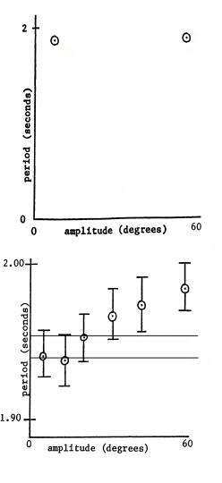

Estimate the uncertainty range in the measurements, if necessary by repeating the measurement 4 or 5 times. Plot vertical error bars on each data point. The experimental uncertainties in your readings will be the same for many data points, so it may only be necessary to do this repetition for one amplitude value.

**Complete the remaining measurements and plot the results on the graph. Plot the points on the graph as you go to allow you to see the pattern as it develops.**

**Draw a horizontal line on the graph that best fits the low amplitude data and parallel to that a line with the maximum allowable period for low amplitude.**

**Question 5. Is period independent of amplitude for the simple pendulum? If you had timed only a single swing for each amplitude, would it have affected your answer to this question?**

|  |
| --- |
| In theory, period is independent of amplitude for a simple pendulum. The equation used to determine the period does not contain the amplitude, which means they aren’t related. However in the real world, there are factors caused by a larger amplitude that can cause a change in the period. For example, a larger amplitude means that the pendulum must travel through more air in each swing, thereby reducing the speed of the pendulum. If the string is slightly elastic, there may be a slight amount of stretching at the bottom of the pendulum’s swing that can affect the value of l in the equation. If only one swing was timed for each amplitude, there would theoretically be no difference, but in practice, as the swing’s amplitude decreases on its own due to energy losses, these factors have a smaller and smaller effect as the pendulum continues to swing. |

**Question 6. Based on the two horizontal lines you drew on the graph above, estimate how large an amplitude can be used with the small-amplitude theory presented in the introduction? You can see that if your measurements were more precise (smaller error bars) the maximum amplitude value would be both smaller and more clearly defined.**

|  |
| --- |
| By finding where the line of best fit intersects the line representing maximum allowable period, one can see that the maximum allowable amplitude is approximately 16 degrees. |

|  |
| --- |
| **BEFORE CONTINUING, BE SURE YOU HAVE COMPLETED 2 DISCUSSION QUESTIONS, 1 TABLE, AND 1 PLOT.** |

**PART C**

In the final part of the experiment, select an easily measured amplitude for which you have shown the simple pendulum theory to be valid. Using this amplitude throughout, determine the periods for 5 different lengths, spaced uniformly over a large range. For the uncertainty range of the periods *T*, use the average value of all *δT*s determined in Parts A and B.

Part C: Variation with Length Amplitude = 7 cm

|  |  |  |  |
| --- | --- | --- | --- |
| Length± 0.2(cm) | Time for 10 swings ± ___ (sec) | Period *T* ± *δ T*  (sec) | *T*2 ± *δ T*2  (sec2) |
| 10 | 7.73 ± 0.25 | 0.773 ± 0.025 | 0.60 ± 0.05 |
| 30 | 12.40 ± 0.25 | 1.240 ± 0.025 | 1.54 ± 0.05 |
| 50 | 16.79 ± 0.25 | 1.679 ± 0.025 | 2.82 ± 0.05 |
| 70 | 18.76 ± 0.25 | 1.876 ± 0.025 | 3.52 ± 0.05 |
| 90 | 21.11 ± 0.25 | 2.111 ± 0.025 | 4.46 ± 0.05 |

For *δ T* use average value from Parts A and B.

Allowing for the error limits, is your result for *g* in agreement with the accepted value? Provide details in the discussion section and, if necessary, give a plausible reason for any disagreement.

This may be one of the first times that you have made a plot with a maximum and minimum line of best fit. You may use the figure below as a guide to help you prepare your plot.

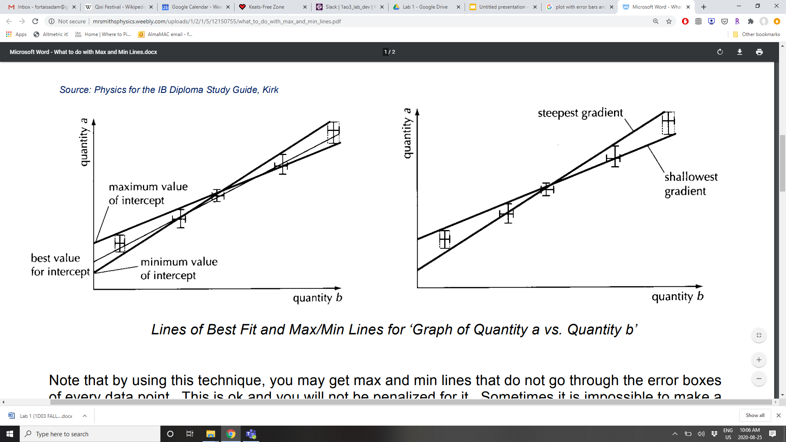

**Question 7. Provide a discussion and conclusions for your report. Since graphs show the results of all your data, refer to them in your discussion.**

|  |  |  |
| --- | --- | --- |
| Length± 0.2(cm) | *T*2 ± *δ T*2  (sec2) | *g(m/s2)* |
| 10 | 0.60 ± 0.05 | 6.58 |
| 30 | 1.54 ± 0.05 | 7.69 |
| 50 | 2.82 ± 0.05 | 7.00 |
| 70 | 3.52 ± 0.05 | 7.85 |
| 90 | 4.46 ± 0.05 | 7.97 |

|  |
| --- |
| Overall, my result for g is somewhat close to the accepted value of 9.81 m/s^2, but there is a considerably large systematic error in the measurement. According to the line of best fit, g = (4π2/slope)/(100cm/m) = 8.14 m/s^2. The maximum line of best fit yields g =7.90 m/s^2. The minimum line of best fit yields g = 8.46 m/s^2. There can be multiple causes of this, some of which have been previously explained. The use of only one trial for each length in this set of data is one point of consideration. Without multiple trials, errors that exist are more prominent as they are unable to cancel each other out. Also, the string that was used was a shoelace, which is somewhat elastic. This undesirable elasticity may cause discrepancies in the value of l depending on the mass of the pendulum and the velocity of its swing. |

**Plot your data for *T*2 as a function of *l*. According to the theory, this should give a straight line through the origin with a slope of 4π2/*g*.**

**Draw the best fit straight line (with a ruler) on your graph and measure the slope and y-axis intercept. Hence determine a value of *g.* Also draw the lines of maximum and minimum slope that go through all the uncertainty ranges to determine the largest and smallest possible values of *g*.**

|  |
| --- |
| *REPLACE THIS TEXT WITH AN IMAGE OF YOUR PLOT. BE SURE TO INCLUDE ALL RELEVANT AXIS TITLES, LINES OF FIT, EQUATIONS OF FIT, DATA, ETC.* |

|  |
| --- |
| **BEFORE CONTINUING, BE SURE YOU HAVE COMPLETED 1 DISCUSSION QUESTION, 1 TABLE, AND 1 PLOT.** |