\

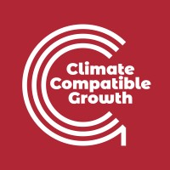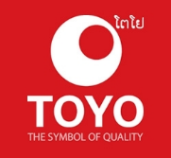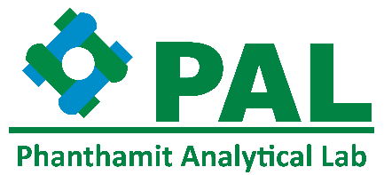

**The 2025 NUOL International Conference on Science, Engineering and Innovation (ICSEI 2025), in Association with AUN/SEED-Net Regional Conference: “Promoting Science, Technology, and Innovation for Sustainable Development in Lao PDR and Beyond”**

**Call for Papers**

**Important Dates:**

**Abstract submission:**

Deadline: August 15, 2025

Acceptance: September 15, 2025

**Full Paper Submission Deadline:**

October 31, 2025

**Registration by:**

November 11, 2025

**Conference Day:**

November 27-28, 2025

**Registration Fee:**

Regular: USD150

Student: USD75

**Venue:**

Crowne Plaza Vientiane, Lao PDR.

**Key Themes and Topics:**

* Renewable Energy and Energy Efficiency
* Water management
* Sustainable Infrastructure Development
* Climate Change and Environmental Sustainability
* Advanced Materials and Manufacturing
* Smart Technologies and Digital Transformation
* Science, Technology, Engineering, and Mathematics (STEM) Education
* Innovation and Entrepreneurship for Sustainable Development
* Circular Economy Applications in waste management

**For more Information:**

https://fe-nuol.edu.la/ICSEI2025/

Email: icnse@fe-nuol.edu.la



Accepted papers can be published in the Scientific Journal of National University of Laos

<https://lsj.sjnl.la/index.php/lsJ>

Alternatively, papers may be considered for publication in the Asia-Pacific Journal of Science and Technology (APST), but subject to APST’s review process and publication criteria

<https://so01.tci-thaijo.org/index.php/APST>

**Organizers:**

* Faculty of Engineering, National University of Laos, Lao PDR.
* AUN/SEED-Net
* Burapha University (Thailand)
* JICA HUGETECH “The Project for Strengthening Human Resource Development of Engineering and Technology for Industry Development in Lao PDR.”
* Climate Compatible Growth, UK
* Ministry of Education and Sports, Lao PDR.