**Title**

1st author name1, *, 2nd author name1 and Last author name2

1 Affiliation

2 Affiliation

*Corresponding author: Please_fill_in@email.

# Abstract

# Here writes the abstract - 200 – 250 words in English! (TNR 12 pt. alignment in block, spacing 1,0) Abstract should outline the purpose of the article, method of the research, data and main results. text, text, text, text, text, text, text, text, text, text, text, text, text, text, text, text, text, text, text, text, text, text, text, text, text, text, text, text,

**Keywords:**

- Keywords should not be given in general and plural terms and should not connote multiple concepts. Do not use words or terms in the title as keywords.

- The keywords are generally used for indexing purposes and as such, they should not be more than 5 words or phrases in alphabetical order.

# Introduction

State the objectives of the work and provide an adequate background, avoiding a summary of the results. Explain how you addressed the problem and clearly state the aims of your study.

- What is the context of the problem?  
- Why is this research important?  
- What are the objectives?  
- Who will benefit? Who will it affect?  
- What has been done so far?  
- What are the contribution/value added to knowledge fund?  
- What is the structure of the paper?

# Methodology

Here, the time and place of the research should be mentioned. A theory section should come after without repeating the background already dealt with in the introduction and this should lay the foundation for empirical work. Explain data, sampling, estimation, hypothesis testing, etc.

For equation, use Time new roman” 12 pt. Write equation number in parenthesis at the end of equation.

# Results and discussion

Results and discussion must be written in the same paragraph. In other words, they should be presented continuously, starting from the main result to the supporting results and equipped with discussion. Units of measurements used should follow the prevailing international system. Use USD for currency and SI unit. All figures and tables should be in their respective places.

* **Tables and Figures.** Tables and figures should be inserted in the text, not at the end of the manuscript. Use font “Times New Roman” 12 pt. The table titles and figure captions should be concise, and represent the data contained. Sources of data must be properly cited. Horizontal lines, no vertical lines, should be used in the tables. The details in the figures are clearly visible. Conclusions

*Figure 1: Figure description (TNR 10pt., centered, italics)*

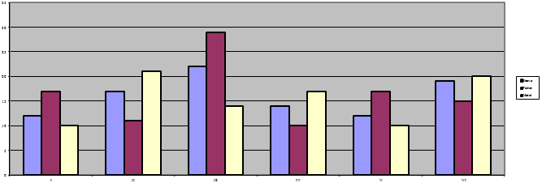

*Source: (TNR 10pt. italics)*

Table 1: Table description (TNR 10pt., italics)

|  |  |  |
| --- | --- | --- |
| Times New Roman 10pt | Times New Roman 10pt | Times New Roman 10pt |
| Times New Roman 10pt | Times New Roman 10pt | Times New Roman 10pt |
| Times New Roman 10pt | Times New Roman 10pt | Times New Roman 10pt |
| Times New Roman 10pt | Times New Roman 10pt | Times New Roman 10pt |

### ***Source:* *(TNR 10pt., italics)***

Equations (refer with: Eq. 1, Eq. 2,...) should be placed in the middle, denoted by numbers in round parentheses and transformed by equation conversion manager, **do not use Print Screen or jpg format**. For example:

 (1)

# Conclusion

The conclusion should be explained clearly with suggestions/recommendations placed after it which can be of use to readers/consumers.

# Acknowledgement (if any)

State the source of grant if any. Also, name the person(s) who assisted you in accomplishing the research work.

# References

* Use **APA (6th edition)** for referencing style.