# 

# 

# The Royal University of Phnom Penh

# Faculty of Engineering

# Department of Data Science and Engineering

**Course :** Data Analytics (DA)

**Topic : Customer Segmentation Using RFM**

**Lecturer** : Mr. CHAP CHAN PISETH

**Prepared By** : ROP BOROM

VARN CHORRATTANAK

## Academic Year: 2024-2025

# Abstract

Customer segmentation is a critical aspect of business strategy that enables organizations to target customers more effectively. This project applies the RFM (Recency, Frequency, and Monetary) model to segment customers based on their purchasing behavior. The study explores how businesses can utilize RFM analysis to improve customer retention, personalize marketing strategies, and optimize revenue. The results highlight different customer segments and their potential impact on business decisions.

# 1. Introduction

Customer segmentation helps businesses categorize customers into meaningful groups for personalized engagement. The RFM model is a widely used method that assesses:  
- **Recency (R):** How recently a customer made a purchase.  
- **Frequency (F):** How often a customer makes purchases.  
- **Monetary (M):** The total spending of a customer.  
  
This study applies RFM analysis to a dataset containing 4,905 orders from 995 unique customers, evaluating customer behavior and segmentation for strategic decision-making.

# 2. Methodology

### 2.1 Data Collection

The dataset consists of 4,905 transaction records, including:  
- Customer ID  
- Order Date  
- Revenue per transaction

### 2.2 Data Preprocessing

- Fixed column names and removed unnecessary columns.  
- Converted order dates to datetime format for accurate analysis.  
- Filtered out erroneous early year data (before 2004).  
- Checked for missing values (none found) and handled duplicate records (none found).  
- Analyzed revenue distribution and detected outliers, finding no extreme values impacting analysis.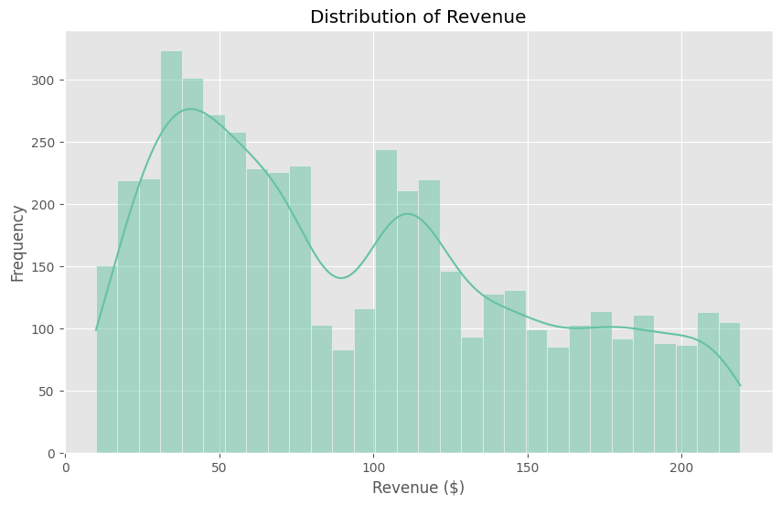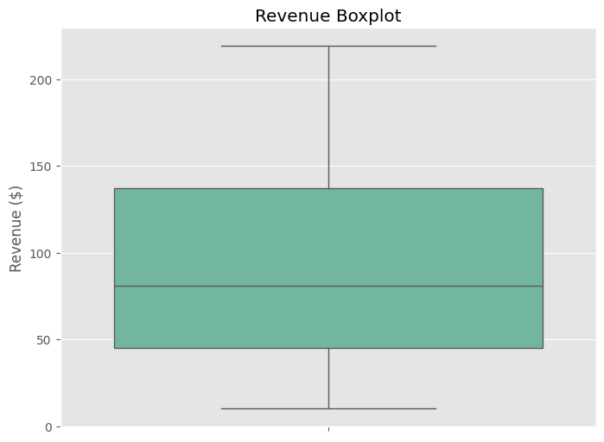

## 2.3 RFM Scoring

**- Recency:** Days since last purchase (relative to 30th Dec 2006, the latest order date).  
**- Frequency:** Total number of orders per customer.  
**- Monetary:** Total spending per customer.  
**- Quintile scoring** (1-5) was applied to each metric to classify customers.

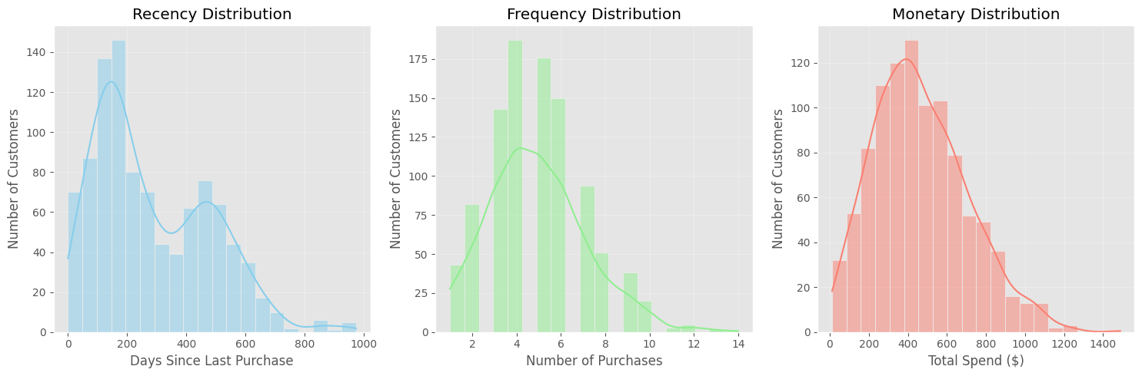

# 2.4 Customer Segmentation

Based on RFM scores, customers were grouped into:  
**- Champions** (Highly engaged, frequent, and high-spending customers)  
**- Loyal Customers** (Consistent shoppers with strong purchase history)  
**- Potential Loyalists** (New but engaged customers with high potential)  
**- At-Risk Customers** (Previously active but showing signs of disengagement)  
**- Lost Customers** (No recent purchases, high risk of churn)

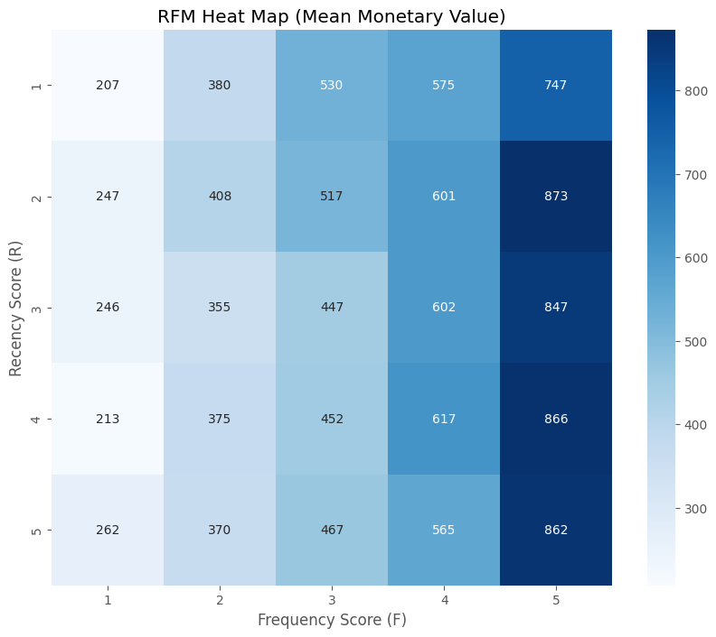

## 3. Data Analysis and Results

### 3.1 Key Business Metrics

**- Total Revenue:** $463,980  
**- Number of Orders:** 4,905  
**- Number of Unique Customers:** 995  
**- Average Order Value:** $94.59  
**- Average Orders per Customer:** 4.93  
**- Average Revenue per Customer:** $466.31

### 3.2 RFM Segmentation Results

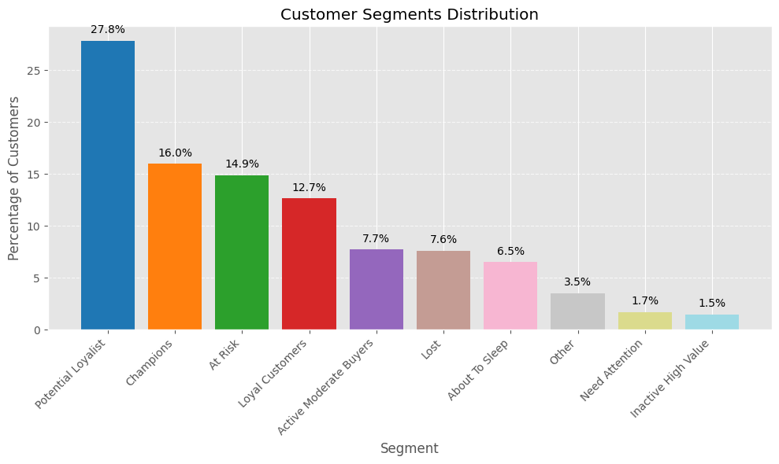

## 4. Discussion

- Revenue distribution showed no significant outliers, indicating consistent customer spending.  
**- Churn Rate:** 59.4% of customers have not purchased in the last 180 days.  
**- Key Segments:**  
 **- Champions (15.98%)** drive the highest revenue and should be nurtured with VIP benefits.  
 **- At-Risk (14.87%) & Lost (7.64%)** customers need re-engagement campaigns.  
 **- Potential Loyalists (27.84%)** should be incentivized with loyalty programs.

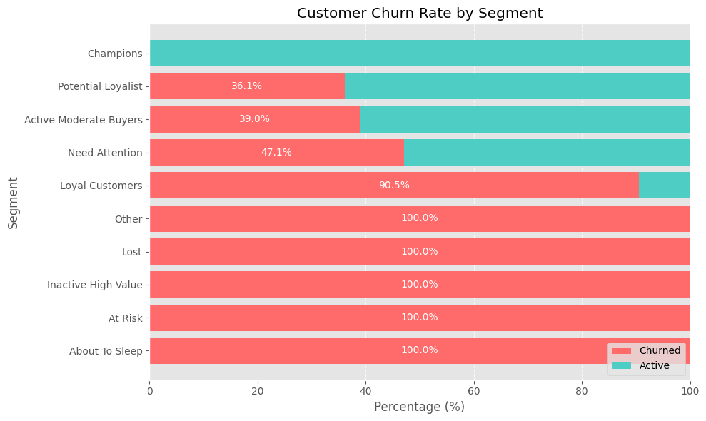

## 5. Conclusion and Recommendations

### 5.1 Conclusion

This study successfully applied RFM analysis to segment customers based on their purchasing behavior. The insights provide actionable data to enhance customer relationships, boost retention, and optimize marketing strategies.

### 5.2 Recommendations

**1. Retention Efforts:** Target high-value, at-risk customers with personalized offers.  
**2. Loyalty Programs:** Incentivize potential loyalists to become champions.  
**3. Win-Back Campaigns:** Engage lost and at-risk customers through discounts and reactivation emails.  
**4. Seasonal Promotions:** Utilize monthly trends to maximize revenue in peak months.  
**5. Data-Driven Marketing:** Leverage customer segmentation for personalized engagement strategies.

## 6. References

1/ [What is RFM Analysis (Recency, Frequency & Monetary Value)? | Marketing91](https://www.marketing91.com/what-is-rfm-model/)

2/ [Customer Segmentation using RFM Analysis - Rsquared Academy Blog - Explore Discover Learn](https://blog.rsquaredacademy.com/customer-segmentation-using-rfm-analysis/)

3/ [RFM - Customer Level Data • rfm](https://rfm.rsquaredacademy.com/articles/rfm-customer-level-data.html)

4/ [An RFM Customer Segmentation with Python | Towards Data Science](https://towardsdatascience.com/an-rfm-customer-segmentation-with-python-cf7be647733d/)

5/ [RFM Analysis. What is RFM Analysis? | by Adi Saputra | Medium](https://medium.com/@adisaputralim2412/rfm-analysis-934e0f04a7ac)