**Crop Production Analysis**

1. **Title**

Crop Production Analysis

1. **Introduction**

The document is an exploratory data analysis on crop production in India, utilizing a dataset from Kaggle. The analysis aims to uncover insights regarding crop yield trends, state-wise production, seasonality, and the performance of different crops over the years. Tools like Python libraries (NumPy, Pandas, Matplotlib, and Seaborn) are used for data cleaning, visualization, and exploratory analysis to answer key questions related to agricultural productivity.

1. **Objectives**

The main objective of the project is to analyze agricultural crop production data in India to:

* Understand the distribution and yield of various crops.
* Identify which states and regions have higher production.
* Discover trends over time related to crop production.
* Investigate the seasonality of crops and their contribution to total production.

1. **Scope of work**

The project will involve the following tasks:

* **Data Exploration:** Understanding the dataset, including crop types, production, and geographical distribution.
* **Data Preprocessing:** Cleaning the dataset by handling missing values, addressing outliers, and preparing data for analysis.
* **Feature Selection:** Identifying the most significant factors affecting crop production, such as region, season, and crop type.
* **Data Visualization:** Using plots and graphs to visualize trends in crop production across states, years, and seasons.
* **Model Building:** Developing and evaluating machine learning models to predict crop production and analyze influential factors.
* **Interpretation of Results:** Analyzing the model outputs to derive insights and draw conclusions about crop yield trends.
* **Reporting:** Documenting the findings and preparing a comprehensive report with actionable insights for improving agricultural practices.

1. **Methodology**

The project will follow a structured approach:

1. **Data Collection:** The dataset will be sourced from a public repository, such as GitHub[crop_production.csv].

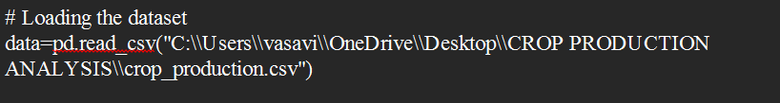

1. **Data Preprocessing:**
   1. Handle missing data using imputation techniques.
   2. 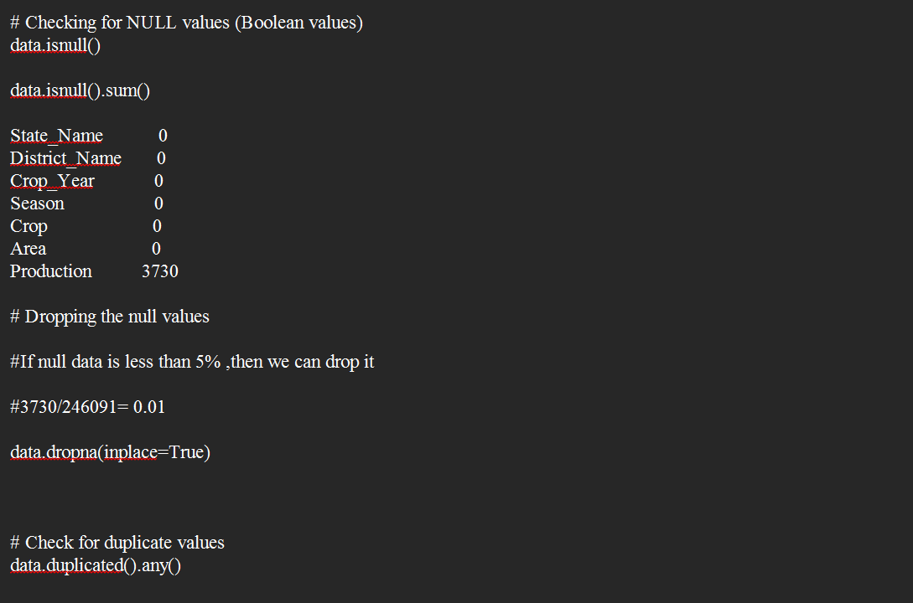Detect and remove outliers.
2. **Exploratory Data Analysis (EDA):**
   1. Use descriptive statistics to summarize the dataset.
   2. Create visualizations like line charts, box plots, and correlation heatmaps to understand feature distributions and relationships.
3. 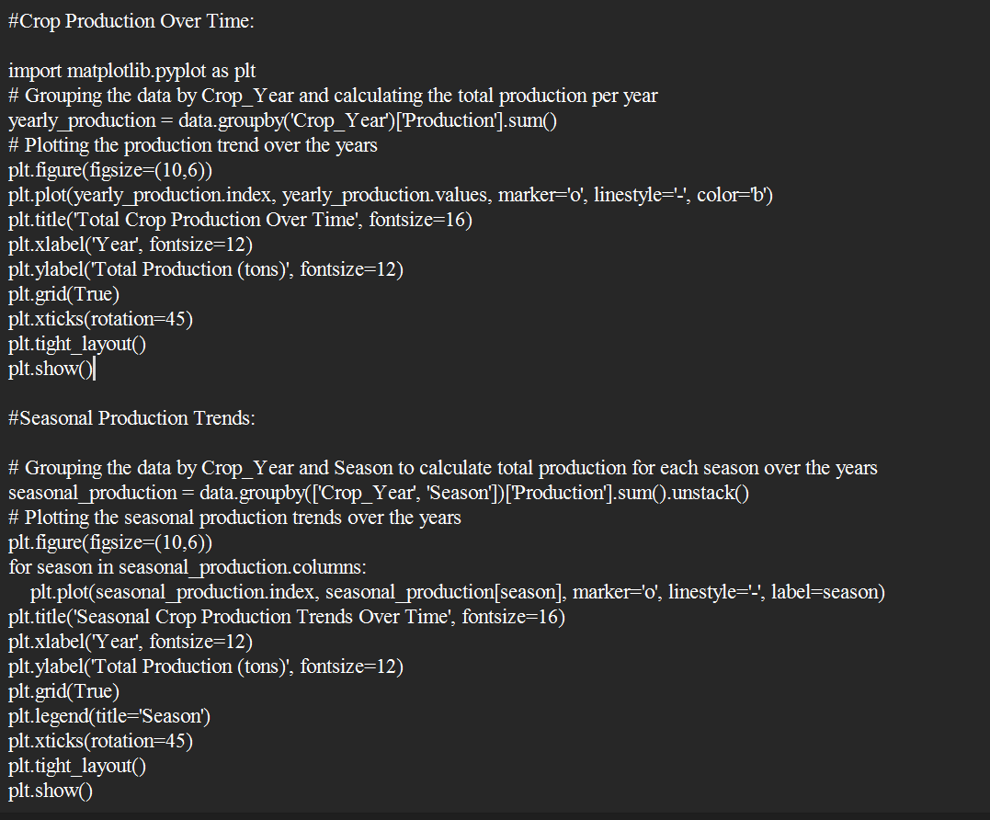**Trend** **Analysis**
4. 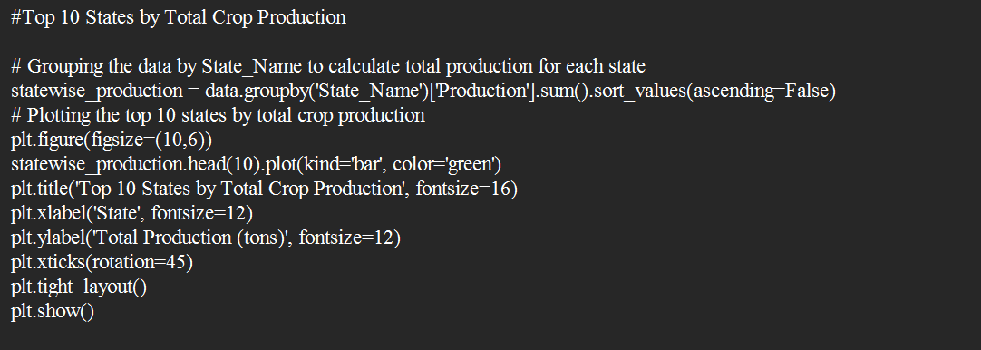**Geographical Analysis**
5. 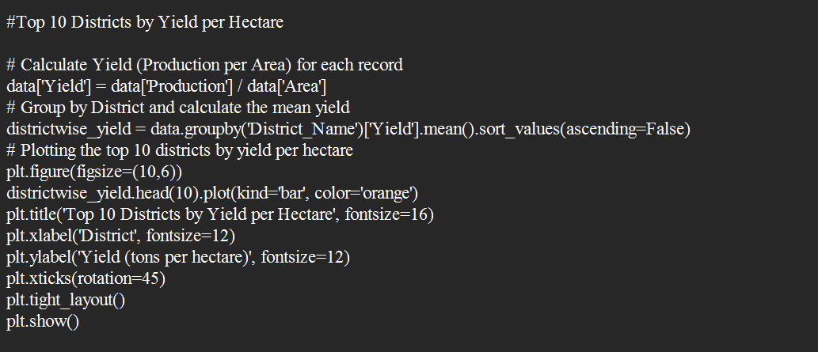**Yield Analysis**
6. 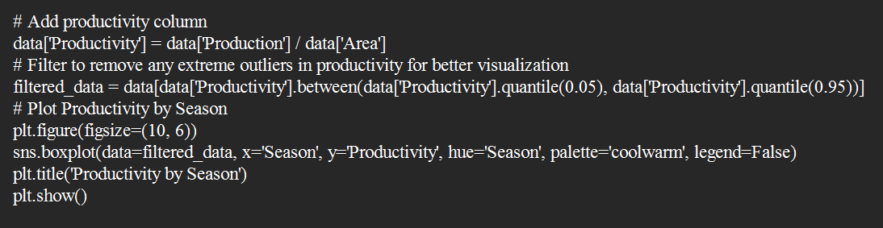**Productivity Analysis**
7. 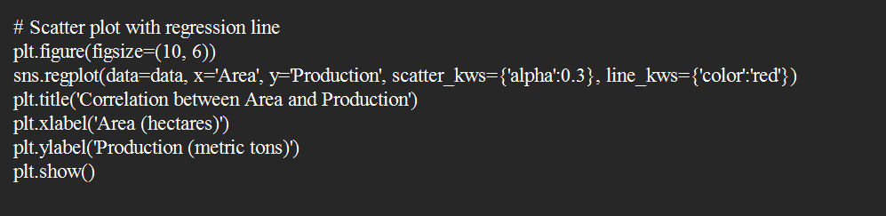**Correlation Analysis**
8. **Feature Selection:**
   1. Use correlation analysis to identify relevant features.
9. **Modelling:**
   1. Split the data into training and testing sets.
   2. Train multiple models (e.g. Random Forest Regressor)

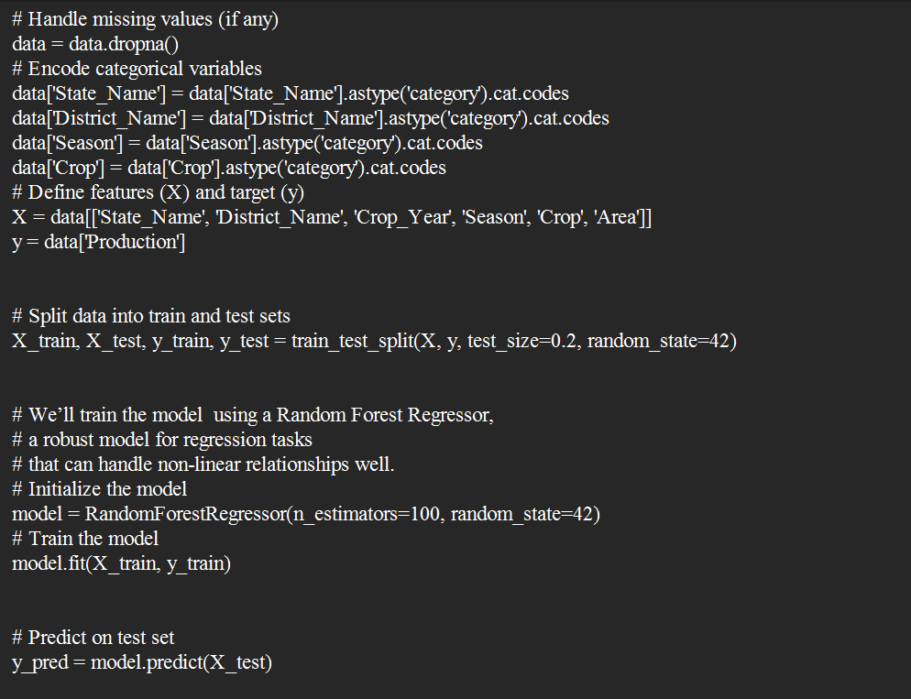

1. **Evaluation and Interpretation:**
   1. Evaluate the model’s performance using Mean Absolute Error (MAE) and Root Mean Square Error (RMSE).
   2. 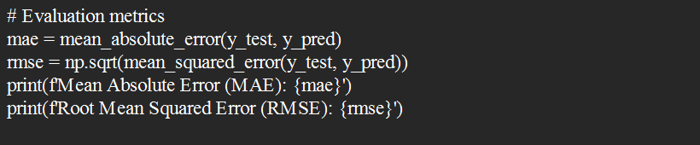Compare model performance.
2. **Visualization:**
   1. Generate charts and graphs to visualize the findings.
3. **Reporting:**
   1. Compile the analysis, results, and insights into a comprehensive report.
4. **Tools and Technologies**

* **Programming Language:** Python
* **Libraries:** Pandas, NumPy, Matplotlib, Seaborn, Scikit-learn
* **IDE**: Jupyter Notebook
* **Data Source:** GitHub [crop_production.csv]

1. **Expected Outcomes**

* Determine long-term trends in crop production, identifying which crops show growth or decline over the years.
* Pinpoint the most productive regions for each crop, helping to identify high-yield areas and those needing support.
* Assess how different seasons affect crop yields, guiding planting schedules for maximum productivity.
* Analyze the link between land area and yield to identify crops with high production per unit area, optimizing land usage.
* Identify the highest-yielding crops overall, helping prioritize them for investment and development.

1. **Timeline**

The project is expected to be completed within a [specific timeframe, e.g., 4 weeks], with the following milestones:

• Week 1: Data Collection and Preprocessing

• Week 2: Exploratory Data Analysis and Feature Selection

• Week 3: Model Building and Evaluation

• Week 4: Visualization, Reporting, and Final Submission

1. **Conclusion**

The crop production analysis highlights significant regional and seasonal variations, revealing high-yield areas and optimal growth periods for specific crops. Trends over time show shifts in crop productivity and popularity, possibly due to changing practices or environmental factors. Some crops achieve high yields on smaller areas, indicating efficient land-use potential, while a few dominant crops could benefit from focused development. Certain regions show favourable conditions for particular crops, suggesting the value of tailored support. The data also enables yield forecasting based on historical patterns, helping adapt to external influences like climate or market incentives. These insights support strategic, data-driven decisions to improve crop yield and sustainability.