**支撑剂沉降运移规律测试报告**

**2021-03-24 22:32:29**

**一、基本信息**

**【1】仪器基本信息**

|  |  |
| --- | --- |
| 设备名称 | 压裂3434 |
| 生产厂家 | 3243 |
| 出厂日期 | 2020.02.21 |
| 保养日期 | 234234 |
| 设备责任人 | 张三 |
| 实验人员 | 李四 |
| 单位名称 | 某公司 |

**【2】实验材料信息**

|  |  |  |  |
| --- | --- | --- | --- |
| 压裂液类型 | 水f23432 | 支撑剂类型： | 石头 |
| 压裂液粘度（mPa.s） | 33 | 支撑剂密度(kg/m3) | 33 |
| 压裂液密度(kg/m3) | 22 | 支撑剂粒径(mm) | 22 |
| 报告存放位置 | D:\ | | |

**【3】测试数据**

|  |  |  |  |  |  |  |  |  |  |  |  |  |  |  |  |  |  |  |  |  |  |  |
| --- | --- | --- | --- | --- | --- | --- | --- | --- | --- | --- | --- | --- | --- | --- | --- | --- | --- | --- | --- | --- | --- | --- |
| **支撑剂密度** | **压裂液密度** | | **支撑剂直径** | | **压裂液粘度** | | **砂比** | | **裂缝宽度** | | **排量** | **裂缝高度** | | **砂堤孔隙度** | | **垂直移动速度** | | **水平运移速度** | | **平衡流速** | | **平衡高度** |
| 234 | 234 | | 234 | | 234 | | 234 | | 234 | | 324 | 324 | | 234 | | 1671.19 | | 21.30 | | 22793.93 | | 1.00 |
| 1 | 33 | | 22 | | 11 | | 22 | | 45 | | 22 | 33 | | 44 | | 1671.19 | | 21.30 | | 22793.93 | | 1.00 |
| 36 | 4436 | | 433 | | 22 | | 22 | | 22 | | 22 | 22 | | 22 | | 1671.19 | | 21.30 | | 22793.93 | | 1.00 |
| 33 | 4433 | | 433 | | 23 | | 3 | | 3 | | 3 | 3 | | 3 | | 1671.19 | | 21.30 | | 22793.93 | | 1.00 |
| 34 | 4434 | | 433 | | 433 | | 433 | | 433 | | 433 | 433 | | 433 | | 1671.19 | | 21.30 | | 22793.93 | | 1.00 |
| 35 | 4435 | | 433 | | 2 | | 3 | | 3 | | 3 | 3 | | 3 | | 1671.19 | | 21.30 | | 22793.93 | | 1.00 |
| 44 | 4444 | | 433 | | 22 | | 22 | | 22 | | 22 | 22 | | 22 | | 1671.19 | | 21.30 | | 22793.93 | | 1.00 |
| 39 | 4439 | | 433 | | 22 | | 22 | | 22 | | 22 | 22 | | 22 | | 1671.19 | | 21.30 | | 22793.93 | | 1.00 |
| 40 | 4440 | | 433 | | 22 | | 22 | | 22 | | 22 | 22 | | 22 | | 1671.19 | | 21.30 | | 22793.93 | | 1.00 |
| 42 | 4442 | | 433 | | 22 | | 22 | | 22 | | 22 | 22 | | 22 | | 1671.19 | | 21.30 | | 22793.93 | | 1.00 |
| 37 | 4437 | | 433 | | 22 | | 22 | | 22 | | 22 | 22 | | 22 | | 1671.19 | | 21.30 | | 22793.93 | | 1.00 |
| 38 | 4438 | | 433 | | 22 | | 22 | | 22 | | 22 | 22 | | 22 | | 1671.19 | | 21.30 | | 22793.93 | | 1.00 |
| 43 | 4443 | | 433 | | 22 | | 22 | | 22 | | 22 | 22 | | 22 | | 1671.19 | | 21.30 | | 22793.93 | | 1.00 |
| 45 | 4445 | | 433 | | 22 | | 22 | | 22 | | 22 | 22 | | 22 | | 1671.19 | | 21.30 | | 22793.93 | | 1.00 |
| 41 | 4441 | | 433 | | 22 | | 22 | | 22 | | 22 | 22 | | 22 | | 1671.19 | | 21.30 | | 22793.93 | | 1.00 |
| 50 | 4447 | | 433 | | 22 | | 22 | | 22 | | 22 | 22 | | 22 | | 1671.19 | | 21.30 | | 22793.93 | | 1.00 |
| 47 | 4447 | | 433 | | 22 | | 22 | | 22 | | 22 | 22 | | 22 | | 1671.19 | | 21.30 | | 22793.93 | | 1.00 |
| 48 | 4447 | | 433 | | 22 | | 22 | | 22 | | 22 | 22 | | 22 | | 1671.19 | | 21.30 | | 22793.93 | | 1.00 |
| 46 | 4446 | | 433 | | 22 | | 22 | | 22 | | 22 | 22 | | 22 | | 1671.19 | | 21.30 | | 22793.93 | | 1.00 |
| 49 | 4447 | | 433 | | 22 | | 22 | | 22 | | 22 | 22 | | 22 | | 1671.19 | | 21.30 | | 22793.93 | | 1.00 |
| **平均速度** | | 34 | | 35 | |  | |  | |  | | |  | |  | |  | |  | |  | |

**【4】支撑剂密度对支撑剂水平运移和沉降速度的影响**

**（1）支撑剂密度与水平速度关系回归式**

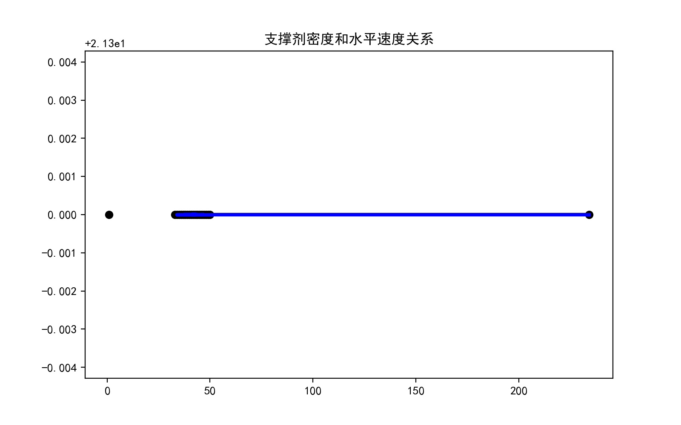

**回归关系式：Y= 0.0* X + 21.3**

**（2）支撑剂密度与垂直速度关系回归式**

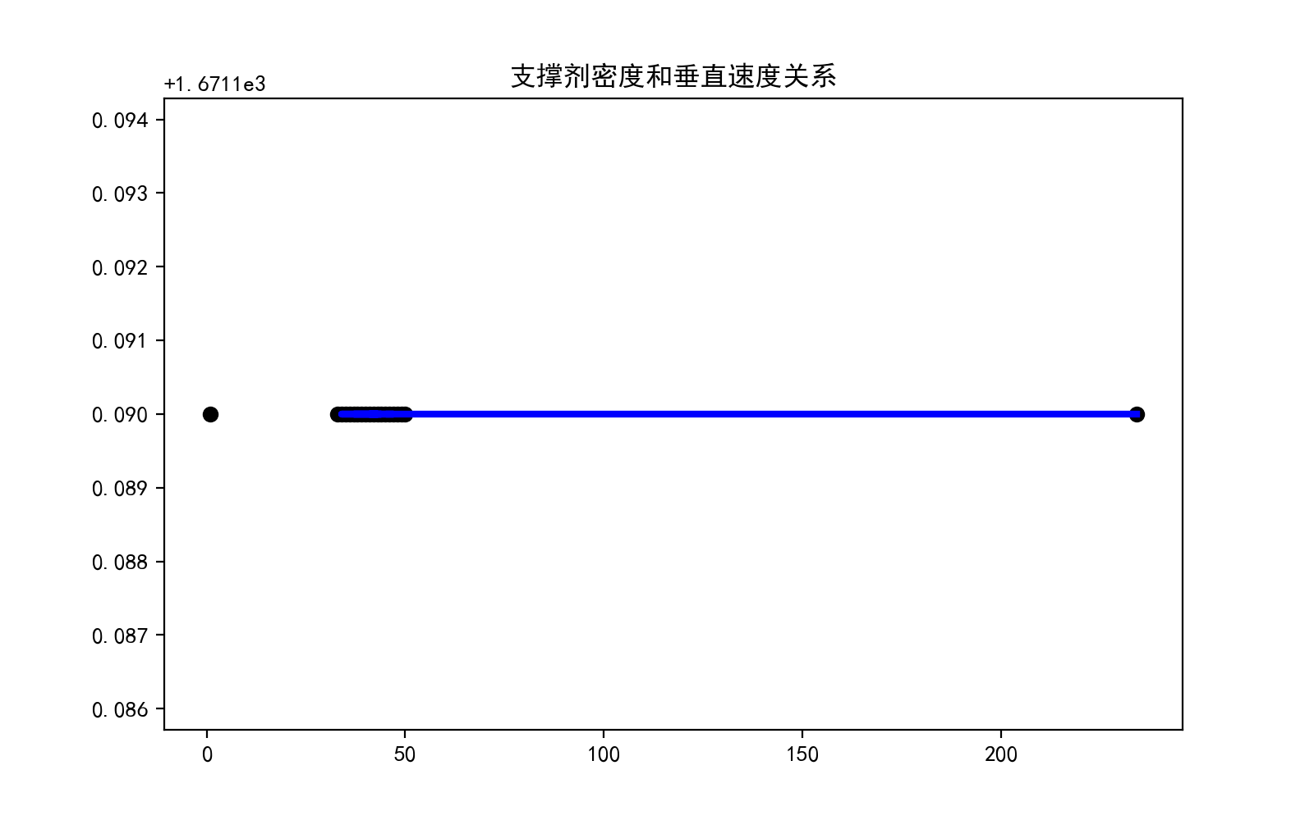

**回归关系式：Y= -0.0 * X + 1671.19**

**【5】排量对支撑剂水平运移和沉降速度的影响**

**（1）排量与水平速度关系回归式**

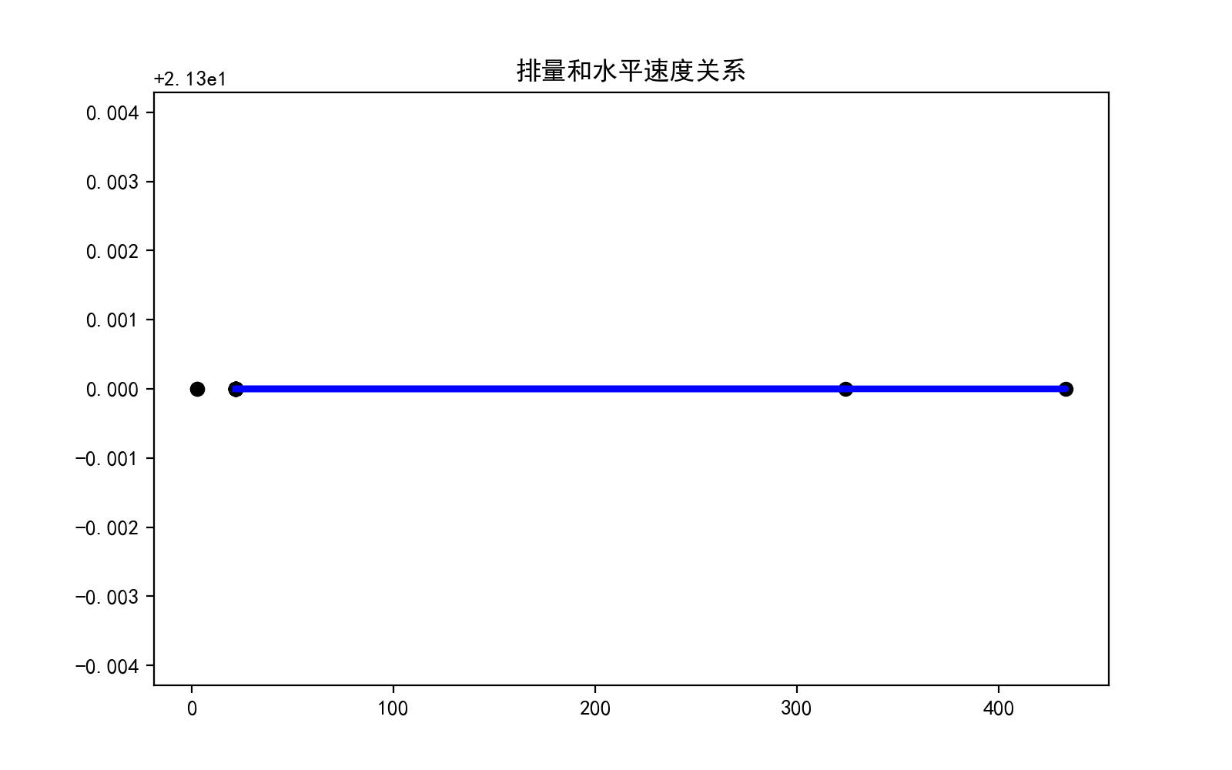

**回归关系式：Y= 0.0* X + 21.3**

**（2）排量与垂直速度关系回归式**

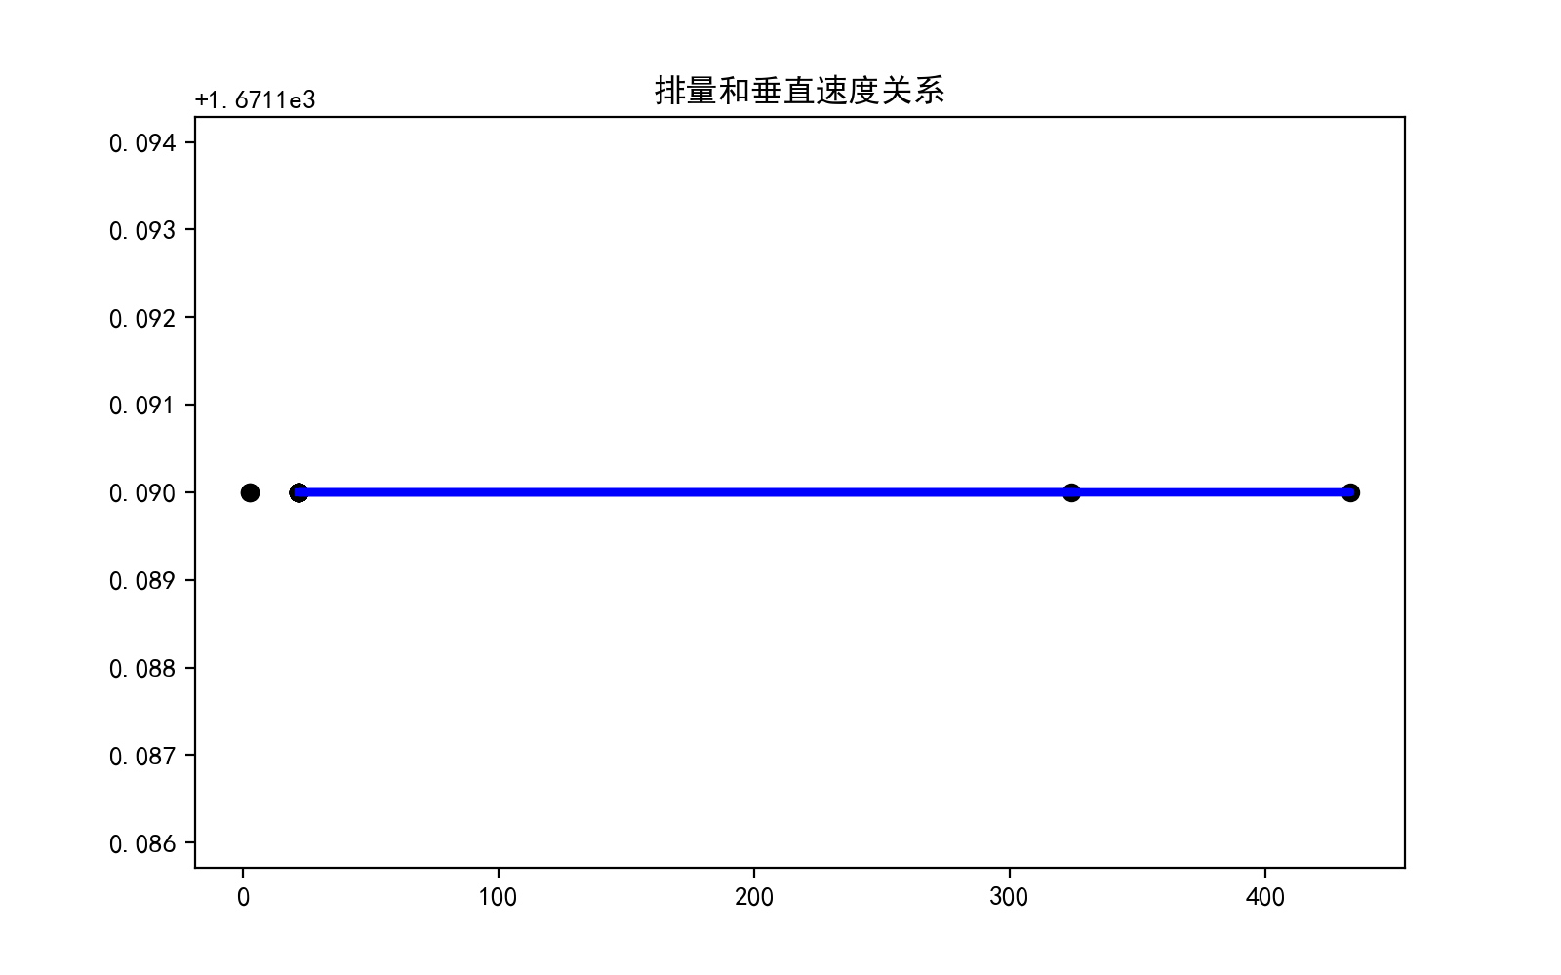

**回归关系式：Y= -0.0* X + 1671.19**

**【6】 压裂液粘度对支撑剂水平运移和沉降速度的影响**

**（1）压裂液粘度与水平速度关系回归式**

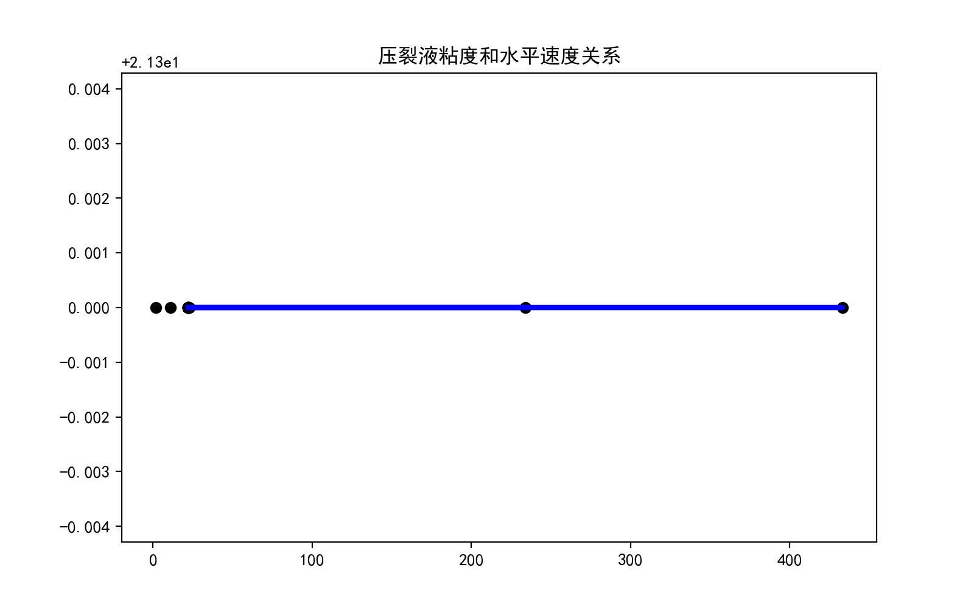

**回归关系式：Y=-0.0 * X + 21.3**

**（2）压裂液粘度与垂直速度关系回归式**

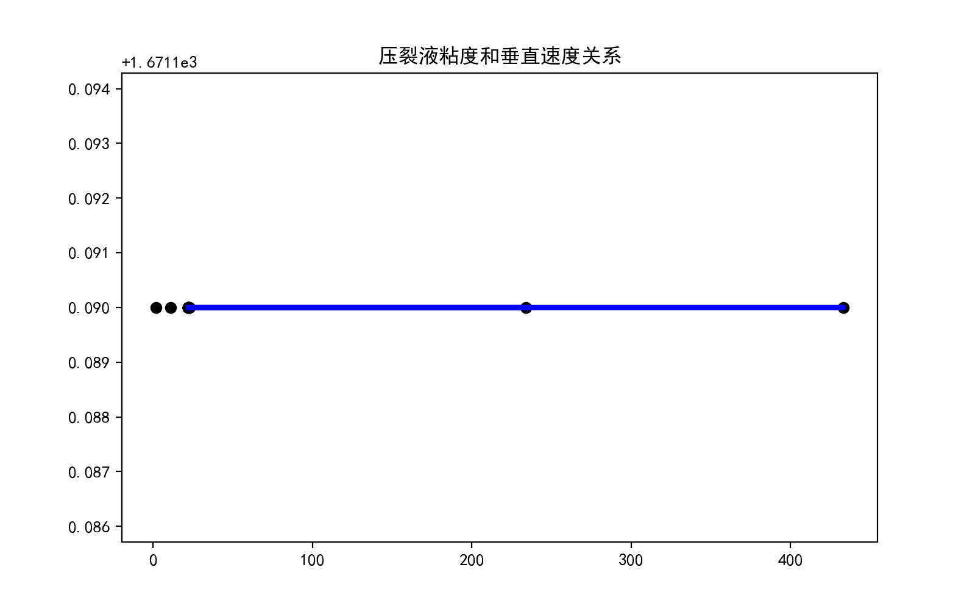

**回归关系式：Y=0.0* X + 1671.19**

**【7】砂比对支撑剂水平运移和沉降速度的影响**

**（1）砂比与水平速度关系回归式**

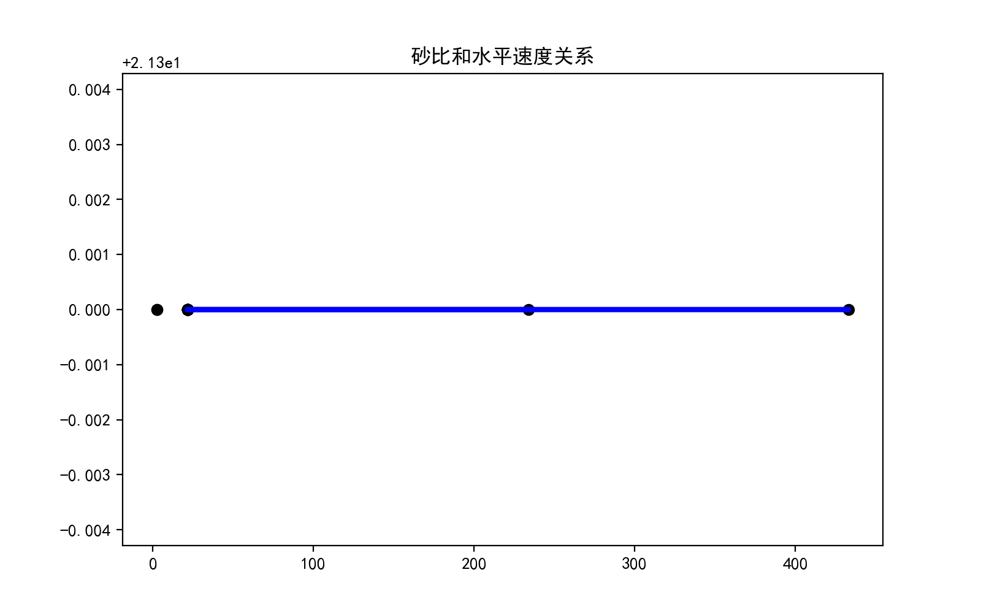

**回归关系式：Y=-0.0 * X + 21.3**

**（2）砂比与垂直速度关系回归式**

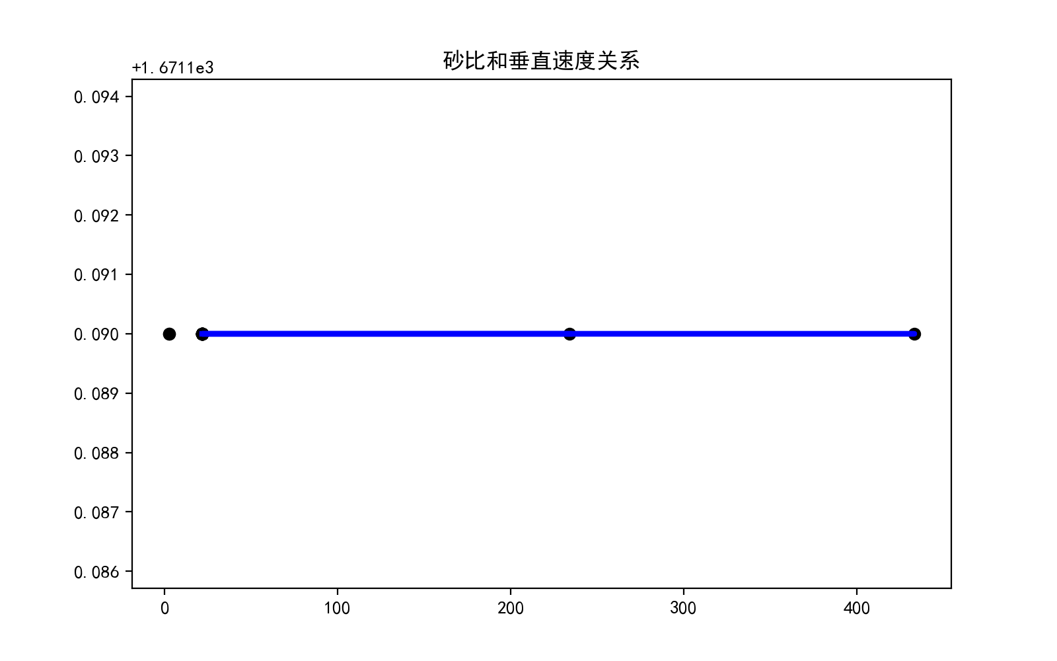

**回归关系式：Y=-0.0 * X + 1671.19**

**【8】各图规律分析**

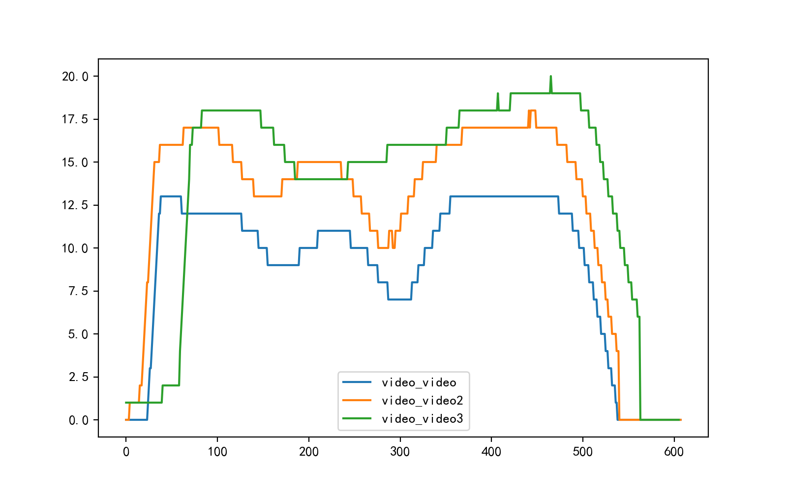

**各图数字化处理曲线**

**各图片各区砂堤面积和高度**

|  |  |  |  |  |  |  |  |  |  |
| --- | --- | --- | --- | --- | --- | --- | --- | --- | --- |
| **名称** | | **1区** | **增幅** | **2区** | **增幅** | **3区** | **增幅** | **4区** | **平均** |
| **1#** | **面积**  **（m2）** | **1464** | **-0.75%** | **1453** | **26.29%** | **1835** | **-58.31%** | **1464** | **1379.25** |
| **高度**  **（m）** | **12.0** | **-21.25%** | **9.45** | **25.71%** | **11.88** | **-23.32%** | **9.11** | **10.61** |
| **2#** | **面积**  **（m2）** | **2392** | **-2.84%** | **2324** | **8.00%** | **2510** | **-70.16%** | **2392** | **1993.75** |
| **高度**  **（m）** | **15.57** | **-2.57%** | **15.17** | **20.70%** | **18.31** | **-23.59%** | **13.99** | **15.76** |
| **3#** | **面积**  **（m2）** | **2067** | **16.88%** | **2416** | **3.48%** | **2500** | **-46.92%** | **2067** | **2077.5** |
| **高度**  **（m）** | **13.7** | **31.02%** | **17.95** | **14.09%** | **20.48** | **-10.60%** | **18.31** | **17.61** |

**【9】曲线内部各部分面积和高度对比分析**

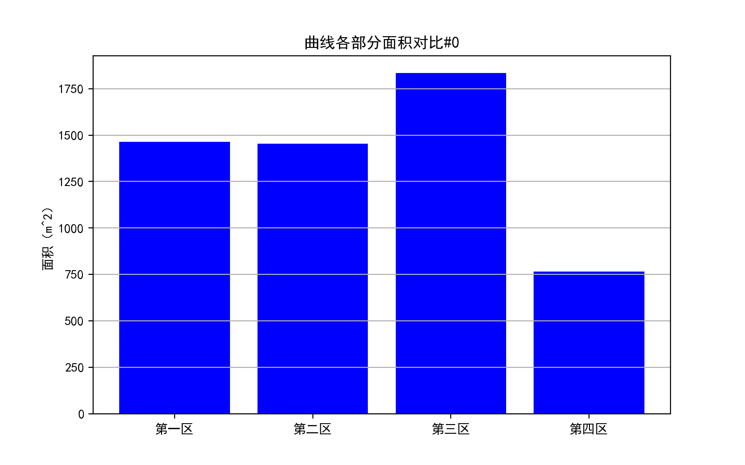 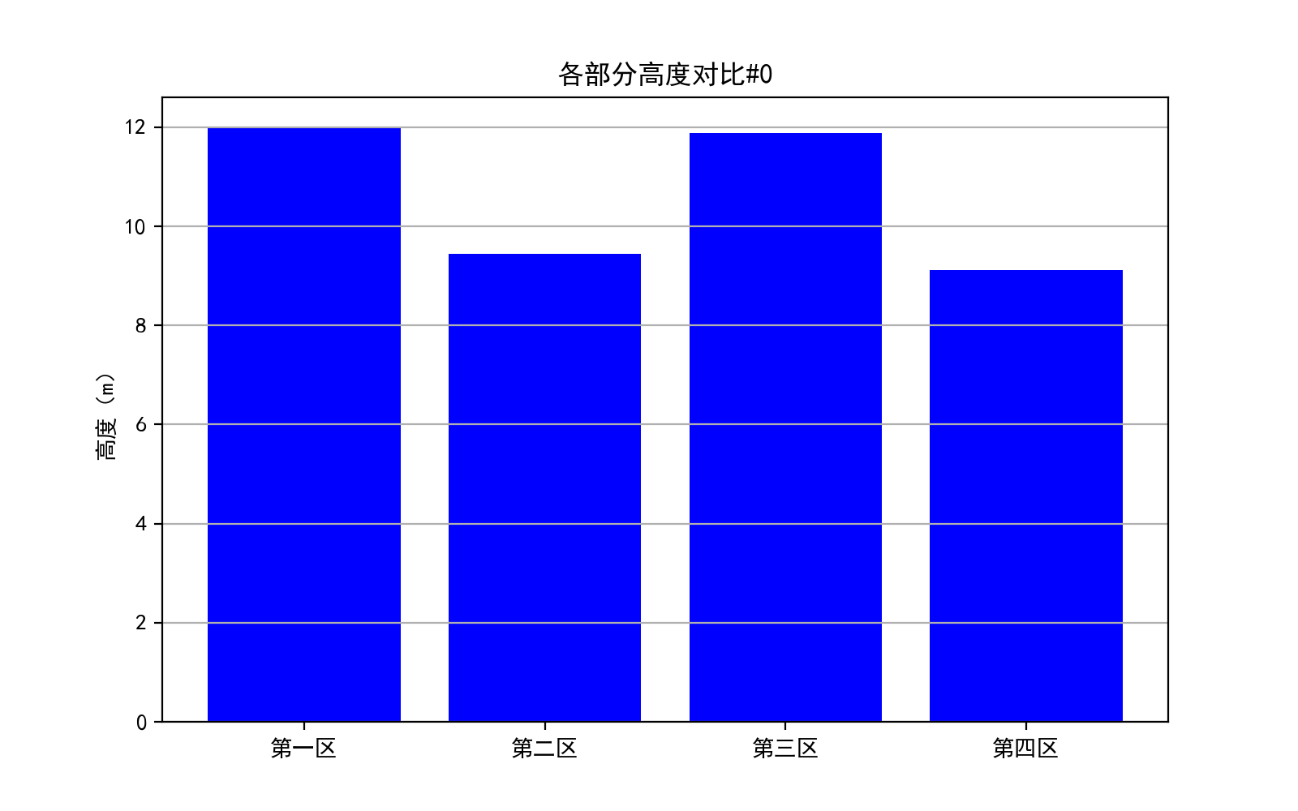.

1**#曲线4个区域面积分布图 1#曲线4个区域高度分布图**

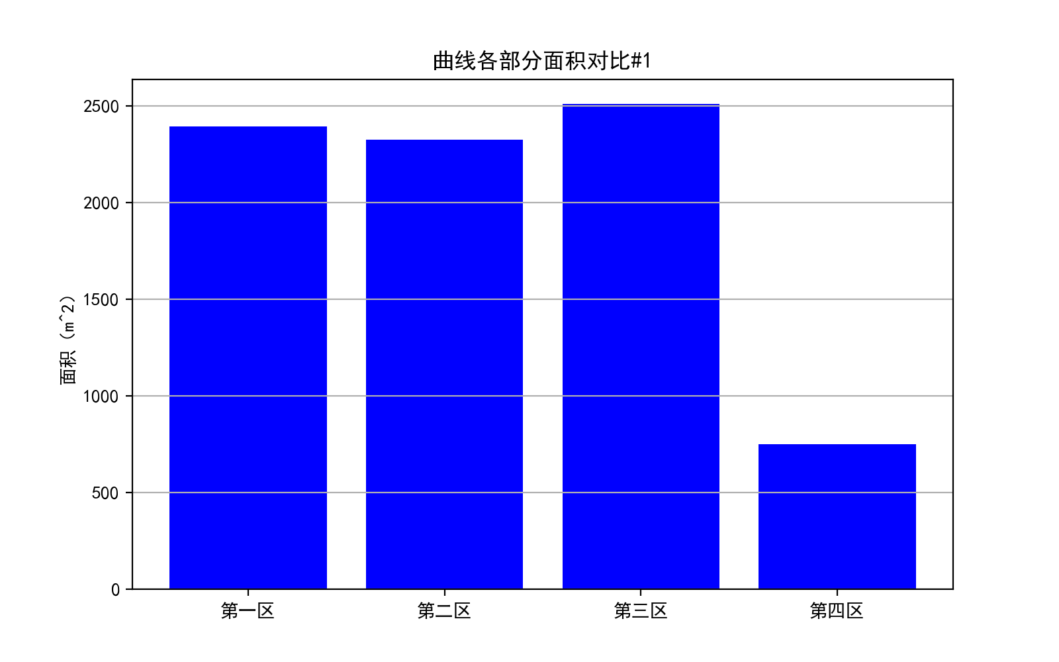 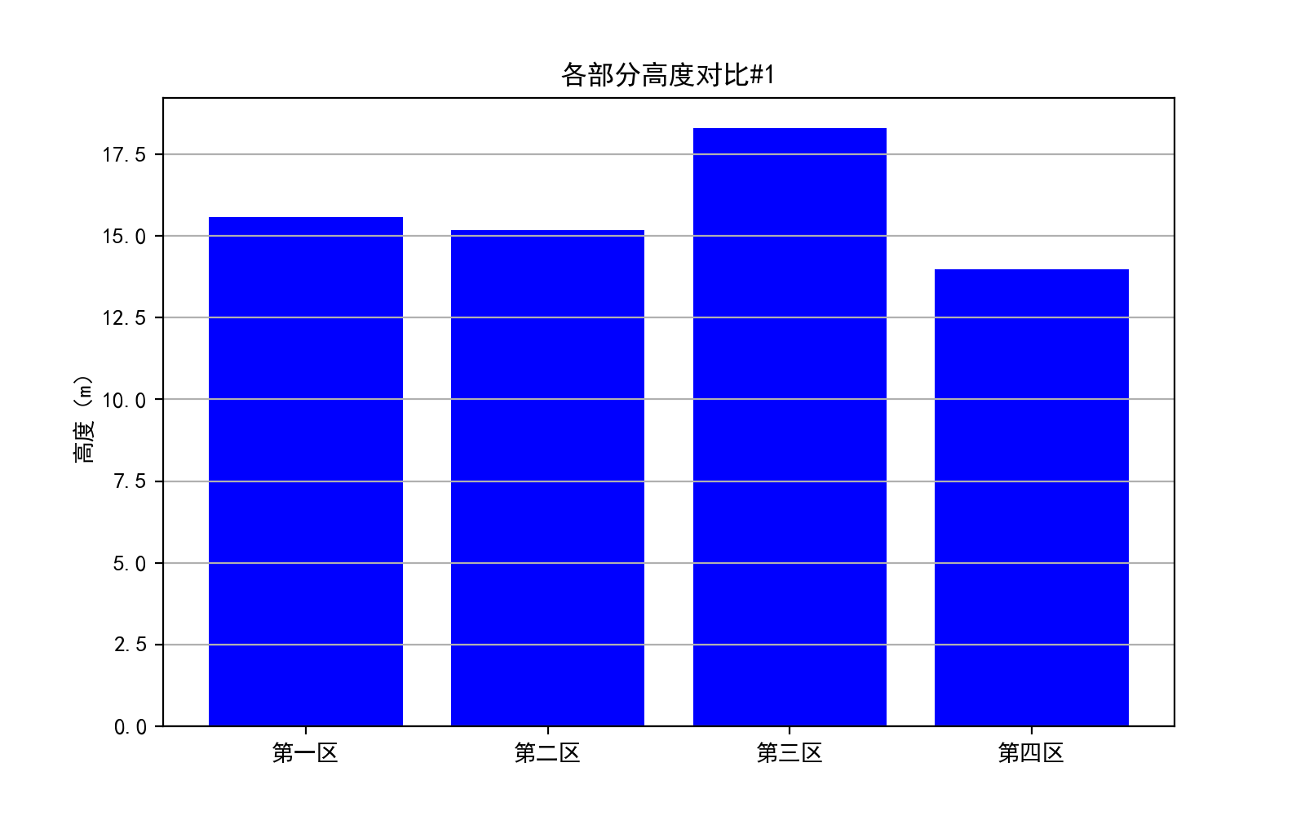.

2**#曲线4个区域面积分布图 2#曲线4个区域高度分布图**

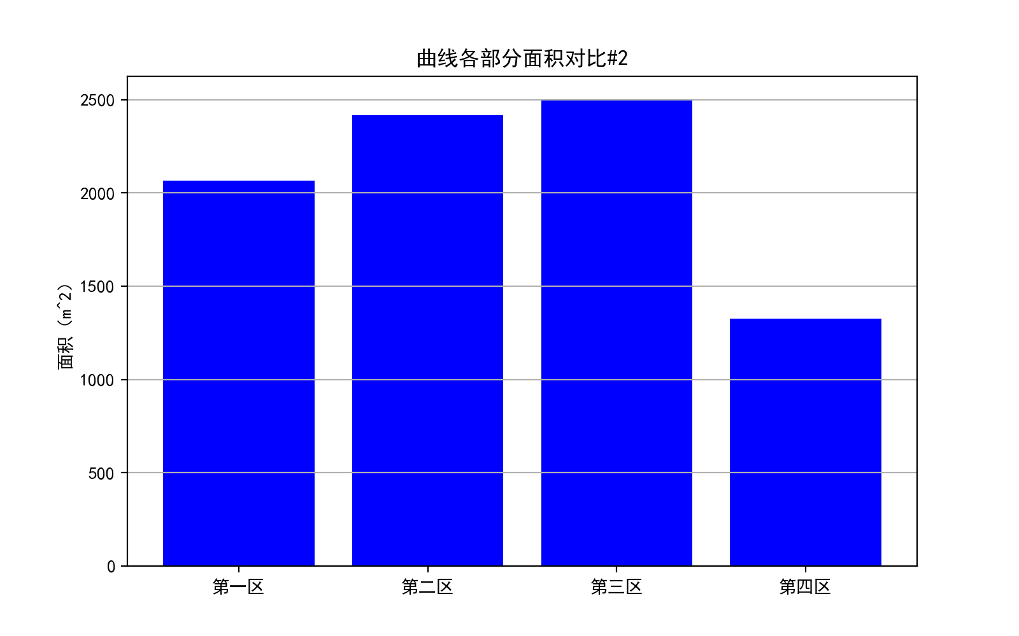 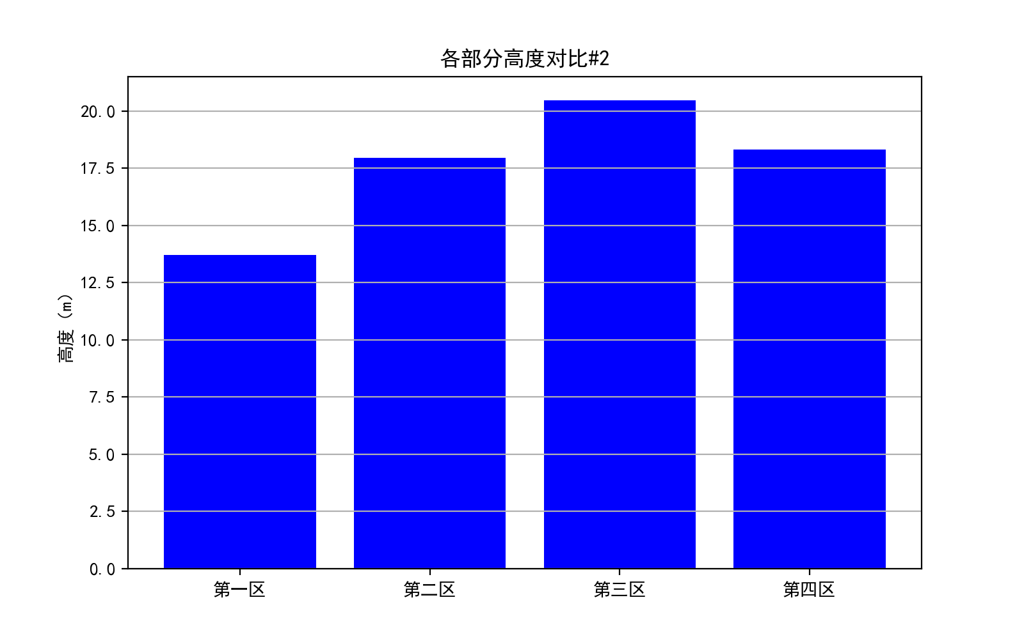.

3**#曲线4个区域面积分布图 3#曲线4个区域高度分布图**