Data Analysis including 2020 and 2021 Season.”Development of criteria for variable N-fertilizer and irrigation management of potatoes”

Fernando Bortolozo

10/29/2021

# 1. Exploratory Analisys

Total yield distribution across sites,irrigation methods and season for In-season decision, Grower’s practice and UF/IFAS N-fertilizer application. The total yield response was 28687.47, 29676.20, and 29411.81 lbs./acre for fixed N application rate, grower’s practice, and in-season decision N application respectively. There is no significant statistical difference between treatments. This results did not specify factor such as site, irrigation and year.

## **1.1 Summary**

## Trt Trt_ n_rates date dap   
## Length:84 Length:84 Min. :0.0 Mode:logical Min. :0   
## Class :character Class :character 1st Qu.:0.0 NA's:84 1st Qu.:0   
## Mode :character Mode :character Median :0.5 Median :0   
## Mean :1.0 Mean :0   
## 3rd Qu.:2.0 3rd Qu.:0   
## Max. :3.0 Max. :0   
## time farm irrig year   
## Min. :5.000 Length:84 Length:84 Min. :2020   
## 1st Qu.:5.000 Class :character Class :character 1st Qu.:2020   
## Median :5.000 Mode :character Mode :character Median :2020   
## Mean :5.429 Mean :2020   
## 3rd Qu.:6.000 3rd Qu.:2021   
## Max. :6.000 Max. :2021   
## plot block tyield   
## Min. : 1.000 Min. :1.000 Min. : 1568   
## 1st Qu.: 3.000 1st Qu.:1.000 1st Qu.:28570   
## Median : 6.000 Median :2.000 Median :31491   
## Mean : 5.857 Mean :2.286 Mean :29258   
## 3rd Qu.: 8.000 3rd Qu.:3.000 3rd Qu.:34492   
## Max. :12.000 Max. :4.000 Max. :50730

##   
## Shapiro-Wilk normality test  
##   
## data: dados$tyield  
## W = 0.73811, p-value = 6.148e-11

# 1.2. Total yield for Sseepage (SEP) and Subirrigation Drain Tile (SDT)

#### **Figure 1.**Total Yield Response considering N rates Fertilizer for Arlie and Parker accounting 2020 and 2021 Season for Seepage (SEP) Irr. System.

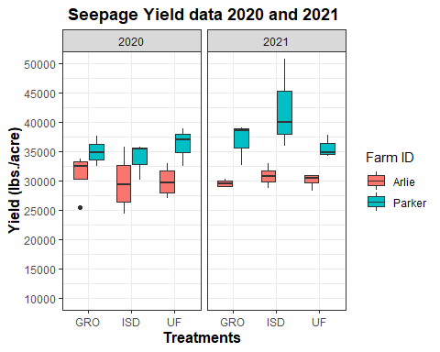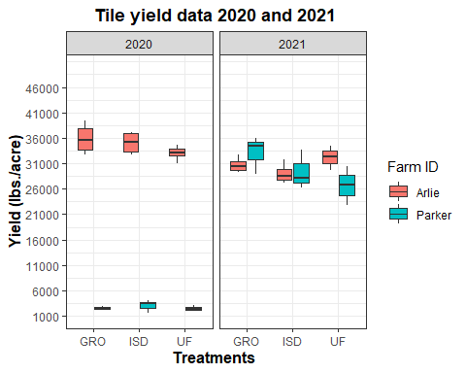

### **Anova and TukeyHSD test**

#### **Figure 2.** Total Yield distribution Across Farms, Irr. Systems, and Year for Each Treatment

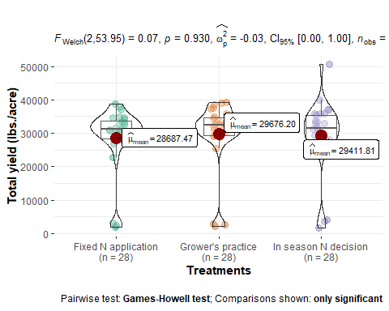

### **Pairwise test**

#### **Figure 2.** Total Yield distribution Across Farms, Irr. Systems, and Year for Each Treatment

## Df Sum Sq Mean Sq F value Pr(>F)  
## Trt 2 1.467e+07 7336787 0.07 0.932  
## Residuals 81 8.467e+09 104531808

## Tukey multiple comparisons of means  
## 95% family-wise confidence level  
##   
## Fit: aov(formula = tyield ~ Trt, data = dados)  
##   
## $Trt  
## diff lwr upr p adj  
## Grower's practice-Fixed N application 988.7342 -5535.239 7512.707 0.9304371  
## In season N decision-Fixed N application 724.3406 -5799.633 7248.314 0.9620229  
## In season N decision-Grower's practice -264.3936 -6788.367 6259.580 0.9948520

## $Trt  
## $Trt$Letters  
## Grower's practice In season N decision Fixed N application   
## "a" "a" "a"   
##   
## $Trt$LetterMatrix  
## a  
## Grower's practice TRUE  
## In season N decision TRUE  
## Fixed N application TRUE

## # A tibble: 3 x 4  
## Trt mean quant cld   
## <chr> <dbl> <dbl> <chr>  
## 1 Grower's practice 29676. 34552. a   
## 2 In season N decision 29412. 35476. a   
## 3 Fixed N application 28687. 33642. a

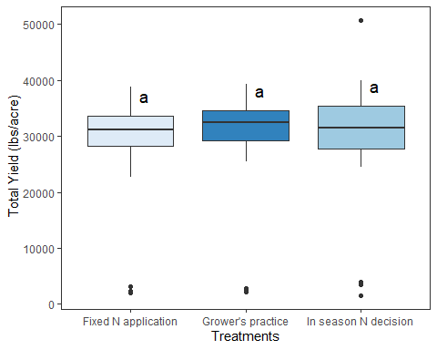

1. Total yield

#### **Figure 3.**Total Yield Response considering N rates Fertilizer for Arlie and Parker accounting 2020 and 2021 Season for Tile (SDT) Irr. System.

# Total Yield Response for N rates for SEP on Parker at 2020

## ------------------------------------------------------------------------  
## Analysis of Variance Table  
## ------------------------------------------------------------------------  
## DF SS MS Fc Pr>Fc  
## Treatament 2 8379822 4189911 0.67523 0.55890  
## Block 2 29144357 14572179 2.34841 0.21154  
## Residuals 4 24820482 6205121   
## Total 8 62344662   
## ------------------------------------------------------------------------  
## CV = 7.13 %  
##   
## ------------------------------------------------------------------------  
## Shapiro-Wilk normality test  
## p-value: 0.7021718   
## According to Shapiro-Wilk normality test at 5% of significance, residuals can be considered normal.  
## ------------------------------------------------------------------------  
##   
## ------------------------------------------------------------------------  
## Homogeneity of variances test  
## p-value: 0.1434011   
## According to the test of oneillmathews at 5% of significance, the variances can be considered homocedastic.  
## ------------------------------------------------------------------------  
##   
## According to the F test, the means can not be considered distinct.  
## Levels Means  
## 1 GRO 34911.16  
## 2 ISD 33769.89  
## 3 UF 36133.02  
## ------------------------------------------------------------------------

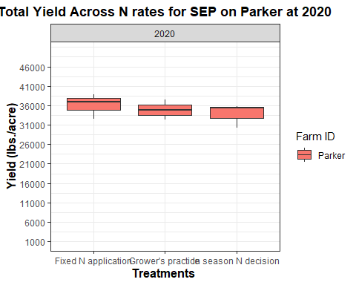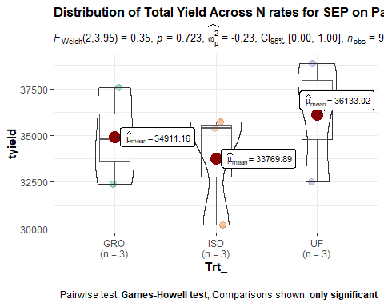

# Total Yield Response for N rates for SEP on Parker at 2021

## ------------------------------------------------------------------------  
## Analysis of Variance Table  
## ------------------------------------------------------------------------  
## DF SS MS Fc Pr>Fc  
## Treatament 2 73787475 36893738 1.8691 0.26720  
## Block 2 72245653 36122826 1.8301 0.27268  
## Residuals 4 78954173 19738543   
## Total 8 224987301   
## ------------------------------------------------------------------------  
## CV = 11.63 %  
##   
## ------------------------------------------------------------------------  
## Shapiro-Wilk normality test  
## p-value: 0.9753152   
## According to Shapiro-Wilk normality test at 5% of significance, residuals can be considered normal.  
## ------------------------------------------------------------------------  
##   
## ------------------------------------------------------------------------  
## Homogeneity of variances test  
## p-value: 0.1255436   
## According to the test of oneillmathews at 5% of significance, the variances can be considered homocedastic.  
## ------------------------------------------------------------------------  
##   
## According to the F test, the means can not be considered distinct.  
## Levels Means  
## 1 GRO 36795.68  
## 2 ISD 42173.70  
## 3 UF 35585.80  
## ------------------------------------------------------------------------

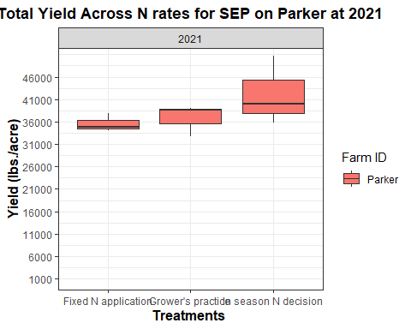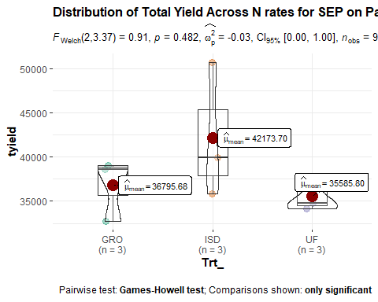

# Total Yield Response for N rates for SEP on Smith at 2020

## tibble [84 x 12] (S3: tbl_df/tbl/data.frame)  
## $ Trt : chr [1:84] "Fixed N application" "Grower's practice" "In season N decision" "Grower's practice" ...  
## $ Trt_ : chr [1:84] "UF" "GRO" "ISD" "GRO" ...  
## $ n_rates: num [1:84] 3 1 2 1 3 2 3 1 2 3 ...  
## $ date : logi [1:84] NA NA NA NA NA NA ...  
## $ dap : num [1:84] 0 0 0 0 0 0 0 0 0 0 ...  
## $ time : num [1:84] 5 5 5 5 5 5 5 5 5 5 ...  
## $ farm : chr [1:84] "Arlie" "Arlie" "Arlie" "Arlie" ...  
## $ irrig : chr [1:84] "SEEP" "SEEP" "SEEP" "SEEP" ...  
## $ year : num [1:84] 2020 2020 2020 2020 2020 2020 2020 2020 2020 2020 ...  
## $ plot : num [1:84] 1 2 3 4 5 6 7 8 9 10 ...  
## $ block : num [1:84] 1 1 1 2 2 2 3 3 3 4 ...  
## $ tyield : num [1:84] 28233 33082 24444 25509 31239 ...

## ------------------------------------------------------------------------  
## Analysis of Variance Table  
## ------------------------------------------------------------------------  
## DF SS MS Fc Pr>Fc  
## Treatament 2 4563665 2281833 0.11718 0.89141  
## Block 3 22141449 7380483 0.37903 0.77195  
## Residuals 6 116832936 19472156   
## Total 11 143538051   
## ------------------------------------------------------------------------  
## CV = 14.61 %  
##   
## ------------------------------------------------------------------------  
## Shapiro-Wilk normality test  
## p-value: 0.1251508   
## According to Shapiro-Wilk normality test at 5% of significance, residuals can be considered normal.  
## ------------------------------------------------------------------------  
##   
## ------------------------------------------------------------------------  
## Homogeneity of variances test  
## p-value: 0.8105969   
## According to the test of oneillmathews at 5% of significance, the variances can be considered homocedastic.  
## ------------------------------------------------------------------------  
##   
## According to the F test, the means can not be considered distinct.  
## Levels Means  
## 1 GRO 31078.97  
## 2 ISD 29701.11  
## 3 UF 29853.85  
## ------------------------------------------------------------------------

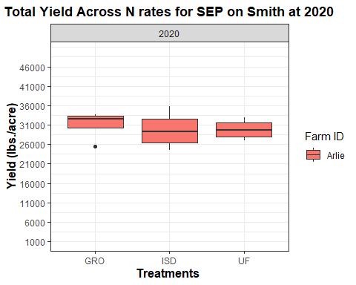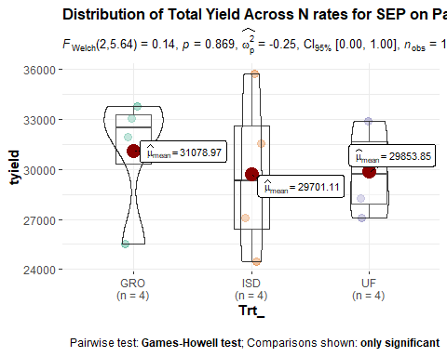

# Total Yield Response for N rates for SEP on Smith at 2021

## ------------------------------------------------------------------------  
## Analysis of Variance Table  
## ------------------------------------------------------------------------  
## DF SS MS Fc Pr>Fc  
## Treatament 2 4563665 2281833 0.11718 0.89141  
## Block 3 22141449 7380483 0.37903 0.77195  
## Residuals 6 116832936 19472156   
## Total 11 143538051   
## ------------------------------------------------------------------------  
## CV = 14.61 %  
##   
## ------------------------------------------------------------------------  
## Shapiro-Wilk normality test  
## p-value: 0.1251508   
## According to Shapiro-Wilk normality test at 5% of significance, residuals can be considered normal.  
## ------------------------------------------------------------------------  
##   
## ------------------------------------------------------------------------  
## Homogeneity of variances test  
## p-value: 0.8105969   
## According to the test of oneillmathews at 5% of significance, the variances can be considered homocedastic.  
## ------------------------------------------------------------------------  
##   
## According to the F test, the means can not be considered distinct.  
## Levels Means  
## 1 GRO 31078.97  
## 2 ISD 29701.11  
## 3 UF 29853.85  
## ------------------------------------------------------------------------

