HO CHI MINH CITY UNIVERSITY OF TECHNOLOGY
COMPUTER ENGINEERING


LAB 1
COURSE: Microcontroller

GVHD: Nguyễn Hòa Hưng – Phan Văn Sỹ

Students:
Fullname | Stu. Id
Huỳnh Trí Đức | 2452269

2026
- Exercise 1.
From the simulation on Proteus, one more LED is connected to pin PA6 of the STM32 (negative pin of the LED is connected to PA6). The component suggested in this exercise is LED-YELLOW,whichcanbefoundfromthedevicelist. In this exercise, the status of two LEDs are switched every 2 seconds, as demonstrated in the figure bellow.
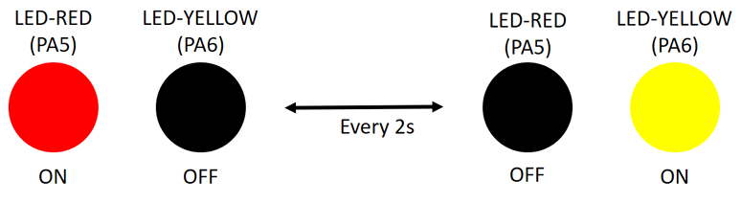
Figure 1.1: State transitions for 2 LEDs
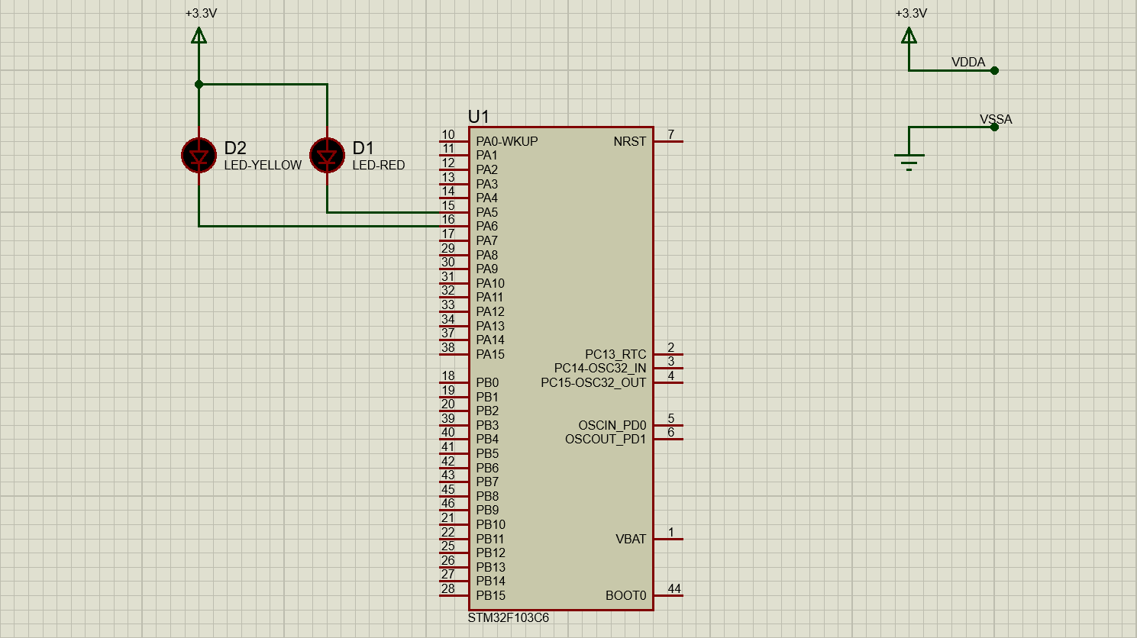
Figure 1.2: Schematic from Proteus simulation

while (1)
{
HAL_GPIO_WritePin(LED_RED_GPIO_Port, LED_RED_Pin, GPIO_PIN_RESET); // PA5 is labeled as LED_RED
HAL_GPIO_WritePin(LED_YELLOW_GPIO_Port, LED_YELLOW_Pin, GPIO_PIN_SET); // PA6 is labeled as LED_YELLOW
HAL_Delay(2000);
HAL_GPIO_WritePin(LED_RED_GPIO_Port, LED_RED_Pin, GPIO_PIN_SET);
HAL_GPIO_WritePin(LED_YELLOW_GPIO_Port, LED_YELLOW_Pin, GPIO_PIN_RESET);
HAL_Delay(2000);
}
Program 1: Source code for Exercise 1
- Exercise 2
Extend the first exercise to simulate the behavior of a traffic light. A third LED, named LED-GREEN is added to the system, which is connected to PA7. A cycle in this traffic light is 5 seconds for the RED, 2 seconds for the YELLOW and 3 seconds for the GREEN. The LED-GREEN is also controlled by its negative pin. Similarly, the report in this exercise includes the schematic of your circuit and a your source code in the while loop.
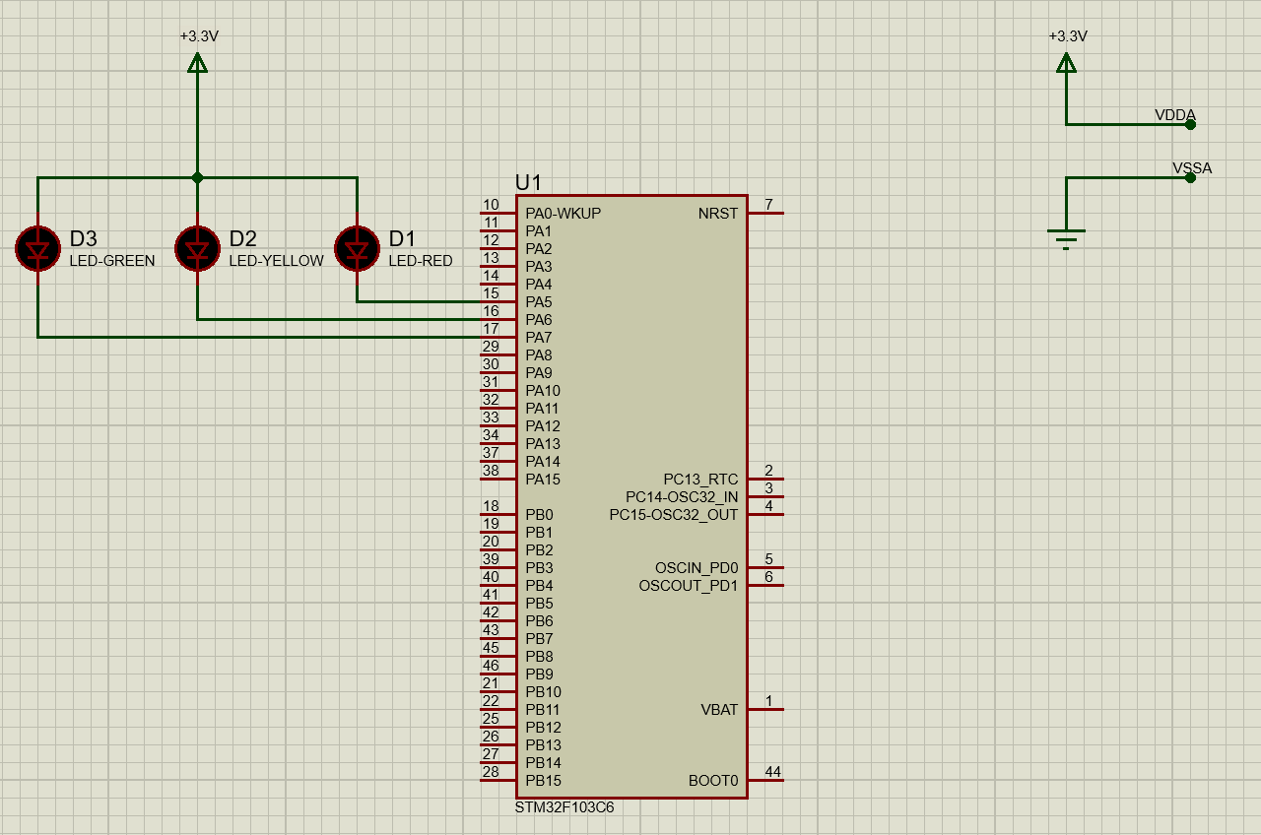
Figure 2.1: Schematic from Proteus simulation

while (1)
{
HAL_GPIO_WritePin(LED_RED_GPIO_Port, LED_RED_Pin, GPIO_PIN_RESET); // PA5 is labeled as LED_RED
HAL_GPIO_WritePin(LED_YELLOW_GPIO_Port, LED_YELLOW_Pin, GPIO_PIN_SET); // PA6 is labeled as LED_YELLOW
HAL_GPIO_WritePin(LED_GREEN_GPIO_Port, LED_GREEN_Pin, GPIO_PIN_SET); // PA7 is labeled as LED_GREEN
HAL_Delay(5000);

HAL_GPIO_WritePin(LED_RED_GPIO_Port, LED_RED_Pin, GPIO_PIN_SET);
HAL_GPIO_WritePin(LED_YELLOW_GPIO_Port, LED_YELLOW_Pin, GPIO_PIN_RESET);
HAL_GPIO_WritePin(LED_GREEN_GPIO_Port, LED_GREEN_Pin, GPIO_PIN_SET);
HAL_Delay(2000);

HAL_GPIO_WritePin(LED_RED_GPIO_Port, LED_RED_Pin, GPIO_PIN_SET);
HAL_GPIO_WritePin(LED_YELLOW_GPIO_Port, LED_YELLOW_Pin, GPIO_PIN_SET);
HAL_GPIO_WritePin(LED_GREEN_GPIO_Port, LED_GREEN_Pin, GPIO_PIN_RESET);
HAL_Delay(3000);
}
Program 2: Source code for Exercise 2
- Exercise 3
Extend to the 4-way traffic light. Arrange 12 LEDs in a nice shape to simulate the behaviors of a traffic light. A reference design can be found in the figure bellow.
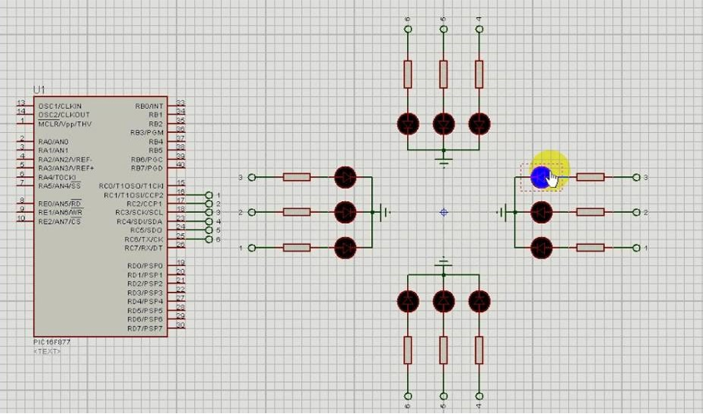
Figure 3.1: Reference design for a 4 way traffic light
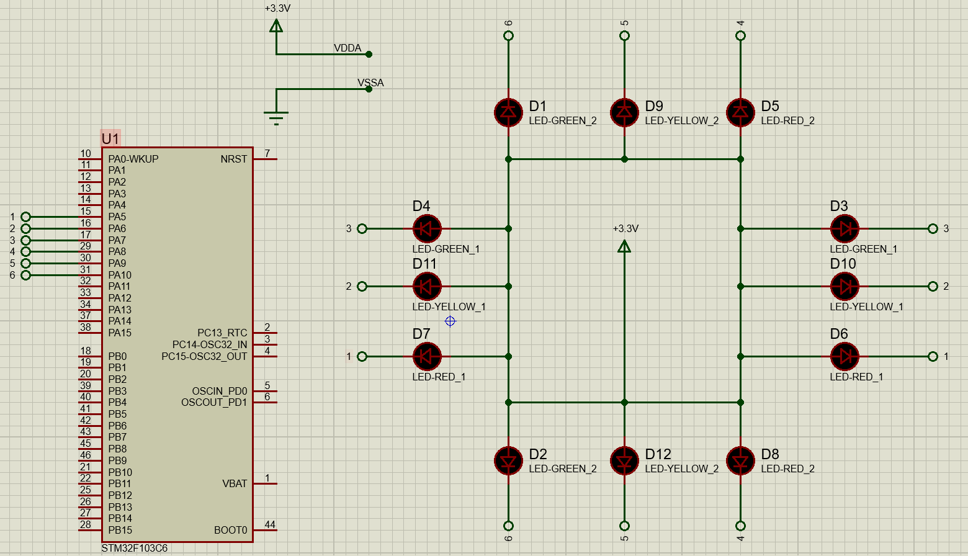
Figure 3.2: Schemetic from Proteus simulation

while (1)
{
// 1: 1: Red(3s) - 2: Green (3s)
HAL_GPIO_WritePin(LED_RED_1_GPIO_Port, LED_RED_1_Pin, GPIO_PIN_RESET); // PA5 is labeled as LED_RED_1
HAL_GPIO_WritePin(LED_YELLOW_1_GPIO_Port, LED_YELLOW_1_Pin, GPIO_PIN_SET); // PA6 is labeled as LED_YELLOW_1
HAL_GPIO_WritePin(LED_GREEN_1_GPIO_Port, LED_GREEN_1_Pin, GPIO_PIN_SET); // PA7 is labeled as LED_GREEN_1

HAL_GPIO_WritePin(LED_RED_2_GPIO_Port, LED_RED_2_Pin, GPIO_PIN_SET); // PA8 is labeled as LED_RED_2
HAL_GPIO_WritePin(LED_YELLOW_2_GPIO_Port, LED_YELLOW_2_Pin, GPIO_PIN_SET); // PA9 is labeled as LED_YELLOW_2
HAL_GPIO_WritePin(LED_GREEN_2_GPIO_Port, LED_GREEN_2_Pin, GPIO_PIN_RESET); // PA10 is labeled as LED_GREEN_2
HAL_Delay(3000);

// 2: 1: Red(hold more 2s) – 2: Yellow (2s)
HAL_GPIO_WritePin(LED_RED_2_GPIO_Port, LED_RED_2_Pin, GPIO_PIN_SET);
HAL_GPIO_WritePin(LED_YELLOW_2_GPIO_Port, LED_YELLOW_2_Pin, GPIO_PIN_RESET);
HAL_GPIO_WritePin(LED_GREEN_2_GPIO_Port, LED_GREEN_2_Pin, GPIO_PIN_SET);
HAL_Delay(2000);

// 3: 1: Green(3s) – 2: Red (3s)
HAL_GPIO_WritePin(LED_RED_1_GPIO_Port, LED_RED_1_Pin, GPIO_PIN_SET);
HAL_GPIO_WritePin(LED_YELLOW_1_GPIO_Port, LED_YELLOW_1_Pin, GPIO_PIN_SET);
HAL_GPIO_WritePin(LED_GREEN_1_GPIO_Port, LED_GREEN_1_Pin, GPIO_PIN_RESET);

HAL_GPIO_WritePin(LED_RED_2_GPIO_Port, LED_RED_2_Pin, GPIO_PIN_RESET);
HAL_GPIO_WritePin(LED_YELLOW_2_GPIO_Port, LED_YELLOW_2_Pin, GPIO_PIN_SET);
HAL_GPIO_WritePin(LED_GREEN_2_GPIO_Port, LED_GREEN_2_Pin, GPIO_PIN_SET);
HAL_Delay(3000);

// 4: 1: Yellow(2s) – 2: Red (hold more 2s)
HAL_GPIO_WritePin(LED_RED_1_GPIO_Port, LED_RED_1_Pin, GPIO_PIN_SET);
HAL_GPIO_WritePin(LED_YELLOW_1_GPIO_Port, LED_YELLOW_1_Pin, GPIO_PIN_RESET);
HAL_GPIO_WritePin(LED_GREEN_1_GPIO_Port, LED_GREEN_1_Pin, GPIO_PIN_SET);
HAL_Delay(2000);
}
Program 3: Souce code for Exercise 3
- Exercise 4
Add only one 7 led segment to the schematic in Exercise3. This component can be found in Proteus by the keyword 7SEG-COM-ANODE. For this device, the common pin should be connected to the power supply and other pins are supposed to connected to PB0 to PB6. Therefore, to turn-on a segment in this 7SEG, the STM32 pin should be in logic 0 (0V).
Implement a function named display7SEG(int num). The input for this function is from 0 to 9 and the outputs are listed as following:
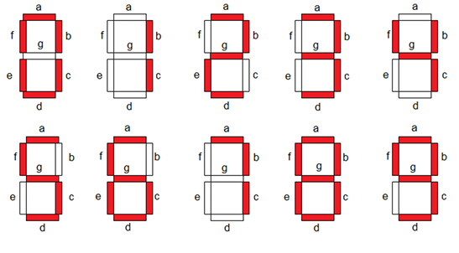
Figure 4.1: Display a number on 7 segment LED
This function is invoked in the while loop for testing as following:
int counter = 0;
while (1){
if (counter >= 10) counter = 0;
display7SEG(counter++);
HAL_Delay(1000);
}
Program 4.1: An example for your source code
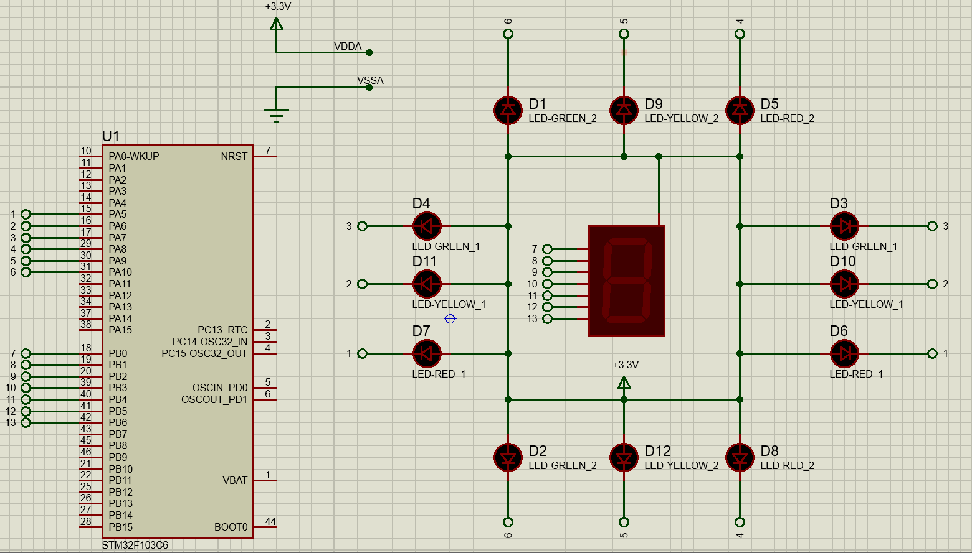
Figure 4.2: Schemetic from Proteus Simulation
void display7SEG(int num) {
uint16_t seg_pins[7] = {
SEG_A_Pin, SEG_B_Pin, SEG_C_Pin,
SEG_D_Pin, SEG_E_Pin, SEG_F_Pin, SEG_G_Pin
}; // PB0-PB6 are labeled as SEG_A-SEG_G respectively

uint8_t seg_data[10][7] = {
{0,0,0,0,0,0,1}, // 0
{1,0,0,1,1,1,1}, // 1
{0,0,1,0,0,1,0}, // 2
{0,0,0,0,1,1,0}, // 3
{1,0,0,1,1,0,0}, // 4
{0,1,0,0,1,0,0}, // 5
{0,1,0,0,0,0,0}, // 6
{0,0,0,1,1,1,1}, // 7
{0,0,0,0,0,0,0}, // 8
{0,0,0,0,1,0,0} // 9
};

if (num >= 0 && num <= 9) {
for (int i = 0; i < 7; i++) {
if (seg_data[num][i] == 0) {
HAL_GPIO_WritePin(GPIOB, seg_pins[i], GPIO_PIN_RESET);
}
else {
HAL_GPIO_WritePin(GPIOB, seg_pins[i], GPIO_PIN_SET);
}
}
}
}

int counter = 0;
while (1){
if (counter >= 10) counter = 0;
display7SEG(counter++);
HAL_Delay(1000);
}
Program 4.2: Source code for Exercise 4
- Exercise 5
Integrate the 7SEG-LED to the 4 way traffic light. In this case, the 7SEG-LED is used to display countdown value.
In this exercise, only source code is required to present. The function display7SEG in previous exercise can be re-used.
void display7SEG(int num) {
uint16_t seg_pins[7] = {
SEG_A_Pin, SEG_B_Pin, SEG_C_Pin,
SEG_D_Pin, SEG_E_Pin, SEG_F_Pin, SEG_G_Pin
}; // PB0-PB6 are labeled as SEG_A-SEG_G respectively

uint8_t seg_data[10][7] = {
{0,0,0,0,0,0,1}, // 0
{1,0,0,1,1,1,1}, // 1
{0,0,1,0,0,1,0}, // 2
{0,0,0,0,1,1,0}, // 3
{1,0,0,1,1,0,0}, // 4
{0,1,0,0,1,0,0}, // 5
{0,1,0,0,0,0,0}, // 6
{0,0,0,1,1,1,1}, // 7
{0,0,0,0,0,0,0}, // 8
{0,0,0,0,1,0,0} // 9
};

if (num >= 0 && num <= 9) {
for (int i = 0; i < 7; i++) {
if (seg_data[num][i] == 0) {
HAL_GPIO_WritePin(GPIOB, seg_pins[i], GPIO_PIN_RESET);
}
else {
HAL_GPIO_WritePin(GPIOB, seg_pins[i], GPIO_PIN_SET);
}
}
}
}
int t = 0;
int counter1 = 0;
while (1)
{
if (t < 5) {
HAL_GPIO_WritePin(LED_RED_1_GPIO_Port, LED_RED_1_Pin, GPIO_PIN_RESET); // PA5 is labeled as LED_RED_1
HAL_GPIO_WritePin(LED_YELLOW_1_GPIO_Port, LED_YELLOW_1_Pin, GPIO_PIN_SET); // PA6 is labeled as LED_YELLOW_1
HAL_GPIO_WritePin(LED_GREEN_1_GPIO_Port, LED_GREEN_1_Pin, GPIO_PIN_SET); // PA7 is labeled as LED_GREEN_1
counter1 = 5 - t;

if (t < 3) {
HAL_GPIO_WritePin(LED_RED_2_GPIO_Port, LED_RED_2_Pin, GPIO_PIN_SET); // PA8 is labeled as LED_RED_2
HAL_GPIO_WritePin(LED_YELLOW_2_GPIO_Port, LED_YELLOW_2_Pin, GPIO_PIN_SET); PA9 is labeled as LED_YELLOW_2
HAL_GPIO_WritePin(LED_GREEN_2_GPIO_Port, LED_GREEN_2_Pin, GPIO_PIN_RESET); // PA10 is labeled as LED_GREEN_2
}
else {
HAL_GPIO_WritePin(LED_RED_2_GPIO_Port, LED_RED_2_Pin, GPIO_PIN_SET);
HAL_GPIO_WritePin(LED_YELLOW_2_GPIO_Port, LED_YELLOW_2_Pin, GPIO_PIN_RESET);
HAL_GPIO_WritePin(LED_GREEN_2_GPIO_Port, LED_GREEN_2_Pin, GPIO_PIN_SET);
}
}
else if (t < 8) {
HAL_GPIO_WritePin(LED_RED_1_GPIO_Port, LED_RED_1_Pin, GPIO_PIN_SET);
HAL_GPIO_WritePin(LED_YELLOW_1_GPIO_Port, LED_YELLOW_1_Pin, GPIO_PIN_SET);
HAL_GPIO_WritePin(LED_GREEN_1_GPIO_Port, LED_GREEN_1_Pin, GPIO_PIN_RESET);

HAL_GPIO_WritePin(LED_RED_2_GPIO_Port, LED_RED_2_Pin, GPIO_PIN_RESET);
HAL_GPIO_WritePin(LED_YELLOW_2_GPIO_Port, LED_YELLOW_2_Pin, GPIO_PIN_SET);
HAL_GPIO_WritePin(LED_GREEN_2_GPIO_Port, LED_GREEN_2_Pin, GPIO_PIN_SET);
counter1 = 8 - t;
}
else {
HAL_GPIO_WritePin(LED_RED_1_GPIO_Port, LED_RED_1_Pin, GPIO_PIN_SET);
HAL_GPIO_WritePin(LED_YELLOW_1_GPIO_Port, LED_YELLOW_1_Pin, GPIO_PIN_RESET);
HAL_GPIO_WritePin(LED_GREEN_1_GPIO_Port, LED_GREEN_1_Pin, GPIO_PIN_SET);

HAL_GPIO_WritePin(LED_RED_2_GPIO_Port, LED_RED_2_Pin, GPIO_PIN_RESET);
HAL_GPIO_WritePin(LED_YELLOW_2_GPIO_Port, LED_YELLOW_2_Pin, GPIO_PIN_SET);
HAL_GPIO_WritePin(LED_GREEN_2_GPIO_Port, LED_GREEN_2_Pin, GPIO_PIN_SET);
counter1 = 10 - t;
}

display7SEG(counter1);
HAL_Delay(1000);

t++;
if (t >= 10) {
t = 0;
}
}
Program 5: Source code for Exercise 5
- Exercise 6
In this exercise, a new Proteus schematic is designed to simulate an analog clock, with 12 different number. The connections for 12 LEDs are supposed from PA4 to PA15 of the STM32. The arrangement of 12 LEDs is depicted as follows.
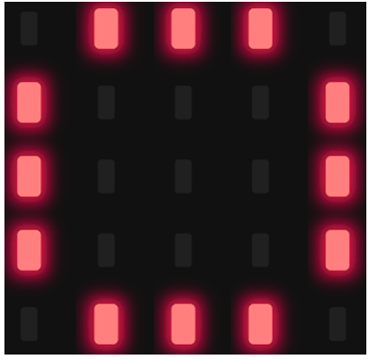
Figure 6.1: 12 LEDs for an analog clock
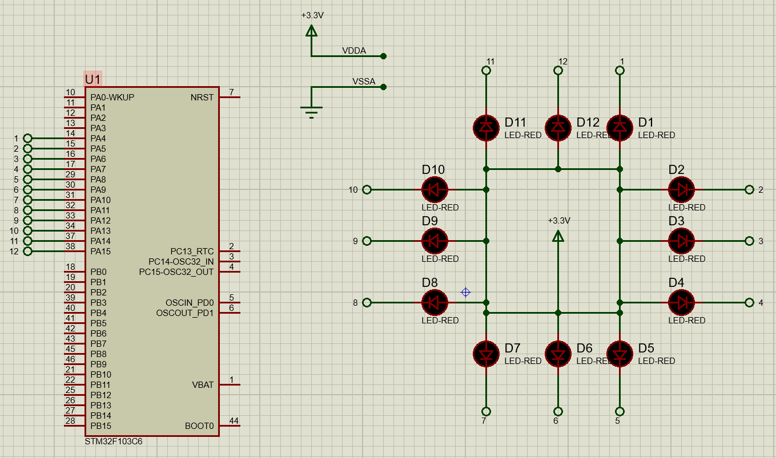
Figure 6.2: Schemetic from Proteus Simulation
uint16_t clock_pins[12] = {
LED_1_Pin, LED_2_Pin, LED_3_Pin, LED_4_Pin,
LED_5_Pin, LED_6_Pin, LED_7_Pin, LED_8_Pin,
LED_9_Pin, LED_10_Pin, LED_11_Pin, LED_12_Pin
}; // PA4-PA15 are labeled as LED_1-LED_12 respectively
while (1)
{
for (int i = 0; i < 12; i++) {
for (int j = 0; j < 12; j++) {
HAL_GPIO_WritePin(GPIOA, clock_pins[j], GPIO_PIN_SET);
}
HAL_GPIO_WritePin(GPIOA, clock_pins[i], GPIO_PIN_RESET);
HAL_Delay(1000);
}
}
Program 6: Source code for Exercise 6
- Exercise 7
Implement a function named clearAllClock() to turn off all 12 LEDs. Present the source code of this function.
void clearAllClock(){
//TODO
}
Program 7.1: Function Implementation

uint16_t clock_pins[12] = {
LED_1_Pin, LED_2_Pin, LED_3_Pin, LED_4_Pin,
LED_5_Pin, LED_6_Pin, LED_7_Pin, LED_8_Pin,
LED_9_Pin, LED_10_Pin, LED_11_Pin, LED_12_Pin
}; // PA4-PA15 are labeled as LED_1-LED_12 respectively
void clearAllClock(void) {
for (int i = 0; i < 12; i++) {
HAL_GPIO_WritePin(GPIOA, clock_pins[i], GPIO_PIN_SET);
}
}
while (1) {
for (int i = 0; i < 12; i++) {
HAL_GPIO_WritePin(GPIOA, clock_pins[i], GPIO_PIN_RESET);
}
HAL_Delay(1000);
clearAllClock();
HAL_Delay(1000);
}
Program 7.2: Source code for Exercise 7
- Exercise 8
Implement a function named setNumberOnClock(intnum). The input for this function is from 0 to 11 and an appropriate LEDis turn on. Present the source code of this function
uint16_t clock_pins[12] = {
LED_1_Pin, LED_2_Pin, LED_3_Pin, LED_4_Pin,
LED_5_Pin, LED_6_Pin, LED_7_Pin, LED_8_Pin,
LED_9_Pin, LED_10_Pin, LED_11_Pin, LED_12_Pin
}; // PA4-PA15 are labeled as LED_1-LED_12 respectively

void clearAllClock(void) {
for (int i = 0; i < 12; i++) {
HAL_GPIO_WritePin(GPIOA, clock_pins[i], GPIO_PIN_SET);
}
}
void setNumberOnClock(int num) {
if (num >= 0 && num < 12) {
int index = (num == 0) ? 11 : (num - 1);
HAL_GPIO_WritePin(GPIOA, clock_pins[index], GPIO_PIN_RESET);
}
}
while (1)
{
for (int i = 0; i < 12; i++) {
clearAllClock();
setNumberOnClock(i);
HAL_Delay(1000);
}
}
Program 8: Source code for Exercise 8
- Exercise 9
Implement a function named clearNumberOnClock(int num). The input for this function is from 0 to 11 and an appropriate LED is turn off.
void clearNumberOnClock(int num) {
uint16_t clock_pins[12] = {
LED_1_Pin, LED_2_Pin, LED_3_Pin, LED_4_Pin,
LED_5_Pin, LED_6_Pin, LED_7_Pin, LED_8_Pin,
LED_9_Pin, LED_10_Pin, LED_11_Pin, LED_12_Pin
}; // PA4-PA15 are labeled as LED_1-LED_12 respectively
if (num >= 0 && num < 12) {
int index = (num == 0) ? 11 : (num - 1);
HAL_GPIO_WritePin(GPIOA, clock_pins[index], GPIO_PIN_SET);
}
}
while (1) {
for (int i = 0; i < 12; i++) {
setNumberOnClock(i);
}
HAL_Delay(1000);

for (int i = 0; i < 12; i++) {
clearNumberOnClock(i);
HAL_Delay(1000);
}
}
Program 9: Source code for Exercise 9
- Exercise 10
Integrate the whole system and use 12 LEDs to display a clock. At a given time, there are only 3 LEDs areturn on for hour,minuteandsecondinformation.
uint16_t clock_pins[12] = {
LED_1_Pin, LED_2_Pin, LED_3_Pin, LED_4_Pin,
LED_5_Pin, LED_6_Pin, LED_7_Pin, LED_8_Pin,
LED_9_Pin, LED_10_Pin, LED_11_Pin, LED_12_Pin
}; // PA4-PA15 are labeled as LED_1-LED_12 respectively
void clearAllClock(void) {

for (int i = 0; i < 12; i++) {
HAL_GPIO_WritePin(GPIOA, clock_pins[i], GPIO_PIN_SET);
}
}
void setNumberOnClock(int num) {
if (num >= 0 && num < 12) {
int index = (num == 0) ? 11 : (num - 1);
HAL_GPIO_WritePin(GPIOA, clock_pins[index], GPIO_PIN_RESET);
}
}
void clearNumberOnClock(int num) {
if (num >= 0 && num < 12) {
int index = (num == 0) ? 11 : (num - 1);
HAL_GPIO_WritePin(GPIOA, clock_pins[index], GPIO_PIN_SET);
}
}
int hour = 11;
int minute = 11;
int second = 0;
while (1)
{
clearAllClock();
setNumberOnClock(hour % 12);
setNumberOnClock(minute / 5);
setNumberOnClock(second / 5);
HAL_Delay(1000);
second++;
if (second >= 60) {
second = 0;
minute++;
if (minute >= 60) {
minute = 0;
hour++;
if (hour >= 24) {
hour = 0;
}
}
}
}
Program 10: Source code for Exercise 10

