DOCUMENTATION

ASSIGNMENT ASSIGNMENT_3

STUDENT NAME: Borz Robert-Ionuț
GROUP: 30424

CONTENTS

1. Assignment Objective 3
2. Problem Analysis, Modeling, Scenarios, Use Cases 3
3. Design 3
4. Implementation 3
5. Results 3
6. Conclusions 3
7. Bibliography 3

Assignment Objective

The main objective of the assignment is to design and implement an application for managing the client orders for a warehouse.

Sub-objectives
Objective | Step
Define and understand the given problem | 2
Analyze the problem by decomposing it | 2
Design the solution | 3
Implement the designed solution | 4
Testing the provided solution | 5

Define and understand the given problem: In order to start working for the given assignment we have to fully know and understand the problem that we are required to solve, because if we don’t accomplish this step we can have difficulties while we start our implementation.
Analyze the problem by decomposing it: Decomposing the problem in sub-problems will help us understand each part of the project better and this strategy will make the working process more organized and efficient.
Design the solution: In order to have a clear view of the programming style, packages, classes, data structures, interfaces and algorithms we want to use, the presented step is needed and it is also very important.
Implement the designed solution: After the design phase we have to start implementing our solution. It consists of implementing every element that we have already chosen in the previous phase, and then linking them together.
Testing the provided solution: After finishing the implementation phase we have to test our product in order to decide whether it works as desired or not. If not, some adjustments must be done in order to achieve the desired behavior.

Problem Analysis, Modeling, Scenarios, Use Cases

Functional requirements
The application should allow an employee to add a new client
The application should allow an employee to add a new product
The application should allow an employee to add a new order
The application should allow an employee to visualize the existent clients and products
The application should allow an employee to edit an existent client or product
The application should allow an employee to delete an existent client or product

Use case diagram
Orders Management

Add/Edit/Delete Client

Add/Edit/Delete Product

Employee/User
View existent Clients/Products
Add Order

Use case description
Use case: Add product/client
Primary actor: Employee/User
Success scenario steps:
- The employee/user selects the option to add a new product.
- The application will display a form in which the product/client details should be inserted.
- The employee/user inserts the required pieces of information.
- The employee/user clicks on the “Add” button.
- The application stores the product/client data in the database and displays an acknowledge message.
Alternative sequences
- Invalid values for the product’s data, the user inserts a negative value for the stock of the product
- The application displays an error message
-The scenario returns to step 3
- Missing values
-The application will inform the user that some data is missing
-The scenario returns to step 3

Design
The chosen strategy is an object-oriented one, the software design being organized around data and objects rather than functions and logic.
Regarding data structures we use Java Records in order to define an immutable Bill class in the Model package.
UML package:
Presentation: ClientView(+), ProductView(+), OrderView, MainView
Business: ClientBLL, ProductBLL, OrderBLL, BillBLL
Data Models: Client, Product, Order, Bill
Data Access: AbstractDAO, ClientDAO, ProductDAO, OrderDAO, BillDAO
Connection: ConnectionFactory

Package diagram:
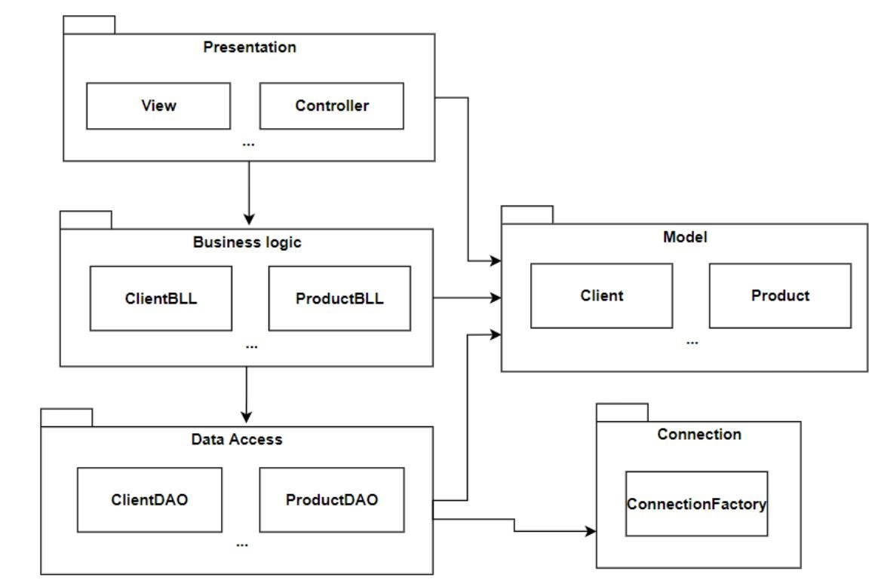

Implementation

Classes:
- The classes descriptions that are not present here can be found in the overview file contained in the JavaDoc folder.

- ClientView(+), ProductView(+), OrderView, MainView
The classes contain all the elements needed for an interactive and responsive graphical interface. The graphical interface is modeled using JavaSwing. The classes provide several JTextFields in order to allow the user to input the required data. Buttons are also present in order to allow the user to perform the desired operations on clients, products and orders.
Some screenshots of the application ca be seen int the folder GUI_presentation

Results

Test scenarios:
- Check system behavior when valid data is inserted
- Check system behavior when invalid data is inserted
- Check system behavior when just some of the data is inserted
- Check system behavior when all the data is inserted correctly and “Add”/”Delete”/ ”Edit” button is pressed

Conclusions
After finalizing all the steps mentioned before we successfully obtained a well-functioning Orders management application which can be used by any warehouse and its employees.
The assignment also provided a list of challenges, from which I was able to refresh my knowledges in Java and in OOP and also to learn new concepts.
As future developments I can mention the addition of a log in system in order to restrict the employee’s access to important and confidential pieces of information about the client and its ability to make changes within the database. In other words, depending on the account that the employee is logging in with, he/she could only perform a specific number of operations based on the type of the account that he/she has(ex: Admin, Worker, Maintenance).

Bibliography
- Laboratories and Courses - https://dsrl.eu/courses/pt/
- https://stackoverflow.com/
- https://www.geeksforgeeks.org/
- https://online.visual-paradigm.com/
- http://www.guru99.com/test-scenario.html
- Java How to Program, Early Objects (Deitel: How to Program), ISBN-10: 9780134743356, Published: February 20, 2017

