DOCUMENTATION

ASSIGNMENT ASSIGNMENT_1

STUDENT NAME: Borz Robert-Ionuț
GROUP: 30424

CONTENTS

1. Assignment Objective 3
2. Problem Analysis, Modeling, Scenarios, Use Cases 3
3. Design 3
4. Implementation 3
5. Results 3
6. Conclusions 3
7. Bibliography 3

Assignment Objective

The main objective of the assignment is to develop a polynomial calculator with a dedicated graphical interface through which the user can insert the desired polynomials according to some requirements, select the operation to be performed on the inserted polynomials and visualize the obtained result.

Sub-objectives
Objective | Step
Define and understand the given problem | 2
Analyze the problem by decomposing it | 2
Design the solution | 3
Implement the designed solution | 4
Testing the provided solution | 5

Define and understand the given problem: In order to start working for the given assignment we have to fully know and understand the problem that we are required to solve, because if we don’t accomplish this step we can have difficulties while we start our implementation.
Analyze the problem by decomposing it: Decomposing the problem in sub-problems will help us understand each part of the project better and this strategy will make the working process more organized and efficient.
Design the solution: In order to have a clear view of the programming style, packages, classes, data structures, interfaces and algorithms we want to use, the presented step is needed and it is also very important.
Implement the designed solution: After the design phase we have to start implementing our solution. It consists of implementing every element that we have already chosen in the previous phase, and then linking them together.
Testing the provided solution: After finishing the implementation phase we have to test our product in order to decide whether it works as desired or not. If not, some adjustments must be done in order to achieve the desired behavior.

Problem Analysis, Modeling, Scenarios, Use Cases

Functional requirements
The user must be able to insert the polynomials
The user must have a dedicated keyboard already integrated in the application with all the needed characters
The user must be able to choose which operation from the operation list must be done
The user must be able to see the result after the selected operation has been successfully done
The user must be informed of the restrictions that the application imposes

Use case diagram
Polynomial Calculator

Insert polynomials

Choose operation
Obtain result
User

Use case description
Use case: Obtain result
Primary actor: User
Success scenario steps:
- The user introduces the polynomial/s
- The calculator checks if the inserted polynomials are valid
- The calculator executes the chosen operation
- The calculator returns the desired result
Alternative sequences
- Incorrect polynomial format
-The calculator will inform the user that the inserted polynomial/s are incorrect
-The scenario returns to step 1
- Missing polynomial/s
-The calculator will inform the user that one or more polynomials are missing
-The scenario returns to step 1

Design

The chosen strategy is an object-oriented one, the software design being organized around data and objects rather than functions and logic.
Regarding data structures we use a TreeMap in order to represent polynomials by using monomials. We use a TreeMap instead of a HashMap because keeping the powers sorted will help us implement easier our solution.

UML package:
Presentation: View
Business: Operations
Data Models: Monomial, Polynomial

Class diagram:
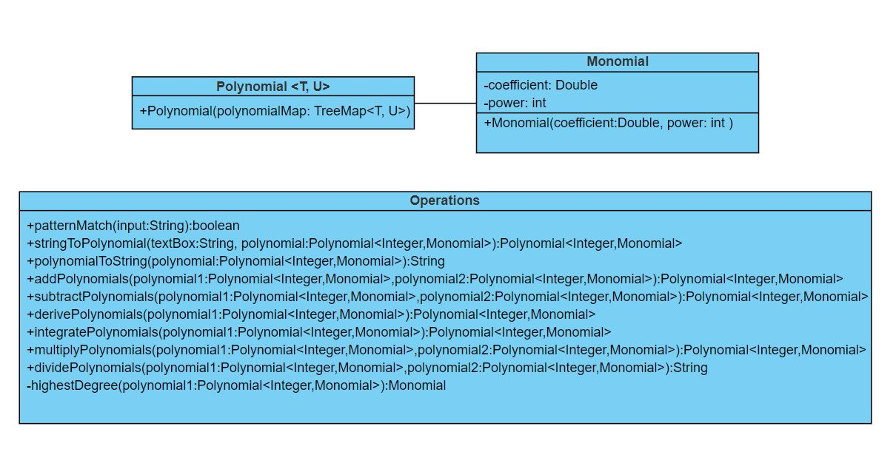

Implementation

Classes:
- Monomial
It has the fields coefficient(double) and power(int), a constructor as presented in the class diagram above and the getters and setters for the class’s fields. It helps us to construct and manipulate our polynomials easier.
- Polynomial
It’s a generic class, consisting of a TreeMap of the 2 generics T and U. It also has a constructor as presented in the class diagram above. We use the TreeMap<Integer,Monomial> to store and work on our polynomials, the advantage being that the elements in the TreeMap are already sorted.
- Operations
The class contains all the methods used to achieve our solution. The methods are the following:
patternMatch: checks if an input given as a string has the required pattern or not. The check is done by using a regex.
stringToPolynomial: transforms a given String into a Polynomial by decomposing it.
polynomialToString: reconstructs the String starting now from a polynomial.
addPolynomials: adds two given polynomials and returns the result as a polynomial.
subtractPolynomials: uses the addPolynomials method, adds the first polynomial two the second polynomial, but the second polynomial gets its coefficients negated(+ becomes - and – becomes +).
derivePolynomial: takes a single polynomial and modifies the coefficients and powers according to the derivation rules.
integratePolynomial: takes a single polynomial and modifies the coefficients and powers according to the integration rules.
dividePolynomials: divides the first given polynomial to the second one according to the steps presented in PT2023_A1_S1 page 27.
highestDegree: returns the highest degree of a given polynomial.

- View
The class contains all the elements needed for an interactive and responsive graphical interface. The graphical interface is modeled using JavaSwing. The class provides several JButtons present on a JDialog, each one doing its specific job and 3 JTextFields for polynomial/s input and showing the desired result. By pressing on the keyboard(application keyboard) on a specific character, it will be written in the selected JTextField(first or second). By pressing on one of the 6 operation buttons a result will be returned if all the restrictions are met.

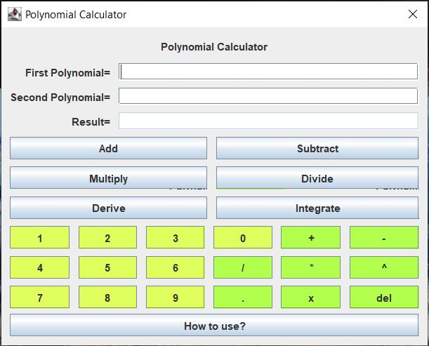

It also provides a “How to use?” section, present in order to help the user to understand how the “Polynomial Calculator” must be used in order to return the desired correct results.

Results

Test scenarios:
- Check system behavior when valid polynomials are inserted
- Check system behavior when invalid polynomials are inserted
- Check system behavior when just the second or none of the two polynomials are inserted
- Check system behavior when the user inserts the polynomial/s using the built-in keyboard
- Check system behavior when the user opens the “How to use?” section
JUnit tests results:

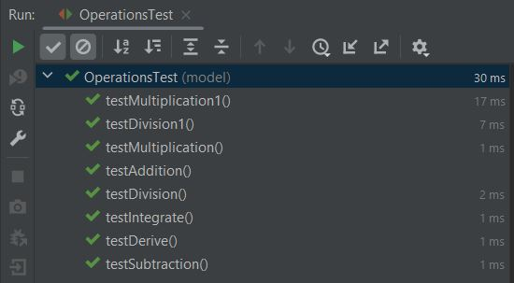

Conclusions
After finalizing all the steps mentioned before we successfully obtained a well-functioning Polynomial Calculator which can be used by any user.
The assignment also provided a list of challenges, from which I was able to refresh my knowledges in Java and in OOP. It was also my first time implementing the polynomial division operation on a computer.
As future developments I can mention the addition of a database in which the earlier polynomials and the operation that has been performed to be stored. By this improvement, the user could easily access the calculator’s history. Also, another useful improvement could be the addition of a section in which the user could see how the operations are performed step by step.

Bibliography
- Laboratories and Courses - https://dsrl.eu/courses/pt/
- https://stackoverflow.com/
- https://www.geeksforgeeks.org/
- https://online.visual-paradigm.com/
- http://www.guru99.com/test-scenario.html
- Java How to Program, Early Objects (Deitel: How to Program), ISBN-10: 9780134743356, Published: February 20, 2017

