DOCUMENTATION

ASSIGNMENT ASSIGNMENT_2

STUDENT NAME: Borz Robert-Ionuț
GROUP: 30424

CONTENTS

1. Assignment Objective 3
2. Problem Analysis, Modeling, Scenarios, Use Cases 3
3. Design 3
4. Implementation 3
5. Results 3
6. Conclusions 3
7. Bibliography 3

Assignment Objective

The main objective of the assignment is to design and implement an application aiming to analyze queuing-based systems by (1) simulating a series of N clients arriving for service, entering Q queues, waiting, being served and finally leaving the queues, and (2) computing the average waiting time, average service time and peak hour.

Sub-objectives
Objective | Step
Define and understand the given problem | 2
Analyze the problem by decomposing it | 2
Design the solution | 3
Implement the designed solution | 4
Testing the provided solution | 5

Define and understand the given problem: In order to start working for the given assignment we have to fully know and understand the problem that we are required to solve, because if we don’t accomplish this step we can have difficulties while we start our implementation.
Analyze the problem by decomposing it: Decomposing the problem in sub-problems will help us understand each part of the project better and this strategy will make the working process more organized and efficient.
Design the solution: In order to have a clear view of the programming style, packages, classes, data structures, interfaces and algorithms we want to use, the presented step is needed and it is also very important.
Implement the designed solution: After the design phase we have to start implementing our solution. It consists of implementing every element that we have already chosen in the previous phase, and then linking them together.
Testing the provided solution: After finishing the implementation phase we have to test our product in order to decide whether it works as desired or not. If not, some adjustments must be done in order to achieve the desired behavior.

Problem Analysis, Modeling, Scenarios, Use Cases

Functional requirements
The simulation application should allow users to setup the simulation
The simulation application should allow users to start the simulation
The simulation application should display the real-time queues evolution
The simulation application should inform the user if an incorrect input is provided

Use case diagram
Queues Management

Setup simulation

User
Start simulation
Analyze results

Use case description
Use case: Setup and start simulation
Primary actor: User
Success scenario steps:
- The user inserts the values for the: number of clients, number of queues, simulation interval, minimum and maximum arrival time, and minimum and maximum service time.
- The user clicks on the “Simulate” button(which also validates the input from the user).
- The application validates the data and starts the simulation
Alternative sequences
- Invalid values for the setup parameters
- The application displays an error message
-The scenario returns to step 1
- Missing values for the setup parameters
-The application will inform the user that one or more parameters are missing
-The scenario returns to step 1

Design

The chosen strategy is an object-oriented one, the software design being organized around data and objects rather than functions and logic.
Regarding data structures we use a BlockingQueue in order to keep track of our tasks. We also use an AtomicInteger field, namely, waitingPeriod, in our Server object, assuring together with the previously mentioned data structure thread-safe operations.

UML package:
Presentation: View
Business: SimulationManager, Scheduler, ConcreteStrategy, Strategy
Data Models: Server, Task

Class diagram:
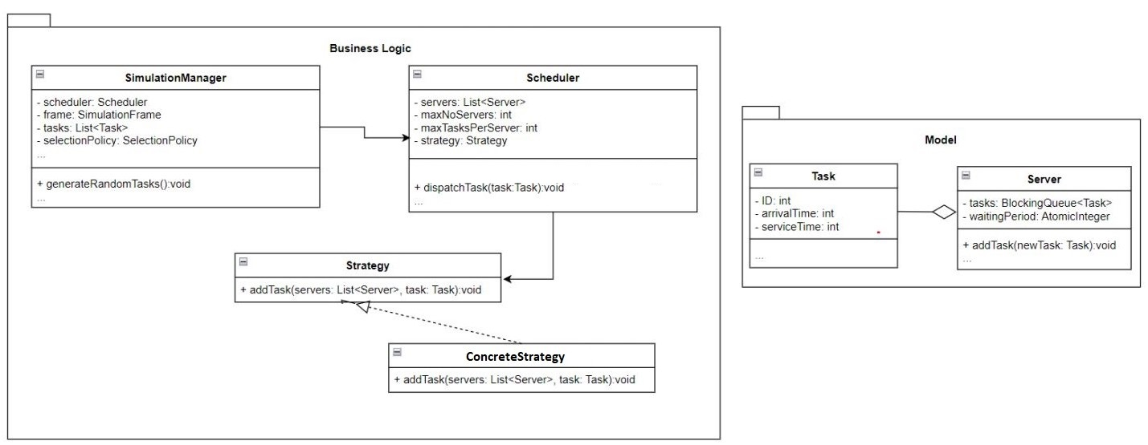

Implementation

Classes:
- Task
It has the fields ID(int), arrivalTime(int), serviceTime(int), describing the characteristics of a client.
- Server
The class extends Runnable, so threads with this type of object will be created in order to process the clients. Its fields consist of a BlockingQueue of Tasks, tasks, and an AtomicInteger, waitingPeriod.
addTask: adds a given Task object to the BlockingQueue and increments the value of the waiting period with the Task’s object service time value.
run: describes the behavior of the thread that will be created with objects of the type Server.
- Strategy
Is an interface implemented by the ConcreteStrategy class.
- ConcreteStrategy
Implements Strategy interface, and defines the method:
addTask: describes the way the clients are distributed to the servers.
- Scheduler
Sends tasks to Server objects according to the established strategy.
dispatchTask: calls the ConcreteStrategy addTask method.
- SimulationManager
Contains the simulation loop, the currentTime, calls Scheduler to dispatch tasks and updates the UI accordingly.
generateRandomTasks: generates random tasks according to the input parameters provided by the user.

- View
The class contains all the elements needed for an interactive and responsive graphical interface. The graphical interface is modeled using JavaSwing. The class provides several JTextFields in order to allow the user to set the simulation’s input parameters. It also contains a button which triggers the start of the simulation after validating the input data and a reportPanel consisting of a JTextArea placed in a JScrollPane. The reportPanel is used by the user to analyze the obtained results.

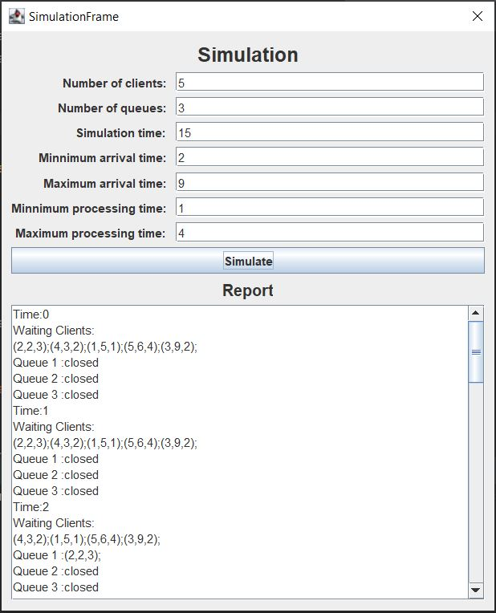

Results

Test scenarios:
- Check system behavior when valid input parameters are inserted
- Check system behavior when invalid input parameters are inserted
- Check system behavior when just some of the input parameters are inserted
- Check system behavior when all the input parameters are inserted correctly and “Simulate” button is pressed
Input data sets:
- The results for the below input data sets can be found in the Documentation folder in a file named LogEvents.txt

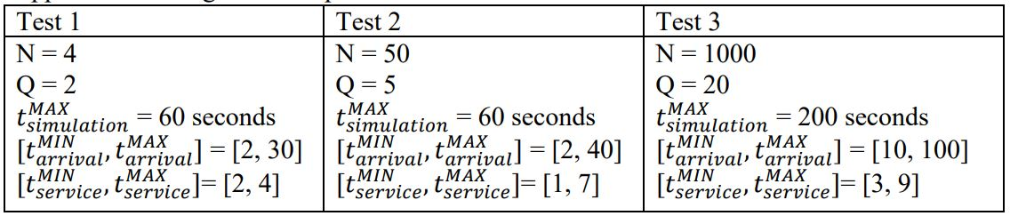

Conclusions
After finalizing all the steps mentioned before we successfully obtained a well-functioning Queues management application which can be used by any user.
The assignment also provided a list of challenges, from which I was able to refresh my knowledges in Java and in OOP and also to learn new concepts.
As future developments I can mention the addition of a database in which the results obtained previously to be stored. The stored data can be retrieved after several simulations on the same sample and some statistics can be made and interpreted.

Bibliography
- Laboratories and Courses - https://dsrl.eu/courses/pt/
- https://stackoverflow.com/
- https://www.geeksforgeeks.org/
- https://online.visual-paradigm.com/
- http://www.guru99.com/test-scenario.html
- Java How to Program, Early Objects (Deitel: How to Program), ISBN-10: 9780134743356, Published: February 20, 2017

