**Evidence for Implementation and Testing**

Ross Murray

Cohort E13

19 July 2017

I.T 1 – Demonstrate the use of encapsulation in a program

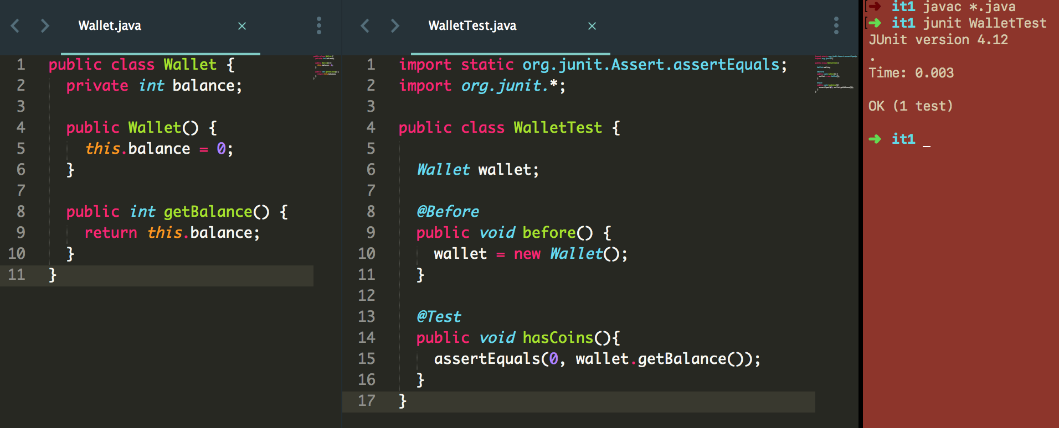

I.T 2 – Demonstrate the use of inheritance in a program

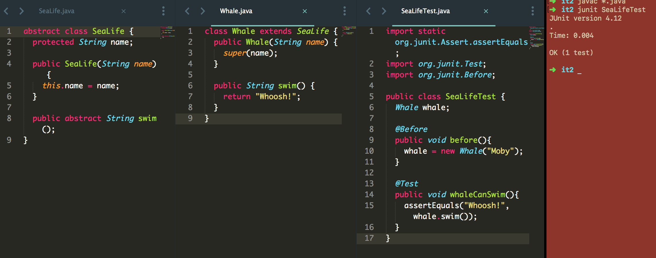

I.T 3 – Demonstrate searching data in a program

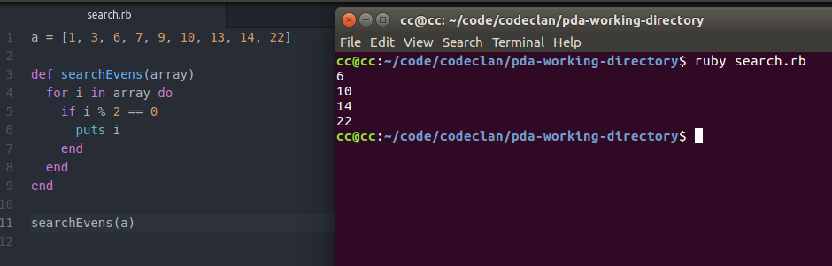

I.T 4 – Demonstrate sorting data in a program

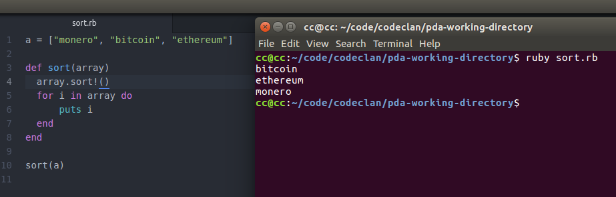

I.T 5 – Demonstrate the use of an array in a program

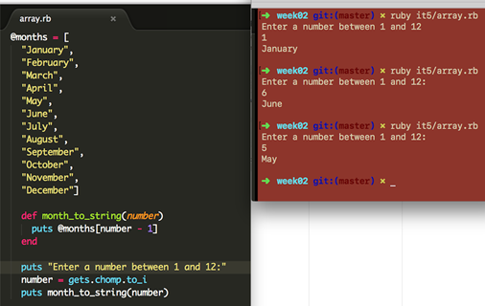

I.T 6 – Demonstrate the use of a hash in a program

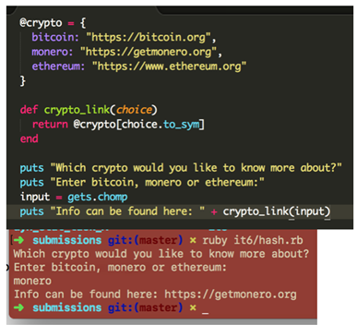

I.T 7 – Demonstrate polymorphism in a program

