**Evidence for Analysis and Design**

Ross Murray

Cohort E13

11 September 2017

**A.D 1 – Use case diagram**

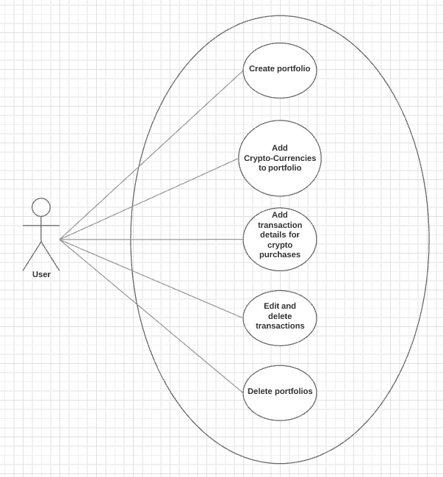

**A.D 2 – Class diagram**

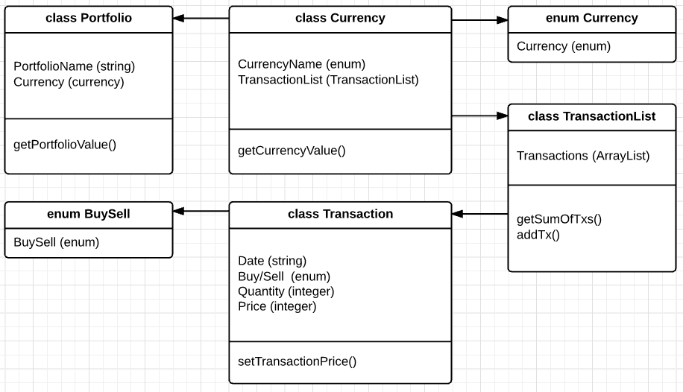

**A.D 3 – Object Diagram**

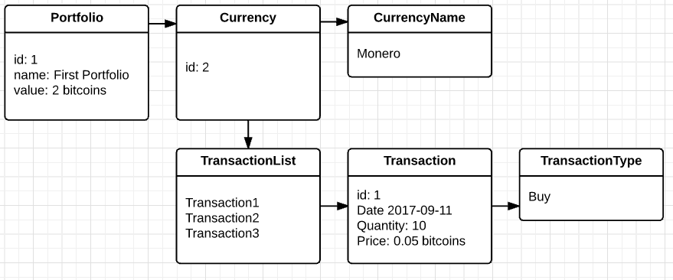

**A.D 4 – Activity Diagram**

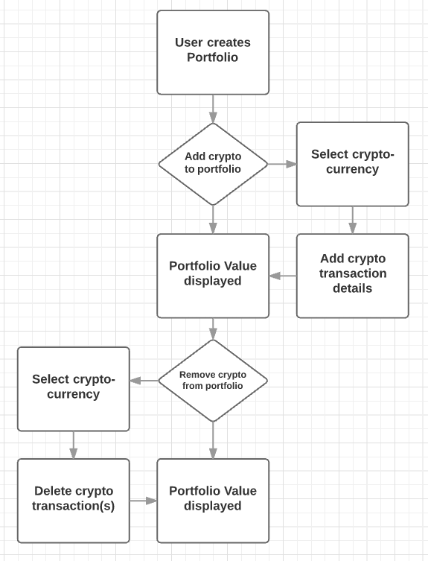

**A.D 5 Inheritance Diagram**

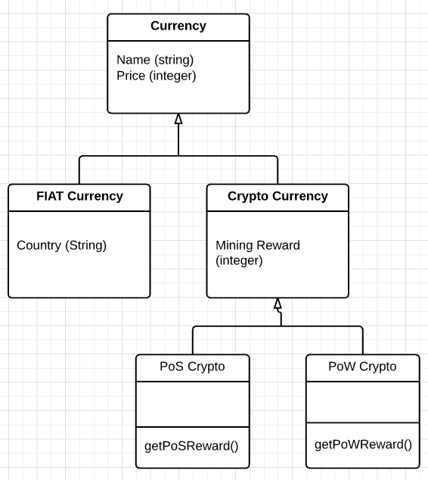

**A.D 6 – Implementations Constraints**

|  |  |  |
| --- | --- | --- |
| **Constraints** | **Possible effect of constraint** | **Details** |
| **Hardware and software platforms** | Written in Android Studio, the application will only work on Android devices | In time, could be coded for iPhone devices |
| **Performance requirements** | Only small static images and text will be displayed, so only a small performance requirement | Should work just as well on older devices |
| **Persistent storage and transactions** | Delete old transaction data to save space on mobile devices | Mobile device storage is limited, so delete old, redundant transaction data. |
| **Usability** | API used to refresh prices may cause app to appear slow | Make app usable during API price refresh |
| **Budgets** | No budget for this project | Personal project |
| **Time** | One week was spent on this project, so not enough time to implement API. | Additional time will be required, maybe two weeks to finish to satisfaction. |