**Evidence for Planning**

Ross Murray

Cohort E13

13 September 2017

**P 1 – Team contributions**

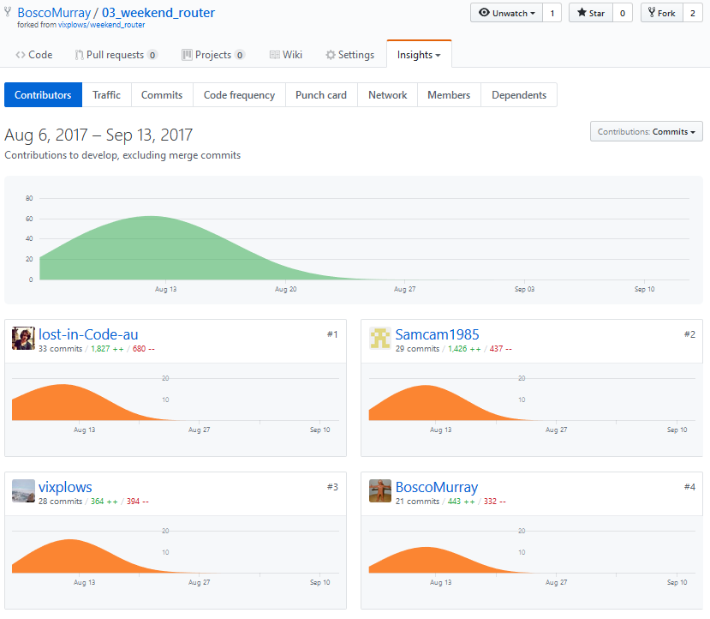

P 2 – Project brief

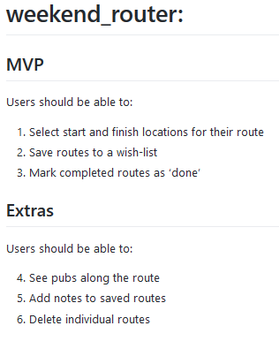

P 3 – Planning on Trello

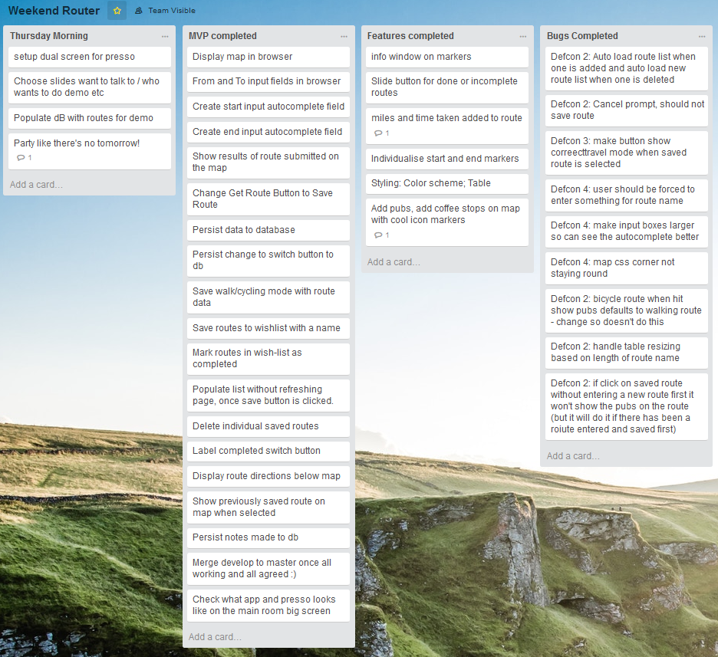

P 4 – Acceptance Criteria and Test Plan

|  |  |  |
| --- | --- | --- |
| Acceptance Criteria | Expected Result/Output | Pass / Fail |
| Users can choose from dropdown autocomplete when entering search criteria | Dropdown populates as user types, and fills search when selected | Pass |
| Route is mapped when both “From” and “To” fields have valid entries | As soon as both fields have valid data, a route is mapped for the user | Pass |
| User can select walking or cycling routes | Walking or Cycling radio buttons switch between walking and cycling routes | Pass |
| Routes can be saved | When a user clicks the save button, route data is saved to MongoDB | Pass |

P 5 – User sitemap

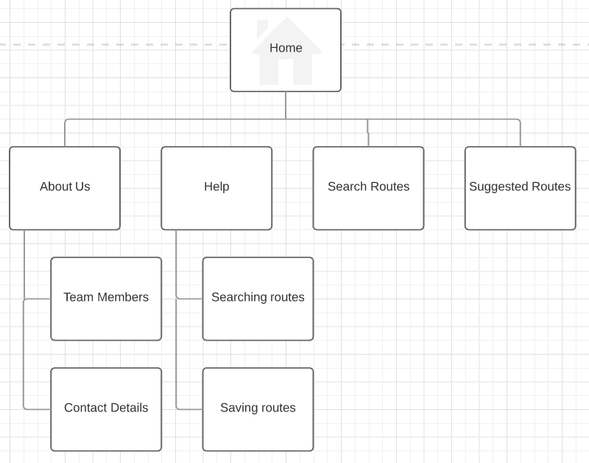

P 6 – Wireframes - 1

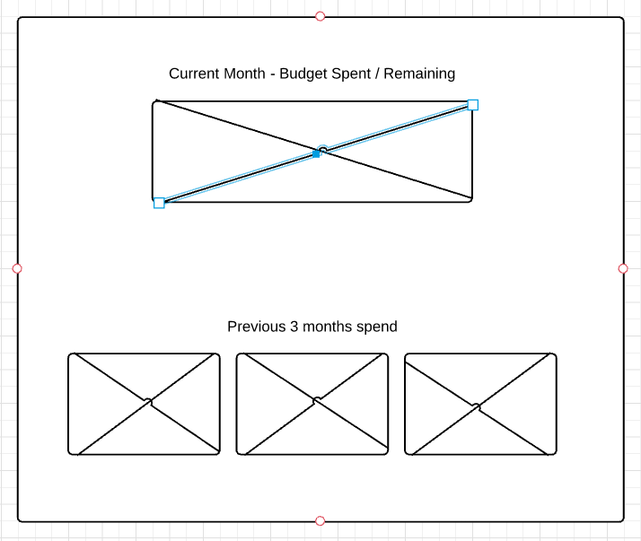

P 6 – Wireframes – 2

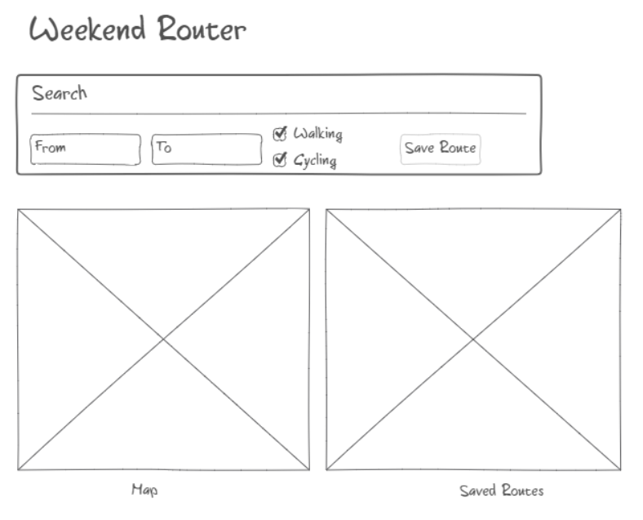

P 7 – System Interaction Diagrams – Sequence Diagram

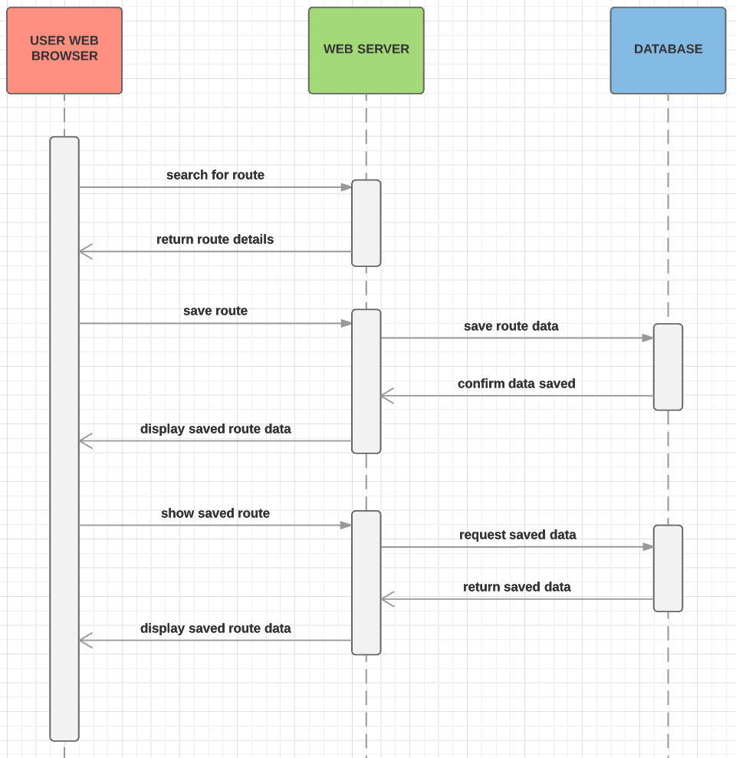

P 7 – System Interaction Diagrams – Collaboration Diagram

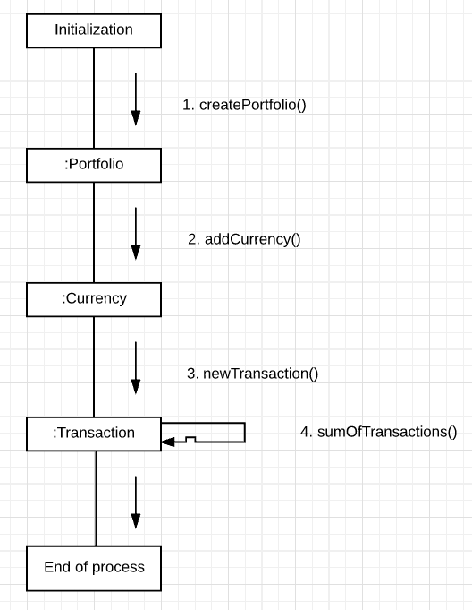

P 8 – Object Diagrams

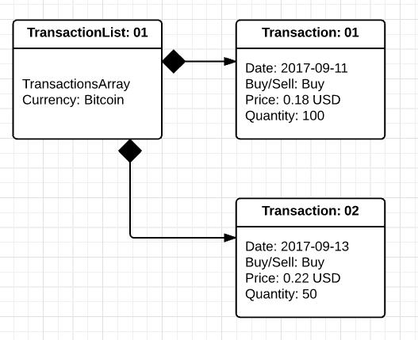

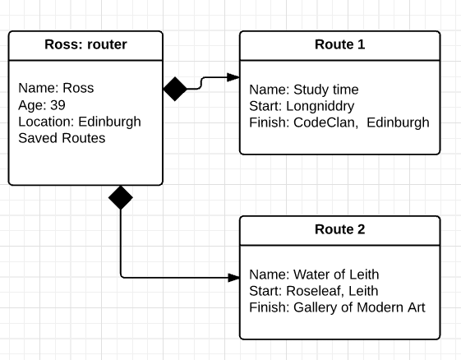

P 9 – Algorithms

1. search

I used this algorithm as part of a Ruby project. I need to find transactions within a particular date range

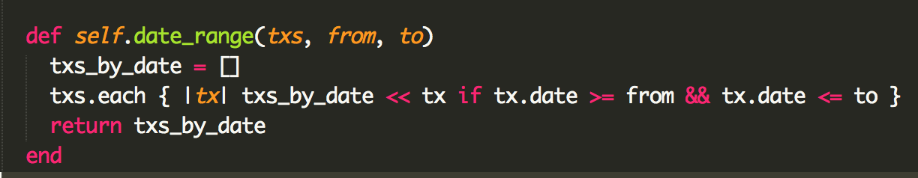

1. addition

I used this algorithm in a Java/Android project to loop through an array of transactions and sum their total

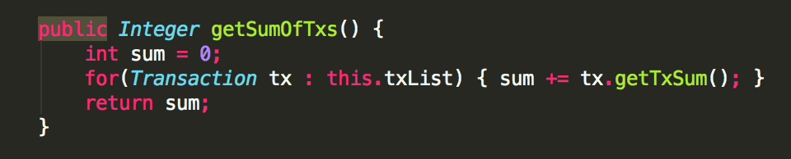

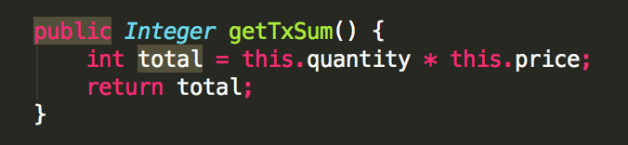

P 10 – Pseudocode

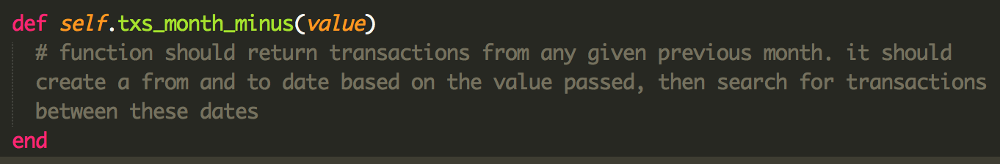

P 11 – Github link to a project repo (https://github.com/BoscoMurray/04_ethereum_taster_dice)

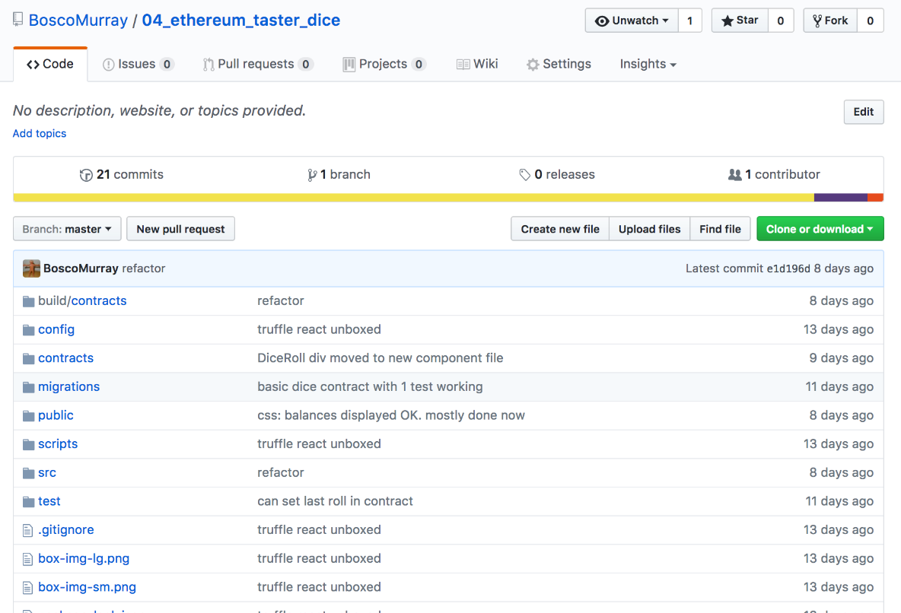

P 12 – Screenshots of planning for Smart Dice project

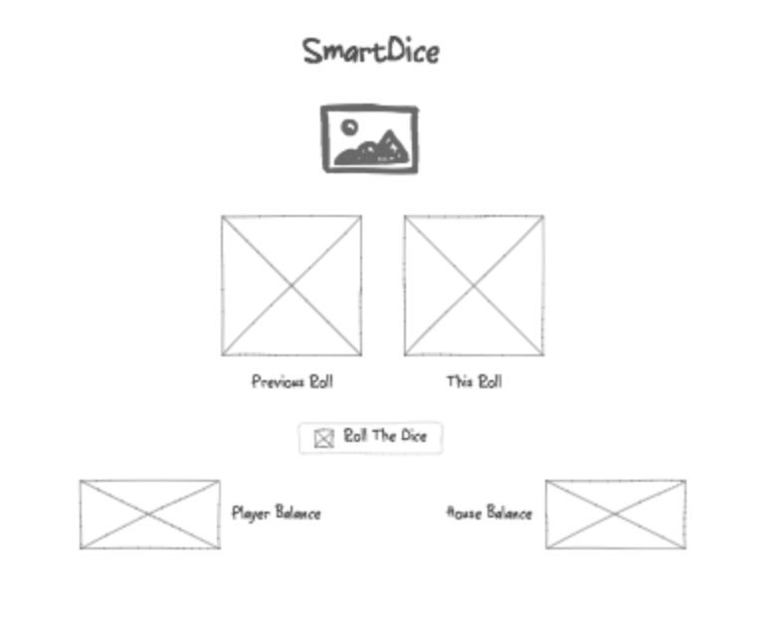

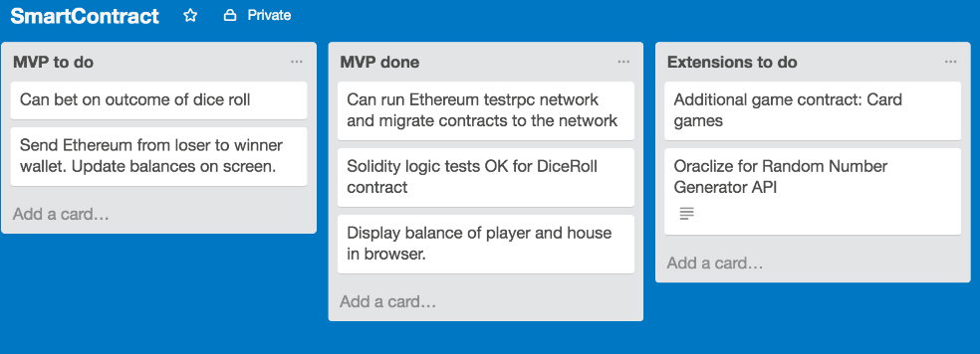

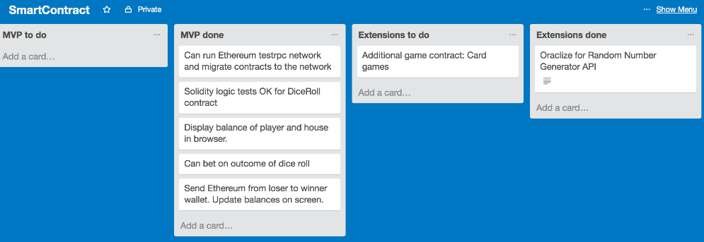

P 13 – User input

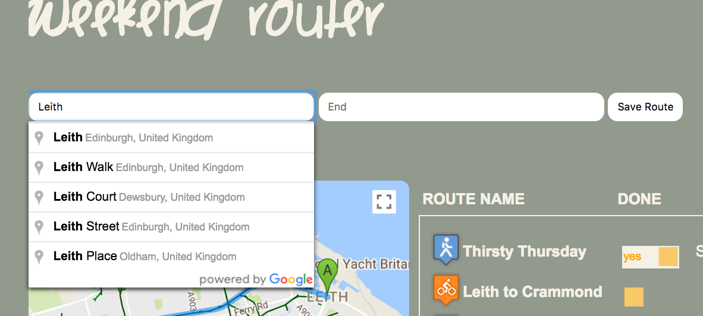

P 14 – Interaction with data persistence

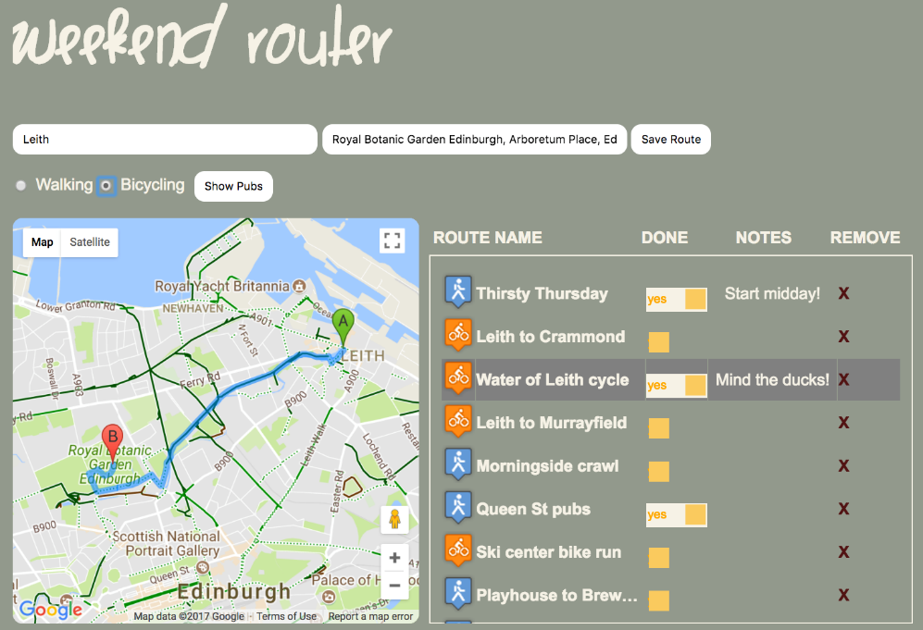

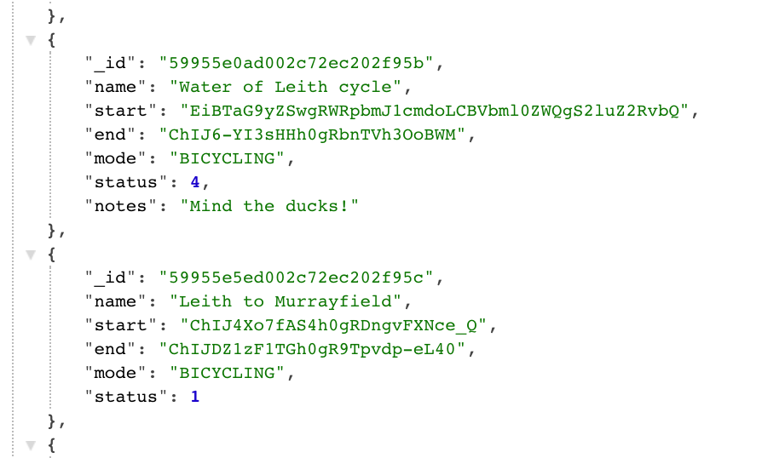

P 15 – User output

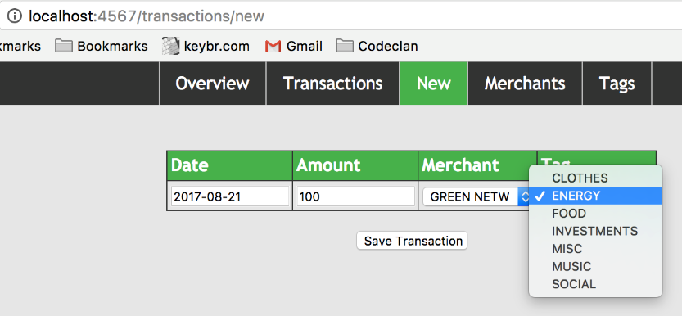

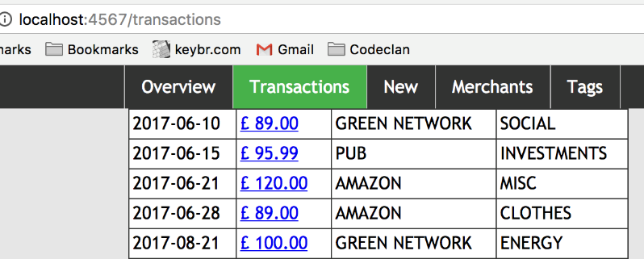

P 16 – API being used

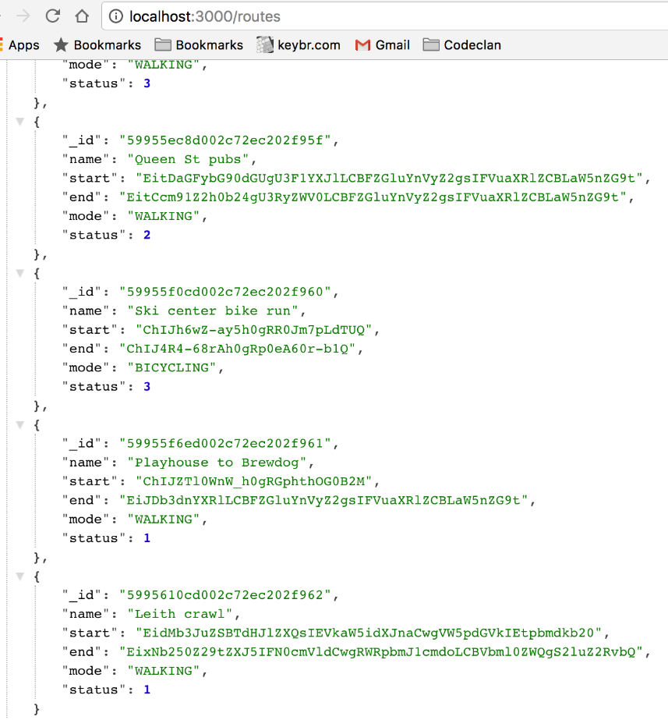

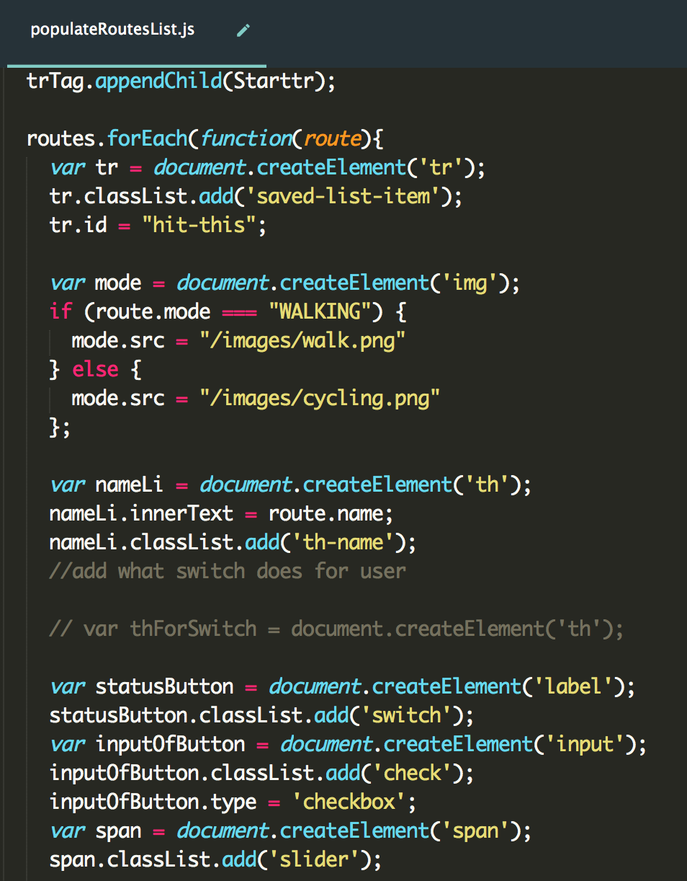

P 17 – Bug tracking report

|  |  |  |  |
| --- | --- | --- | --- |
| **Description** | **Failed** | **Resolution** | **Passed?** |
| From and To fields are not populating when retrieving saved route | Failed | Fields now populate when retrieving saved route | Passed |
| Cancel button saves route. It should not save anything. | Failed | Cancel button now returns to home screen and does not save route | Passed |
| From and To fields should autopopulate dropdown list |  |  | Passed |

P 18 – Example of software testing

Fail:

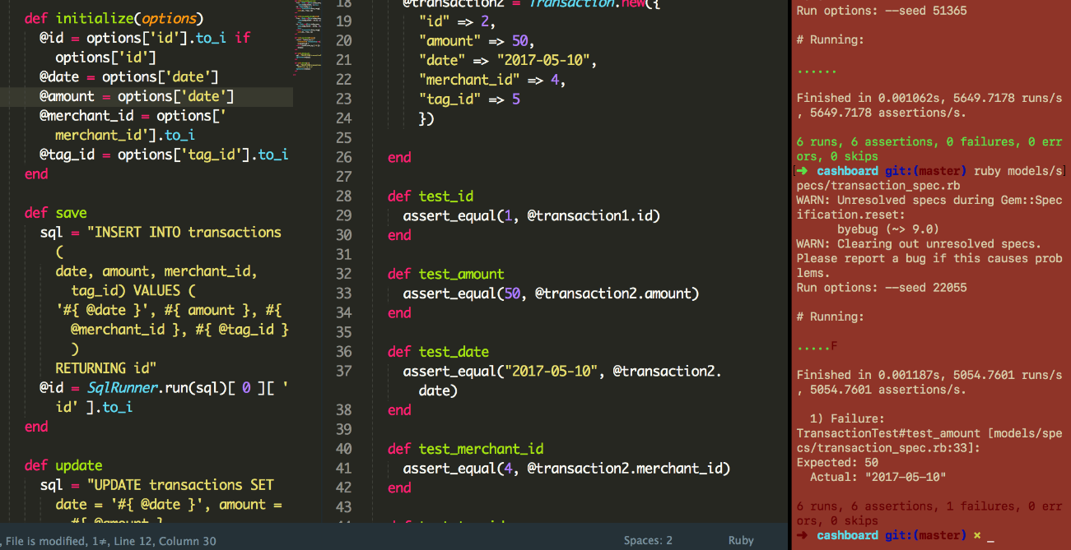

Pass:

