遇到的问题及解决办法总结

# 开发准备阶段

## 给Openstack创建的虚拟机设置密码的脚本

#!/bin/bash

passwd root << EOF  
root  
root  
EOF

## rvm install ruby-1.9.3-p448

There has been error while updating 'apt-get', please give it some time and try again later.

For 404 errors check your sources configured in:

/etc/apt/sources.list

/etc/apt/sources.list.d/*.list

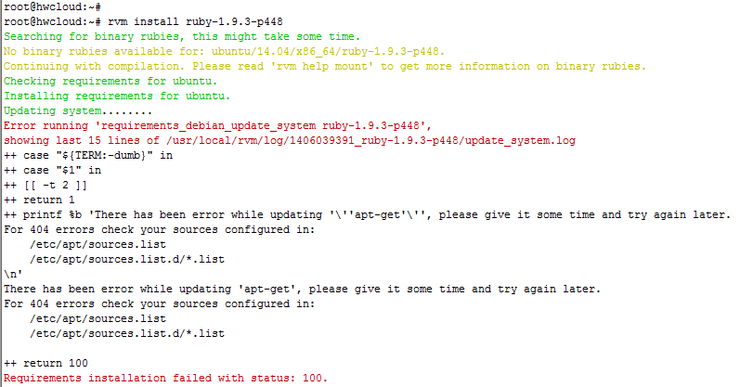

解决办法：

sudo apt-get install build-essential openssl libreadline6 libreadline6-dev curl git-core zlib1g zlib1g-dev libssl-dev libyaml-dev libsqlite3-dev sqlite3 libxml2-dev libxslt-dev autoconf libc6-dev ncurses-dev automake libtool bison subversion nodejs