Business Model Description

The company developed for this project is NovaMart, a multi-seller e-commerce marketplace that provides customers with access to products from different brands, categories, and independent sellers through a single online platform. The company operates in the e-commerce and online retail industry, connecting customers with sellers while supporting the complete purchasing process, including product selection, payment, order processing, delivery, customer feedback, and returns.
The main business process analyzed in the report is the retail sales process, starting when a customer places an order and continuing through payment, seller fulfilment, delivery, and, where applicable, product return. The available Data Warehouse contains information about sales transactions, products, brands, sellers and their business types, customers, payment methods, purchasing devices, delivery locations and statuses, product and seller ratings, discounts, delivery duration, and returned orders. Therefore, the report does not focus only on revenue but provides a broader view.
The purpose of the report is to provide NovaCart management with an interactive analytical environment for monitoring overall performance, identifying factors influencing sales and returns, evaluating products and sellers, and assessing customer and delivery performance. The report is divided into three main analytical areas. The Retail Sales Performance Overview provides a view of sales information. The Product & Seller Analysis focuses on the interaction between products and marketplace sellers, including product and seller ratings, return rates, seller business types, brands, and factors associated with returned orders. Finally, the Customer & Delivery Analysis evaluates the customers and operational process using customer activity.
The primary end users of the report are NovaCart's commercial and operations managers. Commercial managers can use the report to evaluate sales trends, product categories, brands, discounts, and seller performance, while operations managers can monitor delivery efficiency, unsuccessful deliveries, returns, and customer-related indicators.

Report Creation Description
The Power BI report was developed on top of the previously prepared dimensional Data Warehouse model. The report creation process consisted of several main stages: preparing the analytical model, creating additional calculated columns and DAX measures, designing the report pages, configuring interactive functionality, and performing final formatting

1.) Data Model Preparation
The report was developed using the previously prepared dimensional Data Warehouse model. Since the existing model was already designed as a star schema and was relatively well prepared for analytical reporting, no significant structural changes were required before starting the report development. The data was connected using “Import” type.
Only minor adjustments were made - the database schema prefixes were removed from the table names so that the tables were displayed in a more readable way.
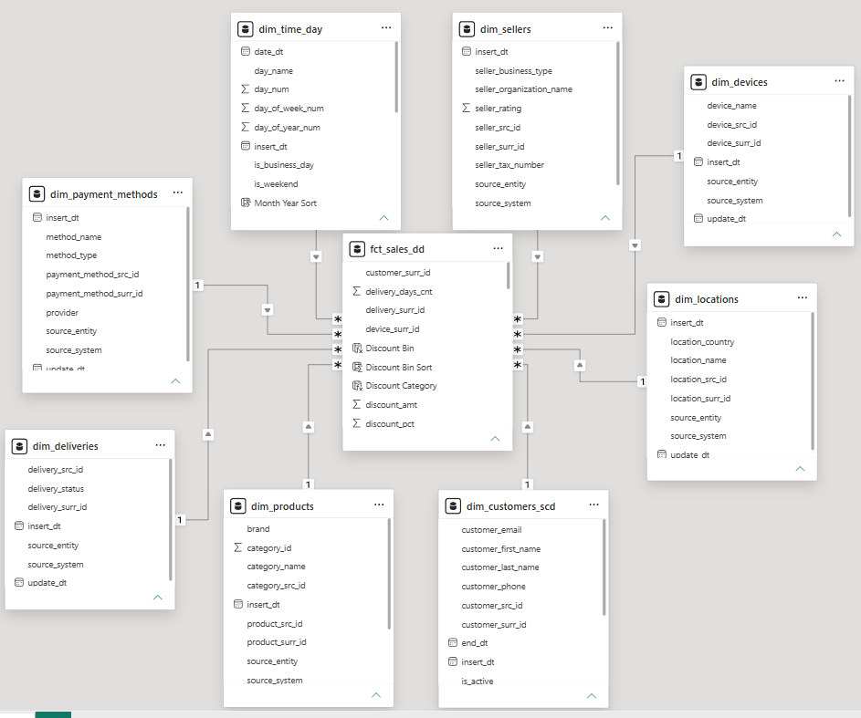

2.)Creation of Calculated Columns and DAX Measures
After the model was prepared, additional calculated columns and measures were created using DAX.
Measures were used for calculations that must dynamically react to the filter context selected by the report user. The main measures include Total Sales, Total Orders, Average Order Value, Total Discount, Discount Percentage, Return %, Average Seller Rating, Average Delivery Time, Successful Delivery %, Total Customers, and Average Orders per Customer.
Where required, separate KPI grand total measures were created so that the main KPI cards ignore unnecessary filters with the exception of date.
Calculated columns were also used where a custom display order was required. Since textual groups are normally sorted alphabetically by Power BI, separate numerical sorting columns were created where necessary to ensure that categories such as rating or discount ranges appeared in their correct logical order.
A Discount Bin column was created to combine individual discount percentages into intervals. Product Rating Group and Seller Rating Group columns were created to transform rating values into categories.

3.) Development of the Sales Performance Overview
The first report page, Retail Sales Performance Overview, was designed to provide management with a overview of commercial performance. The top section contains KPI cards displaying Total Sales, Total Orders, Average Order Value, Total Discount and Discount Percentage. Date, category and location slicers allow users to restrict the analysis to a specific business area or period.
Several visualizations were selected to analyse sales from complementary perspectives. A line chart demonstrates the development of sales over time, while product hierarchy visuals show sales by category and subcategory. Brand performance is analysed using Average Order Value, and discount brackets are compared against order activity.
Bookmark was used to switch between a treemap view and a bar chart view.

4.) Development of Product and Seller Analysis
The second page, Product & Seller Analysis, was created to investigate the relationship between marketplace sellers and products.
Product rating groups are compared using order volume and return percentage, while a scatter chart evaluates seller business types using sales, average seller rating and return percentage. A matrix provides a more detailed comparison of brands and seller business types.
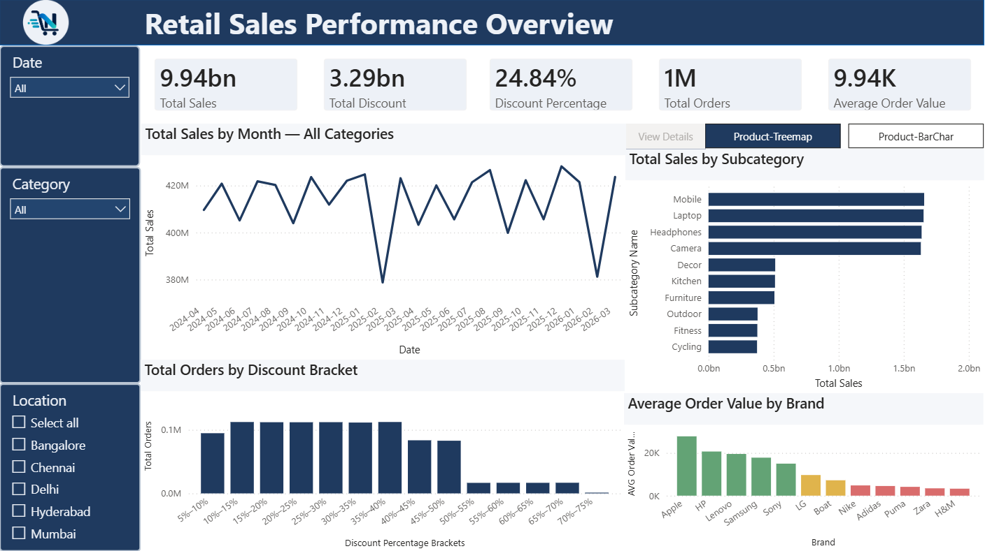
A Key Influencers visual was also implemented to investigate the factors associated with returned orders.
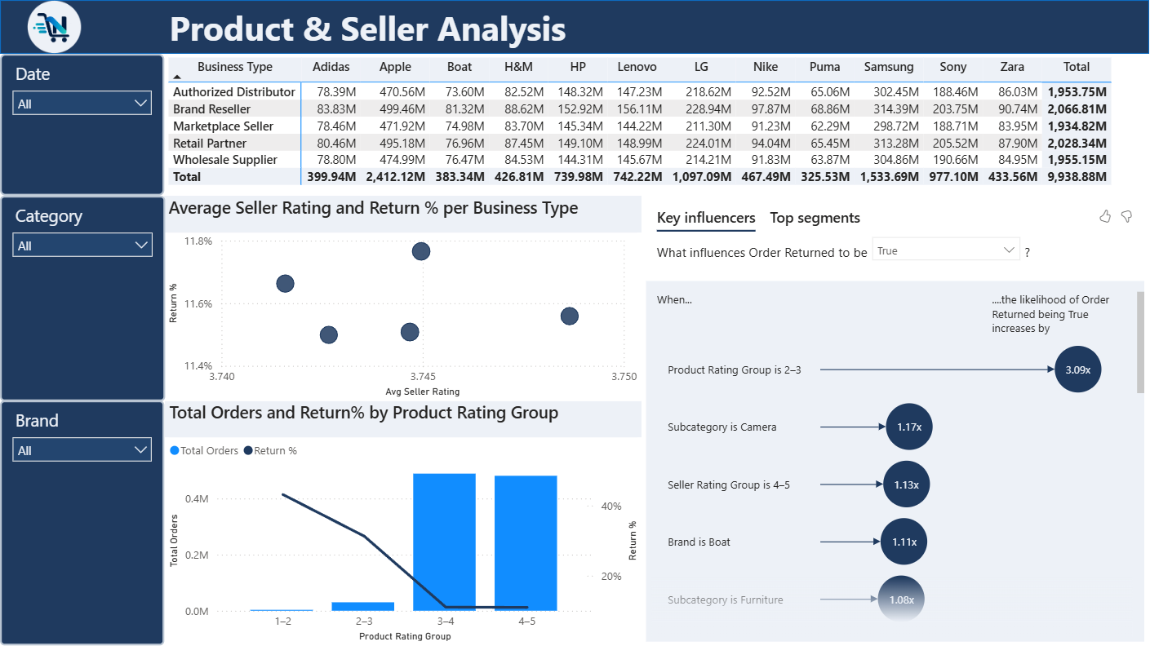

5.) Development of Customer and Delivery Analysis
The third visible page, Customer & Delivery Analysis, focuses on customer behaviour and the operational part of the sales process. The primary KPIs include Total Customers, Average Orders per Customer, Average Delivery Time, Successful Delivery Percentage and Order Return Percentage.
The page contains an analysis of orders by payment method and delivery status. In addition, a Decomposition Tree was introduced to provide an exploratory analysis of Total Sales.
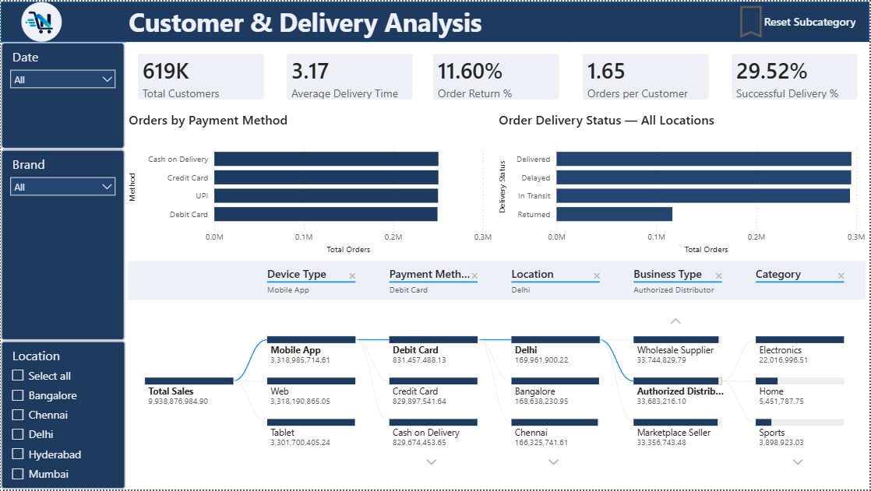

6.) Additional functionality
To make the report easier to interpret, some visualization titles were made dynamic using DAX. For example, the sales trend title reacts to the currently selected filters. A similar approach is used for the delivery-status visualization.
Custom report-page tooltips were created to provide additional information. These pages contain compact KPI information relevant to the visual over which the user places the cursor. The tooltip pages are hidden from normal report navigation.
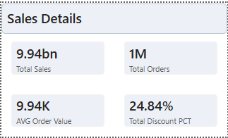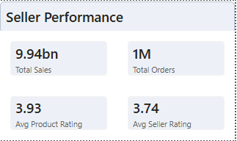

Dynamic conditional coloring was applied to the bar chart on the first report page. The color of each bar is determined by comparing its value with the median value calculated for the currently selected data. Bars representing values above the median are highlighted differently from those below the median.
