Some problems with the previous approaches:
1.The STN is tough to train as stand alone model as it was made to be used as a module in the original model and it learns from the errors generated by the entire model.
a. Some pre trained models can be used to extract the spatial features and then give them as inputs and try to reduce the Euclidean distance between them by applying STNs??(not yet tried)(May be give null)
2.Thinking of tooth and mouth segmentation.. SAM 2 Worked pretty well on these are the individual masks and the original image (BUT IS A HEAVY MODEL)
Some angular parts are not really segmented
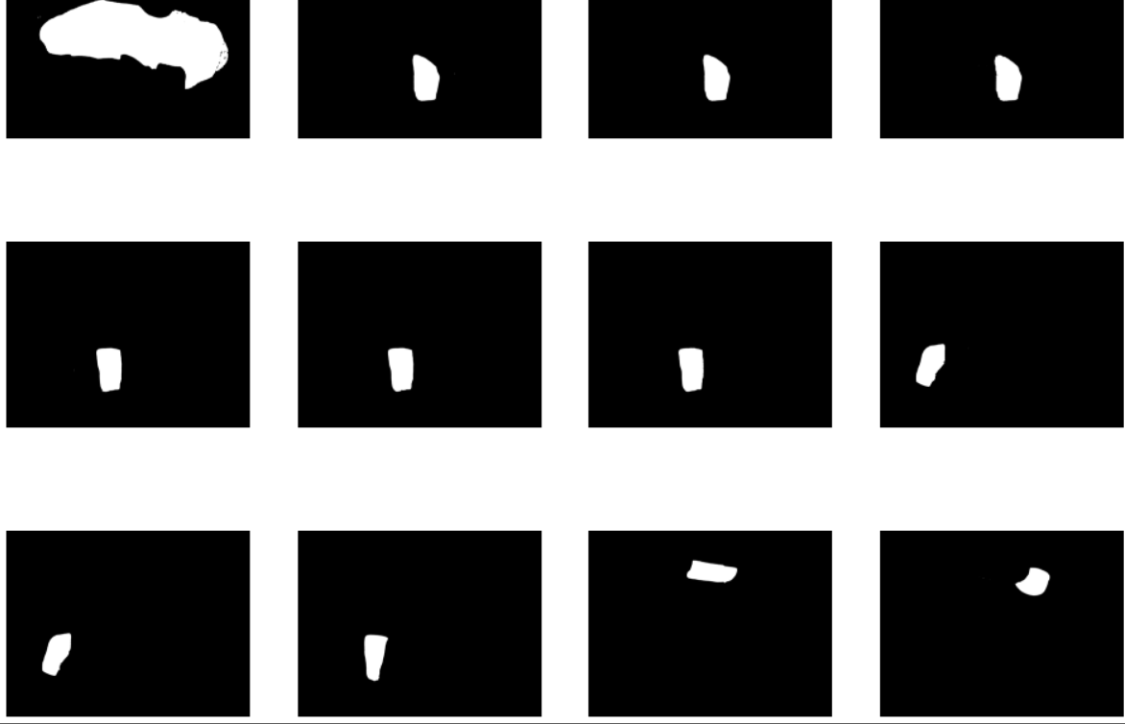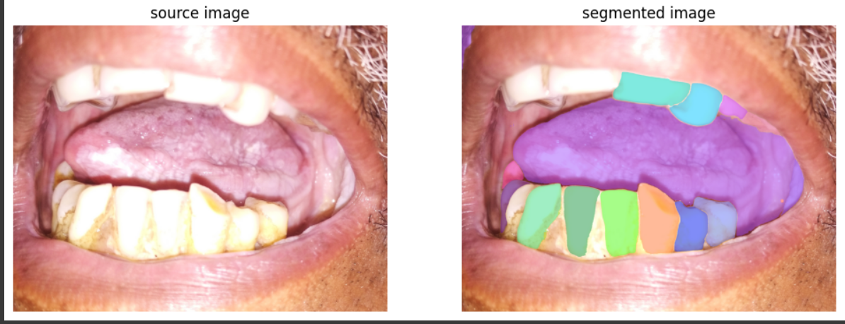
This seems like a tougher approach and less interpretable –
Some research papers read by me:
https://iopscience.iop.org/article/10.1088/1742-6596/1911/1/012006/pdf
https://www.frontiersin.org/journals/oral-health/articles/10.3389/froh.2021.794248/full
https://arxiv.org/abs/1811.10980
https://cdn.publisher.gn1.link/jordi.com.br/pdf/v8aop224.pdf
This paper uses a unique approach considering the colors but is useless currently
These are some of the papers using yolov8 with STNs but isn’t just working
Some Facts about the images:
- The presence of beard and other region except for the oral part is unnecessary this would be hindrance for the models in the learning process. Hence some way that would distinguish between the models
- Again use of STNs can be tried in this setting
- Yolov8 just isn’t working (the model is learning but its not predicting any masks or bounding box
- Trying to use MASK RCNN and integrating STNs with it.

