**Bricolage**

By Boson HUANG

1/14/19 2p.m.

I was added to experimentally game officially. I started to generate idea.

So I start to do some research on *Bricolage*. I found that Bricolage has a similar meaning with DIY (do-it-yourself). Those hand-made items were cute and funny, and they normally had a prototype to base on.

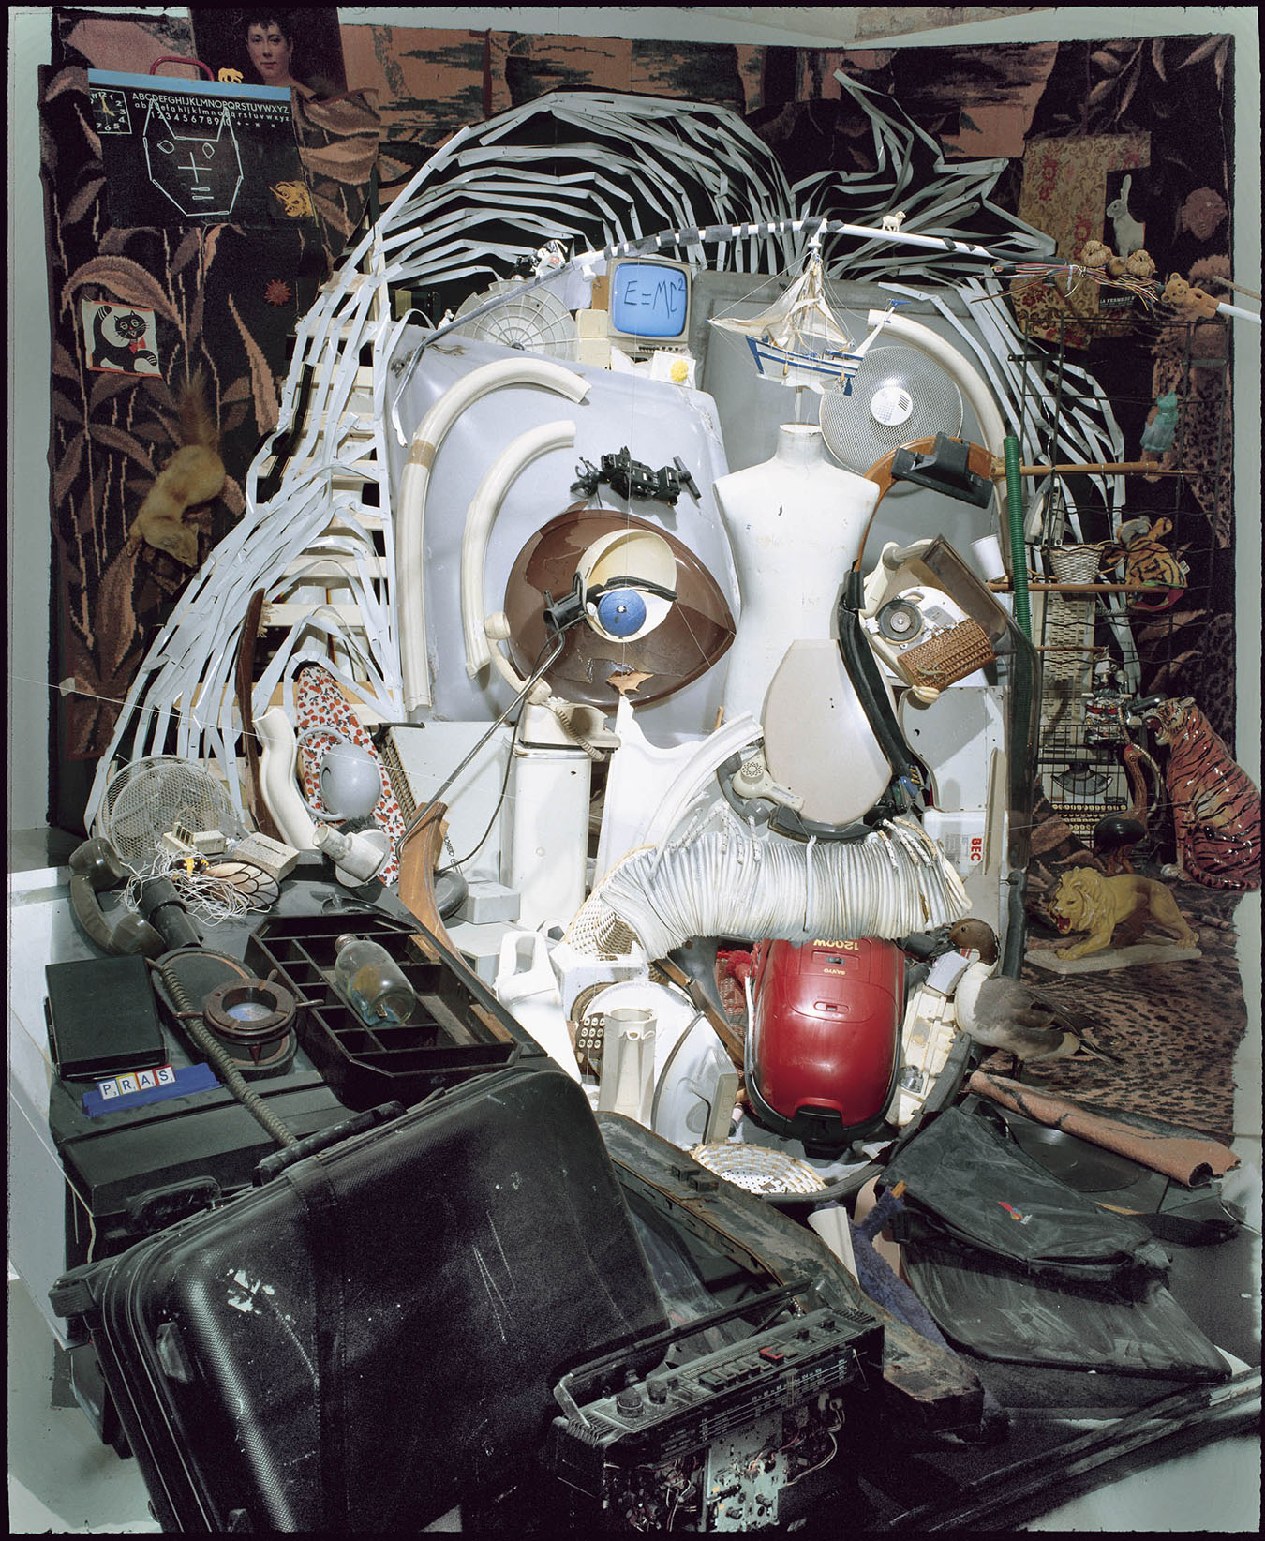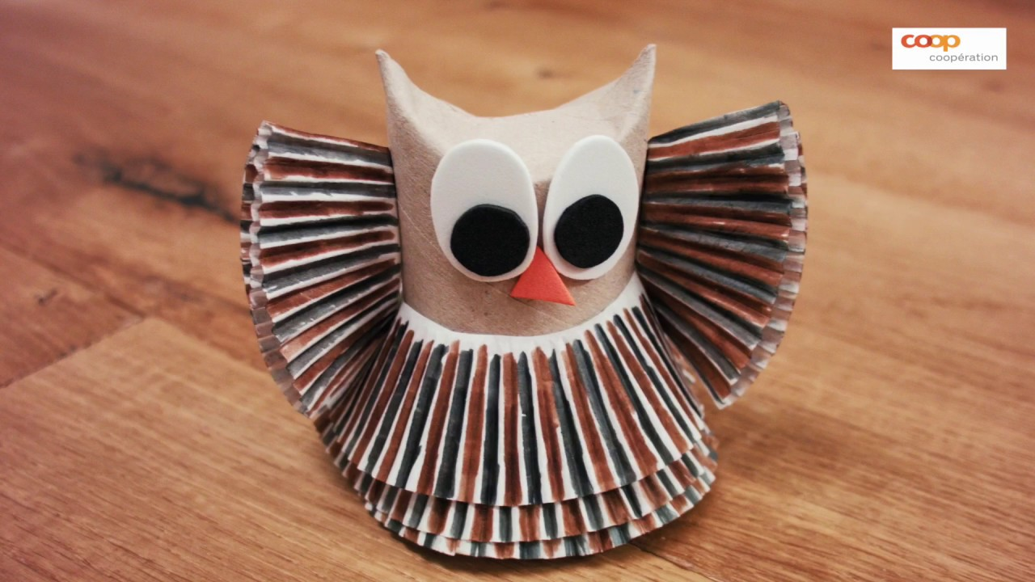

Therefore, I came out an idea that player should use different objects to combine a particular object in a *Tetris* way.

**-what we did**

I basically made an object-making game. Player should use different objects to build an object that has already existed. It looks like Tetris. After placing each object, the block pool will refresh and randomly pick up new set of objects. When finish placing, the game will judge the similarity between the output image and the original image.

**-what we think worked and didn't**

I first think that the image match is easy to make because in C++ OpenCV program, it will just call a function and the similarity will come out. But inside Unity I did not find a proper way to do it. So the best solution might be import OpenCV to unity and use similar way to do that. But I did not have time to do it.

**-what we would change or improve**

Currently, image matching did not work.

Only one image can be used to match.

Small bugs happens when all the placed objects were almost full the sence.