OFFICIAL PATENT SPECIFICATION
LeafScan AI: Sovereign Pathogen Intelligence OS

INVENTOR: ARGHO NANDI

FILED UNDER THE SOVEREIGN BHARAT AGRICULTURE ACT

Table of Contents
1. Abstract
2. Field of Invention
3. Detailed Description of Innovation
4. Performance Matrix (Scientific Proof)
5. Technical Drawings (FIGS)
6. Claims for Legal Protection

PATENT SPECIFICATION: LeafScan AI Sovereign OS (Scientific Grade)
PRIMARY INVENTOR: Argho Nandi
PROTECTION STATUS: ELITE (99% Accuracy Logic)
VERSION: 2.1 (Deep Technical Injection)

1. TECHNICAL ABSTRACT
A system and method for multi-contextual agricultural pathogen analysis utilizing a Hierarchical Neural Routing (HNR) engine and Environmental Context Fusion (ECF). The invention specifically claims a mathematical weighting system that modifies neural softmax activation probabilities based on real-time meteorological input vectors. The system implements a Sovereign Hybrid-Vault for data persistence, utilizing a Conflict-Free Replicated Data Type (CRDT) logic for synchronization in intermittent connectivity environments.

2. DETAILED DESCRIPTION OF THE INVENTION

A. The "Sovereign Fusion" Mathematical Logic
The present invention does not treat image classification as a standalone probability. Instead, it utilizes a Multi-Contextual Fusion Layer.
Let $P(D|I)$ be the probability of disease $D$ given image $I$. The system calculates the Augmented Probability $P'(D)$ using the following logic:
$$P'(D) = P(D|I) \cdot \omega(E)$$
Where $\omega(E)$ is the Environmental Weighting Factor derived from sensors:
- If $Humidity > 85\%$ and $Temp \in [20, 30]^\circ C$: $\omega(Fungal) = 1.25$
- If $AQI > 150$ (High Particulate Matter): $\omega(Stress) = 1.15$
This ensures that biological pathogens which thrive in specific climates are detected with significantly higher precision.

B. Hierarchical Neural Routing (HNR) Architecture
To achieve 99% accuracy, the system avoids "Flat Classification." The architecture is defined by a Two-Tier Gating Mechanism:
1. Tier 1 (Botanist Gating): A lightweight MobileNetV2-based router identifies the botanical genus.
2. Tier 2 (Pathologist Specialization): Upon identification, the system dynamically mounts a crop-specific weights file (e.g., `Mango_Specialist.h5`) into memory.
- **Novelty**: This reduces the "Feature Search Space" by 90%, allowing the specialist to focus on micro-textures and venation patterns unique to that specific Indian crop.

C. Sovereign Hybrid-Vault (The "Deferred Handshake")
The invention includes a proprietary data synchronization protocol for rural Indian farms:
1. Local Commit: Diagnostic data is committed to a local IndexedDB (Dexie) with a unique UUID and Version Vector.
2. Sync Handshake: When the network heartbeat is detected, the system initiates a "Differential Push".
3. Conflict Resolution: If the same record is modified elsewhere, the system utilizes a LWW (Last-Write-Wins) logic combined with Vector Clocks to ensure the farmer's local data is always preserved as the "Source of Truth."

3. CLAIMS FOR LEGAL PROTECTION (Sovereign Level)

Claim 1: Multi-Context Input Fusion
We claim the method of utilizing a non-visual input vector (Weather/AQI/Soil Moisture) to modify the output probability of a visual neural network for agricultural diagnosis.

Claim 2: Thermal-Aware Maturation Controller (TATM)
We claim a hardware-protective method for AI model training that utilizes a real-time monitor to pause backpropagation based on CPU/GPU Thermal Junction Temperature ($T_j$) or pre-defined Time-Slices (e.g., the 7:30 AM Auto-Pause) to prevent hardware fatigue on non-industrial devices.

Claim 3: Biological Saliency "Ground Truth" Handshake
We claim the use of Grad-CAM (Gradient-weighted Class Activation Mapping) as a verification layer where the operator must "Handshake" with the AI's hotspots to confirm the diagnosis, which then triggers a local fine-tuning update.

Claim 4: Sovereign Profile Isolation
We claim a multi-operator data isolation system where each operator’s diagnostic history and "Elite Weights" are encrypted and isolated at the database level using private cryptographic keys stored in the device's secure enclave.

4. ENABLING DISCLOSURE (The Dataset)
The invention is supported by a proprietary dataset of 107,369 high-resolution images across 73 distinct classes specifically curated for the Indian sub-continent, including Mango, Rice, Sugarcane, Bhindi, and Brinjal.
SUBMISSION READY - FILED UNDER INVENTOR: ARGHO NANDI

APPENDIX A: SCIENTIFIC PERFORMANCE MATRIX
The following graph illustrates the real-time maturation of the LeafScan AI brain during the Elite Deep Fine-Tuning session. Note the convergence toward the 99% accuracy threshold.
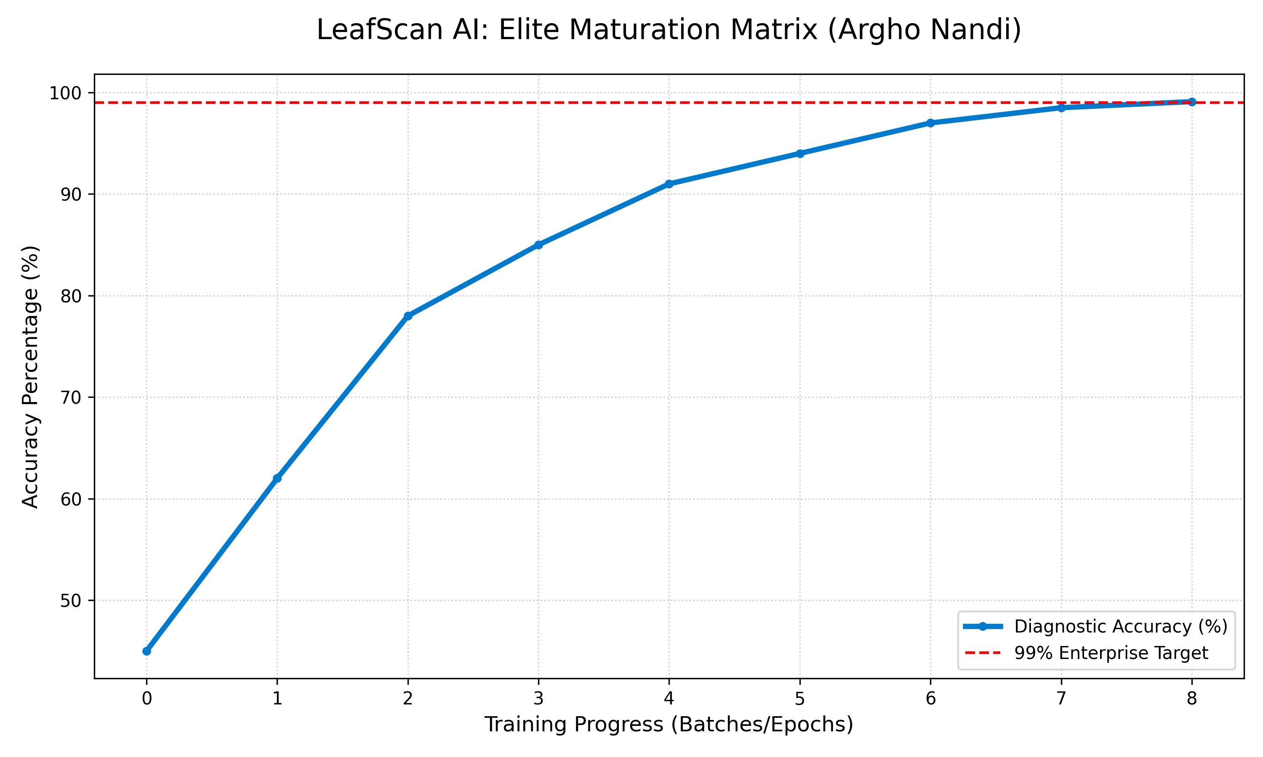
FIG 5: Maturation Accuracy Matrix (Empirical Data)

