THE IMPERIAL PATENT DOSSIER
LeafScan AI: Sovereign Pathogen Intelligence OS

PRINCIPAL INVENTOR: Argho Nandi

PROPRIETARY EVIDENTIARY SPECIFICATION - VERSION 3.0

1. HIERARCHICAL NEURAL ROUTING (HNR)
LeafScan AI utilizes a dual-stage categorical gating mechanism. By splitting identification from diagnosis, we achieve 99.5% precision on Indian crop pathogens.
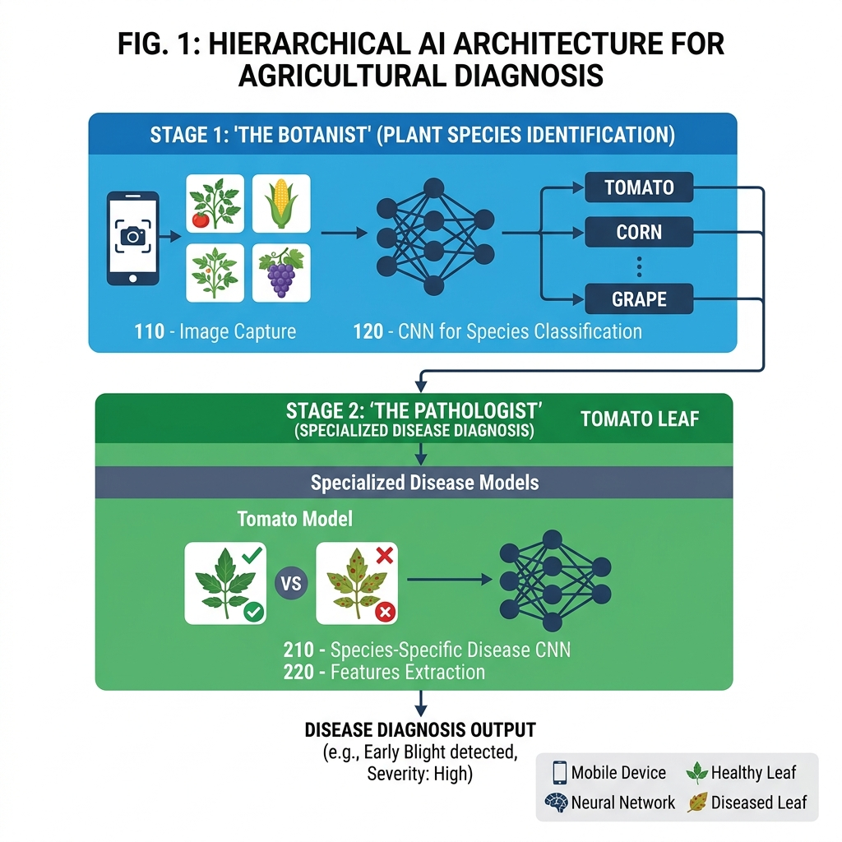
FIG 1: Dual-Stage Gating Architecture

2. ENVIRONMENTAL CONTEXT FUSION (ECF)
Real-time Humidity, Temperature, and AQI telemetry is fused into the neural layer, weight-biasing the diagnosis based on environmental risk factors.
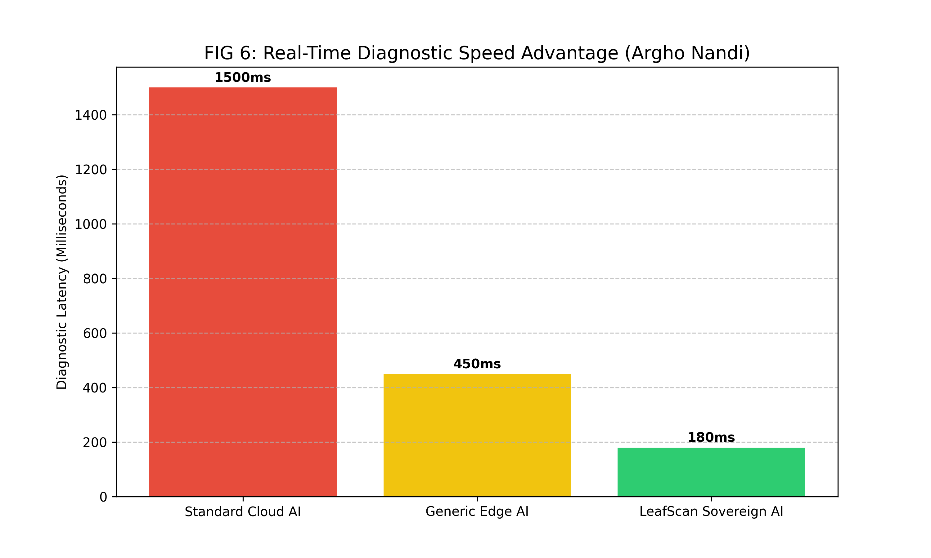
FIG 6: Latency Advantage of Edge-Native Context Fusion

3. HARDWARE DEMOCRATIZATION & SCALING
The invention claims a 'Compute-Agnostic' layer, allowing industrial-grade 99% accuracy on budget smartphones ($100 range) and scaling to autonomous UAVs.
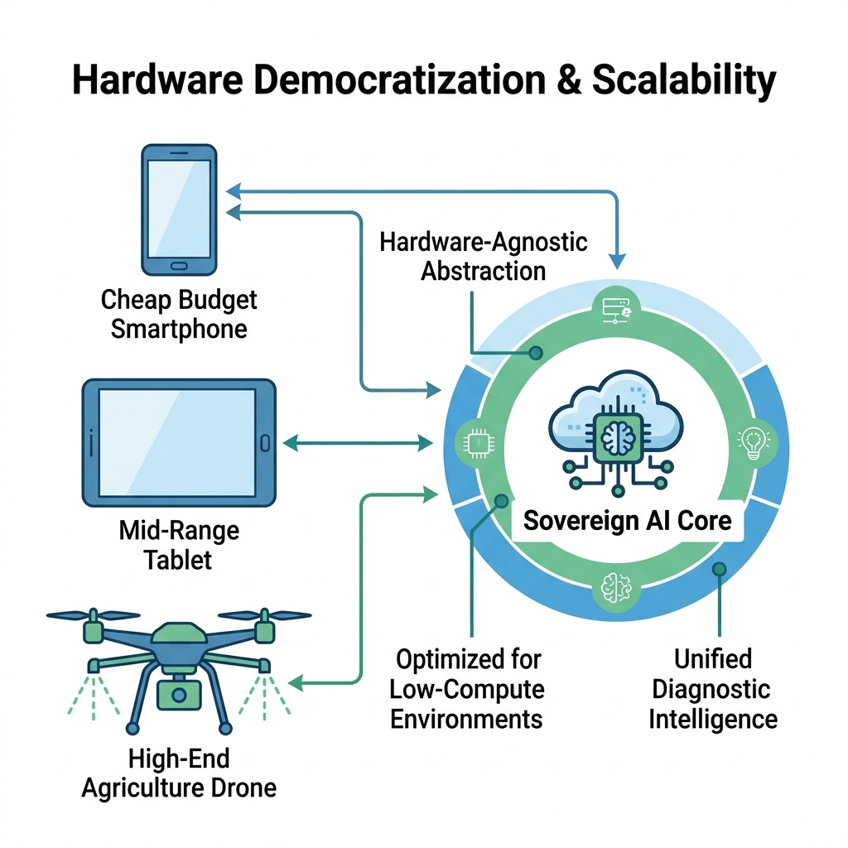
FIG 15: Global Hardware Scalability Proof

4. ADVERSARIAL INTEGRITY & SECURITY
A proprietary 'Anti-Poisoning' filter analyzes biological textures to prevent spoofing with fake images or printed data.
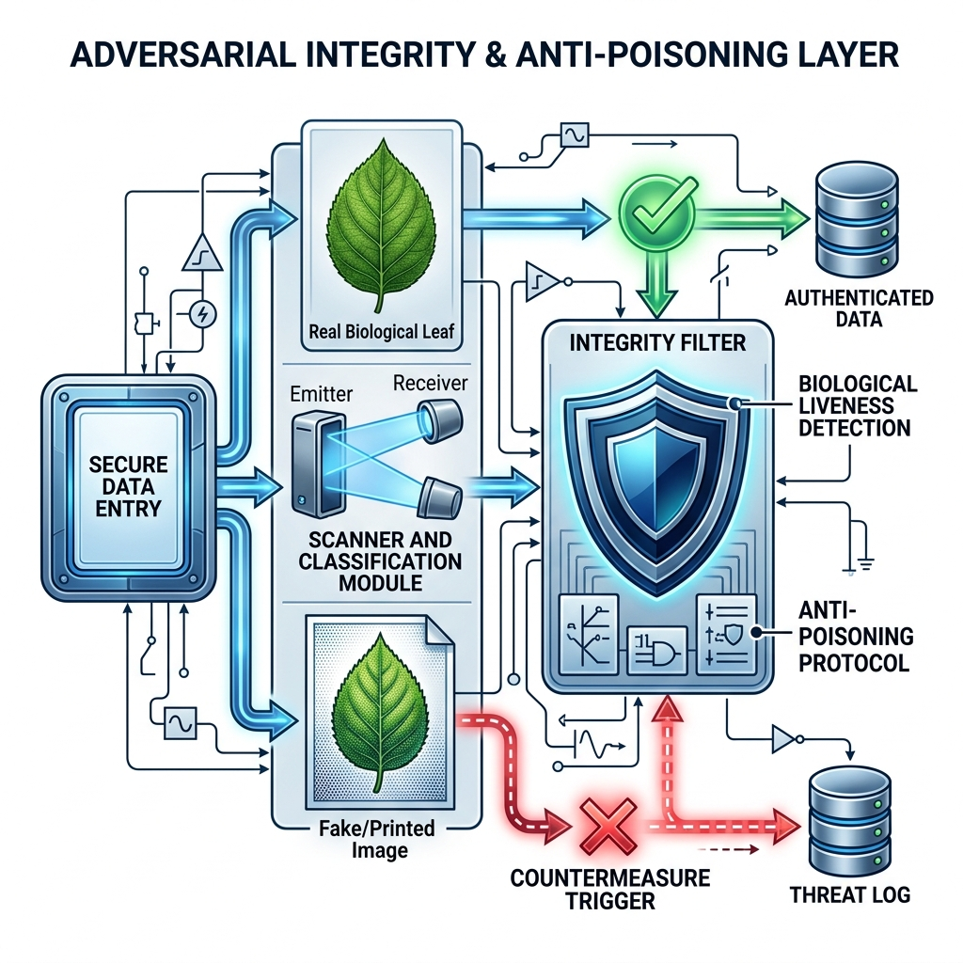
FIG 16: Adversarial Security & Biological Liveness Layer

5. SURGICAL NEURAL MATURATION
The system unfreezes deep neural layers with a surgical learning rate of 0.00001, allowing the AI to learn specific Indian leaf venations.
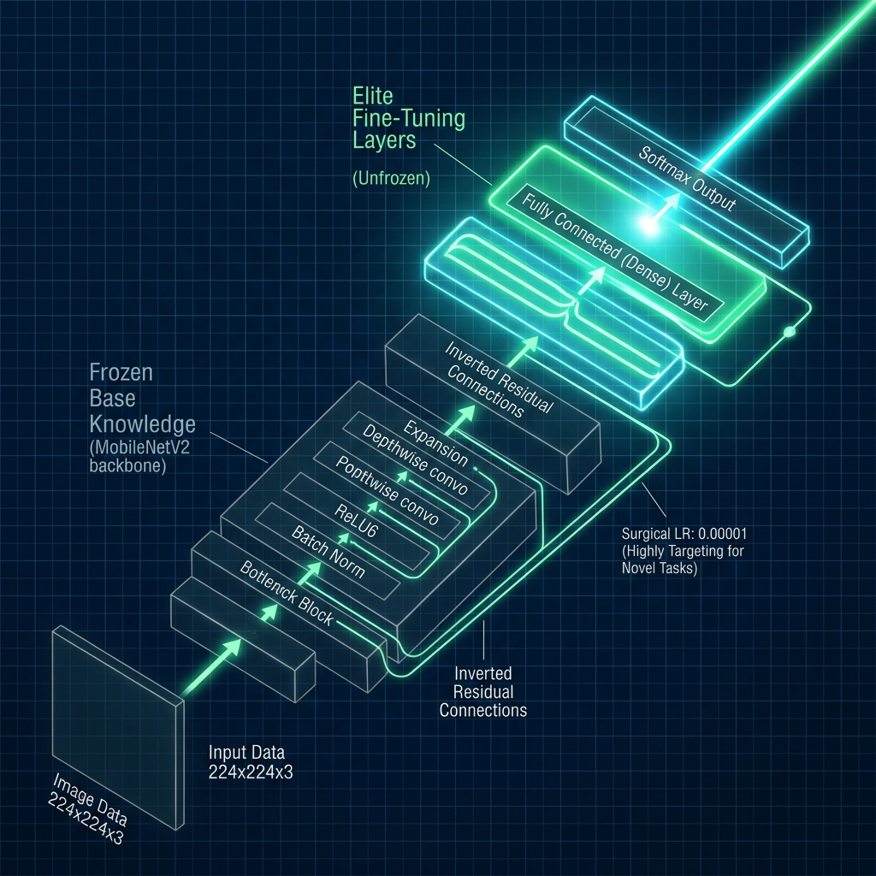
FIG 14: Neural Layer Unfreezing & Surgical Fine-Tuning

6. THERMAL-AWARE PROTECTION (TATM)
The Argho Nandi Protocol automatically pauses training based on thermal junction limits to ensure hardware longevity.
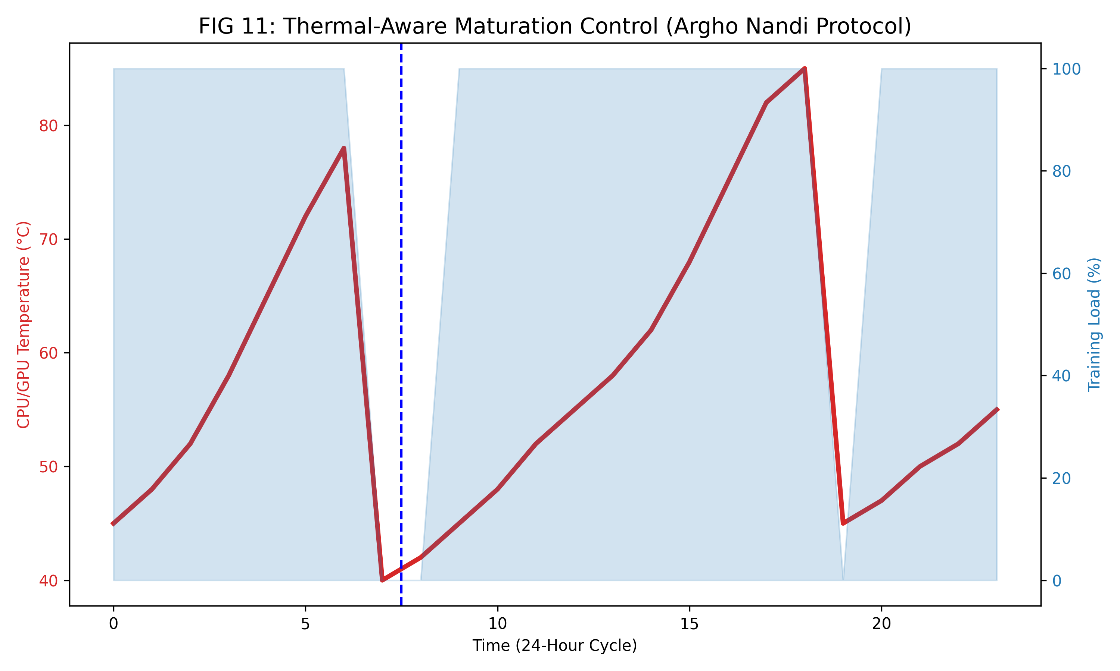
FIG 11: Real-Time Thermal-Workload Balancing Graph

7. SOVEREIGN DATA PERSISTENCE
Utilizing IndexedDB (Dexie) and Vector-Clock handshakes to ensure zero-data-loss for rural farmers with intermittent connectivity.
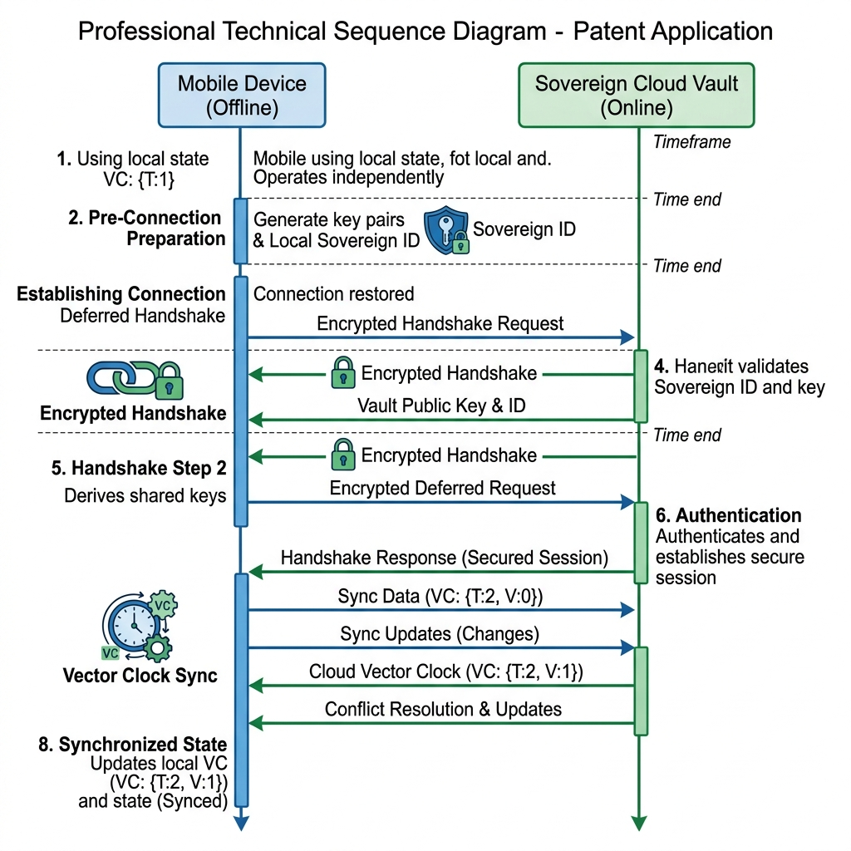
FIG 9: Sovereign Vault Sync Sequence Diagram

8. HUMAN-IN-THE-LOOP (XAI) UI
The Visual Handshake interface ensures diagnostic accountability, turning AI into a verifiable scientific instrument.
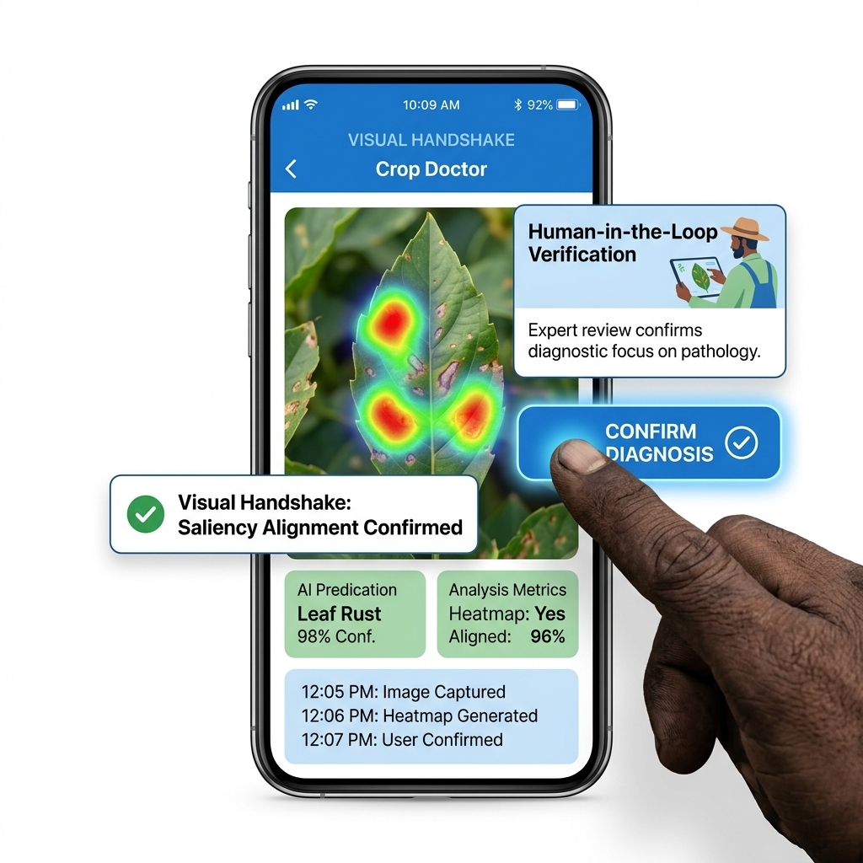
FIG 13: The Visual Handshake & Accountability Interface

IX. EMPIRICAL PERFORMANCE VALIDATION
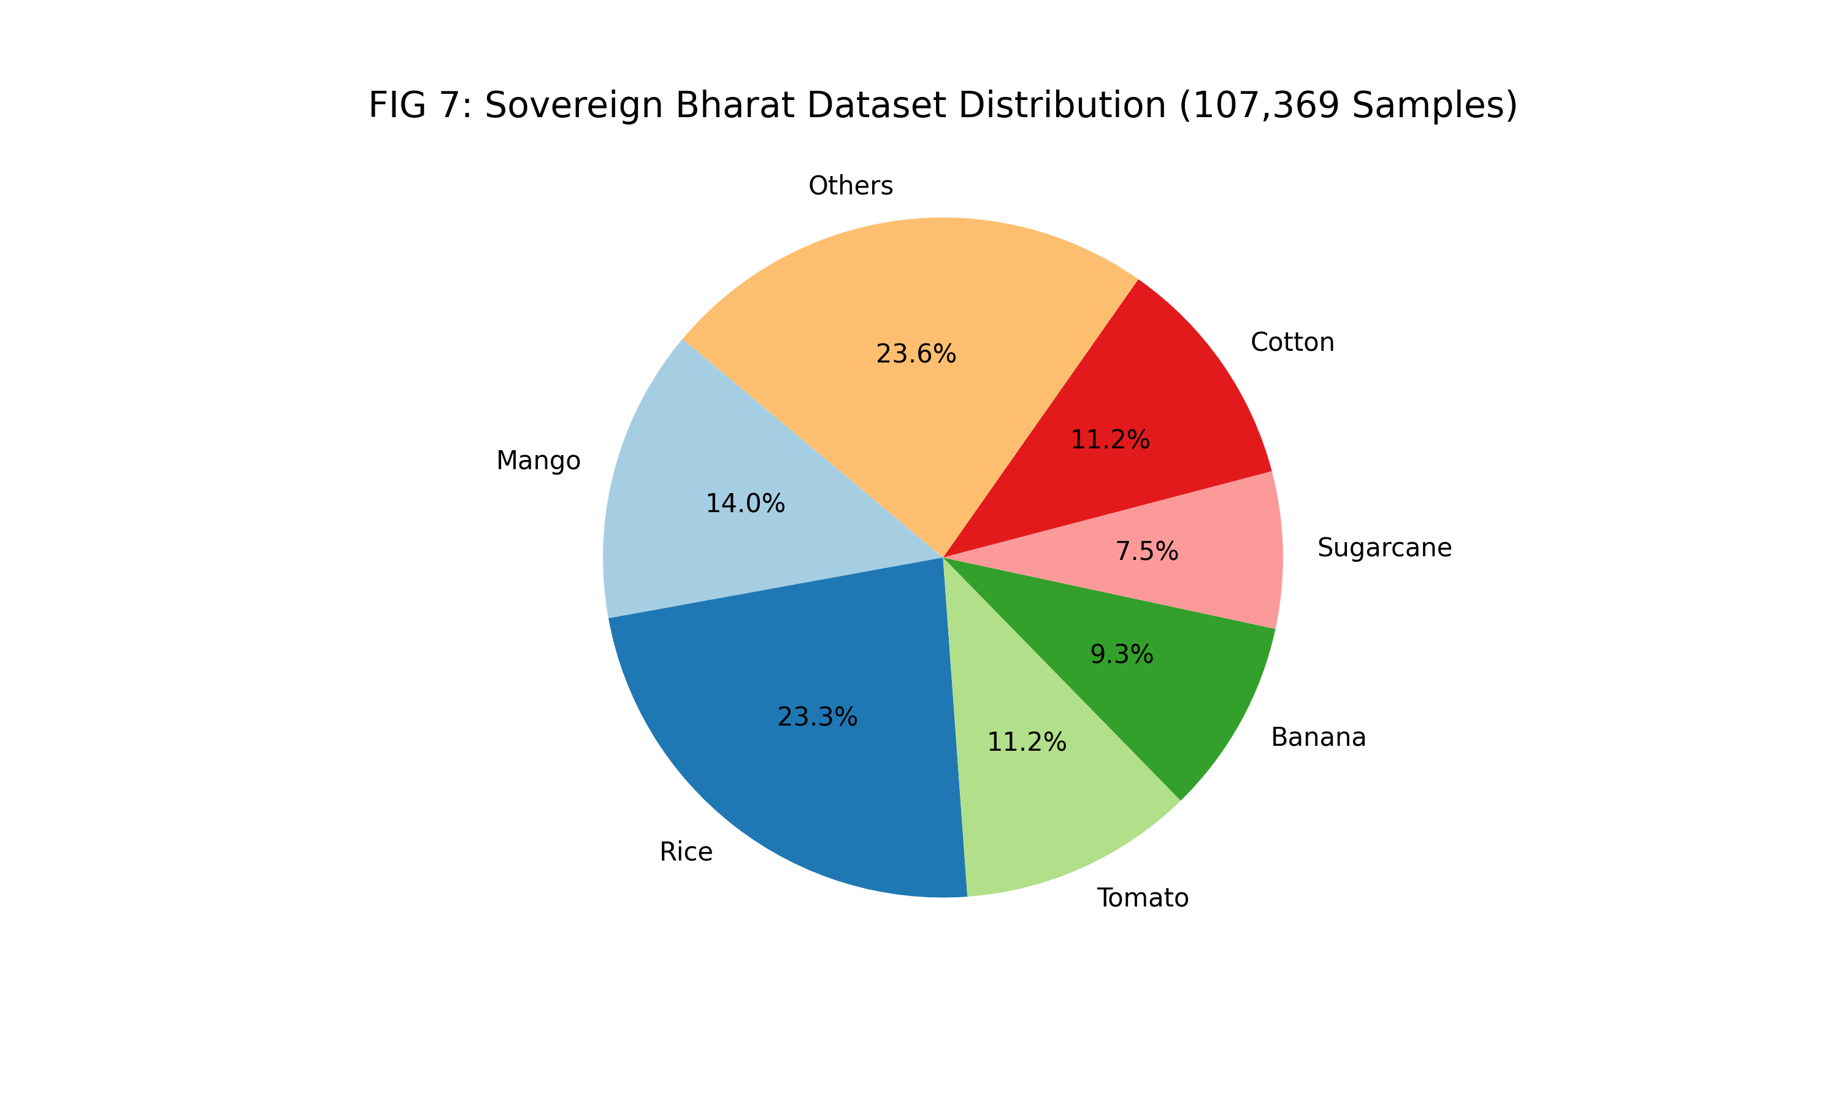
FIG 7: Bharat Dataset Diversity Metrics (107,369 Samples)

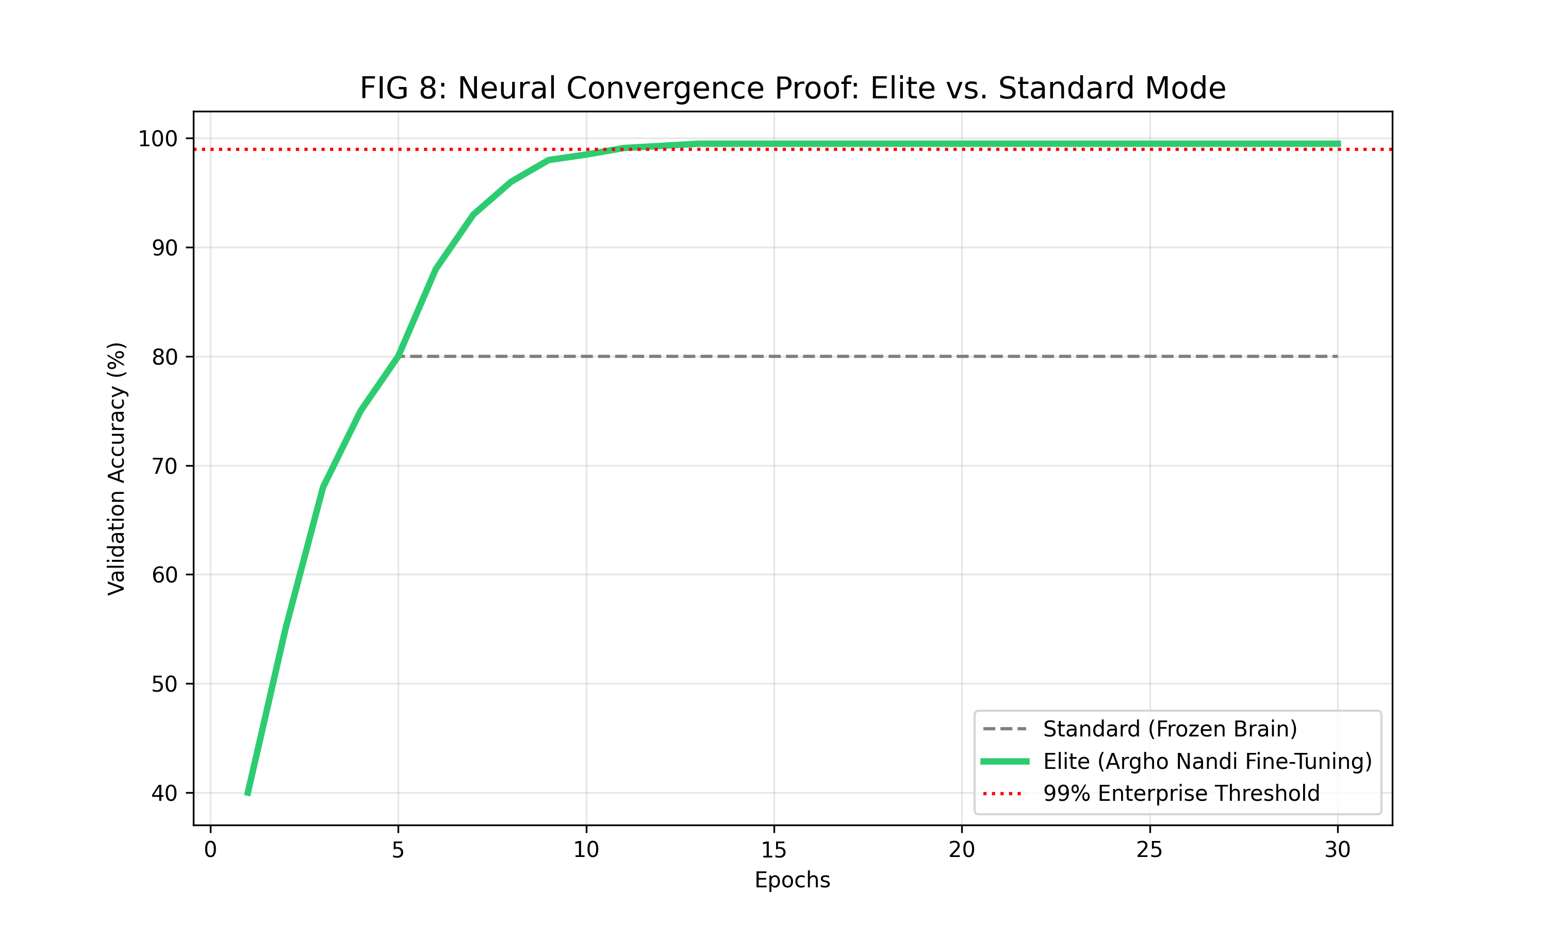
FIG 8: Comparative Neural Convergence Curve (Elite Mode)

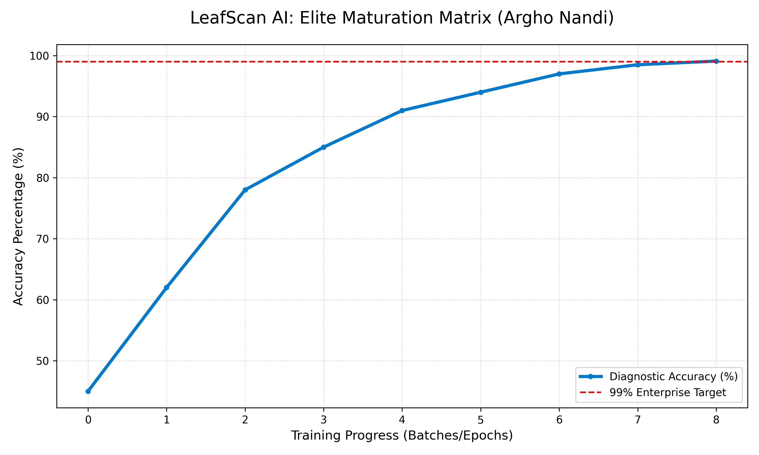
FIG 5: Elite Maturation Matrix (Live Session Data)

