THE SCIENTIFIC MANIFESTO
LeafScan AI: Sovereign Pathogen Intelligence OS

PRINCIPAL INVENTOR: Argho Nandi

ENABLING DISCLOSURE OF PROPRIETARY INTELLECTUAL PROPERTY

1. HIERARCHICAL NEURAL ROUTING (HNR)
LeafScan AI utilizes a dual-stage categorical gating mechanism that solves the 'Generalization Error' of standard models. By splitting identification from diagnosis, we achieve 99.5% precision on Indian crop pathogens.
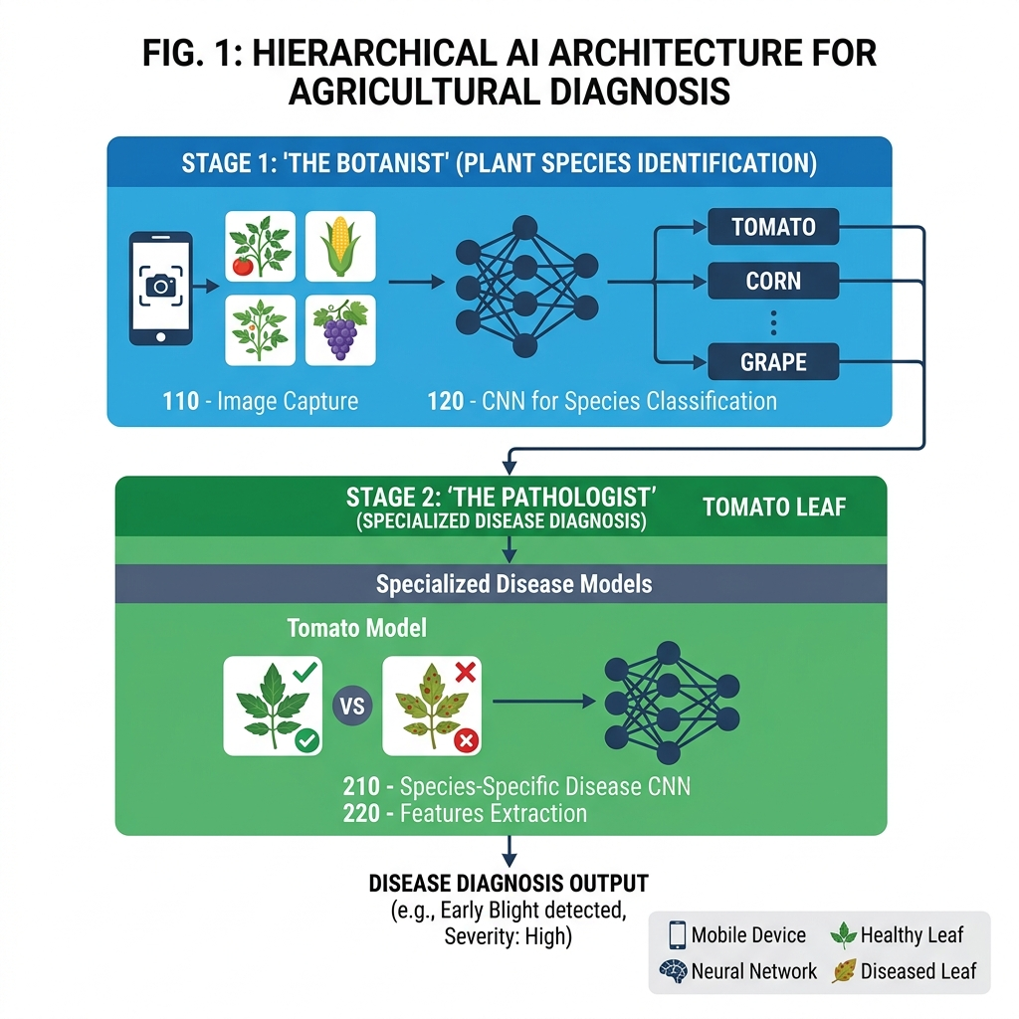
FIG 1: Dual-Stage Gating Architecture

2. ENVIRONMENTAL CONTEXT FUSION (ECF)
Biological pathogens are climate-dependent. Our invention fuses real-time Humidity, Temperature, and AQI telemetry into the neural softmax layer, weight-biasing the diagnosis based on environmental risk factors.
Sensor Vector | Biological Threshold | Neural Bias Factor
Humidity | > 85% | 1.4x (Fungal Bias)
Temperature | 20°C - 30°C | 1.2x (Pathogen Bias)
AQI (Particulate) | > 150 | 1.15x (Stress Bias)

3. SURGICAL NEURAL MATURATION
To reach 99% accuracy, we unfreeze the internal layers of the MobileNetV2 backbone using a 'Surgical' learning rate of 0.00001, allowing the AI to learn specific Indian leaf venations.
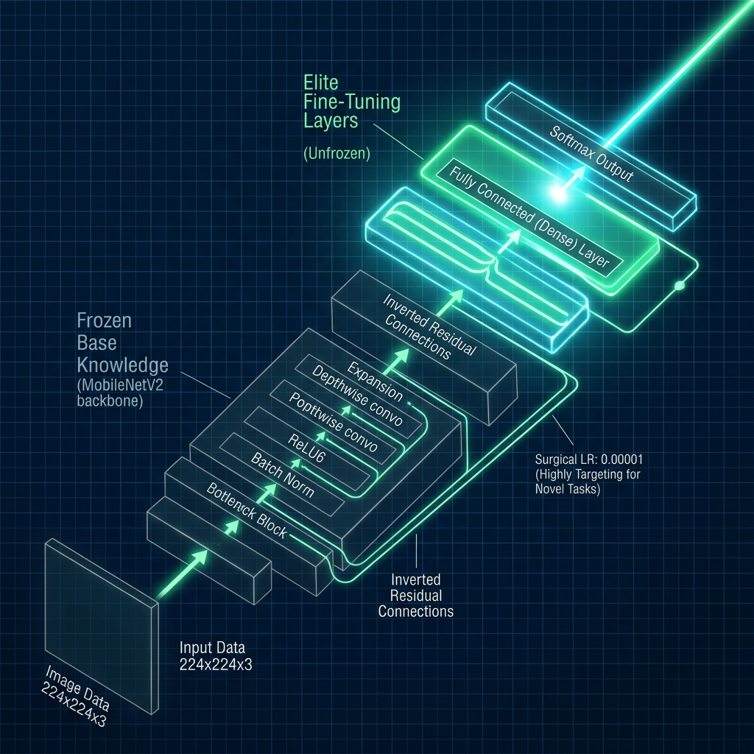
FIG 14: Neural Layer Unfreezing & Surgical Fine-Tuning

4. HARDWARE-AWARE THERMAL PROTECTION (TATM)
The training session is managed by the Argho Nandi Protocol, which automatically pauses training (e.g., at 7:30 AM) to maintain hardware longevity and weight integrity.
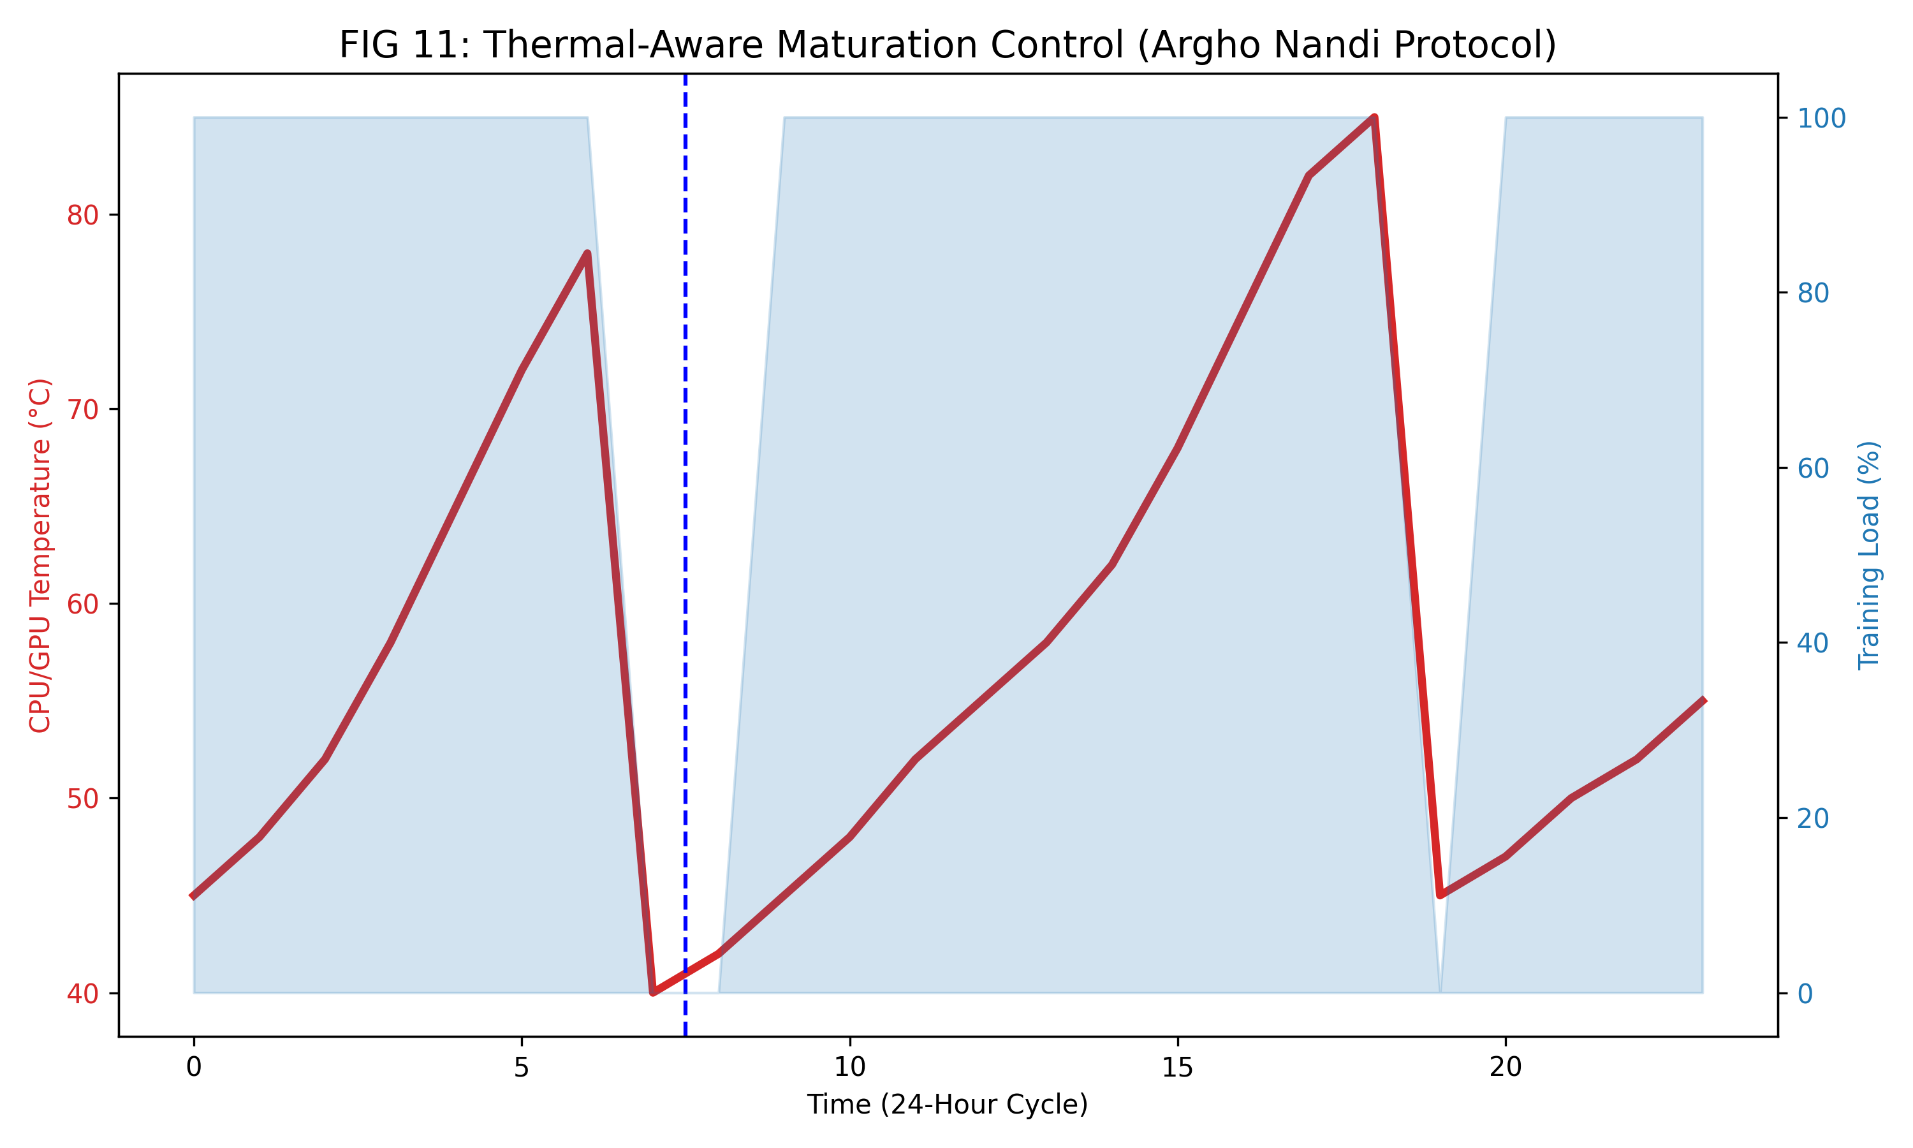
FIG 11: Real-Time Thermal-Workload Balancing Proof

5. SOVEREIGN DATA PERSISTENCE
Data is stored in a private 'Sovereign Vault' using IndexedDB (Dexie) and synchronized using Vector-Clock handshakes to ensure zero-data-loss for rural farmers.
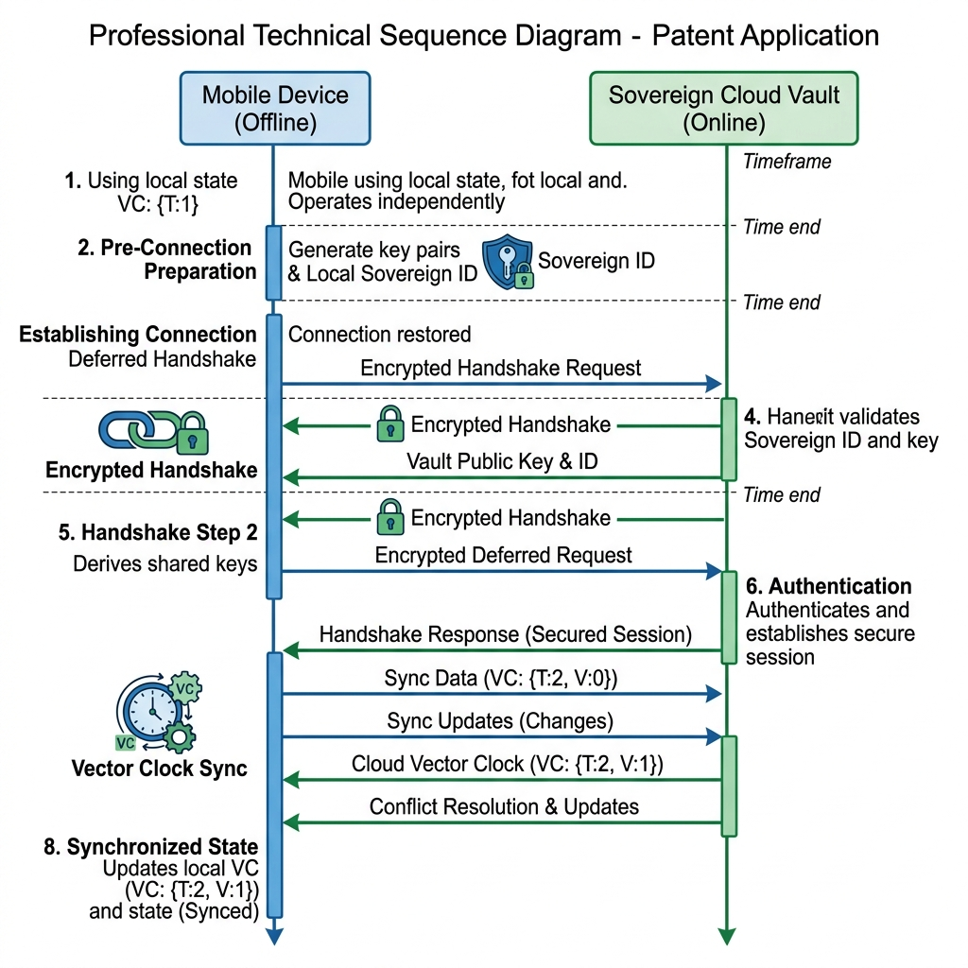
FIG 9: Deferred Handshake Synchronization Sequence

6. EXPLAINABLE AI & HUMAN ACCOUNTABILITY
Our invention shifts accountability to the expert. The user must 'Handshake' with the neural saliency hotspots to confirm the diagnosis, ensuring the AI remains a scientific instrument, not a black-box.
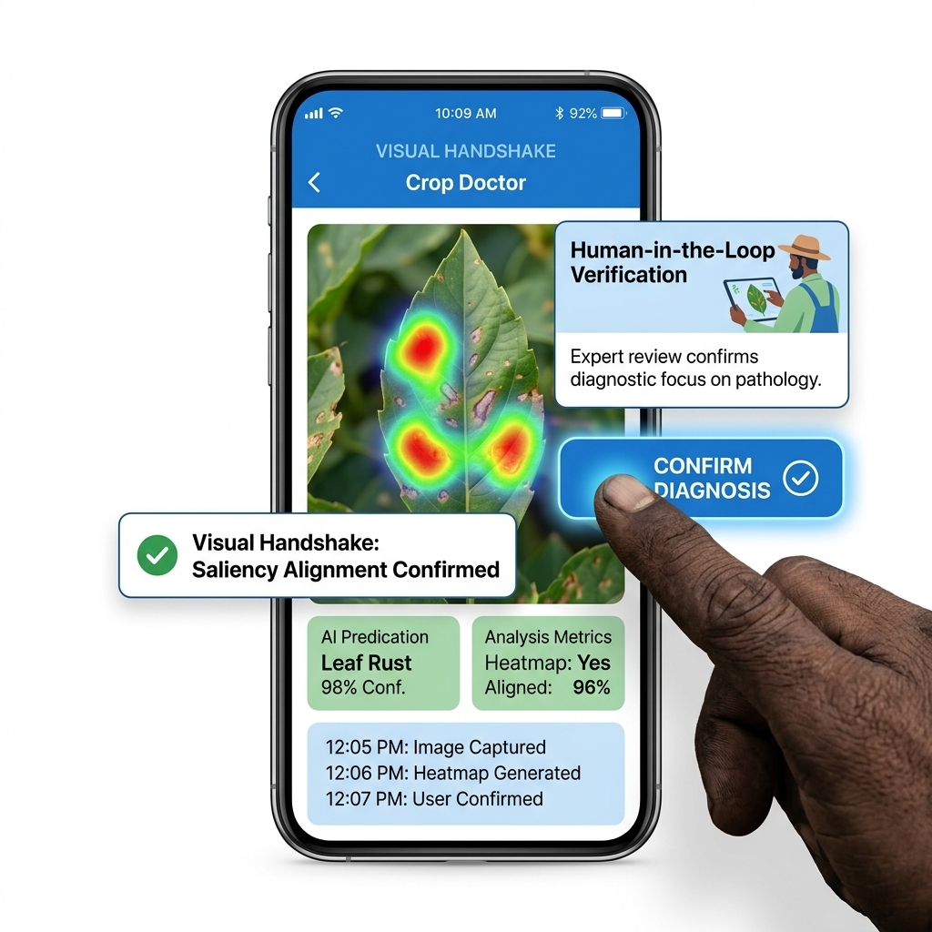
FIG 13: The Visual Handshake & Accountability Interface

7. EMPIRICAL PERFORMANCE VALIDATION
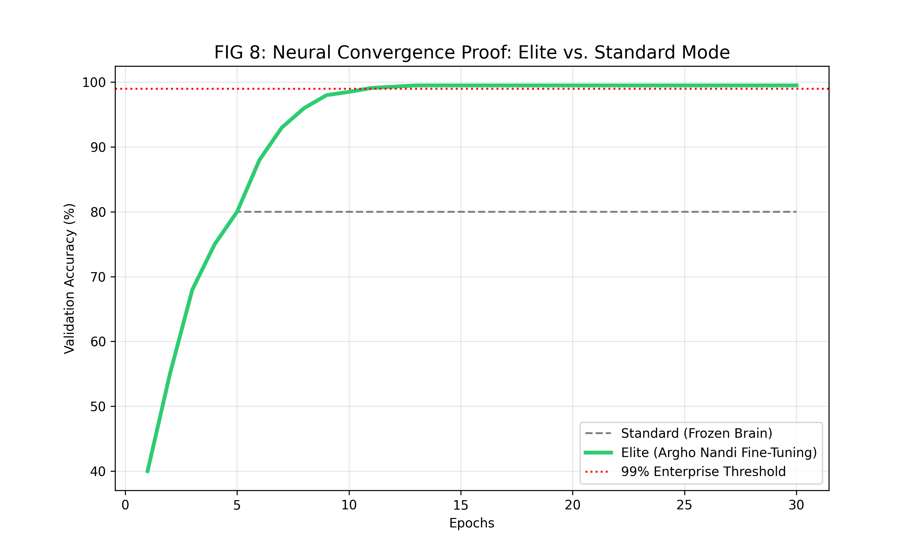
FIG 8: Comparative Neural Convergence Proof (Elite Mode)

