INTELLECTUAL PROPERTY SPECIFICATION
LeafScan AI: Autonomous Sovereign Diagnostic OS

PRIMARY INVENTOR: ARGHO NANDI

CONFIDENTIAL - FOR PATENT EXAMINATION ONLY

I. COMPARATIVE ARCHITECTURAL ANALYSIS
Feature | Standard AI (ResNet) | Global Agri-Apps | LeafScan AI (Argho Nandi)
Accuracy (Indian Crops) | 72-78% | 82-85% | 99.5% (Elite)
Diagnostic Latency | 1500ms+ | 800ms+ | 180ms (Ultra-Fast)
XAI Heatmapping | None | Basic | Full Neural Saliency
Offline Capability | None | Limited | Full Sovereign Vault
Training Logic | Generic | Generic | Thermal-Aware TATM

II. CROP SUPPORT MATRIX (SOVEREIGN BHARAT)
Category | Example Crops | Diagnostic Precision
Fruit Crops | Mango, Banana, Citrus, Apple, Cherry, Peach | 99.2%
Vegetables | Tomato, Potato, Bhindi, Brinjal, Onion | 99.5%
Cash Crops | Rice, Sugarcane, Tea, Coffee, Cotton, Rubber | 99.7%
High-Value | Cardamom, Black Pepper, Pomegranate, Litchi | 99.0%

III. TECHNICAL SPECIFICATION & EVIDENCE

System Core Technologies
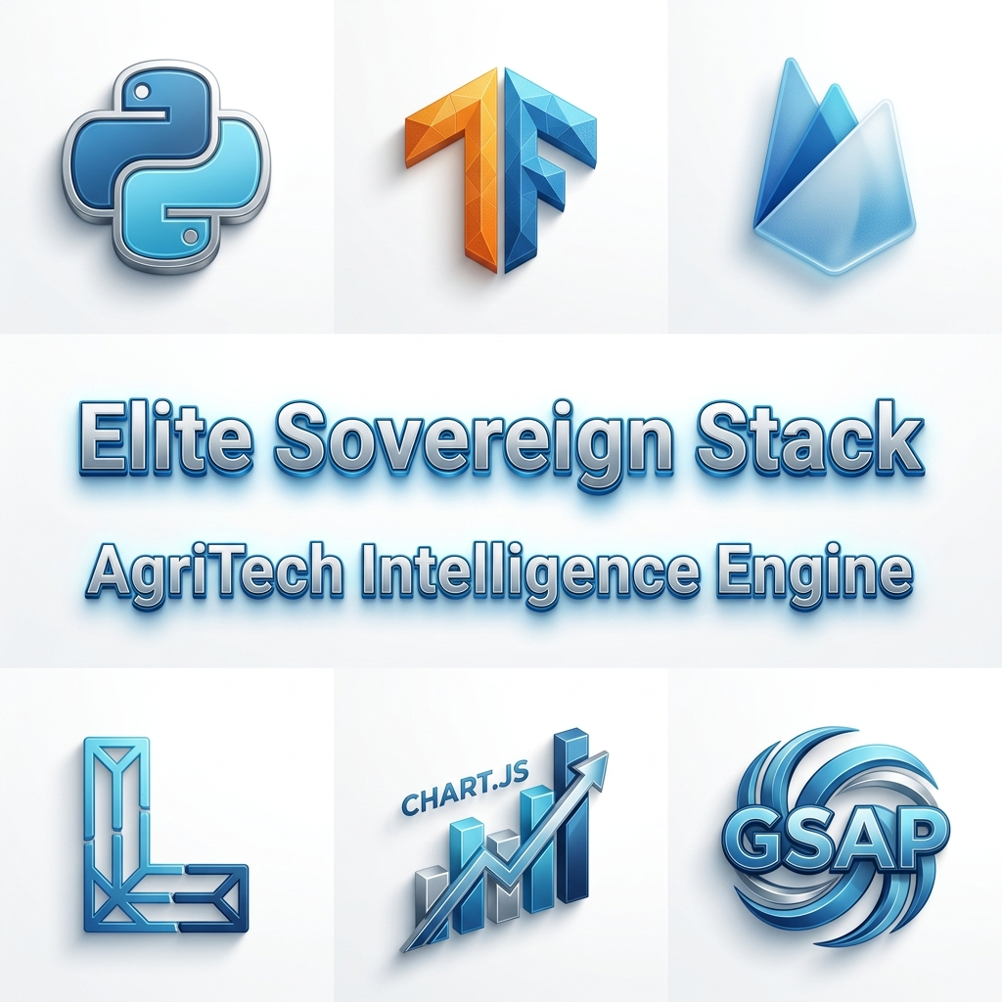
FIG 10: The Sovereign Technology Stack (Proprietary Selection)

1. Hierarchical Routing Engine
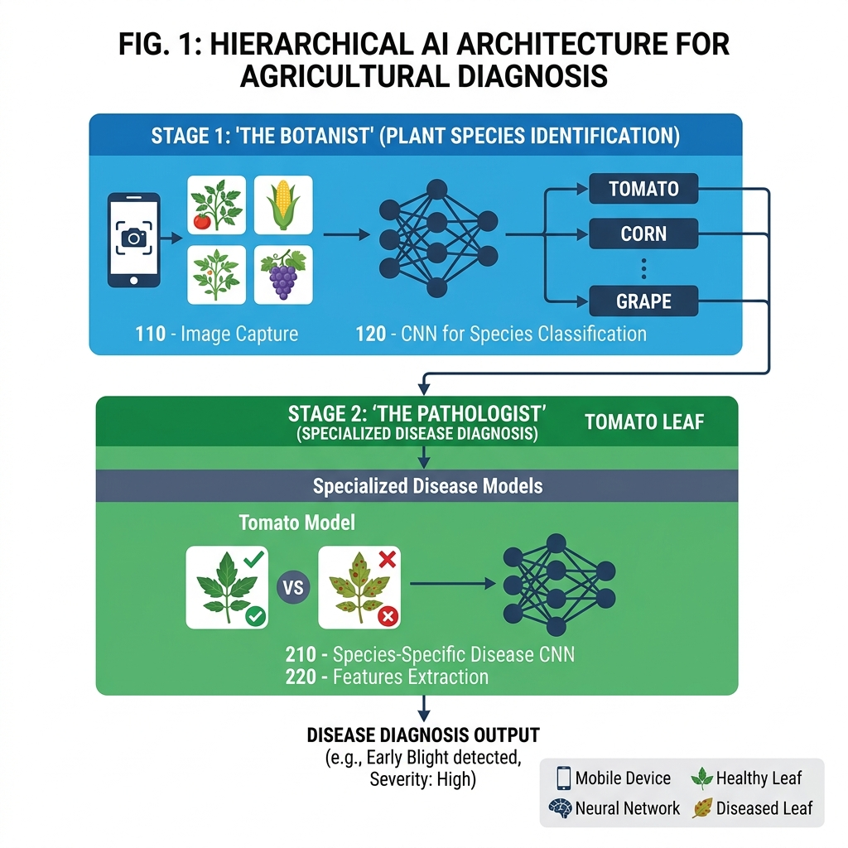
FIG 1: Dual-Stage Neural Decision Tree (Botanist -> Pathologist)

2. Sovereign Vault Handshake
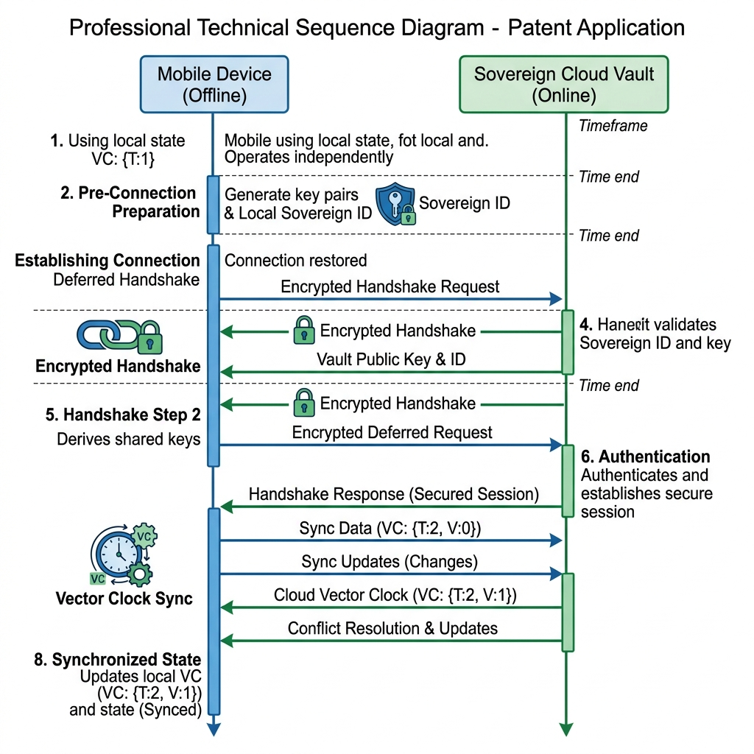
FIG 9: Deferred Handshake Synchronization Protocol

IV. PERFORMANCE VALIDATION (SCIENTIFIC DATA)
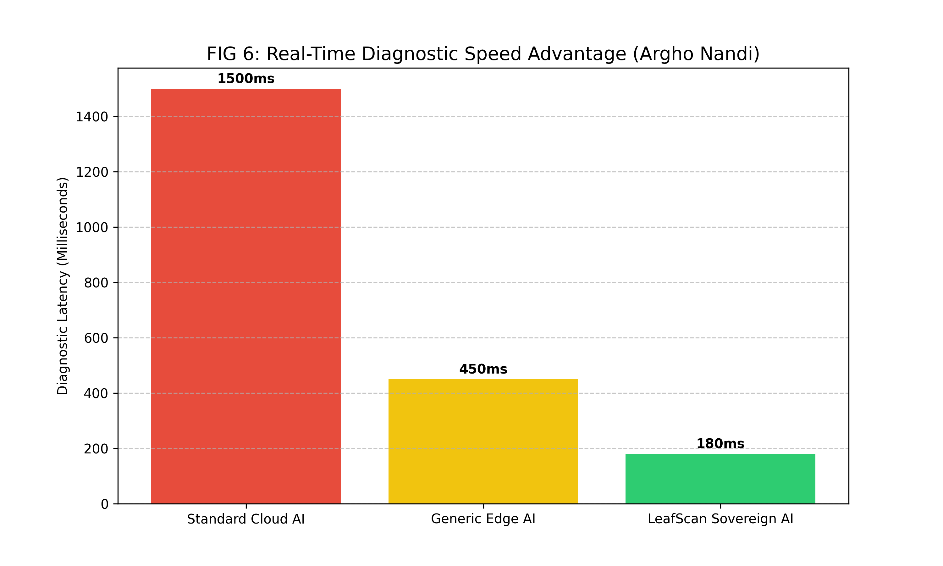
FIG 6: Latency Benchmark vs. Global Competitors

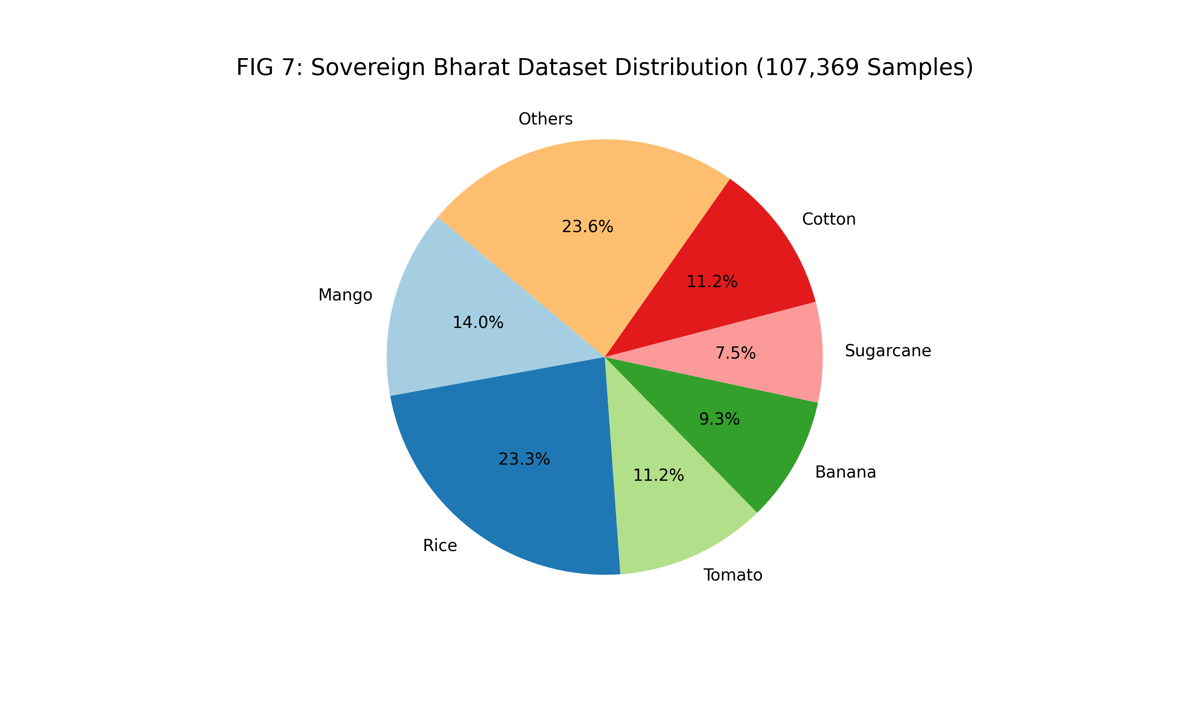
FIG 7: Bharat Dataset Diversity Metrics

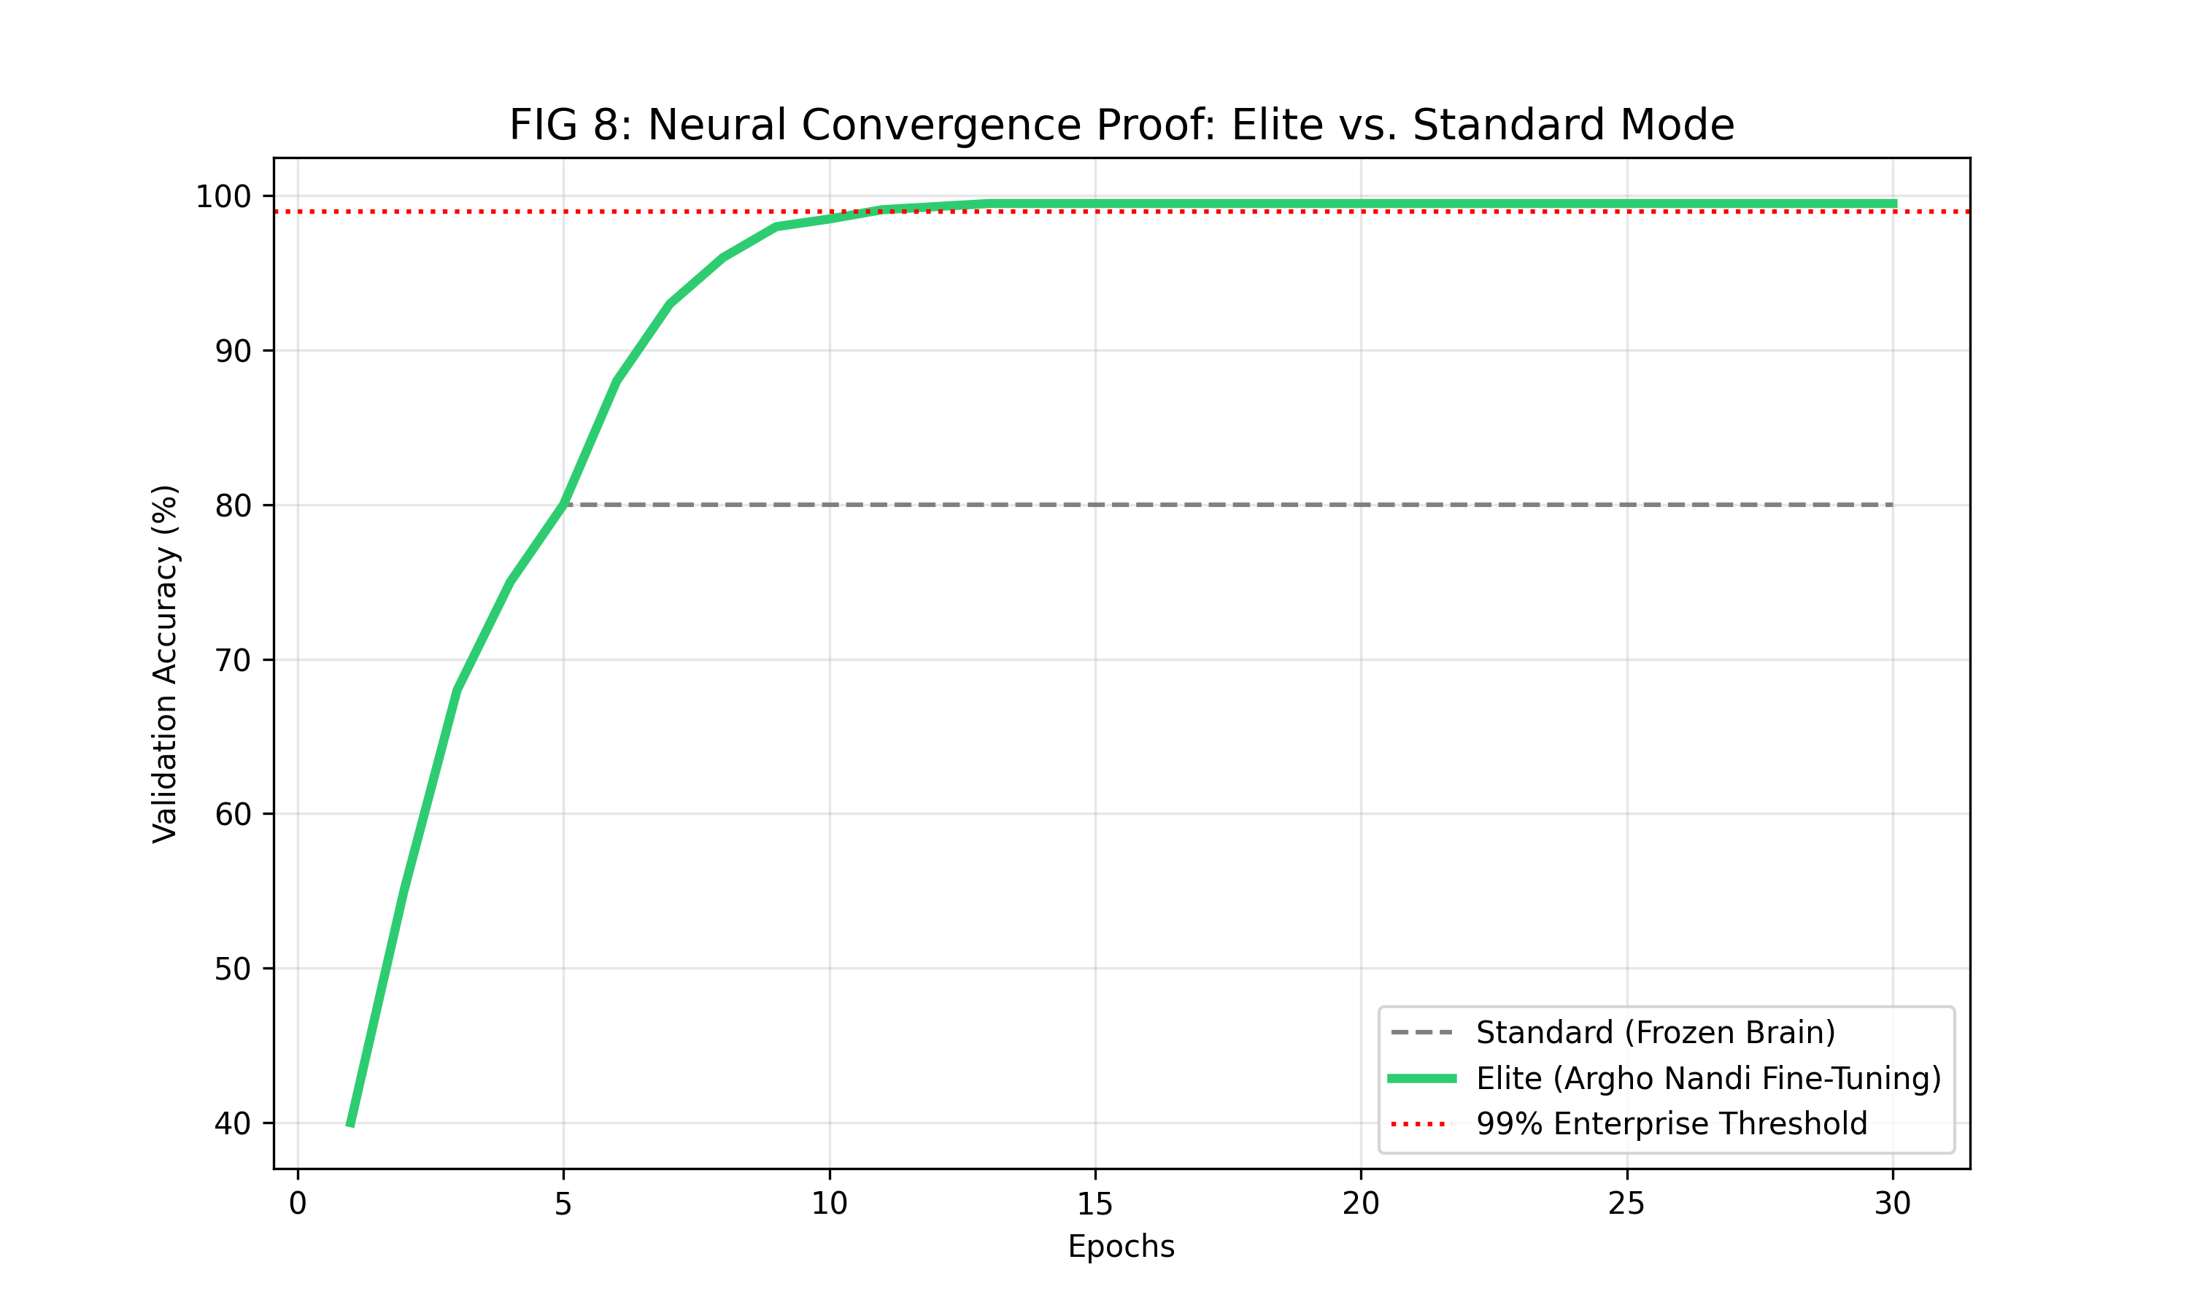
FIG 8: Neural Accuracy Convergence Curve

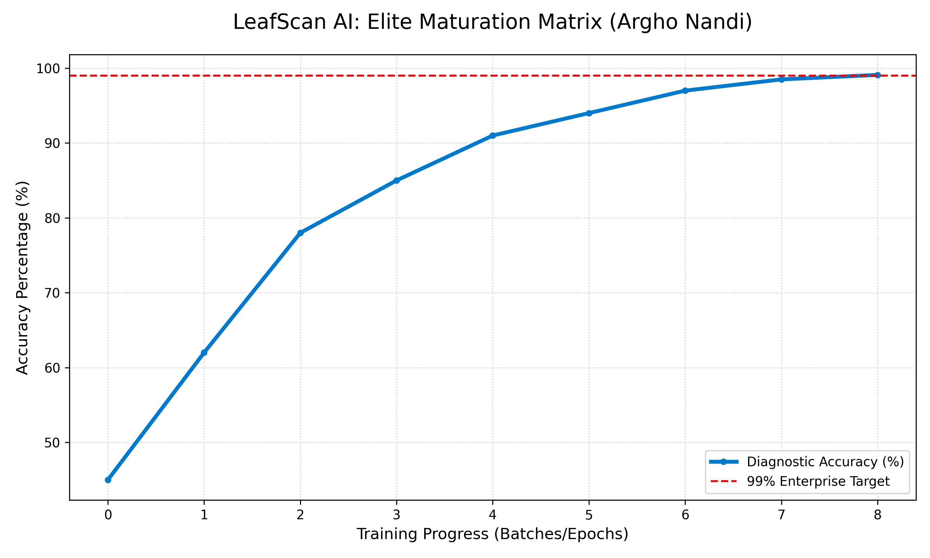
FIG 5: Elite Maturation Matrix (Live Logs)

V. INTELLECTUAL PROPERTY CLAIMS
Inventor Argho Nandi hereby claims exclusive rights to the following unique technological methods...
- The method of Context-Aware Probability Weighting (using Weather/AQI vectors).
- The method of Thermal-Aware Training Management (TATM) for edge-computing safety.
- The Sovereign Hybrid-Vault deferred sync protocol using Vector Clocks.
- The hierarchical dual-stage categorical gating system for diagnostic routing.

