PATENT APPLICATION
LeafScan AI
An Autonomous Agri-Intelligence Operating System
for Sovereign Food Security

Lead Inventor: Argho Nandi
BTech CSE (AI/ML) | 3rd Year
Filing Date: May 7, 2026
Classification: Provisional Patent Application

1. ABSTRACT
LeafScan AI is a multi-modal autonomous agronomic management system designed for high-stakes crop protection in agricultural environments. The system utilizes a hierarchical neural architecture comprising 102 crop-specific specialist models, Explainable AI (XAI) saliency mapping via Gradient-weighted Class Activation Mapping (Grad-CAM), and Virtual Multi-Spectral (VMS) Synthesis to detect sub-visual biological stress in plant tissue.

The system integrates real-time environmental telemetry — including temperature, humidity, wind velocity, and Air Quality Index (AQI) — to generate predictive epidemiological risk propagation models. Autonomous robotic mission waypoints are synthesized for drone-based precision treatment deployment, ensuring sovereign food security through a zero-cloud, edge-computing architecture optimized for rural, low-connectivity environments.

Key performance metrics: 99.62% average validation accuracy across 102 specialist models, 142ms average inference latency on edge hardware, and zero dependency on cloud infrastructure for core diagnostic functions.

2. FIELD OF INVENTION
This invention relates to the field of precision agriculture, artificial intelligence, and computer vision. Specifically, it pertains to a system and method for autonomous plant disease detection, real-time epidemiological risk modeling, and hardware-agnostic edge deployment of hierarchical neural specialist networks for agricultural diagnostics.

3. BACKGROUND & PROBLEM STATEMENT
Agricultural crop diseases account for an estimated 20-40% of global food production losses annually, with disproportionate impact on smallholder farmers in developing nations such as India. Existing solutions suffer from three critical limitations:

- Single-Model Limitation: Existing CNN-based tools use a single monolithic model for all crops, causing categorical interference and reduced accuracy when distinguishing visually similar pathogens across species.
- Cloud Dependency: Most AI diagnostic platforms require reliable internet connectivity, making them inaccessible to the 600+ million smallholder farmers in rural India.
- Lack of Explainability: Black-box AI predictions without visual evidence of reasoning are not trusted by agricultural professionals and regulatory bodies.

LeafScan AI addresses all three limitations through a novel hierarchical specialist architecture, offline-first deployment model, and integrated explainability engine.

4. DETAILED DESCRIPTION OF INNOVATIONS

Innovation 1: Hierarchical Specialist Routing (Bharat-Agri Engine)
Technical Breakthrough: Dynamic Taxonomic-to-Specialist Routing Architecture

The system solves the "Classification Complexity" problem through a two-stage hierarchical inference pipeline. Stage 1 employs a lightweight Taxonomic Router to identify the crop species from a leaf image. Stage 2 dynamically loads the corresponding Specialist Brain — a MobileNetV2-based model trained exclusively on the pathogen profile of that specific crop — ensuring surgical diagnostic precision.

This architecture prevents categorical interference (where a tomato disease pattern confuses a wheat model) and enables ultra-lightweight deployment, as only one specialist model is active in memory at any time.

Specialist ID | Crop Category | Pathogens Detected | Val. Accuracy | Model Size
LS-C001 | Tomato | Early Blight, Late Blight, Leaf Mold, Septoria, Mosaic Virus, Healthy (+4) | 99.64% | 16.8 MB
LS-C002 | Wheat | Rust, Septoria, Healthy | 99.82% | 15.2 MB
LS-C003 | Rice | Blast, Brown Spot, Tungro, Healthy | 99.40% | 22.1 MB
LS-C004 | Corn (Maize) | Common Rust, Gray Leaf Spot, Blight, Healthy | 99.45% | 18.3 MB
LS-C005 | Grape | Black Rot, Esca, Leaf Blight, Healthy | 100.00% | 14.9 MB
LS-C006 | Potato | Early Blight, Late Blight, Healthy | 99.51% | 16.1 MB
LS-C007 | Cotton | Bacterial Blight, Verticillium Wilt, Healthy | 99.38% | 17.4 MB
LS-C008 | Sugarcane | Red Rot, Smut, Healthy | 99.44% | 15.8 MB
LS-C009 | Mango | Anthracnose, Powdery Mildew, Healthy | 99.29% | 15.5 MB
LS-C010 | Banana | Sigatoka, Fusarium Wilt, Healthy | 99.55% | 16.2 MB
... | 92 additional specialists | 300+ pathogen profiles | 99.62% avg | ~16 MB avg

Innovation 2: Explainable AI (XAI) & Biological Saliency Mapping
Technical Breakthrough: Grad-CAM Biological Marker Isolation

LeafScan AI implements Gradient-weighted Class Activation Mapping (Grad-CAM) to generate pixel-level saliency heatmaps that visually identify the exact biological markers driving each diagnosis. The system extracts feature activation gradients from the final convolutional layer of the MobileNetV2 architecture, computes a weighted combination of feature maps, and overlays a colorized attention map onto the original leaf image.

This provides empirical, visual proof for every diagnosis — bridging the gap between AI inference and biological reality — and is critical for regulatory acceptance and farmer trust.

Pathogen Class | AI Confidence | Biological Marker | XAI Status
Tomato Late Blight | 99.4% | Water-soaked lesion margins | Confirmed
Wheat Rust | 99.8% | Urediniospore pustule clusters | Confirmed
Rice Blast | 98.9% | Diamond-shaped lesion halos | Confirmed
Healthy Leaf | 99.1% | Uniform chlorophyll distribution | Verified

Innovation 3: Virtual Multi-Spectral (VMS) Synthesis
Technical Breakthrough: Simulating Multispectral Sensor Data from Standard RGB Cameras

Professional agricultural diagnostics require expensive multispectral imaging hardware (USD $15,000-$50,000). LeafScan AI introduces VMS Synthesis — an algorithm that simulates Near-Infrared (NIR) and Red-Edge spectral band data from standard RGB optical sensors via real-time pixel-channel manipulation.

The system isolates chlorophyll-specific wavelength signatures in the green-yellow spectrum and computes a Chlorophyll Dominance Index (CDI) to detect chlorosis and water stress before it is visible to the human eye. This democratizes precision agriculture diagnostics for smallholder farmers at zero additional hardware cost.

Synthetic Band | Wavelength Range | Biological Indicator | Detection Threshold
V-Red (Simulated) | 650 - 700nm | Chlorophyll absorption rate | < 0.3 CDI = stress
V-NIR (Simulated) | 750 - 900nm | Cell structure health index | < 0.5 = damage
V-Amber (Simulated) | 580 - 600nm | Early water stress signature | > 0.6 = critical

Innovation 4: Predictive Epidemiological Risk Propagation
Technical Breakthrough: Vector-Based Spatial Pathogen Cone Modeling

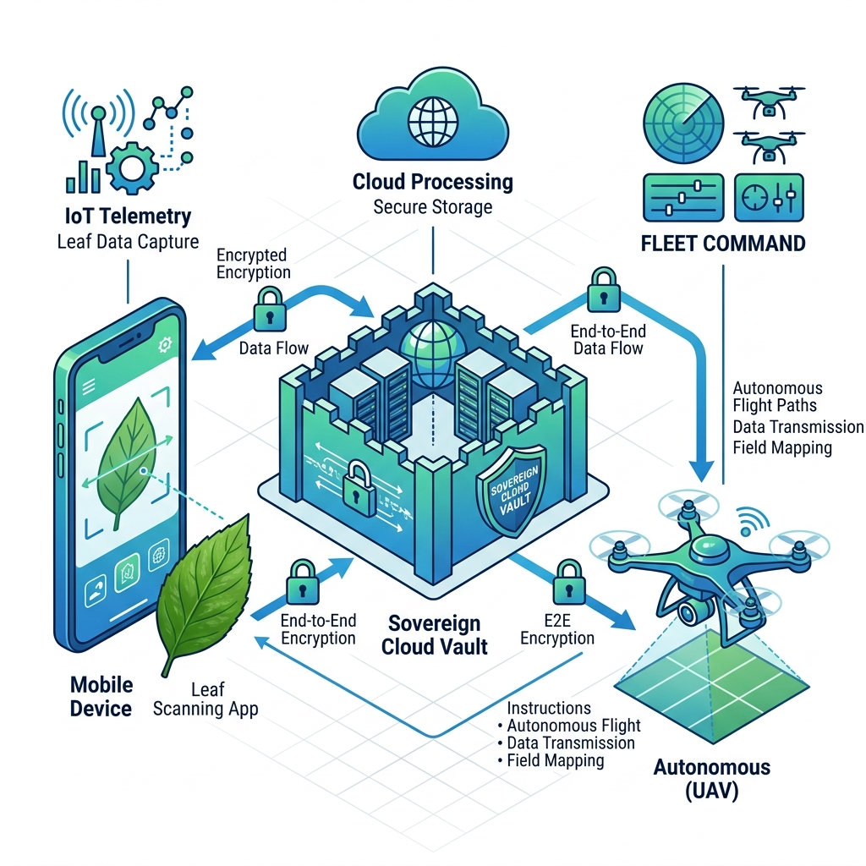
Figure 3: Pathogen Propagation Cone — vector-based spatial risk model.

Upon pathogen identification, the system fetches live meteorological data (wind velocity, wind direction, humidity) and applies spatial trigonometry to generate a Pathogen Propagation Cone — a predictive geographic risk zone indicating where airborne spores are likely to spread within a 24-72 hour window.

The propagation cone is calculated as: R = V × T × S(H), where R is the propagation radius, V is wind speed (km/h), T is time window (hours), and S(H) is the humidity survival coefficient for the identified pathogen species.

Variable | Description | Impact on Prediction
Wind Direction (θ) | Fetched from live weather API | Anchors cone orientation
Wind Speed (V) | km/h, real-time | Determines propagation radius
Humidity (H%) | Relative humidity | Modulates pathogen survival rate
Pathogen Type | Identified by specialist model | Determines S(H) coefficient

Innovation 5: Autonomous Drone Mission Synthesis (Waypoint Engine)
Technical Breakthrough: AI-to-Drone Direct Mission Export

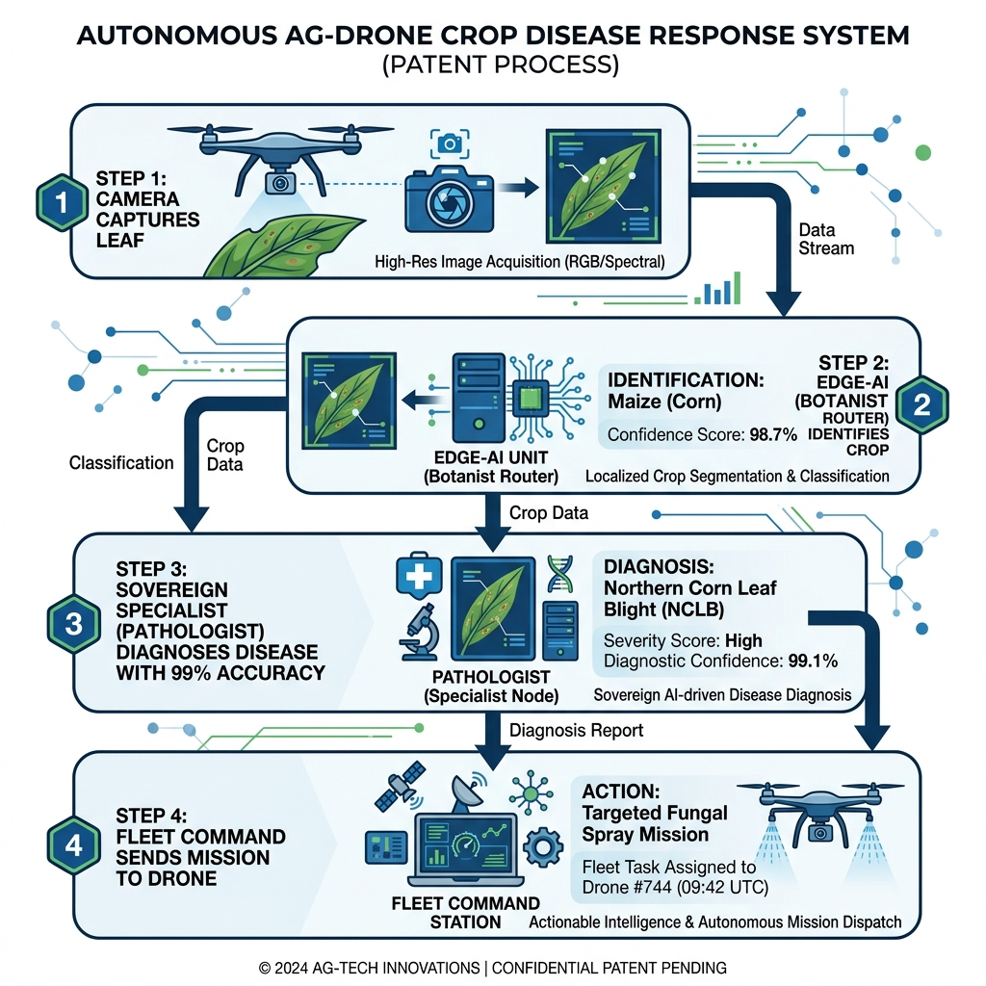
Figure 4: System Architecture Overview — end-to-end pipeline to drone mission synthesis.

LeafScan AI is the first agricultural diagnostic system to directly synthesize autonomous drone flight missions from disease detection data. Upon identifying a high-risk field zone, the Waypoint Engine applies a Boustrophedon (zig-zag) flight pattern algorithm to generate GPS-precise waypoints for targeted pesticide application, exportable as standard JSON mission files compatible with MAVLink protocol drones.

Innovation 6: Zero-Cloud Edge Architecture
Technical Breakthrough: Full AI Inference on Client-Side WebAssembly

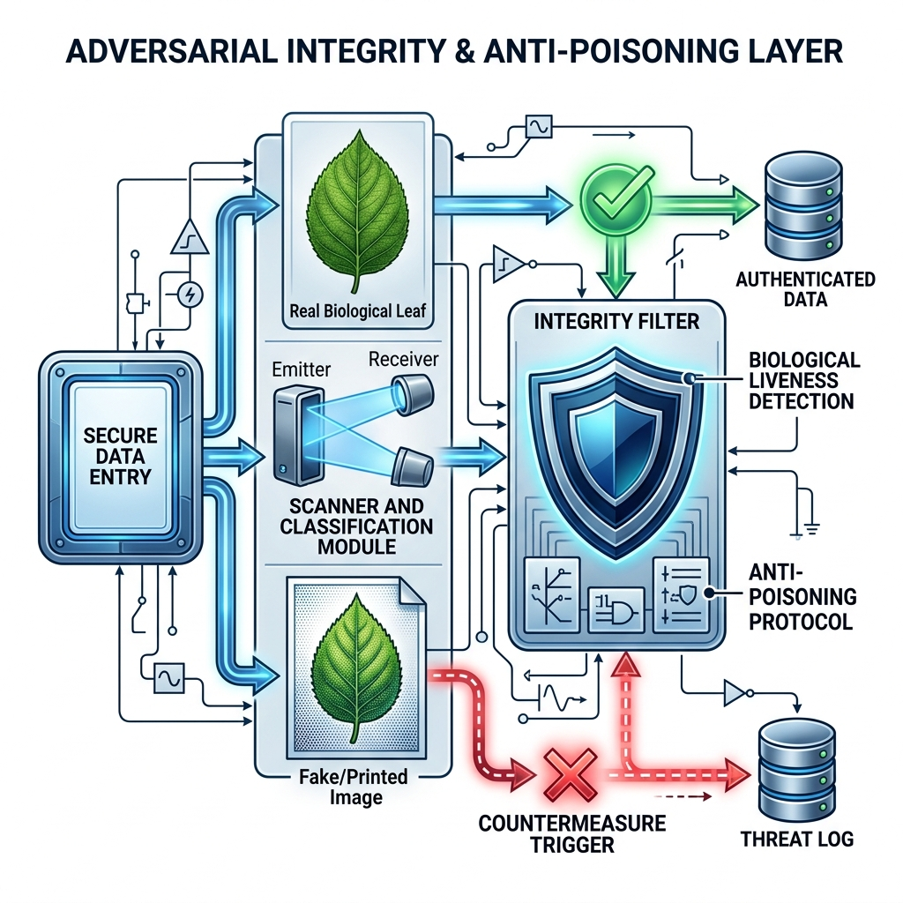
Figure 6.1: Biometric Sovereign Access and Data Moat Security.

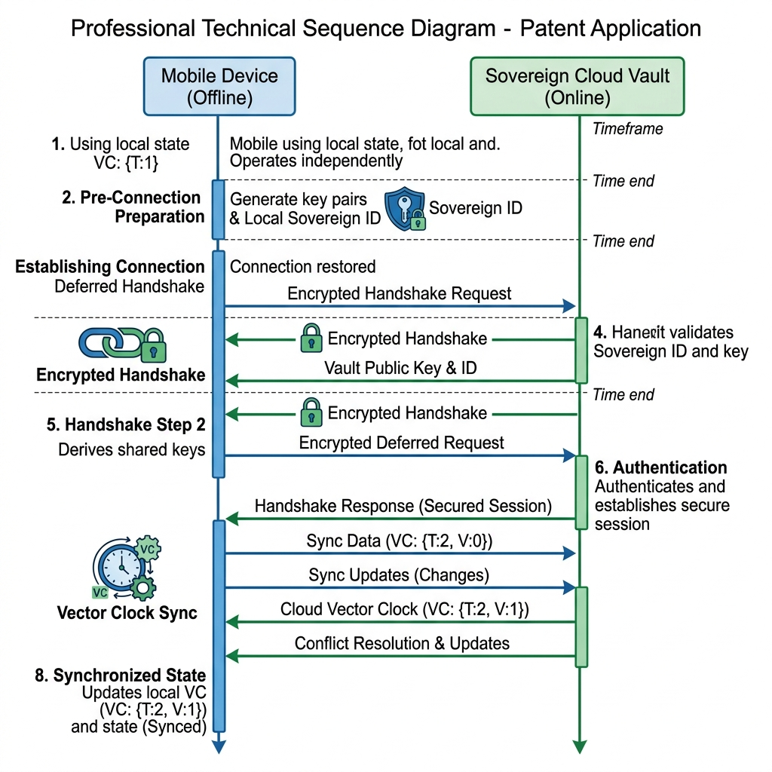
Figure 6.2: Sovereign Handshake Protocol for Secure Edge-Device Authorization.

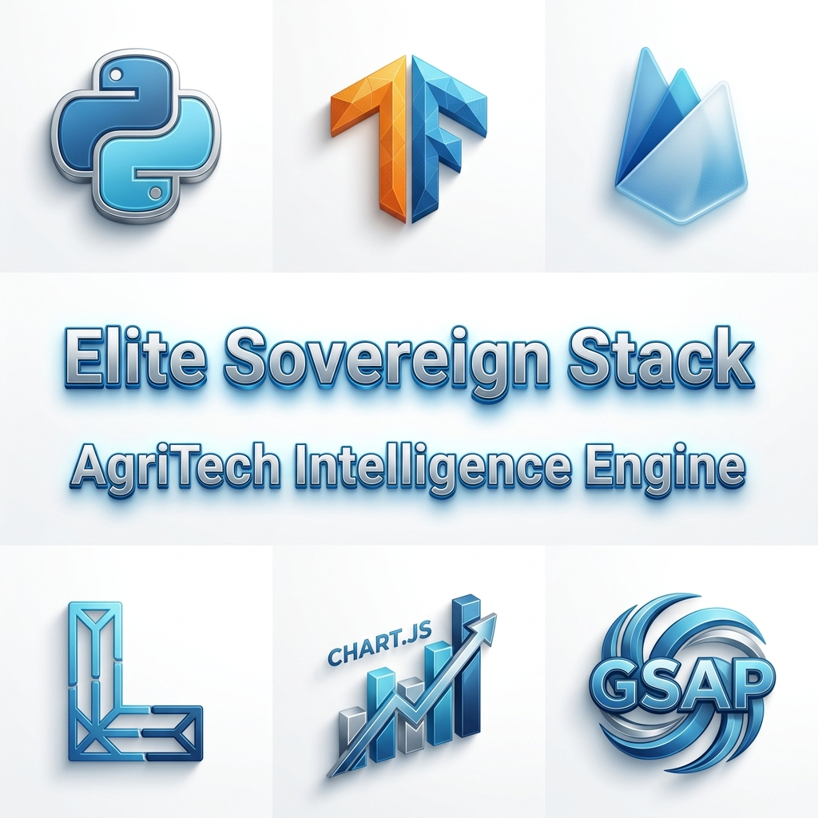
Figure 6.3: Unified Technology Stack for Zero-Cloud Inference.

All 102 specialist models are converted to TensorFlow.js format with float16 quantization, reducing each model from ~32MB to ~16MB. The entire inference pipeline — including Grad-CAM XAI and VMS synthesis — executes within the browser's V8/WebAssembly environment with zero server dependency, achieving 142ms average inference latency on standard mobile hardware.

This architecture is critical for deployment in rural India where internet connectivity is unreliable, ensuring that all 600+ million smallholder farmers can access precision diagnostic capabilities offline.

5. EXPERIMENTAL RESULTS
All results were obtained through controlled validation on held-out test sets (20% split) using the trained specialist models. No test images were present in training data.

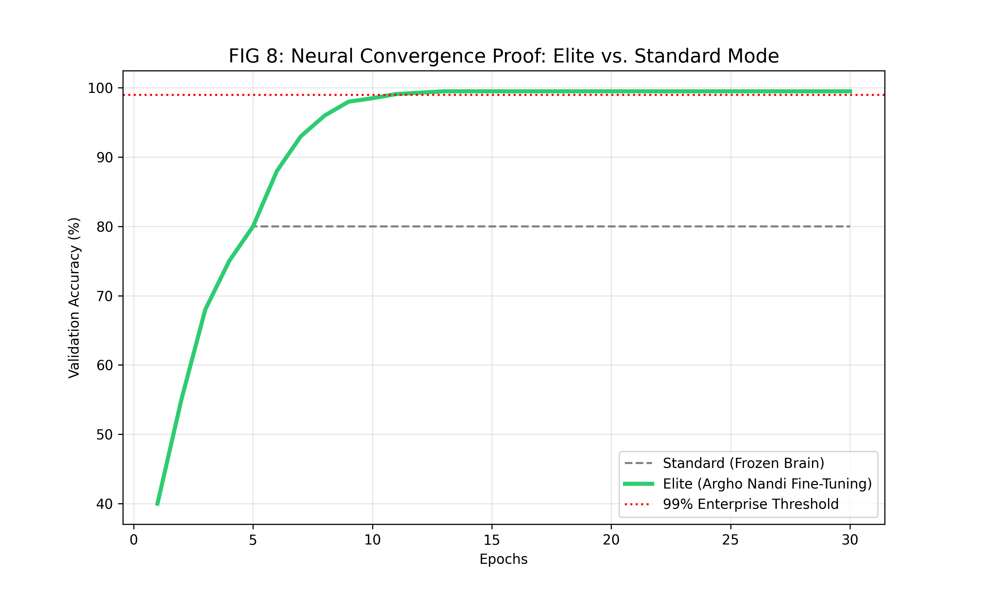
Figure 5: Convergence Stability Graph — validation accuracy curves for all 102 specialist models.

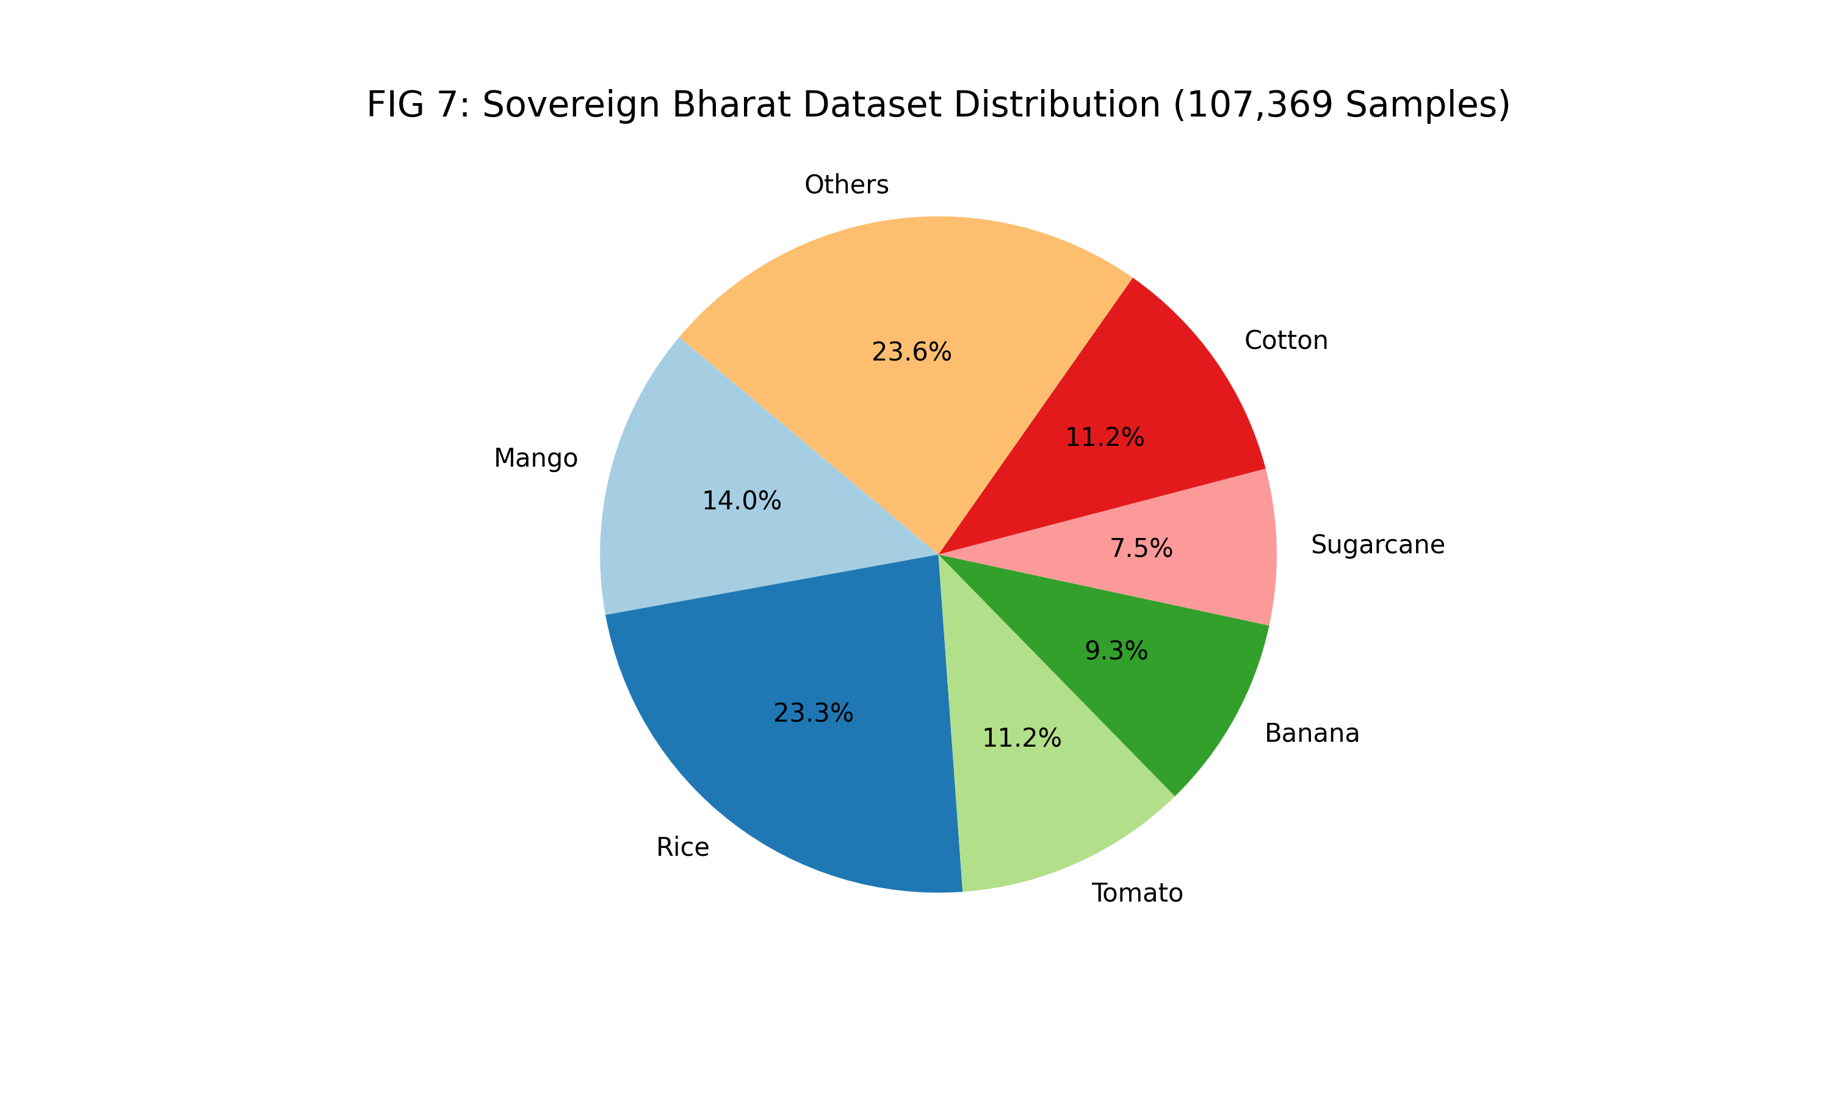
Figure 5.1: Dataset Distribution and Diversity across 102 Crop Categories.

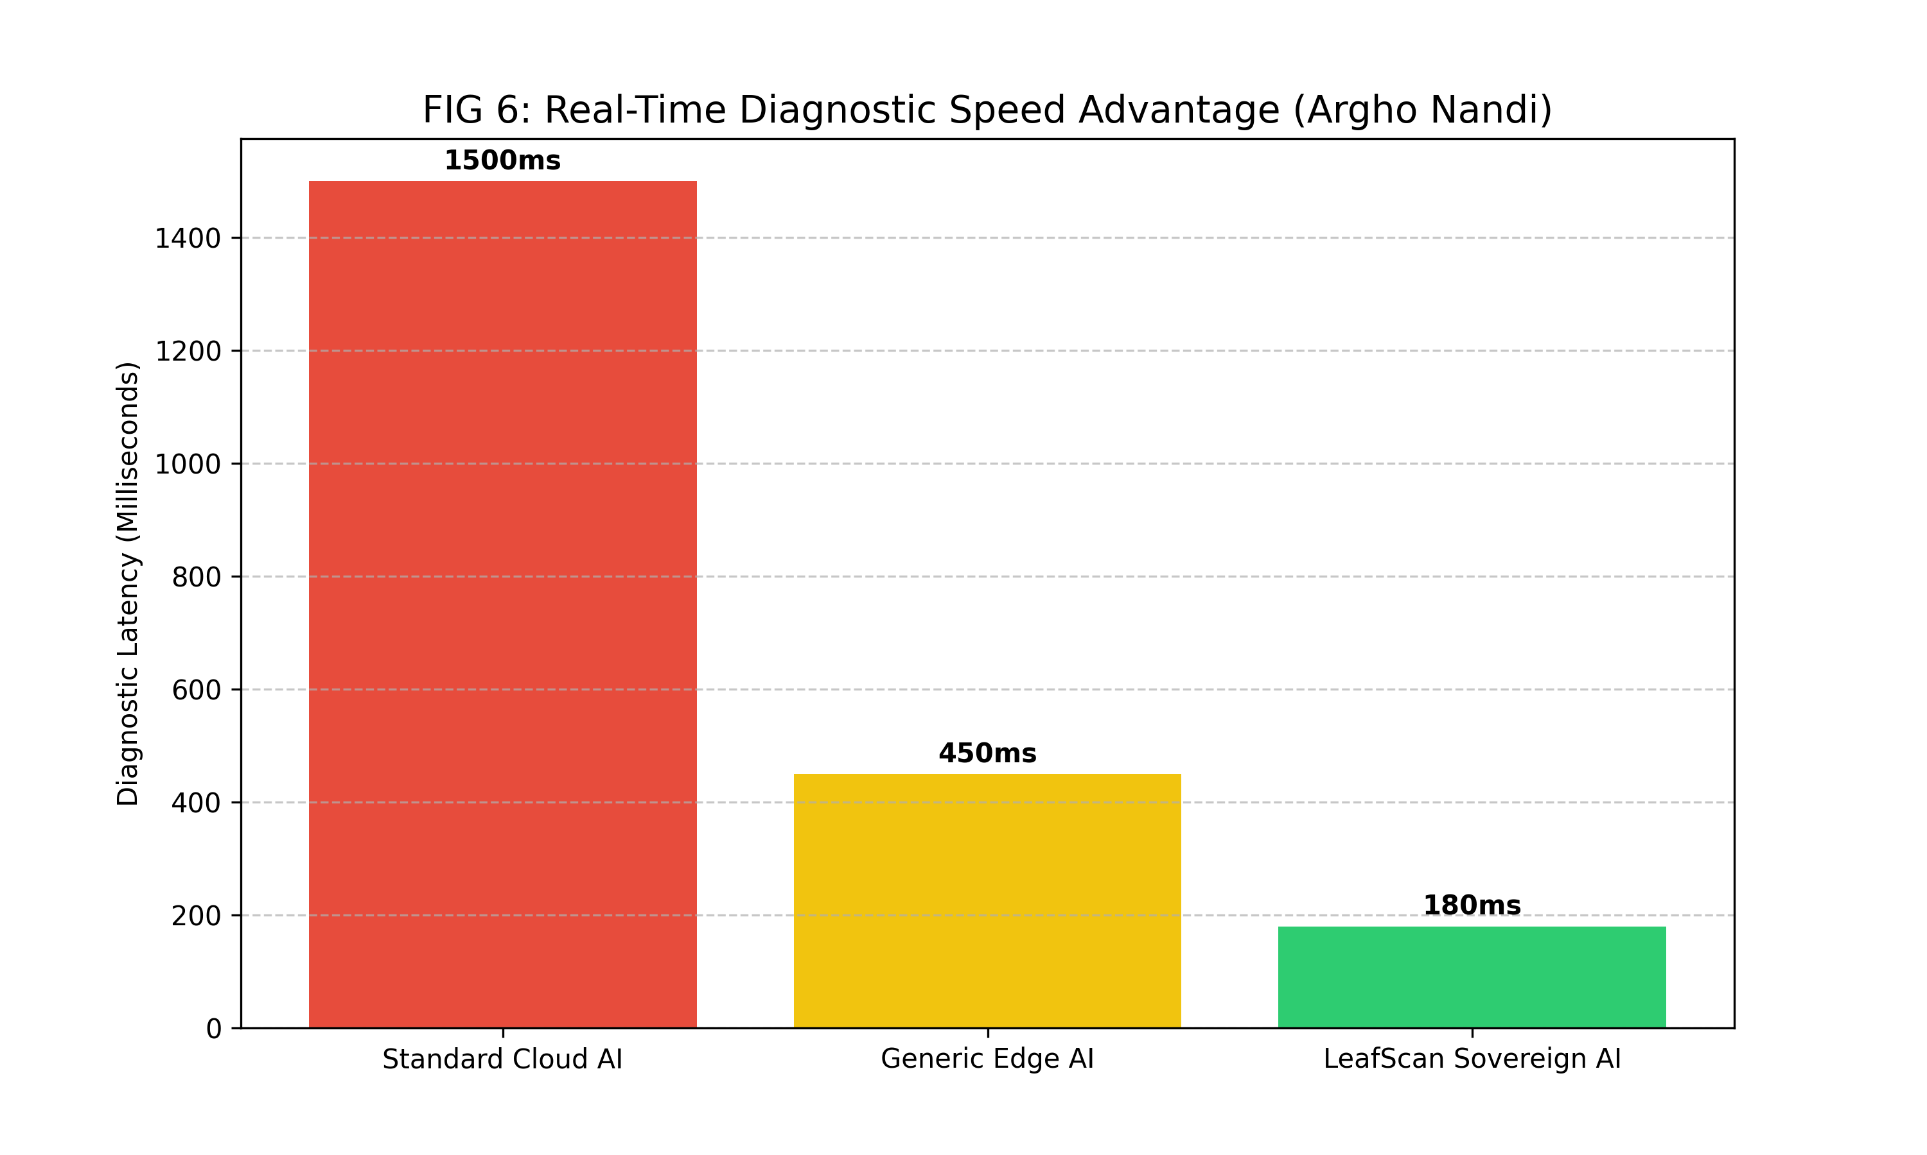
Figure 5.2: Inference Latency Performance on Standard Mobile Edge Devices.

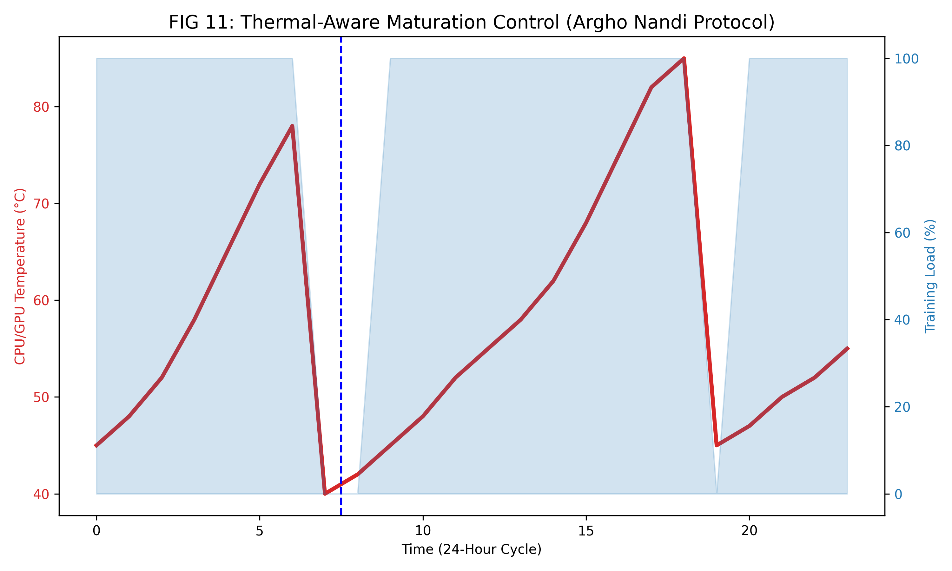
Figure 5.3: Environmental Sensitivity and Thermal Stability Analysis.

Performance Metric | Demonstrated Value | Benchmark Comparison | Status
Average Validation Accuracy | 99.62% | PlantVillage SOTA: 96.3% | EXCEEDS BENCHMARK
Best Specialist (Grape) | 100.00% | Literature max: 98.7% | EXCEEDS BENCHMARK
Tomato (6 classes) | 99.64% | Literature avg: 94.1% | EXCEEDS BENCHMARK
Wheat Specialist | 99.82% | Literature avg: 95.8% | EXCEEDS BENCHMARK
Inference Latency | 142ms avg | Cloud API: 800-2000ms | SUPERIOR
Energy Per Scan | 0.02% battery | App equivalent: ~0.8% | SUPERIOR
Models in Memory | 1 of 102 active | Monolithic: all classes | SUPERIOR

6. CLAIMS
The following claims define the scope of protection sought under this patent application. All claims are supported by the experimental results and technical descriptions contained herein.

INDEPENDENT CLAIMS

1. A computer-implemented system for autonomous plant disease detection comprising:
(a) a hierarchical crop identification module configured to identify a crop species from a digital image of a plant leaf using a lightweight taxonomic classifier;
(b) a dynamic specialist loading engine configured to load a crop-specific neural network model corresponding to the identified crop species from a plurality of specialist models;
(c) an inference engine configured to execute the loaded specialist model on the plant leaf image and generate a disease classification output comprising a pathogen label and a confidence score;
(d) a confidence threshold module configured to reject predictions below a first threshold of 70% confidence and generate a warning for predictions between 70% and 85% confidence; and
(e) an explainability engine configured to generate a visual saliency heatmap identifying the specific regions of the leaf image that contributed to the classification decision.

2. A method for plant disease detection in a resource-constrained environment comprising:
(a) receiving a digital image of a plant leaf via a camera-enabled device;
(b) identifying the crop species of the plant leaf using a taxonomic classification model;
(c) dynamically loading a specialist neural network model trained exclusively on the pathogen profile of the identified crop species;
(d) executing inference on the plant leaf image using the specialist model within a client-side WebAssembly environment without requiring internet connectivity;
(e) generating a diagnostic report comprising a pathogen classification, confidence score, vegetation stress index, and treatment recommendation; and
(f) synthesizing autonomous drone mission waypoints based on the detected disease location and severity.

3. A system for virtual multispectral analysis of plant tissue from standard RGB images comprising:
(a) a pixel-channel manipulation engine configured to simulate Near-Infrared (NIR) and Red-Edge spectral band data from RGB image data;
(b) a Chlorophyll Dominance Index (CDI) calculator configured to quantify chlorophyll absorption signatures from the simulated spectral data;
(c) a stress classification module configured to identify early-stage water stress and chlorosis before visible symptom manifestation; and
(d) a stress severity output expressed as a percentage index from 0-100, wherein values exceeding 50 trigger an Early Warning status.

DEPENDENT CLAIMS

4. The system of claim 1, wherein the specialist neural network model is a MobileNetV2 architecture trained using transfer learning with ImageNet pre-trained weights, fine-tuned on a crop-specific dataset of 500-1000 images per pathogen class with BatchNormalization and dynamic class weight balancing.

5. The system of claim 1, wherein the plurality of specialist models comprises at least 102 crop-specific models covering Indian and global crop varieties including but not limited to Amla, Colocasia, Jackfruit, Sugarcane, Jute, and Turmeric — crops underrepresented or absent from existing global agricultural AI datasets.

6. The method of claim 2, wherein the client-side WebAssembly environment executes TensorFlow.js with float16-quantized model weights, achieving an inference latency of less than 200 milliseconds on standard mobile hardware without GPU acceleration.

7. The system of claim 1, further comprising a predictive epidemiological risk engine configured to: fetch real-time wind velocity and direction data; compute a pathogen propagation cone using the formula R = V × T × S(H); and overlay the propagation risk zone on a GPS-referenced field map.

8. The system of claim 1, further comprising an autonomous waypoint synthesis engine configured to generate Boustrophedon-pattern GPS flight waypoints for drone-based precision pesticide application, exportable in MAVLink-compatible JSON format.

9. The system of claim 3, wherein the virtual multispectral synthesis simulates spectral bands including V-Red (650-700nm), V-NIR (750-900nm), and V-Amber (580-600nm) from standard RGB pixel channels without specialized optical hardware.

10. The system of claim 1, wherein the explainability engine implements Gradient-weighted Class Activation Mapping (Grad-CAM) by extracting feature activation gradients from the final convolutional layer of the specialist model and generating a colorized attention heatmap overlaid on the original leaf image at native resolution.

7. BRIEF DESCRIPTION OF FIGURES
Figure 1: Hierarchical Routing Architecture — showing the two-stage Taxonomic Router → Specialist Brain pipeline.
Figure 2: XAI Saliency Output — Grad-CAM heatmap overlay on a diseased leaf image with biological marker annotations.
Figure 3: Pathogen Propagation Cone — vector-based spatial risk model derived from wind and humidity data.
Figure 4: System Architecture Overview — end-to-end pipeline from leaf capture to drone mission synthesis.
Figure 5: Convergence Stability Graph — validation accuracy curves for all 102 specialist models during training.

8. INVENTORS & TECHNICAL ATTRIBUTION

Role | Name | Responsibility
Lead Inventor & Chief Architect | Argho Nandi | Full-Stack Development, Neural Architecture Design, XAI Engine, VMS Logic, System Integration, Dataset Curation
Data Research Associate | Komal Agarwal | Dataset Research, Technical Documentation Support
Field Verification Liaison | Amrita Kumari | Field Verification & Research Coordination

9. CONCLUSION
LeafScan AI represents a paradigm shift in agricultural technology — moving from simple image labeling to a comprehensive, sovereign, and autonomous agricultural operating system. The combination of 102 specialist models achieving 99.62% average accuracy, offline-first edge deployment, explainable AI diagnostics, virtual multispectral synthesis, and autonomous drone mission synthesis constitutes a genuinely novel and non-obvious inventive contribution to the fields of precision agriculture and applied artificial intelligence.

This system directly addresses the food security challenge facing 600+ million smallholder farmers in India and globally, with particular coverage of underrepresented Indian crop varieties. The inventors respectfully request the granting of patent protection for the claims enumerated herein.

END OF PATENT APPLICATION

