FBLA Club

Constitution 2019-2020

C Leon King High School Honors Club

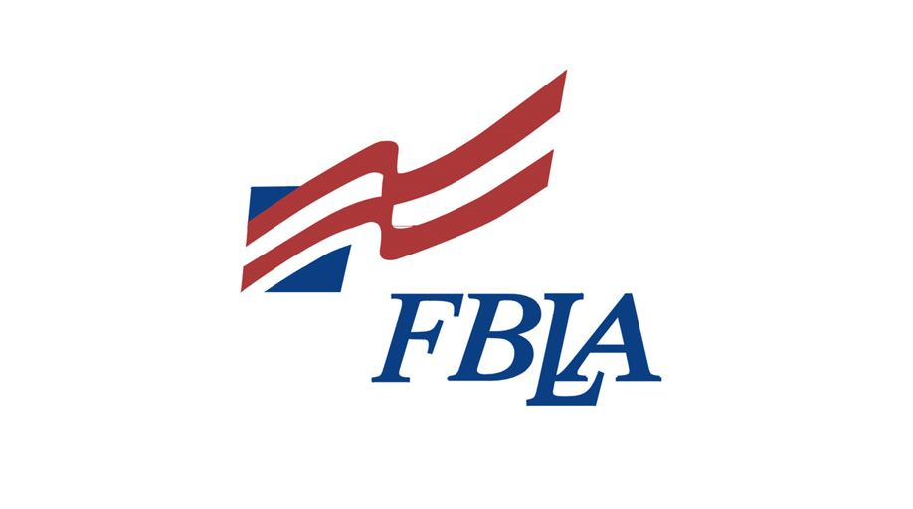FBLA

Constitution Outline

**Article I - Name**

**1**

**Article II - Affiliations**

**1**

**Article III - Purposes and Goals**

**1**

**Article IV - Membership**

**1**

**Article V - Officers**

**1**

**Article VI - Meetings**

**1**

**Article VII - Dues and Finances**

**1**

FBLA Club Constitution - King High School i

FBLA

**Article I - Name**

This club will be named King High School FBLA.

**Article II - Affiliations**

FBLA is affiliated with King High School and, is a registered chapter, of FBLA (Future Business Leaders of America).

**Article III - Purposes and Goals**

**Section I - Mission Statement**

The mission of FBLA is to bring together members, and facilitate successful participation of members in tournaments both district and nationally.

**Section II - Goals**

FBLA will facilitate and train members to participate in tournaments both locally and nationally.

1. We will work toward publishing all local, state and national tournaments throughout the year.

2. We will work toward arranging registration, travel and accommodation for participation in tournaments.

3. We will focus on strengthening our own chapter leadership and structure.

The goal of FBLA is to encourage and train aspiring young business leaders and give them as many opportunities as possible.

Section III - Goals of Affiliate FBLA (from official organization website)

Mission Statement

FBLA-PBL’s mission is to bring business and education together in a positive working relationship through innovative leadership and career development programs.

FBLA-PBL’s programs focus on:

• Leadership Development—members develop essential soft skills by holding chapter officer positions at the local, state, and national levels; by networking with accomplished business professionals; and by participating in business-focused workshops, seminars, and academic competitions.

• Academic Competitions—members demonstrate their business expertise at high-profile regional, state, and national competitive events. The top students are recognized with trophies and cash awards. Learn more about FBLA, PBL, and FBLA-Middle Level competitive events.

• Educational Programs—members create career portfolios, enhance their knowledge with world-recognized skills certifications, and have access to select college scholarships. Learn more about educational programs for FBLA, PBL, and FBLA-Middle Level.

• Membership Benefits—members receive exclusive discounts and enhanced benefits for travel, education, and more. Learn about the benefits available to FBLA, PBL, and FBLA-Middle Level members.

• Community Service—members work with the March of Dimes to help end premature births by participating in aware- ness campaigns and the March for Babies fundraiser. Discover how FBLA, PBL, and FBLA-Middle Level members support the March of Dimes.

• Awards & Recognition—members build a portfolio of accomplishments with a wide range of awards programs. Learn more about FBLA, PBL, and FBLA-Middle Level awards programs.

FBLA Club Constitution - King High School ii

FBLA

FBLA-PBL Divisions

• Future Business Leaders of America (FBLA) for high school students, with over 214,000 members and more than 5,250 chapters.

• FBLA-Middle Level (FBLA-ML) for junior high and middle school students, with over 21,500 members and more than 700 chapters.

• Phi Beta Lambda (PBL) for college students, with over 10,000 members and more than 500 chapters.

• Professional Division (PD) for FBLA-PBL alumni, business professionals, educators, and parents who support the goals of the association, with over 3,350 members.

**Article IV - Membership**

**Section I - Selection**

Application for membership shall be open to all King High School students. Members should be willing to adhere to any rules of the chapter, as well as work with the chapter and its members to attain the goals of the chapter. Members are encouraged to support the club by engaging family members to act as chaperones at state conferences.

**Section II - Organization**

The club members are invited to compete in a host of categories as listed on :

http://www.fbla-pbl.org/fbla/competitive-events/

**Section III - Grounds for Removal**

Any serious violation of the King High School rules, as well as serious federal, state or local law violations will result in punishment up to and including permanent expulsion from FBLA.

**Article V - Officers**

**Section I - Officers and Duties**

All Officers: Shall hold paramount the welfare of the chapter and shall work to ensure its success and continuation.

President (Chapter Organizer): Shall preside over regular and executive meetings, coordinate group activities, and communicate with the officers, club sponsor, and the Chapter Coordinator of the District, State and National Conferences/Tournaments. Shall ensure that officers conduct their duties and work together to create an active club. Shall work as a liaison between campus activities and the chapter. Shall act as a liaison between the school administration and the chapter. Shall perform other functions as appropriate to administer the general operation of the chapter.

Vice President: Shall assist the president and preside over meetings in absence of the president. Shall make note of any issues brought up in official club meetings and officer meetings. Shall work with the President to organize events and plan for meetings. Shall assist as a liaison between the chapter and the school administration and campus activities. Shall assist in coordinating regular executive meetings and group activities.

Treasurer: Shall oversee any funds related to the chapter. Shall be responsible for the collection of club dues. Shall submit any budget reports to the bookkeeper and be responsible for depositing and withdrawing monies from the FBLA funds. Shall be engaged in the process of planning any fundraisers or events which will cost the club money.

FBLA Club Constitution - King High School iii

FBLA

Secretary: Shall take minutes of each club meeting and be responsible for distribution to club members in a timely fashion. Shall collect club cards at each club meeting and give to sponsor to sign. Shall pass around a sign-in sheet at each meeting and total any House Points awarded for club meetings. Shall work with the President/Treasurer when advertisement is necessary.

Reporter: Shall attempt to report on health of the organization and success of conducted events.

Parlimentarian/Historian: Shall attempt to document all club activties.

All officers must have at least one parent chaperone at an FBLA event during the year.

**Section II - Election Process**

1. Elections shall be held at the end of each school year, in April or May. Notice of elections must be given at least 15 days in

advance, with reminders each subsequent week. Elections will be held during normally scheduled meeting hours, provided club schedule is available with adequate prior notice. All positions shall be open during elections.

2. Requirements:

A. President: Student at King High School, chapter member for at least two semesters. Must attend at least two-thirds of

chapter meetings during term of office.

B. All officers: Must submit an application for office, and application must be submitted to a current officer by given deadline. Must attend all lunch meetings set forth with an allowance of three (3) without notice to President. Must attempt to attend any after-school planning meetings. Must carry out duties of elected position, attend club activities, and participate in club campaigns in affiliation with FBLA.

C. After the applications are submitted, the advisor will choose two candidates he/she deems responsible for the task of being an officer. After the decision, the applicants will be voted on to decide who will receive the position.

3. A quorum must be present and a simple majority vote will win. In case of a tie, a run-off election will be held to determine a

winner. Newly elected officers shall assume responsibility at the end of the current semester. President, Vice-President, and club sponsor shall have discretion to determine if all applicants will be eligible and considered for office.

**Section III - Removal of an Officer**

When an officer fails to meet or maintain the minimum duties set forth in Article V, Section I, or violates chapter regulations or officer requirements as defined in Article IV, Section III and Article V, Section II.2, said officer shall be removed.

**Article VI - Meetings**

**Section I - Meeting Schedule**

Regular chapter meetings will be held as determined by the King High School club schedule set forth by the administration. Occasional outside meetings or events may be held.

**Section II - Quorum**

A quorum shall consist of 1/3 of the active chapter members. A quorum must be present to conduct official business.

**Section III - Election Process**

The general election process shall be a simple majority of a quorum.

**Article VII - Dues and Finances**

FBLA shall require $40 club dues not including a club FBLA T-shirt. Separate charges will apply for T-shirts and conferences.

FBLA Club Constitution - King High School iv

FBLA

All monies belonging to this organization shall be deposited and disbursed through a bank account established for this organization by King High School. Expenditures shall be made in accordance with applicable rules/laws governing said transactions. The elected Treasurer shall be responsible for handling finances.

**Faculty Advisor: Mrs. Deborah Mosley**

_______________________________________

_______________________________________

FBLA Club Constitution - King High School v