jobMill
Job Flow Engine · Product Document

Model customer: PINCH
Version: Beta 0.1 — pending answers to open questions
Date: September 21, 2026
Prepared by: Federico
This beta document captures the product model as defined in discovery. Version 1.0 will be issued once the open questions in Section 10 are answered by PINCH.

Contents
1. Executive Summary
2. Product Concept and Principles
3. Model Customer: PINCH
4. The Board and Core Experience
5. Stage-by-Stage Specification
6. Cross-Cutting Capabilities
7. Operating Modes
8. Business Observability Metrics
9. Core Data Objects
10. Open Questions for PINCH
11. Path to Version 1.0

1. Executive Summary
jobMill is a job flow engine that gives an operations team one screen to run every job from the first request to final payment. It tracks each job through seven stages: Request, Pending, Scheduled, In Progress, Complete, Confirmation, and Compensation.
Its defining principle is that it does not replace the systems a company already runs. jobMill is an orchestration layer that sits on top of existing tools, reading from them, interpreting what they contain, and writing back to them. The company keeps its source systems; the operations team gains a single place to work.
PINCH is the model customer. PINCH connects property management companies with vetted local cleaning professionals, which means every job crosses several system boundaries: requests arrive by email, jobs live in PINCH's Work App, cleaners are coordinated by text, on-site work is tracked in TracWork, and payment runs through finance. Those handoffs are where jobs stall or get lost today, and they are exactly what jobMill makes visible.

What jobMill delivers for PINCH
- One board, seven columns. Every job's status is visible at a glance, ordered by urgency.
- One owner per job. An operator takes responsibility at intake and carries the job through to payment.
- One unified thread. Emails with the property manager and texts with the cleaner live in a single conversation per job.
- AI-first deciphering. AI identifies senders and pre-fills job details, so operators review instead of type.
- Built-in observability. Every stage transition is a timestamped business event that powers alerts, anomaly detection, and performance metrics.

2. Product Concept and Principles

2.1 The layer, not the replacement
Most operations platforms ask a company to migrate onto them. jobMill takes the opposite approach: it respects what the company already has. PINCH's email remains the channel for property managers, the Work App remains the system of record for jobs, TracWork remains the on-site tool, and the finance system remains the payment engine. jobMill connects them into one flow.
Design principle
Existing systems stay the source of record. jobMill reads, interprets, and writes back. Adoption happens without migration.

2.2 Core principles
- Seven columns on one screen. Jobs move left to right. The board is the product's primary surface.
- Gates, not guesses. Each stage has explicit conditions a job must meet before it moves forward.
- Single ownership. Every job past Request has exactly one operator responsible for it.
- Equal operators. All operators can view each other's work and take over stalled jobs.
- One thread per job. All communication, across email and SMS, lives in one place.
- AI assists first, automates later. AI suggestions are always distinguishable from human decisions, and automation expands through explicit business rules.
- Every transition is an event. Timestamps on every move make delays, anomalies, and performance measurable.

3. Model Customer: PINCH

3.1 The business
PINCH is a national B2B platform that connects property management companies with a network of vetted local cleaning professionals across commercial, multifamily, student housing, and retail properties. For property managers, PINCH replaces multiple local cleaning contracts with one partner, one point of contact, and unified billing. Services include turnover cleans, post-construction cleaning, common area upkeep, porter services, and guest suite refreshes, all with time-stamped visual proof.
On the supply side, PINCH Pro helps small and mid-sized cleaning operations access commercial and multifamily contracts, with back-office tools, insurance compliance support, and supply cost resources. Cleaner sentiment about onboarding and fees is mixed, which makes a lightweight, low-friction experience for cleaners important.

3.2 The most common job
Multifamily is currently PINCH's largest segment. The most common job is a turnover clean: an apartment or condominium unit being prepared for a new tenant. Jobs vary widely in size and frequency, from one-off requests to weekly or monthly recurring service, and from single units to offices, bank branches, and commercial buildings.

3.3 Actors
Actor | Role in the flow
Property manager | Requests jobs (mostly by email), clarifies details, and may dispute completed work.
PINCH operator | Member of the operations team (a team of about seven, for example). Claims jobs, defines them, coordinates cleaners, and follows each job through to payment.
Cleaning group (PINCH Pro) | Accepts jobs by text, checks in and captures evidence in TracWork, and completes the work.
PINCH finance | Receives notifications of scheduled and confirmed jobs and processes payment.

3.4 System landscape
System | What it does today | jobMill's relationship
PINCH email | Primary request channel. Receives both human-written and auto-generated requests. | Reads incoming requests; sends and receives clarification emails inside the job thread.
Property platforms (Yardi, RealPage, NetVendor) | Some generate structured request emails; NetVendor handles vendor compliance. | Structured emails are parsed with high confidence.
Phone and text | A small share of requests. | Logged into the thread (capture method to be confirmed).
SMS gateway | Texting with cleaning groups. | Sends and receives texts inside the job thread, including automated nudges.
Work App | PINCH's system of record for jobs. | Its fields define the Pending form; jobMill writes confirmed job data back.
TracWork | Cleaner mobile web app for check-in, scope confirmation, evidence, and timing. | Its events move jobs into In Progress and Complete.
Finance / payment system | Payment processing; already notified on confirmation. | Status determines movement to Compensation.
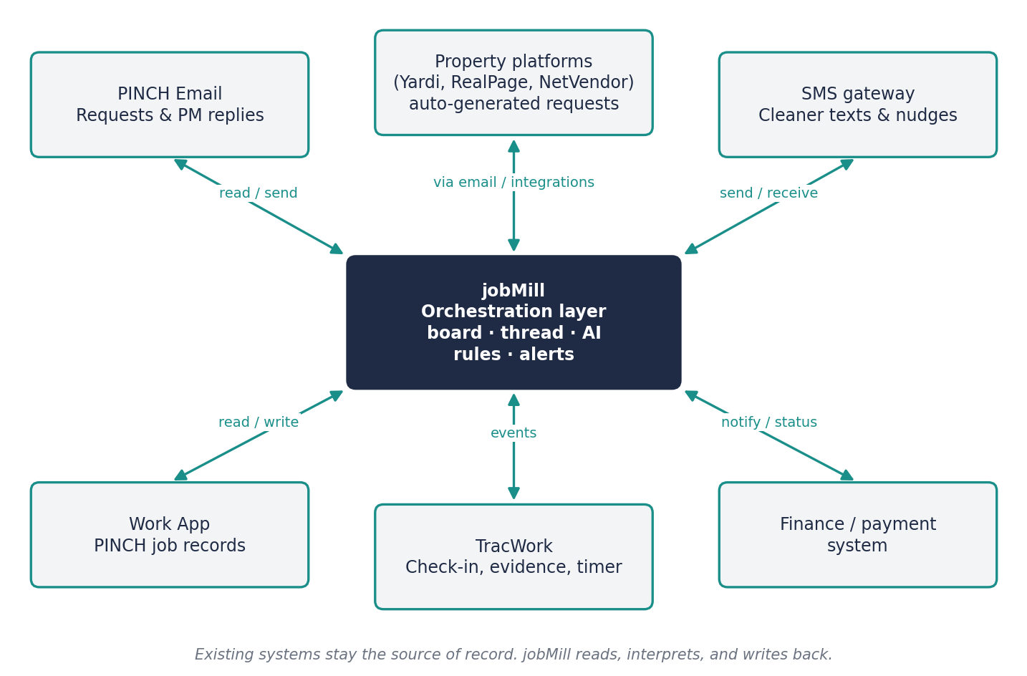
Figure 1. jobMill as the orchestration layer over PINCH's existing systems

4. The Board and Core Experience

4.1 The seven-stage flow
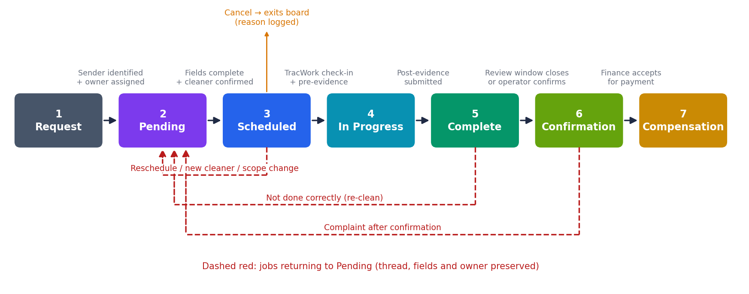
Figure 2. The seven stages, their exit gates, and the paths back to Pending
Stage | Meaning | Exit gate
1. Request | A message has arrived and needs a sender and an owner. | Sender identified and owner assigned.
2. Pending | The job is being defined and a cleaner is being secured. | Required Work App fields complete and cleaner confirmed.
3. Scheduled | The job is defined and the cleaner has committed. | Cleaner checks in on TracWork with pre-evidence.
4. In Progress | The cleaner is on site and the job timer is running. | Cleaner submits post-evidence and ends the job.
5. Complete | The cleaner says it's done; PINCH is reviewing. | Review window closes cleanly, or an operator confirms.
6. Confirmation | The job is sealed and ready for payment. | Finance accepts the job for payment.
7. Compensation | Payment is scheduled or made. The flow ends. | —

4.2 Board layout
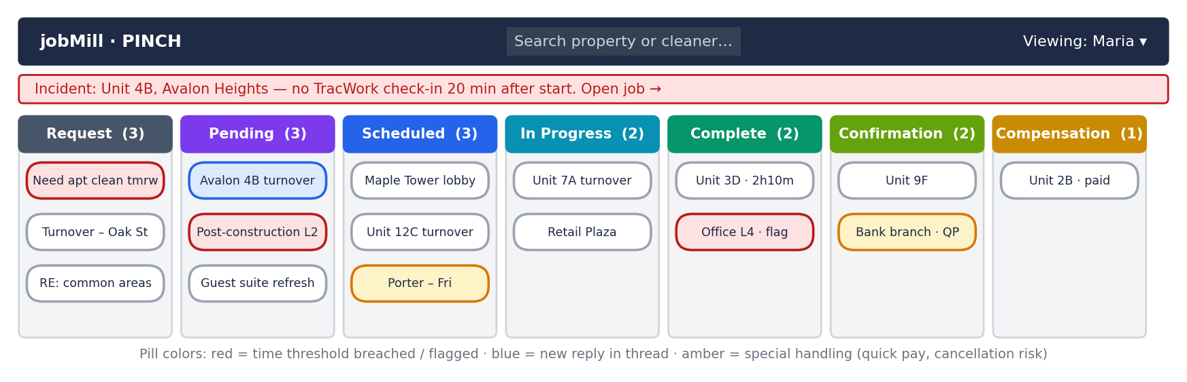
Figure 3. Conceptual board layout (neutral styling; to be restyled to the jobMill visualization standards)
- Pills. Each job appears as a pill with a concise subject, based on the email subject or a shortened version of it.
- Ordering. Request, Pending, and later columns are ordered oldest on top so the most urgent work is always first. Scheduled is ordered by job date, soonest on top.
- Pill colors. Red when a time threshold is breached or a job is flagged; blue when a new reply has arrived in the thread; amber for special handling such as quick pay.
- Default view. Each operator sees the shared Request column plus their own jobs from Pending through Compensation.
- Peer view. A user switcher at the top lets any operator view a colleague's board and reassign a stalled job to themselves.
- Global search. Search by property or cleaner with autocomplete; results span all stages and one click jumps to the pill.
- Incident banners. Critical events fly out as banners and are also listed in an incidents section, each linking directly to its job.

4.3 The job modal
Clicking a pill opens a modal. In Request the modal is compact: the suggested sender and the original message. From Pending onward it is a larger, two-part modal: the unified thread on the left and the Work App fields on the right, with each field marked as filled by AI or by a human.
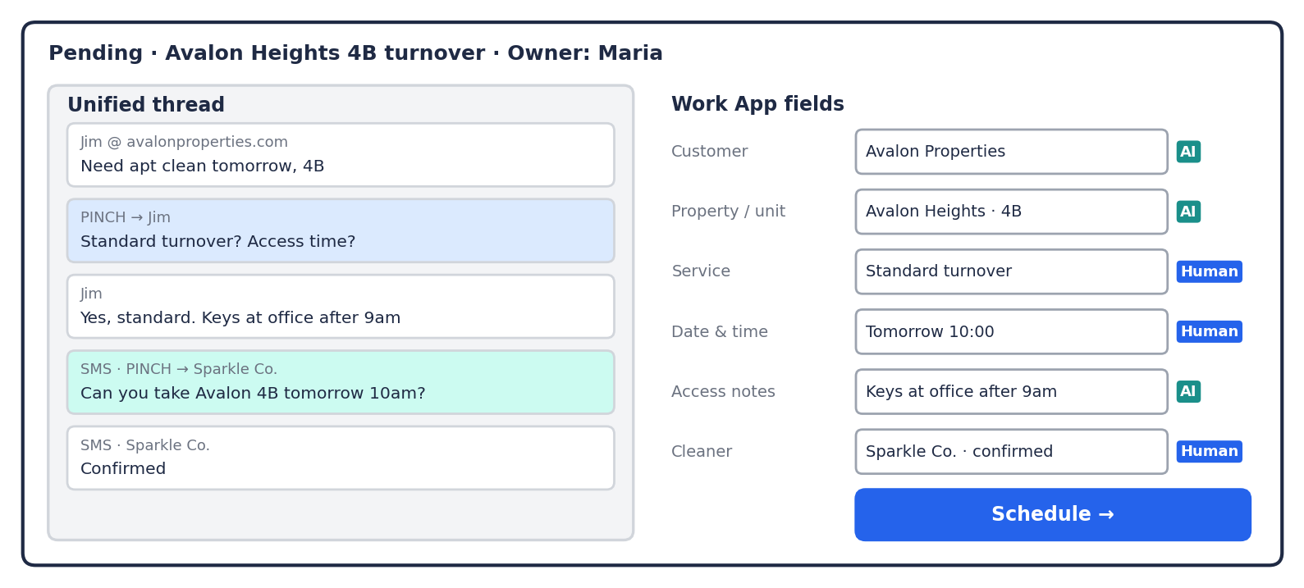
Figure 4. Pending modal: unified thread (left) and Work App fields with AI/Human attribution (right)

5. Stage-by-Stage Specification

5.1 Request
Request is the shared intake column. Every incoming message becomes a pill here, and everyone on the operations team can see it. The stage exists to answer two questions only: who sent this, and who will own it. Job details are resolved later, in Pending.
Attribute | Specification
Entry trigger | A message arrives: mostly email, occasionally phone or text. Timestamp T0 is recorded at arrival.
Visibility | Shared. All operators see all unassigned requests.
Primary actor | Any operator.
Key actions | Confirm or correct the AI-suggested sender; message the sender for clarification if needed; assign an owner (self or a colleague); or close the modal and leave it for someone else.
AI role | Identifies the sender and customer from the email domain, message history, and the customer backend. Recognizes contact changes, such as a new property manager at a known company.
Exit gate | Sender identified and owner assigned. Timestamp T1 is recorded.
Alerts | Time unclaimed since T0.
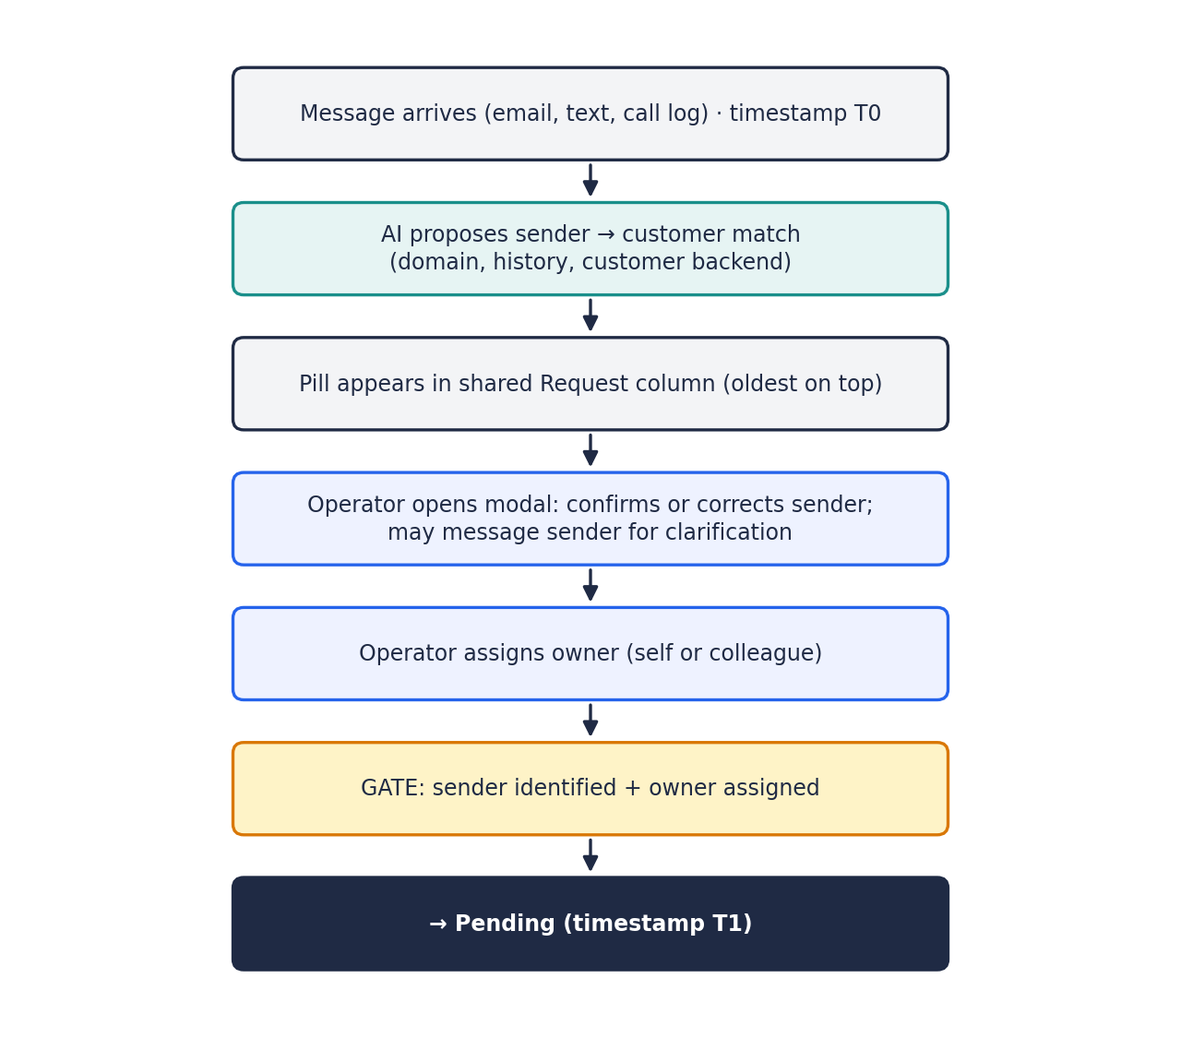
Figure 5. Request flow

The identity problem
Property management staff change. The contact who sent requests three months ago may have left, and a new colleague now sends them from the same company domain, without anyone notifying PINCH. jobMill should recognize the company from the domain and context, suggest the match, and let the operator confirm and update the contact record rather than treating the sender as unknown.

The deciphering problem
Requests range from fully structured, auto-generated emails to a single line such as "need apartment clean tomorrow." The more structured the request, the more AI can resolve on its own; the vaguer it is, the more the operator relies on the thread to ask for details.

5.2 Pending
Pending is where a claimed job becomes a fully defined job with a confirmed cleaner. The operator works entirely inside jobMill: reading the original request, completing the Work App fields, clarifying with the property manager by email, and securing the cleaner by text.
Attribute | Specification
Entry trigger | Owner assigned in Request (T1).
Visibility | Owner's board; visible to peers through the user switcher.
Primary actor | Job owner.
Modal | Left: original request and unified thread. Right: Work App fields, with AI/Human attribution.
Key actions | Verify or complete fields (property, location, service, date, scope and any other Work App requirements); email the property manager from the thread; text the property's default cleaning group or a new one; log confirmations received by phone as notes.
AI role | Pre-fills as many Work App fields as possible from the message and the customer's history. Marks each field it filled.
Exit gate | Required fields complete and cleaner confirmed (text reply or operator note). The operator pushes the job to Scheduled.
Alerts | Time in Pending; pill flashes blue when a customer or cleaner replies.
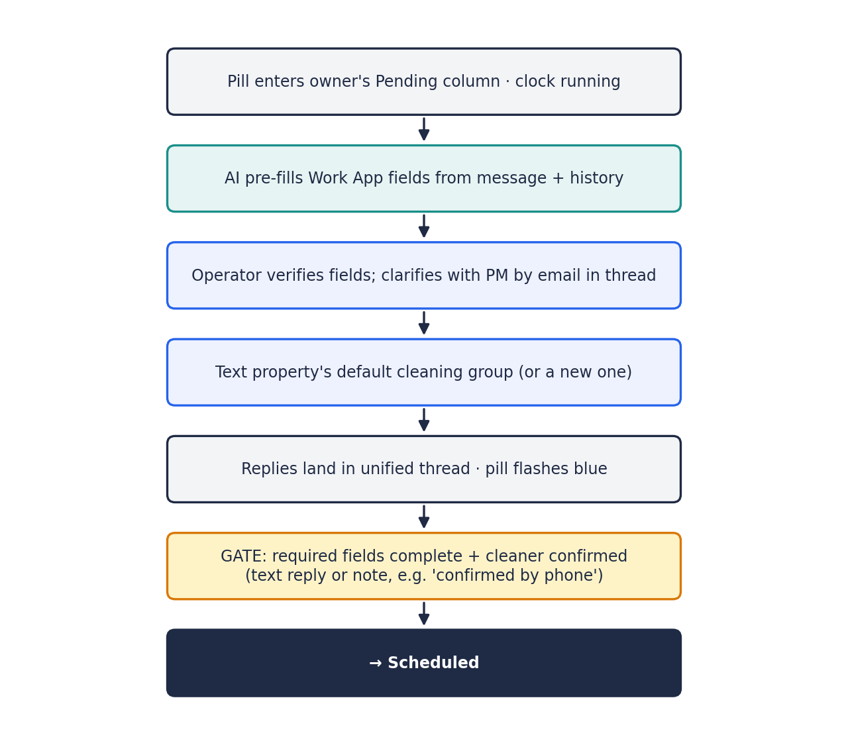
Figure 6. Pending flow

Default cleaning group
Most PINCH properties have a predefined cleaning group. When the form reaches the cleaner field, jobMill proposes that group and the operator texts them for confirmation, which is required every time. If there is no group, or the group can't take the job, the operator texts a new number and assigns a different cleaning group, all within the same thread.

5.3 Scheduled
A Scheduled job is defined and the cleaner has committed. The pill waits here until the cleaner checks in on TracWork. Opening it shows a calendar-style view of the job with options to reschedule, change the cleaner, adjust scope, message, or cancel.
Attribute | Specification
Entry trigger | Operator schedules from Pending (or automatically, under standing rules in later modes).
Ordering | By job date, soonest on top.
Key actions | Reschedule, change cleaner, change scope, message via thread, minor edits, cancel.
Exit gate | TracWork check-in with location confirmation, scope confirmation, and pre-evidence.
Alerts | No check-in after the start threshold triggers an automatic SMS nudge to the cleaner and escalating alerts.

The Scheduled rule
Rule
Scheduled means the job is defined and the cleaner has confirmed it. Any change that breaks either condition sends the job back to Pending. Anything that doesn't stays in Scheduled.
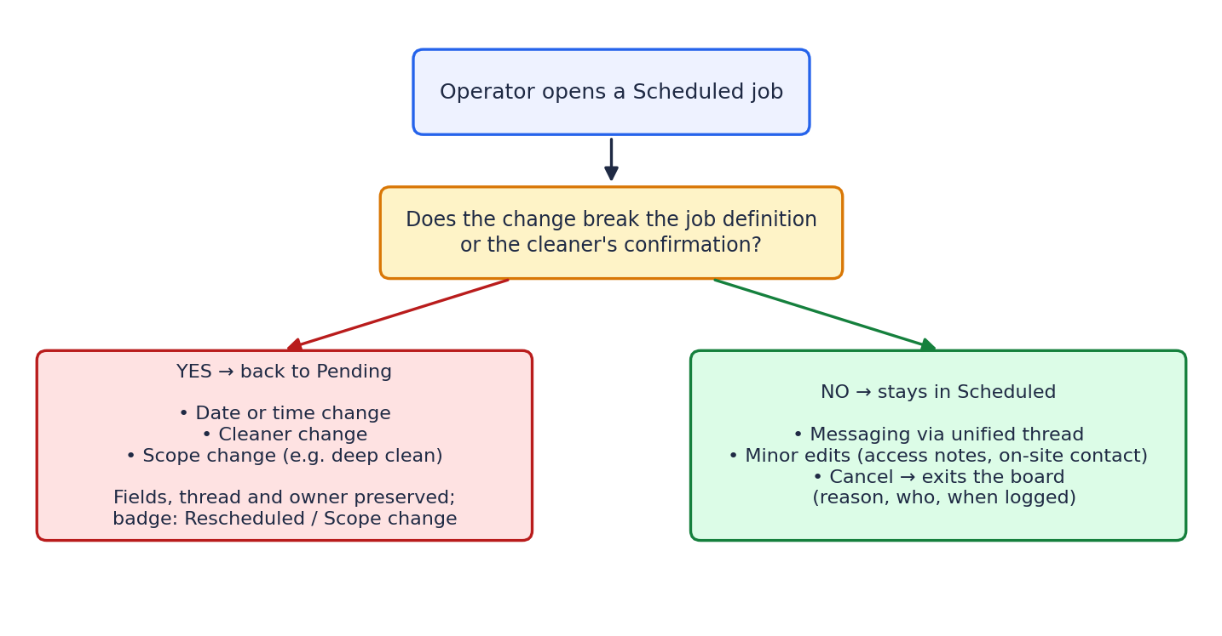
Figure 7. What stays in Scheduled and what returns to Pending
A job sent back to Pending keeps its fields, full thread, and owner, so the operator only changes what's needed. It carries a visible badge (Rescheduled, New cleaner, or Scope change) so it isn't mistaken for a new job. Cancelled jobs leave the board with the reason, the person who cancelled, and the time recorded.

5.4 In Progress
In Progress is driven by TracWork, the mobile web app cleaners use on site. jobMill does not replace TracWork; it listens to it.
Attribute | Specification
Entry trigger | TracWork reports that the cleaner has (1) confirmed location, (2) confirmed the job scope, and (3) captured pre-evidence (photos or video). Only then does the job timer start.
If no check-in | The job stays in Scheduled. jobMill sends an automated text asking whether the cleaner is on the way (logged in the thread) and alerts escalate. This is effectively no-show detection.
Key actions | Handle on-site issues raised by the cleaner, such as conditions beyond a standard clean, through the thread.
Exit gate | Cleaner captures post-evidence and ends the job in TracWork.
Alerts | Late check-in; duration running well beyond expected.
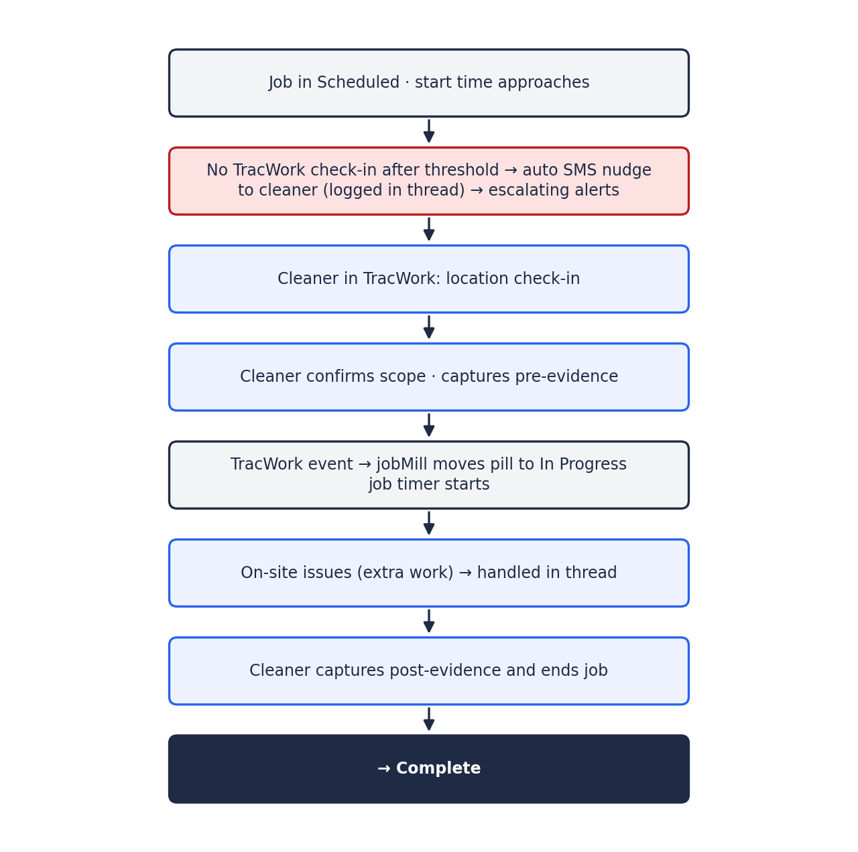
Figure 8. In Progress flow, including the automated check-in nudge

5.5 Complete
Complete means the cleaner says the job is done. It does not mean PINCH has accepted it. Every completed job enters a review window (length to be confirmed, for example 4 to 24 hours). Operators can confirm any job manually; unflagged jobs confirm automatically when the window closes.
Key recommendation
Anomalies should block auto-confirmation, not just highlight a job. Clean jobs flow through on a countdown; flagged jobs pause until an operator reviews them. Operators can't review everything, so their attention goes where the risk is.

Attribute | Specification
Entry trigger | Cleaner ends the job in TracWork with post-evidence.
AI role | Checks each completed job for anomalies: duration far shorter or longer than expected, missing or thin evidence, check-in location mismatch, issues raised in the thread during In Progress, or a first-time pairing of cleaner and property.
Clean job | Countdown to automatic confirmation is visible on the pill.
Flagged job | Countdown paused. Operator reviews and approves, or rejects.
Missing evidence | TracWork allows closing without photos. Under PINCH's new rule, such jobs cannot auto-confirm: an operator must confirm manually with a required note, and payment is delayed.
Rejection | If the property manager reports the work wasn't done correctly, the job returns to Pending as a re-clean, linked to the original job with its evidence and thread.
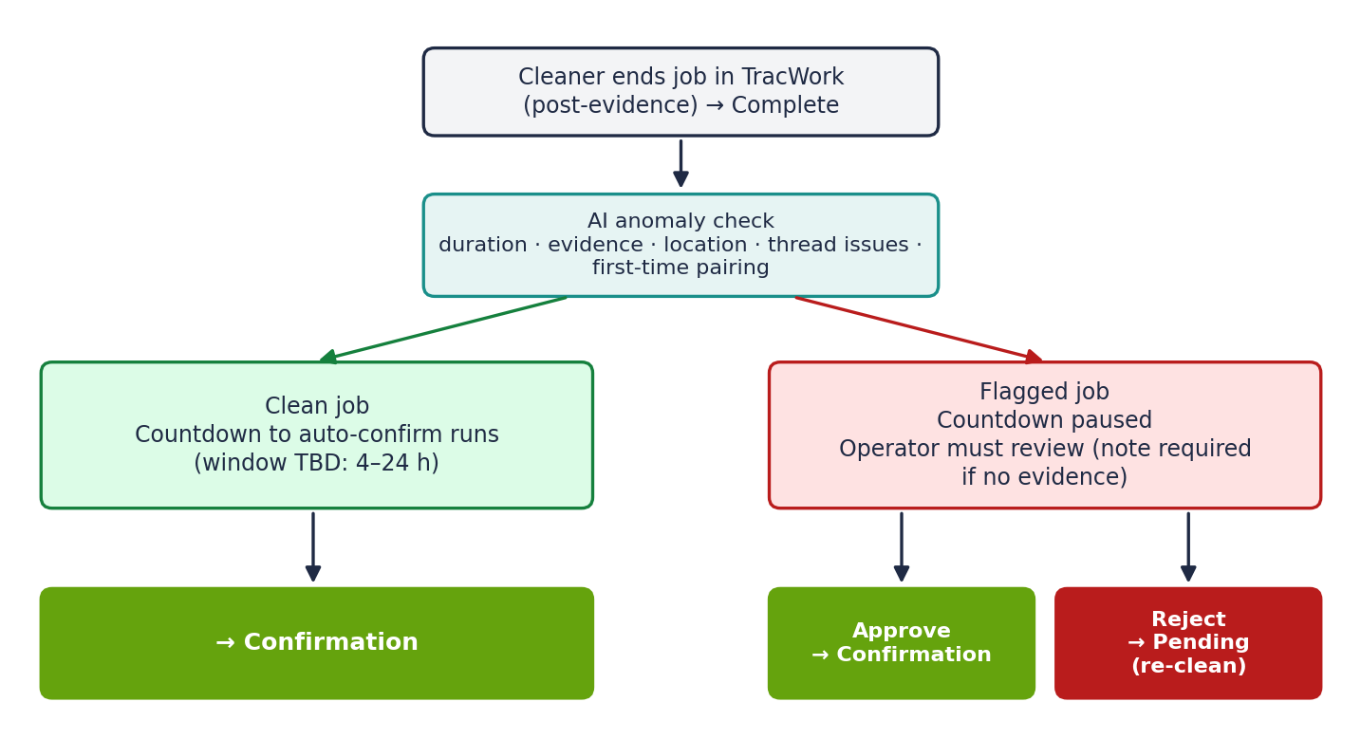
Figure 9. The review window: clean jobs auto-confirm, flagged jobs wait for review

5.6 Confirmation
Confirmation means the job is sealed. All modifications and reviews are done, and the job is ready for payment. PINCH's backend already notifies finance at this point, and finance is also notified when jobs are scheduled so it can see what's coming. A confirmed job can still return to Pending if a complaint arrives.
Quick pay. Some cleaners pay a monthly fee to be paid faster. Their jobs must move from Confirmation to Compensation on a shorter clock, are marked in amber, and have their own alert thresholds.

5.7 Compensation
A job moves to Compensation when the financial system accepts it for payment, meaning payment is scheduled or already made. This is the end of the flow. Confirmation and Compensation exist mainly to make the back office visible, so operators can see exactly where each job sits in the payment pipeline without having to ask finance.
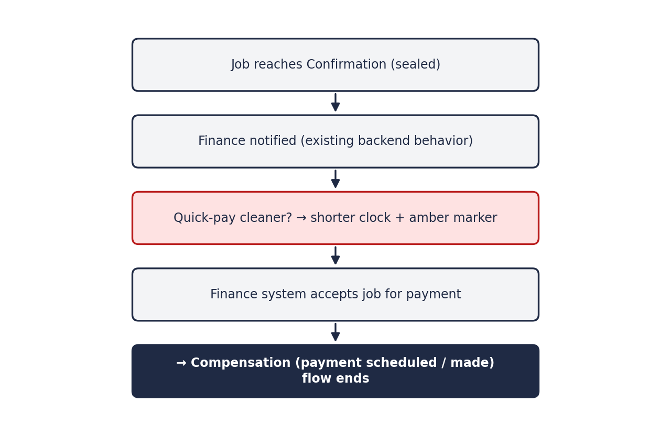
Figure 10. Confirmation to Compensation

6. Cross-Cutting Capabilities

6.1 Unified thread
Each job has one conversation that combines the original request, all email exchanges with the property manager, all texts with cleaners, automated messages such as check-in nudges, and operator notes such as "confirmed by phone." Messages are sent through PINCH's existing email and SMS channels, and replies flow back into the thread. The thread persists when a job moves backward, so history is never lost.

6.2 Ownership and reassignment
- Owner is set in Request, either by claiming or by assigning a colleague.
- The owner carries the job through every stage.
- Any operator can take over a colleague's job through peer view, for example when it has stalled.
- Every assignment and reassignment is recorded with who and when.

6.3 AI and human attribution
Every field and every stage transition records whether it was performed by AI, by automation rules, or by a person. Operators know exactly what to double-check, managers can see which jobs moved on their own, and PINCH can measure AI accuracy over time, which is the evidence needed to expand automation safely.

6.4 Alerts, alarms, and anomalies
Timestamps recorded at every stage transition drive alerting. Pills flash red when thresholds are breached, and critical events surface as incident banners. The detailed alerting method, including thresholds, escalation levels, and anomaly logic, will be built on Federico's existing alerting framework and added in a later version of this document.

6.5 Global search and incidents
When a cleaner or property manager calls about a problem, the operator types the property or cleaner name, sees every matching job across all stages, and jumps to the pill in one click. Incident banners and a dedicated incidents section provide the same one-click path for system-detected problems. The detailed banner behavior is an open design item.

6.6 Business rules layer
Automation in later modes is governed by rules defined per customer, property, or cleaner, for example: "all turnovers at this property go to this cleaning group and schedule automatically." The rules layer also carries PINCH's operational policies, such as the evidence requirement and quick-pay timelines.

7. Operating Modes
jobMill is designed to progress from AI-assisted to AI-automated operation. Each mode builds on the one before, and automation expands only as far as the business rules and measured AI accuracy allow.
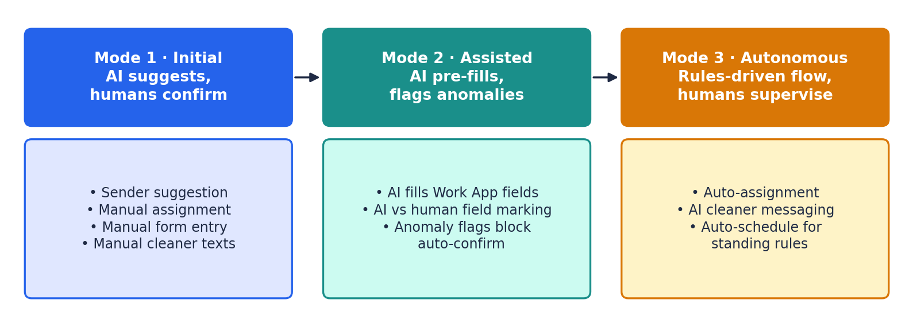
Figure 11. From initial to autonomous operation
Stage | Mode 1 · Initial | Mode 2 · Assisted | Mode 3 · Autonomous
Request | AI suggests sender; operator confirms and assigns. | High-confidence senders pre-confirmed; operator only assigns. | Auto-assignment by workload or familiarity with customer and cleaner.
Pending | Operator fills fields and texts cleaner. | AI pre-fills Work App fields, marked as AI; operator verifies. | AI handles cleaner messaging; auto-advance to Scheduled on confirmation.
Scheduled | Manual reschedule, change, cancel. | AI drafts messages for changes. | Standing rules schedule repeat jobs directly with the known cleaner.
In Progress | Alerts on missing check-in. | Automatic SMS nudges logged in thread. | AI converses with cleaner on delays and on-site issues.
Complete | Operator reviews within window; auto-confirm on timeout. | AI flags anomalies; flagged jobs block auto-confirm. | AI resolves low-risk flags per rules; humans handle exceptions.
Confirmation / Compensation | Status visibility from finance. | Quick-pay tracking and alerts. | Automated handoff and exception routing to finance.

8. Business Observability Metrics
Because every transition is a timestamped event, jobMill produces operational metrics as a by-product of normal work. Initial candidates:
Metric | What it measures | Why it matters
Time to claim | T0 (arrival) to T1 (owner assigned). | Reveals intake bottlenecks and unattended requests.
Time in Pending | Owner assigned to scheduled. | Measures how quickly jobs are defined and staffed.
Clarification rate | Share of requests needing back-and-forth with the property manager. | Indicates request quality by customer.
Cleaner acceptance rate | Share of jobs accepted by the default cleaning group. | Highlights supply gaps by property or region.
Lead time | Scheduled to job date. | Shows planning horizon; flags last-minute demand.
No-show / late check-in rate | Jobs without timely TracWork check-in. | Core reliability signal for cleaners.
Duration variance | Actual versus expected job duration. | Feeds anomaly detection and pricing accuracy.
Evidence compliance | Share of jobs with complete before-and-after evidence. | Supports the new evidence rule.
Re-clean rate | Jobs returned from Complete or Confirmation. | Quality indicator by cleaner and property.
Time to payment | Confirmation to Compensation, including quick pay. | Cleaner satisfaction and quick-pay commitments.
AI accuracy | Share of AI-filled fields accepted unchanged. | Evidence for expanding automation.
Operator load | Active jobs per operator by stage. | Balances work and informs auto-assignment.

9. Core Data Objects
A working view of the objects jobMill tracks. Most mirror records already held in PINCH's systems; jobMill stores references plus its own events and attribution.
Object | Key contents | Source of record
Job | Stage, owner, Work App fields, badges, flags, timestamps. | Work App (job data); jobMill (flow state)
Customer | Property management company, domains, rules. | PINCH backend
Contact | Person at the customer, email, history, active status. | PINCH backend, updated via jobMill
Property | Location, units, default cleaning group. | PINCH backend / Work App
Cleaning group | Contact numbers, quick-pay status, performance history. | PINCH backend
Operator | Team member, workload, customer familiarity. | jobMill
Thread message | Channel, direction, sender, content, time. | Email / SMS systems (referenced)
Stage event | From/to stage, actor (human, AI, rule), time, reason. | jobMill
Evidence | Pre- and post-job photos or video, location. | TracWork (referenced)

10. Open Questions for PINCH
Answers to these questions will turn this beta into version 1.0.

10.1 Systems and integration
- What email platform does PINCH use for requests, and is it a shared inbox or several individual inboxes?
- How can jobMill integrate with the Work App (API, database, other), and what is the full list of required job fields?
- Which SMS provider or phone system is used to text cleaners today?
- How does TracWork expose check-in, evidence, and completion events (API, webhooks, other)?
- Which property platforms send auto-generated request emails, and in what formats?

10.2 Request
- How should phone and text requests be captured into jobMill?
- When a new contact is detected at a known customer, who approves updating the contact record?
- How should requests from unknown domains or first-time senders be handled?

10.3 Pending and automation rules
- Where is the default cleaning group for each property stored?
- Is there a target time for moving a job from Request to Scheduled?
- Which customers, properties, and cleaners qualify for auto-assignment and auto-scheduling, and who sets those rules?
- What criteria should drive auto-assignment (workload, customer familiarity, cleaner relationship, other)?

10.4 Scheduled
- Late cancellations: is the property manager charged, is the cleaner paid, and does PINCH cover anything? This decides whether cancelled jobs exit the flow or go to Compensation.
- How do PINCH's pricing and service standards apply when scope changes after scheduling?
- Is there a minimum lead time for scheduling jobs?

10.5 In Progress
- How is extra work discovered on site handled today, including property manager approval and additional pay?
- How long after the scheduled start should the first check-in nudge and escalation occur?
- Where do expected job durations come from (by service type, property, historical data)?

10.6 Complete
- How long is the review window, and is it the same for every customer or set per customer?
- What defines an anomaly worth flagging (duration thresholds, evidence requirements)?
- Who can reject a completed job: the property manager, the operator, or both?
- Can a property manager dispute a job after it has been confirmed, and until when?
- For a re-clean: same cleaner or a different one, who pays, and is the cleaner still paid for the original visit?
- Does the property manager see the before-and-after evidence, and at what point?

10.7 Confirmation and Compensation
- Which payment system does finance use, and what signal tells jobMill a job has moved to Compensation?
- Should Compensation distinguish "payment scheduled" from "payment made"?
- What is the quick-pay timeline commitment to cleaners?
- How long is the payment delay for jobs without evidence?
- Does Compensation cover only paying the cleaner, or also invoicing the property manager?
- If a complaint arrives after the cleaner has been paid, how is it handled?

10.8 Internal design items (jobMill team)
- Apply the jobMill visualization standards to the board, modals, and diagrams.
- Define the alerting method: thresholds, escalation levels, pill behavior, and anomaly logic.
- Specify incident banner behavior and the incidents section.
- Design the business rules interface for customers, properties, and cleaners.

11. Path to Version 1.0
- Review this beta and confirm the model reflects PINCH's operation.
- Resolve the open questions in Section 10 with PINCH.
- Apply visualization standards and define the alerting method.
- Issue version 1.0 as the basis for build planning, starting with Mode 1.

