

Movie Theater
Software Requirements Specification
Version 1.2

Hanoi, Jan 2020

Approval Page

Prepared by : | Business Analyst | Signature: | ____________________
 |  | Date: | ____ /____ / ____
Reviewed by : | Business Analyst | Signature: | ____________________
 |  | Date: | ____ /____ / ____
Supported by: |  | Signature: | ____________________
 |  | Date: | ____ /____ / ____
Approved by : |  | Signature: | ____________________
 |  | Date: | ____ /____ / ____

Revision History
Date | Version | Author | Change Description
21/06/2018 | 1.0 |  | Create new
15/01/2021 | 1.2 |  | Update

TABLE OF CONTENTS

1.1. Purpose 4
1.2. In scope 4
2. OVERVIEW 4
2.1. Actors 4
2.2. USE CASE DIAGRAM 5
3. Functional Description 5
3.1. Functional Requirements 5
3.1.1 Log in 6
3.1.2 Register account 6
3.1.2.1 Register account 7
3.1.2.2Edit member accounts 10
3.1.2.3View member list 13
3.1.3 Account management of the user 15
3.1.3.1 The user – Booked ticket management 16
3.1.3.2 The user – View history of score adding/using 17
3.1.3.3 Movie list – Search of the user 18
3.1.4 Booking ticket of the user 19
3.1.4.1 Book ticket – Select movie and showtime 20
3.1.4.2 Booking ticket – Selecting seat 22
3.1.4.3 Booking ticket – Confirm booking ticket 24
3.1.4.4 Booking ticket – Ticket information 25
3.1.5 Ticket selling management 26
3.1.5.1 Ticket selling management – Select movie and showtime 26
3.1.5.2 Ticket selling management – Selecting seat 28
3.1.5.3 Ticket selling management – Confirm ticket 30
3.1.5.4 Ticket selling management – Ticket information 33
3.1.6 Ticket booking management 35
3.1.6.1 Ticket booking management – Search 35
3.1.6.2 Ticket booking management – Booking list 36
3.1.6.3 Ticket booking management – Confirm booking 37
3.1.6.4 Ticket booking management – Information of converting into ticket 38
3.1.7 Employee management 40
3.1.7.1 Employee management – View employee list 40
3.1.7.2 Employee management – Add employee 41
3.1.7.3 Employee management – Edit employee 43
3.1.7.4 Employee management – Delete employee 45
3.1.8 Cinema room management 48
3.1.8.1 Cinema room management – Display list of cinema rooms 48
3.1.8.2 Cinema room management – Cinema room detail 49
3.1.9 Movie management 51
3.1.9.1 Movie management – View movie list 51
3.1.9.2 Movie management – Add movie 52
3.1.9.3 Movie management – Edit movie information 54
3.1.9.4 Movie management – Delete movie 56
3.1.10 Promotion management 57
3.1.10.1 Promotion management – View promotion list 57
3.1.10.2 Promotion management – Add promotion 59
3.1.10.3 Promotion management – Edit promotion 60
3.1.10.4 Promotion management – Delete promotion 62
3.2. Detailed Non-Functional Requirements 63
3.2.1 Logical Structure of the Data 63
3.2.2 Security 65
3.2.3 Performance 65
- INTRODUCTION
  - Purpose
The management system allows to easily perform the functions of the movie theater operation management, especially ticket selling of employees and ticket booking of the users. The biggest goal of the system is to improve the performance of employees, minimize the time to conduct ticket selling with each customer, facilitate booking, increase sales, minimize manpower and make the movie theater more competitive compared with other movie theaters.
The system has user authorization function, so that:
- For users who are customers - not members: can view movie list, view promotions, view ticket prices, view showtimes, register an account, log in.
- For users who are customers - members: the same as customers who are not members, besides, they can book tickets, manage accounts ...
- For users who are employees: view and search members, manage movies, ticket selling, ticket booking, and promotion.
- For users who are shop owners or managers: in addition to the functions of management employee, they can use statistical functions, manage employees, members, cinema rooms...
  - In scope
In the movie theatre scope, for learning Mock project, create basic premise for next projects.
- OVERVIEW
  - Actors
The following table describes actors of the movie theatre management system.
Actor |  | Description
Admin |  | Actor has the highest right in the system, admin can add, edit, delete all modules in the system.
Employee |  | Employees who operate directly in the system can manage ticket selling, booking and search for members.
Customer | Not member | Operate directly in the user system, with functions: view movie list, view promotions, view ticket price, showtime, and register accounts
 | Member | Operate functions of customers – not members, besides, member customers can book tickets, manage accounts and manage ticket booking.

  - USE CASE DIAGRAM
The diagram below provides an overview of the function as well as actors of the users
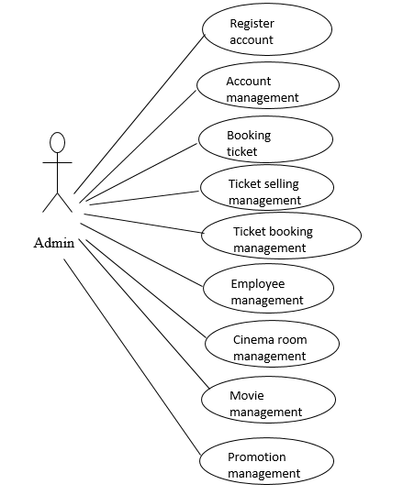
- Functional Description
  - Functional Requirements

Log in
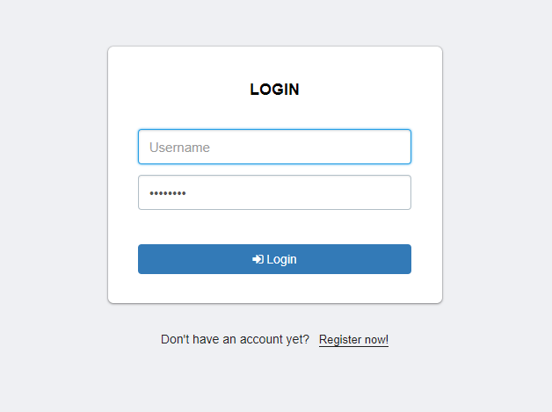
Users must be authenticated with the provided account and password to access the system.
The system provides a login page for users to enter their username and password. The system will verify the entered user information with the user database of the system.
If the account is not found in the system or an account has been found but the entered password does not match the system password, the system will report an error to the user.
"User / password is invalid. Please try again!".
If the account is valid but it has been locked, the system will report an error:
"Account has been locked!"
If login successfully, the system will check the assigned roles and bring users to the main screen of the application.

Register account
Use Case Name | Register account
Use Case ID
High Level Requirement Ref
Actor | User
Description | This is use case which allows the user to register accounts
Trigger | NA
Pre-condition | The user registers account information
Post-processing

Register account
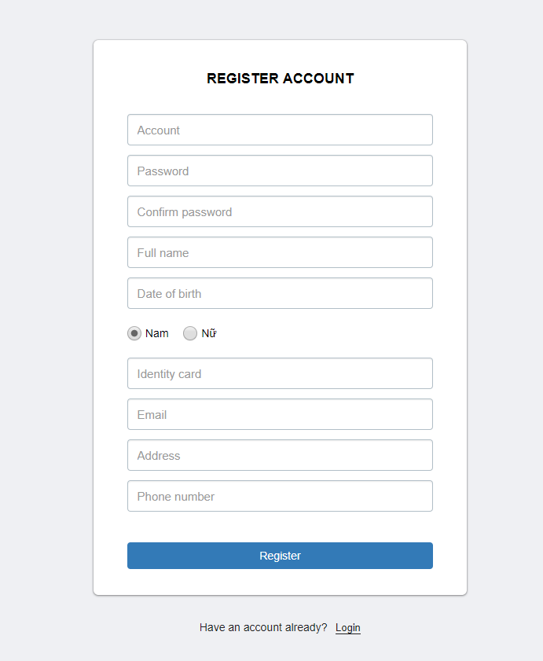

Screen | Register account
Description |  | Register user information
Screen Access |  | The user clicks Register account
Screen Content
Item |  | Type | Data | Description
Account |  | Textbox- String | N/A
Password |  | TextBox -String | N/A
Confirm password |  | Textbox - String | N/A
Full name |  | Textbox - String | N/A
Date of birth |  | Textbox - String | N/A
Sex |  | Radiobutton - String | N/A
Email |  | Textbox – String | N/A
Identity card |  | Texbox - number | N/A
Phone number |  | Textbox - Number | N/A
Address |  | Textbox - String | N/A
Register |  | Button | N/A
Screen action
Action name |  | Description |  | Success | Failure
Register |  | Click Register to send data |  | Forward to login page to log in the main page | The required fields are null

3.1.2.2 Edit member accounts
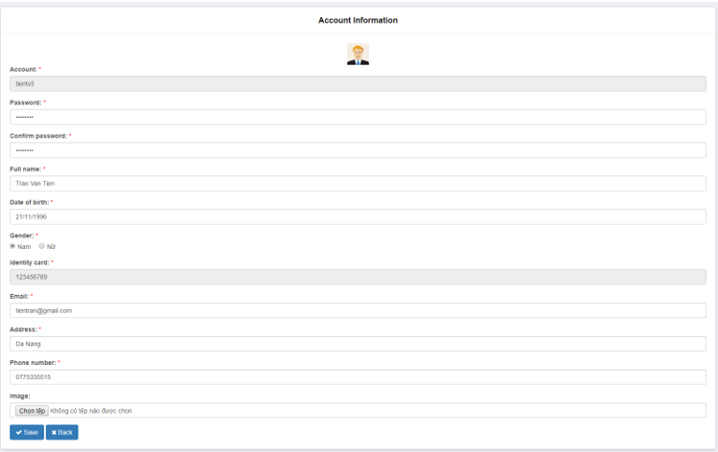

Screen | Edit member account
Description |  | Display information of member whose account need editting
Screen Access |  | The user clicks Edit at Employee list
Screen Content
Action name |  | Description | Success | Failure
Account |  | Textbox - string | N/A
Full name |  | Textbox – string | N/A
Password |  | Textbox - string | N/A
Date of birth |  | Textbox - date | N/A
Sex |  | Radiobutton - string | N/A
Email |  | Textbox - string | N/A
Identity card |  | Textbox - string | N/A
Phone number |  | Textbox - number | N/A
Address |  | Textbox - string | N/A
Ticket management |  | Link - string | N/A
Employee management |  | Link - string | N/A
Member management |  | Link - string | N/A
Statistic |  | Link - string | N/A
Edit |  | Button | N/A
Screen action
Action name |  | Description |  | Success | Failure
Ticket booking management |  | View ticket booking list of members |  | Display booked ticket list of the member | No event has been created for ticket booking management
Employee management |  | View active employees |  | Display list of active employees | No event has been created for Employee management
Member management |  | View list of registered member |  | Display list of registered members | No event has been created for Member management
Statistic |  | View statistic list of the shop |  | Display statistic list of the shop | No event has been created for Statistic
Edit |  | Update member information if necessary |  | Display message: “Update information successfully” | The required fields are null  Edit Button not yet creates event.

3.1.2.3 View member list
Screen | View member list
Description | Dislay all information of registered member
Screen Access | The user clicks Member management
Screen Content
Item | Type | Data | Description
Member ID | Label -string | N/A
Member name | Label -string | N/A
Identity card | Label -string | N/A
Email | Label -string | N/A
Phone number | Label -string | N/A
Address | Label -string | N/A
Ticket management | Link - string | N/A
Employee management | Link - string | N/A
Member management | Link - string | N/A
Statistic | Link - string | N/A
Edit | Link - img | N/A
Screen Action
Action name | Description |  | Success | Failure
Ticket booking management | View ticket booking list of members |  | Display booked ticket list of the member | No event has been created for ticket booking management
Employee management | View active employees |  | Display list of active employees | No event has been created for Employee management
Member management | View list of registered member |  | Display list of registered members | No event has been created for Member management
Statistic | View statistic list of the shop |  | Display statistic list of the shop | No event has been created for Statistic
Edit | Edit member information if necessary |  | Display screen of Edit member information | No event has been created for Edit button

Account management of the user
Use Case Name | Account management
Use Case ID
Actor | Member
Description | This is a use case which allows the users to update information, change password, manage ticket booking, view detail of score adding and use the score.
Trigger | NA
Pre-condition | The user with registered account
Post-processing

The user – Booked ticket management
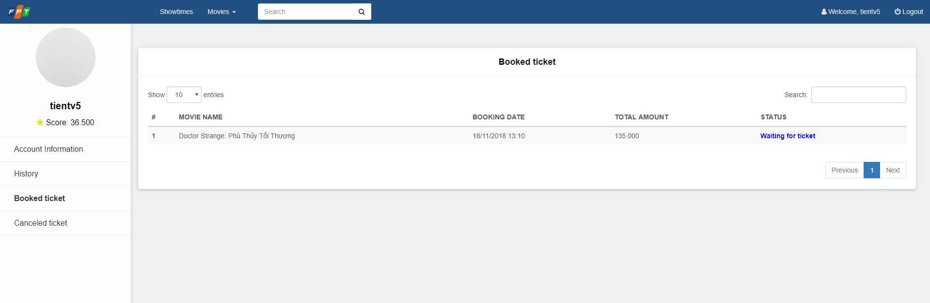
Screen | Booked ticket management
Description |  | Display all booked member
Screen Access |  | Member clicks Account management -> Booked ticket
Screen Content
Item |  | Type | Data | Description
Movie name |  | label- string | N/A
Booking date |  | label- string | N/A
Total amount |  | Label - String | N/A
Status |  | Label - String | N/A
Account information |  | Link - String | N/A
History |  | Link - String | N/A
Booked ticket |  | Link - String | N/A
Canceled ticket |  | Link - String | N/A
Log out |  | Button | N/A
Screen Action
Action name |  | Description |  | Success | Failure
Log out |  | Click the logout button to exit the current member account |  | Back to the login screen | No event has been created for the logout button

The user – View history of score adding/using
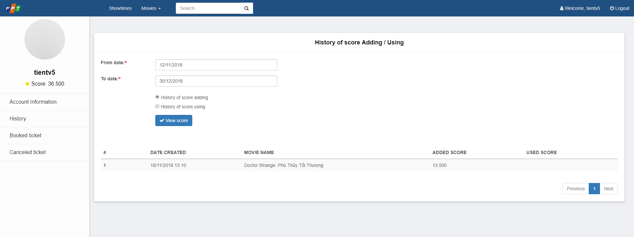

Screen | View history of score adding/using
Description |  | Display all history of score adding/using of the current member
Screen Access |  | The member clicks account management -> History
Screen Content
Item |  | Type |  | Data | Description
From date |  | Date - string |  | N/A
To date |  | Date - string |  | N/A
History of score adding |  | Radiobutton- String |  | N/A
History of score using |  | Radiobutton- String |  | N/A
Date created |  | Label - string |  | N/A
Movie name |  | Label - string |  | N/A
Added score |  | Label - string |  | N/A
Account information |  | Link - String |  | N/A
History |  | Link - String |  | N/A
Booked ticket |  | Link - String |  | N/A
Canceled ticket |  | Link - String |  | N/A
Log out |  | Button |  | N/A
View score |  | Button |  | N/A
Screen Action
Action name |  | Description |  |  | Success | Failure
Log out |  |  | Click the logout button to exit the current member account |  | Back to the login screen | No event has been created for the logout button
View score |  | Click the View score button to see the process of using or adding scores |  |  | Displays a list of added or used scores | No event has been created for the View score button

Movie list – Search of the user
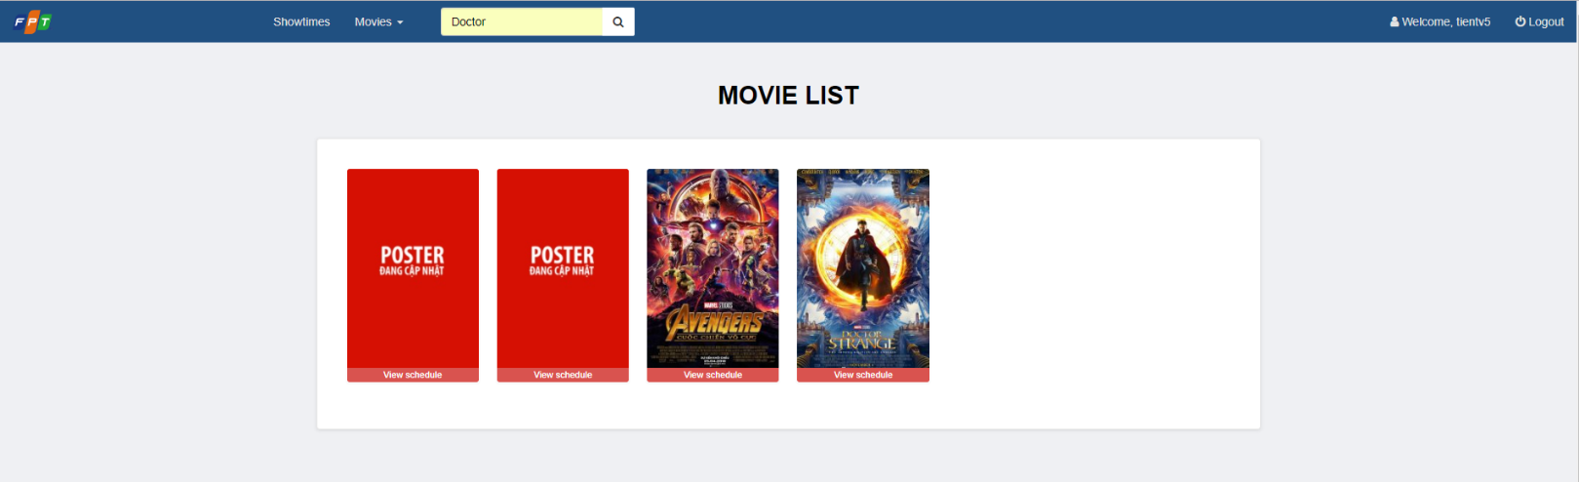
Screen | Movie list - Search
Description |  | Search for movie
Screen Access
Screen Content
Item |  | Type | Data | Description
Search list |  | Table | N/A
Search |  | Button | N/A
Search |  | Textbox
Screen Action
Action name |  | Description |  | Success | Failure
Search |  | Input data into search box to search |  | Hide two slides that are about to appear and then display from top to bottom according to the a-z movie with the same movie names | No movies has found as required

Booking ticket of the user
Use Case Name | Booking ticket
Use Case ID
Actor | Member
Description | This is the use case which allows users to book ticket
Trigger | NA
Pre-condition | The user must login account
Post-processing

Book ticket – Select movie and showtime
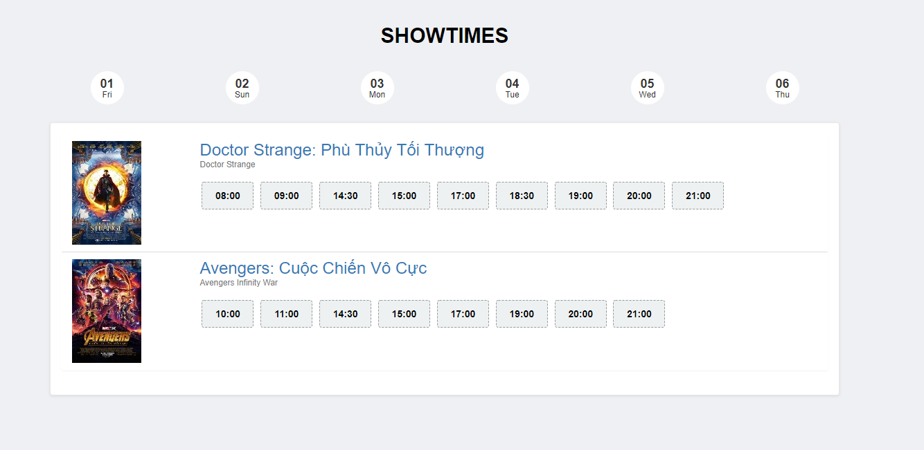

Screen | Book ticket – Select movie and showtime
Description |  | Display the current movies and showtime
Screen Access |  | The user accesses to book ticket
Screen Content
Item |  | Type | Data | Description
Select movie |  | Combobox | N/A | Display current movies for users to select
Select date |  | Combobox | N/A | Display the show date of each selected movie in Select movie combobox for users to select
Select time |  | Combobox | N/A | Display the showtime of each movie according to the movie and the show date for the user to select
Book ticket |  | Button | N/A | Send movie information and showtime, display the screen of selecting seat
Screen action
Action name |  | Description |  | Success | Failure
Select movie |  | Display all show dates for the selected movie |  | Display all the show date of the selected movie in Select movie combobox | The list of show dates is empty when no show date is found
Select date |  | Display all showtimes of selected movies |  | Display all showtimes of movies according to the show date selected in Select show date combobox | The list of schedules is empty when no show schedule is found during the day
Book ticket |  | Send ticket booking request, send movie information and showtime |  | Display screen of Selecting seat | If you have not selected a movie, display the message "Please select a movie"  - If the movie show date has not been selected, display the message "Please select the show date"  - If showtime has not been selected, display the message "Please select showtime"

Booking ticket – Selecting seat
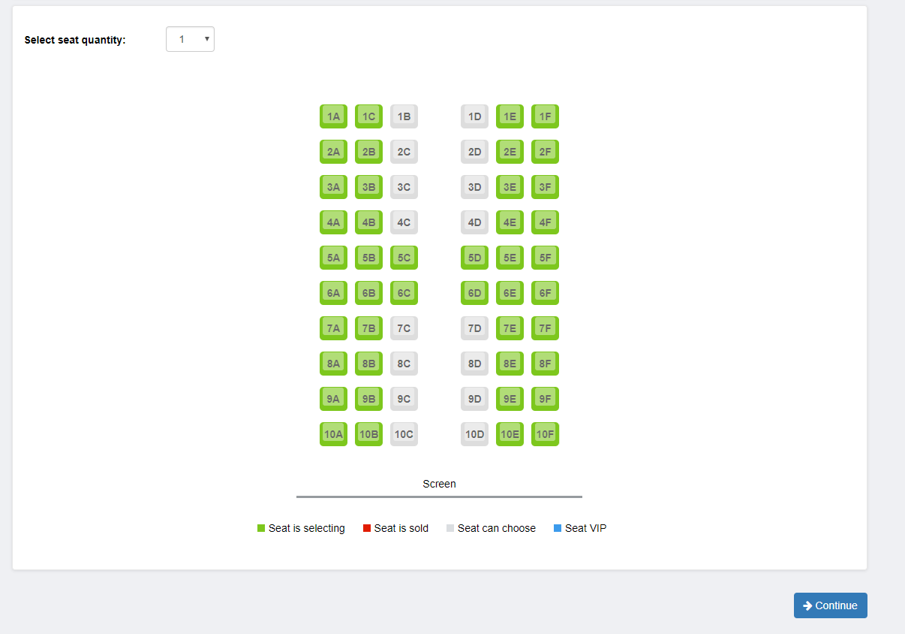

Screen | Booking ticket – Selecting seat
Description |  | Display seat map of the movie and selected showtime
Screen Access |  | The user accesses after selecting movie and showtime
Screen Content
Item |  | Type | Data | Description
Select seat quantity |  | Combobox | N/A | Display list of seat quantity for the user to select
Seat |  | CheckBox | N/A | Display seat map for the user to choose
Continue |  | Button | N/A | Send information of seat selection and display the screen of ticket booking information
Screen Action
Action name |  | Description |  | Success | Failure
Select seat quantity |  | Display list of seat quantity that customer needs to select (0, 1, 2, …8) |  | Display list of seat quantity
Select seat |  | Display seat map for the customer to choose according to selected seat quantity |  | When selecting the seat number as the same as selected seat quantity in combobox of Select seat quantity | If selected seat number is less than the seat quantity at the combobox, display the message "Please selecte x seat more"  - If selected seat number is more than the seat quantity at the combobox, display the message "Please select only x seat"
Continue |  | Send ticket booking request, send seat selection information and display booking information screen |  | Display Confirm booking ticket screen

Booking ticket – Confirm booking ticket
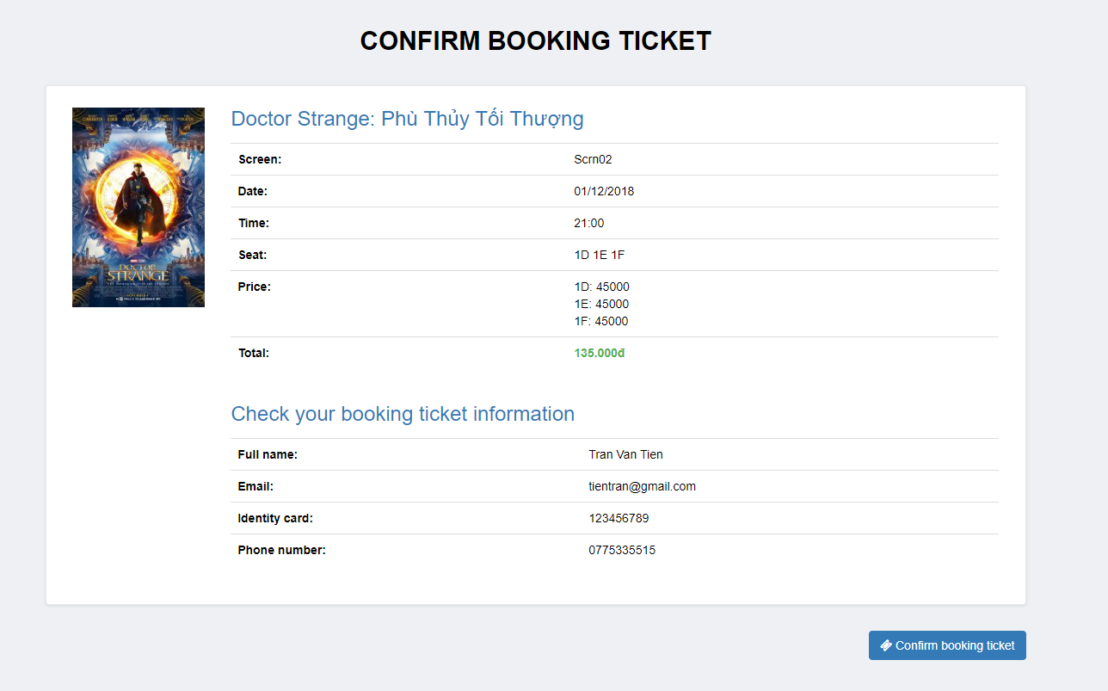
Screen | Booking ticket – Confirm booking ticket
Description |  | Display all ticket booking informatiom
Screen Access |  | The user accesses after selecting seat
Screen Content
Item |  | Type | Data | Description
Movie name |  | Label | N/A
Screen |  | Label | N/A
Date |  | Label | N/A
Time |  | Label | N/A
Seat |  | Label | N/A
Price |  | Label | N/A
Total |  | Label | N/A
Full name |  | Label | N/A
Email |  | Label | N/A
Identity card |  | Label | N/A
Phone number |  | Label | N/A
Confirm booking ticket |  | Button | N/A
Screen Action
Action name |  | Description |  | Success | Failure
Confirm booking ticket |  | Select to send all ticket booking information |  | Display screen of ticket booking information

Booking ticket – Ticket information
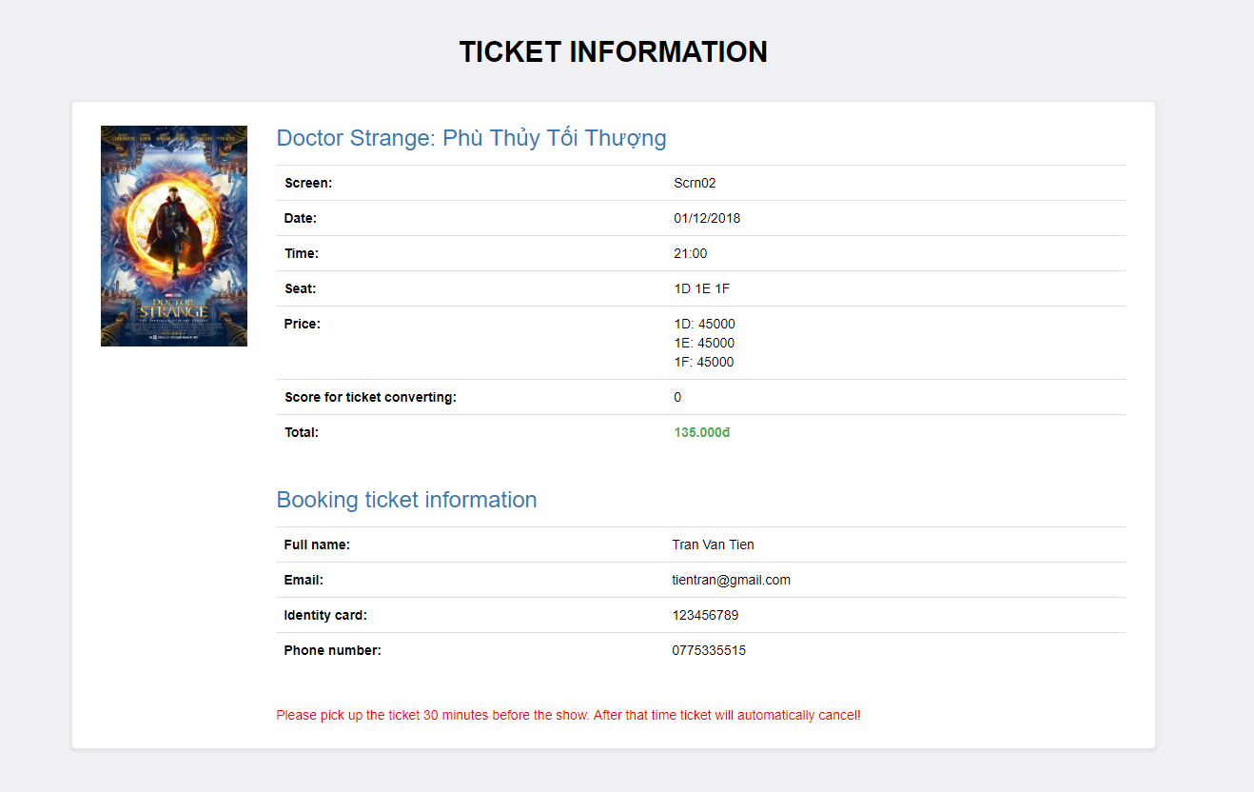

Screen | Booking ticket – Ticket information
Description |  | Display all ticket booking information
Screen Access |  | The user accesses after seleting seat
Screen Content
Item |  | Type | Data | Description
Movie name |  | Label | N/A
Booking ID |  | Label | N/A
Screen |  | Label | N/A
Date |  | Label | N/A
Time |  | Label | N/A
Seat |  | Label | N/A
Price |  | Label | N/A
Total |  | Label | N/A
Full name |  | Label | N/A
Email |  | Label | N/A
Identity card |  | Label | N/A
Phone number |  | Label | N/A
Screen Action
Action name |  | Description |  | Success | Failure

Ticket selling management
Use Case Name | Ticket selling management
Use Case ID
High Level Requirement Ref
Actor | Admin/Manager/Admin
Description | Allows the user to manage selling ticket
Trigger | N/A
Pre-condition | The user must log in the system
Post-processing

Ticket selling management – Select movie and showtime



Screen | Booking ticket – Select movie and showtime
Description |  | Display current movies and showtime
Screen Access |  | The user accesses Booking ticket
Screen Content
Item |  | Type | Data | Description
Date |  | Combobox | N/A
Showtime |  | Button | N/A
Movie name |  | Label | N/A
Time |  | Link | N/A
Screen Action
Action name |  | Description |  | Success | Failure
View showtime |  | Display list of show dates for the user to select |  | Display showtime list of current movies | If no showtime has been found, display message: “No showtime”
Showtime |  | Display showtime of each movie |  | Send information of movies and showtimes, display the Select seat screen

Ticket selling management – Selecting seat

Screen | Booking ticket – Select seat
Description |  | Display seat map of the movie and selected showtime
Screen Access |  | The user accesses after selecting movie and showtime
Screen Content
Item |  | Type | Data | Description
Select seat quanity |  | Combobox | N/A | Display list of seat quantity for the user to select
Seat |  | CheckBox | N/A | Display seat map for the user to select
Continue |  | Button | N/A | Send information of selecting seat and display ticket booking information
Screen Action
Action name |  | Description |  | Success | Failure
Select seat quantity |  | Display list of seat quantity that customer needs (0, 1, 2, …8) |  | Display list of seat quantity
Select seat |  | Display seat map, the employee chooses seat according to selected seat quantity at Combobox of Select seat quantity. |  | When selecting the seat number as the same as selected seat quantity in combobox of Select seat quantity | If selected seat number is less than the seat quantity at the combobox, display the message "Please selecte x seat more"  - If selected seat number is more than the seat quantity at the combobox, display the message "Please select only x seat"
Continue |  | Send ticket booking request, send seat selection information and display booking information screen |  | Display Confirm booking ticket screen

Ticket selling management – Confirm ticket
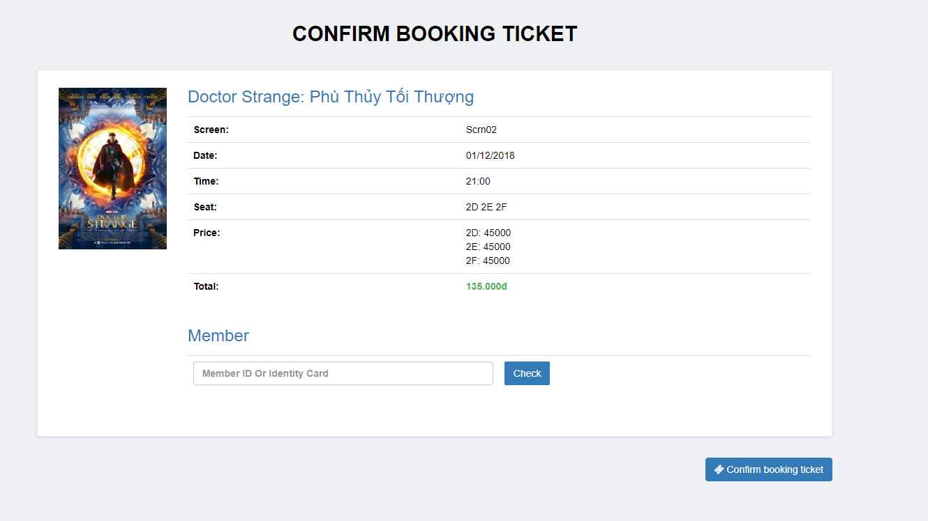
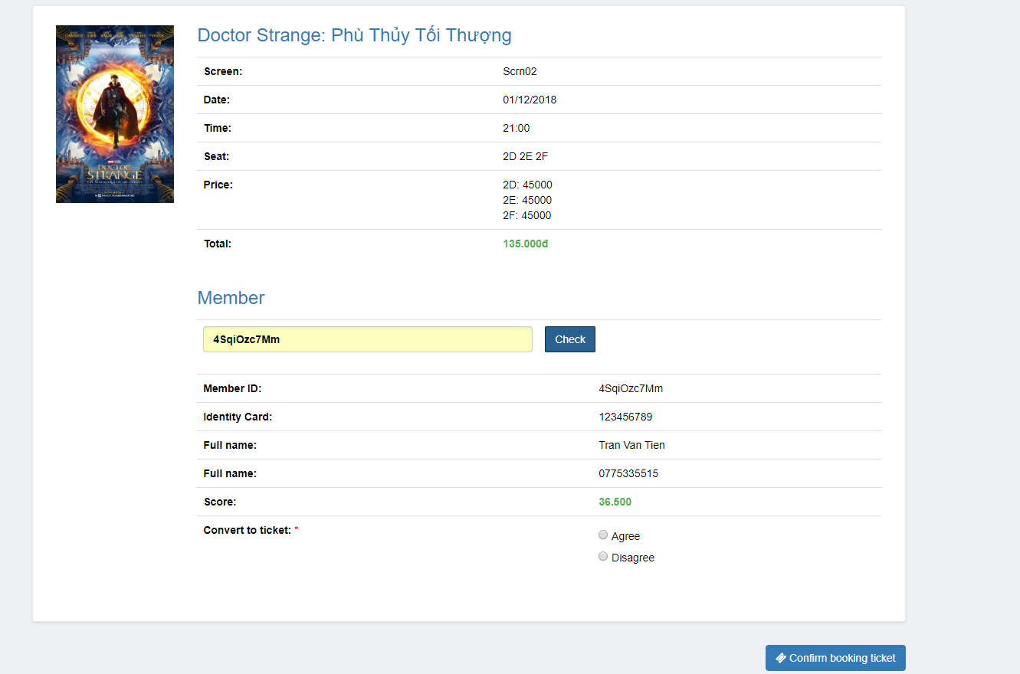
Screen | Ticket selling management – Confirm ticket
Description |  | Display all ticket selling information
Screen Access |  | The user accesses after selecting seat
Screen Content
Item |  | Type | Data | Description
Movie name |  | Label | N/A
Screen |  | Label | N/A
Date |  | Label | N/A
Time |  | Label | N/A
Seat |  | Label | N/A
Price |  | Label | N/A
Total |  | Label | N/A
Member |  | Textbox | N/A
Check |  | Button | N/A
Member ID |  | Label | N/A
Identity card |  | Label | N/A
Full name |  | Label
Member score |  | Label | N/A
Convert to ticket |  | Radio | N/A
Phone number |  | Label | N/A
Confirm booking ticket |  | Button | N/A
Screen Action
Action name |  | Description |  | Success | Failure
Confirm booking ticket |  | Select Confirm booking ticket to send all ticket booking information |  | Send information of ticket selling, display screen of ticket booking information | If the member converts score into ticket, while score is not enough to convert, display message: “Member score is not enough to convert into ticket”
Check member |  | Input member ID or identity card number to get information of member |  | Display information of member | Display the message: “No member has found!”
Convert to ticket |  | Select number of tickets that the member wants to conver into |  | When number of converted tickets matches with enough member score

Ticket selling management – Ticket information
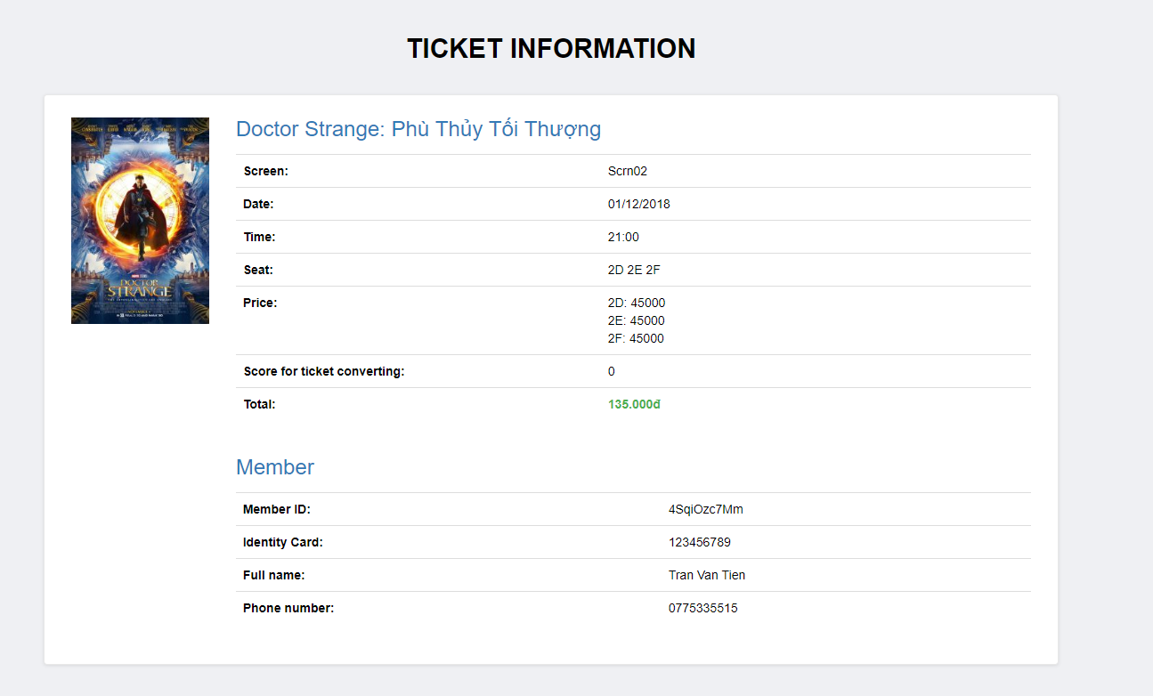
Screen | Ticket selling management – Ticket information
Description |  | Display all ticket information
Screen Access |  | The user accesses after selecting seat
Screen Content
Item |  | Type | Data | Description
Movie name |  | Label | N/A
Ticket booking ID |  | Label | N/A
Screen |  | Label | N/A
Date |  | Label | N/A
Time |  | Label | N/A
Seat |  | Label | N/A
Price |  | Label | N/A
Convert to ticket |  | Label | N/A
Score for ticket converting |  | Label | N/A
Total |  | Label | N/A
Member ID |  | Label | N/A
Email |  | Label | N/A
Identity card |  | Label | N/A
Phone number |  | Label | N/A
Screen Action
Action name |  | Description |  | Success | Failure

Ticket booking management
Use Case Name | Ticket booking management
Use Case ID
High Level Requirement Ref
Actor | Admin/Manager/Employee
Description | Allows the users to manage ticket booking of members
Trigger | NA
Pre-condition | The user must log in the system
Post-processing

Ticket booking management – Search
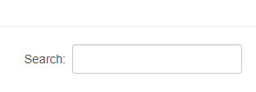
Screen | Ticket booking management - Search
Description |  | Display current movies and showtime
Screen Access |  | The user accesses Ticket booking management
Screen Content
Item |  | Type | Data | Description
Search |  | Textbox | N/A | Input the keywords to search including Booking ID, account ID, phone number or identity card number of booking account
Search |  | Button | N/A | Select Search button
Screen Action
Action name |  | Description |  | Success | Failure
Search |  | Click the search button, the booking list will filter the data  Filtering data by keyword entered in the search textbox matches with the booking code, account code, phone number or identity card number of the booking account, then display on the list |  | Display the booking list of the account | Show the message "No booking found!"

Ticket booking management – Booking list
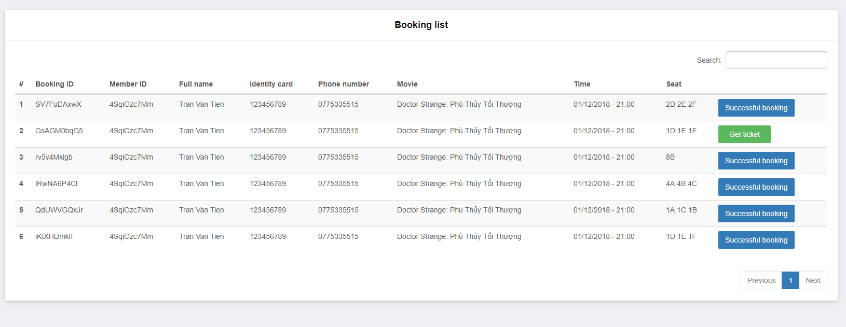
Screen | Ticket booking management – Booking list
Description |  | Display current movies and showtime
Screen Access |  | The user accesses Booking ticket
Screen Content
Item |  | Type | Data | Description
Booking ID |  | Label | N/A
Identity card |  | Label | N/A
Phone number |  | Label | N/A
Movie |  | Label | N/A
Time |  | Label | N/A
Successful booking |  | Button | N/A
Screen Action
Action name |  | Description |  | Success | Failure
Confirm booking |  | Click Confirm booking to view booking information |  | Display information of booking detail of member

Ticket booking management – Confirm booking
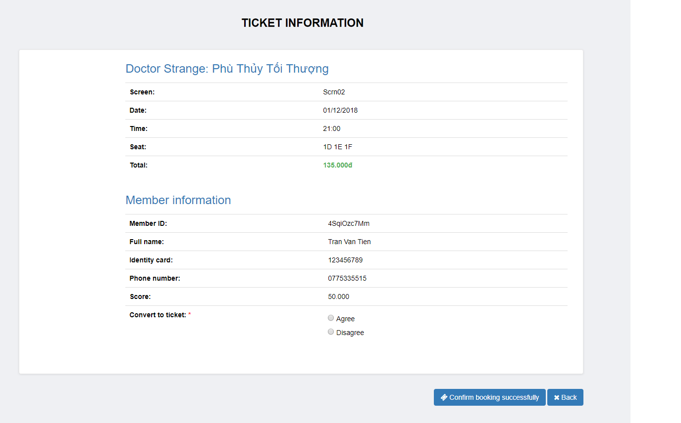
Screen | Booking management – Confirm booking
Description |  | Display all booking information
Screen Access |  | The user accesses after selecting booking ticket at booking list
Screen Content
Item |  | Type | Data | Description
Movie name |  | Label | N/A
Booking ID |  | Label | N/A
Screen |  | Label | N/A
Date |  | Label | N/A
Time |  | Label | N/A
Seat |  | Label | N/A
Price |  | Label | N/A
Total |  | Label | N/A
Member ID |  | Label | N/A
Full name |  | Label | N/A
Member score |  | Label | N/A
Identity card |  | Label | N/A
Convert to ticket |  | Radio | N/A
Phone number |  | Label | N/A
Confirm booking |  | Button | N/A
Screen Action
Action name |  | Description |  | Success | Failure
Member score |  | Click to convert member score into ticket |  | Display screen Information of converting score into ticket | Display message: “Not enough score to convert into ticket”
Confirm booking |  | Click to send request to confirm converting score into ticket |  | Confirm converting into ticket, display ticket booking management

Ticket booking management – Information of converting into ticket
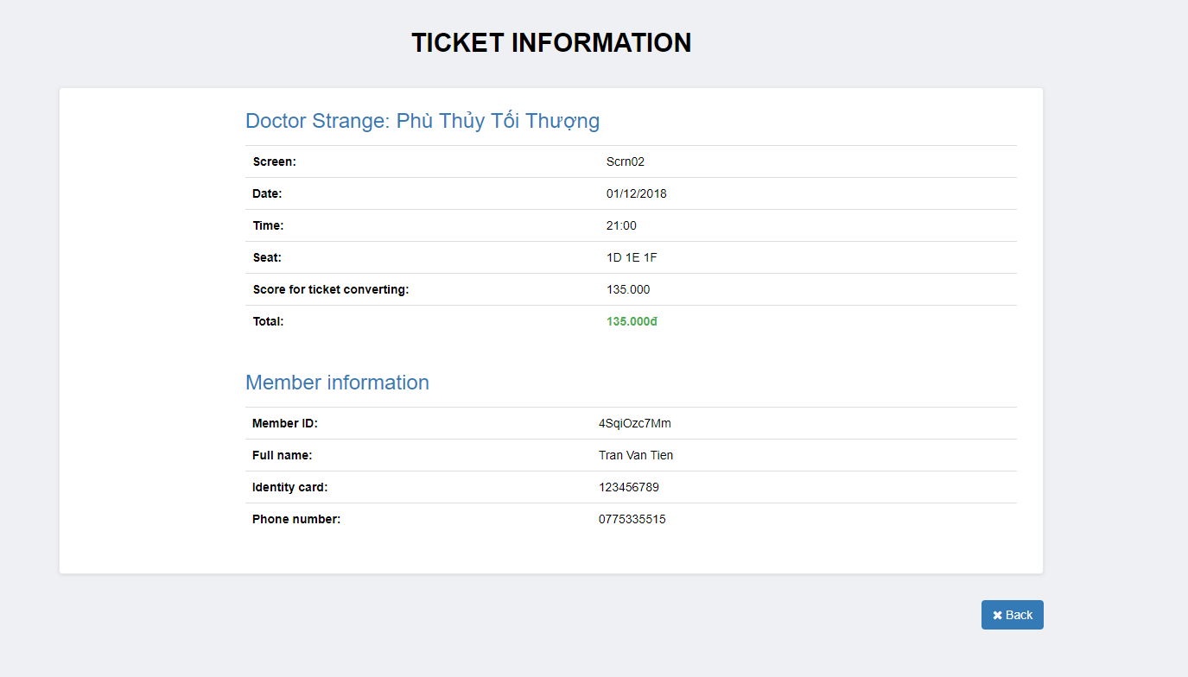
Screen | Booking management – Confirm booking successfully
Description |  | Display all booking information
Screen Access |  | The user accesses after selecting Booking ticket at booking list
Screen Content
Item |  | Type | Data | Description
Movie name |  | Label | N/A
Booking ID |  | Label | N/A
Screen |  | Label | N/A
Date |  | Label | N/A
Time |  | Label | N/A
Seat |  | Label | N/A
Price |  | Label | N/A
Convert to ticket |  | Label | N/A
Score for ticket converting |  | Label | N/A
Total |  | Label | N/A
Member ID |  | Label | N/A
Full name |  | Label | N/A
Identity card |  | Label | N/A
Phone number |  | Label | N/A
Action name |  | Description |  | Success | Failure

Employee management
Use Case Name | Employee management
Use Case ID
High Level Requirement Ref | Admin/Manager
Actor | The function allows to add, edit, delete, change password of employee.
Description | N/A
Trigger | Only admin has right to implement functions
Pre-condition | Admin must login the system
Post-processing

Employee management – View employee list
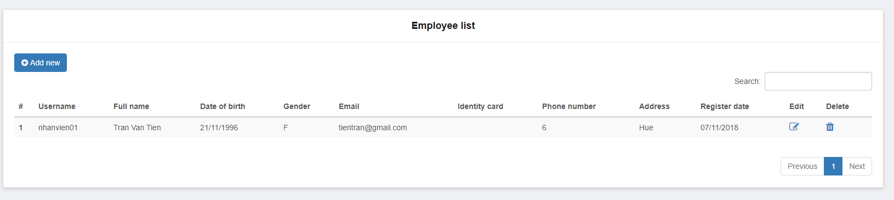
Screen | Screen to display employee list
Description |  | Function of viewing information of movie theater employee  Allows to search, add, edit, delete employees
Screen Access
Screen Content
Item |  | Type | Data | Description
Employee ID |  | Label
Employee name |  | Label
Identity card |  | Label
Email |  | Label
Phone number |  | Label
Address |  | Label
Edit |  | Button | N/A
Delete |  | Button | N/A
Add |  | Button | N/A
Search |  | TextBox - nvarchar (28) | N/A
Search |  | Button | N/A
Screen Action
Action name |  | Description |  | Success | Failure
Add |  | Click Add employee button to add an employee |  | Forward to Add employee function | N/A
Edit |  | Click Edit employee button to edit information of an employee |  | Forward to Edit employee function | N/A
Delete |  | Click Delete employee button to delete information of an employee |  | Forward to Delete employee function | N/A
Search |  | 1.Input keyword into Input_Text Search  2.Click Search button |  | Updated Cinema room list is list of cinema room according to search keyword. | N/A

Employee management – Add employee
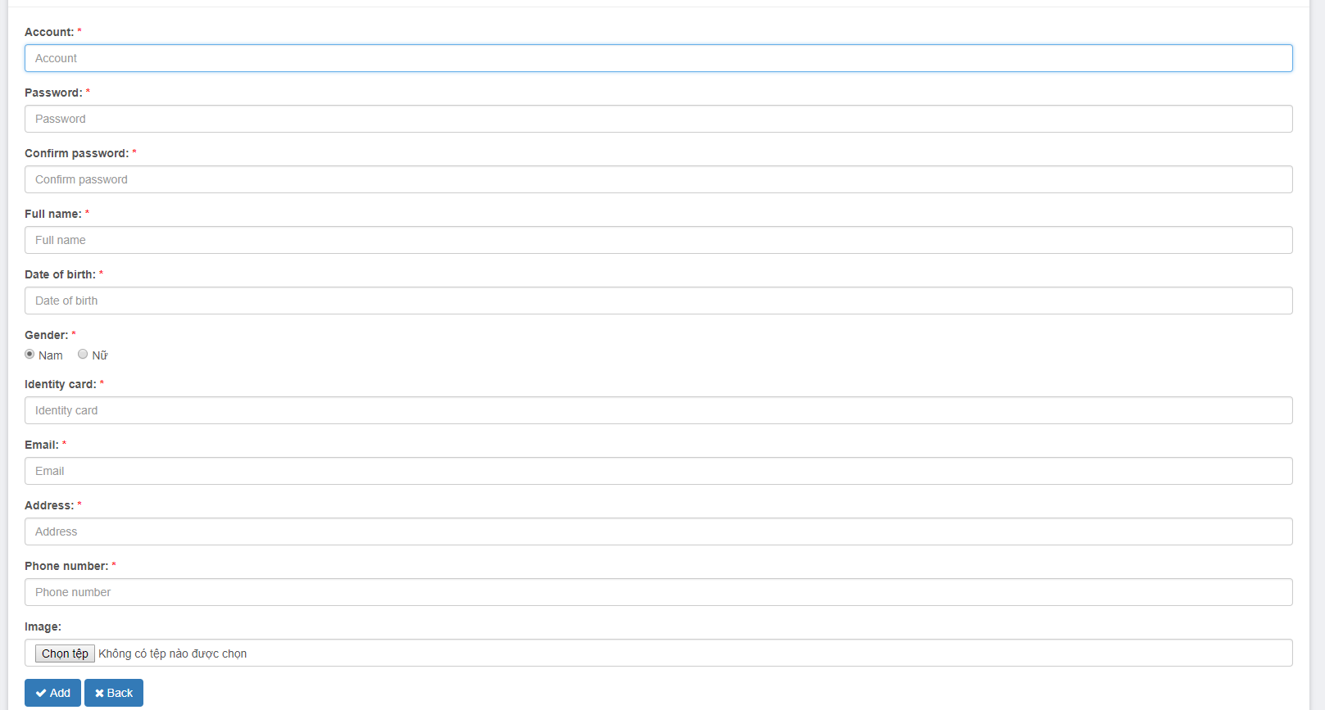
Screen | Screen to add employee
Description |  | Function to add employee
Screen Access
Screen Content
Item |  | Type | Data | Description
Image |  | Button | N/A
Account |  | TextBox - nvarchar (28) | N/A
Password |  | TextBox - nvarchar (28) | N/A
Confirm password |  | TextBox - nvarchar (28) | N/A
Date of birth |  | DataDatetime | N/A
Sex |  | checkbox | N/A
Employee name |  | TextBox - nvarchar (28) | N/A
Identity card |  | TextBox - nvarchar (28) | N/A
Email |  | TextBox - nvarchar (28) | N/A
Phone number |  | TextBox - nvarchar (28) | N/A
Address |  | TextBox - nvarchar (28) | N/A
Add |  | Button | N/A
Back |  | Button
Screen Action
Action name |  | Description |  | Success | Failure
Add |  | Add employee |  | Add inputted employee information into database.  Forward to Employee management screen – View employee list | Display the message: “The inputted account is already existed, please choose another account name”
Back |  | Back to previous screen |  | Back to previous screen | N/A

Employee management – Edit employee
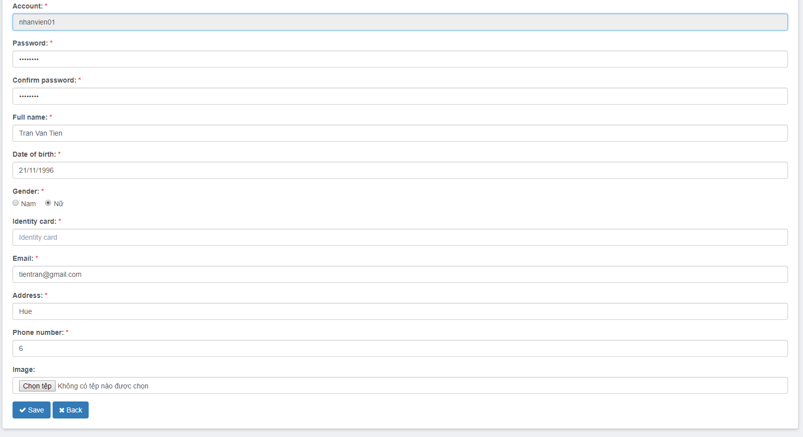
Screen | Screen to edit employee
Description |  | Function to edit employee information
Screen Access
Screen Content
Item |  | Type | Data | Description
Image |  | Button | Display image of the selected employee to edit
Account |  | TextBox - nvarchar (28) | Display account name of selected employee to edit
Password |  | TextBox - nvarchar (28) | N/A
Confirm password |  | TextBox - nvarchar (28) | N/A
Full name |  | TextBox - nvarchar (28) | Display full name of selected employee to edit
Date of birth |  | DataDatetime | Display date of birth of selected employee to edit
Sex |  | chechbox | Display sex of selected employee to edit
Email |  | TextBox - nvarchar (28) | Display email of selected employee to edit
Identity card |  | TextBox - nvarchar (28) | Display identity card number of selected employee to edit
Phone number |  | TextBox - nvarchar (28) | Display phone number of selected employee to edit
Address |  | TextBox - nvarchar (28) | Display address of selected employee to edit.
Edit |  | Button | N/A | Click to edit employee
Back |  | Button |  | Back to the previous screen
Screen Action
Action name |  | Description |  | Success | Failure
Edit |  | Edit information of an employee |  | Edit successfully information of an employee. Edit information of employee in database. Forward to screen of employee management – View employee list | N/A
Back |  | Back to the previous screen |  | Back to the previous screen | N/A

Employee management – Delete employee

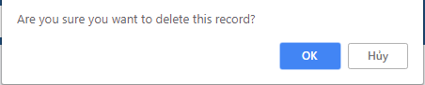
Screen | Employee management – Delete movie
Description |  | Delete movie information
Screen Access |  | Admin clicks menu Movie management -> Delete
Screen Content
Item |  | Type | Data
Yes |  | Button
No |  | Button
Screen Actions
Action Name |  | Description |  | Success
Confirm |  | Agree to delete movie |  | Movie is deleted from database and display screen of movie list
No |  | Close confirm screen |  | Display screen of movie list

Screen | Screen to delete employee
Description | Function to delete employee information
Screen Access
Screen Content
Item |  | Type | Data | Description
Image |  | FormFile | Display image of selected employee to edit
Account |  | TextBox - nvarchar (28) | Display account of selected employee to edit
Password |  | TextBox - nvarchar (28) | N/A
Confirm password |  | TextBox - nvarchar (28) | N/A
Full name |  | TextBox - nvarchar (28) | Display full name of selected employee to edit
Date of birth |  | DataDatetime | Display Date of birth of selected employee to edit
Sex |  | chechbox | Display sex of selected employee to edit
Email |  | TextBox - nvarchar (28) | Display email of selected employee to edit.
Identity card |  | TextBox - nvarchar (28) | Display identity card number of selected employee to edit
Phone number |  | TextBox - nvarchar (28) | Display phone number of selected employee to edit
Address |  | TextBox - nvarchar (28) | Display address of selected employee to edit.
Delete |  | Button | N/A | Click to Delete employee
Back |  | Button |  | Back to the previous screen
Screen Action
Action name |  | Description |  | Success | Failure
Delete |  | Delete an employee |  | Successfully deleting an employee is changing status of the employee into Disable(2) in database. Forward to screen: Employee management – View employee list. | N/A
Back |  | Back to the previous screen |  | Back to the previous screen | N/A

Cinema room management
Use Case Name | Cinema room management
Use Case ID
High Level Requirement Ref | Admin, user
Actor | Allows to add cinema room
Description | NA
Trigger | Only admin has right to implement functions
Pre-condition | Admin must login the system

Cinema room management – Display list of cinema rooms
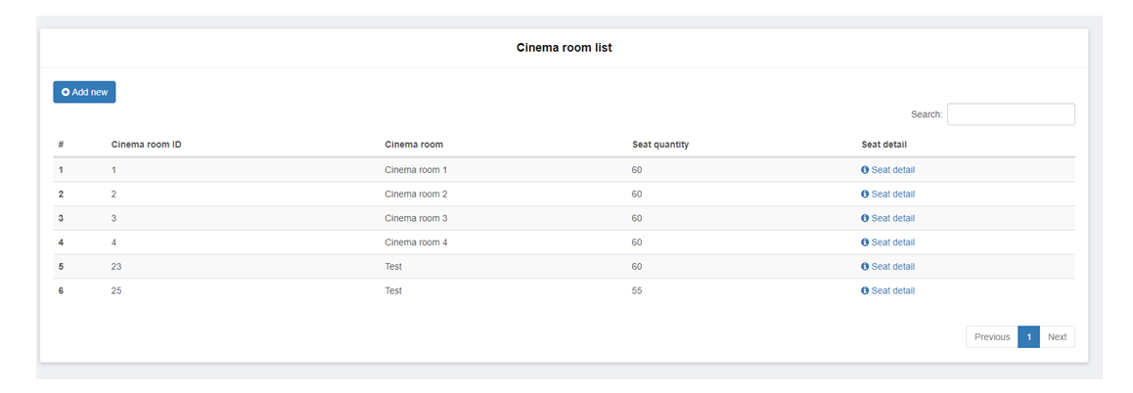
Screen | Screen to display cinema room list
Description |  | Function to view list of cinema room information and search for keyword  Allows to add, edit cinema room seat types
Screen Access
Screen Content
Item |  | Type | Data | Description
Cinema room ID |  | Label
Cinema room |  | Label
Seat quantity |  | Label
Seat detail |  | Button | N/A
Add cinema room |  | Button | N/A
Search |  | TextBox - nvarchar (28) | N/A
Search |  | Button | N/A
Screen Actions
Action name |  | Description |  | Success | Failure
Seat detail |  | Click Seat detail button of each cinema room to view detail, edit seat type in that cinema room. |  | Forward to Cinema room detail screen and implement functions of cinema room details. | N/A
Search |  | 1.Input keyword into Input_Text Search  2.Click Search button |  | Updated Cinema room list is list of cinema room according to search keyword. | N/A
Back |  | Back to previous screen |  | Back to previous screen | N/A

Cinema room management – Cinema room detail
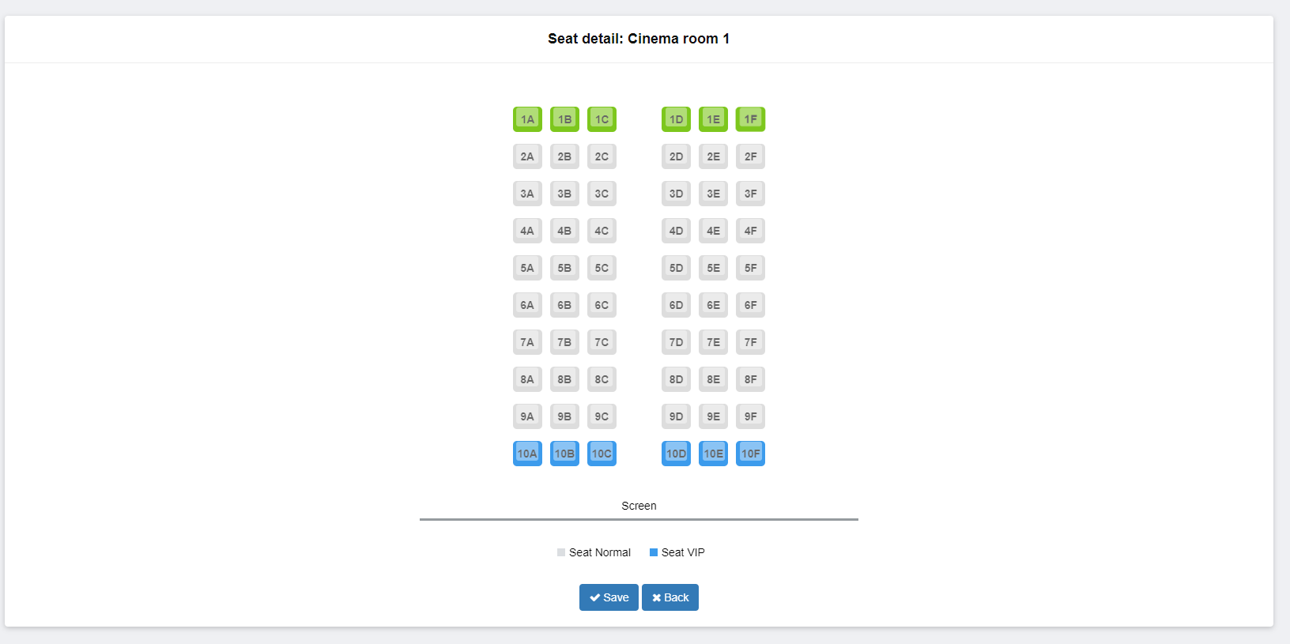
Screen | Detail screen of cinema room
Description |  | Function to view information and edit seat type in selected cinema room
Screen Access
Screen Content
Item |  | Type | Data | Description
Cinema room |  | Label
Seat |  | Checkbox
Save |  | Button | N/A
Back |  | Button | N/A
Screen Action
Action name |  | Description |  | Success | Failure
Select seat |  | Select seat to change status of the seat from this status into another status  (Normal seat – VIP seat) |  | Selected seat color is changed into green color | N/a
Save |  | Click to save change in database |  | Edit successfully in database. Change status of selected seats. Return screen of cinema room management | .  Re-display the screen of this function.

Movie management
Use Case Name | Movie management
Use Case ID
High Level Requirement Ref
Actor | Admin/Manager
Description | Allows admin to view, add, edit movie information
Trigger | The user must log in the system as admin right
Pre-condition

Movie management – View movie list
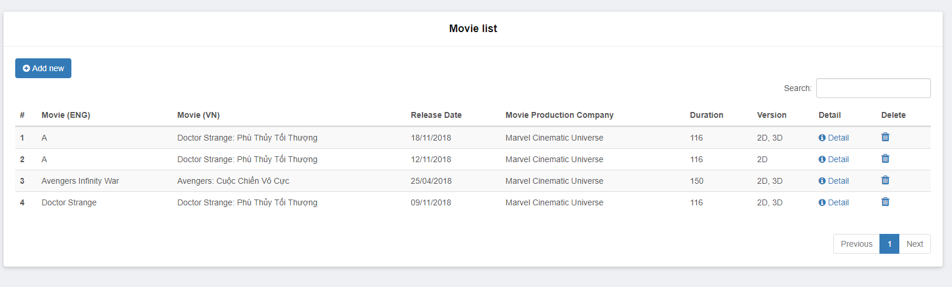
Screen |  | View movie list
Description |  | Display movie list
Screen Access |  | The user clicks Movie management
Screen Content
Item |  | Type | Data |  | Description
Movie |  | Lable – String | N/A
Release date |  | Lable – String | N/A
Movie production company |  | Lable – String | N/A
Movie running time |  | Lable – Number | N/A
Version |  | Lable – String | N/A
Edit |  | Button | N/A
Add movie |  | Button | N/A
Screen Action
Action name | Description |  |  | Success |  | Failure
Add movie | Forward to page of adding movie |  |  | Display page of adding movie
Edit | Forward to page of editing movie |  |  | Display page of editing movie

Movie management – Add movie
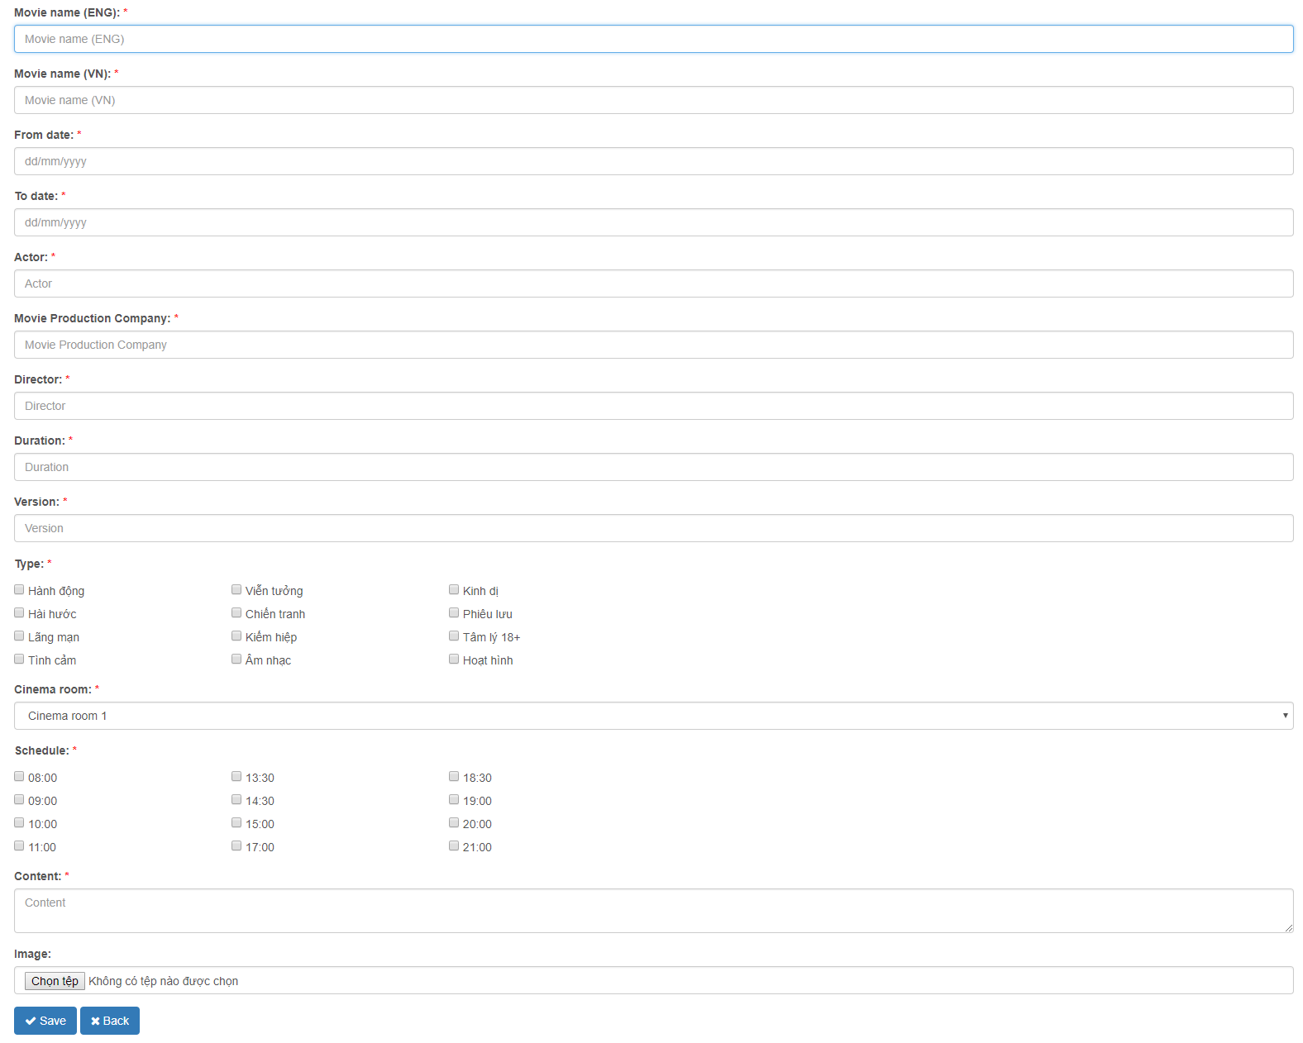
Screen |  | Add movie
Description |  | Add 1 movie into database
Screen Access |  | The user clicks Movie management -> Add movie
Screen Content
Item |  | Type | Data |  | Description
Movie name |  | TextBox – String | N/A
From date |  | Date | N/A
To date |  | Date | N/A
Actor |  | TextBox – String | N/A
Movie production company |  | TextBox – String | N/A
Director |  | TextBox – String | N/A
Running time |  | TextBox – Number | N/A
Version |  | RadioBox | N/A
Trailer |  | TextBox – Number | N/A
Type |  | CheckBox | N/A
Cinema room |  | ComboBox | N/A
Showtime |  | TextBox – String | N/A
Content |  | TextBox – String | N/A
Add cinema time |  | Button | N/A
Choose file |  | Button | N/A
Submit |  | Button | N/A
Screen Action
Action name | Description |  |  | Success |  | Failure
Add movie | Add movie into database, after admin inputs all information, then click Add movie to add movie. |  |  | Back to page of Movie management |  | Display the error message

Movie management – Edit movie information
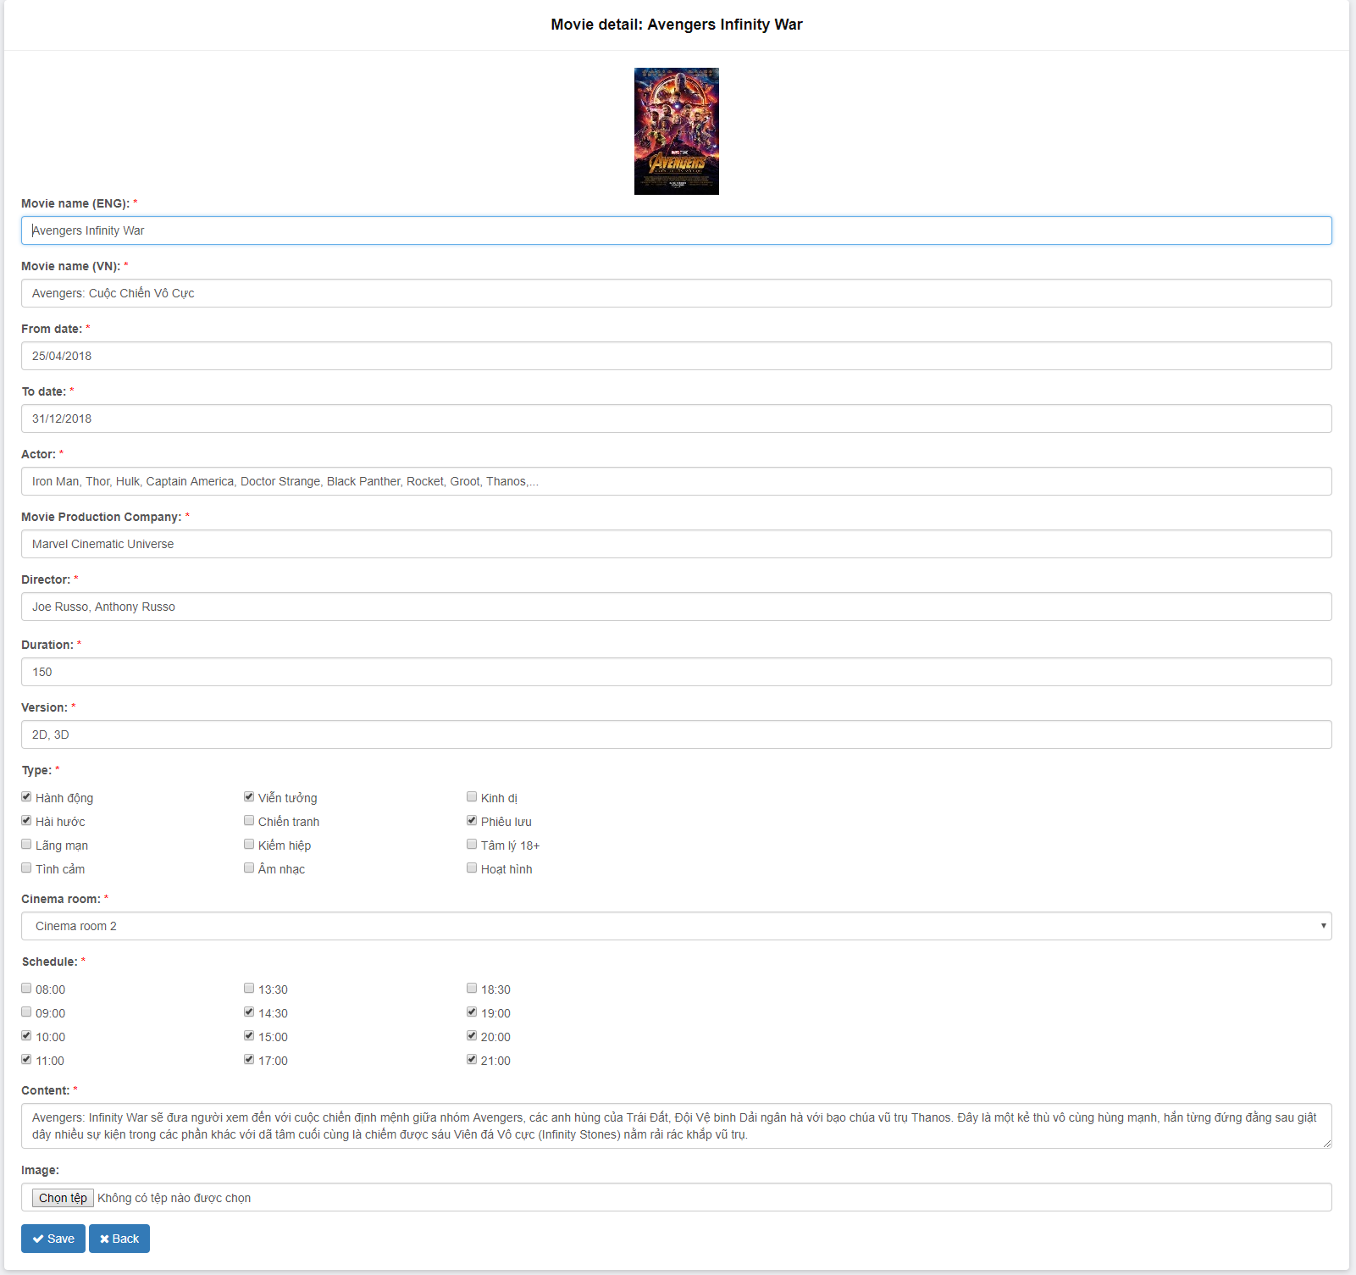
Screen |  | Update movie information
Description |  | Update information of the movie
Screen Access |  | The user clicks Movie management -> Edit
Screen Content
Item |  | Type | Data |  | Description
Movie name |  | TextBox – String | N/A
From date |  | Date | N/A
To date |  | Date | N/A
Actor |  | TextBox – String | N/A
Movie production company |  | TextBox – String | N/A
Director |  | TextBox – String | N/A
Running time |  | TextBox – Number | N/A
Version |  | RadioBox | N/A
Trailer |  | TextBox - String | N/A
Type |  | CheckBox | N/A
Ciname room |  | ComboBox | N/A
Showtime |  | TextBox – String | N/A
Content |  | TextBox – String | N/A
Add movie time |  | Button | N/A
Choose file |  | Button | N/A
Submit |  | Button | N/A
Back |  | Button | N/A
Screen Action
Action name | Description |  |  | Success |  | Failure
Edit | Edit information of movie. After admin edits information, then click Submit to update all information of the movie. |  |  | Back to movie management |  | Display error messages

Movie management – Delete movie

Screen | Movie management – Delete movie
Description |  | Delete information of the movie
Screen Access |  | Admin clicks menu Movie management -> Delete
Screen Content
Item |  | Type | Data
Yes |  | Button
No |  | Button
Screen Actions
Action Name |  | Description |  | Success
Confirm |  | Agree to delete movies |  | The movie is deleted from database and display Movie list screen
No |  | Close confirm screen |  | Display Movie list screen

Promotion management
Use Case Name | Promotion management
Use Case ID
High Level Requirement Ref
Actor | Admin
Description | Allows users to manage promotion programs of the movie theater
Trigger
Pre-condition | The user must log in the system
Post-processing

Promotion management – View promotion list
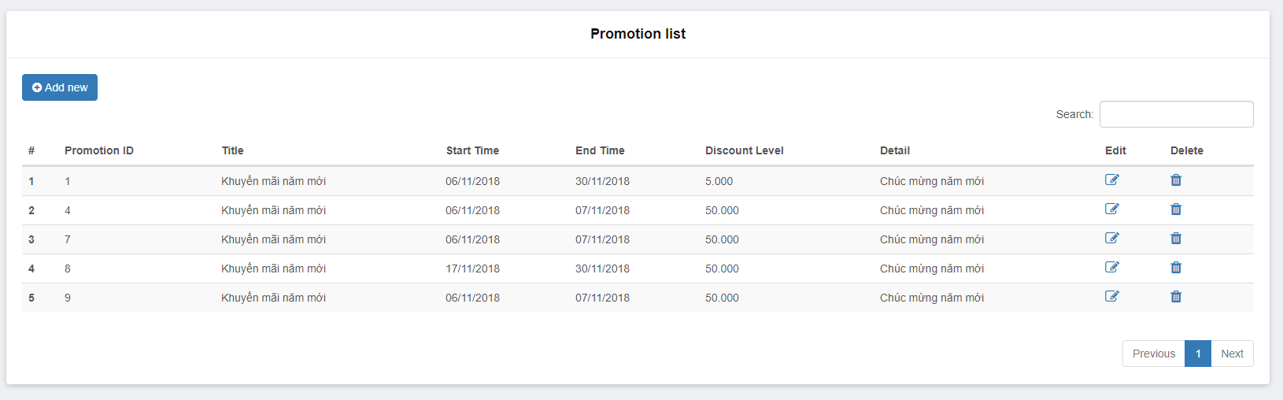
Screen | View promotion list of system
Description |  | Allows to search, add, edit, delete promotions
Screen Access |  | Admin clicks menu Promotion management
Screen Content
Item |  | Type | Data | Description
Title |  | Lable – String | N/A
Start time |  | Lable – String | N/A
End time |  | Lable – String | N/A
Promotion |  | Lable – String | N/A
Detail |  | Lable – String | N/A
Edit |  | Button | N/A
Add |  | Button | N/A
Delete |  | Button | N/A
Search |  | TextBox - nvarchar (28) | N/A
Search |  | Button | N/A
Screen Action
Action name |  | Description |  | Success | Failure
Add |  | Click Add promotion button to add a promotion |  | Forward to Add promotion function | N/A
Edit |  | Click Edit promotion button to edit information of a promotion |  | Forward to Edit promotion function | N/A
Delete |  | Click Delete promotion button to delete information of a promotion |  | Forward to Delete promotion function | N/A
Search |  | 1.Input keyword into Input_Text Search  2.Click Search button |  | Updated promotion list is list of promotion according to search keyword. | N/A

Promotion management – Add promotion
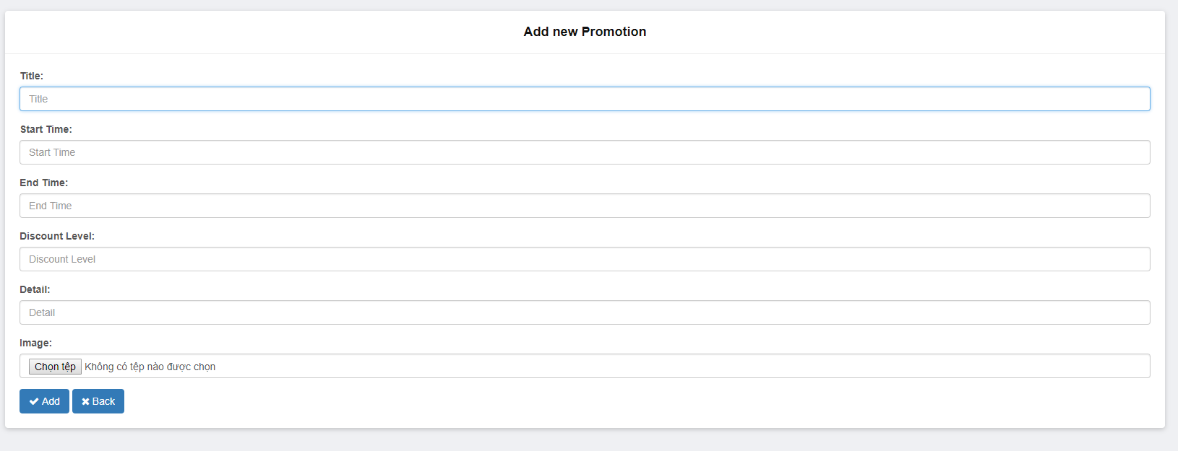
Screen |  | Add promotion
Description |  | Add promotion
Screen Access |  | Admin clicks menu Promotion management -> Add promotion
Screen Content
Item |  | Type | Data |  | Description
Image |  | Button | N/A
Title |  | TextBox – String | N/A
Start time |  | ComboBox | N/A
End time |  | ComboBox | N/A
Promotion |  | TextBox – Number | N/A
Detail |  | TextBox – String | N/A
Add |  | Button | N/A
Back |  | Button
Screen action
Action name | Description |  |  | Success |  | Failure
Add | After admin inputs and selects all information, then click Add, the system will add a promotion into database |  |  | Add inputted promotion information into database.  Back to Promotion management screen – View promotion list |  | Display the message: “Unsuccessfully add”. Display Add promotion screen.
Back | Back to previous screen |  |  | Back to previous screen |  | N/A

Promotion management – Edit promotion

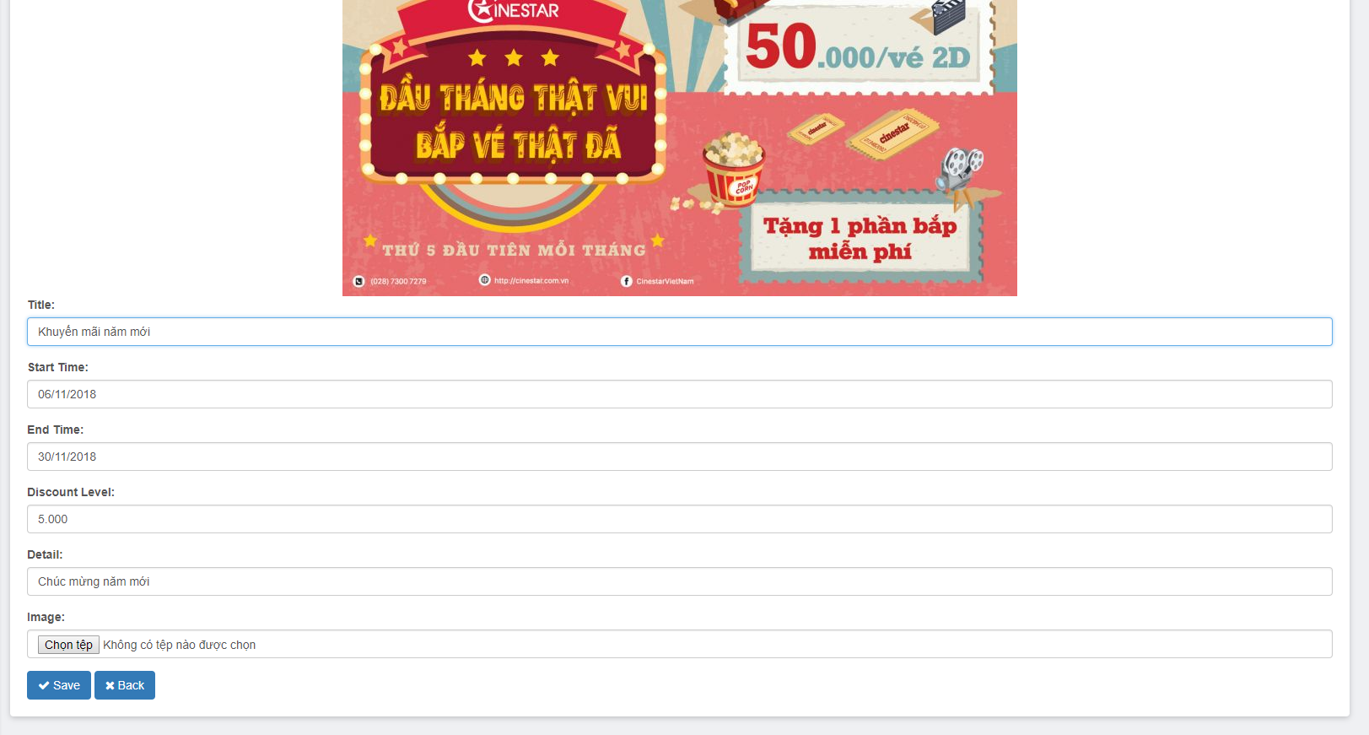
Screen |  | Edit promotion
Description |  | Edit information of promotion
Screen Access |  | Admin clicks menu Promotion management -> Edit
Screen Content
Item |  | Type | Data |  | Description
Image |  | Button | Display image of the selected promotion to edit
Title |  | TextBox – String | Display title of the selected promotion to edit
Start time |  | ComboBox | Display start time of the selected promotion to edit
End time |  | ComboBox | Display end time of the selected promotion to edit
Promotion |  | TextBox – Number | Display sales off detail of the selected promotion to edit
Detail |  | TextBox – String | Display detail of the selected promotion to edit
Edit |  | Button | N/A
Screen Action
Action name | Description |  |  | Success |  | Failure
Edit | Edit the information that needs updating of the promotion |  |  | Display the message “Successfully add”. Edit information of promotion in database. Forward to screen of Promotion management – View promotion list |  | Display the message: “Unsuccessfully add”. Display Edit promotion screen.
Back | Back to previous screen |  |  | Back to previous screen |  | N/A

Promotion management – Delete promotion


Screen | Delete promotion
Description |  | Delete information of the promotion
Screen Access |  | Admin clicks menu Promotion management -> Delete
Screen Content
Item |  | Type | Data
Yes |  | Button
No |  | Button
Screen Actions
Action Name |  | Description |  | Success
Confirm |  | Agree to delete promotion |  | Promotion is deleted from database and display screen of promotion list
No |  | Close confirm screen |  | Display screen promotion list

  - Detailed Non-Functional Requirements

Logical Structure of the Data
The logical structure of the data to be stored on the system is given below
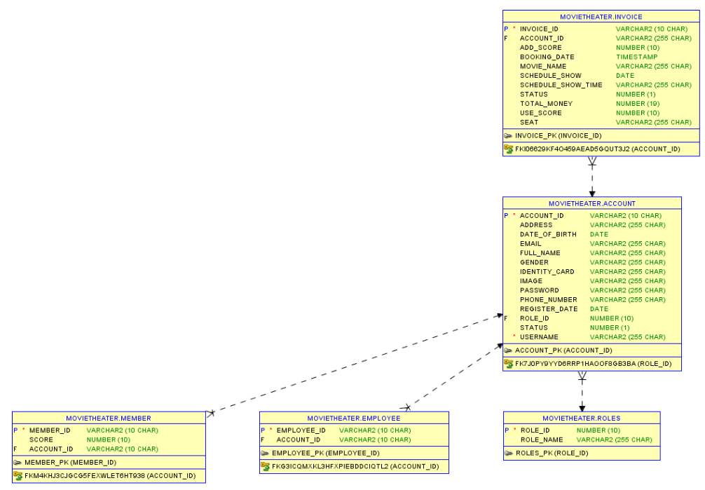

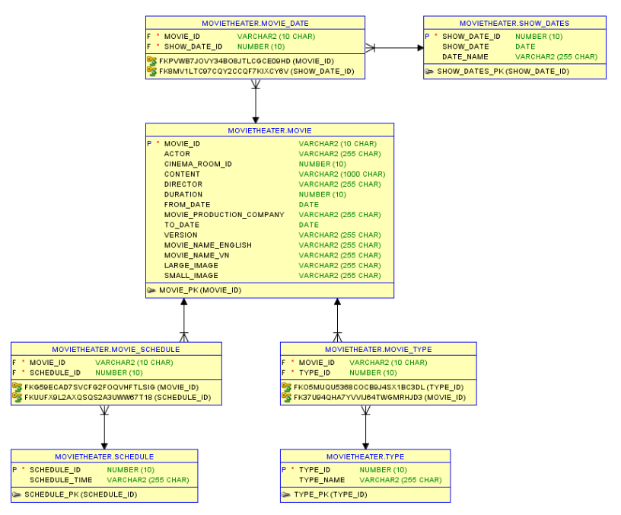
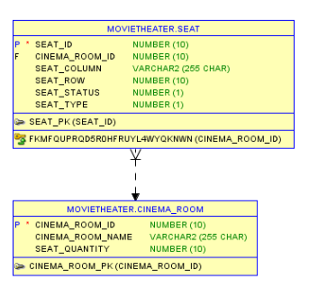
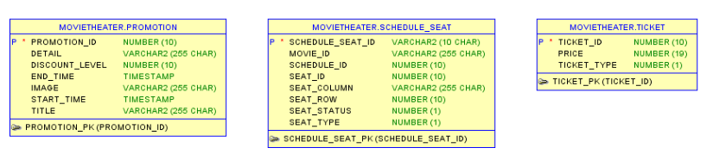

Security
TBD

Performance
TBD

