Staff Shift Report Dashboard
Test evidence and report screenshot for GET /api/dashboard/staff/shift-report
Branch | Tom/staff-shift-report-dashboard
Test command | dotnet test CinemaSystem.Tests\CinemaSystem.Tests.csproj --no-build --filter StaffShiftReportApiIntegrationTests
Result | Passed: 8, Failed: 0, Skipped: 0
Generated | 2026-07-11

Evidence Summary
Outcome: targeted Staff Shift Report integration tests passed 8/8.
Scope rule: Staff can see self only; Manager is limited to assigned cinema; Admin can bypass cinema scope; Customer is forbidden.
Data rule: report uses CHECKIN_LOG success rows, BOOKING counter orders, and BOOKING online F&B fulfillment rows tracked by fbFulfilledByStaffProfileId.

Screenshot
The following screen is generated from the passing integration-test fixture data because this task exposes a backend API and no frontend page exists yet.
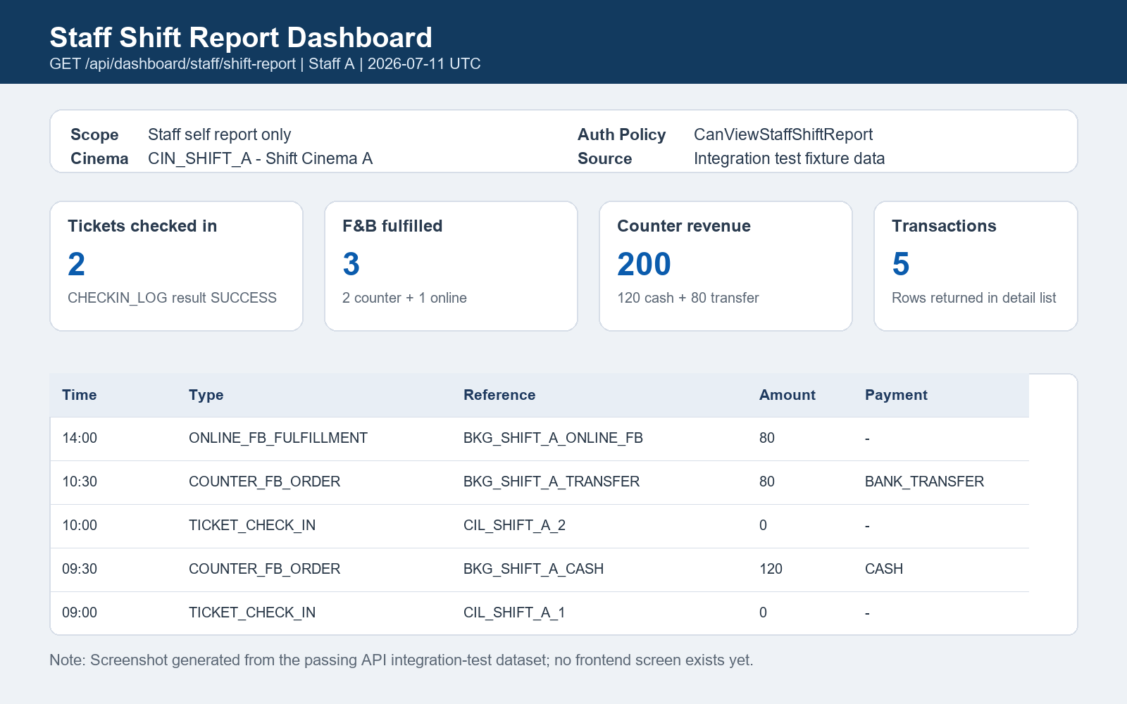
Figure 1. Staff Shift Report dashboard evidence screen

Functional Test Matrix
Case | Actor | Expected | Status
Staff xem báo cáo của chính mình | Staff | 200 OK | Passed
Staff xem báo cáo Staff khác | Staff | 403 Forbidden | Passed
Manager xem Staff cùng cinema | Manager | 200 OK | Passed
Manager xem Staff khác cinema | Manager | 403 Forbidden | Passed
Customer gọi endpoint | Customer | 403 Forbidden | Passed
Admin gọi không filter | Admin | 200 OK | Passed
Date range sai hoặc thiếu tham số | Admin | 400 Bad Request | Passed
Calculation validation | Staff/Admin | Counts and revenue match fixture | Passed

Sample Report Metrics
Metric | Value | Source
Checked-in tickets | 2 | CHECKIN_LOG where Result = SUCCESS
Fulfilled F&B orders | 3 | 2 counter + 1 online fulfillment
Counter revenue | 200 | BOOKING totalAmount for COUNTER orders
Cash revenue | 120 | PaymentMethod = CASH
Transfer revenue | 80 | PaymentMethod = BANK_TRANSFER
Transaction detail rows | 5 | Combined report transactions

