# Hands-on Experiment # 1

Section______1________ Date____6 January 2020_____

Student ID ____________Name___________________

Student ID ____________Name___________________

Student ID ____________Name___________________

## Part A: Setting up Java

1. Find out how to install Java on your operating systems by yourselves. Try googling or searching on YouTube with “how to install java on …”
2. Follow the instruction and have Java ready for the next part.

## Part B: Compiling and executing Java programs

1. Follow the source code presented in the lecture slides, write a Java source code called “HelloWorld.java” that will show “Hello World!” on the console screen.
2. Use “javac” to compile “HelloWorld.java” to “HelloWorld.class”.
3. Capture a screenshot showing the existence of “HelloWorld.java” and “HelloWorld.class”. (*Hint: From the console, use the* dir *command for Windows or the* ls *command for Linux/OS X*)
4. Use “java” to execute the program. Capture a screenshot showing the output.

## Part C: Syntax Errors

1. Compile “SyntaxError1.java”. Observe the response. Fix the code so that it gets compiled successfully.
2. Compile “SyntaxError2.java”. Observe the response. Fix the code so that it gets compiled successfully.
3. Compile “SyntaxError3.java”. Observe the response. Fix the code so that it gets compiled successfully.

# Worksheet

Respond to R1 – R7 below.

R1. Can you successfully set up Java, write the program, and execute it? (Yes/No)

Yes

R2. Did you run into any difficulties in setting up Java? If so, explain the difficulties.

No

R3. Insert the screenshot showing the existence of “HelloWorld.java” and “HelloWorld.class”.

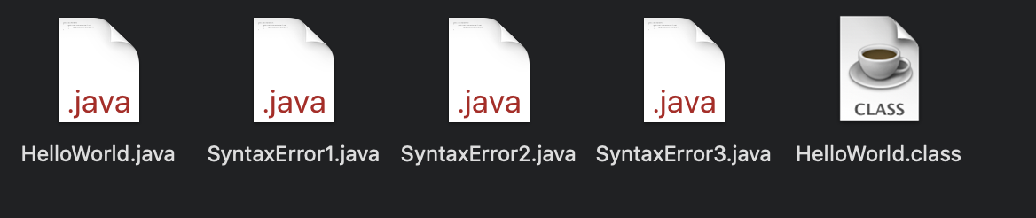

R4. Insert the screenshot showing the output of your program.

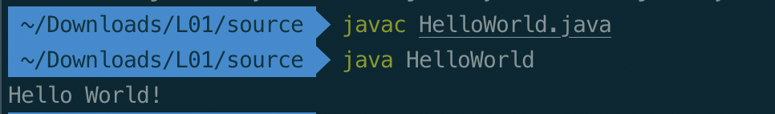

R5. Explain what was (were) wrong with “SyntaxError1.java”.

There is no ; after the System.out.println.

R6. Explain what was (were) wrong with “SyntaxError2.java”.

There is no double quotes symbol(“ “) for the message in syntax.

R7. Explain what was (were) wrong with “SyntaxError3.java”.

The name of class is not same as file name(SyntaxError).

Submit this worksheet (by only one member of the group) via <http://www.myCourseVille.com> (Assignments > Hands-on Experiment # 1) before noon of the day after your lecture.