# Hands-on Experiment # 2 : Worksheet

Section___1____ Date___27 January 2020__________

No more than 3 students per one submission of this worksheet.

Student ID ____________Name___________________

Student ID ____________Name___________________

Student ID ____________Name___________________

In this lab, you should be able to write a program, compile, and run your program. You should be able to use simple mathematic operations to find the correct answer.

## Part A: Write a simple calculation program

1. Assign three double values to *a, b,* and c, all of which are coefficient in the quadratic equation, ax2+bx+c=0.
2. Find the answer of the equation. Assume that there exists solutions of a, b, and c.

List the source code of you program below.

public class Part_A {

public static void main(String[] *args*) {

double a = 1;

double b = -5;

double c = 4;

double ans1 = ((-1 * b) + Math.sqrt(b * b - 4 * a * c)) / (2 * a);

double ans2 = ((-1 * b) - Math.sqrt(b * b - 4 * a * c)) / (2 * a);

System.out.println(ans1);

System.out.println(ans2);

}

}

Insert the screenshot of the output below.



## Part B: Change your data type

1. Use your program from Part A. But this time, change your data type to int for all variables, a, b, and c.
2. Check the result and guess the reason of the strange results.

Insert the screenshot of the output below.

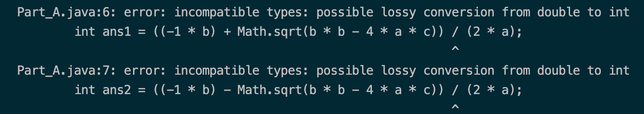

Because Math.sqrt() return double value and it can’t be divided by (2*a) which is an int value.

## Part C: Try to play with String

1. Assign a string “Hello” to variable *s1*
2. Add a string “ World” to s1, store the result in *s2*
3. Add a statement *s3=s1;*
4. Add a string “ Java” to *s3,* store the result in *s1*

Guess the value of *s1, s2,* and *s3*.

s1 = Hello Java  
s2 = Hello World  
s3 = Hello

Print the actual results obtained from the program.

