# Hands-on Experiment # 3 : Worksheet

Section_____1_________ Date______3 February 2020_______________

No more than 3 students per one submission of this worksheet.

Student ID ____________Name___________________

Student ID ____________Name___________________

Student ID ____________Name___________________

This time, you are provided with a new “Java101.class” as well as its source code.

The file “Java101.class” provides a new method called *Java101.typeOf()* which can be used to determine the data type of its input value.

## Part A: Indicate Resulting Data Types of Expressions with Multiple Data Types

1. Determine the data type as well as the value of each expression in the table below.
2. Write a Java program to verify that your answers (both the data types and the values) are correct.
3. Capture a screenshot showing the output of your program.

|  |  |  |
| --- | --- | --- |
| Expression | Data Type | Value |
| 20.0/2.5 | double | 8.0 |
| “3”+2+1 | String | 321 |
| 5+“6”+7 | String | 567 |
| 4/6*3 | Int | 0 |
| 3.0/4*4 | Double | 3.0 |
| (short)1.5 | Short | 1 |
| 3+2.0F+4.0 | Double | 9.0 |
| 4-6==7-9 | Boolean | True |
| (int)(5-6.5)==1-2 | Boolean | True |

List the source code of you program below.

public class Part_A {

public static void main(String[] *args*) {

Java101 j = new Java101();

System.out.println(j.typeOf("3" + 2 + 1));

System.out.println("3" + 2 + 1);

System.out.println(j.typeOf(5 + "6" + 7));

System.out.println(5 + "6" + 7);

System.out.println(j.typeOf(4 / 6 * 3));

System.out.println(4 / 6 * 3);

System.out.println(j.typeOf(3.0 / 4 * 4));

System.out.println(3.0 / 4 * 4);

System.out.println(j.typeOf((short) 1.5));

System.out.println((short) 1.5);

System.out.println(j.typeOf((3 + 2.0F + 4.0)));

System.out.println(3 + 2.0F + 4.0);

System.out.println(j.typeOf((int) (5 - 6.5) == 1 - 2));

System.out.println((int) (5 - 6.5));

}

}

Insert the screenshot below.

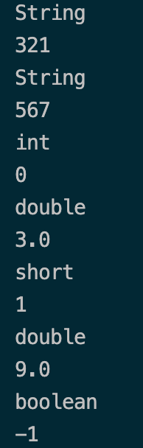

## Part B: Random Number Generator

In this part, you will write a “random generator” program.

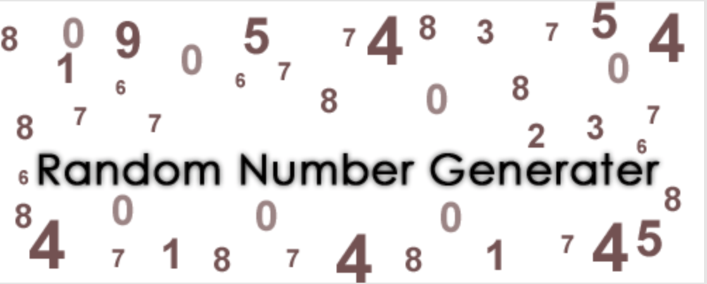

A random number generator that generates integer number from 1 to 10 and normally distributed with an average of 5 and standard deviation of 2.

*An execution of the program generate an integer number.*

The file “Java101.class” also provides a method called *Java101.showRomanNumber()* which takes an int value as its input. When invoked, the method shows a Roman numeric associated with the input value.

1. Study the following two methods: *java.util.Random()* and *java.lang.Math.ceil()* from

<http://docs.oracle.com/javase/8/docs/api/index.html>

1. Come up with a Java expression using *Random()*, *Math.ceil()*, and an appropriate cast operator so that the expression produces a random int value in the range of 1 to 10 that is normally distributed with an average of 5 and standard deviation of 2.
2. Write a Java program that performs the number generation described. Name the program appropriately.
3. List the source code as well as screenshots of the program.

Hint: nextGaussian() returns the next pseudorandom, Gaussian ("normally") distributed double value with mean 0.0 and standard deviation 1.0 from this random number generator's sequence.

Show your Java expression in step 2 here.

Random rn = new Random();

double randomNum = Math.ceil(rn.nextGaussian() * 2 + 5)

Also, list the source code of the program you wrote below.

import java.util.Random;

import java.lang.Math;

public class Num_Gen {

public static void main(String[] *args*) {

Random rn = new Random();

for (int i = 0; i < 30; i++) {

double randomNum = Math.ceil(rn.nextGaussian() * 2 + 5);

System.out.print(Math.max(1, Math.min(randomNum, 10)) + ",");

}

}

}

Insert the screenshots below.



## Part C: Test the Random Number Generator

1. Run the program you wrote in Part B 30 times. Note the result of each generation in the table below.

|  |  |  |  |  |  |
| --- | --- | --- | --- | --- | --- |
| Trial # | Result | Trial # | Result | Trial # | Result |
| 1 | 8.0 | 11 | 9.0 | 21 | 7.0 |
| 2 | 10.0 | 12 | 6.0 | 22 | 7.0 |
| 3 | 4.0 | 13 | 3.0 | 23 | 1.0 |
| 4 | 5.0 | 14 | 8.0 | 24 | 6.0 |
| 5 | 5.0 | 15 | 2.0 | 25 | 6.0 |
| 6 | 4.0 | 16 | 9.0 | 26 | 4.0 |
| 7 | 7.0 | 17 | 5.0 | 27 | 5.0 |
| 8 | 7.0 | 18 | 8.0 | 28 | 7.0 |
| 9 | 5.0 | 19 | 9.0 | 29 | 5.0 |
| 10 | 4.0 | 20 | 5.0 | 30 | 5.0 |

1. Calculate mean and standard deviation of generated numbers.

**Mean (Average) = 5.866666667**

**Standard Deviation (SD) = 2.109238936**