# Hands-on Experiment # 8 : Worksheet

Section_____1_________ Date_____March 23, 2020_______________

No more than 3 students per one submission of this worksheet.

Student ID ____________Name___________________

Student ID ____________Name___________________

Student ID ____________Name___________________

## Sorting.

We are revisiting the processing of *score.csv* again. Now that we know how to use array, things should be much simpler. Also, this time, you are also given with a class called *StudentScore* which is designed so that all scores of a student with a specific ID are stored in a single object of *StudentScore*.

First, study, compile and run *TestStudentScore.java* so that you get some idea of how the *StudentScore* class can be used.

Explain what each statement in TestStudentScore.java does.

boolean withHeader = true; // declare variable withHeader

StudentScore s1 = new StudentScore("5630000021,10,10,9,8,7"); // create object s1 to store data and split by ‘,’

s1.printScore(withHeader); // call method printScore with parameter withHeader = true

withHeader = false; // declare variable withHeader= false

StudentScore s2 = new // create object s2 to store data and split by ‘,’StudentScore("5630000121,8,8,10,6,5");

s2.printScore(withHeader); // call method printScore with parameter withHeader = false

Complete *ScoreSort.java*.

Include the screenshots below.

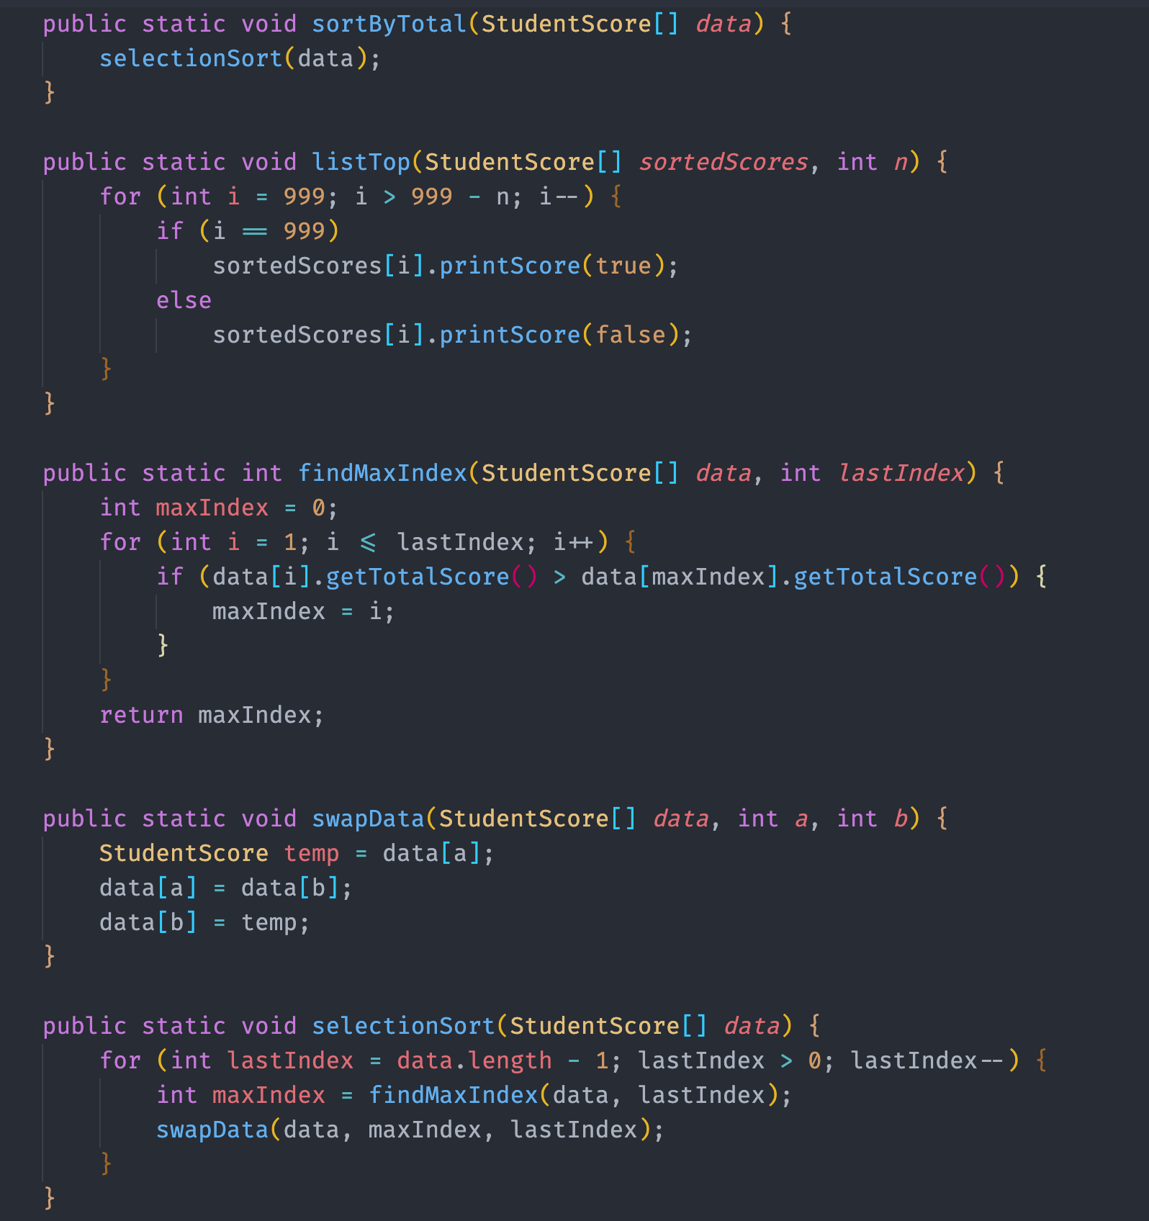

List all your source code here.

import java.io.*;

import java.util.Scanner;

public class ScoreSort {

*// Do not change main().*

public static void main(String[] *args*) throws IOException {

StudentScore[] scores = readScoreFile(); *// Read score data from "score.csv" and store the data in an array of*

*// StudentScore*

sortByTotal(scores);

listTop(scores, 25);

}

*// List neccessary methods here.*

*// Do not change method headers.*

public static StudentScore[] readScoreFile() throws IOException {

Scanner sc = new Scanner(new File("score.csv"));

sc.useDelimiter("\\r\\n|,");

sc.nextLine();

StudentScore[] score = new StudentScore[1000];

int n = 0;

while (sc.hasNext()) {

String data = sc.nextLine();

score[n++] = new StudentScore(data);

}

return score;

}

public static void sortByTotal(StudentScore[] *data*) {

selectionSort(data);

}

public static void listTop(StudentScore[] *sortedScores*, int *n*) {

for (int i = 999; i > 999 - n; i--) {

if (i == 999)

sortedScores[i].printScore(true);

else

sortedScores[i].printScore(false);

}

}

public static int findMaxIndex(StudentScore[] *data*, int *lastIndex*) {

int maxIndex = 0;

for (int i = 1; i <= lastIndex; i++) {

if (data[i].getTotalScore() > data[maxIndex].getTotalScore()) {

maxIndex = i;

}

}

return maxIndex;

}

public static void swapData(StudentScore[] *data*, int *a*, int *b*) {

StudentScore temp = data[a];

data[a] = data[b];

data[b] = temp;

}

public static void selectionSort(StudentScore[] *data*) {

for (int lastIndex = data.length - 1; lastIndex > 0; lastIndex--) {

int maxIndex = findMaxIndex(data, lastIndex);

swapData(data, maxIndex, lastIndex);

}

}

}

Submit this worksheet (by only one member of the group) via <http://www.myCourseVille.com> (Assignments > Hands-on Experiment # 8) **within the day after your lecture**.