# Hands-on Experiment # 11: Worksheet

Section_____1_________ Date______13 April 2020______________________

No more than 3 students per one submission of this worksheet.

Student ID ______6238197821______Name__Witchayut Thongyoi______

Student ID ______6238228621______Name__Sopon Kongnithigarn_____

Student ID ______6238233721______ Name__Adam Morgan__________

## Part A: Getting Familiar with The MyDate Class[1]

A class called MyDate, which models a date instance, is defined as shown in the class diagram.

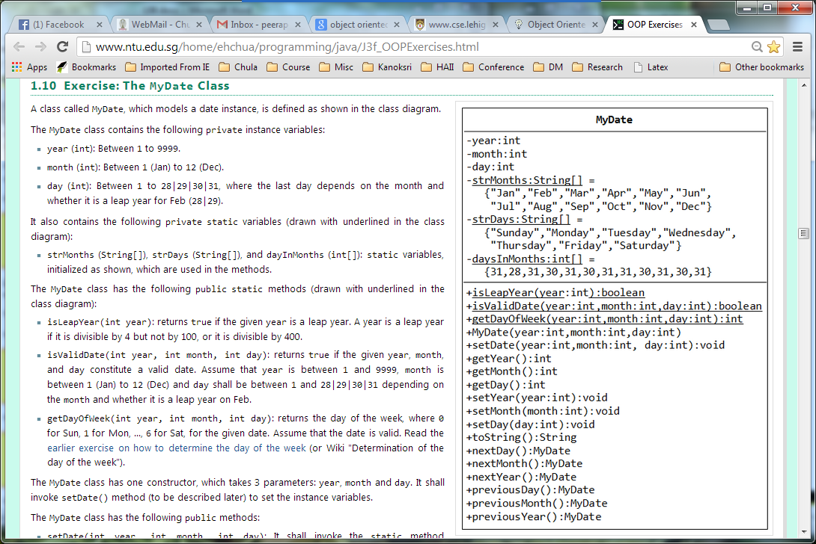

The MyDate class contains the following private instance variables:

* year (int): Between 1 to 9999.
* month (int): Between 1 (Jan) to 12 (Dec).
* day (int): Between 1 to 28|29|30|31, where the last day depends on the month and whether it is a leap year for Feb (28|29).

It also contains the following **private static variables** (drawn with underlined in the class diagram):

* strMonths (String[]), strDays (String[]), and dayInMonths (int[]): static variables, initialized as shown, which are used in the methods.

The MyDate class has the following **public static methods** (drawn with underlined in the class diagram):

* isLeapYear(int year): returns true if the given year is a leap year. A year is a leap year if it is divisible by 4 but not by 100, or it is divisible by 400.
* isValidDate(int year, int month, int day): returns true if the given year, month, and day constitute a valid date. Assume that year is between 1 and 9999, month is between 1 (Jan) to 12 (Dec) and day shall be between 1 and 28|29|30|31 depending on the month and whether it is a leap year on Feb.
* getDayOfWeek(int year, int month, int day): returns the day of the week, where 0 for Sun, 1 for Mon, ..., 6 for Sat, for the given date. This method is provided in “DayOfWeek.java”

The followings are descriptions of **some public methods**:

* toString(): returns a date string in the format "xxxday d mmm yyyy", e.g., "Tuesday 14 Feb 2012".
* next/previousMonth(): must start from the 1st day of that month!
* next/previousYear(): must start from Jan 1 of that year!

## Part B: Questions about The MyDate Class

How many attributes and methods in the class?

6 attributes and 18 methods

Please give the code to create an object of “today” date

MyDate date = new MyDate(2020, 4, 13)

Please specify which of the followings are leap years?

* 2000, 2007, 2013, 2004, 2001, 2012

2000, 2004, 2012

Are “1/15/2013” and “1/12/10000” a valid date? If not, why?

Month exceeds 12 and year exceeds 9999

Use “DayOfWeek.java” to find out the day of week of “1/1/2014”?

Wednesday

What should the toString() method return if the input date is “1/1/2014”?

Wednesday 1 Jan 2014

## Part C: Coding

Write the code for the MyDate class.

Use the following test statements to test the MyDate class:

MyDate d1 = new MyDate(2012, 2, 28);

System.out.println(d1); // Tuesday 28 Feb 2012

System.out.println(d1.nextDay()); // Wednesday 29 Feb 2012

System.out.println(d1.nextMonth()); // Thursday 1 Mar 2012 – must be “Day 1st”

System.out.println(d1.nextYear()); // Tuesday 1 Jan 2013 – must be “Jan 1”

MyDate d2 = new MyDate(2012, 1, 2);

System.out.println(d2); // Monday 2 Jan 2012

System.out.println(d2.previousDay()); // Sunday 1 Jan 2012

System.out.println(d2.previousMonth()); // Thursday 1 Dec 2011

System.out.println(d2.previousYear()); // Saturday 1 Jan 2011

MyDate d3 = new MyDate(2012, 2, 29);

System.out.println(d3.previousYear()); // Saturday 1 Jan 2011

// MyDate d4 = new MyDate(2099, 11, 31); // Invalid year, month, or day!

// MyDate d5 = new MyDate(2011, 2, 29); // Invalid year, month, or day!

Include the screenshots below.

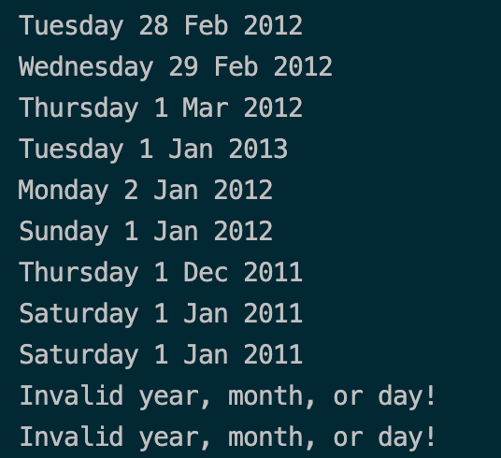

List all your source code here.

public class MyDate {

*// Attributes*

private int year;

private int month;

private int day;

private static final String[] strMonths = new String[] { "Jan", "Feb", "Mar", "Apr", "May", "Jun", "Jul", "Aug",

"Sep", "Oct", "Nov", "Dec" };

private static final String[] strDays = new String[] { "Sunday", "Monday", "Tuesday", "Wednesday", "Thursday",

"Friday", "Saturday" };

private static final int[] daysInMonths = new int[] { 31, 28, 31, 30, 31, 30, 31, 31, 30, 31, 30, 31 };

*// Methods*

public static boolean isLeapYear(int *year*) {

return (year % 4 == 0 && year % 100 != 0) || (year % 400 == 0);

}

public static boolean isValidDate(int *year*, int *month*, int *day*) {

return (year >= 1 && year <= 9999) && (month >= 1 && month <= 12)

&& (day >= 1 && day <= ((month == 2 && MyDate.isLeapYear(year)) ? 29 : MyDate.daysInMonths[month - 1]));

}

public static int getDayOfWeek(int *year*, int *month*, int *day*) {

return DayOfWeek.getDayOfWeek(day, month, year);

}

public MyDate(int *year*, int *month*, int *day*) {

this.setDate(year, month, day);

}

public void setDate(int *year*, int *month*, int *day*) {

if (!MyDate.isValidDate(year, month, day))

System.out.println("Invalid year, month, or day!");

else {

this.year = year;

this.month = month;

this.day = day;

}

}

public int getYear() {

return this.year;

}

public int getMonth() {

return this.month;

}

public int getDay() {

return this.day;

}

public void setYear(int *year*) throws IllegalArgumentException {

if (!MyDate.isValidDate(year, this.month, this.day))

throw new IllegalArgumentException("Invalid year!");

this.year = year;

}

public void setMonth(int *month*) throws IllegalArgumentException {

if (!MyDate.isValidDate(this.year, month, this.day))

throw new IllegalArgumentException("Invalid month!");

this.month = month;

}

public void setDay(int *day*) throws IllegalArgumentException {

if (!MyDate.isValidDate(this.year, this.month, day))

throw new IllegalArgumentException("Invalid day!");

this.day = day;

}

public String toString() {

return MyDate.strDays[MyDate.getDayOfWeek(this.year, this.month, this.day)] + " " + getDay() + " "

+ MyDate.strMonths[getMonth() - 1] + " " + getYear();

}

public MyDate nextDay() {

if (isValidDate(this.year, this.month, this.day + 1))

return new MyDate(this.year, this.month, this.day + 1);

return this.nextMonth();

}

public MyDate nextMonth() {

if (isValidDate(this.year, this.month + 1, 1))

return new MyDate(this.year, this.month + 1, 1);

return this.nextYear();

}

public MyDate nextYear() {

return new MyDate(this.year + 1, 1, 1);

}

public MyDate previousDay() {

if (isValidDate(this.year, this.month, this.day - 1))

return new MyDate(this.year, this.month, this.day - 1);

else if (isValidDate(this.year, this.month - 1, 1)) {

return new MyDate(this.year, this.month - 1,

((this.month - 1 == 2 && MyDate.isLeapYear(this.year)) ? 29 : MyDate.daysInMonths[this.month - 2]));

} else

return new MyDate(this.year - 1, 12, 31);

}

public MyDate previousMonth() {

if (isValidDate(this.year, this.month - 1, 1))

return new MyDate(this.year, this.month - 1, 1);

return new MyDate(this.year - 1, 12, 1);

}

public MyDate previousYear() {

return new MyDate(this.year - 1, 1, 1);

}

}

Submit this worksheet (by only one member of the group) via <http://www.myCourseVille.com> (Assignments > Hands-on Experiment # 11) **within the day after your lecture**.

1. This exercise is updated from “Java Programming Tutorial OOP Exercises” at  
   <http://www.ntu.edu.sg/home/ehchua/programming/java/J3f_OOPExercises.html>