Drivers of sponge assemblages of a reef plate : decoupling effects of natural and anthropic factors

Journiac Lysandre1, Le Bozec Charles1, Laura Mégevand1, François Xavier–Lamure1, Mercky Yann1, Trabelsi Chiraz1,2, Corse Emmanuel1,3

1Centre Universitaire de Formation et de Recherche de Mayotte (CUFR), Dembeni, France

2 Institut Montpelliérain Alexander Grothendieck (IMAG), UMR CNRS 5149, Université de Montpellier, France

3MARBEC, University of Montpellier, CNRS, Ifremer, IRD, Montpellier, FRANCE

**Keywords** : Structural Equation Modelling, environmental determinism, sponges, lagoon, fringing reef, coastal anthropization, silting

ABSTRACT

INTRODUCTION

Understanding how coastland-use changes due to human activity affect coral reef is a step towards a well-informed policy for management and conservation of ecosystems. This understanding is particularly challenging in emerging tropical territories that are often characterised by biotopes with high biodiversity values but suffer from particularly rapid changes that pressure the urgency of environmental protection implementation. This challenge requires a well understanding of how environment drives biological community and more particularly the anthropization processes to identify which factors are implied and their hierarchy in function of their intensity effects on biodiversity. Testing environmental and faunistic survey correlation is an effective strategy for this purpose. However, this strategy is not as evident in marine reef as many factors are implied in complex interactions where correlations does not necessarily implicate direct causal links. As example Zae (2001) highlighted the difficulty of disentangling water enrichment from other factors such as sediment that are both increase by human anthropisation of coastal areas. Structural equation modelling (SEM) is appropriate to overcome some of these limitations as it provides the multidimensional framework needed to capture the complexity of ecological networks and relationships (Grace et al., 2014).

Mayotte is a tropical island in a biodiversity hotspot of the southwest Indian Ocean which belongs to the Comoros archipelag The island is surrounded by an 1100 km2 lagoon, the third largest enclosed lagoon in the world, and boasts a double barrier reef. Mayotte's lagoon is an entire Marine Protected Area and is home to a wide variety of marine habitats, including mangroves, seagrass beds and highly diverse coral reefs. Mayotte is dotted with a large number of different species including almost 760 recensed species of tropical fish, 300 species of corals, 25 species of marine mammals. The diversity of other taxonomic groups is poorly documented and remains to be investigated. Since its integration to French overseas territory in 2011, Mayotte experiences a considerable growth of the human population which is expected to double by 2050 (Daubaire 2020). This population growth struggles to be followed by political (unplanned urban sprawl) and infrastructure development (eg. 40% of dwellings were in decrepit housing and 29% of households did not have access to clean water, Daubaire 2020), This global context of rapid and extensive changes makes Mayotte an ideal study zone to investigate ongoing anthropization processes of a biodiversity hotspot. The human pressure on coral reef is already demonstrated and different processes are expected through direct or mediated effects related to land erosion, wastewater, water turbidity, chemical pollution, siltation and habitat loss of coastal habitat (Landemaine et al. 2017; Courteille et al. 2022; Mégevand et al. 2021; Theuerkauff et al. 2018). In that context, there is an urgent need to set up tools to monitor biological changes and hierarchizes the anthropization processes to guide environmental politics for the next decades.

Sponges (Porifera) display relevant feature making them sensitive to local environmental conditions (*ie* sessiles macrobenthos and filtering organisms) and as consequently sponges are appropriate to monitor effects of environmental changes on biodiversity (Carballo et al. 1996). Previous studies have shown that depth, substrate, slope and water exposure are among the main abiotic factors impacting sponges, the last one appeared as limiting factors for their growth (de Voogd et al., 2009; Fromont et al., 2006; Wilkinson & Evans, 1989; Bell et al. 2010; Bell 2007; Voogd, Becking, et Cleary 2009; Fromont, Vanderklift, et Kendrick 2006; Wilkinson et Evans 1989). In addition to these factors, sponges species may serve as biological indicators to monitor human impacts on marine coastal environment (Celis-Hernández et al. 2021; Cebrian, Uriz, et Turon 2007; Carballo, Naranjo, et García-Gómez 1996; Nava et al. 2014) with the identification of indicative species toward specific environmental cues (Alcolda 2007; Alcolado, Herrera-Moreno, et Martinez-Estalella 1993) (Reiswig (1973), Hooper & Kennedy 2002).

To meet the local expectations of environmental stakeholders of Mayotte we aim to investigate the relevancy of using sponges as a model to understand and monitor the littoral anthropisation effects on the lagoon biodiversity. For that, the first aim of this study was to characterize spatial changes of sponges among fringing reef areas (as we expected that littoral area was the most exposed zone to coastland-use) and testing correlation with environmental condition, including meso and micro-scale factors. Then, we aim to improve our understanding of processes that shape sponges assemblages using path analysis approach to disentangle direct *vs* indirect effects and making causal relationships between environmental factors and proxys of sponge assemblage structure, *ie* richness and abundance of sponge.

MATERIAL & METHODS

*Sampling protocol*

We sampled sponge assemblages of 30 stations on the fringing reef spread around Mayotte island. The stations are subject to different types of natural and anthropogenic pressure and were chosen to be representative of the environmental gradients that exist in Mayotte. An initial exploratory phase enabled us to divide stations into a sequence of five habitats according to the substrate type and depth (ie. Zone 1: reef crest with sand and rock; Zone 2: reef crest with sand, rocks and coral; Zone 3: fringing reef with 100% coral cover; Zone 4; Lagoon adjacent zone of the fringing reef ; Zone 5: Lagoon 20m above the fringing reef; see Figure 1). Sponge surveys were carried out along two independent 50m transects parallel to the shoreline, by snorkelling (Zone 1 to 3) and diving (Zone 4 & 5). We counted all individuals within one meter on either side of each transect. We included all "macrosponges" large enough to be seen while diving in the centre of transect. All sponge not observable according the counting methodology (ie small, encrusting or endopsammic form) were not considered. In parallel, substrate was characterised based on three one square-meter quadrats randomly placed along each transect (further details are given in the following sections). We used the concept of the operational taxonomic unit (OTU) for the evaluation of an ID that allow us to deal with the insufficient taxonomic knowledge of the studied geographic area. OTU corresponded to specimen with singular external characteristics considering different phenotypic component (*ie* morphology, color, size, texture, lifestyle).

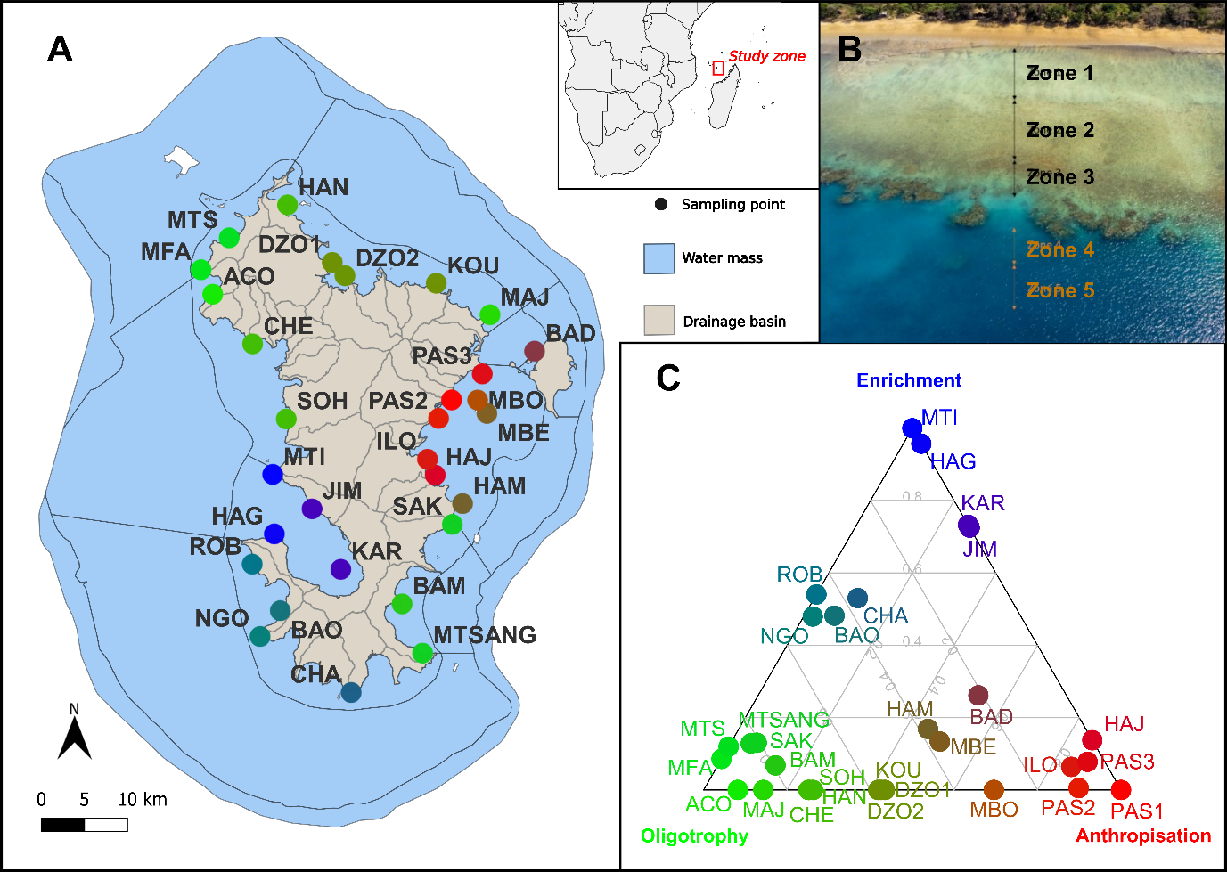

**Figure 1 : Map of study sites. (A)** Lagoon was divided in water mass according to the French water framework and island was delimited divided by catchment area. (B) Aerial pictures depicting the five recurrent zones of the fringing reef in Mayotte. In (A) sampling stations were indicated by dots coloured according to their position in the archetypal analysis of environmental factors figurated in (C).

**Potential drivers of abundance and richness of sponges**

We described several facets of the global environment of each of our sampling stations using seventeen variables related to the geographic context, human context, water quality and substrates. The geographic context encompassed variables related to the location of the stations and main drivers of marine assemblages independent of human activity. The human context is based on proxies of human pressure on adjacent marine ecosystems whereas the water quality is based on indicators of the environmental enrichment and productivity which could be influenced by either the human or geographic context. The substrates are a direct depiction of the available substrates for sponges to grow on. In the case of human and geographic variables we used water mass defined in the 2019 report assessment from SANDRE [(*Masses d’eau Côtières - Mayotte - Version État Des Lieux 2019*)](https://www.zotero.org/google-docs/?gTkzBF) as the geographical boundaries of their influence on the stations. Thus, each station was included in one of the eight coastal water masses of Mayotte’s lagoon and the geographic and human contexts of the stations were measured at the scale of either this water body or its adjacent drainage basins.

*Geographic variables.* We extracted the *Depth* of the sampling points from their GPS position using a bathymetric map of Mayotte [(*MNT bathymétrique combiné des fonds marins des zones récifales de Mayotte - Projet CARMAY*)](https://www.zotero.org/google-docs/?TRI38N). All points on the reef flat (zones 1, 2 & 3) were given a fixed depth of 3 metres. We attributed a value of *Confinement* between 1 and 5 based on the basin characteristics reports for the DCE (Water Directive framework) available in the Water and Biodiversity of Mayotte agency. It represents the extent of sea waters renewal or confinement inside the water body with 5 corresponding to a high confinement. *Mangrove distance* is the linear distance to the closest mangrove reported in the Corine Land Cover 2012 [(*Corine Land Cover 2012 (Raster 100m) - Version 2020_20u1, May 2020*)](https://www.zotero.org/google-docs/?GZMMjj) in the same water body as the station. A *Mangrove distance* of 20km was attributed to stations located in water bodies without any mangrove. Drainage basins of Mayotte were extracted from the Carthage database [(](https://www.zotero.org/google-docs/?PqMQlT) [*Zones hydrographiques - Mayotte 2013 - BD Carthage*](https://www.zotero.org/google-docs/?PqMQlT)). We measured the linear distance in kilometres from each sampling point to the closest border of each drainage basin in the same water body as the station. Then, we calculated the *Drainage basin size* as the area of each drainage basin adjacent to the water body weighted by the distance between drainage basins and sampling points. Drainage basins situated closer than 2km from a point were given a weight of 1 and drainage basins farther away were given a decreasing weight of 1/distance.

*Human variables.* We calculated three human related variables based on the human pressure on the drainage basins adjacent to the water body of each station and following the same methodology as for the *Drainage basin size* variable. We extracted land use in Mayotte from the Large-scale land use database from IGN (<https://geoservices.ign.fr/ocsge>). Land-use was classified in three classes : “natural” if not regularly managed by humans, “cultivated” if any kind of agriculture is practised and “urbanised” if transformed by human activities. *Urbanised surface* was calculated as the sum of “urbanised” areas in drainage basins adjacent to the water body of the sampling point weighted by the distance between the two of them. *Cultivated surface* was computed in the same manner, using “cultivated” areas. We retrieved human population counts in 2017 from INSEE database [(*Populations Légales Des Communes de Mayotte En 2017 − Populations Légales de Mayotte En 2017*)](https://www.zotero.org/google-docs/?1MqpBy). Then, human population by drainage basin was calculated as the sum of population counts of municipalities covering the drainage basin weighted by the proportion of the area of each municipality covering this basin. As for the three previous variables we computed *Human population* as the sum of these counts by drainage basin over all drainage basins adjacent to the station’s water body and weighted it by the linear distances between drainage basins and sampling points.

*Water quality.* We described the water quality of each station using five variables which covers several facets of water enrichment and pollution. The *DCE note* was extracted from the DCE basin characteristic reports and integrates the chemical, ecological and environmental state of each coastal water body. We attributed to stations a *DCE note* between 1 and 5 with 1 corresponding to stations in water bodies with a deteriorated chemical, ecological and environmental state. *Chlorophyll A* and *Turbidity* were both calculated as the mean for each coastal water mass of chlorophyll A and turbidity measures over the 2008-2022 period found in the Surval database (https://surval.ifremer.fr).

*Substrates.* Habitats of sampling points were assessed on field by deploying three quadrats [1m2] alongside each transect. We described the substrates in these quadrats by estimating the percentage of coverage of sand, pebble, stone, silt, slab, seagrass bed, macroalgae, living and dead coral. Then, for each sampling point we computed the variables *Sand, Silt, Slab* and *Living corals* as the mean coverage of each of these substrates over the six quadrats of the two transects. Moreover, we computed a *Substrate diversity* index as H = -sum(pi) * log(pi) where *pi* is the proportional coverage of substrate *i*.

**Statistical analyses**

All statistical analyses were conducted using R (version 4.3.0).

*Sponge diversity analysis.* We characterised the sponge assemblages using two complementary measures. The *Abundance* was calculated as the total number of individuals counted in the two transects of each zones. The *Richness* was computed as the total number of different OTU observed in the two transects of each sampling zones. Zone and station effects on these two response variables were assessed using ANOVAs.

*Redundancy analysis.* We analysed the dissimilarity between the sponge assemblages of the sampling points based on the differential abundance of the OTU and linked them to the potential environmental drivers. We applied a Hellinger transformation to the transect x species matrix using the *decostand* function from the *vegan* package [(Oksanen et al., 2022)](https://www.zotero.org/google-docs/?RznBFR). Abundance data for each species in each transect was divided by the total abundance in this transect and the square root of this proportion was taken as advised in [Legendre & Gallagher, (2001)](https://www.zotero.org/google-docs/?fGPsE2). Then, we performed a redundancy analysis on this transformed matrix using the *rda* function from the *vegan* package. We used all the seventeen potential drivers as predictors and selected the significant ones based on the maximisation of the model adjusted R² and P-value [(Blanchet et al., 2008)](https://www.zotero.org/google-docs/?jAYlMC) using the *ordiR2step* function. This process resulted in the ordination of each transect data based on the dissimilarity between their sponge assemblages. A linear regression model based on the potential drivers was then built to explain this distance between sponge assemblages.

*Indicator species.* We highlighted the sponge OTU indicating a peculiar type of environment by classifying the stations according to their environmental conditions (see above) and evaluating the specificity and fidelity of each morphotype to the different clusters of stations (Dufrene et Legendre 1997). We aggregated the sponge counts over the different zones of the stations by summing the counts and taking the mean of the potential drivers. We represented the environmental conditions of the stations in a multidimensional space using the *PCA* function from the *FactoMineR* package (Lê, Josse, et Husson 2008). We selected all the environmental conditions described by our potential drivers at the exception of the *Depth* and used them to build a multidimensional space with distance between stations representing environmental dissimilarity between them. We kept the two first axes and performed an archetypal analysis using the *stepArchetypes* function from the *Archetypes* package (Eugster et Leisch 2009). This method is similar to cluster analysis but avoids classifying arbitrarily a station with mixed environmental conditions by characterising stations according to their proximity to each archetype instead of attributing them to a unique cluster (Mørup et Hansen 2012). The analysis was performed iteratively for 1 to 15 archetypes and the optimal number of archetypes was chosen following the “elbow criterium” i.e. the one minimising both the residual sum of squares of the model and the number of archetypes. We characterised the type of environment of each station by keeping their distance to the three retained archetypes. Then, we evaluated the fidelity and specificity of sponge OTU to these three types of environments using the *multipatt* function from the *indicspecies* package [(Cáceres et Legendre 2009)](https://www.zotero.org/google-docs/?BUMfoJ). We simplified the type of environment of the stations by attributing to each of them only one type of environment based on the minimal distance between the stations and the three archetypes. Then, we examined the associations between OTU and each of the three types of environments or combinations of them using the transect x species matrix and the *IndVal.g* function.

*Causal analysis.* In order to determine the direct, indirect and relative effects of geographic, human, water quality and substrate variables on the abundance and richness of sponges, we performed Structural Equation Modelling (SEM, Grace 2006 using *piecewiseSEM* package, Lefcheck 2016). One model was specified for each endogenous variable (i.e. variables hypothesised to be explained by one or several exogenous variables) and all of them are assembled in a SEM. We built two SEMs to explain each of the endogenous variables related to sponges’ abundance and species richness using a set of *a priori* hypotheses (SII Appendix). All variables with a tail distribution were log-transformed (*Abundance, Richness, Depth, Mangrove distance, Drainage basin size, Urbanised surface, Cultivated surface, Human population, Chlorophyll A, Turbidity, Nitrite* and *Phosphate*). Then, we scaled all the variables (µ = 0, sigma = 1) to get comparable effects.

Following Grace (2006), we built a first global model composed of all hypothesised causal relationships and derived a linear model for each endogenous variable (*lm* function). The SEM was built upon these individual linear models using the *psem* function from the *piecewiseSEM* package [(Lefcheck, 2016)](https://www.zotero.org/google-docs/?gwW5Mz). We evaluated model fit using Fisher’s C statistic and considered it incomplete if the associated P-value was below 0.05. In the case of an incomplete model, we added potential missing paths recursively based on pairwise tests of directed separation (*dSep* function from *piecewiseSEM*; [(Lefcheck, 2016)](https://www.zotero.org/google-docs/?tAr2mb) on unstated relationships between variables in our *a priori* model (SII Appendix). The final models had a Fisher’s C of 89.5 (P-value = 0.321). They contained 103 paths between explanatory and endogenous variables, and a correlated error was specified between 24 variables (SII Appendix).

We analysed the resulting models by retrieving the R² associated with each endogenous variable. We finally derived direct, indirect and total effects of the explanatory variables on the response variables by using a non-parametric bootstrapping method (n = 10,000 samples) through the *bootEff* function from the *semEff* package (Murphy 2023).

RESULTS

**Spatial diversity of sponges**

Of the 30 stations, we sampled 23 from Z1 to Z5, 6 from Z1 to Z3 for technical reasons and only one in Z2-Z4-Z5 due to a specific configuration of the sampling site (see SI Appendix for details of sampling localisation) constituting a total of 273 transects. A total of 8632 sponges were counted classified into 88 different OTUs, some of which could be assigned to a taxon retrieved from available taxonomic list from the geographic area (see SI Appendix). To assess spatial variation of richness and abundance of sponges we used type III ANOVA that were most appropriated for unbalanced data. Important significant variation were observed between zones and between station in term of richness and abundance (see figure 2; results of ANOVA were available in SI appendix).Station were the main effect for both richness and abundance explaining respectively 40% and 49% of their total variance whereas zones explained 20% and 10% of variance. Sponge abundance also varied, from 58 to 651, while the average abundance was 287. Zone 3 appeared as the lesser rich and abundant zone, whereas zone 4 and 5 were generally the most rich and and abundant zones compare to reef plate zones (see figure 2). Interestingly stations associated with anthropized conditions tends to displayed higher richness and abundance.



**Figure 2. Spatial diversity of sponges.** Variation of richness (top) and abundance (bottom) of OTU among zones (left) and station (right) were showed. Results of type III ANOVA were indicated. Station were coloured according to their proximity to each environment archetype: green = Oligotropy; blue= Enrichment; red= Anthropization.

**Redundancy analysis**

Eleven environmental variables (i.e. *Depth, Living corals, Mangrove distance, Nitrate, Confinement, Substrate diversity, Slab, Urbanised area, Drainage basin size, Turbidity* and *Human population*) were retained in the maximisation process of our redundancy analysis (RDA). Overall, they explained 23 % of the total inertia (permutation test, F=4.86, *p* < 0.001) with *Depth* and *Living corals* being the two main drivers (Fig. 3; Table S1). The first axis of the ordination of the sponge assemblages of the sampling points was primarily associated with their zonation and *Depth*. Assemblages from the two first zones and from low depth are clustered on the left side of the ordination whereas assemblages from zone four and zone five and higher depth are clustered on the right side of the ordination (Figure 3). The second axis is associated with variables linked to the enrichment of the medium (e.g. *Human population, Urbanised area, Confinement, Nitrate* and *Drainage basin size*) on one side and oligotrophy on the other side (e.g. *Mangrove distance, Slab* and *Living corals*). This second axis is independent of the zonation and categorises the sponge assemblages according to their response to these environmental conditions. Some sponge OTUs were found to be particularly associated with some of the studied environmental conditions. OTU 10 and 11 (*Stylissa massa*) were more abundant at low depth and in the two first zones whereas OTU 28 (*Stylissa carteri*) and 35 (*Chalinula milnei*) were more abundant in zones four and five with the first one being more associated with enriched environmental conditions and the second to oligotrophic ones. OTU 27 (*Paratetilla bacca*), 54 (*Mycale humilis*) and 20 were also more abundant in sampling points characterised by high levels of nitrate, wide associated drainage basins, confined water masses and a high influence of urbanisation and human population density. In contrast, morphotype 45 (*Ectyoplasia coccinea*) was associated with oligotrophic conditions such as low nitrate levels, substrates dominated by slab and living corals far from the mangroves.

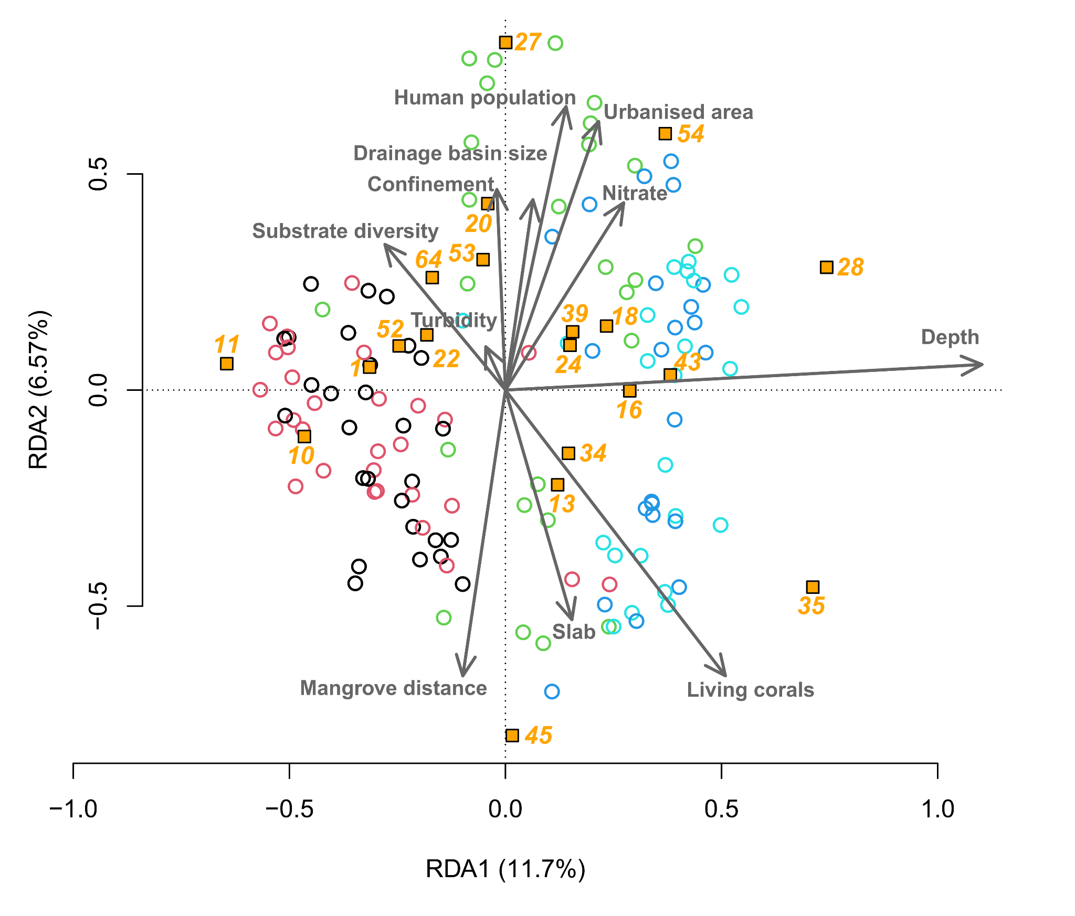

**Figure 3. Redundancy analysis between sponge assemblages and environmental conditions.** The two first axes are represented along with the percentage of total inertia explained. Circles represent sampling points and are coloured according to the zonation (red = zone 1; black = zone 2; green = zone 3; dark blue = zone 4; light blue = zone 5) and yellow squares represent sponge OTUs. Only OTU with the sum of the two first eigenvalues over 0.5 are represented.

**Indicator species**

The fifteen studied environmental conditions aggregated over the zones of the stations were summarised in two axes of a principal component analysis (Figure 4) explaining 58 % of the total variance. We found that three archetypes was the optimal number of archetypes to encompass the diversity of conditions between stations and minimise the residual sum of squares (RSS = 0.06). A first archetype was named “Oligotrophy” as it was associated with conditions such as high substrate diversity, high DCE index and substrates dominated by sand, slab and living corals. A second one was named “Anthropization” as it gathered stations close to wide drainage basins, highly urbanised, populated and cultivated and substrates dominated by silt. The “Enrichment” one stood out on the second axis of the PCA and was associated with high levels of chlorophyll A and turbidity. Stations in the water mass close to the island’s largest city, Mamoudzou, were close to the “Anthropisation” archetype (e.g. PAS1, PAS2, PAS3, HAJ and ILO; Fig. 1 & Figure 4) whereas stations in the enclosed bay of Boueni were better characterised by the “Enrichment” archetype (e.g. KAR, HAG, JIM and MTI; Figure 1 & Figure 4). Stations from the northwest and southeast coasts of Mayotte were closer to the “Oligotrophy” archetype (e.g. MFA, MTS, SAK and ACO; Figure 1 & Figure 4).

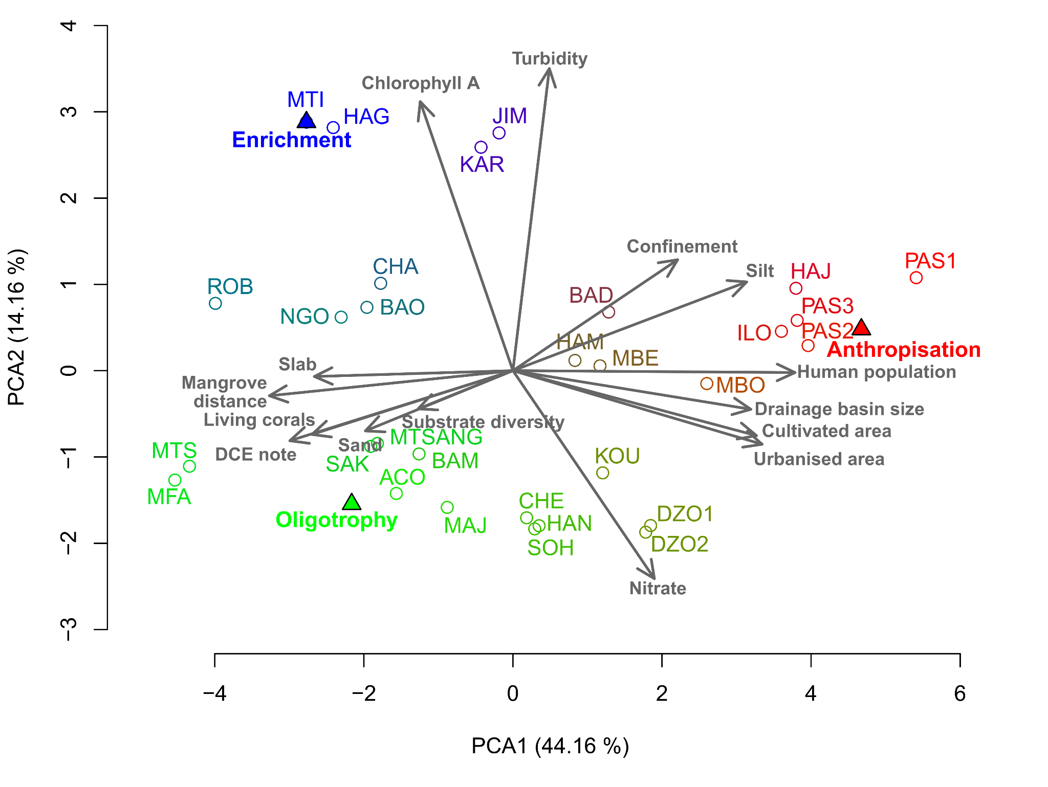

**Figure 4. Ordination of the thirty sampled stations according to their environmental conditions.** The two first axes are represented along with the percentage of total inertia explained. Triangles indicate the position of the archetypes. Circles represent sampling stations and are coloured according to their proximity to each archetype.

Over the 75 OTUs that occurred in, at least, one the 30 stations sampled over five zones, five were found to be preferentially associated to one type of environmental conditions (Table 1). No morphotype exhibited high specificity and fidelity to a combination of two clusters. OTU 54 (*Mycale humilis*), 24 (*Paratetilla bacca*) and 57 (*Spheciospongia vagabunda*) were found to be more abundant in stations belonging to the “Anthropisation” cluster than in the two other clusters. OTU 54 (*Mycale humilis*) and 24 had a fidelity of 1 meaning that they were sampled in each and every station of the “Anthropisation” cluster. Morphotype 57 (*Spheciospongia vagabunda*) had a lower fidelity (Fidelity = 0.43) but a higher specificity (Specificity = 0.86) which indicates that this morphotype is mainly present only in stations belonging to this cluster. OTU 13 and 28 (*Stylissa carteri*) were more present in stations of the “Enrichment” cluster while morphotype 31 (*Haliclona fascigera*) was the only morphotype potentially indicator of the “Oligotrophy” cluster.

|  |  |  |  |  |  |
| --- | --- | --- | --- | --- | --- |
| **Cluster** | **Morphotype** | **Specificity** | **Fidelity** | **Statistic** | **P-value** |
| Anthropisation | 54 (*Mycale humilis)* | 0.76 | 1.00 | 0.87 | 0.010 |
| 27 *(Paratetilla bacca)* | 0.67 | 1.00 | 0.82 | 0.025 |
| 57 (*Spheciospongia vagabunda*) | 0.86 | 0.43 | 0.61 | 0.035 |
| Enrichment | 13 (Unidentified) | 0.90 | 0.60 | 0.73 | 0.030 |
| 28 *(Stylissa carteri)* | 0.50 | 1.00 | 0.71 | 0.045 |
| Oligotrophy | 31 *(Haliclona fascigera)* | 0.95 | 0.64 | 0.78 | 0.005 |

**Table 1. Indicator species of the three types of stations**

**Environmental processes of sponge assemblage determinism**

Several correlated errors between endogenous and exogenous variables were added to the global model and led to a complete model meeting the requirements for modelling the abundance and richness of sponges (Fisher’s C = 46.68, *p* = 0.75). Ten variables had a significant total effect on sponge abundance (*R²* = 0.59): *Human population, Urbanised area, Cultivated area, Depth, Nitrate, Turbidity, Living corals, Sand, Silt* and *Substrate diversity* (confidence intervals at 95% (CI95) not crossing zero; Figure 5 & 6A) and nine variables had a significant total effect on sponge richness (*R²* = 0.55):  *Human population, Cultivated area, Depth, Nitrate, Living corals, Slab, Sand, Silt* and *Substrate diversity* (Figure 5 & 6B). *Depth* was the only geography-related driver to have a significant direct effect on sponge abundance (CI95: [0.24; 0.46]; Fig. 5 & 6A) and sponge richness (CI95: [0.24; 0.48]; Figure 5 & 6B). In contrast, almost all substrate-related drivers had significant total effects on sponge abundance and richness. *Substrate diversity* had the strongest influence on both variables emerging from a strong positive direct effect on sponge abundance (CI95: [0.22; 0.47]; Figure 5 & 6A) and sponge richness (CI95: [0.24; 0.50]; Figure 5 & 6B). The other substrate variables, at the exception of *Living corals*, had significant indirect negative effects on sponge abundance and richness mediated by substrate diversity (Figure 5 & 6). In the case of *Living corals*, it had a strong direct negative effect on sponge abundance (CI95: [-0.36; -0.10]; Figure 5 & 6A) but a weaker direct effect on sponge richness which, combined to a very weak negative indirect effect, led to a significant negative total effect on sponge richness (CI95: [-0.22; -0.02]; Figure 5 & 6B).

Among the variables linked to water quality, *Turbidity* had a weak positive direct effect on sponge abundance (CI95: [0.01; 0.21]; Figure 5 & 6A) but not on sponge richness, whereas *Nitrate* had a positive total effect on both sponge abundance (CI95: [0.03; 0.20]; Figure 5 & 6A) and sponge richness (CI95: [0.06; 0.22]; Figure 5 & 6B).

On top of that, the three human-related variables had an overall positive total effect on sponge richness and abundance (Figure 5 & 6) which resulted from the combination of direct and indirect effects influencing sponge richness and abundance in the opposite direction. *Urbanised area* had a weak negative indirect effect on sponge abundance (CI95: [-0.11; -0.03]; Figure 5 & 6A) and sponge richness (CI95: [-0.10; -0.03]; Figure 5 & 6B) but a stronger positive direct effect on sponge abundance (CI95: [0.07; 0.31]; Figure 5 & 6A) and sponge richness (CI95: [0.05; 0.22]; Figure 5 & 6B). In contrast, *Human population* had a positive indirect effect on sponge abundance (CI95: [0.09; 0.30]; Figure 5 & 6A) and sponge richness (CI95: [0.12; 0.29]; Figure 5 & 6B) but a weaker negative direct effect on sponge richness (CI95: [-0.22; -0.02]; Figure 5 & 6B) and no significant direct effect on sponge abundance (Figure 5 & 6A). As for *Cultivated area*, its positive total effect on sponge abundance and richness resulted from the combination of non-significant indirect and direct effects (Figure 5 & 6).

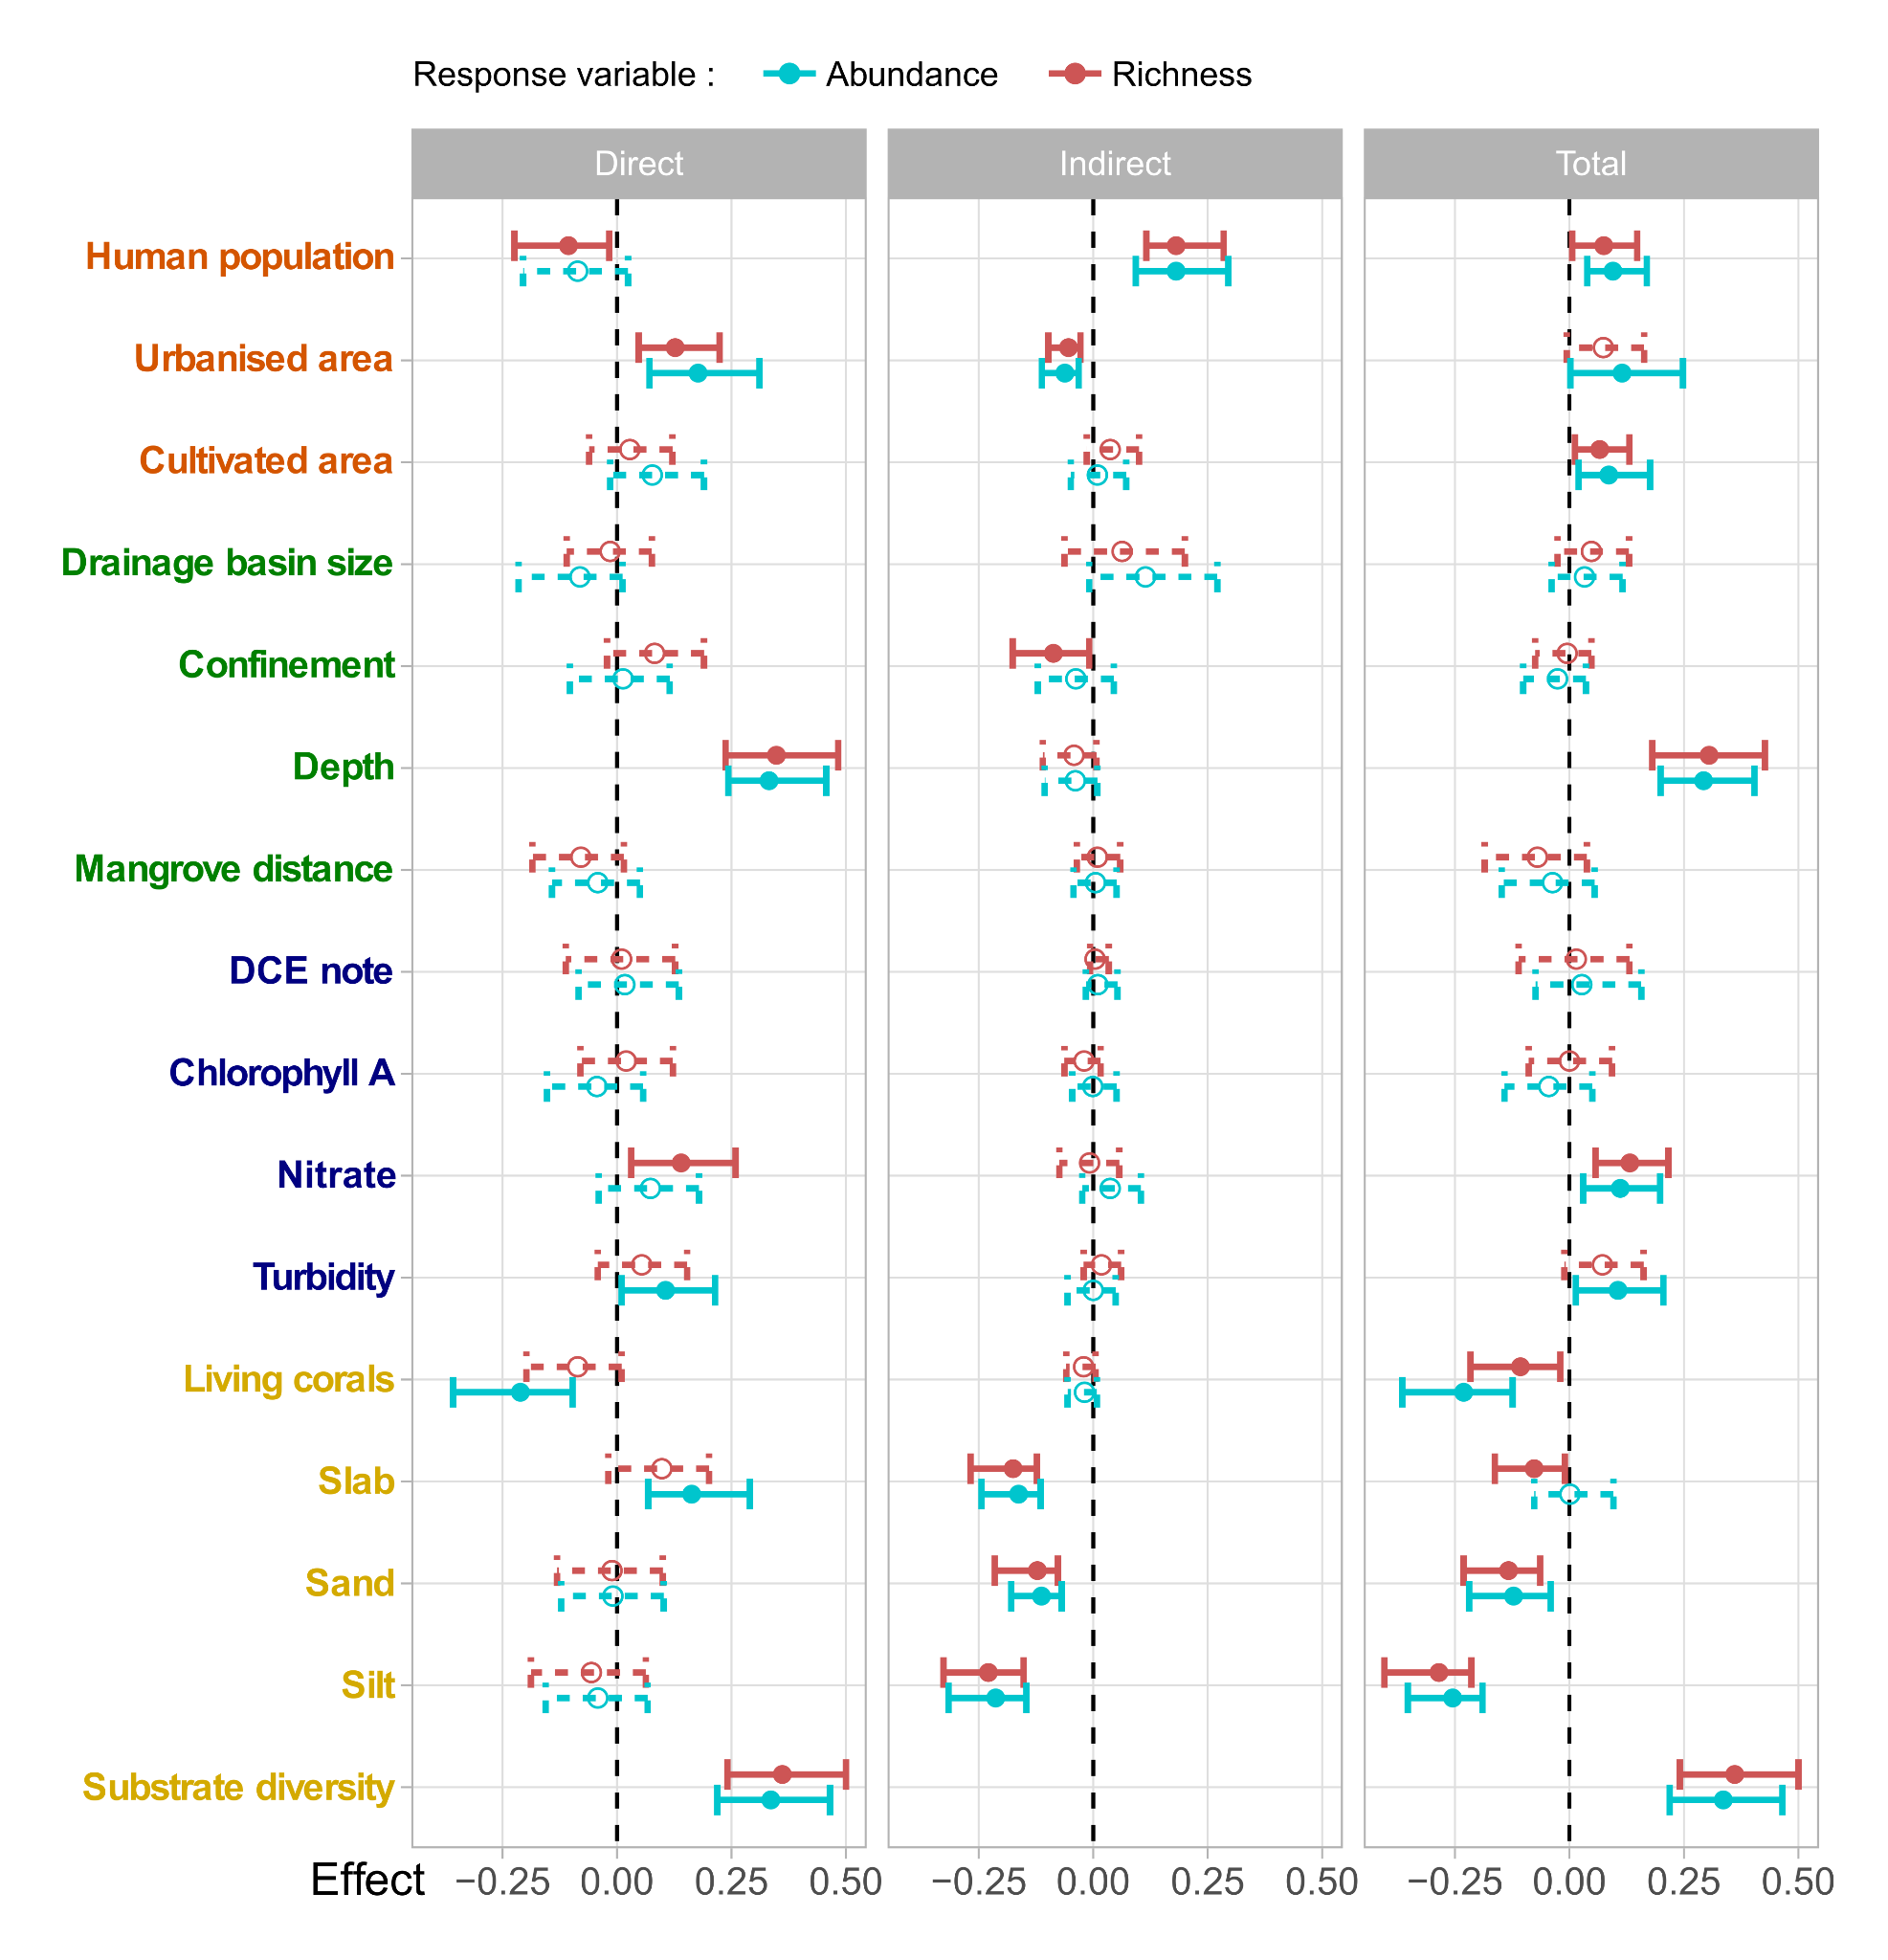

**Figure 5. The direct, indirect and total effect of all explanatory variables on sponge abundance and sponge richness.** Dots represent standardised mean effects, and error bars depict 95% confidence intervals (dotted lines represent intervals crossing zero). Variable names are coloured following their context: human (orange), geographical (green), water quality (blue) and substrate (yellow).

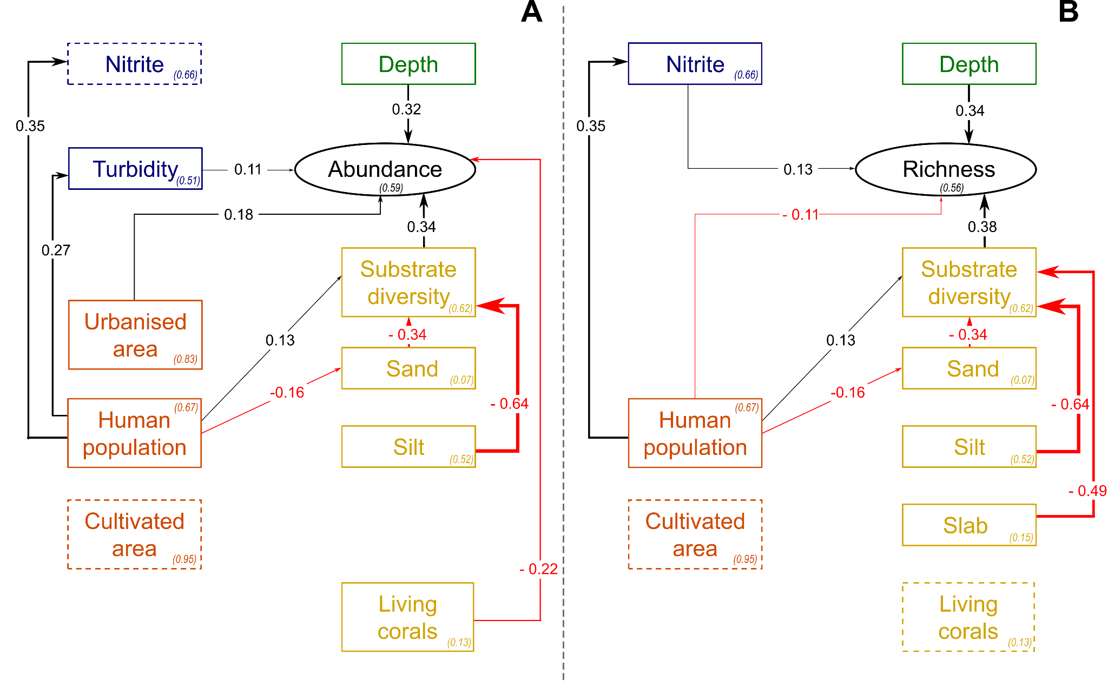

**Figure 6. Schematic path diagram representing causal relationships between the environmental conditions and the sponge abundance (A) and richness (B).** Line width is scaled to the absolute value of effects. Standardised *R²* coefficients are specified in brackets for each endogenous variable. Variable names are coloured following their context: human (orange), geographical (green), water quality (blue) and substrate (yellow). We only represented the effects for the variables with a significant total effect on sponge abundance or sponge richness. The dotted lines represent variables with a significant total effect (resulting from adding direct and multiple indirect effects through other variables) but no direct or indirect significant effect.

DISCUSSION

**Spatial variation of sponge assemblage among coastal zones of Mayotte**

Sponge assemblages were highly variable across the coastal zones of Mayotte in terms of richness and abundance. Such variations of assemblages were reported numerous times at various spatial scales [(Barnes, 2009; Bell et al., 2010; de Voogd et al., 2009; Duckworth et al., 2007; Easson et al., 2015; Fromont et al., 2006; González-Díaz et al., 2010; Hooper & Kennedy, 2002; Monteiro & Muricy, 2004; Nava et al., 2014; Turon et al., 2019; Villamizar et al., 2014; Wilkinson & Evans, 1989)](https://www.zotero.org/google-docs/?JYUiFl). However such variation were not always explained thanks to stochastic process originated from intrinsic features of sponges biology (particularly traits related to their reproduction and dispersion), that may limit or blurred the relationship between sponge and environmental conditions (Zae 2001; Becerro et al., 2012). In this study, stations identified as anthropized archetype had the richest and most abundant assemblages with more than 500 individuals. Conversely, stations identified as oligotrophic archetype were inhabited by less rich and abundant assemblages with less than 100 individuals. In addition RDA analysis and the finding of indicator species of environment context suggested that sponges assemblages of the fringing reef of Mayotte in large part resulted from a combination of micro to meso scale environmental effects rather than stochastic processes. In the following parts, we discussed about main factors that shaped sponge assemblage and at which the spatial scale they play. We also discussed about the processes by which anthropization may act and the implication for biological monitoring perspectives.

**Micro-scale environmental conditions as main drivers of sponge assemblages**

The redundancy analysis gave a first insight of environmental conditions influencing the structure of sponge assemblages. Zonation and depth were the major discriminators of sponge assemblages as they were responsible for two-thirds of the explanatory power of the model. It is an expected result as depth was shown to be a key factor in sponge assemblage structuration [(Fromont et al., 2006; Wilkinson & Evans, 1989)](https://www.zotero.org/google-docs/?aRSSOR). In addition to depth variation, zonation is also linked to substrate composition in Mayotte, which is congruent with bibliography [(Fromont et al., 2006)](https://www.zotero.org/google-docs/?eyTilX). For instance, the first zone is the one closest to the shore and is often covered by sand or silt whereas living and dead corals start to appear in zone 2 and are often ubiquitous in zone 3. It can be explained by the differences of ecology of the sponge species with some of them like encrusting sponges which grow mainly on hard substrates like slab while other species grow partly buried in the substrate and thus are mainly found in zones covered by sand and silt. The RDA highlights certain species whose ecology restricts them to specific zones suggesting narrower niche breadth. For example, the morphotype 11 (*Stylissa massa*) appeared to be associated with the two first zones and indeed we observed it most of the time in zone 2 and it was nearly always present in this zone. In contrast, another member of the *Stylissa* genus, the morphotype 28 (*Stylissa carteri*) was indicative of the reef-front and beyond as it was always found in zones 4 and 5. Thus, micro-scale environmental conditions, i.e. within each station was the first determinant of sponge assemblage structure.

This finding was supported by our SEM analysis which looked more closely at the drivers of the richness and abundance of sponge assemblages. Overall, sponge richness and abundance exhibited similar relationships with the studied variables. It stands out that the depth was one of the main drivers of sponge richness and abundance in terms of both direct and total effects. It shows that more abundant and diversified assemblages are found in deeper environments. This result is true for our depth gradient which spans from 3 metres to 20 metres. It was reported that depths around 10-30 metres are particularly favourable for sponges and that deeper waters limit the growth of phototrophic sponges as light becomes scarcer and of sponges in general due to a lack of nutrients [(Wilkinson & Evans, 1989)](https://www.zotero.org/google-docs/?ppX1Xd). Thus, we cannot extend this conclusion to a wider depth gradient as the relationship is expected to become non-linear. As for the RDA, the substrates and in particular the substrate diversity had a strong influence on our path analysis of sponge richness and abundance. This result was expected as a greater diversity of substrates is linked to an increase in the diversity of ecological niches available which could in turn lead to an increase in sponge richness as more species could exploit the available niches at the same time (eg. Schlacher et al. 2007). Along with substrate diversity, each type of substrate (ie silt, slab and sand) in itself had a negative total effect on sponge abundance and richness. This total effect is mainly driven by a negative indirect effect which is mediated by the diversity of substrates. It points out that stations dominated by one type of substrate have less substrate diversity and thus poorer and less abundant sponge assemblages. Here again, these results highlight the importance of micro-scale drivers in shaping sponge assemblage diversity.

Among substrates, living corals seem to have a peculiar role. They exhibited a strong direct negative effect on sponge abundance but a weaker effect on sponge richness. These findings support the hypothesis of competition for habitat between corals and sponges as both are sessile organisms [(Bell et al., 2013; Wilkinson, 1978)](https://www.zotero.org/google-docs/?80PMSM). Parts of the reef where living corals prevail harbour sponge assemblage slightly less diversified but, above all, less abundant.

It is quite intriguing that no direct negative impact of silt was found on either sponge richness or abundance. Indeed, previous studies have shown that high levels of sedimentation were associated with substrates dominated by silt often harboured less diverse assemblage [(Bell et al., 2015; Carballo, 2006; Hsiao et al., 2021; Monteiro & Muricy, 2004)](https://www.zotero.org/google-docs/?4Lh44E). It was proposed that siltation tends to occlude oscules of sponges and that mobile fine substrate is inappropriate for settlement and recruitment of sponges affecting local carrying capacity (see (Maldonado, Giraud, et Carmona 2008; Bell et al. 2015). However, (Bell et al. 2015) pointed out that if there is a consensus that sediment is a key factor for sponges, its effect is not uniform since species have differential ability to tolerate settled sediment. Hence, we expected that the lack of direct effect may be attributed to a non-linear relationship between silt dominance and sponge richness and abundance. We observed in the field that sponge assemblages of stations with a balanced presence of silt were often more abundant and diverse than those of stations without silt. However, in stations dominated by silt, the abundance and richness of sponges were often really low leading to a suspicion of a non-linear relationship with an optimal for stations with balanced substrates.

**Natural meso-scale environmental conditions marginally shape sponge assemblages**

Along with depth, three variables linked to the global geographic environment of the stations were included: the size of the drainage basins adjacent to each station, the distance to the nearest mangrove and the relative confinement of the water mass. These variables are at a meso-scale as they do not differ between the different zones of a station but only between stations themselves. We did not find any effect of these meso-scale variables on either sponge abundance or richness in the SEM analysis while we were expecting them to influence several processes potentially impacting sponges. For instance, we were expecting that the size of the drainage basin would be associated with the amount of sediment discharged as well as the availability of nutrients [(Carballo, 2006; Duckworth et al., 2007; Monteiro & Muricy, 2004)](https://www.zotero.org/google-docs/?n0dl8q). This lack of drainage basin size effect can be partly caused by the low values and narrowness of the gradients of these variables in Mayotte. Indeed, Mayotte archipelago is composed of small, low-lying islands with small and fairly evenly distributed rivers. Similarly, we evaluated water quality at each stations point using four indicators which are related to nutrients availability (i.e. *Nitrate* and *Chlorophyll A* variables and to a lesser extent *Turbidity*), sedimentation (i.e. *Turbidity*) and to the general ecological and chemical water quality (i.e. *DCE note*). We were also expecting a strong impact of these variables and, in particular, an increase of sponge abundance following higher concentrations of nutrients [(Barnes, 2009; de Voogd et al., 2009; Hooper & Kennedy, 2002; Monteiro & Muricy, 2004; Nava et al., 2014; Zea, 1994)](https://www.zotero.org/google-docs/?EtprQD). However, we did not find any significant impact of the concentration of chlorophyll A and of the DCE note on sponge richness and abundance. Nevertheless, we obtained a small positive effect of the nitrate concentration on sponge abundance and richness and of turbidity on sponge abundance. Once again, these results can be partly influenced by narrow gradients of the selected variables in the context of Mayotte.

These meso-scale geographic and water quality variables emerge more clearly from the RDA analysis. Indeed, the size of the drainage basin, the confinement of the water mass, nitrate concentration and to a lesser extent turbidity were associated with one direction of the second axis of the ordination whereas the distance to the nearest mangrove was associated with the other direction. Altogether, these variables draw a second axis which is consistent with a dissimilarity between assemblages based on environmental nutrient enrichment gradient. Though, this second axis only explains 7% of assemblages structure variation. Morphotype 27 (*Paratetilla bacca*) appeared to be particularly abundant in enriched stations whereas morphotype 45 (*Ectyoplasia coccinea*) was more abundant in stations with a more oligotrophic environment. It leads us to conclude that these meso-scale environmental conditions marginally shape sponge assemblages in Mayotte.

**Anthropic processes influence directly and indirectly sponge assemblages**

In addition to the previously mentioned variables, the size of human population and size of urbanised area in adjacent drainage basins stood out as driving the second axis of the RDA. Both are correlated to the other variables linked to environmental enrichment. It supports the hypothesis that anthropogenic activities are involved in a non-natural enrichment of the environment both on land and through run-off into the sea [(Barnes, 2009; González-Díaz et al., 2010; Monteiro & Muricy, 2004; Nava et al., 2014; Zea, 1994)](https://www.zotero.org/google-docs/?xHi3Z3). The SEM analysis has enabled us to delve deeper into the processes underlying human influence on sponge assemblages. Indeed, we were expecting human activities to interfere with the natural drivers of sponge assemblages at all the scales by impacting water quality and substrate availability. Overall, human activities had a total positive impact on sponge richness and abundance. This result is not so intuitive as some studies have found a negative correlation between human activities and sponge diversity [(Barnes, 2009; Monteiro & Muricy, 2004)](https://www.zotero.org/google-docs/?v2qtdT), no correlation [(González-Díaz et al., 2010)](https://www.zotero.org/google-docs/?ZZ2W9T) or a positive correlation [(Nava et al., 2014)](https://www.zotero.org/google-docs/?S8YOze). As we are dealing with complex processes that can have an opposing impact on many variables, SEM demonstrates its relevance. For instance, human activities can be a source of higher sedimentation rates which would in turn decrease sponge diversity or conversely a source of nutrients which would increase sponge diversity. The size of human population in adjacent drainage basins had a positive effect on sponge abundance and richness originating mainly from indirect effects. It was mediated on the one hand by an environmental enrichment which is expressed by an increase in nitrate concentration and turbidity. On the other hand, it was mediated by an increase in the proportion of silt concomitant with a decrease in the proportion of sand and an overall increase in substrate diversity. More intriguingly, the positive effect of urbanisation on sponge richness and abundance is mainly driven by a direct effect. This direct effect leads us to think that we still have missing important mediator drivers as urbanisation on land cannot be directly linked to changes in sponge assemblages on sea. Similarly, human population density also had a direct negative effect on sponge richness and a weaker negative one on sponge abundance. Here again, we may lack the exact mechanism underlying this effect. It is noticeable that human population density does not only promote sponge assemblage diversity but also decreases it through processes which may be linked to anthropogenic pollution as already suggested [(Barnes, 2009; Monteiro & Muricy, 2004)](https://www.zotero.org/google-docs/?7d8Ixf). These latest results lead us to remain cautious about the conclusions to be drawn, given that SEM is usually designed for causal relationships. In our case, the direct causal relations between predictors were not always possible which forced us to deal with many latent variables. The amount of cultivated area exhibited other kinds of interesting relationships with sponge abundance and richness. Indeed, taken separately its direct and indirect effects do not significantly impact sponge abundance and richness but they complement each other leading to a total positive effect. Thus, effects of the amount of cultivated area are rather diffuse and have a marginal impact on many mechanisms. Overall, these results indicate that anthropisation interferes at different scales with natural processes of species assembly and now play a prominent role in them. Moreover, they highlight the complexity of these processes and the importance of considering all the possible paths to avoid misleading conclusions.

**Towards bioindicators of anthropogenic disturbance?**

We built a complex model which integrates numerous complementary and diverging processes. It showed the importance of anthropogenic disturbance on sponge assemblages. We hypothesised that some sponge OTU could be indicators of these anthropogenic disturbances for Mayotte lagoon. The RDA gave a first insight with OTU like morphotype 27 (*Paratetilla bacca*) associated with its second axis and thus to environmental enrichment. The archetypal analysis differentiated three types of environmental conditions of stations. We obtained on one side the stations with a high DCE grade, substrate diversity and proportions of sand, slab and living corals. These conditions indicate a globally oligotrophic environment. On another side we had the stations in naturally enriched conditions i.e. with high levels of chlorophyll A and turbidity. Interestingly, it allowed us to differentiate between natural and anthropogenic enrichment as human related variables were all associated with a third kind of station. Using this classification of stations, we found that some sponge OTU were particularly associated with each kind of environmental conditions and may serve as ecological indicators. Morphotype 27 (*Paratetilla bacca*) stands out once again and seems to have a high specificity and fidelity to anthropized conditions. OTU 54 (*Mycale* *humilis*) and 57 also exhibited properties indicative of anthropised areas whereas OTU 13 and 28 (*Stylissa carteri*) can better indicate naturally enriched conditions. Interestingly, closed species of *Mycale humilis*, *Mycale microsigmatosa* (inAlcolda 2007) and *Mycale micracanthroxea* (Carballo, Naranjo, et García-Gómez 1996) were also indicative of area dominated by anthropized area. Morphotype 31 (*Haliclona fascigera*) was the only morphotype particularly associated with oligotrophic conditions. Those OTU easy to recognize and frequent may serve as target species for development of indices for local biological survey of environmental changes of Mayotte lagoon.

CONCLUSION

Our results demonstrated that sponge assemblage was highly structured around coastal area in Mayotte which was partly explained by meso and micro scale factors. Path analysis highlighted the processes by which environmental factors and most particularly human activity shaped sponge distribution. Overall, these results demonstrated that long term sponge surveys could be useful to monitor coral reef changes in Mayotte and may serve for decision makers and environmental stakeholders in complementation to already existing biological surveys. The present study should inspire other territories sharing similar issues as we expected taxonomic overlap of sponge assemblage in neighbouring WIO territories (*eg* Comores, Madagascar or Mozambica) to reinforce the synergy of biological surveys at regional scale. Regional studies could build up on those local surveys to draw more general conclusions based on wider environmental gradients.

CREDIT AUTHOR STATEMENT

**Journiac L.** Field investigation, statistical analysis and writing the original draft **LeBozec C.** Field investigation and writing the original draft **Mégevand** **L.** and **Mercky Y.** Field investigation and manuscript improvement **Lamure F.X.** Geomatic data acquisition, **Trabelsi C.** Statistical analysis **Corse E.** Conceptualization, field investigation and writing the original draft.

FUNDING

This study was funded by the Direction de l'environnement, de l'aménagement et du logement de Mayotte: EPODIC I & II “Implications des assemblages d’éponges et de leur microbiote pour la bioindication lagonaire de Mayotte”.

DECLARATION OF COMPETING INTEREST

The authors declare that they have no known competing financial interests or personal relationships that could have appeared to influence the work reported in this paper.

DATA ACCESSIBILITY

Appendix I : Original sponge assemblage and habitat data:

Sheet 1: Sampling details. Median coordinates of latitude and longitude are averages from several collection sites on each reef.

Sheet 2: Table of OTU counting by transects

Sheet 3: Habitat data

Sheet 4 : Notes for habitat data

Sheet 6: Results of the ANOVA type III testing the station and zone effect on the richness and abundance of sponges

Sheet 7: Details of the Redundancy Analysis results

Appendix II : Details of SEM anlaysis

ACKNOWLEDGEMENT

We are grateful to Thierry Perez, Marie Grenier, Jean Vacelet and Michelle Klautau for their precious advices during development of sampling and categorization of morphotype methodologies. We are also grateful to Elliot Sucré, Arrou Clément, Thomas Claverie & Héloize Rouzé for their help with fieldwork. We especially thank Julie Richard and Julie Lietar for their continuous support during the project EpoDic I & II.

BIBLIOGRAPHY

[Barnes, P. (2009). Environmental impacts and the ecology of sponges and ascidians in south-eastern Australian coastal lakes and lagoons. *University of Wollongong Thesis Collection 1954-2016*. https://ro.uow.edu.au/theses/849](https://www.zotero.org/google-docs/?hCdw3Z)

[Bell, J. J., Berman, J., Jones, T., & Hepburn, L. J. (2010). Variability in the spatial association patterns of sponge assemblages in response to environmental heterogeneity. *Marine Biology*, *157*(11), 2503–2509. https://doi.org/10.1007/s00227-010-1514-5](https://www.zotero.org/google-docs/?hCdw3Z)

[Bell, J. J., Davy, S. K., Jones, T., Taylor, M. W., & Webster, N. S. (2013). Could some coral reefs become sponge reefs as our climate changes? *Global Change Biology*, *19*(9), 2613–2624. https://doi.org/10.1111/gcb.12212](https://www.zotero.org/google-docs/?hCdw3Z)

[Bell, J. J., McGrath, E., Biggerstaff, A., Bates, T., Bennett, H., Marlow, J., & Shaffer, M. (2015). Sediment impacts on marine sponges. *Marine Pollution Bulletin*, *94*(1), 5–13. https://doi.org/10.1016/j.marpolbul.2015.03.030](https://www.zotero.org/google-docs/?hCdw3Z)

[Blanchet, F. G., Legendre, P., & Borcard, D. (2008). Forward selection of explanatory variables. *Ecology*, *89*(9), 2623–2632. https://doi.org/10.1890/07-0986.1](https://www.zotero.org/google-docs/?hCdw3Z)

[Cáceres, M. D., & Legendre, P. (2009). Associations between species and groups of sites: Indices and statistical inference. *Ecology*, *90*, 3566–3574. https://doi.org/10.1890/08-1823.1](https://www.zotero.org/google-docs/?hCdw3Z)

[Carballo, J. L. (2006). Effect of natural sedimentation on the structure of tropical rocky sponge assemblages. *Ecoscience*, *13*(1), 119–130. https://doi.org/10.2980/1195-6860(2006)13[119:EONSOT]2.0.CO;2](https://www.zotero.org/google-docs/?hCdw3Z)

[*Corine Land Cover 2012 (raster 100m)—Version 2020_20u1, May 2020*. (n.d.). EEA Geospatial Data Catalogue. Retrieved 30 May 2023, from https://sdi.eea.europa.eu/catalogue/geoss/api/records/a84ae124-c5c5-4577-8e10-511bfe55cc0d](https://www.zotero.org/google-docs/?hCdw3Z)

[de Voogd, N., Becking, L., & Cleary, D. (2009). Sponge community composition in the Derawan Islands, NE Kalimantan, Indonesia. *Marine Ecology Progress Series*, *396*, 169–180. https://doi.org/10.3354/meps08349](https://www.zotero.org/google-docs/?hCdw3Z)

[Duckworth, A. R., Wolff, C. W., Duckworth, A. R., & Wolff, C. W. (2007). Patterns of abundance and size of Dictyoceratid sponges among neighbouring islands in central Torres Strait, Australia. *Marine and Freshwater Research*, *58*(2), 204–212. https://doi.org/10.1071/MF06104](https://www.zotero.org/google-docs/?hCdw3Z)

[Easson, C. G., Matterson, K. O., Freeman, C. J., Archer, S. K., & Thacker, R. W. (2015). Variation in species diversity and functional traits of sponge communities near human populations in Bocas del Toro, Panama. *PeerJ*, *3*, e1385. https://doi.org/10.7717/peerj.1385](https://www.zotero.org/google-docs/?hCdw3Z)

[Eugster, M. J. A., Leisch, F., & Seth, S. (2019). *archetypes: Archetypal Analysis* (2.2-0.1) [Computer software]. https://CRAN.R-project.org/package=archetypes](https://www.zotero.org/google-docs/?hCdw3Z)

[Fromont, J., Vanderklift, M. A., & Kendrick, G. A. (2006). Marine sponges of the Dampier Archipelago, Western Australia: Patterns of species distributions, abundance and diversity. *Biodiversity & Conservation*, *15*(11), 3731–3750. https://doi.org/10.1007/s10531-004-1871-9](https://www.zotero.org/google-docs/?hCdw3Z)

[González-Díaz, P., González-Sansón, G., Álvarez Fernández, S., & Perera Pérez, O. (2010). High spatial variability of coral, sponges and gorgonian assemblages in a well preserved reef. *Revista de Biología Tropical*, *58*(2), 621–634.](https://www.zotero.org/google-docs/?hCdw3Z)

[Grace, J. B. (2006). *Structural Equation Modeling and Natural Systems*. Cambridge University Press. https://doi.org/10.1017/CBO9780511617799](https://www.zotero.org/google-docs/?hCdw3Z)

[Hooper, J. N. A., & Kennedy, J. A. (2002). Small-scale patterns of sponge biodiversity (Porifera) from the Sunshine Coast reefs, eastern Australia. *Invertebrate Systematics*, *16*(4), 637–653. https://doi.org/10.1071/is02015](https://www.zotero.org/google-docs/?hCdw3Z)

[Hsiao, W. V., Lin, Y. V., Lin, H.-T., & Denis, V. (2021). Learning from differences: Abiotic determinism of benthic communities in Northern Taiwan. *Marine Environmental Research*, *170*, 105361. https://doi.org/10.1016/j.marenvres.2021.105361](https://www.zotero.org/google-docs/?hCdw3Z)

[IFREMER. (n.d.). *Cartographie—Donnees par parametre*. Surval. Retrieved 2 June 2023, from https://surval.ifremer.fr/Donnees/Cartographie-Donnees-par-parametre](https://www.zotero.org/google-docs/?hCdw3Z)

[Lê, S., Josse, J., & Husson, F. (2008). FactoMineR: An R Package for Multivariate Analysis. *Journal of Statistical Software*, *25*(1), Article 1. https://doi.org/10.18637/jss.v025.i01](https://www.zotero.org/google-docs/?hCdw3Z)

[Lefcheck, J. S. (2016). PiecewiseSEM: Piecewise structural equation modeling in R for ecology, evolution, and systematics. *Methods in Ecology and Evolution*, *7*(5), 573–579. https://doi.org/10.1111/2041-210X.12512](https://www.zotero.org/google-docs/?hCdw3Z)

[Legendre, P., & Gallagher, E. D. (2001). Ecologically meaningful transformations for ordination of species data. *Oecologia*, *129*(2), 271–280. https://doi.org/10.1007/s004420100716](https://www.zotero.org/google-docs/?hCdw3Z)

[*Masses d’eau côtières—Mayotte—Version État des Lieux 2019*. (n.d.). L’Atlas-Catalogue Du Sandre. Retrieved 2 June 2023, from https://www.sandre.eaufrance.fr/atlas/static/api/records/e2120da4-4665-4fd9-9ca9-df0a09b57099](https://www.zotero.org/google-docs/?hCdw3Z)

[*MNT bathymétrique combiné des fonds marins des zones récifales de Mayotte—Projet CARMAY*. (n.d.). Sextant. Retrieved 2 June 2023, from https://sextant.ifremer.fr/Donnees/Catalogue](https://www.zotero.org/google-docs/?hCdw3Z)

[Monteiro, L. C., & Muricy, G. (2004). Patterns of sponge distribution in Cagarras Archipelago, Rio de Janeiro, Brazil. *Journal of the Marine Biological Association of the United Kingdom*, *84*(4), 681–687. https://doi.org/10.1017/S0025315404009750h](https://www.zotero.org/google-docs/?hCdw3Z)

[Mørup, M., & Hansen, L. K. (2012). Archetypal analysis for machine learning and data mining. *Neurocomputing*, *80*, 54–63. https://doi.org/10.1016/j.neucom.2011.06.033](https://www.zotero.org/google-docs/?hCdw3Z)

[Murphy, M. V. (2022). *semEff: Automatic calculation of effects for piecewise structural equation models* [Manual]. https://CRAN.R-project.org/package=semEff](https://www.zotero.org/google-docs/?hCdw3Z)

[Nava, H., Ramírez-Herrera, M. T., Figueroa-Camacho, A. G., & Villegas-Sanchez, B. M. (2014). Habitat characteristics and environmental factors related to boring sponge assemblages on coral reefs near populated coastal areas on the Mexican Eastern Pacific coast. *Marine Biodiversity*, *44*(1), 45–54. https://doi.org/10.1007/s12526-013-0182-3](https://www.zotero.org/google-docs/?hCdw3Z)

[Oksanen, J., Simpson, G. L., Blanchet, F. G., Kindt, R., Legendre, P., Minchin, P. R., O’Hara, R. B., Solymos, P., Stevens, M. H. H., Szoecs, E., Wagner, H., Barbour, M., Bedward, M., Bolker, B., Borcard, D., Carvalho, G., Chirico, M., Caceres, M. D., Durand, S., … Weedon, J. (2022). *vegan: Community Ecology Package*. https://CRAN.R-project.org/package=vegan](https://www.zotero.org/google-docs/?hCdw3Z)

[*Populations légales des communes de Mayotte en 2017 − Populations légales de Mayotte en 2017 | Insee*](https://www.zotero.org/google-docs/?hCdw3Z). Retrieved 2 June 2023, from https://www.insee.fr/fr/statistiques/3291775?sommaire=2120838#consulter-sommaire

[Turon, M., Cáliz, J., Triadó-Margarit, X., Casamayor, E. O., & Uriz, M. J. (2019). Sponges and Their Microbiomes Show Similar Community Metrics Across Impacted and Well-Preserved Reefs. *Frontiers in Microbiology*, *10*. https://doi.org/10.3389/fmicb.2019.01961](https://www.zotero.org/google-docs/?hCdw3Z)

[Villamizar, E., Díaz, M. C., Rützler, K., & De Nóbrega, R. (2014). Biodiversity, ecological structure, and change in the sponge community of different geomorphological zones of the barrier fore reef at Carrie Bow Cay, Belize. *Marine Ecology*, *35*(4), 425–435. https://doi.org/10.1111/maec.12099](https://www.zotero.org/google-docs/?hCdw3Z)

[Wilkinson, C. R. (1978). Microbial associations in sponges. I. Ecology, physiology and microbial populations of coral reef sponges. *Marine Biology*, *49*(2), 161–167. https://doi.org/10.1007/BF00387115](https://www.zotero.org/google-docs/?hCdw3Z)

[Wilkinson, C. R., & Evans, E. (1989). Sponge distribution across Davies Reef, Great Barrier Reef, relative to location, depth, and water movement. *Coral Reefs*, *8*(1), 1–7. https://doi.org/10.1007/BF00304685](https://www.zotero.org/google-docs/?hCdw3Z)

[Wulff, J. L. (2006). Rapid diversity and abundance decline in a Caribbean coral reef sponge community. *Biological Conservation*, *127*(2), 167–176. https://doi.org/10.1016/j.biocon.2005.08.007](https://www.zotero.org/google-docs/?hCdw3Z)

[Zea, S. (1994). Patterns of coral and sponge abundance in stressed coral reefs at Santa Marta, Colombian Caribbean. *Sponges in Time and Space*, 257–264.](https://www.zotero.org/google-docs/?hCdw3Z)

[*Zones hydrographiques—Mayotte 2013—BD Carthage*](https://www.zotero.org/google-docs/?hCdw3Z). (n.d.). geo.data.gouv.fr. Retrieved 2 June 2023, from https://geo.data.gouv.fr/fr/datasets/6979fa12b236d7cb3f2c5b6b896db6632e722049