1.Database Schema:

First creating the database**,**

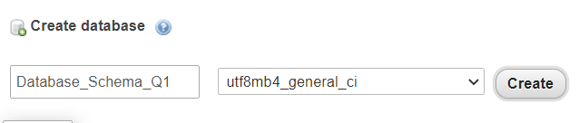

**Query:**

1.(i) Create the tables with the appropriate integrity constraints, insert around 10 records in each of the Tables.

Then creating the tables,

**Customer:**

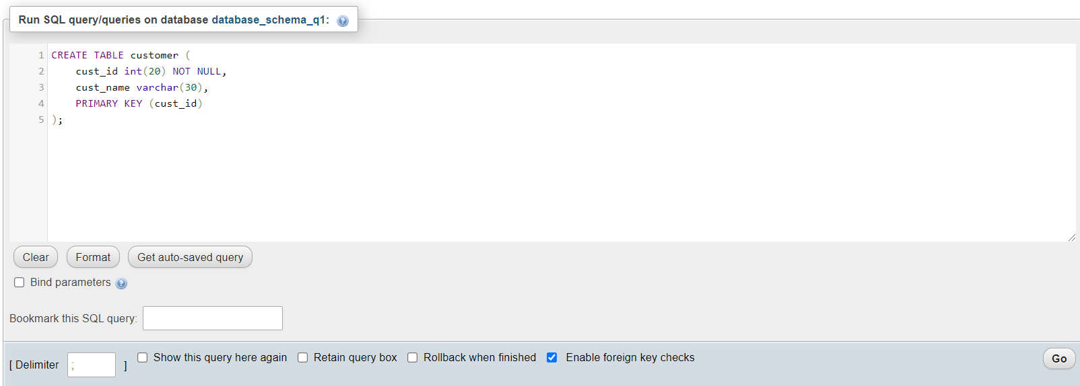





**Item:**

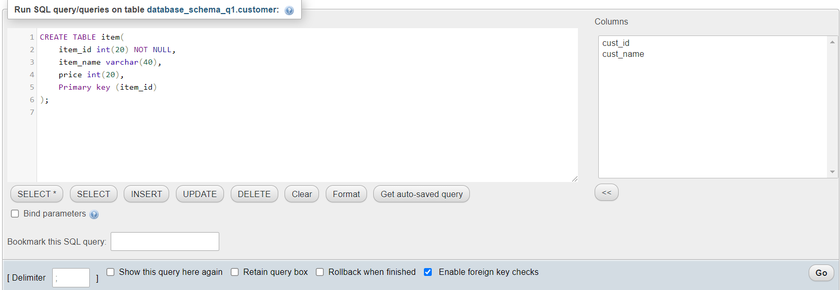





**Sale:**

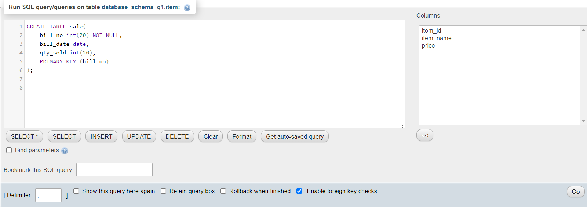





**relation_r_i:**

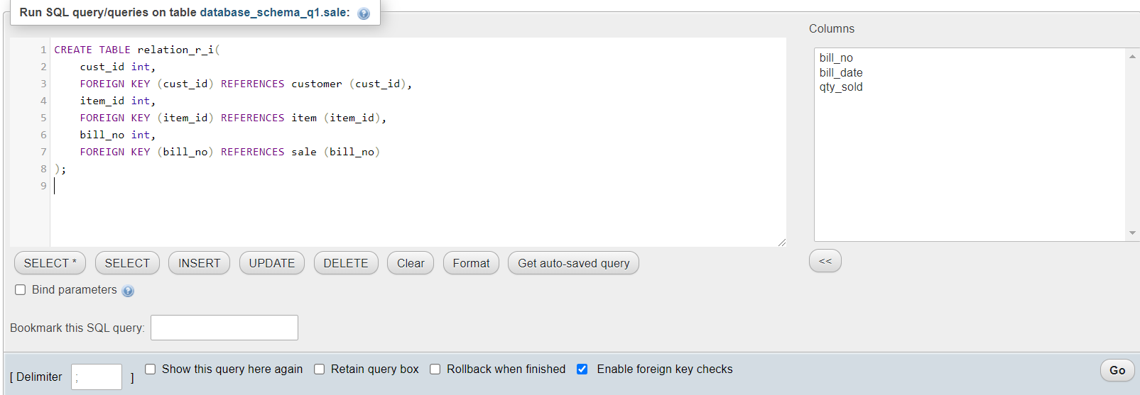





**Database:**

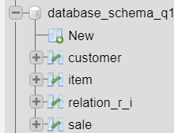

**Structure of Customer Table:**

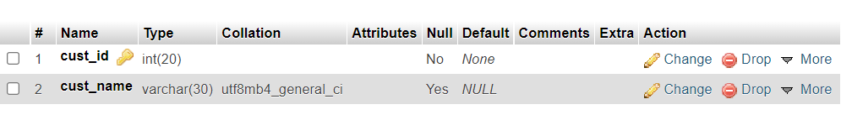

Structure of Item Table:

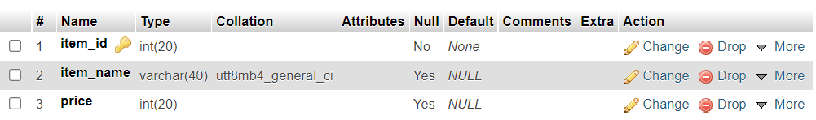

**Structure of Sale Table:**

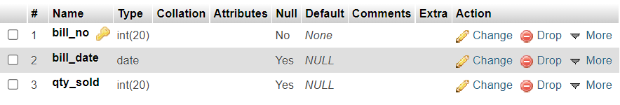

Structure of relation_r_i table:

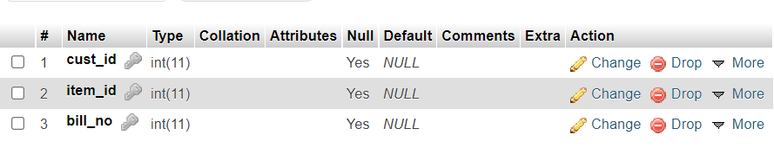

Then Insert the value in the respective Table,

**Customer :**

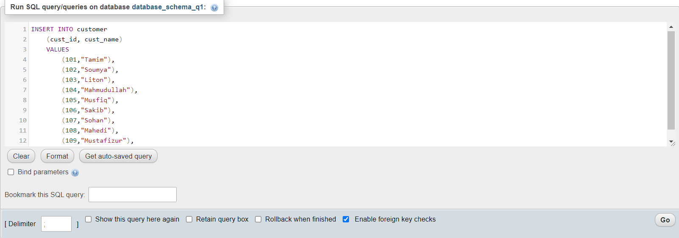



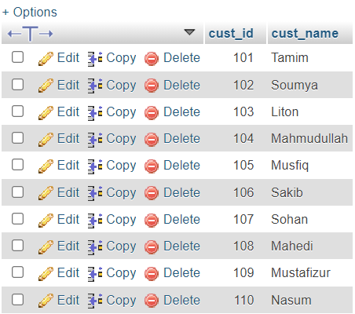

**Item:**

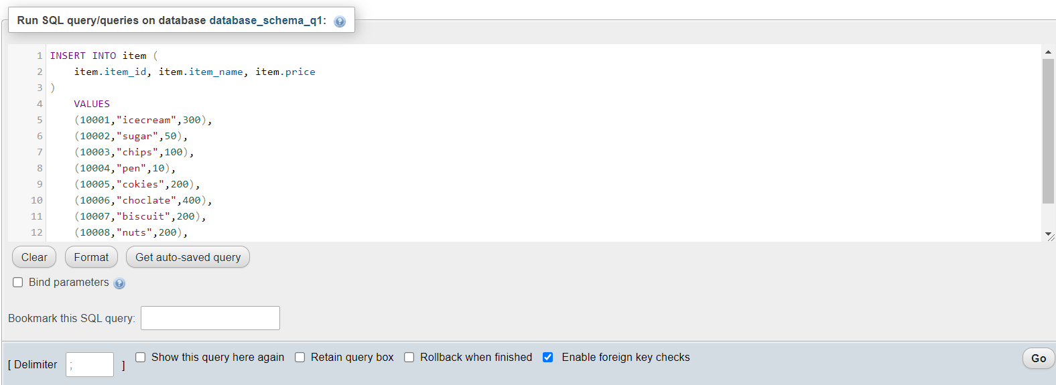



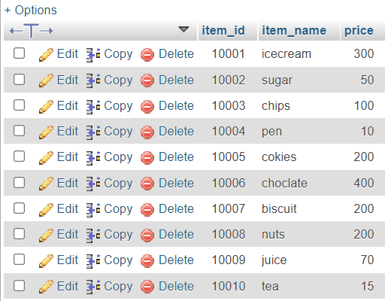

**Sale:** Here I update January month to July month and qty_sold when I watch the query (v) & (vi)

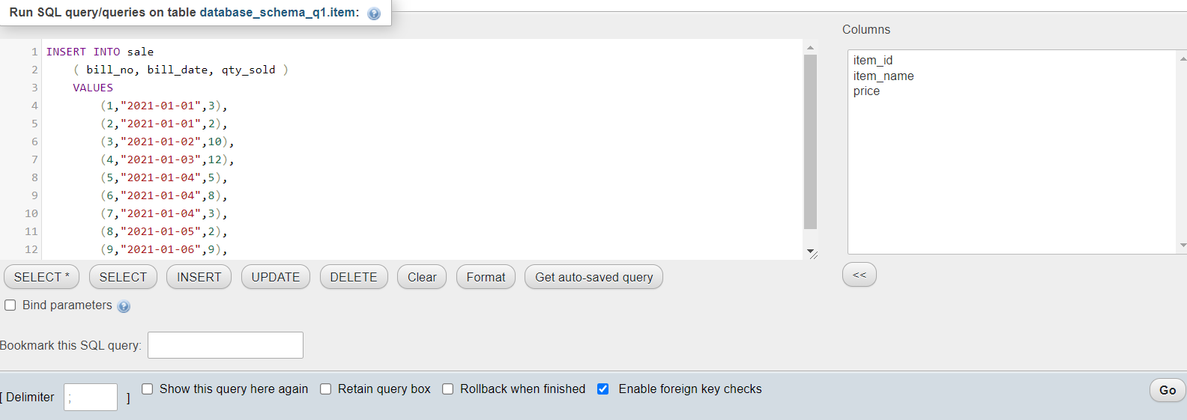

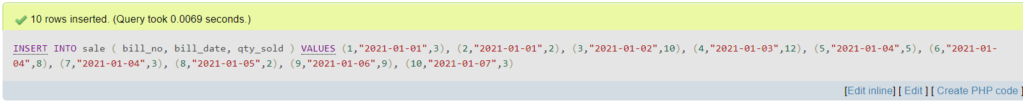

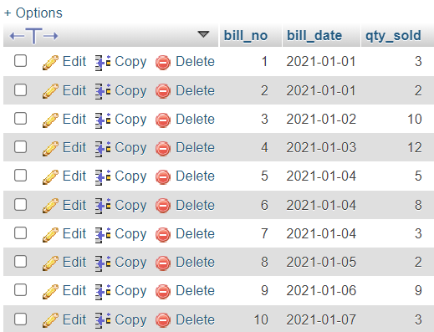

Updated Table,

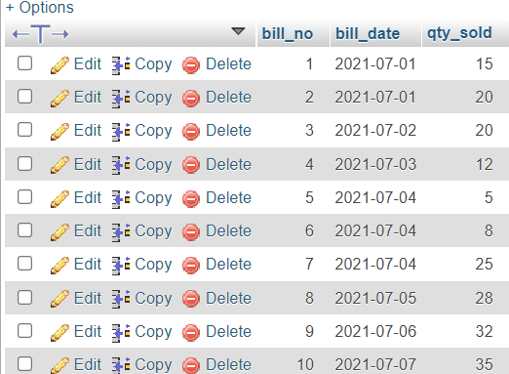

**relation_r_i:**

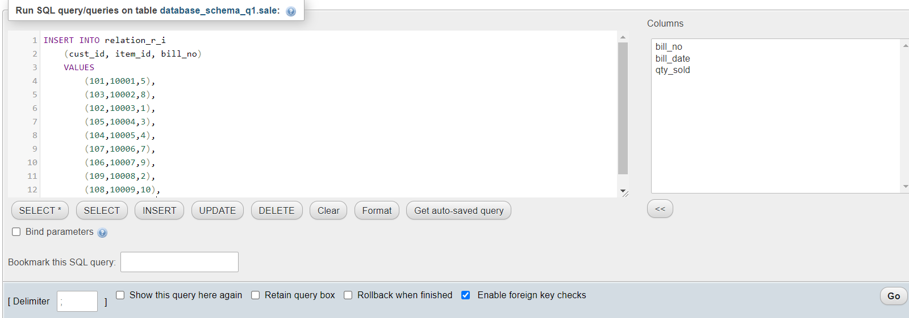

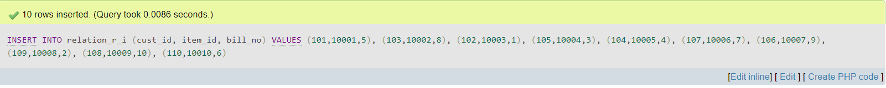

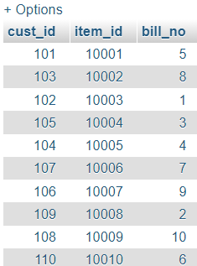

1.(ii ) Design the relationship set table to associate the relationship among the given entity set.

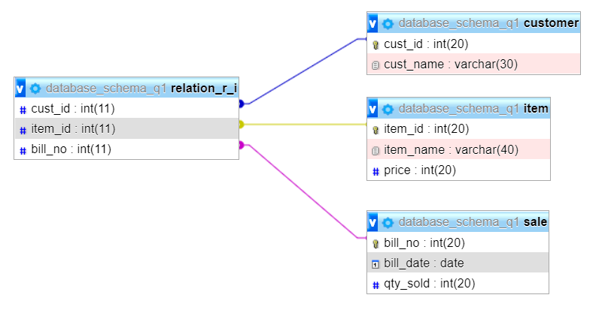

(iii) Give a count of how many items have been purchased by each customer in different bill number.

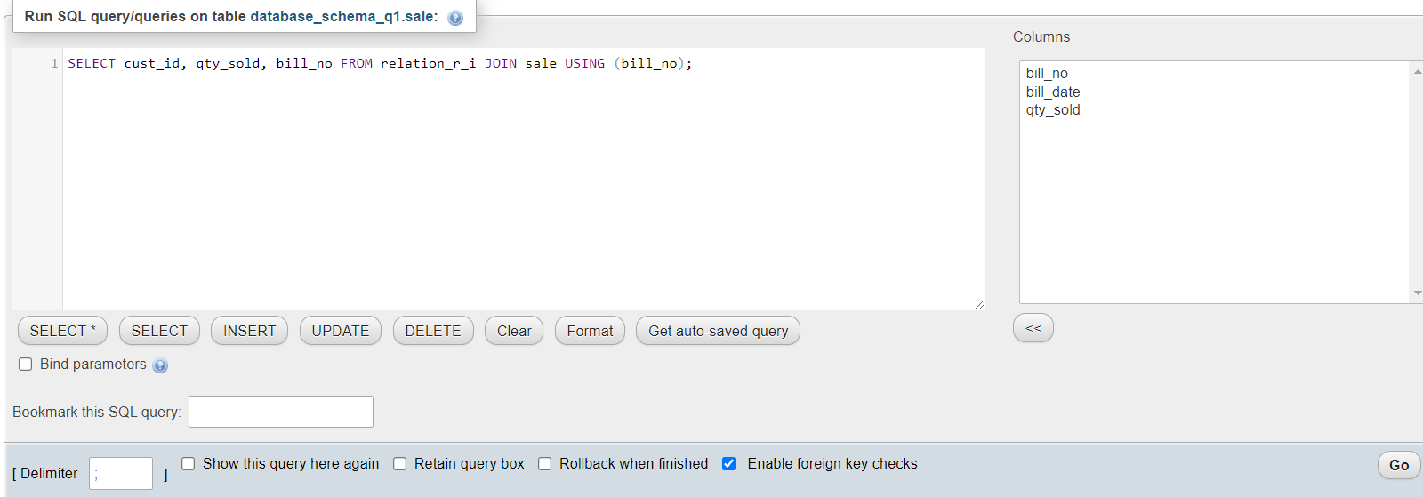

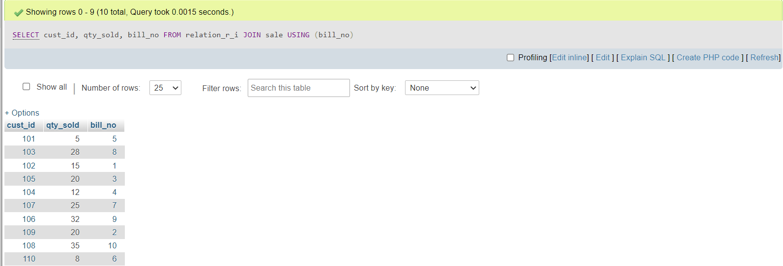

(iv) List the total bill amount with the quantity sold, total price of the items.

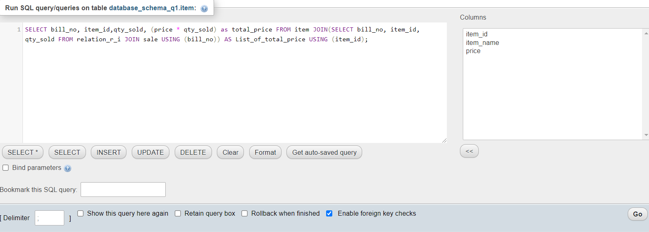

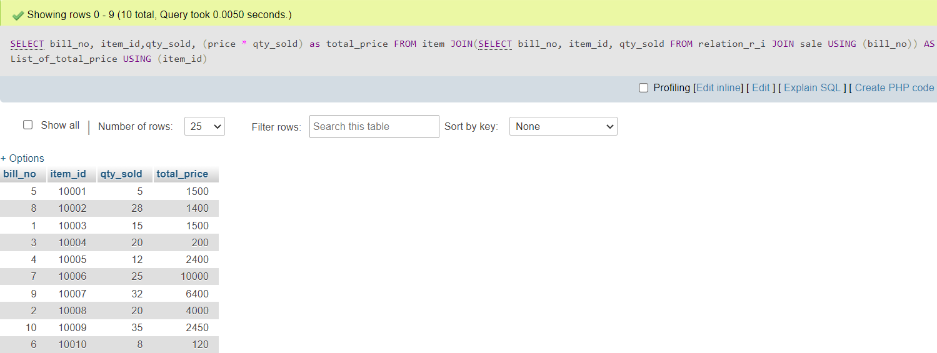

(v) Determine the total sold of a particular item in the month July 2021.

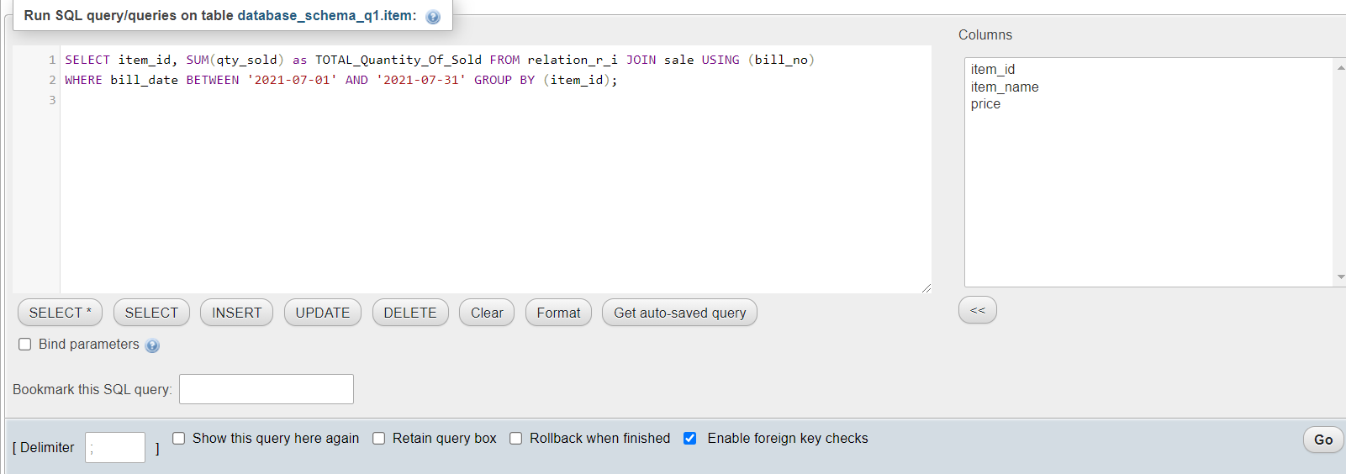

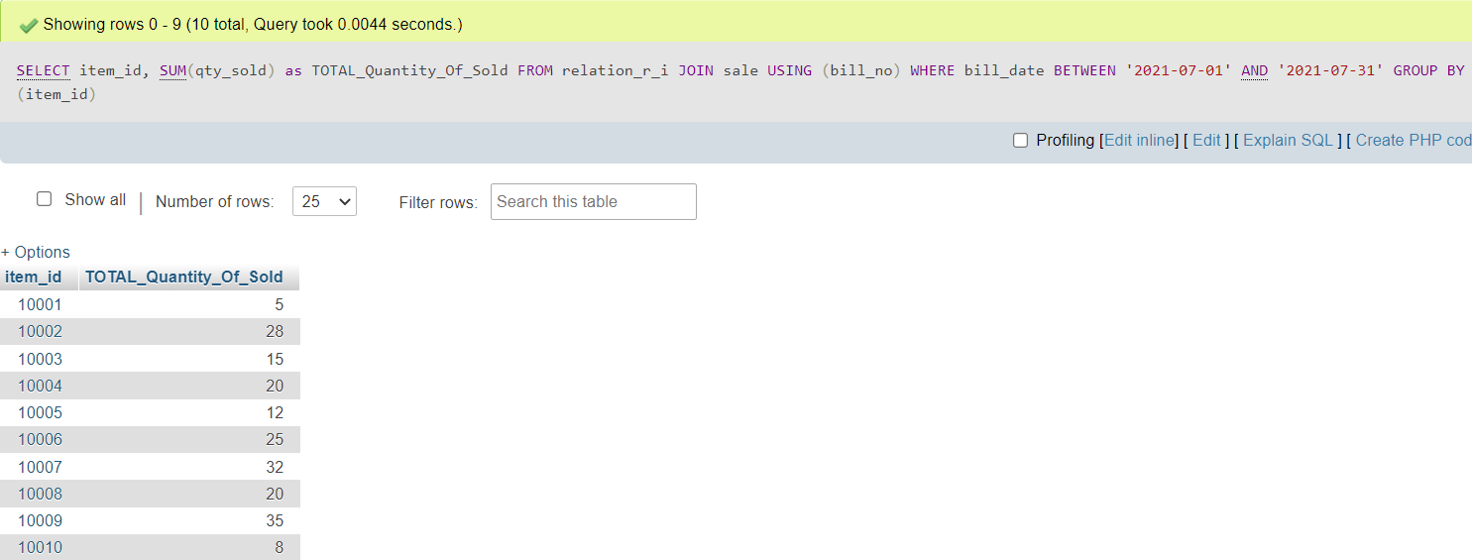

(vi) Produce 20% less bill for a customer who have bill more than BDT3000.

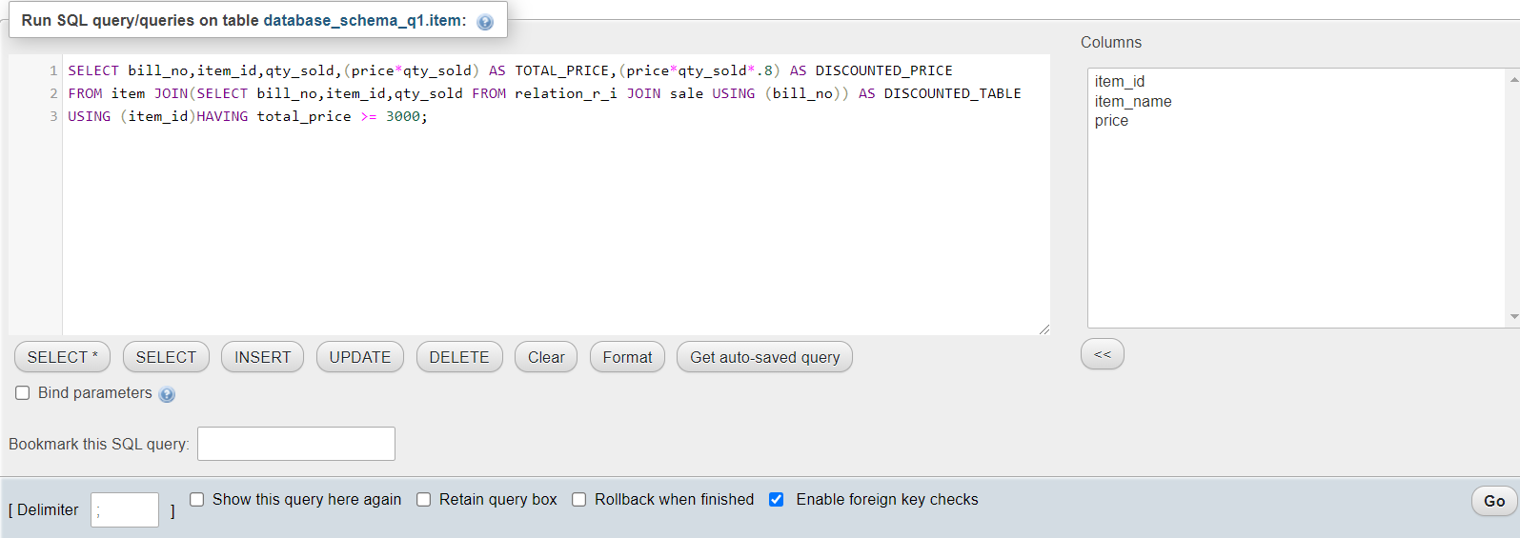

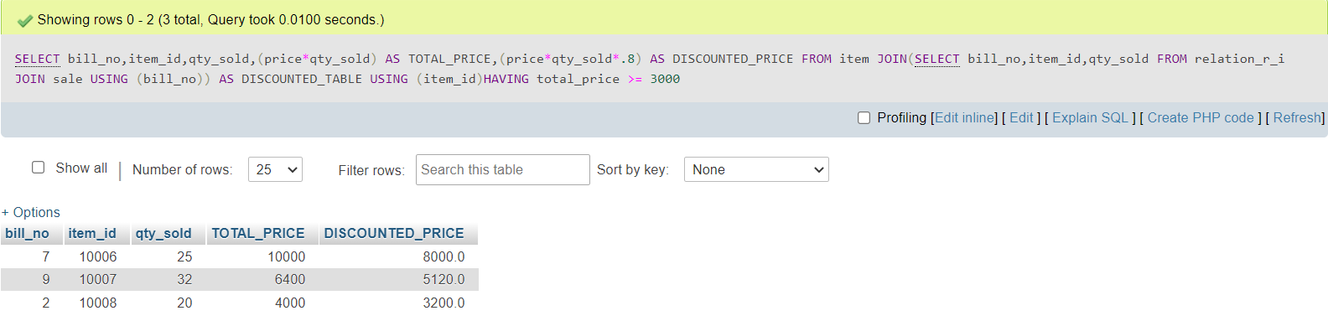

**2.DESIGN TOUR:**

First creating the database,

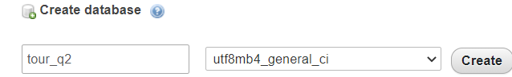

Then creating the tables,

**Bus:**

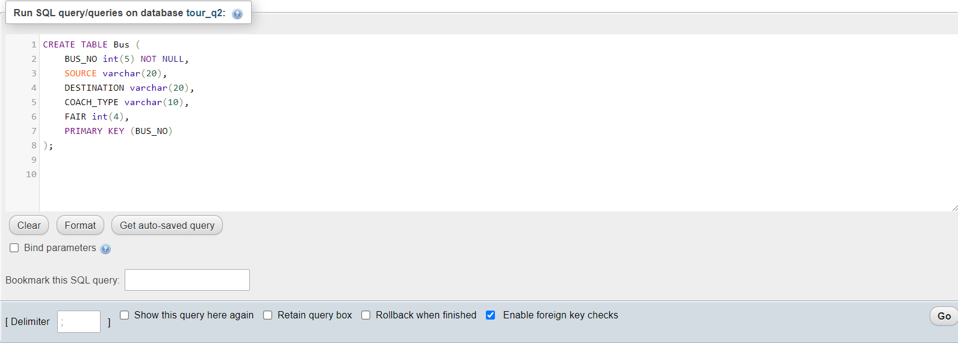





**Reservation:**

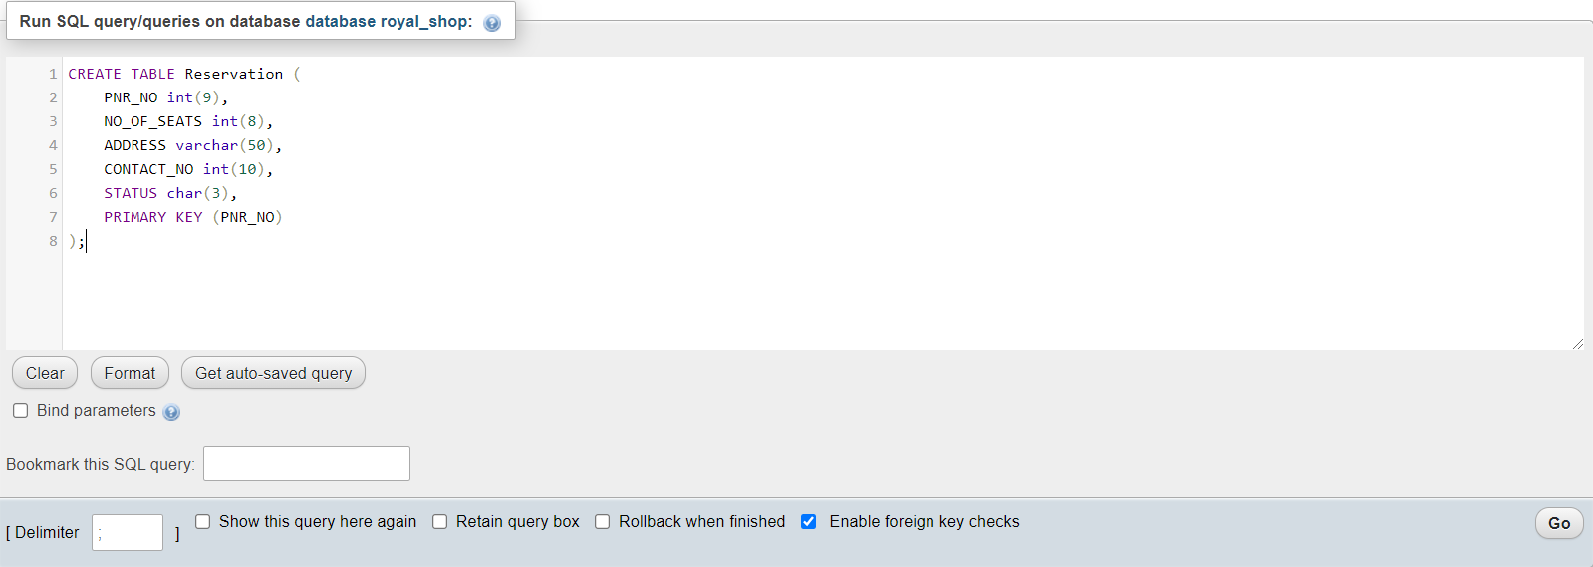





**Ticket:**

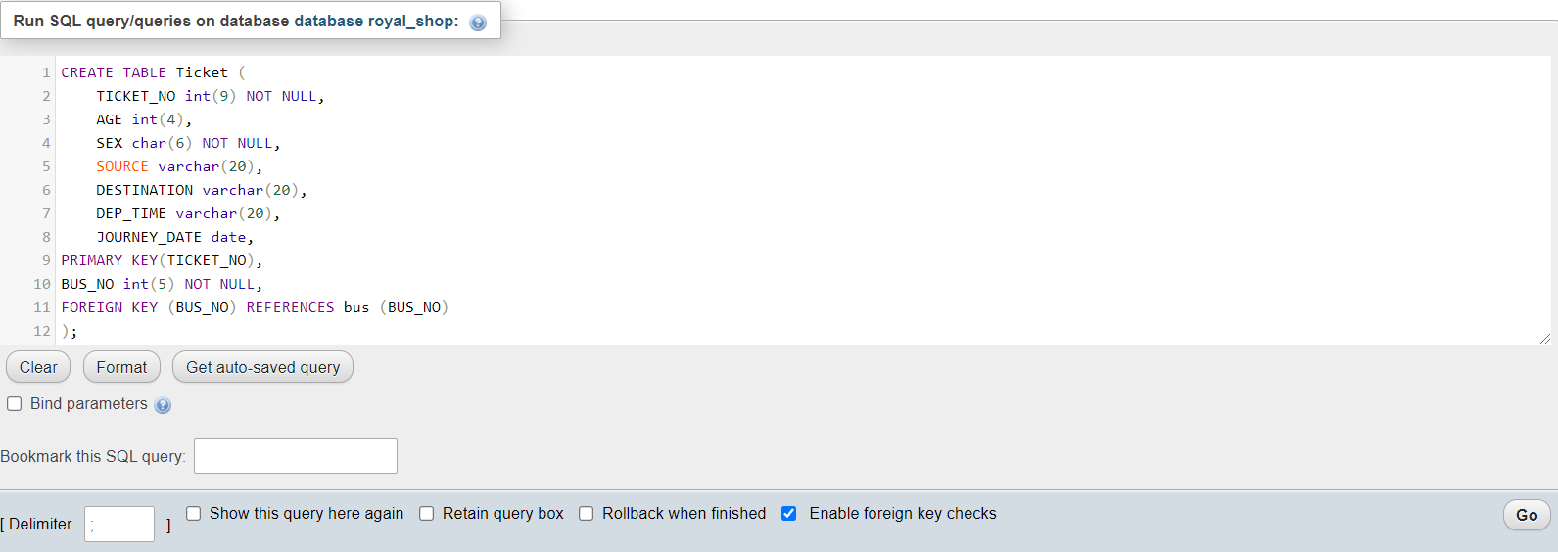





**Passenger:**

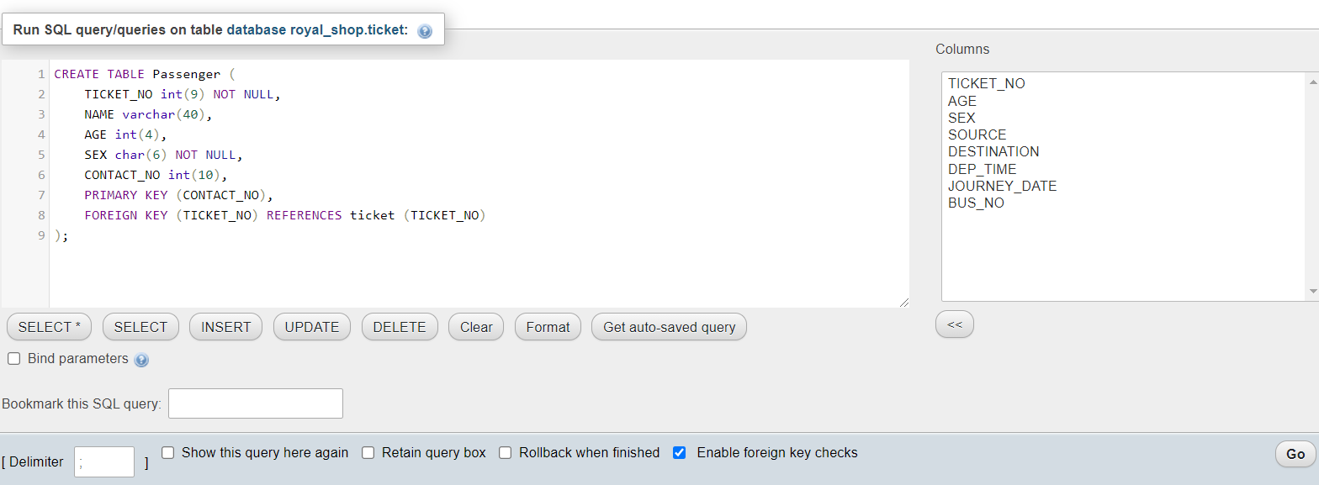





**Cancellation:**

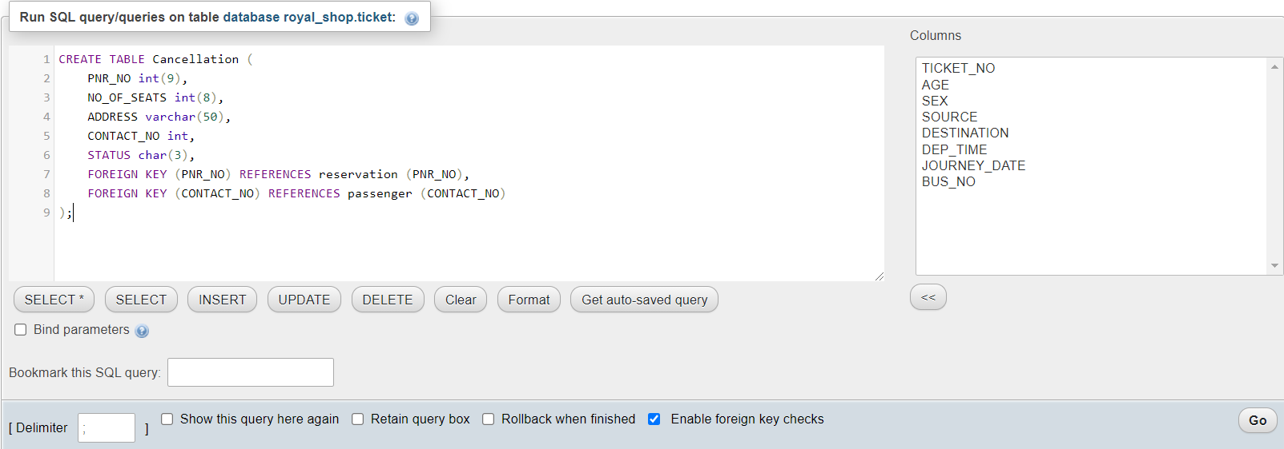

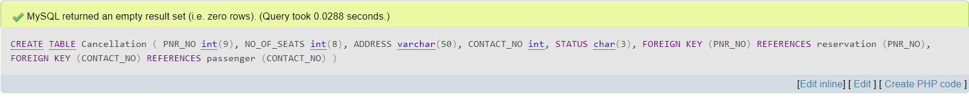



**Database:**

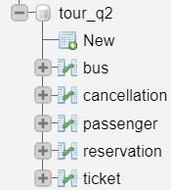

**Structure of Bus Table:**

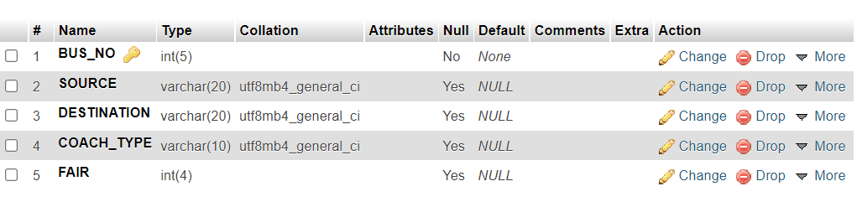

**Structure of Reservation Table:**

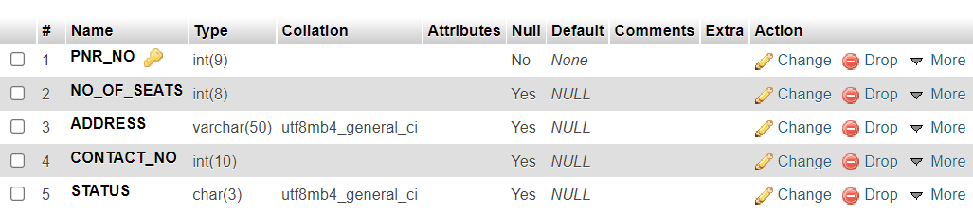**Structure of Ticket Table:**

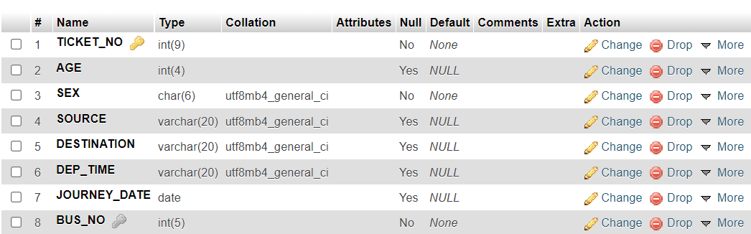

**Structure of Passenger Table:**

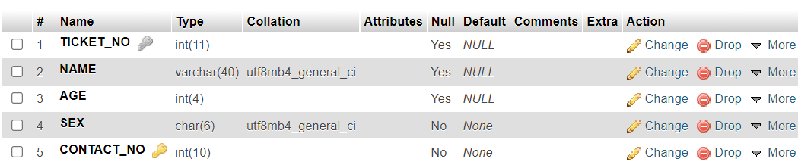

**Structure of Cancellation Table:**

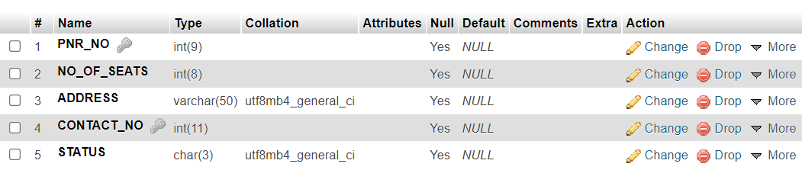

Database Schema:

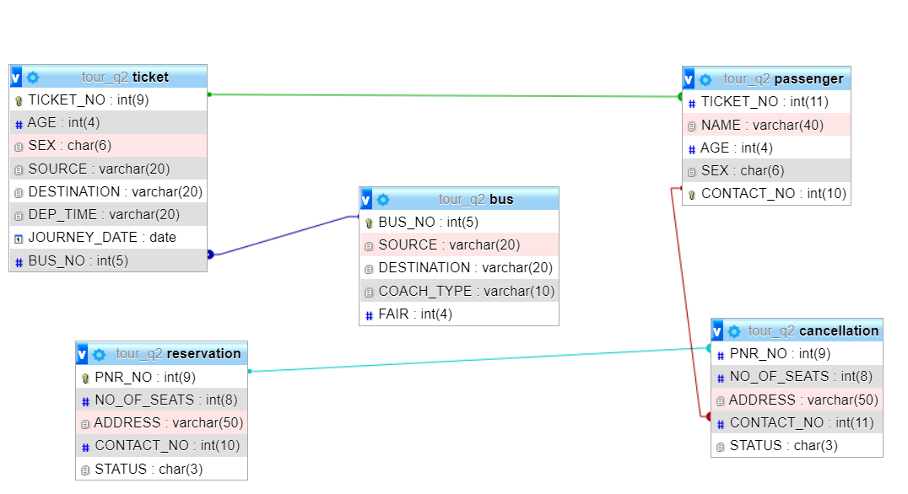

Then Insert the value in the respective Table,

**Bus:**

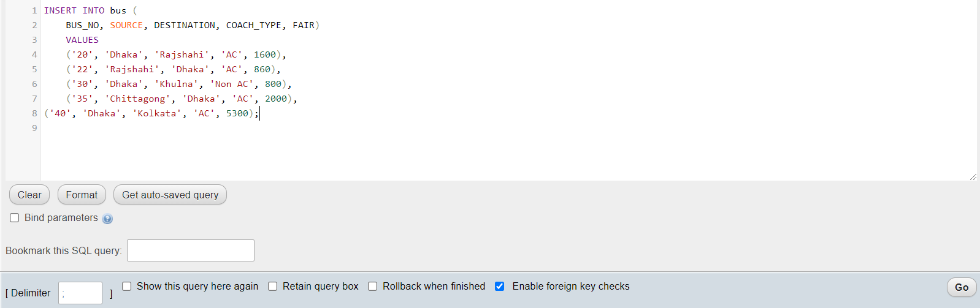



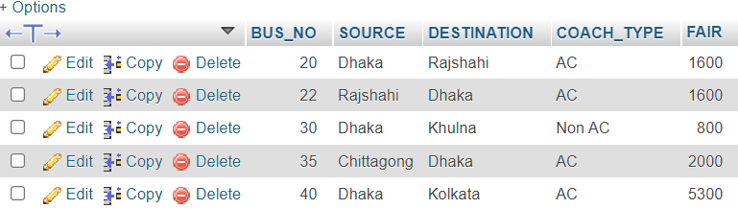

**Reservation:**

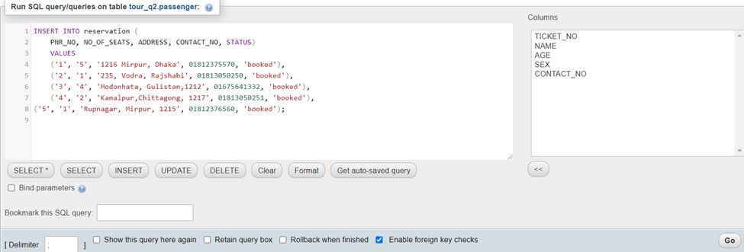

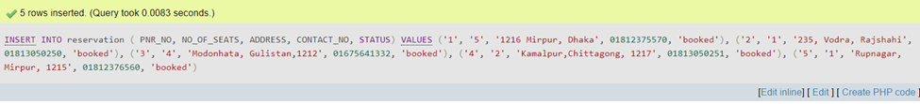

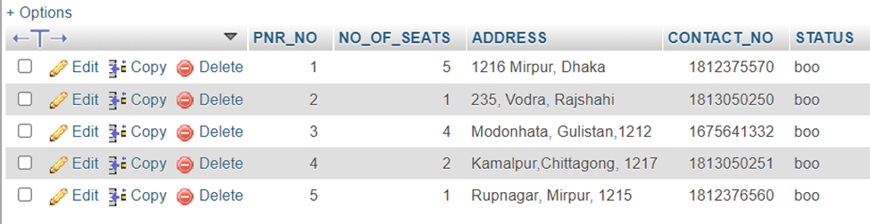

**Ticket:** Here I update the age 35 to 17 later when I watch the query (iii)

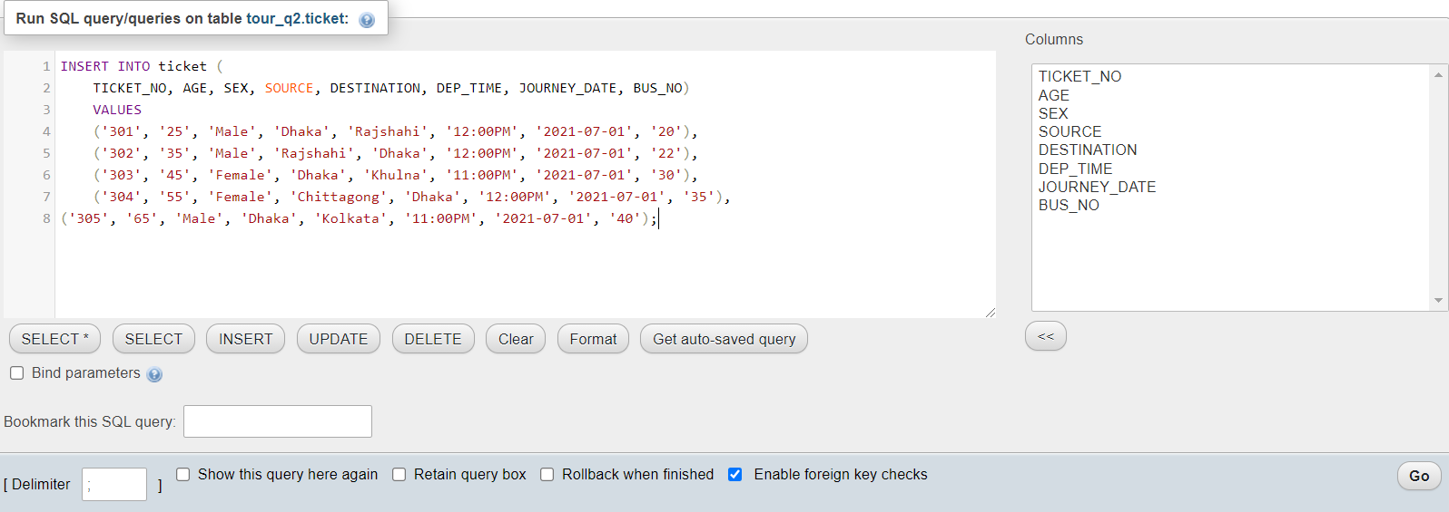



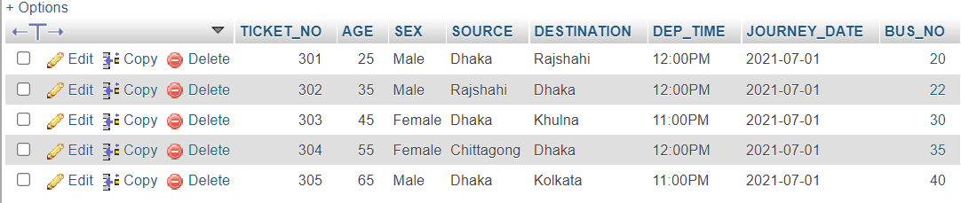

Updated Table,

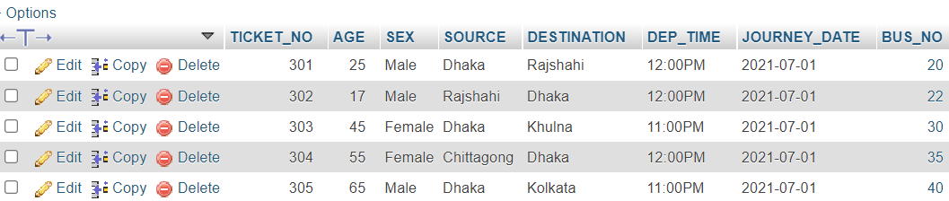

**Passenger:** Here I update the age 35 to 17 later when I watch the query (iii)

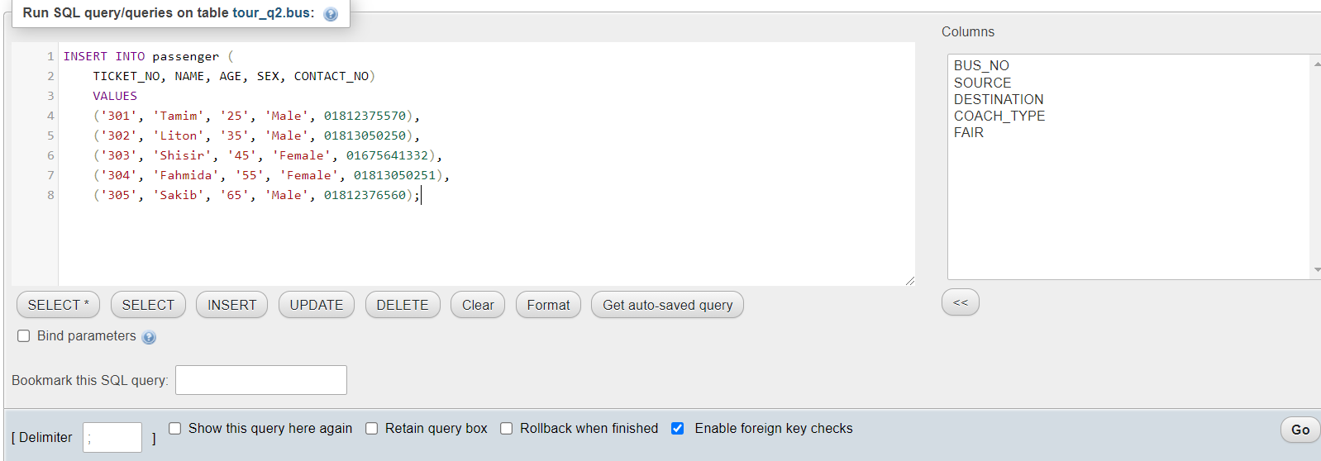



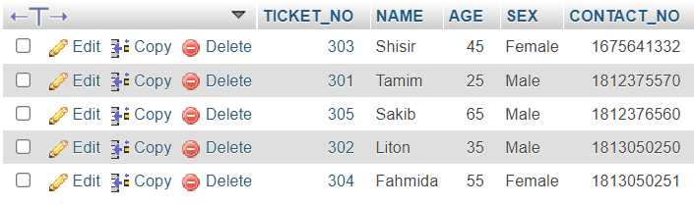

Updated Table,

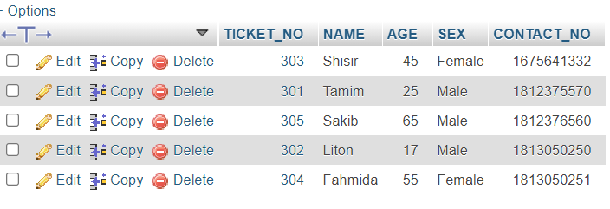

**Cancellation:**

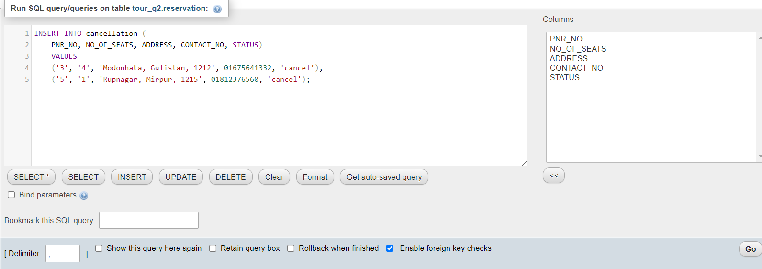



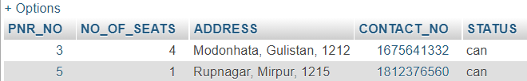

**Query:**

2.(i) How many passenger booked ticket for bus no 22 which is scheduled to run from Rajshahi to Dhaka on 1st of July 21, at 12:00PM.

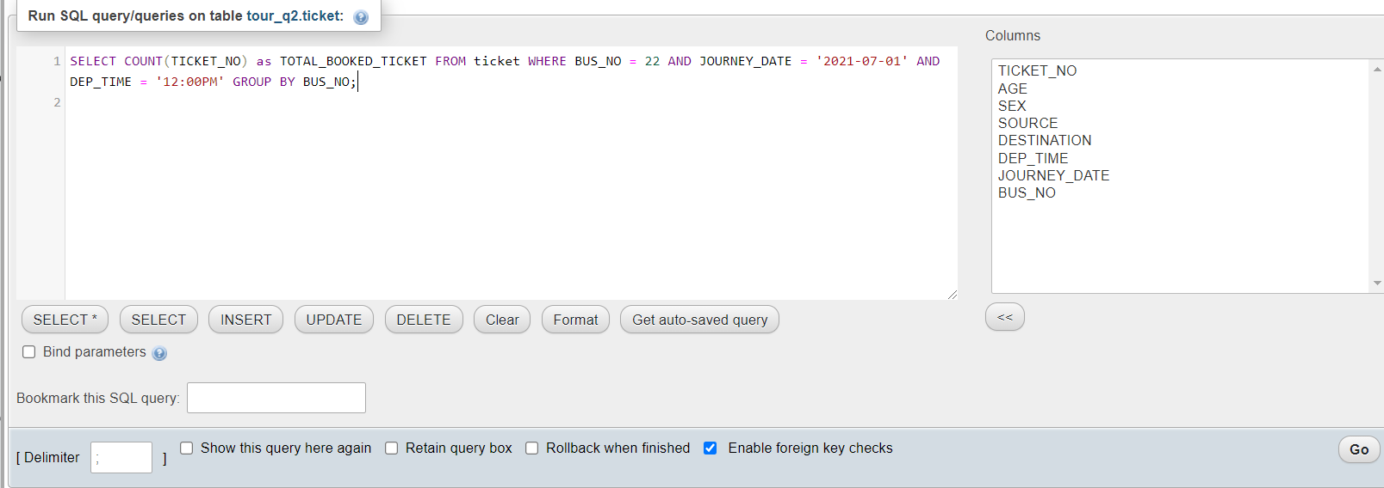

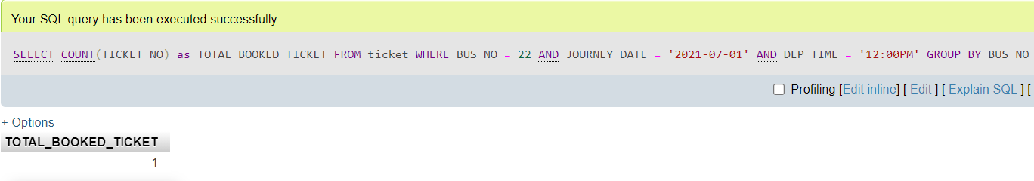

2.(ii) How many tickets have been canceled in the month of July 2021?

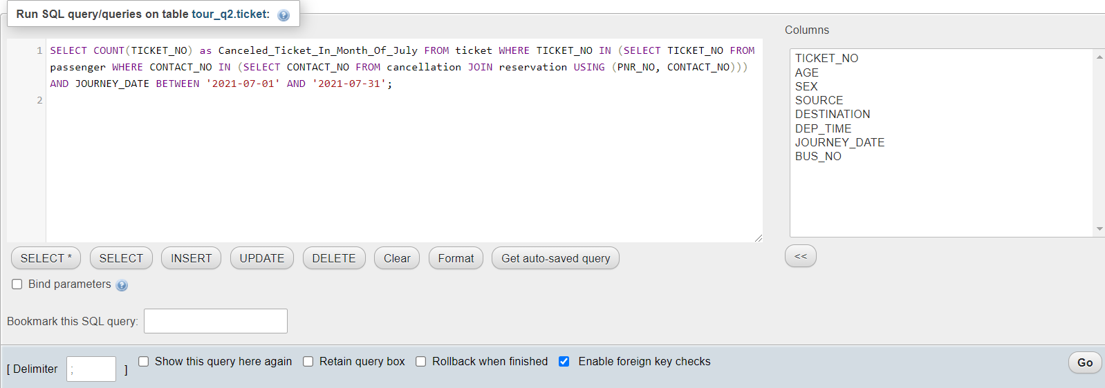

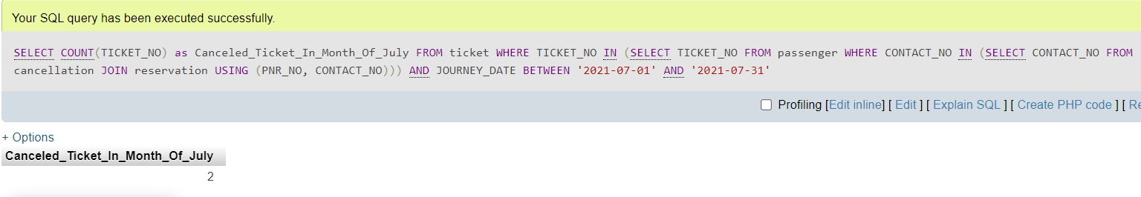

2.(iii) List the details of the customer who are travelling under age of 18 in bus no 22 on 1st July 2021 at 12:00 PM.

