## Project Title

*Firstname1 Lastname1, Firstname2 Lastname2*

*{user1,user2}@bu.edu*

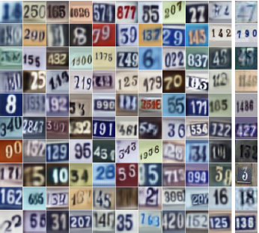

Figure 1. Illustrate your task and/or approach

**1. Task**

Describe the task you are going to solve and illustrate it, e.g. generating natural images like those shown in Fig. 1. Say a few words about what is difficult about the task, e.g. preserving spatial relationships.

**2. Related Work**

Briefly recap 3-5 most relevant papers. E.g., recurrent networks have been used for this task with some success [1], etc. What are some major flaws in the state of the art models that you want to address?

**3. Approach**

Outline the approach you plan to take. Try to be somewhat detailed, e.g. “we plan to implement the DRAW architecture proposed in [1]. To address the problem … we plan to change the architecture/loss function/etc in the following way …” If you plan to re-use existing libraries or implementations, say which ones, and say what additional code you will write for the project. Note, it is okay to change your approach later in the project, if it becomes necessary.

**4. Dataset and Metric**

Say which dataset you will use, how many training and test examples it has, and describe any data pre-processing that will be needed. The dataset must contain sufficient labels if your project needs them, typical deep learning datasets have 10K-1M examples. Some dataset repositories:

* [http://deeplearning.net/datasets](http://deeplearning.net/datasets/)
* <https://www.kaggle.com/datasets>
* <http://riemenschneider.hayko.at/vision/dataset>

You should NOT plan on extensive data collection and/or annotation, there is no time for that in such a short term project. **Metrics**: Define at least one metric you will use to evaluate success, e.g. “classification accuracy, defined as …” State explicitly how you will measure success, e.g. “we hope to show that our new loss function can improve accuracy on the test set compared to the method in [4]”.

**5. Approximate Timeline**

Make a plan with approximate deadlines, e.g.

| **Task** | **Deadline** |
| --- | --- |
| E.g., Implement DRAW | MM/DD/YY |
| Make improvements X, Y, Z | MM/DD/YY |
| Prepare report and presentation | MM/DD/YY |

**References**

**NOTE**: Should be in this format

1. K. Gregor, I. Danihelka, A. Graves, D. Jimenez Rezende, D. Wierstra. DRAW: A Recurrent Neural Network For Image Generation, arXiv.org, 2015.
2. G. Hinton and R. Salakhutdinov. Reducing the dimensionality of data with neural networks. Science, 313(5786):504–507, 2006.
3. S. Hochreiter and J. Schmidhuber, Long short term memory. Neural computation, 9(8):1735–1780,1997.

**NOTE**: All proposals must follow this exact formatting including fonts and must not exceed 2 pages. LaTeX is okay.

**SUBMISSION**: Hand in a printed hard copy version in class.