AD698 - Applied Generative AI
Early Neural Networks & Natural Language Processing
2024-11-21

1. What Is Generative AI?
Generative AI refers to machine learning models capable of creating new content — text, images, code, audio — that was not directly present in the training data. What distinguishes generative models from earlier AI systems is their ability to produce outputs that are coherent, context-aware, and semantically meaningful.

1.1 Generative vs. Traditional AI
Traditional AI systems primarily classify, detect, optimize, or recommend. A classifier trained on customer reviews answers: “Is this review positive or negative?”
Generative AI creates. A language model trained on text asks:
“Given what I’ve learned about language, what should come next?”
Both paradigms share the same roots: neural networks. Understanding those roots — from the single neuron of 1943 to the multi-layer perceptron of 1986 — is essential for building intuition about how modern LLMs and GenAI systems work.

2. The Early History of Neural Networks

2.1 The McCulloch-Pitts Neuron (1943)
The conceptual journey toward modern AI began in 1943 with Warren McCulloch and Walter Pitts’ paper McCulloch and Pitts (1943), “A Logical Calculus of the Ideas Immanent in Nervous Activity.”
McCulloch, a neuroscientist, and Pitts, a logician, proposed that neurons could be modeled as binary threshold units: an artificial neuron receives multiple binary inputs, computes a weighted sum, and fires if the sum exceeds a threshold.
$$y=\left\{\begin{matrix}1 & \text{if }\sum_{i=1}^{n}{w_{i}}x_{i}≥θ \\ 0 & \text{otherwise}\end{matrix}\right.$$
where $x_{i}$ are input signals, $w_{i}$ are synaptic weights, and $θ$ is the threshold.
The profound insight: networks of such neurons could compute any logical function — they were Turing complete. However, the weights were manually set (not learned), and the model used hard thresholds rather than smooth activations.

2.2 The Perceptron: Learning Emerges (1958)
Frank Rosenblatt’s 1958 paper Rosenblatt (1958) introduced the perceptron — a neuron that could learn from examples via a simple update rule:
$$w_{i}^{(new)}=w_{i}^{(old)}+η (t−y) x_{i} (1)$$
where $η$ is the learning rate, $t$ is the target output, and $y$ is the model’s output.
This rule embodies a principle that persists in deep learning: learn from errors by adjusting weights proportionally to the mistake. Rosenblatt built the Mark I Perceptron — a physical machine that could recognize simple geometric shapes — and the media proclaimed machines might soon rival human intelligence.
The perceptron came with a theoretical guarantee: for linearly separable problems, the algorithm converges to a solution in finite time.

2.3 The XOR Problem and First AI Winter (1969)
In 1969, Marvin Minsky and Seymour Papert published Perceptrons Minsky and Papert (1969), proving a critical limitation: a single-layer perceptron cannot solve the XOR problem because the XOR function is not linearly separable.
import matplotlib.pyplot as plt
import numpy as np
X = np.array([[0, 0], [0, 1], [1, 0], [1, 1]])
def AND(x): return np.array([a & b for a, b in x])
def NAND(x): return np.array([1 - (a & b) for a, b in x])
def OR(x): return np.array([a | b for a, b in x])
def XOR(x): return np.array([a ^ b for a, b in x])
gates = {"AND": AND(X), "NAND": NAND(X), "OR": OR(X), "XOR": XOR(X)}
fig, axes = plt.subplots(2, 2, figsize=(6, 6))
axes = axes.ravel()
for ax, (name, y) in zip(axes, gates.items()):
for (x1, x2), label in zip(X, y):
color = "#D95F5F" if label == 1 else "#3A86B7"
marker = "D" if label == 1 else "o"
ax.scatter(x1, x2, c=color, marker=marker, s=80, zorder=3)
if name in ["AND", "NAND", "OR"]:
xs = np.linspace(-0.2, 1.2, 100)
if name == "AND": ax.plot(xs, 1.5 - xs, color="#555")
elif name == "NAND": ax.plot(xs, 0.5 - xs, color="#555")
elif name == "OR": ax.plot(xs, 0.5 - xs, color="#555")
ax.set_title(name, fontsize=12)
ax.set_xlim(-0.3, 1.3); ax.set_ylim(-0.3, 1.3)
ax.set_xticks([0, 1]); ax.set_yticks([0, 1])
ax.set_xlabel("x1"); ax.set_ylabel("x2")
plt.suptitle("Linear Separability of Logic Gates", fontsize=13, y=1.01)
plt.tight_layout()
plt.show()
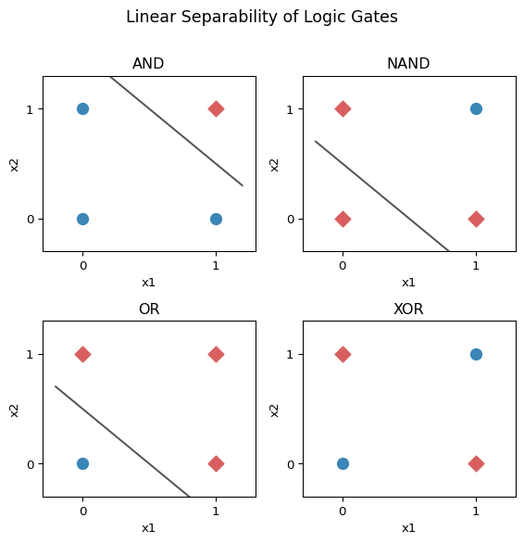
Figure 1. Logic gate separability. AND, NAND, and OR are linearly separable (a single line divides the two classes); XOR is not.
More broadly, single-layer perceptrons could only classify linearly separable patterns — excluding most real-world problems. Minsky and Papert’s critique triggered the first AI Winter: funding dried up, and neural network research stagnated through the 1970s.

2.4 Backpropagation: Training Deep Networks (1986)
The neural network renaissance arrived with Rumelhart et al. (1986) “Learning representations by back-propagating errors” by Rumelhart, Hinton, and Williams.
Backpropagation solved the core problem Minsky and Papert identified: how to train multi-layer networks. It applies the chain rule of calculus to propagate error signals backward through layers:
$$\frac{∂E}{∂w_{ij}}=\frac{∂E}{∂y_{j}}⋅\frac{∂y_{j}}{∂{\text{net}}_{j}}⋅\frac{∂{\text{net}}_{j}}{∂w_{ij}} (2)$$
where $E$ is the loss, $y_{j}$ is neuron $j$’s output, and $w_{ij}$ is the weight connecting neuron $i$ to $j$.
This allowed networks to learn internal representations — patterns in hidden layers that emerge from training rather than being hand-engineered. Networks could now solve XOR and other non-linearly separable problems.

2.5 Multi-Layer Perceptrons (1986)
The backpropagation paper demonstrated that multi-layer perceptrons (MLPs) — networks with one or more hidden layers — could be trained reliably.
Key advances:
- Hidden layers learn intermediate representations, not hand-crafted features
- Non-linear activations (sigmoid, tanh, ReLU) enable complex decision boundaries
- Learning is distributed across layers: early layers capture simple patterns, deeper layers combine them hierarchically
import sys
sys.path.insert(0, "..")
from utils.nn_diagrams import COLORS
import matplotlib.pyplot as plt
import numpy as np
fig, ax = plt.subplots(figsize=(8, 5))
ax.set_xlim(0, 1); ax.set_ylim(0, 1); ax.axis("off")
def draw_layer(ax, x, n_neurons, label, hex_color):
ys = np.linspace(0.15, 0.85, n_neurons)
for y in ys:
circle = plt.Circle((x, y), 0.04, color=f"#{hex_color}", zorder=3,
ec="white", lw=1.5)
ax.add_patch(circle)
ax.text(x, 0.04, label, ha="center", fontsize=10, color="#333")
return ys
layer_defs = [
(0.15, 4, "Input\n(features)", COLORS["nodeblue"]),
(0.50, 5, "Hidden\n(learned)", COLORS["nodeorange"]),
(0.85, 3, "Output\n(classes)", COLORS["forward"]),
]
ys_list = [draw_layer(ax, x, n, lbl, c) for x, n, lbl, c in layer_defs]
for i in range(len(layer_defs) - 1):
x_in = layer_defs[i][0]
x_out = layer_defs[i+1][0]
for y1 in ys_list[i]:
for y2 in ys_list[i+1]:
ax.plot([x_in + 0.04, x_out - 0.04], [y1, y2],
color="#ccc", lw=0.7, zorder=1)
ax.set_title("Multi-Layer Perceptron (MLP)", fontsize=13, pad=10)
plt.tight_layout()
plt.show()
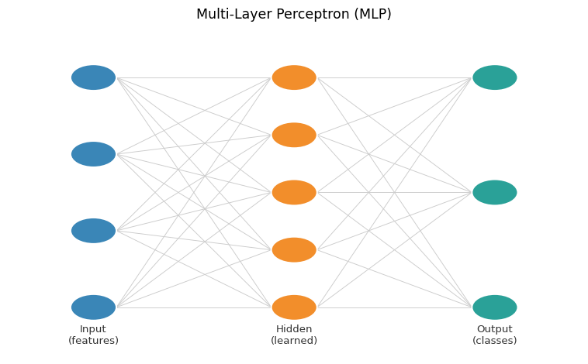
Figure 2. A simple MLP with one hidden layer. Input features are transformed through a hidden layer into class probabilities.

2.6 Why Neural Networks Stalled Again (1990s)
Despite backpropagation’s power, networks struggled through the 1990s due to limited data, insufficient compute, unstable optimization, and competing methods (SVMs). This led to the second AI Winter.

2.7 AlexNet and the Deep Learning Breakthrough (2012)
Krizhevsky et al. (2012) presented AlexNet, winning ImageNet with ~16% top-5 error (vs ~26% previously). Key innovations: ReLU activations, dropout regularization, GPU training. Lesson: deep networks scale with data + compute.

2.8 The Transformer Era (2017)
The transformer Vaswani et al. (2017) replaced recurrence with self-attention, enabling parallelization and long-range dependencies:
$$\text{Attention}(Q,K,V)=\text{softmax}​\left(\frac{QK^{⊤}}{\sqrt{d_{k}}}\right)V (3)$$
Transformers proved extraordinarily scalable, launching the era of Large Language Models.
In the next lecture we examine how text is tokenized, represented, and classified — building the vocabulary of representations that carry us from raw language into the world of vectors and probabilities.

3. How Generative Models Work

3.1 Representing Data as Distributions
Traditional classification estimates $P(y∣x)$. Generative models estimate $P(x)$ or $P(x,y)$, allowing them to generate new examples.

3.2 Next-Token Prediction
At its core, a generative language model predicts:
$$P(w_{t}∣w_{1},w_{2},…,w_{t−1})$$
Stacking this prediction across billions of parameters and trillions of training tokens produces systems capable of complex reasoning, code synthesis, summarization, and creative writing.

4. Limitations of Generative AI
- Hallucinations: Models fabricate details when lacking reliable context
- Bias: Training data biases appear in model outputs
- No true understanding: Statistical pattern manipulation, not comprehension
- Explainability: Reasoning behind outputs is difficult to audit
- Resource demands: Substantial compute required for training and deployment
Understanding these limitations — grounded in the history of how these systems were built — is essential for responsible deployment in business and analytics contexts.

References
Krizhevsky, Alex, Ilya Sutskever, and Geoffrey E. Hinton. 2012. “ImageNet Classification with Deep Convolutional Neural Networks.” Advances in Neural Information Processing Systems 25.
McCulloch, Warren S., and Walter Pitts. 1943. “A Logical Calculus of the Ideas Immanent in Nervous Activity.” The Bulletin of Mathematical Biophysics 5 (4): 115–33.
Minsky, Marvin, and Seymour Papert. 1969. Perceptrons: An Introduction to Computational Geometry. MIT Press.
Rosenblatt, Frank. 1958. “The Perceptron: A Probabilistic Model for Information Storage and Organization in the Brain.” Psychological Review 65 (6): 386.
Rumelhart, David E., Geoffrey E. Hinton, and Ronald J. Williams. 1986. “Learning Representations by Back-Propagating Errors.” Nature 323 (6088): 533–36.
Vaswani, Ashish, Noam Shazeer, Niki Parmar, et al. 2017. “Attention Is All You Need.” Advances in Neural Information Processing Systems 30.

