M03: Lecture Note 1
Prompting as System Design
November 21, 2024

1. The Shift to Prompt‑Based Approaches

1.1 Introduction: From Training-Centric to Inference-Centric AI
For most of the history of machine learning, the behavior of a model was determined almost entirely during training. Once deployed, a model was effectively frozen: its parameters encoded everything it knew, and any change in behavior required a new round of training, fine‑tuning, or feature engineering. This paradigm made sense when models were small, tasks were narrow, and data distributions were relatively stable.
Large Language Models (LLMs) fundamentally alter this workflow. Their behavior is no longer fixed at deployment. Instead, they can be steered, adapted, and repurposed at inference time through prompts, context, and task specifications. This shift represents not just a new technique, but a new architecture for building AI systems — one where control moves from weight updates to inference‑time conditioning.

1.2 Classical Learning vs. Generative Conditioning

1.2.1 Classical Supervised Learning
In the classical paradigm, we model a deterministic or probabilistic mapping:
$$\begin{matrix}y=f_{θ}(x)\end{matrix}$$
Here:
- $θ$ encodes all learned knowledge.
- Changing the model’s behavior requires modifying $θ$.
- Training is the primary locus of intelligence.
This creates a rigid workflow:
- Training phase: expensive, offline, compute‑heavy
- Deployment phase: static, brittle, slow to adapt

1.2.2 Generative Language Models
Generative models instead define a conditional distribution:
$$\begin{matrix}P(Y∣X,θ)\end{matrix}$$
The model does not output a single deterministic label; it samples from a probability distribution over sequences. This opens the door to a new control variable:
$$\begin{matrix}P(Y∣X,p,θ)\end{matrix}$$
where $p$ is a prompt — an inference‑time input that shapes the distribution without modifying the parameters.

1.2.3 Why This Matters
Prompts act as soft constraints on the model’s generative process. Instead of retraining, we can:
- specify tasks,
- provide examples,
- impose structure,
- inject domain knowledge,
- or shape style and behavior
all without touching the weights.
This is the essence of generative conditioning: the model’s behavior is governed not only by its parameters but by the context supplied at inference.

1.3 Prompt as an Inference-Time Control Signal
Prompts are not merely instructions. They function as a control interface for a probabilistic model.

1.3.1 Prompt as Conditioning Signal
A prompt provides additional context that shifts the model’s posterior distribution. It is analogous to conditioning in Bayesian inference: the prompt narrows the space of plausible outputs.

1.3.2 Prompt as Soft Constraint
Unlike hard-coded rules, prompts influence behavior probabilistically. They bias the model toward certain trajectories without enforcing deterministic outcomes.

1.3.3 Prompt as Semantic Policy
Prompts encode policies for how the model should behave:
- “Be concise.”
- “Explain step-by-step.”
- “Act as a SQL expert.”
- “Follow this schema.”
These policies are expressed in natural language rather than code.

1.3.4 Prompt as Steering Mechanism
Prompts steer the model’s sampling process by altering token likelihoods. This enables:
- rapid task adaptation
- interactive workflows
- dynamic behavior shaping
- domain-specific reasoning without retraining
In effect, prompting turns inference into a programmable interface.

1.4 Why Prompting Represents an Architectural Shift
The move from training-centric to inference-centric control changes how we design AI systems:

1.4.1 Adaptation Without Retraining
Instead of updating weights, we update context. This reduces:
- compute cost
- data requirements
- iteration time
- operational complexity

1.4.2 AI as a Configurable Component
LLMs become general-purpose engines whose behavior is configured through:
- prompts
- examples
- instructions
- retrieved documents
- structured templates
This mirrors how operating systems or databases are configured: through interfaces, not recompilation.

1.4.3 Human-AI Interaction as a First-Class Design Space
Because prompts are written in natural language, users participate directly in system design. This democratizes control and shifts power from ML engineers to domain experts.

1.5 Prompt Engineering, Fine-Tuning, and RAG: A Comparative View
Prompting, fine‑tuning, and retrieval‑augmented generation (RAG) are not competing techniques but complementary axes of control.
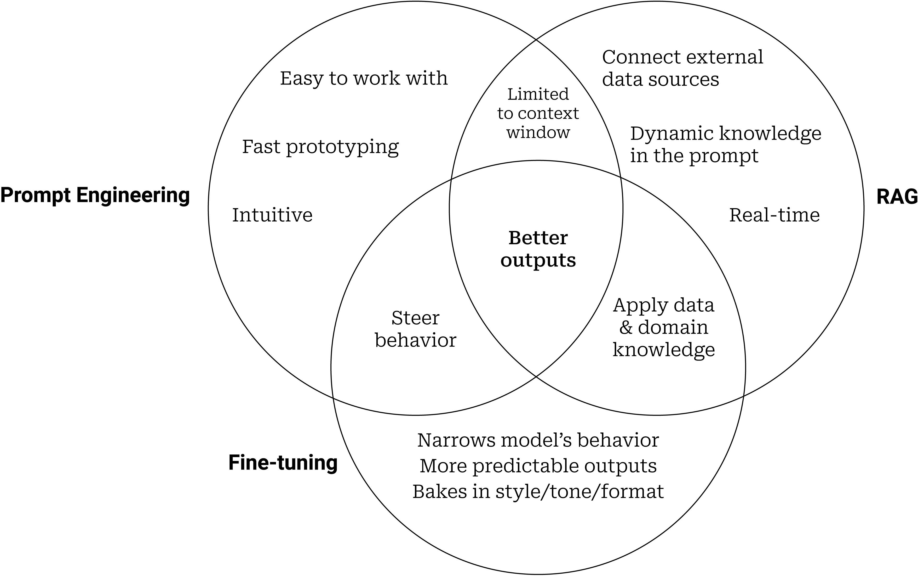
Figure 1. Venn Diagram of Prompt Engineering, Fine-tuning, and RAG

1.5.1 Prompt Engineering
- No weight updates
- Fastest iteration cycle
- Best for: task specification, style control, reasoning scaffolds
- Limitations: brittle, sensitive to phrasing, limited by model’s latent knowledge

1.5.2 Fine-Tuning
- Updates model parameters
- Best for: domain adaptation, new skills, safety alignment
- Limitations: expensive, requires data, risk of overfitting or catastrophic forgetting

1.5.3 Retrieval-Augmented Generation (RAG)
- Injects external knowledge at inference
- Best for: factual accuracy, up-to-date information, domain grounding
- Limitations: requires retrieval infrastructure, depends on document quality

1.5.4 How They Interact
- Prompting + RAG = controlled reasoning over external knowledge
- Prompting + fine-tuning = stable, specialized behavior with flexible interfaces
- RAG + fine-tuning = domain-specific systems with strong grounding
Together, they form a toolbox for inference-time system design.

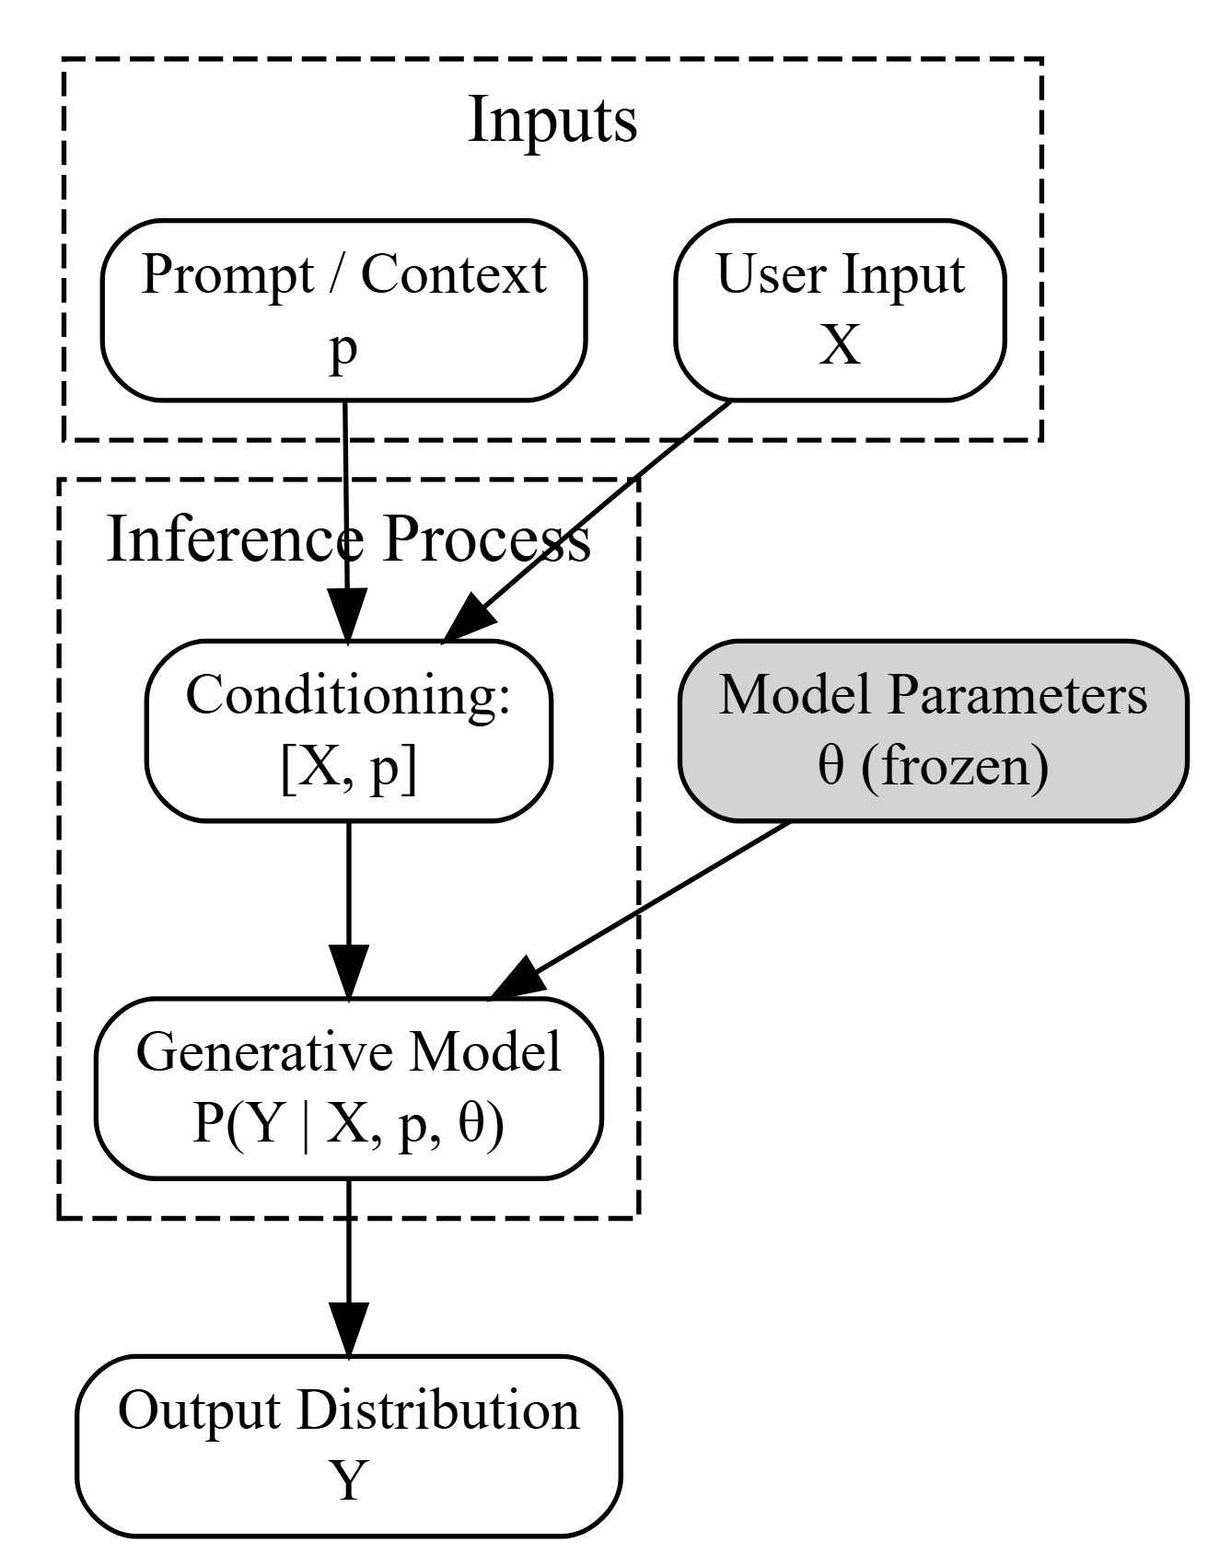

1.6 Worked Example: How a Prompt Changes Token Probabilities
sentence 1 = "The cat runs."
sentence 2 = "The cat sleeps."
sentence 3 = "The dog runs."
$$\begin{matrix}PY=The=1 \\ PY=cat|Y_{t−1}=The=2/3 \\ PY=runs|Y_{t−1}=cat,Y_{t−2}=The=0.40 \\ \end{matrix}$$
We’ll use a tiny vocabulary to illustrate the idea:
Vocabulary = {“the”, “cat”, “dog”, “runs”, “sleeps”, “.”}

1.6.1 Without a Prompt
Input:
"Complete the sentence: The cat"
The model’s next‑token distribution might look like:
Token | Probability
runs | 0.40
sleeps | 0.35
. | 0.15
dog | 0.05
cat | 0.05
The model is relying on its pretrained priors about typical continuations.

1.7 With a Prompt That Acts as a Soft Constraint
Prompt:
"Write a dramatic action scene. Complete the sentence: The cat"
dramatic $\in$ {action, suspense, conflict} $\implies$ high-energy verbs like "runs", "leaps", "attacks"
Now the model conditions on the semantic policy “dramatic action scene.”
New distribution:
Token | Probability
runs | 0.55
leaps | 0.25 (new token from extended vocab)
attacks | 0.10
sleeps | 0.03
. | 0.02
dog | 0.02
cat | 0.01

1.7.1 What changed?
- The prompt reshaped the distribution toward high‑energy verbs.
- “sleeps” collapses from 0.35 → 0.03.
- “leaps” and “attacks” become viable high‑probability tokens.
- No weights changed — only the conditioning context changed.

1.8 With a Prompt That Specifies Style + Role
Prompt:
"You are a veterinarian writing a calm, factual report.
Complete the sentence: The cat"
Distribution:
Token | Probability
sleeps | 0.50
rests | 0.20
is | 0.15
runs | 0.05
. | 0.05
dog | 0.03
cat | 0.02
- The prompt now acts as a semantic policy (“calm, factual report”).
- The model shifts toward clinical, low‑emotion verbs.
- “runs” becomes unlikely because it violates the style constraint.

1.9 Summary and Implications for System Builders
The shift to prompt-based approaches is not a superficial change in interface — it is a rethinking of how intelligence is deployed:
- Models are no longer static artifacts; they are dynamic, programmable components.
- Inference becomes the primary site of adaptation, not training.
- Prompts act as probabilistic control signals, shaping behavior without modifying weights.
- Prompting, fine-tuning, and RAG form a unified design space for building modern AI systems.
This new paradigm enables faster iteration, more flexible systems, and a more direct alignment between user intent and model behavior.

2. Recurrent Neural Networks
Up until now, we have focused primarily on fixed-length data. When introducing linear and logistic regression in Regression and Classification and multilayer perceptrons in Perceptrons, we were happy to assume that each feature vector $x_{i}$ consisted of a fixed number of components $x_{1},…,x_{d}$, where each numerical feature $x_{j}$ corresponded to a particular attribute. These datasets are sometimes called tabular, because they can be arranged in tables, where each example $i$ gets its own row, and each attribute gets its own column. Crucially, with tabular data, we seldom assume any particular structure over the columns.
Although we did not cover Convolutional Neural Networks (CNNs), that deal wit image data, where inputs consist of the raw pixel values at each coordinate in an image. Image data hardly fitted the bill of a protypical tabular dataset. There, we needed to call upon convolutional neural networks (CNNs) to handle the hierarchical structure and invariances. However, our data were still of fixed length. Every Fashion-MNIST image is represented as a $28×28$ grid of pixel values. Moreover, our goal was to develop a model that looked at just one image and then outputted a single prediction. But what should we do when faced with a sequence of images, as in a video, or when tasked with producing a sequentially structured prediction, as in the case of image captioning?
A great many learning tasks require dealing with sequential data. Image captioning, speech synthesis, and music generation all require that models produce outputs consisting of sequences. In other domains, such as time series prediction, video analysis, and musical information retrieval, a model must learn from inputs that are sequences. These demands often arise simultaneously: tasks such as translating passages of text from one natural language to another, engaging in dialogue, or controlling a robot, demand that models both ingest and output sequentially structured data.
Recurrent neural networks (RNNs) are deep learning models that capture the dynamics of sequences via recurrent connections, which can be thought of as cycles in the network of nodes. This might seem counterintuitive at first. After all, it is the feedforward nature of neural networks that makes the order of computation unambiguous. However, recurrent edges are defined in a precise way that ensures that no such ambiguity can arise. Recurrent neural networks are unrolled across time steps (or sequence steps), with the same underlying parameters applied at each step. While the standard connections are applied synchronously to propagate each layer’s activations to the subsequent layer at the same time step, the recurrent connections are dynamic, passing information across adjacent time steps. As the unfolded view in :numref:fig_unfolded-rnn reveals, RNNs can be thought of as feedforward neural networks where each layer’s parameters (both conventional and recurrent) are shared across time steps.
On the left recurrent connections are depicted via cyclic edges. On the right, we unfold the RNN over time steps. Here, recurrent edges span adjacent time steps, while conventional connections are computed synchronously.
Like neural networks more broadly, RNNs have a long discipline-spanning history, originating as models of the brain popularized by cognitive scientists and subsequently adopted as practical modeling tools employed by the machine learning community. As we do for deep learning more broadly, in this book we adopt the machine learning perspective, focusing on RNNs as practical tools that rose to popularity in the 2010s owing to breakthrough results on such diverse tasks as handwriting recognition (Graves et al. 2008), machine translation (Sutskever et al. 2014), and recognizing medical diagnoses (Lipton et al. 2016). We point the reader interested in more background material to a publicly available comprehensive review (Lipton et al. 2015). We also note that sequentiality is not unique to RNNs. For example, the CNNs that we already introduced can be adapted to handle data of varying length, e.g., images of varying resolution. Moreover, RNNs have recently ceded considerable market share to Transformer models, which will be covered in Attentions and Transformers in Module 8. However, RNNs rose to prominence as the default models for handling complex sequential structure in deep learning, and remain staple models for sequential modeling to this day. The stories of RNNs and of sequence modeling are inextricably linked, and this is as much a chapter about the ABCs of sequence modeling problems as it is a chapter about RNNs.
One key insight paved the way for a revolution in sequence modeling. While the inputs and targets for many fundamental tasks in machine learning cannot easily be represented as fixed-length vectors, they can often nevertheless be represented as varying-length sequences of fixed-length vectors. For example, documents can be represented as sequences of words; medical records can often be represented as sequences of events (encounters, medications, procedures, lab tests, diagnoses); videos can be represented as varying-length sequences of still images.
While sequence models have popped up in numerous application areas, basic research in the area has been driven predominantly by advances on core tasks in natural language processing. Thus, throughout this chapter, we will focus our exposition and examples on text data. If you get the hang of these examples, then applying the models to other data modalities should be relatively straightforward. In the next few sections, we introduce basic notation for sequences and some evaluation measures for assessing the quality of sequentially structured model outputs. After that, we discuss basic concepts of a language model and use this discussion to motivate our first RNN models. Finally, we describe the method for calculating gradients when backpropagating through RNNs and explore some challenges that are often encountered when training such networks, motivating the modern RNN architectures that will follow in Morden RNN Section in Module 8.

2.1 Working with Sequences
Up until now, we have focused on models whose inputs consisted of a single feature vector $x∈R^{d}$. The main change of perspective when developing models capable of processing sequences is that we now focus on inputs that consist of an ordered list of feature vectors $x_{1},…,x_{T}$, where each feature vector $x_{t}$ is indexed by a time step $t∈Z^{+}$ lying in $R^{d}$.
Some datasets consist of a single massive sequence. Consider, for example, the extremely long streams of sensor readings that might be available to climate scientists. In such cases, we might create training datasets by randomly sampling subsequences of some predetermined length. More often, our data arrives as a collection of sequences. Consider the following examples: (i) a collection of documents, each represented as its own sequence of words, and each having its own length $T_{i}$; (ii) sequence representation of patient stays in the hospital, where each stay consists of a number of events and the sequence length depends roughly on the length of the stay.
Previously, when dealing with individual inputs, we assumed that they were sampled independently from the same underlying distribution $P(X)$. While we still assume that entire sequences (e.g., entire documents or patient trajectories) are sampled independently, we cannot assume that the data arriving at each time step are independent of each other. For example, the words that likely to appear later in a document depend heavily on words occurring earlier in the document. The medicine a patient is likely to receive on the 10th day of a hospital visit depends heavily on what transpired in the previous nine days.
This should come as no surprise. If we did not believe that the elements in a sequence were related, we would not have bothered to model them as a sequence in the first place. Consider the usefulness of the auto-fill features that are popular on search tools and modern email clients. They are useful precisely because it is often possible to predict (imperfectly, but better than random guessing) what the likely continuations of a sequence might be, given some initial prefix. For most sequence models, we do not require independence, or even stationarity, of our sequences. Instead, we require only that the sequences themselves are sampled from some fixed underlying distribution over entire sequences.
This flexible approach allows for such phenomena as (i) documents looking significantly different at the beginning than at the end; or (ii) patient status evolving either towards recovery or towards death over the course of a hospital stay; or (iii) customer taste evolving in predictable ways over the course of continued interaction with a recommender system.
We sometimes wish to predict a fixed target $y$ given sequentially structured input (e.g., sentiment classification based on a movie review). At other times, we wish to predict a sequentially structured target ($y_{1},…,y_{T}$) given a fixed input (e.g., image captioning). Still other times, our goal is to predict sequentially structured targets based on sequentially structured inputs (e.g., machine translation or video captioning). Such sequence-to-sequence tasks take two forms: (i) aligned: where the input at each time step aligns with a corresponding target (e.g., part of speech tagging); (ii) unaligned: where the input and target do not necessarily exhibit a step-for-step correspondence (e.g., machine translation).
Before we worry about handling targets of any kind, we can tackle the most straightforward problem: unsupervised density modeling (also called sequence modeling). Here, given a collection of sequences, our goal is to estimate the probability mass function that tells us how likely we are to see any given sequence, i.e., $p(x_{1},…,x_{T})$.
import torch
from torch import nn

2.2 Autoregressive Models
Before introducing specialized neural networks designed to handle sequentially structured data, let’s take a look at some actual sequence data and build up some basic intuitions and statistical tools. In particular, we will focus on stock price data from the FTSE 100 index (:numref:fig-ftse100). At each time step $t∈Z^{+}$, we observe the price, $x_{t}$, of the index at that time.
import yfinance as yf
import pandas as pd
import seaborn as sns
import matplotlib.pyplot as plt
# 1. Setup Ticker
ticker = "^FTSE"
# 2. Download history
# 'multi_level_index=False' prevents the creation of nested columns
ftse = yf.download(ticker, start="1984-01-01", multi_level_index=False);
# 3. Clean Data
# Check if data is empty first
if ftse.empty:
print("No data found. Check your internet connection or ticker symbol.")
else:
# Drop rows with missing Close prices
ftse = ftse[['Close']].dropna()
# Reset index to turn 'Date' from an index into a regular column
ftse = ftse.reset_index()
# 4. Visualization
fig, ax = plt.subplots(figsize=(7, 4.75))
# Use a lineplot - specifying 'Date' and 'Close' explicitly
sns.lineplot(data=ftse, x="Date", y="Close", color="teal", linewidth=1.0, ax=ax)
# 5. Formatting
ax.set_title("FTSE 100 Index Performance (1984–Present)", fontsize=14, pad=10, fontweight='bold')
ax.set_xlabel("Year", fontsize=12, fontweight='bold')
ax.set_ylabel("Index Level (Points)", fontsize=12, fontweight='bold')
ax.tick_params(axis='x', labelsize=9, labelfontfamily='serif')
ax.tick_params(axis='y', labelsize=9, labelfontfamily='serif')
# Optional: Add a log scale if you want to see percentage growth more clearly
# ax.yscale('log')
plt.tight_layout()
plt.show()
[*********************100%***********************] 1 of 1 completed
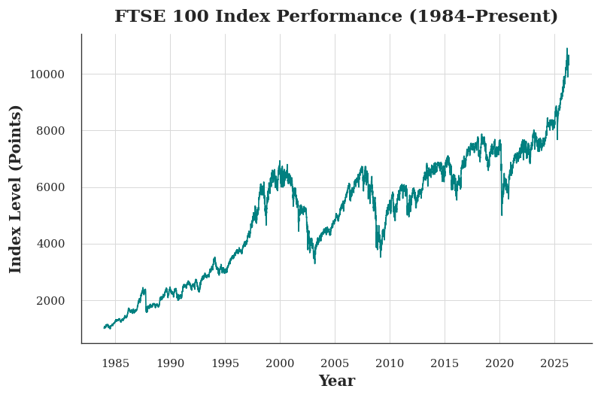
Figure 2. FTSE 100 index over about 30 years.
Now suppose that a trader would like to make short-term trades, strategically getting into or out of the index, depending on whether they believe that it will rise or decline in the subsequent time step. Absent any other features (news, financial reporting data, etc.), the only available signal for predicting the subsequent value is the history of prices to date. The trader is thus interested in knowing the probability distribution
$$\begin{matrix}P(x_{t}∣x_{t−1},…,x_{1})\end{matrix}$$
over prices that the index might take in the subsequent time step. While estimating the entire distribution over a continuously valued random variable can be difficult, the trader would be happy to focus on a few key statistics of the distribution, particularly the expected value and the variance. One simple strategy for estimating the conditional expectation
$$\begin{matrix}E[(x_{t}∣x_{t−1},…,x_{1})],\end{matrix}$$
would be to apply a linear regression model (recall Linear Regression from Module 8). Such models that regress the value of a signal on the previous values of that same signal are naturally called autoregressive models. There is just one major problem: the number of inputs, $x_{t−1},…,x_{1}$ varies, depending on $t$. In other words, the number of inputs increases with the amount of data that we encounter. Thus if we want to treat our historical data as a training set, we are left with the problem that each example has a different number of features. Much of what follows in this chapter will revolve around techniques for overcoming these challenges when engaging in such autoregressive modeling problems where the object of interest is $P(x_{t}∣x_{t−1},…,x_{1})$ or some statistic(s) of this distribution.
A few strategies recur frequently. First of all, we might believe that although long sequences $x_{t−1},…,x_{1}$ are available, it may not be necessary to look back so far in the history when predicting the near future. In this case we might content ourselves to condition on some window of length $τ$ and only use $x_{t−1},…,x_{t−τ}$ observations. The immediate benefit is that now the number of arguments is always the same, at least for $t>τ$. This allows us to train any linear model or deep network that requires fixed-length vectors as inputs. Second, we might develop models that maintain some summary $h_{t}$ of the past observations (see Figure 3) and at the same time update $h_{t}$ in addition to the prediction ${\hat{x}}_{t}$. This leads to models that estimate not only $x_{t}$ with ${\hat{x}}_{t}=P(x_{t}∣h_{t})$ but also updates of the form $h_{t}=g(h_{t−1},x_{t−1})$. Since $h_{t}$ is never observed, these models are also called latent autoregressive models.
Figure 3. Diagram showing a latent autoregressive model, where the hidden state $h_{t}$ is updated based on the previous hidden state and the previous observation, and the prediction $x_{t}$ is made based on the hidden state
To construct training data from historical data, one typically creates examples by sampling windows randomly. In general, we do not expect time to stand still. However, we often assume that while the specific values of $x_{t}$ might change, the dynamics according to which each subsequent observation is generated given the previous observations do not. Statisticians call dynamics that do not change stationary.

2.3 Sequence Models
Sometimes, especially when working with language, we wish to estimate the joint probability of an entire sequence. This is a common task when working with sequences composed of discrete tokens, such as words. Generally, these estimated functions are called sequence models and for natural language data, they are called language models. The field of sequence modeling has been driven so much by natural language processing, that we often describe sequence models as “language models”, even when dealing with non-language data. Language models prove useful for all sorts of reasons. Sometimes we want to evaluate the likelihood of sentences. For example, we might wish to compare the naturalness of two candidate outputs generated by a machine translation system or by a speech recognition system. But language modeling gives us not only the capacity to evaluate likelihood, but the ability to sample sequences, and even to optimize for the most likely sequences.
While language modeling might not, at first glance, look like an autoregressive problem, we can reduce language modeling to autoregressive prediction by decomposing the joint density of a sequence $p(x_{1},…,x_{T})$ into the product of conditional densities in a left-to-right fashion by applying the chain rule of probability:
$$\begin{matrix}P(x_{1},…,x_{T})=P(x_{1})\prod_{t=2}^{T}{P}(x_{t}∣x_{t−1},…,x_{1}).\end{matrix}$$
Note that if we are working with discrete signals such as words, then the autoregressive model must be a probabilistic classifier, outputting a full probability distribution over the vocabulary for whatever word will come next, given the leftwards context.

2.3.1 Markov Models
Now suppose that we wish to employ the strategy mentioned above, where we condition only on the $τ$ previous time steps, i.e., $x_{t−1},…,x_{t−τ}$, rather than the entire sequence history $x_{t−1},…,x_{1}$. Whenever we can throw away the history beyond the previous $τ$ steps without any loss in predictive power, we say that the sequence satisfies a Markov condition, i.e., that the future is conditionally independent of the past, given the recent history. When $τ=1$, we say that the data is characterized by a first-order Markov model, and when $τ=k$, we say that the data is characterized by a $k^{\text{th}}$-order Markov model. For when the first-order Markov condition holds ($τ=1$) the factorization of our joint probability becomes a product of probabilities of each word given the previous word:
$$\begin{matrix}P(x_{1},…,x_{T})=P(x_{1})\prod_{t=2}^{T}{P}(x_{t}∣x_{t−1}).\end{matrix}$$
We often find it useful to work with models that proceed as though a Markov condition were satisfied, even when we know that this is only approximately true. With real text documents we continue to gain information as we include more and more leftwards context. But these gains diminish rapidly. Thus, sometimes we compromise, obviating computational and statistical difficulties by training models whose validity depends on a $k^{\text{th}}$-order Markov condition. Even today’s massive RNN- and Transformer-based language models seldom incorporate more than thousands of words of context.
With discrete data, a true Markov model simply counts the number of times that each word has occurred in each context, producing the relative frequency estimate of $P(x_{t}∣x_{t−1})$. Whenever the data assumes only discrete values (as in language), the most likely sequence of words can be computed efficiently using dynamic programming.

2.3.2 The Order of Decoding
You may be wondering why we represented the factorization of a text sequence $P(x_{1},…,x_{T})$ as a left-to-right chain of conditional probabilities. Why not right-to-left or some other, seemingly random order? In principle, there is nothing wrong with unfolding $P(x_{1},…,x_{T})$ in reverse order. The result is a valid factorization:
$$\begin{matrix}P(x_{1},…,x_{T})=P(x_{T})\prod_{t=T−1}^{1}{P}(x_{t}∣x_{t+1},…,x_{T}).\end{matrix}$$
However, there are many reasons why factorizing text in the same direction in which we read it (left-to-right for most languages, but right-to-left for Arabic and Hebrew) is preferred for the task of language modeling. First, this is just a more natural direction for us to think about. After all we all read text every day, and this process is guided by our ability to anticipate which words and phrases are likely to come next. Just think of how many times you have completed someone else’s sentence. Thus, even if we had no other reason to prefer such in-order decodings, they would be useful if only because we have better intuitions for what should be likely when predicting in this order.
Second, by factorizing in order, we can assign probabilities to arbitrarily long sequences using the same language model. To convert a probability over steps $1$ through $t$ into one that extends to word $t+1$ we simply multiply by the conditional probability of the additional token given the previous ones: $P(x_{t+1},…,x_{1})=P(x_{t},…,x_{1})⋅P(x_{t+1}∣x_{t},…,x_{1})$.
Third, we have stronger predictive models for predicting adjacent words than words at arbitrary other locations. While all orders of factorization are valid, they do not necessarily all represent equally easy predictive modeling problems. This is true not only for language, but for other kinds of data as well, e.g., when the data is causally structured. For example, we believe that future events cannot influence the past. Hence, if we change $x_{t}$, we may be able to influence what happens for $x_{t+1}$ going forward but not the converse. That is, if we change $x_{t}$, the distribution over past events will not change. In some contexts, this makes it easier to predict $P(x_{t+1}∣x_{t})$ than to predict $P(x_{t}∣x_{t+1})$. For instance, in some cases, we can find $x_{t+1}=f(x_{t})+ϵ$ for some additive noise $ϵ$, whereas the converse is not true (Hoyer et al. 2009). This is great news, since it is typically the forward direction that we are interested in estimating. The book by Peters et al. (2017) contains more on this topic. We barely scratch the surface of it.

2.4 Training
Before we focus our attention on text data, let’s first try this out with some continuous-valued synthetic data.
(Here, our 1000 synthetic data will follow the trigonometric sin function, applied to 0.01 times the time step. To make the problem a little more interesting, we corrupt each sample with additive noise.) From this sequence we extract training examples, each consisting of features and a label.
import numpy as np
import torch
class Data:
def __init__(self, batch_size=16, T=1000, num_train=600, tau=4):
self.batch_size = batch_size
self.T = T
self.num_train = num_train
self.tau = tau
# time steps 1..T
self.time = torch.arange(1, T + 1, dtype=torch.float32)
# synthetic noisy sine wave
noise = torch.randn(T) * 0.2
self.x = torch.sin(0.01 * self.time) + noise
import matplotlib.pyplot as plt
import seaborn as sns
data = Data()
plt.figure(figsize=(7, 4.5))
plt.plot(data.time.numpy(), data.x.numpy())
plt.xlabel("time", fontsize=12, fontweight='bold')
plt.ylabel("x", fontsize=12, fontweight='bold')
plt.xlim(1, 1000)
plt.tight_layout()
plt.show()
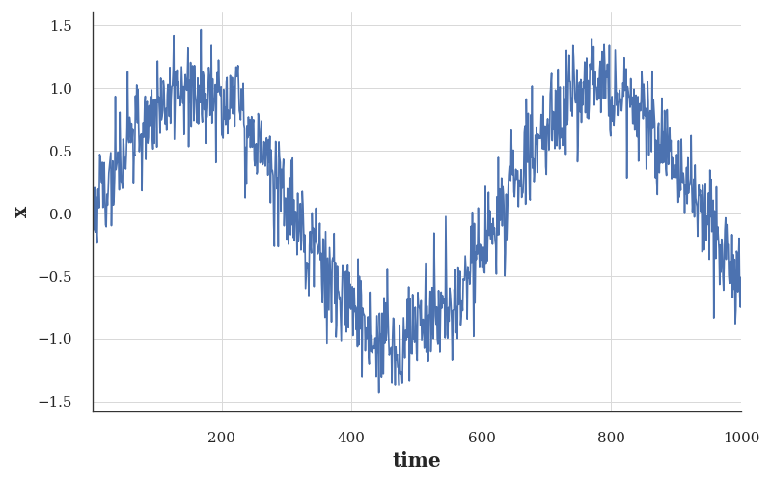
Figure 4. Plot of the synthetic data, which is a noisy sine wave.
To begin, we try a model that acts as if the data satisfied a $τ^{\text{th}}$-order Markov condition, and thus predicts $x_{t}$ using only the past $τ$ observations. [Thus for each time step we have an example with label $y=x_{t}$ and features $x_{t}=[x_{t−τ},…,x_{t−1}]$.] The astute reader might have noticed that this results in $1000−τ$ examples, since we lack sufficient history for $y_{1},…,y_{τ}$. While we could pad the first $τ$ sequences with zeros, to keep things simple, we drop them for now. The resulting dataset contains $T−τ$ examples, where each input to the model has sequence length $τ$. We (create a data iterator on the first 600 examples), covering a period of the sin function.
from torch.utils.data import TensorDataset, DataLoader
import torch
class Data:
def __init__(self, batch_size=16, T=1000, num_train=600, tau=4):
self.batch_size = batch_size
self.T = T
self.num_train = num_train
self.tau = tau
# Raw time series
self.time = torch.arange(1, T + 1, dtype=torch.float32)
noise = torch.randn(T) * 0.2
self.x = torch.sin(0.01 * self.time) + noise
# --- NEW: build sliding-window features ONCE ---
self.features = torch.stack(
[self.x[i : self.T - self.tau + i] for i in range(self.tau)],
dim=1
) # shape: [T - tau, tau]
self.labels = self.x[self.tau:].reshape(-1, 1) # shape: [T - tau, 1]
def get_dataloader(self, train=True):
idx = slice(0, self.num_train) if train else slice(self.num_train, None)
X = self.features[idx]
Y = self.labels[idx]
dataset = TensorDataset(X, Y)
return DataLoader(dataset, batch_size=self.batch_size, shuffle=train)

2.4.1 PyTorch Linear Regression Model
In this example our model will be a standard linear regression.
import torch
import torch.nn as nn
class LinearRegression(nn.Module):
def __init__(self, lr=0.01):
super().__init__()
self.net = nn.Linear(4, 1) # tau = 4 in your Data class
self.loss_fn = nn.MSELoss()
self.lr = lr
def forward(self, X):
return self.net(X)
def training_step(self, batch):
X, y = batch
y_hat = self(X)
return self.loss_fn(y_hat, y)
def validation_step(self, batch):
X, y = batch
y_hat = self(X)
return self.loss_fn(y_hat, y)

2.4.2 PyTorch‑Native Trainer With Train/Test Loss Logging
from torch.utils.data import DataLoader
class Trainer:
def __init__(self, max_epochs=5, device=None):
self.max_epochs = max_epochs
self.device = device or ("cuda" if torch.cuda.is_available() else "cpu")
self.train_losses = []
self.test_losses = []
def fit(self, model, data):
model.to(self.device)
train_loader = data.get_dataloader(train=True)
test_loader = data.get_dataloader(train=False)
optimizer = torch.optim.SGD(model.parameters(), lr=model.lr)
for epoch in range(self.max_epochs):
model.train()
epoch_train_loss = 0
for X, y in train_loader:
X, y = X.to(self.device), y.to(self.device)
loss = model.training_step((X, y))
optimizer.zero_grad()
loss.backward()
optimizer.step()
epoch_train_loss += loss.item()
epoch_train_loss /= len(train_loader)
self.train_losses.append(epoch_train_loss)
# Validation
model.eval()
epoch_test_loss = 0
with torch.no_grad():
for X, y in test_loader:
X, y = X.to(self.device), y.to(self.device)
loss = model.validation_step((X, y))
epoch_test_loss += loss.item()
epoch_test_loss /= len(test_loader)
self.test_losses.append(epoch_test_loss)
print(f"Epoch {epoch+1}: train={epoch_train_loss:.4f}, test={epoch_test_loss:.4f}")

2.4.3 Poltting It All Together
import matplotlib.pyplot as plt
import seaborn as sns
def plot_train_test_loss(trainer):
set_economist_theme()
plt.figure(figsize=(7, 4.5))
plt.plot(trainer.train_losses, label="Train Loss", linewidth=1.0)
plt.plot(trainer.test_losses, label="Test Loss", linewidth=1.0)
plt.xlabel("Epoch")
plt.ylabel("MSE Loss")
plt.title("Train vs Test Loss")
plt.legend()
plt.tight_layout()
plt.show()
data = Data()
model = LinearRegression(lr=0.01)
trainer = Trainer(max_epochs=20)
trainer.fit(model, data)
plot_train_test_loss(trainer)
Epoch 1: train=0.1193, test=0.0787
Epoch 2: train=0.0707, test=0.0566
Epoch 3: train=0.0600, test=0.0526
Epoch 4: train=0.0573, test=0.0517
Epoch 5: train=0.0556, test=0.0515
Epoch 6: train=0.0556, test=0.0514
Epoch 7: train=0.0548, test=0.0513
Epoch 8: train=0.0545, test=0.0511
Epoch 9: train=0.0545, test=0.0509
Epoch 10: train=0.0542, test=0.0507
Epoch 11: train=0.0552, test=0.0505
Epoch 12: train=0.0539, test=0.0504
Epoch 13: train=0.0542, test=0.0504
Epoch 14: train=0.0537, test=0.0502
Epoch 15: train=0.0533, test=0.0501
Epoch 16: train=0.0534, test=0.0500
Epoch 17: train=0.0531, test=0.0499
Epoch 18: train=0.0530, test=0.0498
Epoch 19: train=0.0530, test=0.0497
Epoch 20: train=0.0538, test=0.0498
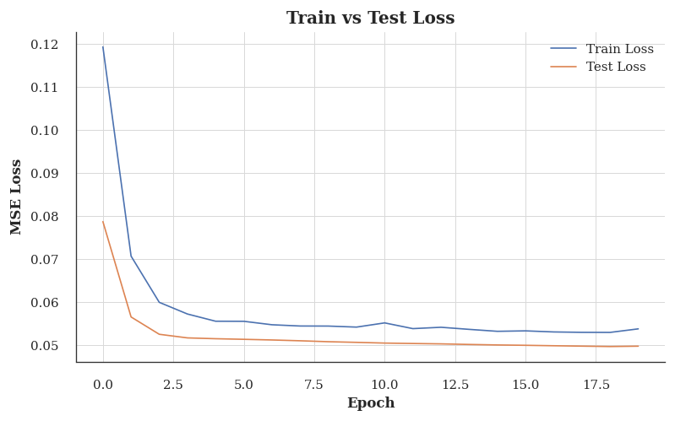
Figure 5. Plot showing the training and test loss over epochs.

2.5 Prediction
To evaluate our model, we first check how well it performs at one-step-ahead prediction.
model.eval()
with torch.no_grad():
onestep_preds = model(data.features).cpu().numpy()
labels = data.labels.cpu().numpy()
time = data.time[data.tau:].cpu().numpy()
import matplotlib.pyplot as plt
import seaborn as sns
set_economist_theme()
plt.figure(figsize=(7, 4.5))
plt.plot(time, labels, label="labels", color="steelblue", linewidth=1.5)
plt.plot(time, onestep_preds, label="1-step preds", color="crimson", linestyle="--", linewidth=1.5)
plt.xlabel("time")
plt.ylabel("x")
plt.title("1-Step Ahead Prediction")
plt.legend()
plt.tight_layout()
plt.show()
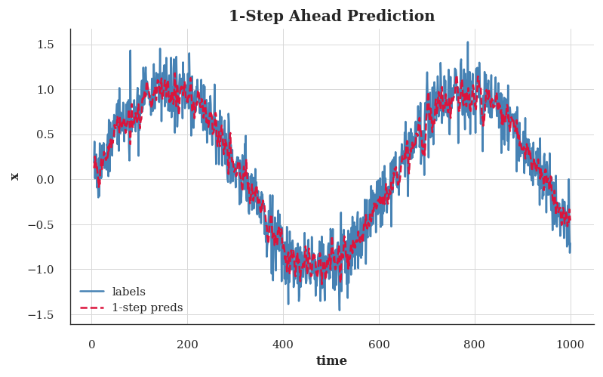
Figure 6. Plot comparing the true labels and the 1-step-ahead predictions.
These predictions look good, even near the end at $t=1000$.
But what if we only observed sequence data up until time step 604 (n_train + tau) and wished to make predictions several steps into the future? Unfortunately, we cannot directly compute the one-step-ahead prediction for time step 609, because we do not know the corresponding inputs, having seen only up to $x_{604}$. We can address this problem by plugging in our earlier predictions as inputs to our model for making subsequent predictions, projecting forward, one step at a time, until reaching the desired time step:
$$\begin{aligned}{\hat{x}}_{605}&=f(x_{601},x_{602},x_{603},x_{604}), \\ {\hat{x}}_{606}&=f(x_{602},x_{603},x_{604},{\hat{x}}_{605}), \\ {\hat{x}}_{607}&=f(x_{603},x_{604},{\hat{x}}_{605},{\hat{x}}_{606}), \\ {\hat{x}}_{608}&=f(x_{604},{\hat{x}}_{605},{\hat{x}}_{606},{\hat{x}}_{607}), \\ {\hat{x}}_{609}&=f({\hat{x}}_{605},{\hat{x}}_{606},{\hat{x}}_{607},{\hat{x}}_{608}), \\ &⋮\end{aligned}$$
Generally, for an observed sequence $x_{1},…,x_{t}$, its predicted output ${\hat{x}}_{t+k}$ at time step $t+k$ is called the $k$-step-ahead prediction. Since we have observed up to $x_{604}$, its $k$-step-ahead prediction is ${\hat{x}}_{604+k}$. In other words, we will have to keep on using our own predictions to make multistep-ahead predictions. Let’s see how well this goes.

2.5.1 Multi‑Step Forecasting
import torch
def multistep_forecast(model, data):
model.eval()
# Start with the true series (same as D2L)
preds = data.x.clone()
with torch.no_grad():
for i in range(data.num_train + data.tau, data.T):
window = preds[i - data.tau : i].reshape(1, -1)
preds[i] = model(window).item()
return preds

2.5.2 Generate the predictions
# 1-step predictions (already trained model)
model.eval()
with torch.no_grad():
onestep_preds = model(data.features).squeeze().cpu()
# k-step predictions
multistep_preds = multistep_forecast(model, data).cpu()

2.6 Plotting the results
import matplotlib.pyplot as plt
import seaborn as sns
set_economist_theme()
time = data.time.cpu()
plt.figure(figsize=(7, 4.5))
# 1-step predictions
plt.plot(
time[data.tau:],
onestep_preds,
label="1-step preds",
color="steelblue",
linewidth=1.5
)
# multi-step predictions (only future region)
plt.plot(
time[data.num_train + data.tau:],
multistep_preds[data.num_train + data.tau:],
label="multistep preds",
color="crimson",
linestyle="--",
linewidth=1.0
)
plt.xlabel("time")
plt.ylabel("x")
plt.title("1-Step vs Multi-Step Forecasting")
plt.legend()
plt.tight_layout()
plt.show()
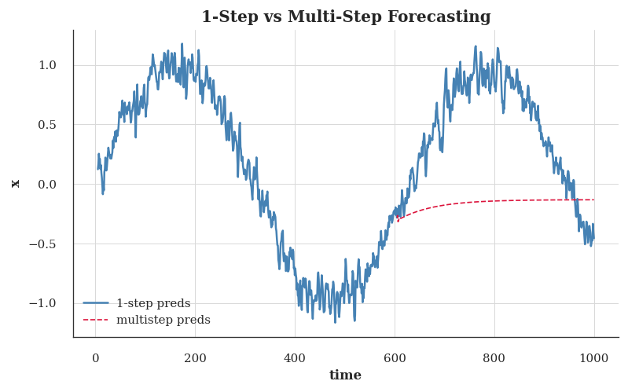
Figure 7. Plot comparing the 1-step-ahead predictions and the multi-step predictions for the future region.
Unfortunately, in this case we fail spectacularly. The predictions decay to a constant pretty quickly after a few steps. Why did the algorithm perform so much worse when predicting further into the future? Ultimately, this is down to the fact that errors build up. Let’s say that after step 1 we have some error $ϵ_{1}=\overset{‾}{ϵ}$. Now the input for step 2 is perturbed by $ϵ_{1}$, hence we suffer some error in the order of $ϵ_{2}=\overset{‾}{ϵ}+cϵ_{1}$ for some constant $c$, and so on. The predictions can diverge rapidly from the true observations. You may already be familiar with this common phenomenon. For instance, weather forecasts for the next 24 hours tend to be pretty accurate but beyond that, accuracy declines rapidly. We will discuss methods for improving this throughout this chapter and beyond.
Let’s take a closer look at the difficulties in $k$-step-ahead predictions by computing predictions on the entire sequence for $k=1,4,16,64$.

2.6.1 K step ahead predictions
def k_step_pred(model, data, k):
"""
Vectorized k-step-ahead prediction following D2L semantics.
Returns a list of tensors, where the i-th element is the (i+1)-step prediction.
"""
T = data.T
tau = data.tau
x = data.x
# Step 1: initial tau feature rows (true data)
features = []
for i in range(tau):
# shape: [T - tau - k + 1]
features.append(x[i : i + T - tau - k + 1])
# Step 2: generate k future steps
for i in range(k):
# Stack the last tau rows to form the feature matrix
window = torch.stack(features[i : i + tau], dim=1) # shape: [N, tau]
# Predict next step
with torch.no_grad():
preds = model(window).reshape(-1) # shape: [N]
# Append predictions as the next row
features.append(preds)
# Step 3: return only the predicted rows (skip the initial tau)
return features[tau:]
steps = (1, 4, 16, 64)
pred_rows = k_step_pred(model, data, steps[-1])
import matplotlib.pyplot as plt
import seaborn as sns
set_economist_theme()
plt.figure(figsize=(7, 4.5))
start = data.tau + steps[-1] - 1
time = data.time[start:].numpy()
for k in steps:
plt.plot(
time,
pred_rows[k-1].numpy(),
label=f"{k}-step preds",
linewidth=1.0
)
plt.xlabel("time")
plt.ylabel("x")
plt.title("k-step Ahead Predictions")
plt.legend()
plt.tight_layout()
plt.show()
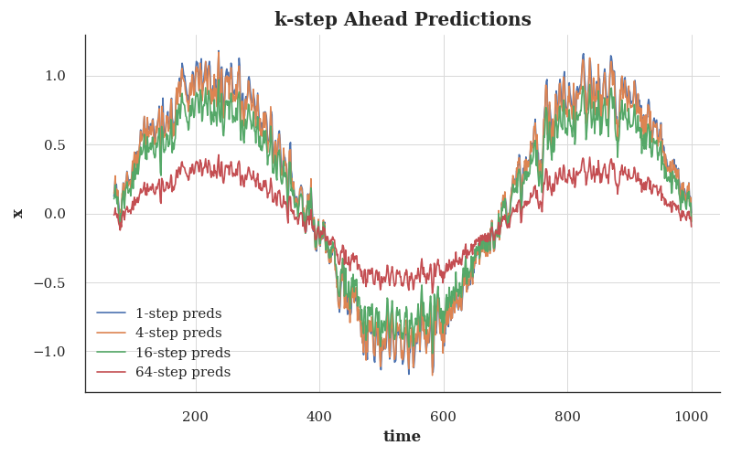
Figure 8. Plot comparing the k-step-ahead predictions for k=1, k=4, k=16, and k=64.
This clearly illustrates how the quality of the prediction changes as we try to predict further into the future. While the 4-step-ahead predictions still look good, anything beyond that is almost useless.

2.7 Summary
There is quite a difference in difficulty between interpolation and extrapolation. Consequently, if you have a sequence, always respect the temporal order of the data when training, i.e., never train on future data. Given this kind of data, sequence models require specialized statistical tools for estimation. Two popular choices are autoregressive models and latent-variable autoregressive models. For causal models (e.g., time going forward), estimating the forward direction is typically a lot easier than the reverse direction. For an observed sequence up to time step $t$, its predicted output at time step $t+k$ is the $k$-step-ahead prediction. As we predict further in time by increasing $k$, the errors accumulate and the quality of the prediction degrades, often dramatically.

2.8 Converting Raw Text into Sequence Data
Throughout the class, we will often work with text data represented as sequences of words, characters, or word pieces. To get going, we will need some basic tools for converting raw text into sequences of the appropriate form. Typical preprocessing pipelines execute the following steps:
- Load text as strings into memory.
- Split the strings into tokens (e.g., words or characters).
- Build a vocabulary dictionary to associate each vocabulary element with a numerical index.
- Convert the text into sequences of numerical indices.
import collections
import os
import re
import torch
import random
import tensorflow as tf
import requests

2.9 Reading the Dataset
Here, we will work with H. G. Wells’ The Time Machine, a book containing just over 30,000 words. While real applications will typically involve significantly larger datasets, this is sufficient to demonstrate the preprocessing pipeline. Let’s download the dataset programmatically. This is a simple .txt file download. We can also utilize BeautifulSoup to scrape the text from the website, but that is not necessary here.
class TimeMachine:
URL = "https://d2l-data.s3-accelerate.amazonaws.com/timemachine.txt"
def __init__(self, root="data"):
self.root = root
os.makedirs(root, exist_ok=True)
self.path = os.path.join(root, "timemachine.txt")
self.raw_text = self._download()
# Cached values (initially None)
self.cleaned_text = None
self.tokens = None
def _download(self):
if not os.path.exists(self.path):
print("Downloading Time Machine dataset...")
r = requests.get(self.URL)
with open(self.path, "w", encoding="utf-8") as f:
f.write(r.text)
with open(self.path, "r", encoding="utf-8") as f:
return f.read()
def _preprocess(self, text):
text = text.lower()
text = re.sub(r'[^a-z]+', ' ', text)
text = re.sub(r'\s+', ' ', text).strip()
return text
def _tokenize(self, text):
return list(text)
# NEW: ensures cleaned_text and tokens exist
def prepare(self):
if self.cleaned_text is None:
self.cleaned_text = self._preprocess(self.raw_text)
if self.tokens is None:
self.tokens = self._tokenize(self.cleaned_text)
def build(self, raw_text=None, vocab=None):
raw_text = raw_text or self.raw_text
# Cache cleaned text + tokens
self.cleaned_text = self._preprocess(raw_text)
self.tokens = self._tokenize(self.cleaned_text)
if vocab is None:
vocab = Vocab(self.tokens)
corpus = [vocab[token] for token in self.tokens]
return corpus, vocab
data = TimeMachine()
data.prepare()
print(data.raw_text[:60])
The Time Machine, by H. G. Wells [1898]
I
The Time Tra
For simplicity, we ignore punctuation, numbers, additional spaces and capitalization when preprocessing the raw text.
print(data._preprocess(data.raw_text)[:60])
the time machine by h g wells i the time traveller for so it

2.10 Tokenization
Tokens are the atomic (indivisible) units of text. Each time step corresponds to 1 token, but what precisely constitutes a token is a design choice. For example, we could represent the sentence “Baby needs a new pair of shoes” as a sequence of 7 words, where the set of all words comprise a large vocabulary (typically tens or hundreds of thousands of words). Or we would represent the same sentence as a much longer sequence of 30 characters, using a much smaller vocabulary (there are only 256 distinct ASCII characters). Below, we tokenize our preprocessed text into a sequence of characters.
tokens = data._tokenize(data.cleaned_text)
print(tokens[:30])
['t', 'h', 'e', ' ', 't', 'i', 'm', 'e', ' ', 'm', 'a', 'c', 'h', 'i', 'n', 'e', ' ', 'b', 'y', ' ', 'h', ' ', 'g', ' ', 'w', 'e', 'l', 'l', 's', ' ']

2.11 Vocabulary
These tokens are still strings. However, the inputs to our models must ultimately consist of numerical inputs. Lets now build a class for for constructing vocabularies, i.e., objects that associate each distinct token value with a unique index. First, we determine the set of unique tokens in our training corpus. We then assign a numerical index to each unique token. Rare vocabulary elements are often dropped for convenience. Whenever we encounter a token at training or test time that had not been previously seen or was dropped from the vocabulary, we represent it by a special “<unk>” token, signifying that this is an unknown value.
class Vocab:
def __init__(self, tokens=None, min_freq=0, reserved_tokens=None):
tokens = tokens or []
reserved_tokens = reserved_tokens or []
if tokens and isinstance(tokens[0], list):
tokens = [t for seq in tokens for t in seq]
counter = collections.Counter(tokens)
self.token_freqs = sorted(counter.items(), key=lambda x: x[1], reverse=True)
uniq_tokens = ['<unk>'] + reserved_tokens + [
token for token, freq in self.token_freqs if freq >= min_freq
]
self.idx_to_token = uniq_tokens
self.token_to_idx = {tok: i for i, tok in enumerate(self.idx_to_token)}
def __len__(self):
return len(self.idx_to_token)
def __getitem__(self, tokens):
if isinstance(tokens, (list, tuple)):
return [self.token_to_idx.get(t, self.unk) for t in tokens]
return self.token_to_idx.get(tokens, self.unk)
def to_tokens(self, indices):
if isinstance(indices, (list, tuple)):
return [self.idx_to_token[int(i)] for i in indices]
return self.idx_to_token[int(indices)]
@property
def unk(self):
return self.token_to_idx['<unk>']
We can now construct a vocabulary for our dataset, converting the sequence of strings into a list of numerical indices. Note that we have not lost any information and can easily convert our dataset back to its original (string) representation.
tokens = data._tokenize(data.cleaned_text)
vocab = Vocab(tokens)
print(len(vocab))
print(vocab['t'], vocab['x'])
print(vocab.to_tokens([10, 11, 12]))
28
3 24
['r', 'd', 'l']

2.12 Putting It All Together
Using the above classes and methods, we can package everything into the following build method of the TimeMachine class, which returns corpus, a list of token indices, and vocab, the vocabulary of The Time Machine corpus. The modifications we did here are:
- We tokenize text into characters, not words, to simplify the training in later sections
- corpus is a single list, not a list of token lists, since each text line in The Time Machine dataset is not necessarily a sentence or paragraph.
corpus, vocab = data.build()
len(corpus), len(vocab)
(173427, 28)

2.13 Exploratory Language Statistics
Using the real corpus and the Vocab class defined over words, we can inspect basic statistics concerning word use in our corpus. Below, we construct a vocabulary from words used in The Time Machine and print the ten most frequently occurring of them.
data.prepare() # ensures cleaned_text exists
text = data.cleaned_text # cleaned, lowercase, punctuation-free
words = text.split() # word-level tokens
vocab = Vocab(words) # build vocabulary
vocab.token_freqs[:10] # top-10 most frequent words
[('the', 2261),
('i', 1267),
('and', 1245),
('of', 1155),
('a', 816),
('to', 695),
('was', 552),
('in', 541),
('that', 443),
('my', 440)]
Note that the ten most frequent words are not all that descriptive. You might even imagine that we might see a very similar list if we had chosen any book at random. Articles like “the” and “a”, pronouns like “i” and “my”, and prepositions like “of”, “to”, and “in” occur often because they serve common syntactic roles. Such words that are common but not particularly descriptive are often called (stop words) and, in previous generations of text classifiers based on so-called bag-of-words representations, they were most often filtered out. However, they carry meaning and it is not necessary to filter them out when working with modern RNN- and Transformer-based neural models. If you look further down the list, you will notice that word frequency decays quickly. The ${10}^{\text{th}}$ most frequent word is less than $1/5$ as common as the most popular. Word frequency tends to follow a power law distribution (specifically the Zipfian) as we go down the ranks. To get a better idea, we can plot the word frequency.
import matplotlib.pyplot as plt
import seaborn as sns
set_economist_theme()
freqs = [freq for token, freq in vocab.token_freqs]
plt.figure(figsize=(7, 4.5))
plt.plot(freqs)
plt.xscale("log")
plt.yscale("log")
plt.xlabel("token: x")
plt.ylabel("frequency: n(x)")
plt.title("Word Frequency Distribution (Log–Log)")
plt.tight_layout()
plt.show()
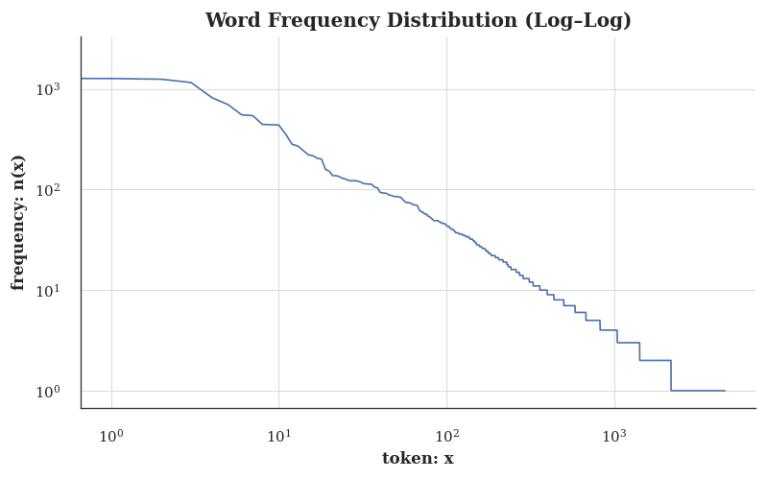
Figure 9. Word frequency distribution (log-log plot)
After dealing with the first few words as exceptions, all the remaining words roughly follow a straight line on a log–log plot. This phenomenon is captured by Zipf’s law, which states that the frequency $n_{i}$ of the $i^{\text{th}}$ most frequent word is:
$$\begin{matrix}n_{i}∝\frac{1}{i^{α}},\end{matrix} (1)$$
which is equivalent to
$$\begin{matrix}logn_{i}=−αlogi+c,\end{matrix}$$
where $α$ is the exponent that characterizes the distribution and $c$ is a constant. This should already give us pause for thought if we want to model words by counting statistics. After all, we will significantly overestimate the frequency of the tail, also known as the infrequent words. But, what about the other word combinations, such as two consecutive words (bigrams), three consecutive words (trigrams), and beyond? Let’s see whether the bigram frequency behaves in the same manner as the single word (unigram) frequency.
# Bigram tokens: "word1--word2"
bigram_tokens = ['--'.join(pair) for pair in zip(words[:-1], words[1:])]
bigram_vocab = Vocab(bigram_tokens)
bigram_vocab.token_freqs[:10]
[('of--the', 309),
('in--the', 169),
('i--had', 130),
('i--was', 112),
('and--the', 109),
('the--time', 102),
('it--was', 99),
('to--the', 85),
('as--i', 78),
('of--a', 73)]
One thing is notable here. Out of the ten most frequent word pairs, nine are composed of both stop words and only one is relevant to the actual book—“the time”. Furthermore, let’s see whether the trigram frequency behaves in the same manner.
# Trigram tokens: "word1--word2--word3"
trigram_tokens = [
'--'.join(triple)
for triple in zip(words[:-2], words[1:-1], words[2:])
]
trigram_vocab = Vocab(trigram_tokens)
trigram_vocab.token_freqs[:10]
[('the--time--traveller', 59),
('the--time--machine', 30),
('the--medical--man', 24),
('it--seemed--to', 16),
('it--was--a', 15),
('here--and--there', 15),
('seemed--to--me', 14),
('i--did--not', 14),
('i--saw--the', 13),
('i--began--to', 13)]
Now, let’s [visualize the token frequency] among these three models: unigrams, bigrams, and trigrams.
import matplotlib.pyplot as plt
import seaborn as sns
set_economist_theme()
# Extract frequencies
unigram_freqs = [freq for token, freq in vocab.token_freqs]
bigram_freqs = [freq for token, freq in bigram_vocab.token_freqs]
trigram_freqs = [freq for token, freq in trigram_vocab.token_freqs]
plt.figure(figsize=(7, 4.5))
plt.plot(unigram_freqs, label="unigram", linewidth=1.0)
plt.plot(bigram_freqs, label="bigram", linewidth=1.0)
plt.plot(trigram_freqs, label="trigram", linewidth=1.0)
plt.xscale("log")
plt.yscale("log")
plt.xlabel("token: x")
plt.ylabel("frequency: n(x)")
plt.title("Token Frequency Distribution (Unigram / Bigram / Trigram)")
plt.legend()
plt.tight_layout()
plt.show()
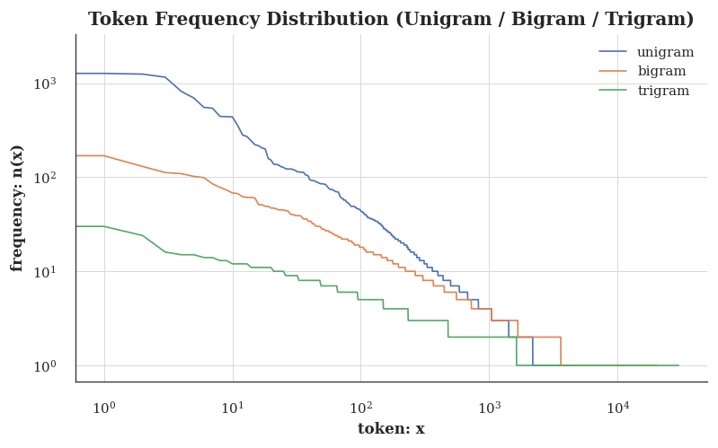
This figure is quite exciting. First, beyond unigram words, sequences of words also appear to be following Zipf’s law, albeit with a smaller exponent $α$ in Equation 1, depending on the sequence length. Second, the number of distinct $n$-grams is not that large. This gives us hope that there is quite a lot of structure in language. Third, many $n$-grams occur very rarely. This makes certain methods unsuitable for language modeling and motivates the use of deep learning models.

2.14 Summary
Text is among the most common forms of sequence data encountered in deep learning. Common choices for what constitutes a token are characters, words, and word pieces. To preprocess text, we usually:
- Split text into tokens;
- Build a vocabulary to map token strings to numerical indices;
- Convert text data into token indices for models to manipulate.
In practice, the frequency of words tends to follow Zipf’s law. This is true not just for individual words (unigrams), but also for $n$-grams.

3. Transformers and the Attention Mechanism
We will cover transformers in the next lecture, but it’s important to understand the historical context of how we got here. The transformer architecture, introduced in the seminal paper “Attention is All You Need” (Vaswani et al. 2017), revolutionized natural language processing and laid the groundwork for the development of large language models.

3.1 The Transformers Timeline
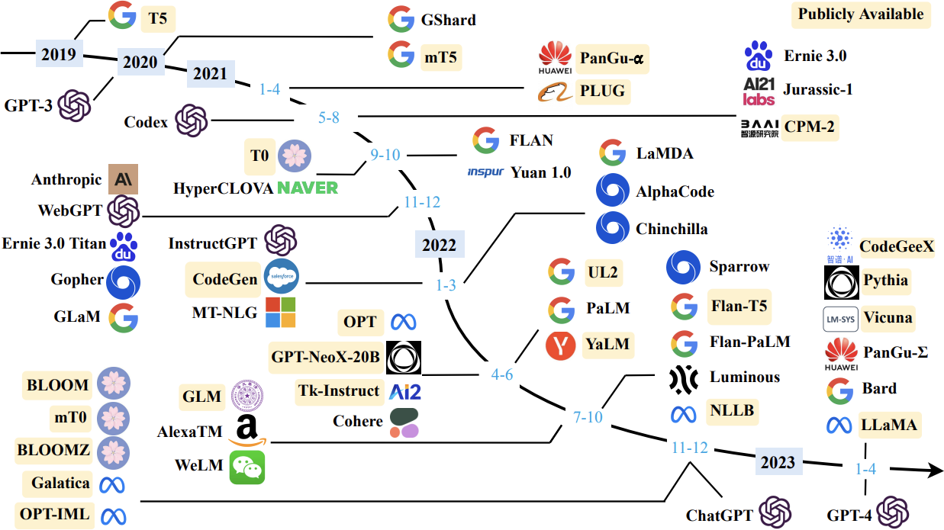
Figure 10. Timeline of transformer-based models

3.2 Transformer Models
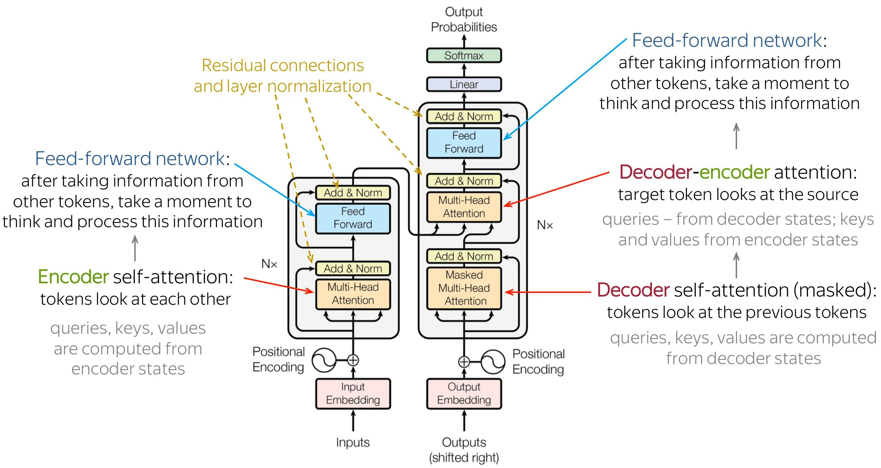
Figure 11. Transformer Architecture

4. Prompting Patterns: Code Demonstrations

4.1 Zero-Shot vs Few-Shot Prompt Construction
These cells demonstrate prompt formatting patterns in pure Python — no API key required. The patterns here translate directly to any LLM API (OpenAI, Anthropic, HuggingFace).
# ─── Zero-shot prompt ────────────────────────────────────────────────────────
def zero_shot_prompt(task: str, input_text: str) -> str:
return f"{task}\n\nInput: {input_text}\nOutput:"
# ─── Few-shot prompt ─────────────────────────────────────────────────────────
def few_shot_prompt(task: str, examples: list[dict], input_text: str) -> str:
prompt = task + "\n\n"
for ex in examples:
prompt += f"Input: {ex['input']}\nOutput: {ex['output']}\n\n"
prompt += f"Input: {input_text}\nOutput:"
return prompt
# Sentiment analysis examples
task = "Classify the sentiment of the following text as POSITIVE, NEGATIVE, or NEUTRAL."
examples = [
{"input": "The product exceeded all my expectations.", "output": "POSITIVE"},
{"input": "Delivery was delayed by two weeks.", "output": "NEGATIVE"},
{"input": "The report was submitted on time.", "output": "NEUTRAL"},
]
test_text = "Revenue grew 12% year-over-year driven by strong cloud adoption."
print("=== ZERO-SHOT PROMPT ===")
print(zero_shot_prompt(task, test_text))
print()
print("=== FEW-SHOT PROMPT (k=3) ===")
print(few_shot_prompt(task, examples, test_text))

4.2 Chain-of-Thought Prompting
Chain-of-thought (CoT) prompting instructs the model to reason step-by-step before giving a final answer. It is especially effective for multi-step problems.
def cot_prompt(task: str, examples: list[dict], input_text: str) -> str:
"""Build a chain-of-thought few-shot prompt."""
prompt = task + "\n\n"
for ex in examples:
prompt += f"Question: {ex['question']}\n"
prompt += f"Reasoning: {ex['reasoning']}\n"
prompt += f"Answer: {ex['answer']}\n\n"
prompt += f"Question: {input_text}\nReasoning:"
return prompt
task_cot = (
"You are a financial analyst. "
"For each question, show your reasoning step by step, "
"then provide a concise final answer."
)
cot_examples = [
{
"question": "A company reports $500M revenue with 20% YoY growth. What was last year's revenue?",
"reasoning": (
"If this year is $500M with 20% growth, then: "
"last_year × 1.20 = $500M → last_year = $500M / 1.20 = $416.7M"
),
"answer": "Last year's revenue was approximately $416.7 million.",
},
{
"question": "Operating margin is 15% on $200M revenue. What is operating income?",
"reasoning": "Operating income = revenue × margin = $200M × 0.15 = $30M.",
"answer": "Operating income is $30 million.",
},
]
question = "A firm's net income grew from $80M to $104M. What is the percentage growth?"
print(cot_prompt(task_cot, cot_examples, question))

4.3 Role Prompting and Structured Output
def role_prompt(role: str, context: str, request: str) -> str:
return (
f"You are {role}.\n\n"
f"Context:\n{context}\n\n"
f"Task: {request}\n\n"
f"Respond in valid JSON."
)
role = "a senior equity research analyst specializing in technology sector 10-K filings"
context = """
Item 1A. Risk Factors (excerpt):
The Company faces intense competition from well-established and emerging companies.
Rapid technological changes could render our products obsolete.
We are subject to significant regulatory requirements in multiple jurisdictions.
"""
request = (
"Extract the top 3 risk categories from the excerpt. "
"For each, provide: category, description (one sentence), and severity (High/Medium/Low)."
)
print(role_prompt(role, context, request))
Graves, A., Liwicki, M., Fernández, S., Bertolami, R., Bunke, H., and Schmidhuber, J. 2008. “A Novel Connectionist System for Unconstrained Handwriting Recognition,” IEEE Transactions on Pattern Analysis and Machine Intelligence (31:5), IEEE, pp. 855–868.
Hoyer, P. O., Janzing, D., Mooij, J. M., Peters, J., and Schölkopf, B. 2009. “Nonlinear Causal Discovery with Additive Noise Models,” in Advances in Neural Information Processing Systems, pp. 689–696.
Lipton, Z. C., Berkowitz, J., and Elkan, C. 2015. “A Critical Review of Recurrent Neural Networks for Sequence Learning,” ArXiv:1506.00019.
Lipton, Z. C., Kale, D. C., Elkan, C., and Wetzel, R. 2016. “Learning to Diagnose with LSTM Recurrent Neural Networks,” in International Conference on Learning Representations (ICLR).
Peters, J., Janzing, D., and Schölkopf, B. 2017. Elements of Causal Inference: Foundations and Learning Algorithms, MIT Press.
Sutskever, I., Vinyals, O., and Le, Q. V. 2014. “Sequence to Sequence Learning with Neural Networks,” in Advances in Neural Information Processing Systems, pp. 3104–3112.
Vaswani, A., Shazeer, N., Parmar, N., Uszkoreit, J., Jones, L., Gomez, A. N., Kaiser, Ł., and Polosukhin, I. 2017. “Attention Is All You Need,” Advances in Neural Information Processing Systems (30).

