AD698 - Applied Generative AI
Prompting: Pre-Train, Prompt, and Predict
March 12, 2026

1. From Pretraining to Prompting
In Module 4 Lecture 1 we saw how transformers are pretrained: masked language modeling (BERT), causal language modeling (GPT), and span corruption (T5) teach a model to represent language deeply from raw text. Pretraining produces a powerful general-purpose encoder or decoder — but a general-purpose model still needs to be aimed at a specific task.
This lecture covers the full spectrum of adaptation strategies:
Strategy | Cost | Data needed | Suited for
Prompt engineering | Zero compute | Zero labels | Rapid prototyping, task spec
Few-shot prompting | Zero compute | 3–10 examples | Low-data settings
Instruction tuning | Medium | 10k–1M examples | Multi-task generalization
RLHF / DPO | High | Human preference pairs | Alignment, safety
Full fine-tuning | High | 1k–100k labels | Max accuracy, domain shift
LoRA / Adapters | Low | 1k–100k labels | VRAM-constrained adaptation

2. The Shift to Prompt-Based Approaches

2.1 From Training-Centric to Inference-Centric AI
For most of ML history, behavior was determined at training. Once deployed, a model was frozen: changing behavior required retraining. LLMs shatter this assumption. Their behavior is no longer fixed at deployment — it can be steered at inference time through prompts, context, and task specifications.
This is the Pre-train, Prompt, and Predict paradigm (liu2023pretrain?):
- Pretrain: learn a general language model on a massive unlabelled corpus.
- Prompt: supply a natural-language template that converts the downstream task into a language modeling problem.
- Predict: let the model fill in the blanks — no gradient updates required.

2.2 Formal Notation
Given: - $x$ — original input (e.g., a sentence) - $f_{\text{prompt}}(x)$ — a prompting function that converts $x$ into a prompted input $x^{′}$ (fills in a template around $x$) - $x^{′}$ — the prompted input (template + input) - $z$ — the answer (filled slot, e.g., a class label, a word, or a generated span) - $f_{\text{fill}}(x^{′},z)$ — the answer search function that scores candidate answers $z$
The prediction is:
$$\begin{matrix}\hat{z}=arg\max_{z∈Z} P(f_{\text{fill}}(x^{′},z)∣θ)\end{matrix}$$
where $Z$ is the set of candidate answers and $θ$ are the (frozen) model parameters.
Example — sentiment classification:
Step | Text
Input $x$ | “The quarterly earnings exceeded expectations.”
Template | “[X] The sentiment of this text is [Z].”
Prompted $x^{′}$ | “The quarterly earnings exceeded expectations. The sentiment of this text is ___”
Answer space $Z$ | {“positive”, “negative”, “neutral”}
Prediction $\hat{z}$ | “positive” (highest log-prob under the LM)

2.3 Classical Learning vs. Generative Conditioning

2.3.1 Classical Supervised Learning
In the classical paradigm:
$$\begin{matrix}y=f_{θ}(x)\end{matrix}$$
$θ$ encodes all learned behavior. Changing the model’s behavior requires modifying $θ$. This creates a rigid workflow: expensive offline training followed by static, brittle deployment.

2.3.2 Generative Conditioning
Generative models define a conditional distribution:
$$\begin{matrix}P(Y∣X,θ)\end{matrix}$$
Adding a prompt $p$ at inference time adds a third control variable:
$$\begin{matrix}P(Y∣X,p,θ)\end{matrix}$$
Prompts act as soft constraints: they reshape the model’s posterior distribution without touching the weights.

2.4 Prompt as an Inference-Time Control Signal
A prompt functions as a control interface for a probabilistic model:
- Conditioning signal — narrows the space of plausible outputs (Bayesian analogy).
- Soft constraint — biases trajectories probabilistically, not deterministically.
- Semantic policy — encodes how the model should behave (“Be concise”, “Act as a SQL expert”).
- Steering mechanism — alters token likelihoods to enable rapid task adaptation without retraining.
digraph InferenceConditioning {
rankdir=TB;
node [shape=rectangle, style=rounded, fontsize=12];
subgraph cluster_input {
label="Inputs";
style=dashed;
X [label="User Input\nX"];
P [label="Prompt / Context\np"];
}
Theta [label="Model Parameters\nθ (frozen)", shape=rectangle, style="rounded,filled", fillcolor=lightgray];
subgraph cluster_inference {
label="Inference Process";
style=dashed;
Combine [label="Conditioning:\n[X, p]"];
LM [label="Generative Model\nP(Y | X, p, θ)"];
}
Y [label="Output Distribution\nY"];
X -> Combine;
P -> Combine;
Theta -> LM;
Combine -> LM;
LM -> Y;
}

2.5 Prompt Engineering, Fine-Tuning, and RAG: A Comparative View
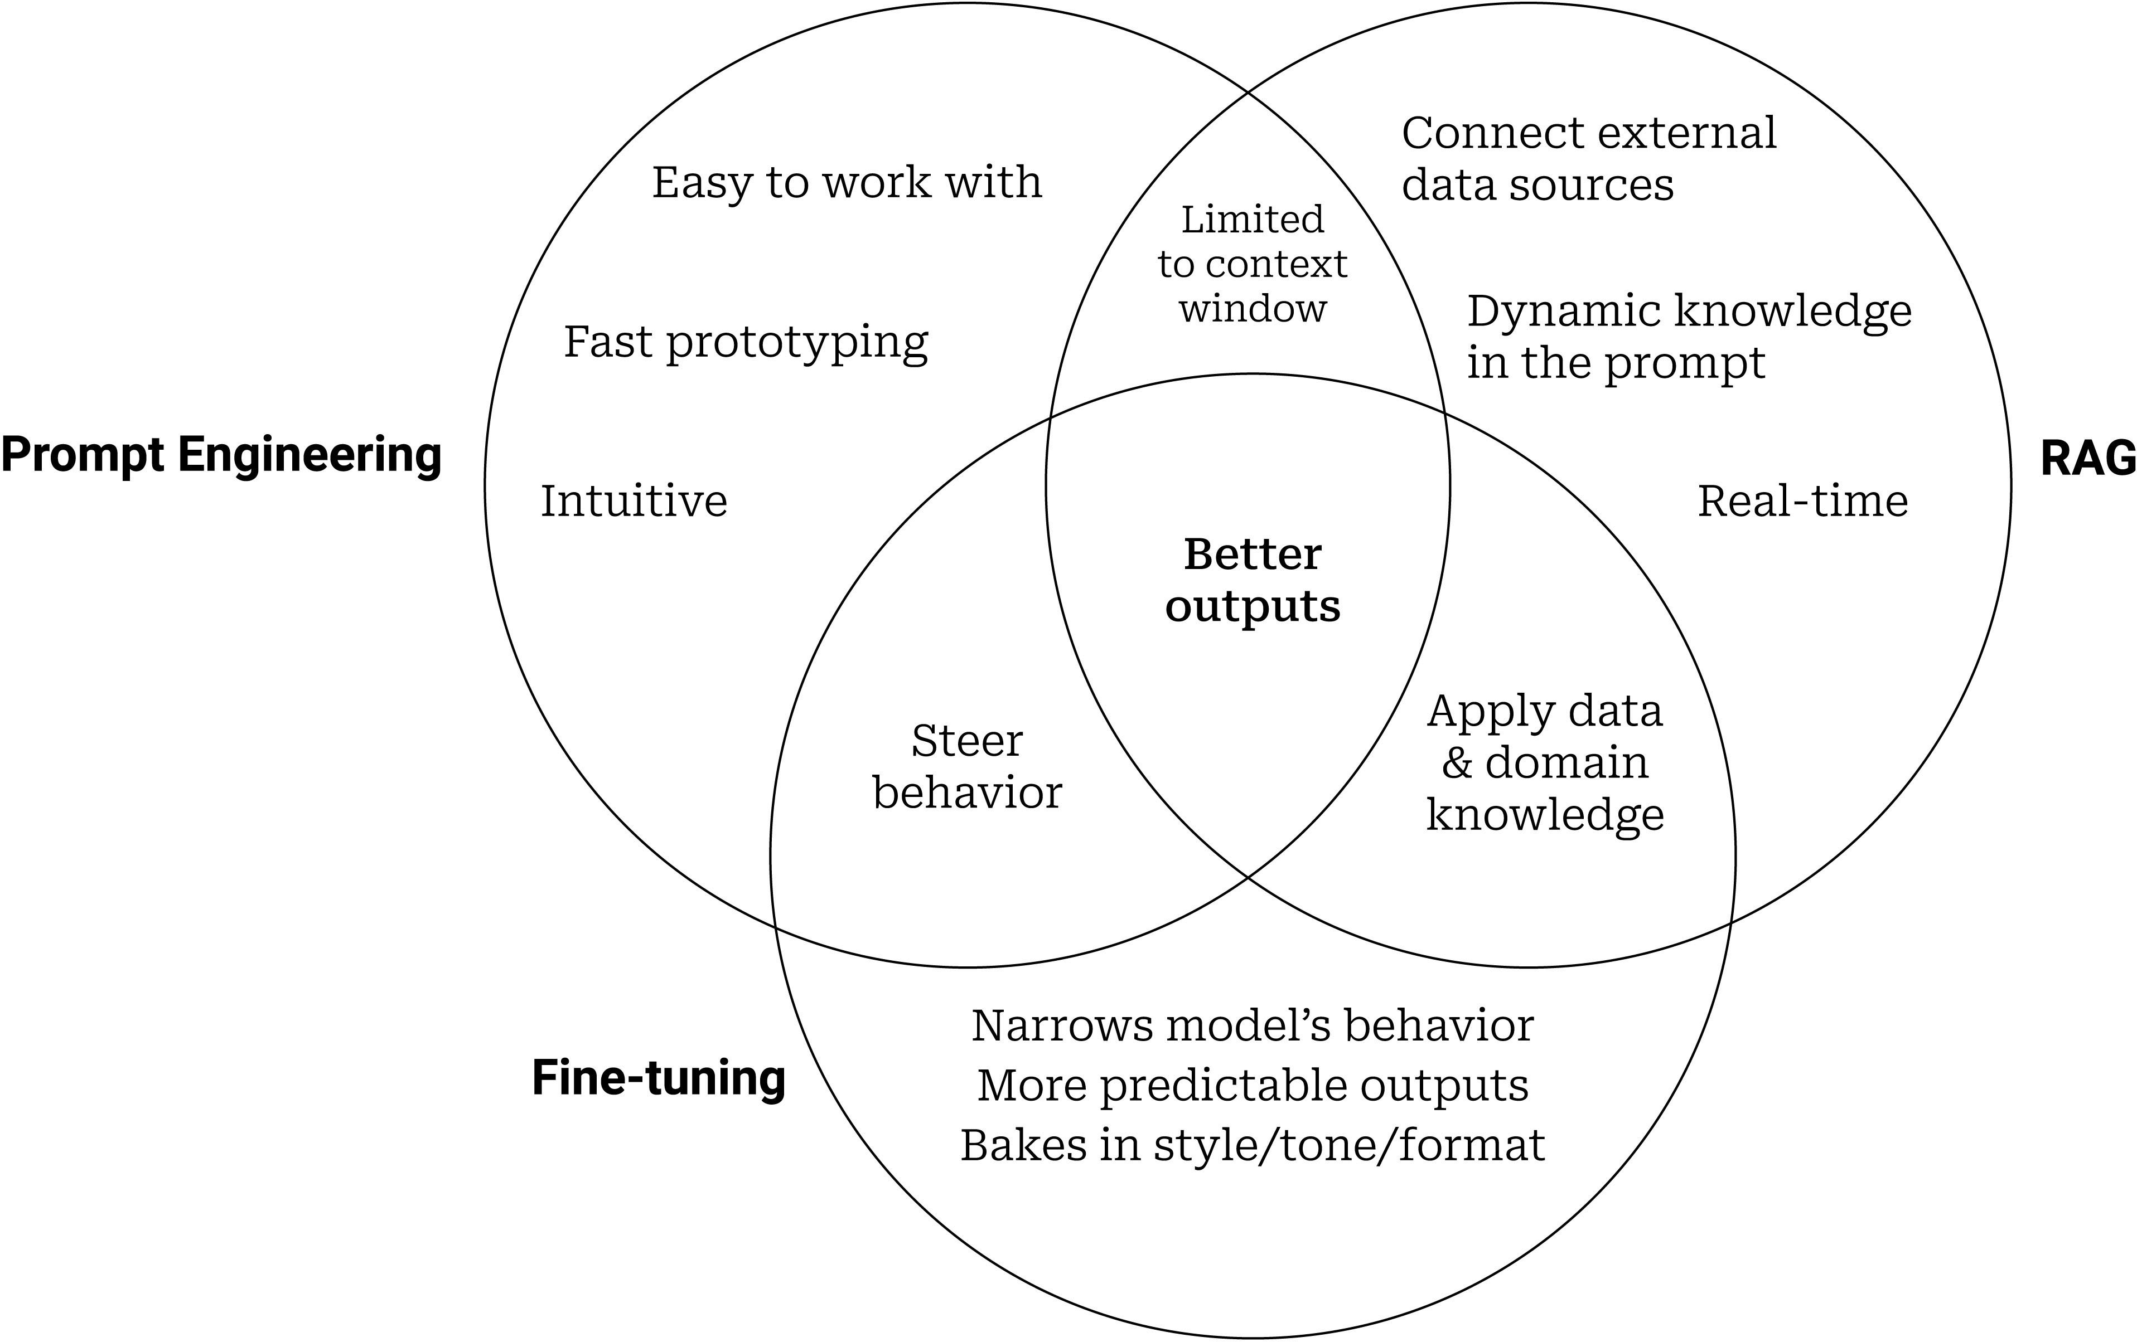
Figure 1. Venn Diagram of Prompt Engineering, Fine-tuning, and RAG

Approach | Weight Update | Data Required | Iteration Speed | Best For
Prompt Engineering | None | 0 labels | Minutes | Task spec, style control
Fine-Tuning | Yes — all | Labeled examples | Hours–days | Domain adaptation, new skills
RAG | None | Document corpus | Minutes | Factual accuracy, recency
LoRA / PEFT | Yes — subset | Labeled examples | Hours | VRAM-limited adaptation
They interact: Prompting + RAG = reasoning over external knowledge; Prompting + Fine-tuning = stable specialized behavior; RAG + Fine-tuning = domain-specific grounding.

2.6 Worked Example: How a Prompt Reshapes Token Probabilities

2.6.1 Without a Prompt
Input: "Complete the sentence: The cat"
The model’s next-token distribution (pretrained priors):
Token | Probability
runs | 0.40
sleeps | 0.35
. | 0.15
dog | 0.05
cat | 0.05

2.6.2 With a Dramatic-Scene Prompt
Prompt: "Write a dramatic action scene. Complete the sentence: The cat"
Token | Probability
runs | 0.55
leaps | 0.25
attacks | 0.10
sleeps | 0.03
. | 0.02
“sleeps” collapses 0.35 → 0.03. No weights changed — only the conditioning context.

2.6.3 With a Role + Style Prompt
Prompt: "You are a veterinarian writing a calm, factual report. Complete the sentence: The cat"
Token | Probability
sleeps | 0.50
rests | 0.20
is | 0.15
runs | 0.05
. | 0.05
The prompt now acts as a semantic policy — “calm, factual” shifts the distribution toward clinical, low-emotion verbs.

2.7 Training Settings: Zero-Shot, Few-Shot, Full-Data
The prompting framework naturally accommodates different data regimes (liu2023pretrain?):
Setting | Labeled examples | Parameter update? | Notes
Zero-shot | 0 | No | Model infers task from the template alone
Few-shot (in-context) | 1–10 | No | Examples in the prompt context window
Full-data supervised | 1k–100k | Yes (fine-tune) | Standard supervised learning on top of pretrained features
In-context few-shot is a distinguishing emergent ability of large models: GPT-3 (175B) can solve new tasks from 3 examples; GPT-2 (1.5B) largely cannot.

3. Prompting Patterns: Code Demonstrations

3.1 Zero-Shot vs Few-Shot Prompt Construction
These cells demonstrate prompt formatting patterns in pure Python — no API key required. The patterns translate directly to any LLM API (OpenAI, Anthropic, HuggingFace).
def zero_shot_prompt(task: str, input_text: str) -> str:
return f"{task}\n\nInput: {input_text}\nOutput:"
def few_shot_prompt(task: str, examples: list[dict], input_text: str) -> str:
prompt = task + "\n\n"
for ex in examples:
prompt += f"Input: {ex['input']}\nOutput: {ex['output']}\n\n"
prompt += f"Input: {input_text}\nOutput:"
return prompt
task = "Classify the sentiment of the following text as POSITIVE, NEGATIVE, or NEUTRAL."
examples = [
{"input": "The product exceeded all my expectations.", "output": "POSITIVE"},
{"input": "Delivery was delayed by two weeks.", "output": "NEGATIVE"},
{"input": "The report was submitted on time.", "output": "NEUTRAL"},
]
test_text = "Revenue grew 12% year-over-year driven by strong cloud adoption."
print("=== ZERO-SHOT PROMPT ===")
print(zero_shot_prompt(task, test_text))
print()
print("=== FEW-SHOT PROMPT (k=3) ===")
print(few_shot_prompt(task, examples, test_text))

3.2 Chain-of-Thought Prompting
Chain-of-thought (CoT) prompting instructs the model to reason step-by-step before giving a final answer. It is especially effective for multi-step problems.
def cot_prompt(task: str, examples: list[dict], input_text: str) -> str:
prompt = task + "\n\n"
for ex in examples:
prompt += f"Question: {ex['question']}\n"
prompt += f"Reasoning: {ex['reasoning']}\n"
prompt += f"Answer: {ex['answer']}\n\n"
prompt += f"Question: {input_text}\nReasoning:"
return prompt
task_cot = (
"You are a financial analyst. "
"For each question, show your reasoning step by step, "
"then provide a concise final answer."
)
cot_examples = [
{
"question": "A company reports $500M revenue with 20% YoY growth. What was last year's revenue?",
"reasoning": "last_year × 1.20 = $500M → last_year = $500M / 1.20 = $416.7M",
"answer": "Last year's revenue was approximately $416.7 million.",
},
{
"question": "Operating margin is 15% on $200M revenue. What is operating income?",
"reasoning": "Operating income = $200M × 0.15 = $30M.",
"answer": "Operating income is $30 million.",
},
]
question = "A firm's net income grew from $80M to $104M. What is the percentage growth?"
print(cot_prompt(task_cot, cot_examples, question))

3.3 Role Prompting and Structured Output
def role_prompt(role: str, context: str, request: str) -> str:
return (
f"You are {role}.\n\n"
f"Context:\n{context}\n\n"
f"Task: {request}\n\n"
f"Respond in valid JSON."
)
role = "a senior equity research analyst specializing in technology sector 10-K filings"
context = """
Item 1A. Risk Factors (excerpt):
The Company faces intense competition from well-established and emerging companies.
Rapid technological changes could render our products obsolete.
We are subject to significant regulatory requirements in multiple jurisdictions.
"""
request = (
"Extract the top 3 risk categories from the excerpt. "
"For each, provide: category, description (one sentence), and severity (High/Medium/Low)."
)
print(role_prompt(role, context, request))

4. Full Fine-Tuning
All model parameters are updated during training on labelled task data.

4.0.1 Classification Head
import torch.nn as nn
class TransformerClassifier(nn.Module):
"""
Wrap a frozen (or partially frozen) transformer encoder with a classification head.
In practice, replace `encoder` with a HuggingFace model.
"""
def __init__(self, encoder: nn.Module, hidden_dim: int, num_classes: int,
dropout: float = 0.1):
super().__init__()
self.encoder = encoder
self.dropout = nn.Dropout(dropout)
self.classifier = nn.Linear(hidden_dim, num_classes)
def forward(self, x):
# x: (B, T) token ids → (B, T, H) hidden states
hidden = self.encoder(x) # placeholder call
cls = hidden[:, 0, :] # take [CLS] representation
return self.classifier(self.dropout(cls))

4.0.2 Fine-Tuning Training Loop
import torch
def fine_tune(model, train_loader, val_loader, epochs: int = 3, lr: float = 2e-5):
device = torch.device("cuda" if torch.cuda.is_available() else "cpu")
model = model.to(device)
optimizer = torch.optim.AdamW(model.parameters(), lr=lr, weight_decay=0.01)
criterion = nn.CrossEntropyLoss()
for epoch in range(1, epochs + 1):
model.train()
total_loss = correct = total = 0
for x, y in train_loader:
x, y = x.to(device), y.to(device)
optimizer.zero_grad()
logits = model(x)
loss = criterion(logits, y)
loss.backward()
torch.nn.utils.clip_grad_norm_(model.parameters(), max_norm=1.0)
optimizer.step()
total_loss += loss.item()
correct += (logits.argmax(-1) == y).sum().item()
total += len(y)
train_acc = correct / total
model.eval()
correct = total = 0
with torch.no_grad():
for x, y in val_loader:
x, y = x.to(device), y.to(device)
correct += (model(x).argmax(-1) == y).sum().item()
total += len(y)
print(f"Epoch {epoch} loss={total_loss/len(train_loader):.4f} "
f"train_acc={train_acc:.3f} val_acc={correct/total:.3f}")
Practical tips: Use a small learning rate (1e-5 – 5e-5), warm up the learning rate for the first 6–10% of steps, and apply weight decay to all parameters except biases and LayerNorm weights.

4.1 Instruction Tuning
Instruction tuning fine-tunes a model on (instruction, response) pairs drawn from a wide variety of tasks, teaching the model to follow natural language commands zero-shot.

4.1.1 Prompt Format
def format_instruction_prompt(instruction: str, input_text: str = "",
response: str = "") -> str:
parts = [f"### Instruction:\n{instruction}"]
if input_text:
parts.append(f"### Input:\n{input_text}")
parts.append(f"### Response:\n{response}")
return "\n\n".join(parts)
example = format_instruction_prompt(
instruction="Classify the sentiment of the following financial headline.",
input_text="Apple reports record-breaking Q4 revenue.",
response="POSITIVE",
)
print(example)
Key datasets: FLAN (1,800 tasks), Alpaca (52k GPT-4-generated examples), Dolly, OpenAssistant.

4.2 RLHF: Reinforcement Learning from Human Feedback
RLHF (Ouyang et al., 2022) aligns a language model with human preferences through three stages:
- Supervised Fine-Tuning (SFT): Fine-tune on demonstrations of the desired behaviour.
- Reward Model: Train a model to predict human preference scores from ranked output pairs.
- PPO Optimisation: Use Proximal Policy Optimization to maximise reward while a KL penalty keeps the policy close to the SFT baseline.
$$L_{\text{PPO}}=E​\left[r(x,y)−β⋅D_{\text{KL}}(π_{θ} ∥ π_{\text{SFT}})\right]$$
Alternative — DPO (Rafailov et al., 2023): directly optimises a preference objective without a separate reward model, dramatically simplifying the training pipeline.

4.3 Parameter-Efficient Fine-Tuning (PEFT)

4.3.1 The Problem
Full fine-tuning of a 7B-parameter model requires ~56 GB of GPU memory (fp16 + Adam states). PEFT methods freeze the pretrained weights and add a small number of trainable parameters.

4.3.2 LoRA: Low-Rank Adaptation
LoRA (Hu et al., 2021) decomposes weight updates into low-rank matrices:
$$W^{′}=W+ΔW=W+BA$$
where $B∈R^{d×r}$, $A∈R^{r×k}$, and $r≪min(d,k)$.
class LoRALinear(nn.Module):
"""Drop-in replacement for nn.Linear with LoRA adaptation."""
def __init__(self, in_features: int, out_features: int,
rank: int = 8, alpha: float = 16.0, dropout: float = 0.0):
super().__init__()
self.rank = rank
self.alpha = alpha
self.scaling = alpha / rank
# Frozen pretrained weight (no gradient)
self.weight = nn.Parameter(torch.randn(out_features, in_features), requires_grad=False)
self.bias = nn.Parameter(torch.zeros(out_features), requires_grad=False)
# Trainable low-rank matrices
self.lora_A = nn.Parameter(torch.randn(rank, in_features) * (1 / rank)**0.5)
self.lora_B = nn.Parameter(torch.zeros(out_features, rank))
self.dropout = nn.Dropout(dropout)
def forward(self, x: torch.Tensor) -> torch.Tensor:
base = F.linear(x, self.weight, self.bias)
lora = F.linear(self.dropout(x), self.lora_A) # (B, T, rank)
lora = F.linear(lora, self.lora_B) # (B, T, out)
return base + lora * self.scaling
def merge_weights(self) -> nn.Linear:
"""Fuse LoRA into the base weight for zero-latency inference."""
merged = self.weight + (self.lora_B @ self.lora_A) * self.scaling
layer = nn.Linear(self.weight.size(1), self.weight.size(0), bias=True)
layer.weight.data = merged
layer.bias.data = self.bias.clone()
return layer
# Parameter count comparison
d, k, r = 768, 768, 8
full_params = d * k
lora_params = r * (d + k)
print(f"Full weight: {full_params:,} params")
print(f"LoRA (r={r}): {lora_params:,} params ({lora_params/full_params*100:.1f}%)")

4.3.3 Adapter Modules
Adapters (Houlsby et al., 2019) insert small feed-forward bottleneck layers inside each transformer block.
class AdapterModule(nn.Module):
"""Bottleneck adapter inserted after attention and FFN sub-layers."""
def __init__(self, hidden_dim: int, bottleneck_dim: int, dropout: float = 0.1):
super().__init__()
self.down = nn.Linear(hidden_dim, bottleneck_dim)
self.act = nn.GELU()
self.up = nn.Linear(bottleneck_dim, hidden_dim)
self.dropout= nn.Dropout(dropout)
def forward(self, x: torch.Tensor) -> torch.Tensor:
return x + self.up(self.dropout(self.act(self.down(x)))) # residual
adapter = AdapterModule(hidden_dim=768, bottleneck_dim=64)
x = torch.randn(2, 10, 768)
print(f"Adapter output: {adapter(x).shape}")
total = sum(p.numel() for p in adapter.parameters())
print(f"Trainable params: {total:,} vs 768×768 = {768*768:,}")

4.4 Summary
Method | Updates | Params (7B) | Use When
Prompt engineering | None | 0 MB | Zero-label task spec, rapid prototyping
Few-shot (in-context) | None | 0 MB | 3–10 examples, no GPU
Full fine-tuning | All | ~14 GB (fp16) | Large data, max accuracy
Instruction tuning | All | ~14 GB | Multi-task generalisation
LoRA (r=8) | A, B matrices | ~20 MB | Limited VRAM, fast iteration
Adapters | Bottleneck layers | ~50 MB | Modular task plug-ins
Prompt tuning | Soft prompt only | ~1 MB | Very limited compute

References

