AD 698 Generative AI Business Analytics
  - Syllabus

1 Course Sections
Section | Title | Instructor | Day | Time
A1 | Generative Artificial Intelligence for Business Analytics | Nakul Padalkar | Mon | 6:00PM
O | Generative Artificial Intelligence for Business Analytics | Nakul Padalkar | Tue | 7:00PM

2 Course Content and Objectives
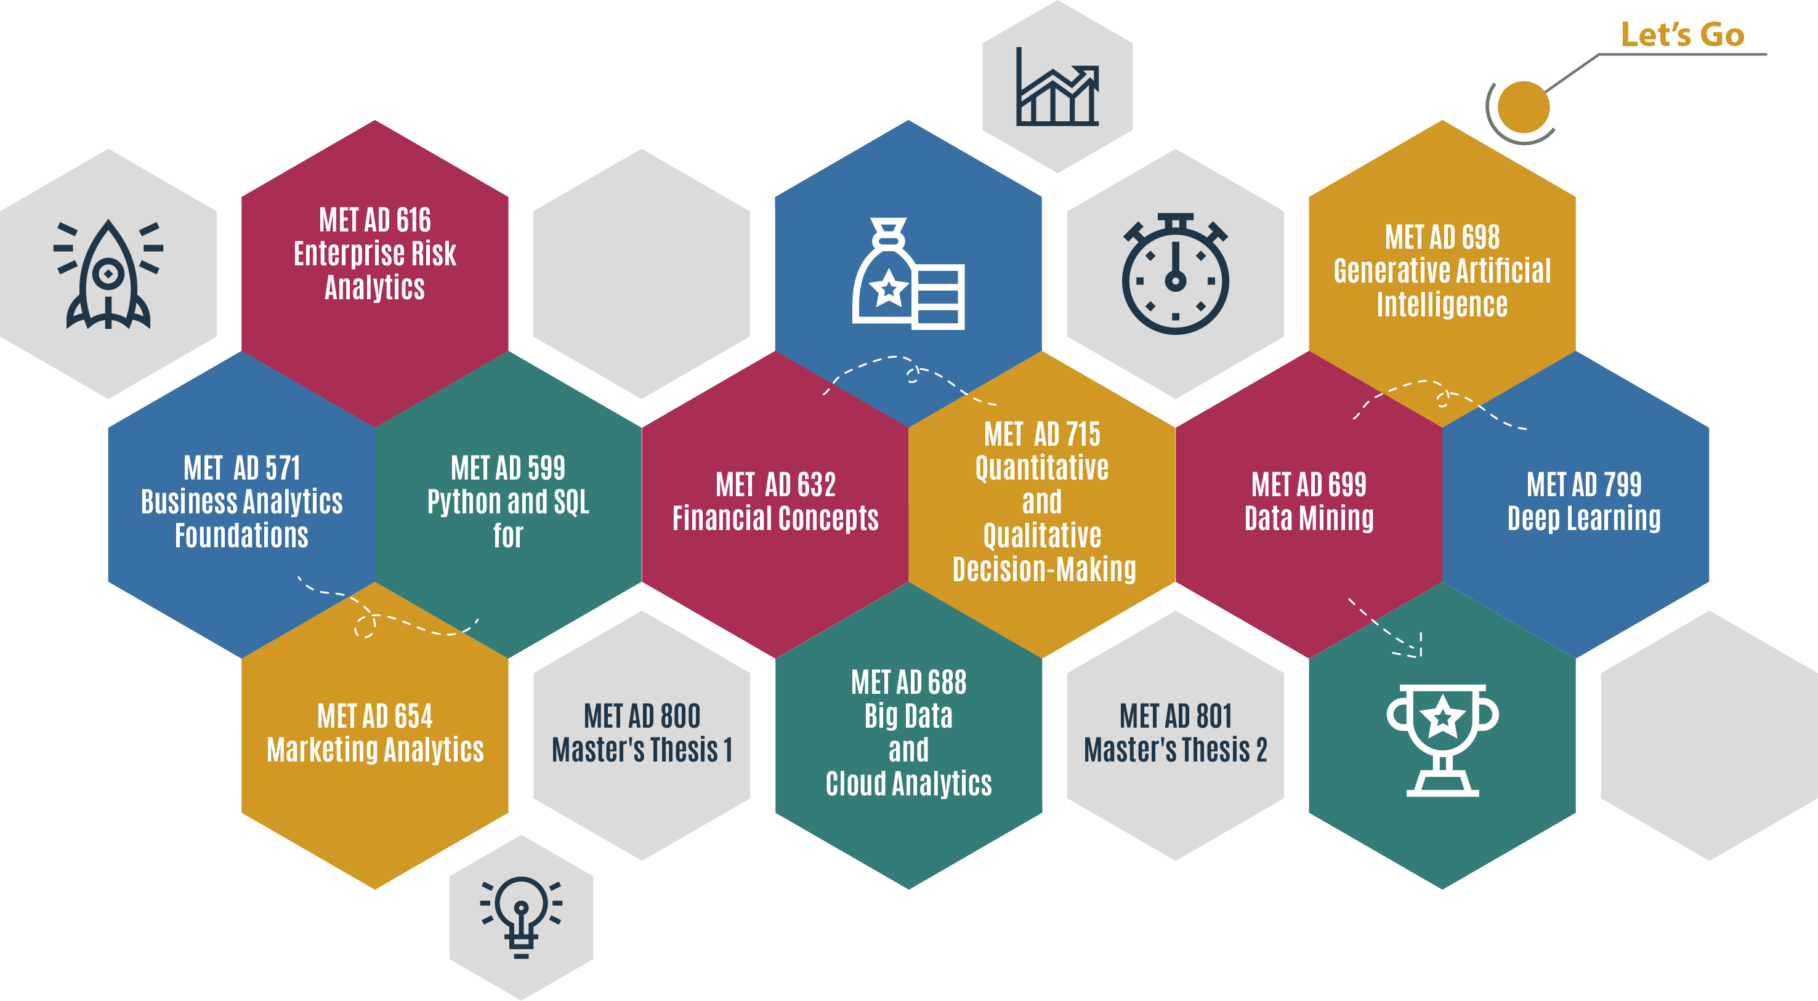

2.1 Course Description
This course is designed for analytics developers and advanced business students seeking to build practical, production-ready Generative AI (GenAI) Applications. Emphasizing hands-on learning, students will explore key techniques such as Natural Language Processing, Recurrent Neural Networks and Transformer Architectures, prompt engineering, in-context learning (ICL), retrieval-augmented generation (RAG), Agentic Artificial Intelligence, and responsible AI design.
Students will work with open-source tools and APIs including LangChain, LlamaIndex, and embedding models, while learning to implement GenAI systems across the entire development lifecycle — from prompt design and knowledge retrieval to fine-tuning and deployment.
The course will emphasize practical development over theoretical model internals and will cover topics such as:
- Model optimization strategies (e.g., quantization, adapter-based tuning)
- Inference pipelines and GenAI app deployment
- Evaluation and benchmarking of model performance
- Responsible and explainable GenAI usage in enterprise settings
This course bridges the gap between business analytics fluency and technical AI development, equipping students to build domain-specific LLM applications that solve real-world problems.

3 Course Learning Objectives
By the end of this course, students will be able to:
- Design and implement prompt workflows to extract relevant, accurate, and useful outputs from large language models using in-context learning (ICL) strategies.
- Build retrieval-augmented generation (RAG) systems that combine language models with structured and unstructured knowledge bases.
- Develop autonomous AI agents that can reason, retrieve, and execute tasks across business workflows using frameworks such as LangChain and AutoGen.
- Fine-tune and customize foundation models (e.g., LLaMA, Mistral) using parameter-efficient techniques like LoRA and QLoRA to adapt to business-specific domains.
- Evaluate and audit generative models for quality, risk, bias, and alignment using both manual and automated tools (e.g., OpenAI Evals, GPT-judge, Trulens).
- Critically assess ethical and governance implications of deploying GenAI in enterprise settings, including risks of hallucination, misinformation, and data leakage.

4 Course Resources
Fundamentals of Generative AI required for this course. All core readings, technical documentation, and video tutorials will be provided on the blackboard course site. Please choose the latest release pdf version of the book.
Required Readings:
- Lecture notes per module are available on Blackboard. You can click on them to view and use Crtl+p to print them in PDF format.
- Each Module has two lecture notes.
  - For Online class you will need to use both lecture notes from Module
  - For In Person class you will need to use one lecture notes per lecture from Module.
Recommended (not required):
- Designing LLM Applications with LangChain
- OpenAI Cookbook
- The Hitchhiker’s Guide to LLMOps
- Generative AI with Python and Hugging Face Transformers
Tools & Platforms Used:
- Jupyter, VS Code, GitHub, Python (LangChain, LlamaIndex, OpenAI, Hugging Face)
- APIs: OpenAI, Cohere, Claude (Anthropic), Gemini (Google)
- Deployment tools: Streamlit, FastAPI, GitHub Actions
- Vector DBs: FAISS, ChromaDB
- Evaluation tools: GPT-Eval, Trulens, PromptLayer
All resources are available through GitHub Education and GitHub Classrooms. Students are required to create a GitHub account using their Boston University email address in the first week.

5 Course Schedule
The class will generally run for 12 weeks with 6 modules. Module 0 will be a prep module open at the same time as Module 1. Module 7 and 8 are advanced contain materials and are optional.

5.1 Class Schedule
Lecture | Title | Description
L0.1 | Optional GitHub Classroom & Version Control Basics Optional GitHub account setup | GitHub Classroom workflow; cloning and opening notebooks in Colab; basic version control concepts (commit, push, pull); when and why GitHub is used in applied GenAI work.
L0.2 | Google Colab & Execution Environment Setup with technical orientation | Google Colab setup; notebook fundamentals; Python runtime basics; managing files, sessions, and outputs; running, saving, exporting, and submitting notebooks.
L1.1 | Course Orientation and Reproducible GenAI Setup | Course overview; GenAI system framing; AI disclosure files and accountability.
L1.2 | Language Probability and Generative Systems | Why language is probabilistic; prediction as generation; uncertainty in text; NLP as the foundation of GenAI.
L2.1 | Mathematical Foundations Through Language Modeling | Vectors as meaning; probability and conditional likelihood; loss functions; entropy and perplexity introduced through language modeling.
L2.2 | From Words to Structured Text | Foundations of text representation; tokenization and normalization; n-grams; static versus contextual representations; document structure awareness.
L3.1 | Prompting as System Design | Prompt engineering as probabilistic control; zero and few-shot learning; in-context learning; common failure modes.
L3.2 | Tokenization Embeddings and Semantic Geometry | Subword tokenization; embedding spaces; cosine similarity; semantic neighborhoods; semantic drift.
L4.1 | Transformers Attention and Context | Self-attention; positional encoding; scaling intuition; why transformers replaced RNNs and LSTMs.
L4.2 | Training Paradigms and Fine-Tuning Pipelines | Pretraining versus fine-tuning; instruction tuning; dataset formatting; overfitting and data leakage risks.
L5.1 | Retrieval Augmented Generation Concepts | Chunking and indexing; embedding-based retrieval; grounding strategies; hallucination risks.
L5.2 | Designing Retrieval-Augmented Pipelines | End-to-end retrieval-augmented workflows; query design; citation tracing; system limitations.
L6.1 | Efficient Adaptation LoRA QLoRA and PEFT | Parameter-efficient fine-tuning; tradeoffs between prompting retrieval and adaptation; cost governance.
L6.2 | Semantic Search Clustering and Change Detection | Embedding-based clustering; similarity search; longitudinal semantic analysis across document collections.

6 Boston University Library Information
As Boston University students, you have full access to various articles and resources within the BU Library. From any computer, you can gain access to anything at the library that is electronically formatted. These articles are downloadable without extra charges from the BU Library by following the steps. They are easily downloadable from BU Library, e-Journals (name & password protected). You may be asked to login with your BU login name and Kerberos password.
- Go to BU Library main page http://www.bu.edu/library and from Library Location on the top right of the page, select Pardee Management Library.
- From the Pardee Management Library main page, select eJournals under Related Links (right-hand side of page).
- In the Advanced Search window, type “Harvard business review” or “MIT Sloan Management Review” or your preferred title of a journal and click Search.
- Select the title of the journal Online Access Available.
- On the page that opens, click on Business Source Complete (for HBR) or ProQuest (for MIT Sloan MR).
- Login with your BU name and Kerberos account
- Click on the icon PDF Full text.
- Click on the Download icon (in Mozilla Firefox the location of the icon is on the top right of the main screen).
- Save the file on your computer.
Please note that you are not to post attachments of the required or other readings in the water cooler or other areas of the course, as it is an infringement on copyright laws and department policy. All students have access to the library system and will need to develop research skills that include how to find articles through library systems and databases.

7 Blackboard Course Website
To access your course website, go to http://learn.bu.edu/ and select AD698 Generative AI for Business Analytics

7.1 Software Applications & Remote Access to Virtual Labs
In this course, students will be using AWS Academy and a massive dataset connected through Azure cloud. The instructions can be found in the Module 0 Lecture 1 video. As part of the tuition, all BU students can use these software applications free of charge. For directions to get free remote access to our BU MET Virtual Labs, please visit
https://www.bu.edu/metit/services/client-technology/virtual-lab/

7.2 Live Classroom in Zoom
Select Live Classroom in the Live Classroom and Offices Module on the course homepage. Please note that the live sessions are only for the online class.
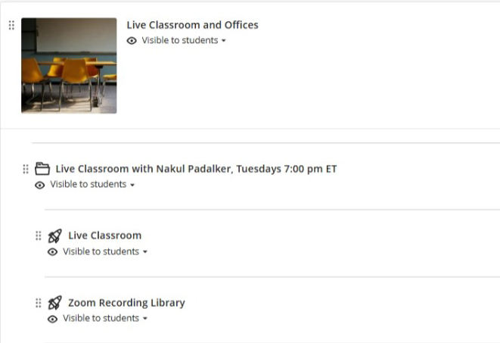

8 Grading and Assessment

8.1 Grading Structure
On the course homepage, all the material is presented by modules and each module covers two lectures. In the on-campus version of this course, each week we will have a live classroom session that will cover one lecture. In addition, students will work in teams in our virtual labs and will participate in group discussion boards. Please review the Course Calendar & Outline document to get the full schedule of this course.

9 Grading Breakdown

9.1 Course Structure and Learning Format
All course materials are organized by modules, with each module covering two lectures. In the on-campus version of this course, we will meet weekly for a live classroom session that covers one lecture. In addition to in-class instruction, students will work in teams on a semester-long project and participate in structured discussions and applied activities.
Please refer to the Course Calendar & Outline for detailed scheduling of lectures, assignments, milestones, and presentations.

10 Grading Breakdown
Your final grade is based on the following components:

10.1 AWS Academy Generative AI Foundations
All students are required to complete the AWS Academy Generative AI Foundations course during the first 10 weeks of the semester.
- This is a self-paced, external certification
- The final deliverable is the AWS Academy completion badge
- Points are awarded based on AWS module check completion, translated to a 100-point scale
This requirement ensures all students develop a shared baseline in industry-standard generative AI concepts and practices. The assignment is scheduled to be submitted in the 10th week of the semester. Later submission after that week will result in a deduction of 2% per day.

10.2 Group Paper Presentation (Once per Group)
Each student group will deliver one research paper presentation during the semester.
- Presentation length: approximately 15 minutes
- Each presentation will be followed by guided class discussion
- All students are expected to read the assigned paper(s), regardless of whether they are presenting
Presentations focus on:
- The problem the paper addresses
- The technical or conceptual contribution
- Limitations and assumptions
- Implications for building generative AI systems
This component develops skills in critical reading, synthesis, and technical communication.

10.3 Individual Assignments
There are four individual assignments, each aligned with a stage of the generative AI pipeline using SEC 10-K filings. These assignments are submitted individually, even though students work within project teams.
The assignments correspond to the following themes:
- Corpus Familiarization & Chatbot Scope Understanding the provided 10-K data and defining the scope of a domain-specific GenAI chatbot.
- Text Structuring & Retrieval Units Cleaning, structuring, and chunking SEC filings for retrieval-based systems.
- Embeddings & Retrieval Baseline Creating semantic representations and validating retrieval quality.
- Grounded Generation & Guardrails Designing prompts and retrieval-augmented generation with explicit grounding and constraints.

10.4 Managerial Report with Application Demo
The managerial report is the primary written deliverable for the course.
- Submitted as a GitHub-hosted website
- Synthesizes the full GenAI chatbot system built throughout the semester
- Written for a managerial or executive audience, not a purely technical one
The report must clearly explain:
- The problem addressed
- The data used
- The generative AI pipeline
- Key insights and limitations
- Appropriate and inappropriate use cases
This component evaluates your ability to translate technical systems into decision-relevant narratives.

10.5 Group Project Presentation
At the end of the semester, each group will deliver a final project presentation.
- Focuses on the chatbot system, insights, and managerial implications
- Emphasizes clarity, evidence, and responsible design
- Not a code walkthrough
This presentation assesses your ability to communicate complex GenAI systems clearly and professionally.

10.6 Group Feedback
Students are required to provide structured feedback on other group presentations.
- Feedback will be guided by prompts provided by the instructor
- Evaluates engagement, critical thinking, and comparative analysis
This component ensures active participation and shared responsibility for the learning environment.

10.7 Use of Generative AI
Generative AI tools are allowed and expected in this course. However, all students must:
- Document AI usage
- Validate outputs
- Take responsibility for final submissions
Failure to appropriately disclose or validate AI-assisted work may result in penalties.

10.8 Grade Points
Class Activity | Count | Points | Max Points
AWS Academy Generative AI Foundations | 1 | 100 | 100
Group Paper Presentation (Once per Group)* | 1 | 50 | 50
Assignment | 4 | 50 | 200
Managerial report with Application Demo | 1 | 70 | 70
Corpus Familiarization & Chatbot Scope | 1 | - | -
Text Structuring & Retrieval Units | 1 | - | -
Embeddings & Retrieval Baseline | 1 | - | -
Grounded Generation & Guardrails | 1 | - | -
Group Project Presentation | 1 | 40 | 40
Group Feedback | 1 | 40 | 40
Total | - | - | 500
Labs are available in each module deliverables and are meant for self learning and not graded.

11 Class Policies

11.1 Attendance & Absences
Class attendance is mandatory. Please inform your instructor if you know in advance that you will need to miss a class. More than two absences will influence your participation grade in this class.
Regularly engaging in discussions on course-related topics, any cases and readings (during the class and on the Discussion Board), asking questions that lead to better understanding of a concept by the class as a whole, clarifying concepts, readiness to help peers during the consultation sessions and between classes, and sharing professional experience about course-related topics constitute superior class participation and contribute to our collective learning.

11.2 Submission Format
All written contributions should follow the APA writing style, in particular, the requirements how to lay out a paper, as well as how to cite and reference correctly You can get an excellent guide to APA style here.

11.3 Assignment Completion & Due Dates & Late Work
Students should submit completed assignments on the Blackboard course website. All work requests from the instructor (quizzes, assignments, contributions in the teamwork, etc.) have due dates. These are the last dates that stated material is due. This means that it is a good idea to set personal targets before then as your personal completion date to avoid difficulties. Dates are often viewed by students as the date to turn in an assignment. We view assignment due dates as the last date on which to turn in an assignment. With this warning, please note that we are not inclined to accept late work; if late work should be accepted it will be done only after considerable weighing of rationale, and with penalty.

11.4 Academic Conduct Code
Students are expected to adhere to the highest standards of honesty and integrity for this course. Cheating and plagiarism will not be tolerated in any Metropolitan College course. They will result in no credit for the assignment or examination and may lead to disciplinary actions. Please take the time to review the Student Academic Code of Conduct and Generative AI Guidelines.
This should not be understood as a discouragement for discussing the material or your particular approach to a problem with other students in the class. On the contrary – you should share your thoughts, questions and solutions. Naturally, if you choose to work in a group, you will be expected to come up with more than one and highly original solutions rather than the same mistakes.

11.5 Request for Accommodations
If you have a disability and will be requesting accommodations for this course, please inform the instructor early in the semester. Advance notice and appropriate documentation are required for accommodations.

12 References

