Employer industry classification and healthcare analyst opportunities
  - Jobs 2026 analysis and a PySpark classification workflow
2026-10-03
Table of contents

Abstract
This exploratory study examines employer-industry classification as a data-quality component of a career evaluation product for healthcare data analysts. It reconstructs a 2017 study and adapts its approach to a local Jobs_2026_US snapshot. A scan of 815,193 records yielded 362 eligible employers for classification and 112 postings for a January–September 2026 US career benchmark. Employer-name-disjoint scikit-learn evaluation produced positive-class F1 scores of 0.553 for a linear SVM and 0.717 for GBDT. A separate PySpark experiment compares nine classifier families and two baselines, with data preparation, feature construction and evaluation code included. The multilayer perceptron led that experiment on validation F1 and achieved test F1 of 0.848. Different employer splits prevent direct attribution of score differences to the software engine. These scores measure agreement with dataset-derived labels rather than independently established employer truth. SQL appeared in 63 career postings; sparse salary evidence and missing work-arrangement fields restricted recommendations. The findings do not establish national hiring patterns or personal skill deficits.
Keywords: employer industry classification; job postings; healthcare data analysts; NAICS; career evaluation; data quality.
An additional multiclass experiment on the updated source snapshot retains six broad NAICS sectors and 328 employers. The validation-selected random forest achieves test macro-F1 of 0.377 against a training-majority baseline of 0.112. Per-sector results and exclusions expose the limits of extending the method to sparsely represented industries.

1. Introduction
This report reconstructs Goindani et al. (2017) and applies their employer-industry classification approach to Jobs_2026_US (Jobs_2026_US 2026). The career audience is students targeting healthcare data analyst roles in NAICS sector 62. The new analysis provides a selected-sample market benchmark and classifier evaluation, with explicit limitations on label quality and personal skill assessment.
The analysis uses a local data snapshot. Employer labels have not been independently adjudicated.
The multiclass extension asks how well the same feature concept distinguishes multiple supported sectors. It supplements the healthcare career analysis with a separate class-coverage assessment and employer-level evaluation.

1.1 Research rationale
A career evaluation tool depends on the quality of the industry labels used to select its vacancies. If an employer is assigned to the wrong industry, a student can receive a misleading picture of sector-specific skills and opportunities. Employer-industry classification therefore serves as a data-quality task within a broader career product (Goindani et al. 2017).
The target reader is a student seeking a healthcare data analyst role. The product question is: Which skills and work arrangements recur in the selected US healthcare analyst postings, and how reliably can posting-derived features identify healthcare employers for reviewing that analytical sample? The primary focus is skill and career readiness. Salary and geography provide context where the observed coverage permits interpretation.
Healthcare is relevant to this pathway because its service organizations generate questions about data quality, reporting and operational decisions. In the analyzed sample, SQL and visualization tools occur frequently enough to support a concrete learning-priority discussion. This rationale concerns the observed sample; it does not establish that healthcare is the strongest industry for every analyst.

1.2 Scope and research questions
The selected pathway is healthcare data analysts, including the documented analyst-title variants. The industry anchor is NAICS 62, Health Care and Social Assistance, whose official definition covers both healthcare and social-assistance establishments (Executive Office of the President, Office of Management and Budget 2022, sector 62). Consequently, results should not be described as hospital-only findings.
The study uses two-digit sector 62, a broader scope than the four- or six-digit industries preferred in Module 1 (AD688 course materials, n.d.-a). The implementation prefers NAICS_2022_2 and falls back to NAICS2; retained labels are therefore not all verified against the 2022 revision. Results apply to the combined sector, with potentially different patterns across its subsectors.
- RQ1, employer classification: How do a linear SVM and GBDT compare on precision, recall and F1 for dataset-derived NAICS 62 employer labels under an employer-name-disjoint split?
- RQ2, career evidence: Which skills, work arrangements and locations are observed among the selected US healthcare analyst postings from January through September 2026?
- RQ3, decision limits: Which missing fields and label-quality issues prevent reliable salary, accessibility or personal skill-fit recommendations?
The classification task requires non-healthcare employers as a comparison class. That training sample does not expand the career product into an all-industry comparison. The career benchmark remains restricted to NAICS 62 and the selected pathway.

1.3 Short literature review
Five sources establish the method, scope and interpretation of this study. This is a focused narrative review, not a systematic or exhaustive review.
Employer-industry signals. Goindani et al. (2017) aggregate titles and employer-name keywords to classify employers and flag disagreement with legacy labels. Their distinction between classification and error discovery motivates separate treatment of predictive agreement and independently reviewed label errors in this project.
Broader error-detection features. Chern et al. (2018) examine employer-industry errors using additional employer and job-description signals and compare SVM with random forest. That study supports exploring richer features, but it is a different experiment from the supplied 2017 SVM/GBDT paper. Its results are not substituted for the original paper’s tables.
Representativeness of job advertisements. Tsvetkova et al. (2024) benchmark Lightcast vacancy distributions against official sources in four countries and find that representativeness differs across geographic, occupational and sectoral dimensions. Their evidence concerns Lightcast, not this Jobs_2026_US snapshot. It motivates caution about population claims and a future external benchmark; it does not supply a correction factor for our sample.
Industry definition. The 2022 NAICS manual defines the sector that bounds the career sample (Executive Office of the President, Office of Management and Budget 2022). It classifies establishments by economic activity rather than by an employee’s occupation. This distinction explains why a data analyst title alone cannot establish healthcare-industry membership.
Reproducible implementation. Pedregosa et al. (2011) describe scikit-learn as a general-purpose machine-learning library. The new study uses its estimators as an implementation adaptation. The software citation credits the library; actual versions, parameter choices and results are supported by the saved run manifest rather than by the 2011 paper.
Together, these sources motivate a limited contribution: a reproducible adaptation that connects employer-label checks to a dated, pathway-specific market benchmark. The study does not demonstrate an improvement over the original proprietary system or establish causal effects of skill acquisition on employment.

1.4 Analytical expectations and design status
The analysis explores whether hiring profiles carry an industry signal and whether the career subset yields actionable skill priorities. These are retrospective organizing questions for an already executed exploratory study. They are not preregistered hypotheses. The limited holdout, noisy target labels and absence of participant ratings restrict the strength of the conclusions.

1.5 Data fields and intended use
The following fields connect the project question to the local Jobs_2026_US snapshot (Jobs_2026_US 2026). Their availability was established by inspecting the local schema; an API-schema equivalence is not assumed.
Purpose | Fields used | Interpretation control
Cohort and duplicates | ID, POSTED | One retained row per ID; explicit date window
Career industry | NAICS_2022_2, NAICS2 | Prefer 2022 field; exclude unknown codes
Employer grouping | COMPANY_NAME, COMPANY_IS_STAFFING | Case/whitespace normalization; unresolved aliases remain
Occupation and features | TITLE_RAW, TITLE_CLEAN, TITLE_NAME | Declared title matching; training-only vocabulary fitting
Skills | SKILLS_NAME | Decode lists and count a skill once per posting
Compensation | NORMALIZED_SALARY, TEXT_PAY_CURRENCY, SALARY_NORMALIZATION_STATUS | Explicit currency and coverage checks
Accessibility | MIN_YEARS_EXPERIENCE | Zero is not independently verified as entry level
Flexibility and location | REMOTE_TYPE_NAME, STATE_NAME, PARSED_COUNTRY_ISO_ABBR | Standardize categories and retain missingness
The employer classification and market analysis support the career evaluation framework in Modules 1 and 5 (AD688 course materials, n.d.-a, n.d.-d).

2. Original study and reconstruction
The paper aggregates normalized job titles and employer-name keywords to predict Transportation or Health Care industry membership. It uses within-employer title shares, a 1% title cutoff, positive-class significance and frequency thresholds, and SVM or GBDT models. Reported collection covers April–June 2017 and an initial sample of 10,000 employers.
The legacy system has higher classification F-scores on defined employers, while GBDT provides greater utility for finding undefined employers than SVM. Classification and error discovery evaluate different outcomes.
Industry | System | Precision | Recall | F-score
Transportation | Random guessing | 0.05 | 0.50 | 0.09
Transportation | All positives | 0.05 | 1.00 | 0.10
Transportation | Legacy system | 0.94 | 0.92 | 0.93
Transportation | SVM | 0.97 | 0.70 | 0.81
Transportation | GBDT | 1.00 | 0.65 | 0.79
Health Care | Random guessing | 0.14 | 0.50 | 0.22
Health Care | All positives | 0.14 | 1.00 | 0.25
Health Care | Legacy system | 0.96 | 0.82 | 0.89
Health Care | SVM | 0.97 | 0.71 | 0.82
Health Care | GBDT | 0.98 | 0.76 | 0.86
Source: Goindani et al. (2017), Table IV. These are published results, not new estimates.
Industry | System | Utility precision | Utility recall | Utility F-score
Transportation | SVM | 0.14 | 0.78 | 0.23
Transportation | GBDT | 0.17 | 0.89 | 0.28
Health Care | SVM | 0.24 | 0.57 | 0.34
Health Care | GBDT | 0.29 | 0.86 | 0.44
Source: Goindani et al. (2017), Table V. Utility is measured within the reviewed disagreement pool. The paper’s split counts do not fully reconcile to its initial sample; the website documents the discrepancies.

3. Materials and methods
The source is a local snapshot of 82 Jobs_2026_US partitions (Jobs_2026_US 2026). Records must fall in January–September 2026, have an explicit US country value and recognized industry sector, and not be explicitly flagged as staffing. Posting IDs define duplicates. Employer-name groups require at least 20 eligible postings and an 80% dominant-sector share. The career benchmark additionally requires sector 62 and the declared analyst-title pattern.
Upstream selection requires 2026 dates and consistent, exclusively US parsed location evidence, excluding ambiguous, conflicting or truncated location evidence. This is not independently verified worksite geography. Original IDs, fields and globally scoped duplicate pointers are retained. The 815,193-row input yields 800,461 rows within January–September.
Following the feature concept in Goindani et al. (2017), title shares and employer-name words represent each employer. Vocabulary thresholds are fitted only on training employers. The adaptation uses scikit-learn (Pedregosa et al. 2011), stratified train/validation/test partitions and validation F1 to select settings. The endpoint is agreement with supplied sector labels. Independent adjudication and the original undefined-employer utility endpoint are unavailable. The results below provide the filtering ledger, split counts and model details.

4. Data processing and classification in PySpark

4.1 Analysis design and execution
The measured SVM and GBDT results elsewhere in this report were produced with scikit-learn. This PySpark implementation is a separate comparison using the same source partitions and employer-level feature concept. Its hash-based split, quantile convention, regularization settings and estimator implementations differ, so its scores must be reported separately. Spark’s regParam is not substituted directly for scikit-learn’s C.
The complete Python script and Jupyter notebook expose the steps below. The script reads an authorized copy of the source data and writes aggregate results to a separate directory. Source postings are not redistributed. PySpark 4.2.0 is pinned in the repository requirements.
spark-submit --master local[2] --conf spark.ui.enabled=false scripts/run_spark_study.py --data-dir /path/to/Jobs_2026_US --output-dir data/spark-study

4.2 Libraries and feature scope
import argparse
import hashlib
import json
from pathlib import Path
import pyspark
from pyspark.sql import SparkSession, Window, functions as F
from pyspark.ml.classification import (
LogisticRegression,
DecisionTreeClassifier,
RandomForestClassifier,
GBTClassifier,
LinearSVC,
NaiveBayes,
MultilayerPerceptronClassifier,
OneVsRest,
FMClassifier,
)
from pyspark.ml.feature import VectorAssembler
SECTORS = (
"11 21 22 23 31 32 33 31-33 42 44 45 44-45 48 49 48-49 "
"51 52 53 54 55 56 61 62 71 72 81 92"
).split()

4.3 Load, clean and filter postings
The input is a set of Parquet posting partitions. The code selects only the fields needed for employer classification, parses dates in UTC, applies the January–September window, requires US geography and a recognized sector, and excludes explicitly marked staffing records. Missing staffing status is retained. Blank employer names and titles cannot contribute to employer features. Duplicate IDs cause an error rather than an arbitrary choice between conflicting records.
def prepare(spark, files):
raw = spark.read.parquet(*[str(p) for p in files])
columns = [
"ID",
"POSTED",
"COMPANY_NAME",
"TITLE_NAME",
"PARSED_COUNTRY_ISO_ABBR",
"NAICS_2022_2",
"NAICS2",
"COMPANY_IS_STAFFING",
]
raw = raw.select(*columns).cache()
ledger = {"source_rows": raw.count()}
# Conflicting duplicate IDs need an explicit source ordering rule.
unique = raw.filter(F.col("ID").isNotNull()).dropDuplicates(["ID"])
ledger["unique_id_rows"] = unique.count()
if (
raw.filter(F.col("ID").isNotNull()).count()
!= ledger["unique_id_rows"]
):
raise ValueError(
"Duplicate IDs found; resolve source order before analysis"
)
dated = unique.withColumn(
"date", F.to_date(F.try_to_timestamp("POSTED"))
)
dated = dated.filter(
(F.col("date") >= "2026-01-01") & (F.col("date") < "2026-10-01")
)
ledger["period_rows"] = dated.count()
us = dated.filter(
F.upper(F.trim("PARSED_COUNTRY_ISO_ABBR")) == "US"
)
ledger["us_rows"] = us.count()
sector = F.when(
F.length(F.trim("NAICS_2022_2")) > 0, F.trim("NAICS_2022_2")
).otherwise(F.trim("NAICS2"))
known = us.withColumn("sector", sector).filter(
F.col("sector").isin(SECTORS)
)
ledger["sector_known_rows"] = known.count()
jobs = known.filter(
~F.coalesce(F.col("COMPANY_IS_STAFFING") == 1, F.lit(False))
)
ledger["nonstaffing_or_unknown_rows"] = jobs.count()
jobs = (
jobs.withColumn(
"employer",
F.regexp_replace(
F.lower(F.trim("COMPANY_NAME")), r"\s+", " "
),
)
.withColumn("title", F.lower(F.trim("TITLE_NAME")))
.filter(
F.col("employer").isNotNull()
& ~F.col("employer").isin("", "unknown", "unclassified")
)
.filter(
F.col("title").isNotNull()
& ~F.col("title").isin("", "unclassified")
)
.select("employer", "title", "sector")
.cache()
)
ledger["employer_model_postings"] = jobs.count()
raw.unpersist()
return jobs, ledger

4.4 Aggregate employers and split before learning features
Each employer is one observation. At least 20 usable postings and an 80% dominant-sector share are required. The binary target is 1 for NAICS 62 and 0 for other recognized sectors. Within each class, a seeded hash orders employer keys for a reproducible 70/10/20 split. This prevents one normalized employer key from appearing in both training and test data. Different names for the same organization remain an unresolved source of leakage.
def employers_and_splits(jobs):
totals = jobs.groupBy("employer").agg(
F.count("*").alias("postings")
)
counts = jobs.groupBy("employer", "sector").count()
dominant = (
counts.withColumn(
"rank",
F.row_number().over(
Window.partitionBy("employer").orderBy(
F.desc("count"), "sector"
)
),
)
.filter("rank = 1")
.join(totals, "employer")
.filter(
(F.col("postings") >= 20)
& (F.col("count") / F.col("postings") >= 0.8)
)
.withColumn("label", (F.col("sector") == "62").cast("double"))
.orderBy(F.desc("postings"), "employer")
.limit(10000)
.select("employer", "postings", "label")
)
# Rank within class by a seeded hash; no posting can cross employer splits.
order = Window.partitionBy("label").orderBy(
F.sha2(F.concat(F.lit("2017:"), F.col("employer")), 256),
"employer",
)
size = Window.partitionBy("label")
split = (
dominant.withColumn("rank", F.row_number().over(order))
.withColumn("class_n", F.count("*").over(size))
.withColumn(
"split",
F.when(
F.col("rank") <= F.floor(0.7 * F.col("class_n")),
"train",
)
.when(
F.col("rank") <= F.floor(0.8 * F.col("class_n")),
"validation",
)
.otherwise("test"),
)
.select("employer", "postings", "label", "split")
.cache()
)
support = [
r.asDict()
for r in split.groupBy("split", "label").count().collect()
]
if len(support) != 6 or any(r["count"] < 2 for r in support):
raise ValueError(
"Every split needs at least two employers of each class"
)
return split, support

4.5 Construct title shares and employer-name indicators
A title feature equals its posting count divided by all usable postings for that employer. Name-word features are binary indicators. Industry codes define the target and are excluded from the predictor vector. For example, 30 occurrences of a title among 100 employer postings give a title-share value of 0.30.
def feature_rows(jobs, employers):
titles = (
jobs.groupBy("employer", "title")
.count()
.join(employers, "employer")
.withColumn("feature", F.concat(F.lit("t:"), F.col("title")))
.withColumn("value", F.col("count") / F.col("postings"))
)
words = (
employers.withColumn(
"word",
F.explode(
F.array_distinct(
F.split(
F.regexp_replace("employer", "[^a-z]+", " "),
" ",
)
)
),
)
.filter(F.length("word") > 0)
.withColumn("feature", F.concat(F.lit("w:"), F.col("word")))
.withColumn("value", F.lit(1.0))
.withColumn("count", F.lit(1))
)
cols = ["employer", "label", "split", "feature", "value", "count"]
return titles.select(*cols).unionByName(words.select(*cols))

4.6 Fit vocabulary on training employers
For each candidate, significance is positive-class frequency divided by total training frequency. Candidates need more than one positive occurrence. Median significance and frequency thresholds are applied separately to title and name features; if fewer than 50 survive, the frequency threshold falls to the first quartile. Title shares below 1% are removed. Spark uses exact observed quantiles here, which can differ from NumPy interpolated quantiles. The vocabulary is frozen before validation and test vectors are built. An unseen title contributes no new column. Zero means the employer lacks a selected feature, not that its industry is unknown.
def fit_vocabulary(long):
# Frequency counts postings for titles, employers for name words.
stats = (
long.filter("split = 'train'")
.groupBy("feature")
.agg(
F.sum("count").alias("frequency"),
F.sum(
F.when(F.col("label") == 1, F.col("count")).otherwise(0)
).alias("positive"),
)
.filter("positive > 1")
.withColumn(
"significance", F.col("positive") / F.col("frequency")
)
)
vocab, thresholds = [], {}
for prefix in ["t:", "w:"]:
part = stats.filter(F.col("feature").startswith(prefix)).cache()
if not part.count():
raise ValueError("No training vocabulary for " + prefix)
s = part.approxQuantile("significance", [0.5], 0)[0]
f = part.approxQuantile("frequency", [0.5], 0)[0]
selected = part.filter(
(F.col("significance") >= s) & (F.col("frequency") >= f)
)
if selected.count() < 50:
f = part.approxQuantile("frequency", [0.25], 0)[0]
selected = part.filter(
(F.col("significance") >= s) & (F.col("frequency") >= f)
)
vocab.extend(
r.feature for r in selected.select("feature").collect()
)
thresholds[prefix] = {"significance": s, "frequency": f}
part.unpersist()
# Remove title columns absent after the within-employer cutoff in training.
active = long.filter(
(F.col("value") >= 0.01) & (F.col("split") == "train")
)
observed = {
r.feature for r in active.select("feature").distinct().collect()
}
return sorted(set(vocab) & observed), thresholds
def vectorize(long, employers, vocabulary):
if not vocabulary:
raise ValueError("Empty training feature matrix")
# Bound the driver vocabulary by the fitted training features, not raw rows.
wide = (
long.filter(F.col("value") >= 0.01)
.groupBy("employer")
.pivot("feature", vocabulary)
.sum("value")
)
# Safe column aliases avoid interpreting dots in title names as nested fields.
aliases = ["x" + str(i) for i in range(len(vocabulary))]
wide = wide.toDF("employer", *aliases)
matrix = employers.join(wide, "employer", "left").fillna(
0.0, subset=aliases
)
return VectorAssembler(
inputCols=aliases, outputCol="features"
).transform(matrix)

4.7 Specify the classification algorithms
The following constructors cover the nine classification families in the Spark DataFrame classification guide (Apache Software Foundation 2026). Every model receives the same nonnegative feature vectors. Two parameter settings per family illustrate validation-based selection; this small search does not establish a globally optimal model.
def candidates(dimension):
# Two small validation candidates per family keep the example tractable.
return {
"Logistic regression": [
LogisticRegression(regParam=r, maxIter=100)
for r in [0.01, 0.1]
],
"Decision tree": [
DecisionTreeClassifier(maxDepth=d, seed=2017)
for d in [2, 3]
],
"Random forest": [
RandomForestClassifier(numTrees=100, maxDepth=d, seed=2017)
for d in [2, 3]
],
"GBT": [
GBTClassifier(
maxIter=100, maxDepth=d, stepSize=0.1, seed=2017
)
for d in [2, 3]
],
"Linear SVM": [
LinearSVC(regParam=r, maxIter=100, weightCol="weight")
for r in [0.01, 0.1]
],
"Naive Bayes": [
NaiveBayes(smoothing=s, modelType="multinomial")
for s in [0.5, 1.0]
],
"Multilayer perceptron": [
MultilayerPerceptronClassifier(
layers=[dimension, h, 2], maxIter=100, seed=2017
)
for h in [8, 16]
],
"One-vs-rest logistic": [
OneVsRest(
classifier=LogisticRegression(regParam=r, maxIter=100),
parallelism=1,
)
for r in [0.01, 0.1]
],
"Factorization machine": [
FMClassifier(
factorSize=k, maxIter=100, stepSize=0.01, seed=2017
)
for k in [4, 8]
],
}

4.8 Select settings and evaluate held-out employers
Only training employers fit model parameters. Validation positive-class F1 selects the first best setting in the declared candidate order. The selected model is tested once without refitting. Confusion matrices use rows for observed labels and columns for predictions: [[TN, FP], [FN, TP]]. Precision is TP/(TP+FP), recall is TP/(TP+FN), and F1 is 2TP/(2TP+FP+FN). Undefined ratios are reported as zero. Accuracy is shown beside F1 because the two answer different questions. The majority baseline is learned from training labels; the all-positive baseline reveals how much recall can be obtained without discrimination.
def binary_metrics(predictions):
counts = {
(int(r.label), int(r.prediction)): r["count"]
for r in predictions.groupBy("label", "prediction")
.count()
.collect()
}
tn, fp = counts.get((0, 0), 0), counts.get((0, 1), 0)
fn, tp = counts.get((1, 0), 0), counts.get((1, 1), 0)
total = tn + fp + fn + tp
if not total:
raise ValueError("Empty evaluation partition")
return {
"precision": tp / (tp + fp) if tp + fp else 0.0,
"recall": tp / (tp + fn) if tp + fn else 0.0,
"f1": 2 * tp / (2 * tp + fp + fn) if 2 * tp + fp + fn else 0.0,
"accuracy": (tp + tn) / total,
"confusion_matrix": [[tn, fp], [fn, tp]],
"support": total,
}
def evaluate(matrix, dimension):
train = matrix.filter("split = 'train'").cache()
validation = matrix.filter("split = 'validation'").cache()
test = matrix.filter("split = 'test'").cache()
class_counts = {
int(r.label): r["count"]
for r in train.groupBy("label").count().collect()
}
n = sum(class_counts.values())
train = train.withColumn(
"weight",
F.when(
F.col("label") == 1, n / (2 * class_counts[1])
).otherwise(n / (2 * class_counts[0])),
).cache()
results = []
for name, options in candidates(dimension).items():
trials, best, best_score = [], None, -1.0
for estimator in options:
model = estimator.fit(train)
score = binary_metrics(model.transform(validation))["f1"]
params = {
p.name: str(v)
for p, v in estimator.extractParamMap().items()
}
trials.append(
{"parameters": params, "validation_f1": score}
)
if score > best_score:
best, best_score = model, score
result = {
"model": name,
"validation_f1": best_score,
"trials": trials,
**binary_metrics(best.transform(test)),
}
results.append(result)
print(json.dumps(result), flush=True)
majority = max(class_counts, key=class_counts.get)
for name, value in [
("Training majority", majority),
("All positive", 1),
]:
results.append(
{
"model": name,
**binary_metrics(
test.withColumn("prediction", F.lit(float(value)))
),
}
)
return results

4.9 What each classifier tests
Classifier | Role in the comparison | Important constraint
Logistic regression | Linear probability model | Default prediction threshold is 0.5
Decision tree | A small set of feature splits | Depth limits complexity
Random forest | Average over randomized trees | More trees increase computation
Gradient-boosted trees | Sequentially improve tree predictions | Spark GBT classification is binary
Linear SVM | Maximum-margin linear separation | Binary; balanced training weights; no calibrated probabilities
Naive Bayes | Conditional-independence baseline | Multinomial variant needs nonnegative features; title shares are a modeling approximation
Multilayer perceptron | Nonlinear neural network | Input width equals feature count; output width equals two classes
One-vs-rest logistic | Demonstrate a multiclass reduction | Redundant for this binary task; two logistic classifiers are fitted
Factorization machine | Model pairwise feature interactions | More latent factors increase capacity
Source for available estimator families and constraints: Apache Software Foundation (2026). The comparison uses the binary healthcare task; it does not claim to test every variant of every estimator or the older RDD API.

4.10 Run the workflow
The entry point connects the stages, prints filtering counts and each model’s evaluation, and records versions, settings, split support and input hashes. A failed run does not write a new completed manifest.
def main():
parser = argparse.ArgumentParser()
parser.add_argument("--data-dir", type=Path, required=True)
parser.add_argument("--output-dir", type=Path, required=True)
args = parser.parse_args()
files = sorted(args.data_dir.glob("jobs_2026_part_*.parquet"))
if not files:
parser.error("No posting partitions found")
spark = (
SparkSession.builder.appName("HealthcareEmployerClassification")
.config("spark.sql.session.timeZone", "UTC")
.config("spark.sql.shuffle.partitions", "4")
.getOrCreate()
)
spark.sparkContext.setLogLevel("ERROR")
try:
jobs, ledger = prepare(spark, files)
print("FILTER LEDGER " + json.dumps(ledger), flush=True)
employers, support = employers_and_splits(jobs)
long = feature_rows(jobs, employers).cache()
vocabulary, thresholds = fit_vocabulary(long)
matrix = vectorize(long, employers, vocabulary).cache()
results = evaluate(matrix, len(vocabulary))
manifest = {
"engine": "pyspark",
"version": pyspark.__version__,
"seed": 2017,
"split_method": "within-class SHA256 rank 70/10/20",
"ledger": ledger,
"splits": support,
"feature_count": len(vocabulary),
"thresholds": thresholds,
"models": results,
"files": [],
}
for path in files:
with path.open("rb") as stream:
digest = hashlib.file_digest(
stream, "sha256"
).hexdigest()
manifest["files"].append(
{"file": path.name, "sha256": digest}
)
args.output_dir.mkdir(parents=True, exist_ok=True)
(args.output_dir / "run.json").write_text(
json.dumps(manifest, indent=2, allow_nan=False),
encoding="utf-8",
)
print("SPARK STUDY COMPLETE", flush=True)
finally:
spark.stop()
if __name__ == "__main__":
main()

4.11 Spark execution evidence
The completed PySpark 4.2.0 run processed 815,193 source rows and fitted 424 feature columns. The Spark manifest records the inputs, partition sizes, candidate settings and measured results.
The processing counts below are computed by the Spark functions above.
{
"source_rows": 815193,
"unique_id_rows": 815193,
"period_rows": 800461,
"us_rows": 800461,
"sector_known_rows": 357682,
"nonstaffing_or_unknown_rows": 352567,
"employer_model_postings": 352566
}
Partition | Other employers | NAICS 62 employers
train | 133 | 119
validation | 19 | 17
test | 39 | 35

Model | Precision (NAICS 62) | Recall | F1 | Accuracy
Logistic regression | 0.941 | 0.457 | 0.615 | 0.730
Decision tree | 1.000 | 0.171 | 0.293 | 0.608
Random forest | 1.000 | 0.343 | 0.511 | 0.689
GBT | 1.000 | 0.486 | 0.654 | 0.757
Linear SVM | 1.000 | 0.371 | 0.542 | 0.703
Naive Bayes | 1.000 | 0.200 | 0.333 | 0.622
Multilayer perceptron | 0.903 | 0.800 | 0.848 | 0.865
One-vs-rest logistic | 0.941 | 0.457 | 0.615 | 0.730
Factorization machine | 1.000 | 0.200 | 0.333 | 0.622
Training majority | 0.000 | 0.000 | 0.000 | 0.527
All positive | 0.473 | 1.000 | 0.642 | 0.473
Confusion counts use TN (true negatives), FP (false positives), FN (false negatives) and TP (true positives).
Model | TN | FP | FN | TP
Logistic regression | 38 | 1 | 19 | 16
Decision tree | 39 | 0 | 29 | 6
Random forest | 39 | 0 | 23 | 12
GBT | 39 | 0 | 18 | 17
Linear SVM | 39 | 0 | 22 | 13
Naive Bayes | 39 | 0 | 28 | 7
Multilayer perceptron | 36 | 3 | 7 | 28
One-vs-rest logistic | 38 | 1 | 19 | 16
Factorization machine | 39 | 0 | 28 | 7
Training majority | 39 | 0 | 35 | 0
All positive | 0 | 39 | 0 | 35
Multilayer perceptron achieved the highest validation F1 (0.765) in this small search; its held-out F1 was 0.848. This comparison is exploratory. A single small holdout cannot establish a stable ordering of algorithm families. The counts expose missed healthcare employers and false inclusions that F1 alone obscures. The original scikit-learn and Spark holdouts contain different employers; differences between their scores cannot be attributed solely to the software engine.

5. Results

5.1 Local Jobs_2026_US exploratory analysis
The analysis and EDA use the Jobs_2026_US snapshot (Jobs_2026_US 2026). This scan contains 815,193 rows across 82 posting partitions. Only jobs_2026_part_*.parquet files are inputs; supporting exports and backups are excluded. The repository contains aggregates and file hashes.
EDA describes raw rows before the healthcare study’s filters. Duplicate IDs are counted but retained in these distributions. Posting-ID uniqueness does not rule out repeated advertisements with different IDs. Populated industry and skills fields are not independently verified labels.
Measure | Observed value
Nonmissing unique IDs | 815,193
Repeated-ID rows beyond first occurrence | 0
Missing IDs | 0
Earliest parsed posting date (UTC) | 2026-01-01 00:00:00+00:00
Latest parsed posting date (UTC) | 2026-12-05 00:00:00+00:00
Missing or unparseable dates | 0
Dated January–September 2026, before other filters | 800,461
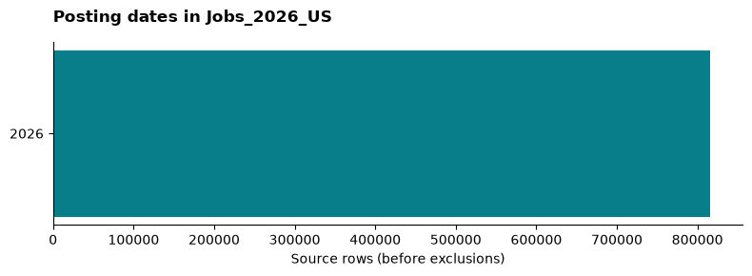
Posting-year distribution across all source rows.

5.1.1 Field coverage
Missingness covers the 17 fields consumed by the study. Missing means null or whitespace-only; strings such as [], Unknown or Unclassified still count as populated. Full input schemas are recorded in the EDA manifest.
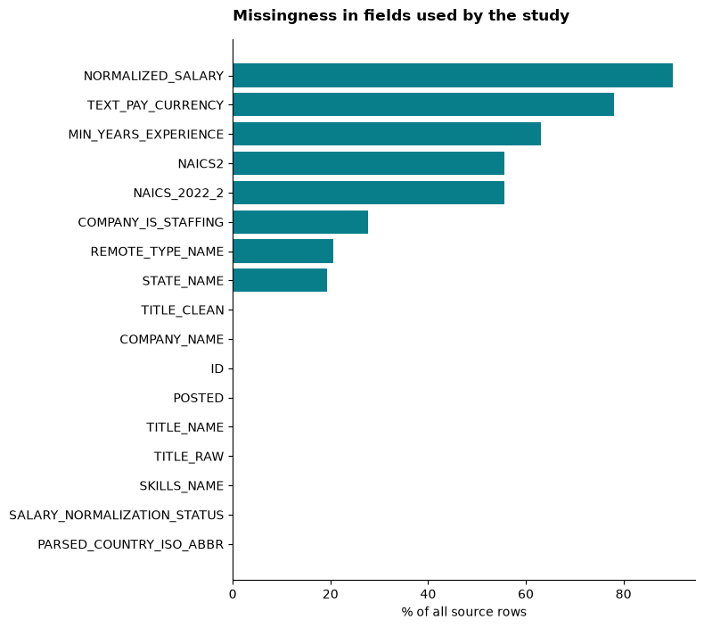
Missingness across study fields, denominator all source rows.
Field | Missing rows | Missing share
NORMALIZED_SALARY | 734,925 | 90.2%
TEXT_PAY_CURRENCY | 635,962 | 78.0%
MIN_YEARS_EXPERIENCE | 514,273 | 63.1%
NAICS2 | 453,997 | 55.7%
NAICS_2022_2 | 453,997 | 55.7%
COMPANY_IS_STAFFING | 226,174 | 27.7%
REMOTE_TYPE_NAME | 167,132 | 20.5%
STATE_NAME | 156,978 | 19.3%
TITLE_CLEAN | 66 | 0.0%
COMPANY_NAME | 2 | 0.0%
ID | 0 | 0.0%
POSTED | 0 | 0.0%
TITLE_NAME | 0 | 0.0%
TITLE_RAW | 0 | 0.0%
SKILLS_NAME | 0 | 0.0%
SALARY_NORMALIZATION_STATUS | 0 | 0.0%
PARSED_COUNTRY_ISO_ABBR | 0 | 0.0%

5.1.2 Industry, geography and work arrangement
The following tables show the ten most frequent categories, including missing where it ranks in the top ten. Every share uses all 815,193 source rows. Full distributions are saved as CSVs. Sector uses NAICS_2022_2, falling back to NAICS2 only when blank; 849 nonempty values are outside the study’s accepted sector vocabulary. States normalize US abbreviations and full names; other state values share an explicit unrecognized category. Remote labels are lowercased and On-site is merged with Onsite.

5.1.2.1 Sector codes
Category | Rows | Share of source
(missing) | 453,997 | 55.7%
62 | 66,881 | 8.2%
44-45 | 48,720 | 6.0%
54 | 38,460 | 4.7%
23 | 37,449 | 4.6%
31-33 | 37,415 | 4.6%
52 | 26,336 | 3.2%
61 | 23,856 | 2.9%
48-49 | 23,480 | 2.9%
51 | 20,724 | 2.5%

5.1.2.2 Parsed country
Category | Rows | Share of source
US | 815,193 | 100.0%

5.1.2.3 US states
Category | Rows | Share of source
(missing or unrecognized) | 208,253 | 25.5%
California | 76,281 | 9.4%
Texas | 54,960 | 6.7%
New York | 45,876 | 5.6%
Florida | 32,599 | 4.0%
Virginia | 25,584 | 3.1%
Ohio | 23,916 | 2.9%
Illinois | 23,175 | 2.8%
Pennsylvania | 21,460 | 2.6%
North Carolina | 19,724 | 2.4%

5.1.2.4 Work arrangement
Category | Rows | Share of source
unknown | 448,911 | 55.1%
(missing) | 167,132 | 20.5%
onsite | 98,300 | 12.1%
remote | 52,653 | 6.5%
hybrid | 48,197 | 5.9%

5.1.3 Salary coverage and study boundary
There are 2,756 rows (0.3%) with a finite positive normalized salary, explicitly USD currency, consistent with the healthcare study salary filter. These are annual-equivalent advertised amounts; they may include compensation beyond base pay. They are not observed earnings or a representative wage survey. Raw amounts with mixed or unknown pay periods are not pooled.
Annual-equivalent USD measure | Amount
Minimum | 37.00
25th percentile | 76,138.40
Median | 134,528.00
75th percentile | 205,000.00
Maximum | 514,176,000.00
All input filenames, row counts and SHA-256 hashes match the saved healthcare study. The healthcare analysis further restricts dates, country, sector, staffing status and usable employer/title fields. Its employer model and analyst career sample have different units and denominators; the filtering ledger is in the 2026 study.
The EDA manifest, field missingness, posting months, sector distribution, country distribution, state distribution and work arrangements provide the aggregate evidence.
The pipeline read 815,193 rows in 82 posting partitions from the local snapshot (Jobs_2026_US 2026) and selected January–September 2026 observations. All input files have recorded SHA-256 hashes. No posting ID appeared twice in this input snapshot.
Filter stage | Remaining postings
All source rows | 815,193
Dated January–September 2026 | 800,461
Parsed country explicitly US | 800,461
Valid sector code available | 357,682
Not explicitly marked as staffing | 352,567
Employer name and normalized title available | 352,566
Unknown country and unknown sector are exclusions, not negative industry labels. Staffing status that is missing is retained. The date, sector and staffing filters reduce the US-only source, so the retained sample is not representative of all Jobs_2026_US records or all US hiring.

5.2 Employer sample and split
There are 24,214 employer-name groups before employer-level filters. Of these, 22,438 have fewer than 20 eligible postings. A further 1,414 lack a sector covering at least 80% of their postings. The model therefore uses 362 employers, below the paper’s 10,000-employer target; 85 have exactly consistent sector labels.
Partition | Employers | NAICS 62 | Other
train | 253 | 120 | 133
validation | 36 | 17 | 19
test | 73 | 34 | 39
The split uses seed 2017 and stratification, with zero shared employer-name keys across partitions. It is 70/10/20 up to integer rounding. Exact company-name case and whitespace normalization is used; aliases and subsidiaries may still appear as separate entities. This is weaker than the paper’s proprietary entity normalization.

5.3 Model results on the held-out employers
Model | Precision for NAICS 62 | Recall | F1 | Accuracy
Linear SVM | 1.000 | 0.382 | 0.553 | 0.712
GBDT | 1.000 | 0.559 | 0.717 | 0.795
Majority negative | 0.000 | 0.000 | 0.000 | 0.534
All positive | 0.466 | 1.000 | 0.636 | 0.466
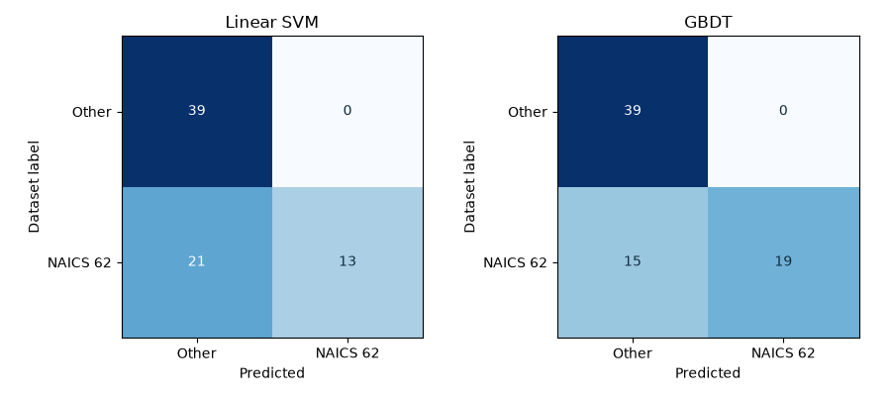
Confusion matrices on held-out employers. Rows are dataset-derived labels and columns are model predictions.
These metrics measure agreement with dataset-derived sector labels, not independently verified employer truth. GBDT misses 15 of the 34 healthcare employers, with 0 false positives among 39 other employers. This small sample cannot establish perfect precision in deployment. The all-positive baseline has F1 0.636, compared with GBDT’s 0.717; ranking models on F1 alone would conceal their very different precision and recall.
For a career product, predicted healthcare labels could narrow an employer-review queue, but the missed healthcare employers would make automatic exclusion costly. Retain existing labels and review disagreements before changing the career sample. No manually adjudicated undefined-employer labels are available, so the paper’s utility scores cannot be reproduced here.

5.4 Training and feature details
Vocabulary thresholds are learned from the training employers only. The selected vocabulary contains 431 title candidates and 12 name words. After the 1% within-employer filter, the fitted matrix has 258 observed columns; candidates absent from all training feature vectors are dropped.
The linear SVM tests C = 0.1, 1 and 10 with balanced class penalties. GBDT tests depths 2 and 3 with 100 estimators and learning rate 0.1. Each model is chosen by validation F1, then evaluated on the test partition without refitting. Exact configurations, validation scores, versions and full classification reports are in run.json.

5.5 Differences from the paper
The reference design is Goindani et al. (2017); the implementation uses scikit-learn (Pedregosa et al. 2011).
This is an exploratory adaptation: a 2026 dataset, one industry, US-only observations, scikit-learn LinearSVC and GBDT, validation-based tuning instead of the paper’s reported cross-validation, and normalized employer-name unigrams without all raw name variants. Name-word frequency counts employers containing the word. The 80% dominant-sector rule is an explicit adaptation for inconsistent posting-level labels. The final study is not a preregistered confirmatory replication.
Industry fields may themselves derive from title or employer heuristics. Their provenance has not been independently audited. Label circularity, unresolved aliases, cohort selection and noisy titles limit the meaning of predictive agreement. A temporal holdout and independent label review remain future validation work.

5.6 Exploratory analysis

5.7 Exploratory data analysis
This descriptive analysis uses the saved Jobs_2026_US aggregates (Jobs_2026_US 2026). It examines selection, available career evidence, normalized role labels and skills before interpreting the predictive results. All career percentages use the 112 selected postings unless another denominator is stated. Figures describe recorded advertisements, not live vacancies or population employment.

5.7.1 Selection and units of analysis
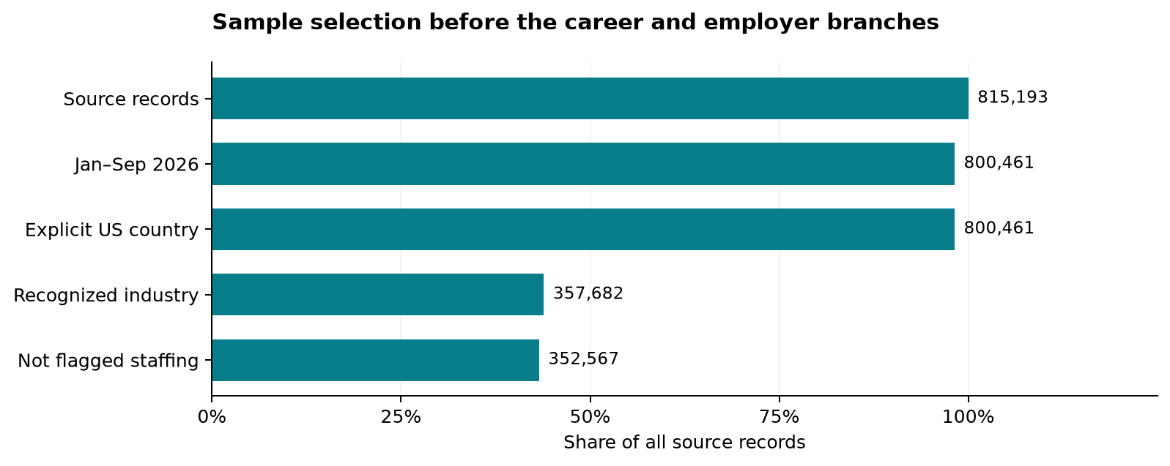
Figure 1: Sequential posting filters before industry-and-title career selection or employer aggregation. Bar lengths use all 815,193 source records as the denominator; labels give retained counts.
The common filters retain 352,567 of 815,193 records (43.2%). The explicit-US filter removes 0 dated records; unknown country and non-US country are combined in the saved exclusion count. These exclusions describe selection, not proof that every excluded record is erroneous. The pipeline then branches: industry-and-title matching yields 112 career postings, while employer aggregation and eligibility rules yield 362 employers for classification. Those are different units and should not appear as consecutive steps in a single funnel.

5.7.2 Field coverage and missing evidence
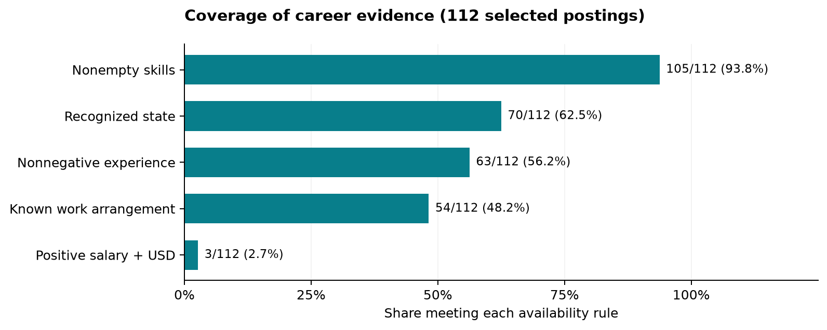
Figure 2: Availability of five career fields, with a common denominator of 112 postings. A positive salary with explicit USD passes the availability rule but is not independently validated compensation.

Evidence rule | Observed | Unavailable under rule | Coverage
Nonempty skills | 105 | 7 | 93.8%
Recognized state | 70 | 42 | 62.5%
Nonnegative experience | 63 | 49 | 56.2%
Known work arrangement | 54 | 58 | 48.2%
Positive salary + USD | 3 | 109 | 2.7%
Availability is field-specific: unavailable can mean missing, unrecognized or excluded by a validity rule. The fields can be missing in the same posting; these counts cannot be added to estimate incomplete records. Salary coverage supports withholding a distribution plot or salary ranking. Recorded experience values require review against requirement text, even when nonnegative.

5.7.3 Role-label consistency
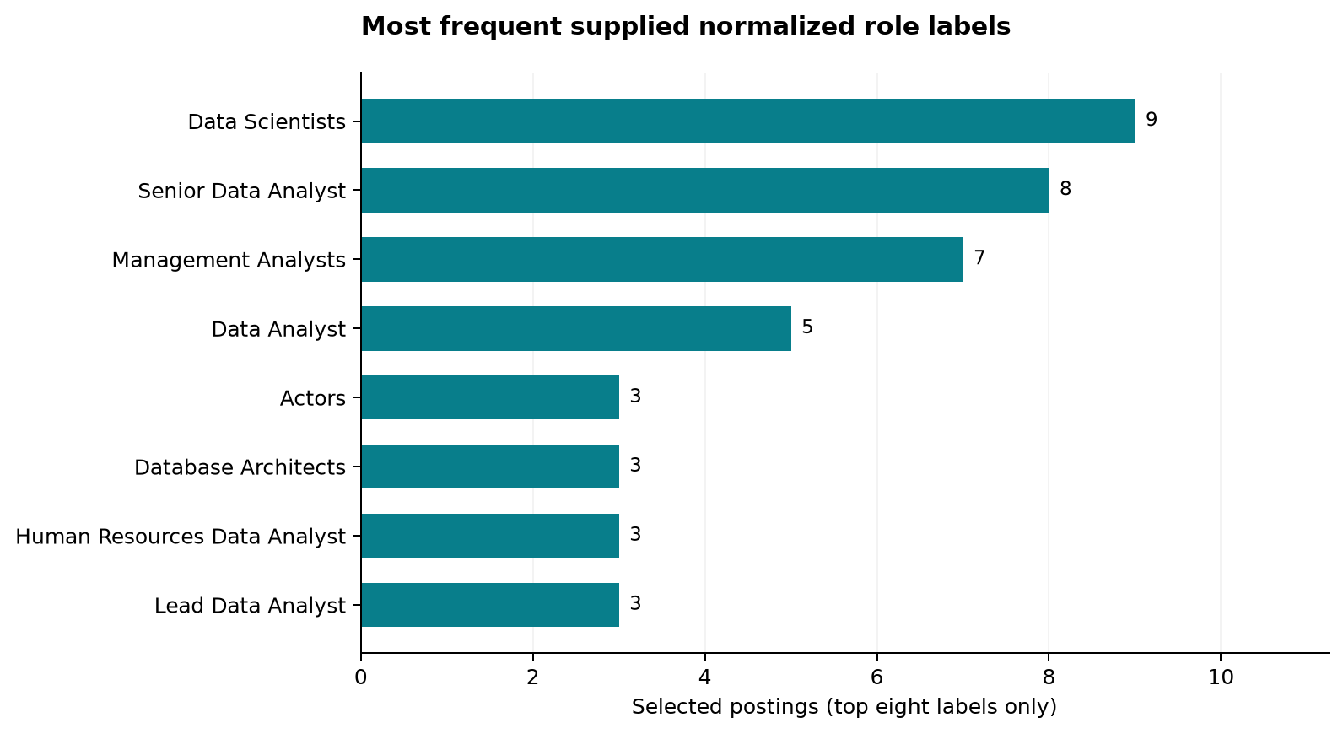
Figure 3: Eight most frequent supplied TITLE_NAME labels in the career subset; ties are ordered alphabetically. Labels are reproduced for a data-quality check.
The saved table contains 67 distinct labels. The eight shown account for 41 of 112 postings; the other 59 labels account for 71. The career filter matches raw titles, with clean titles as fallback, whereas this chart uses supplied normalized titles. Labels such as Actors therefore signal records to inspect for disagreement; they do not establish that acting is a healthcare analytics pathway. Counts alone cannot determine whether the raw title, normalization or industry assignment is wrong. No records were relabeled or removed based on this plot.

5.7.4 Skill frequencies and denominators
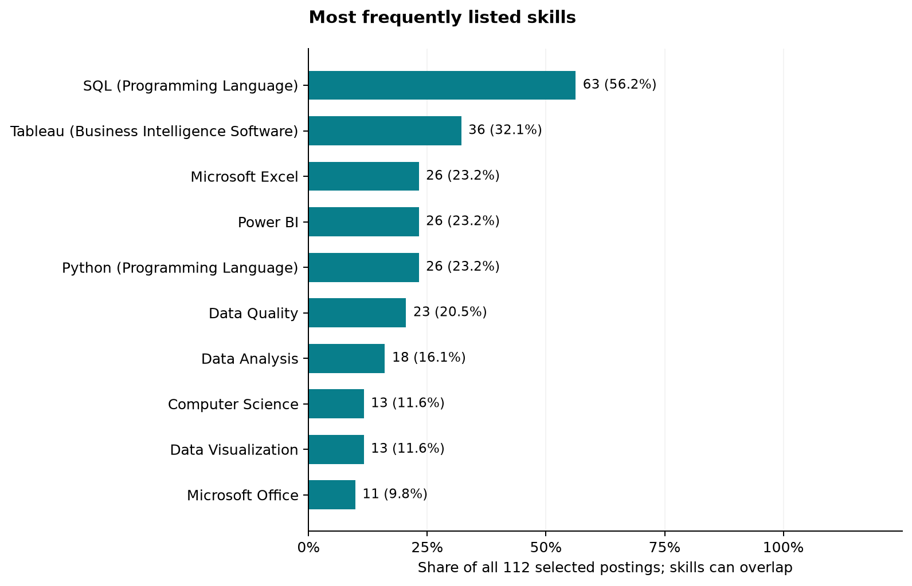
Figure 4: Ten most frequently listed skills as percentages of all selected postings. Multiple skills can occur in one posting, so percentages need not sum to 100.
SQL appears in 63 postings: 56.2% of all 112, or 60.0% of the 105 with nonempty skill lists. Keeping the 7 postings without skill lists in the primary denominator makes the coverage boundary visible. A missing list does not imply that a role requires no skills. These are marginal frequencies; no skill co-occurrence, correlations or causal training effects can be recovered from these aggregate tables.

5.7.5 Interpretation and reproducibility
The sample provides stronger descriptive support for skill priorities than for compensation advice. Work-arrangement and state summaries below retain their unknown categories. Temporal trends, salary-by-location comparisons and multivariable EDA require additional row-level summaries; the saved aggregates cannot establish those relationships.
Run python scripts/publish_eda.py to regenerate these figures and tables from run.json and market_skills.csv, without refitting models. Download selection counts, coverage, role labels and skill shares. Input hashes are recorded in the EDA manifest.

5.8 Multiclass industry classification
The additional experiment predicts one broad NAICS sector per employer. It extends the employer-name and job-title feature design in Goindani et al. (2017) beyond separate industry-membership questions. The healthcare career benchmark and the binary experiments retain their original scope.

5.8.1 Sector definitions and coverage
The input contains 815,193 records in 82 Jobs_2026_US partitions. Source file hashes differ from the saved healthcare experiment in 82 partitions. The current dataset documents a NAICS hierarchy repair, while the healthcare results retain their earlier input manifest. Equal row counts do not establish an identical snapshot; this extension is evaluated separately. The January–September 2026, US, staffing, employer-name and normalized-title filters apply before employer aggregation. Codes 31, 32 and 33 map to manufacturing (31–33); 44 and 45 to retail trade (44–45); and 48 and 49 to transportation and warehousing (48–49). These mappings change 0 posting labels in the current input, which already uses combined sectors, before computing employer dominance. Missing and invalid sectors are excluded, not treated as a learnable industry.
Employers require at least 20 retained postings and an 80% dominant-sector share. After normalization, 375 employers satisfy these rules. A sector requires at least 20 eligible employers to enter the experiment. This support rule retains 6 sectors and 328 employers; 47 eligible employers belong to sectors below the threshold. There is no employer cap. Labels describe broad sectors and remain unadjudicated dataset labels.
NAICS | Industry | Employers
23 | Construction | 41
44-45 | Retail trade | 33
52 | Finance and insurance | 27
54 | Professional, scientific and technical services | 23
61 | Educational services | 33
62 | Health care and social assistance | 171
Excluded sectors (eligible employer counts): 11 Agriculture, forestry, fishing and hunting (1); 21 Mining, quarrying, and oil and gas extraction (0); 22 Utilities (0); 31-33 Manufacturing (17); 42 Wholesale trade (0); 48-49 Transportation and warehousing (9); 51 Information (12); 53 Real estate and rental and leasing (5); 55 Management of companies and enterprises (1); 56 Administrative/support and waste management/remediation services (1); 71 Arts, entertainment and recreation (0); 72 Accommodation and food services (0); 81 Other services (except public administration) (1); 92 Public administration (0).

5.8.2 Employer partitions and features
Within each retained class, employers are ordered by SHA-256 of the seed 2017 and normalized employer name. The first floor(70%) form training, the next employers up to floor(80%) form validation, and the remainder form testing. Each employer belongs to exactly one partition. Normalized names do not resolve corporate aliases, so related entities may still cross partitions. The class-support rule is set before feature fitting; it uses label counts to define the study population.
NAICS | Train | Validation | Test
23 | 28 | 4 | 9
44-45 | 23 | 3 | 7
52 | 18 | 3 | 6
54 | 16 | 2 | 5
61 | 23 | 3 | 7
62 | 119 | 17 | 35
The partitions contain 227 training, 32 validation and 69 test employers. For each class, title and employer-word significance/frequency thresholds are calculated against the other training classes; the union of those selected vocabularies supplies 743 features. This replaces the healthcare-only positive-class feature selection. Titles retain the 1% within-employer share cutoff. Validation and test employers contribute neither vocabulary nor thresholds. Zero-feature employers remain in evaluation: 35 training, 12 validation and 28 test.

5.8.3 Model selection and held-out results
Scikit-learn implementations (Pedregosa et al. 2011) compare linear SVM, logistic regression, random forest and multiclass GBDT on identical partitions. SVM and logistic regression search C = 0.1, 1 and 10 with balanced class weights; random forest uses 200 trees and maximum depths 5 or unrestricted with balanced class weights; GBDT uses 100 boosting stages and tree depths 2 or 3 with default learning rate 0.1. GBDT uses unweighted training. Random states are fixed at 2017. Hyperparameters and then the model family are selected by validation macro-F1, with ties resolved by the listed order. Models are not refitted on validation data. The baseline always predicts the most frequent training class.
Macro-F1 gives each retained sector equal weight. Weighted-F1 and accuracy describe the observed test mix; balanced accuracy averages sector recall. Zero-denominator precision or F1 is recorded as zero. The validation-selected model is Random forest, with test macro-F1 0.377, compared with 0.112 for the training-majority baseline. This is a separate endpoint from healthcare-positive F1, so scores cannot be read as a direct improvement over the binary experiment.
Model | Valid. macro-F1 | Test macro-F1 | Weighted-F1 | Accuracy | Bal. accuracy
Linear SVM | 0.183 | 0.424 | 0.568 | 0.638 | 0.369
Logistic regression | 0.143 | 0.251 | 0.331 | 0.319 | 0.295
Random forest | 0.317 | 0.377 | 0.520 | 0.464 | 0.394
GBDT | 0.183 | 0.319 | 0.485 | 0.580 | 0.285
Training majority | — | 0.112 | 0.341 | 0.507 | 0.167
Per-sector test results for the validation-selected Random forest:
NAICS | Precision | Recall | F1 | Test employers
23 | 1.000 | 0.333 | 0.500 | 9
44-45 | 0.163 | 1.000 | 0.280 | 7
52 | 0.000 | 0.000 | 0.000 | 6
54 | 1.000 | 0.200 | 0.333 | 5
61 | 1.000 | 0.286 | 0.444 | 7
62 | 1.000 | 0.543 | 0.704 | 35
The selected model recovered no test employers in sector(s) 52. This limits its use for filtering those industries.
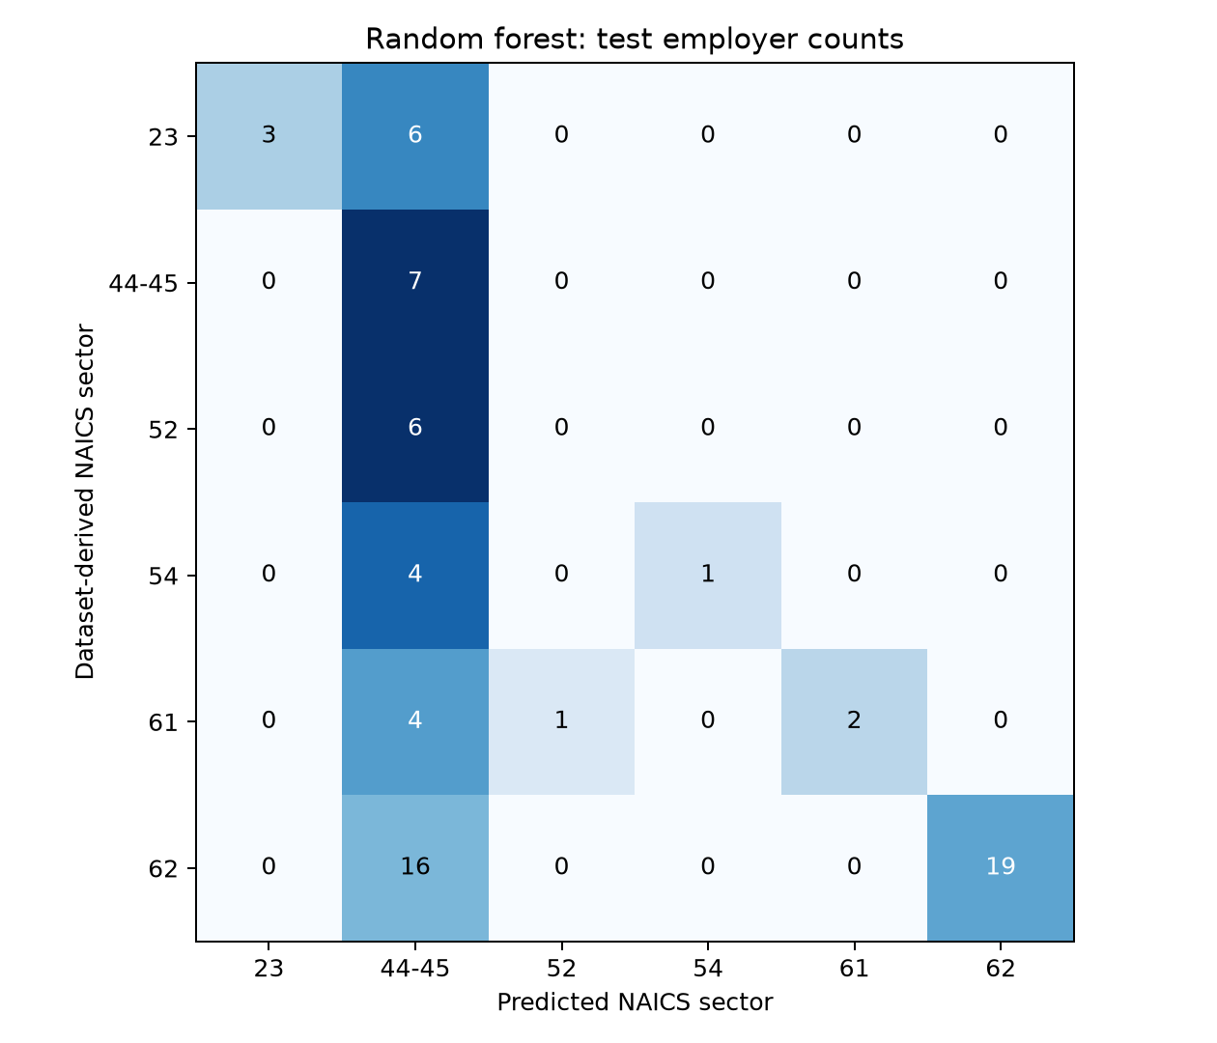
Confusion matrix for the validation-selected model. Cells show employer counts; color is normalized within each actual-sector row. Sector names appear in the coverage table.

5.8.4 Interpretation and limits
This experiment measures agreement across the supported broad industries. The predictions cover only retained sectors: an employer from an excluded sector would still be forced into one of these classes. No open-set detection or deployment inference is claimed. Rare sectors remain in the coverage report instead of being merged into an incoherent “other” class. The two-employer minimum validation support makes tuning sensitive to individual cases, and this single split does not establish stable sector-level performance. Independent label review, repeated employer-grouped evaluation and a later-period test remain necessary. Missing industry labels limit population coverage, and the results do not establish national hiring patterns.
The multiclass results do not replace the 112-posting healthcare career analysis or support personal skill-gap scores. Aggregate class support, metrics, per-sector results and all model confusion matrices accompany the source and run manifest.

5.9 Career market baseline
The selected career sample contains 112 postings dated 2026-01-15 through 2026-09-28. The scope is US healthcare data analysts in NAICS 62. Title matching includes data analyst, data analytics analyst, business intelligence analyst, BI analyst, clinical analyst and healthcare analyst phrases. Matching uses raw title, with clean title as fallback. This includes some clinical systems roles and can miss analyst titles phrased differently.
The benchmark uses the posting’s supplied industry label. It does not filter on a model prediction. These are observed dataset counts, not estimates of all open jobs or currently live vacancies. Expiration and active-URL status were not used to define the cohort.
Measure | Observed result | Interpretation
Hiring volume | 112 | Unique posting IDs; cross-ID reposts may remain
Salary with explicit USD and positive normalized amount | 3 / 112 | Too few for a headline salary estimate
Minimum experience field available | 63 / 112 | Supplied values; zero may encode unspecified experience
Recorded minimum of 0–2 years | 44 | Not a verified count of entry-level jobs
At least one listed skill | 105 / 112 | Empty skill lists remain in the denominator
Source: local snapshot (Jobs_2026_US 2026), analyzed by this project’s scripts; these observed counts are not findings of the 2017 paper.

5.10 Work arrangement
Arrangement | Postings | Share of selected sample
Unknown | 58 | 51.8%
Remote | 24 | 21.4%
Hybrid | 20 | 17.9%
Onsite | 10 | 8.9%
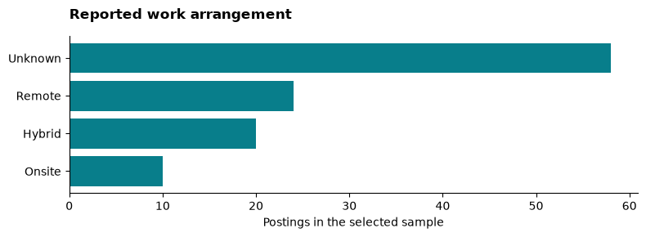
Work arrangement counts with missing status shown explicitly.
Unknown work arrangement is not onsite. The remote share is a lower bound on explicitly documented remote postings in this dataset, not a population estimate.

5.11 Geography
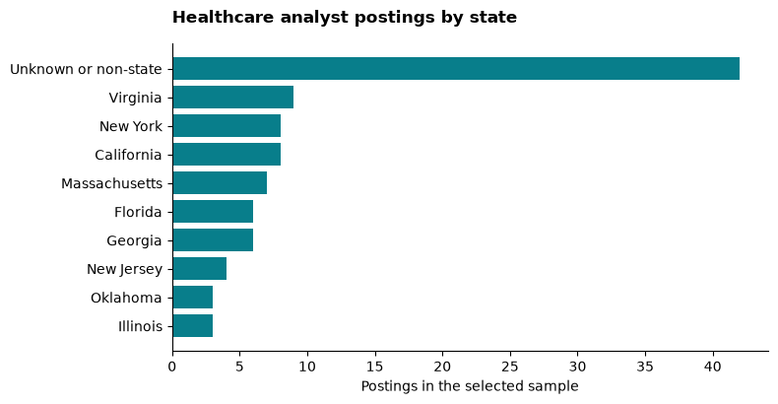
Leading standardized states, including the unknown or non-state category.
Abbreviations and full state names were merged. Country-level strings such as USA and United States were placed in the unknown-or-non-state category. Counts use the supplied single state field; they do not resolve all multi-location postings. Missing geography limits comparisons.

5.12 Salary and experience limits
Only 3 observations have both explicit USD currency and a positive normalized salary amount. The website withholds a headline median because this is below an analyst-selected minimum of 10 comparable observations. Missing currency is not assumed to be USD. Normalization factors and extracted salary evidence were not independently reviewed, so even the retained values require validation before salary advice.
The median supplied minimum-experience value is 0, but zero values cannot establish that employers accept beginners. Review original requirement text before making accessibility recommendations. Raw job descriptions are intentionally not republished by this website.
Download the benchmark table, state counts, and work-arrangement counts. Reproduce them with the script and input hashes listed on the study page.

5.13 Market skills and personal skill gaps
Across 112 selected healthcare analyst postings, 105 have a nonempty skills list. Skills are decoded from the supplied JSON arrays and counted once per posting. The denominator includes all 112 postings; a missing list does not prove that the job needs no skills.
Skill | Postings | Share of all selected postings
SQL (Programming Language) | 63 | 56.2%
Tableau (Business Intelligence Software) | 36 | 32.1%
Python (Programming Language) | 26 | 23.2%
Power BI | 26 | 23.2%
Microsoft Excel | 26 | 23.2%
Data Quality | 23 | 20.5%
Data Analysis | 18 | 16.1%
Computer Science | 13 | 11.6%
Data Visualization | 13 | 11.6%
Microsoft Office | 11 | 9.8%
Data Science | 10 | 8.9%
Verbal Communication Skills | 10 | 8.9%
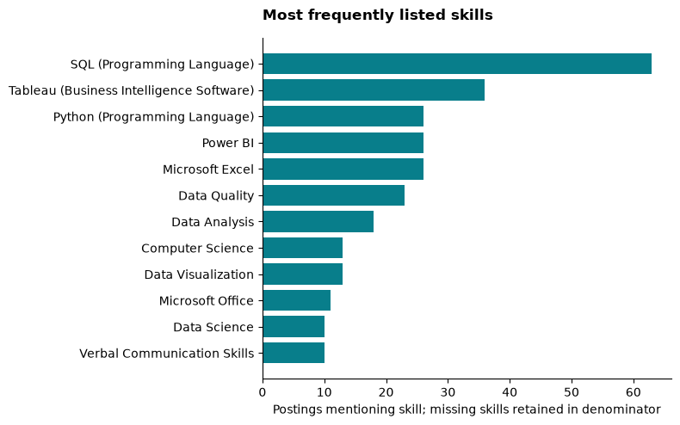
Most frequently listed skills in the selected healthcare analyst sample.
Download the full market skill table. Source: local snapshot (Jobs_2026_US 2026), analyzed by this project. Skills retain the dataset’s names rather than applying a newly invented synonym taxonomy. Frequency supports a market-skills benchmark; it does not measure required proficiency or any individual’s gap.
Participant ratings are unavailable, so no personal skill gap is calculated. The course’s proposed 1–5 scale can support a later comparison, but skill frequency does not establish required proficiency.

6. Discussion and career implications
SQL appears in 63 of 112 selected postings. Tableau appears in 36; Power BI, Python and Excel each appear in 26. These frequencies support prioritizing SQL and a visualization tool for a sample-relevant learning portfolio. They do not establish individual deficiencies or the causal effect of training on job placement.
The sample contains 24 explicitly remote and 20 hybrid postings, with 58 unknown. Check each listing before recommending it as a remote option. The largest known state counts are Virginia, New York and California, but missing geography and selection prevent population-level rankings. Three usable currency-explicit salary observations are too few for a headline salary recommendation.
A proposed opportunity scorecard weights demand 25%, salary 20%, accessibility 20%, skill fit 25% and remote flexibility 10%. These weights are illustrative. A composite ranking is withheld because personal profiles and adequate salary coverage are missing. The completed analytical track is employer-industry classification, with metrics and confusion matrices above.

7. Limitations and next validation
This is an exploratory adaptation, not an exact replication of the proprietary 2017 system. Input coverage, missing industry fields, noisy labels, title matching, unresolved aliases and missing salary evidence affect the sample. Dataset-derived labels cannot independently validate the employer knowledge base. Personal profiles are unavailable.
Independent review of model agreement and disagreement cases, alias resolution and evaluation on a later time period are needed before predictions can reliably filter career opportunities.
The multiclass model covers six sectors with at least 20 eligible employers each. Transportation and warehousing has nine eligible employers and is excluded from that evaluation; manufacturing has 17. The selected model’s macro-F1 of 0.377 and small validation groups limit claims about broad industry classification. Its scores measure a different target and population from the binary healthcare experiments.

8. Conclusion
Posting-derived features recover part of the dataset’s employer-industry signal, but missed healthcare employers and unverified target labels limit automatic filtering. The career subset supports a sample-specific emphasis on SQL and visualization skills. Stronger recommendations require better compensation coverage, independent review and, for personal advice, assessed participant profiles.

Data and code availability
Code, aggregates and input-file hashes are retained in this repository. Source job records are not redistributed. No public repository or independent data-access guarantee is implied. The project framing follows Module 1 (AD688 course materials, n.d.-a); subsequent requirements are documented in Modules 3–5 (AD688 course materials, n.d.-b, n.d.-c, n.d.-d).

AI disclosure
OpenAI Codex assisted with extraction, implementation, analysis and writing on October 3, 2026. Reported computational results are traceable to the accompanying code and saved run manifests.

References
AD688 course materials. n.d.-a. Module 1 Project Instructions: Complete Career Evaluation Pipeline and Step 1. Local course guide, M1/M01_Proj.qmd.
AD688 course materials. n.d.-b. Module 3 Career Evaluation Project Instructions. Local course guide, M3/M03_Proj.qmd.
AD688 course materials. n.d.-c. Module 4 Project Checkpoint: Mid-Project Progress Review. Local course guide, M4/M04_Proj.qmd.
AD688 course materials. n.d.-d. Module 5 Final Analytics and Project Packaging Instructions. Local course guide, M5/M05_Proj.qmd.
Apache Software Foundation. 2026. Classification and Regression: Spark 4.2.0 Documentation. https://spark.apache.org/docs/4.2.0/ml-classification-regression.html.
Chern, Alan, Qiaoling Liu, Josh Chao, Mahak Goindani, and Faizan Javed. 2018. “Automatically Detecting Errors in Employer Industry Classification Using Job Postings.” Data Science and Engineering 3: 221–31. https://doi.org/10.1007/s41019-018-0071-7.
Executive Office of the President, Office of Management and Budget. 2022. North American Industry Classification System: United States, 2022. https://www.census.gov/naics/reference_files_tools/2022_NAICS_Manual.pdf.
Goindani, Mahak, Qiaoling Liu, Josh Chao, and Valentin Jijkoun. 2017. “Employer Industry Classification Using Job Postings.” 2017 IEEE International Conference on Data Mining Workshops (ICDMW). https://doi.org/10.1109/ICDMW.2017.30.
Jobs_2026_US: Local Course Dataset Snapshot. 2026. 82 local Parquet posting partitions.
Pedregosa, Fabian, Gaël Varoquaux, Alexandre Gramfort, et al. 2011. “Scikit-Learn: Machine Learning in Python.” Journal of Machine Learning Research 12 (85): 2825–30. https://www.jmlr.org/papers/v12/pedregosa11a.html.
Tsvetkova, Alexandra, Elettra D’Amico, Alexander Lembcke, Polina Knutsson, and Wessel Vermeulen. 2024. How Well Do Online Job Postings Match National Sources in Large English Speaking Countries? Benchmarking Lightcast Data Against Statistical Sources Across Regions, Sectors and Occupations. OECD Local Economic and Employment Development (LEED) Papers 2024/01. OECD Publishing. https://doi.org/10.1787/c17cae09-en.

