**PROJECT PHASE 1 DOCUMENT**

**Group: DE:AD:BE:EF**

**Names: Jacob Austin**

**Boston Messbarger**

**Kevin Newell**

**Problem Statement**

We intend to build an application that users can use to manage their games, online friends, achievements (earned by playing games), trading cards (also earned by playing games), and downloadable content for their games. A database is required for this because of the sheer amount of each of these entities that can be related to a single user. It’s helpful if that user can view all of this information in an organized and manageable manner.

**Conceptual Database Design**

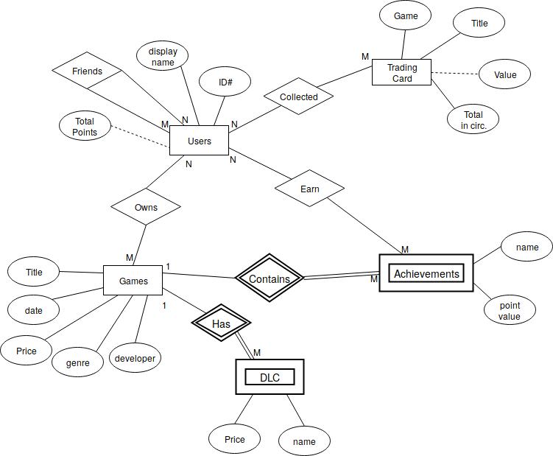

Assumptions:

Games will have unique names.

Keys: ID# for users, Title for Trading Card, Game title and Achievement name for

Achievements, Game Title for Games, Name and Game Title for DLC

**Functional Requirements**

* Search for a game given its name, publisher, developer, genre, or price. This uses the entities Game, and DLC
* Purchase a game and add it to your library. Uses Game, DLC, User, Achievements
* Gift a game to another user listed as a friend. Uses Game, DLC, User, Achievements
* Trade a card with another user. Requires User, and Trading Card
* Earn Trading cards by playing games. Requires User, Game, and Trading Cards
* Earn Achievements from Games that you own. Requires User, Achievements, and Game