

**TRIBHUVAN UNIVERSITY (12, Bold, Center Justified)**

**INSTITUTE OF ENGINEERING**

**THAPATHALI CAMPUS**

**A Major Project Report (12, Bold, Center Justified)**

**On**

**[Project Title]**

**Submitted By: (12, Bold, Center Justified)**

[Student Name] ([Student Exam Roll No.]) (12, Center Justified)

[Student Name] ([Student Exam Roll No.])

[Student Name] ([Student Exam Roll No.])

[Student Name] ([Student Exam Roll No.])

**Submitted To: (12, Bold, Center Justified)**

DEPARTMENT OF ELECTRONICS AND COMPUTER ENGINEERING

THAPATHALI CAMPUS

KATHMANDU, NEPAL

November, 2016 (12, Center Justified)

# DECLARATION

We hereby declare that the report of the project entitled **“Project Title”** which is being submitted to the **Department of Electronics and Computer Engineering, IOE, Thapathali Campus**, in the partial fulfillment of the requirements for the award of the Degree of Bachelor of Engineering in **Electronics and Communication Engineering**, is a bonafide report of the work carried out by us. The materials contained in this report have not been submitted to any University or Institution for the award of any degree and we are the only author of this complete work and no sources other than the listed here have been used in this work.

[Student Name] (Class Roll No: [070/BEX/101]) ________________________

[Student Name] (Class Roll No: [070/BEX/101]) ________________________

[Student Name] (Class Roll No: [070/BEX/101]) ________________________

[Student Name] (Class Roll No: [070/BEX/101]) ________________________

[Student Name] (Class Roll No: [070/BEX/101]) ________________________

**Date:** November, 2016

# CERTIFICATE OF APPROVAL

The undersigned certify that they have read and recommended to the **Department of Electronics and Computer Engineering, IOE, Thapathali Campus**, a minor project work entitled “**Project Title**” submitted by **Student Name, Student Name, Student Name** and **Student Name** in partial fulfillment for the award of Bachelor’s Degree in Electronics and Communication Engineering. The Project was carried out under special supervision and within the time frame prescribed by the syllabus.

We found the students to be hardworking, skilled and ready to undertake any related work to their field of study and hence we recommend the award of partial fulfillment of Bachelor’s degree of Electronics and Communication Engineering.

Project Supervisor

[Supervisor’s Name]

Department of Electronics and Computer Engineering, Thapathali Campus

External Examiner

[External Examiner’s Name]

Department of Electronics and Computer Engineering, Pulchowk Campus

Project Coordinator

[Coordinator’s Name]

Department of Electronics and Computer Engineering, Thapathali Campus

Er. Janardan Bhatta

Head of the Department,

Department of Electronics and Computer Engineering, Thapathali Campus

November, 2016

# COPYRIGHT

The author has agreed that the library, Department of Electronics and Computer Engineering, Thapathali Campus, may make this report freely available for inspection. Moreover, the author has agreed that the permission for extensive copying of this project work for scholarly purpose may be granted by the professor/lecturer, who supervised the project work recorded herein or, in their absence, by the head of the department. It is understood that the recognition will be given to the author of this report and to the Department of Electronics and Computer Engineering, IOE, Thapathali Campus in any use of the material of this report. Copying of publication or other use of this report for financial gain without approval of the Department of Electronics and Computer Engineering, IOE, Thapathali Campus and author’s written permission is prohibited.

Request for permission to copy or to make any use of the material in this project in whole or part should be addressed to department of Electronics and Computer Engineering, IOE, Thapathali Campus.

# ACKNOWLEDGEMENT

Your acknowledgement here. Your acknowledgement here. Your acknowledgement here. Your acknowledgement here. **(1 – 5 paragraphs)**

[Student Name] (Class Roll No.: 070/BEX/111)

[Student Name] (Class Roll No.: 070/BEX/111)

[Student Name] (Class Roll No.: 070/BEX/111)

[Student Name] (Class Roll No.: 070/BEX/111)

# ABSTRACT

Your abstract here. Your abstract here . Your abstract here . Your abstract here . Your abstract here . Your abstract here . Your abstract here . Your abstract here . Your abstract here . **(Maximum 1 paragraph)**

*Keywords: [most frequently used words in your report (may be technology, algorithms etc.) (Italic)*

# TABLE OF CONTENTS

DECLARATION i

CERTIFICATE OF APPROVAL ii

COPYRIGHT iii

ACKNOWLEDGEMENT iv

ABSTRACT v

List of Figures viii

List of Tables ix

List of Abbreviations x

1. INTRODUCTION 1

1.1 Sub-heading 1 – Background Introduction 1

1.2 Sub-heading 2 – Other related topics suitable for introduction 1

1.3 Sub heading 3 – Motivation 1

1.4 Sub heading 4 – Problem Definition 1

1.5 Sub heading 5 – Objectives 1

1.6 Sub-heading 6 – Scope and Applications 2

1.7 Sub-heading 7 – Report Organization 2

2. LITERATURE REVIEW 3

2.1 Sub-heading 1 3

2.2 Sub-heading 2 and so on 3

3. REQUIREMENT ANALYSIS 4

3.1 Sub-heading 1 – Project Requirement (may be Hardware and Software Requirements) 4

3.2 Sub-heading 2 – Feasibility Study 4

4. SYSTEM ARCHITECTURE AND METHODOLOGY 5

4.1 Sub-heading 1 – Block Diagram or System Architecture 5

4.1.1 Sub-heading od 5.1 5

4.2 Sub-heading 2 5

4.3 Sub-Heading 3 - Data Flow Diagram (and other design methods) 5

4.4 Sub-heading 2 6

4.4.1 Sub-heading of 5.2 6

4.4.2 Sub-heading of 5.2 6

4.5 Sub-Heading 3 6

5. IMPLEMENTATION DETAILS 7

5.1 Sub-heading 1 for e.g. Hardware Components 7

5.2 Sub-heading 2 7

6.2.1 Sub-heading of 6.2 7

6. RESULTS AND ANALYSIS 8

6.1 Sub-heading 1 8

6.1.1 Sub-heading 1 of 7.1 8

6.2 Sub-heading 2 8

7. CONCLUSION AND FUTURE ENHANCEMENT 9

7.1 Conclusion 9

7.2 Limitations 9

7.3 Future Enhancement 9

8. APPENDICES 10

Appendix A: Circuit Diagram 10

Appendix B: PCB Diagram 11

Appendix C: Zigbee Module Specification 13

Appendix D: Used Linux Commands [3] 14

1. References 17

# List of Figures

Figure 5‑1: Block Diagram of abc 5

Figure 5‑2: Block Diagram of abc 6

Figure 5‑1: Block Diagram of abc 6

Figure 7‑1: figure abc 8

Figure 10‑1: Circuit Diagram of AVR with sensors and XBee 10

Figure 10‑2: Circuit Diagram of Motor Driver and Relay 10

Figure 10‑3: PCB Diagram of AVR with sensors and Xbee (Top Layer) 11

Figure 10‑4: PCB Diagram of AVR with sensors and Xbee (Bottom Layer) 11

Figure 10‑5: PCB Diagram of Motor Driver and Relay (Top Layer) 12

Figure 10‑6: PCB Diagram of Motor Driver and Relay (Bottom Layer) 12

# List of Tables

Table 10‑1: XBee S2 Pin Description [4] 13

Table 10‑2: XBee S2 General Features [4] 13

# List of Abbreviations

|  |  |
| --- | --- |
| AC | Alternating Current |
| ADC | Analog to Digital Converter |
| API | Application Programming Interface |
| BCM | Broadcom |
| CMOS | Complementary Metallic Oxide Semiconductor |
| CMS | Center Monitoring System |
| CSS | Cascading Style Sheets |
| DHCP | Dynamic Host Control Protocol |
| et al. | And Others |
| FTP | File Transfer Protocol |
| FTPS | File Transfer Protocol Secure |
| GIS | Geographic Information System |
| GPIO | General Purpose Input Output |
| GPRS | General Packet Radio Service |
| GPS | Global Positioning System |
| GPU | Graphics Processor Unit |
| GUI | Graphical User Interface |
| HDMI | High Definition Media Interface |
| HTTP | Hypertext Transfer Protocol |
| HTML | Hypertext Markup Language |
| IDLE | Integrated Development Environment |
| IP | Internet Protocol |
| IOT | Internet Of Things |
| ISP | Internet Service Provider |
| ISR | Interrupt Service Routine |
| IT | Information Technology |

# INTRODUCTION

Your introduction here. Your introduction here. Your introduction here. Your introduction here. Your introduction here. Your introduction here. Your introduction here. Your introduction here.

## Sub-heading 1 – Background Introduction

Your introduction here. Your introduction here. Your introduction here. Your introduction here.

## Sub-heading 2 – Other related topics suitable for introduction

Your introduction here. Your introduction here. Your introduction here. Your introduction here.

## Sub heading 3 – Motivation

Your introduction here. Your introduction here. Your introduction here. Your introduction here.

## Sub heading 4 – Problem Definition

Your introduction here. Your introduction here. Your introduction here. Your introduction here.

## Sub heading 5 – Objectives

The main objectives of our project are listed below **(maximum 2 points and to the point):**

* point 1
* point 2

## Sub-heading 6 – Scope and Applications

Your introduction here. Your introduction here. Your introduction here. Your introduction here.

## Sub-heading 7 – Report Organization

**(briefly explains all the chapters and their focus)** Your introduction here. Your introduction here. Your introduction here. Your introduction here. Your introduction here. Your introduction here. Your introduction here. Your introduction here.

# LITERATURE REVIEW

**(Contains all the existing works that have already been carried out in the field related to your project topic. You have to explain each of the works as a separate subtopic with following details:**

* **What is the work of existing/researched related topic?**
* **How it is done? used methods, techniques, technology, algorithms and any new innovations of existing/researched related topic)**
* **Its importance or applications existing/researched related topic**
* **drawbacks and limitations existing/researched related topic**
* **Criticize the work of existing/researched related topic**
* **Link these criticisms on the existing/researched related topic to the motivation explained in previous chapter. )**

Your literature review here. Your literature review here. Your literature review here. Your literature review here. Your literature review here. Your literature review here. Your literature review here. Your literature review here [1].

## Sub-heading 1

Your literature review here. Your literature review here. Your literature review here. Your literature review here. Your literature review here. Your literature review here. Your literature review here. Your literature review here [2].

## Sub-heading 2 and so on

Your literature review here. Your literature review here. Your literature review here. Your literature review here. Your literature review here. Your literature review here. Your literature review here. Your literature review here [3].

# REQUIREMENT ANALYSIS

Description of requirement analysis. Description of requirement analysis. Description of requirement analysis. Description of requirement analysis. Description of requirement analysis [4].

## Sub-heading 1 – Project Requirement (may be Hardware and Software Requirements)

Description of requirement analysis. Description of requirement analysis. Description of requirement analysis. Description of requirement analysis. Description of requirement analysis.

## Sub-heading 2 – Feasibility Study

Description of requirement analysis. Description of requirement analysis. Description of requirement analysis. Description of requirement analysis. Description of requirement analysis

# SYSTEM ARCHITECTURE AND METHODOLOGY

**(Explanation should be in details in a particular sequence in which you have done your work along with detail algorithms, procedures, circuit diagrams or others which illustrate the “*how”* part details)**Your system and architecture here. Your system and architecture here. Your system and architecture here. Your system and architecture here. Your system and architecture here.

## Sub-heading 1 – Block Diagram or System Architecture

**(Explain all the building blocks of your system in details explaining what and how it does the things)**Your system and architecture here. Your system and architecture here. Your system and architecture here. Your system and architecture here. Your system and architecture here.

### Sub-heading 1

Your text here. Your test here. Your text here. Your text here. Your text here. Your text here.

Center Justified Figure

###### Figure 4‑1: Block Diagram of abc

## Sub-heading 2

Your system and architecture here. Your system and architecture here. Your system and architecture here. Your system and architecture here. Your system and architecture here.

## Sub-Heading 3 - Data Flow Diagram (and other design methods)

Your methodology here. Your methodology here. Your methodology here. Your methodology here. Your methodology here.

Center Justified Figure

###### Figure 4‑2: Block Diagram of abc

#### Sub-heading of 4.3.1

Your methodology here. Your methodology here. Your methodology here. Your methodology here. Your methodology here.

#### Sub-heading of 4.3.1

Your methodology here. Your methodology here. Your methodology here. Your methodology here. Your methodology here.

## Sub-heading 4

Your methodology here. Your methodology here. Your methodology here. Your methodology here. Your methodology here.

### Sub-heading of 4.4

Your methodology here. Your methodology here. Your methodology here. Your methodology here. Your methodology here.

### Sub-heading of 4.4

Your methodology here. Your methodology here. Your methodology here. Your methodology here. Your methodology here.

## Sub-Heading 5

Your methodology here. Your methodology here. Your methodology here. Your methodology here. Your methodology here.

# IMPLEMENTATION DETAILS

**(It contains the details of the implementation of the things that have been explained in the methodology. In short, it describes about how the methodology is implemented. The implementation can be done using any programming language, simulators or any other tools. Explain how you used your programming language or tools to implement the methodology. You may also include your language or simulator or tool specific algorithms or diagrams)** Your system components description here. Your system components description here. Your system components description here. Your system components description here. Your system components description here.

## Sub-heading 1 for e.g. Hardware Components

Your system components description here. Your system components description here. Your system components description here. Your system components description here. Your system components description here.

## Sub-heading 2

Your system components description here. Your system components description here. Your system components description here. Your system components description here. Your system components description here.

### 5.2.1 Sub-heading of 5.2

Your system components description here. Your system components description here. Your system components description here. Your system components description here. Your system components description here.

# RESULTS AND ANALYSIS

**(It contains the result/output of your project. The output can be numeric or graphical based. Represent or write down the results in tabular form if applicable and analyze that by using graphs or charts. Also make a comparison of your works with existing one(s))**Your text here. Your text here. Your text here. Your text here. Your text here. Your text here. Your text here. Your text here.

## Sub-heading 1

### Sub-heading 1 of 6.1

Your text here. Your text here. Your text here. Your text here. Your text here. Your text here. Your text here. Your text here.

center justified Figure

###### Figure 6‑1: figure abc

## Sub-heading 2

Your text here. Your text here. Your text here. Your text here. Your text here. Your text here. Your text here. Your text here.

# CONCLUSION AND FUTURE ENHANCEMENT

## Conclusion

Your conclusion here. Your conclusion here. Your conclusion here. Your conclusion here. Your conclusion here. Your conclusion here. Your conclusion here. Your conclusion here. Your conclusion here. Your conclusion here. Your conclusion here. Your conclusion here. Your conclusion here. Your conclusion here. Your conclusion here. Your conclusion here. Your conclusion here. Your conclusion here. Your conclusion here. Your conclusion here.

## Limitations

Your Limitations here. Your Limitations here. Your Limitations here. Your Limitations here. (You can list one by one).

## Future Enhancement

Future Enhancement here. Future Enhancement here. Future Enhancement here. Future Enhancement here. (You can list one by one).

# APPENDICES

It may contains the additional topics or data sheets or reference sheets or even user manual. The appendix name should be given as fillows.

## Appendix A: Circuit Diagram

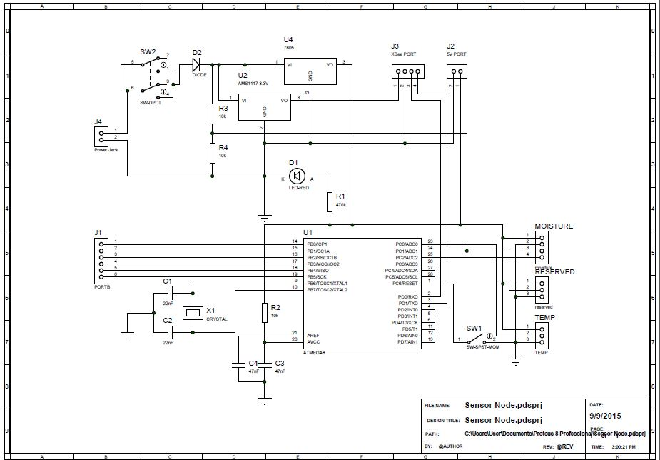

###### Figure 8‑1: Circuit Diagram of AVR with sensors and XBee

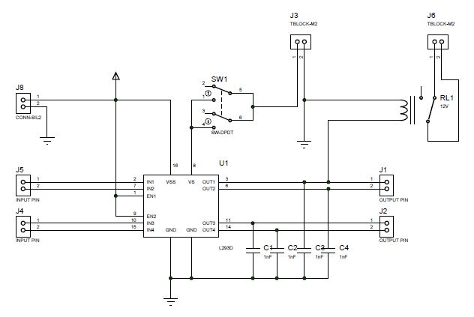

Figure 8‑2: Circuit Diagram of Motor Driver and Relay

## Appendix B: PCB Diagram

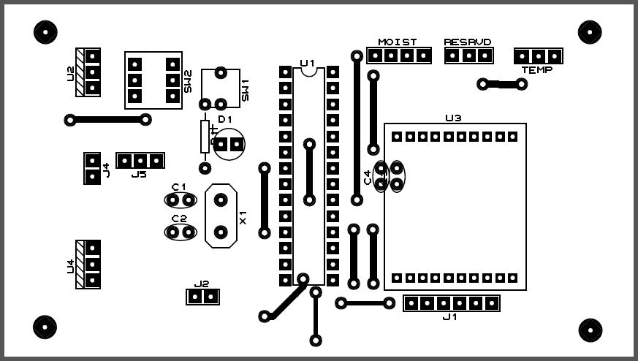

###### Figure 8‑3: PCB Diagram of AVR with sensors and Xbee (Top Layer)

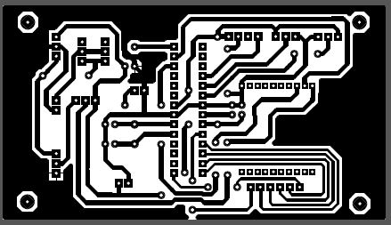

###### Figure 8‑4: PCB Diagram of AVR with sensors and Xbee (Bottom Layer)

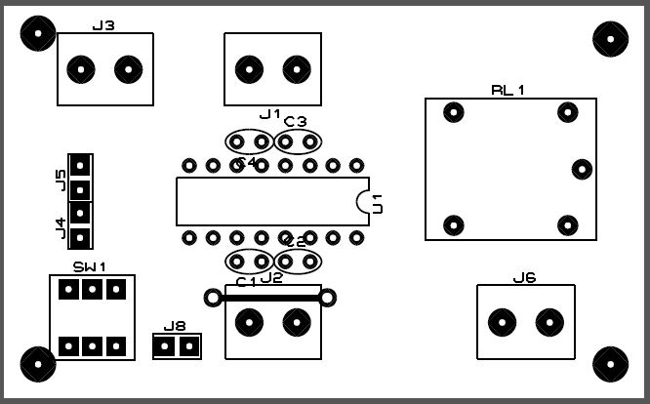

###### Figure 8‑5: PCB Diagram of Motor Driver and Relay (Top Layer)

###### Motor Driver PCB.JPG

###### Figure 8‑6: PCB Diagram of Motor Driver and Relay (Bottom Layer)

## Appendix C: Zigbee Module Specification

###### Table 8‑1: XBee S2 Pin Description [4]

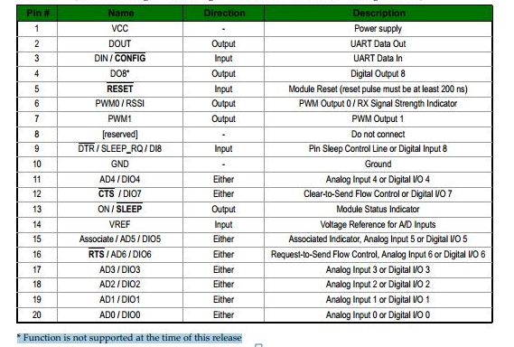

Table 8‑2: XBee S2 General Features [4]

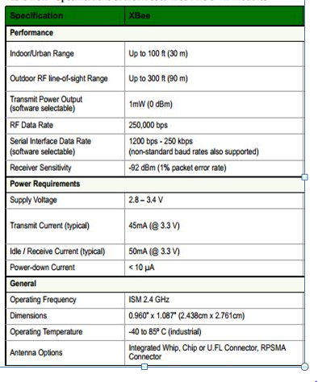

## Appendix D: Used Linux Commands [3]

#### General Commands

* *apt-get update*: Updates your version of Raspbian.
* *apt-get* *upgrade*: Upgrades all of the software packages you have installed.
* *clear*: Clears the terminal screen of previously run commands and text.
* *Data*: Prints the current date.
* *date -s "3 Sep 2015 10:18:00":* Reset time and date
* */etc/init.d/ntp start*: restart npt.
* *find / -name example.txt*: Searches the whole system for the file example.txt and outputs a list of all directories that contain the file.
* *nano example.txt*: Opens the file example.txt in “Nano”, the Linux text editor.
* *poweroff*: To shutdown immediately.
* *raspi-config*: Opens the configuration settings menu.
* *reboot*: To reboot immediately.
* *shutdown -h now*: To shutdown immediately.
* *shutdown -h 01:22*: To shutdown at 1:22 AM.
* *startx*: Opens the GUI (Graphical User Interface).

#### File/Directory Commands

* *cat example.txt*: Displays the contents of the file example.txt.
* *cd /abc/xyz*: Changes the current directory to the /abc/xyz directory.
* *cp XXX*: Copies the file or directory XXX and pastes it to a specified location; i.e. *cp examplefile.txt* */home/pi/office/* copies examplefile.txt in the current directory and pastes it into the /home/pi/ directory. If the file is not in the current directory, add the path of the file’s location (i.e. *cp /home/pi/documents/examplefile.txt /home/pi/office/* copies the file from the documents directory to the office directory).
* *ls -l*: Lists files in the current directory, along with file size, date modified, and permissions.
* *mkdir example_directory*: Creates a new directory named example_directory inside the current directory.
* *mv XXX*: Moves the file or directory named XXX to a specified location. For example, mv *examplefile.txt /home/pi/office/* moves examplefile.txt in the current directory to the /home/pi/office directory. If the file is not in the current directory, add the path of the file’s location (i.e. *cp /home/pi/documents/examplefile.txt* */home/pi/office/* moves the file from the documents directory to the office directory). This command can also be used to rename files (but only within the same directory). For example, *mv examplefile.txt* *newfile*.txt renames examplefile.txt to newfile.txt, and keeps it in the same directory.
* *rm example.txt*: Deletes the file example.txt.
* *rmdir example_directory*: Deletes the directory example_directory (only if it is empty).
* *scp user@10.0.0.32:/some/path/file.txt*: Copies a file over SSH. Can be used to download a file from a desktop/laptop to the Raspberry Pi.
* *touch*: Creates a new, empty file in the current directory.

#### Networking/Internet Commands

* *ifconfig:* To check the status of the wireless connection you are using  (to see if wlan0 has acquired an IP address).
* *iwconfig*: To check which network the wireless adapter is using.
* *iwlist wlan0 scan*: Prints a list of the currently available wireless networks.
* *iwlist wlan0 scan | grep ESSID*: Use grep along with the name of a field to list only the fields you need (for example to just list the ESSIDs).
* *nmap*: Scans your network and lists connected devices, port number, protocol, state (open or closed) operating system, MAC addresses, and other information.
* *ping*: Tests connectivity between two devices connected on a network. For example, ping 10.0.0.32 will send a packet to the device at IP 10.0.0.32 and wait for a response. It also works with website addresses.
* *wget http://www.website.com/example.txt*: Downloads the file example.txt from the web and saves it to the current directory.

#### System Information Commands

* *cat /proc/meminfo*: Shows details about your memory.
* *cat /proc/partitions*: Shows the size and number of partitions on your SD card or hard drive.
* *cat /proc/version*: Shows you which version of the Raspberry Pi you are using.
* *df -h*: Shows information about the available disk space.
* *df /*: Shows how much free disk space is available.
* *dpkg –get-selections | grep XXX*: Shows all of the installed packages that are related to XXX.
* *dpkg –get-selections*: Shows all of your installed packages.
* *free*: Shows how much free memory is available.
* *hostname -I*: Shows the IP address of your Raspberry Pi.
* *lsusb*: Lists USB hardware connected to your Raspberry Pi.
* *vcgencmd measure_temp*: Shows the temperature of the CPU.
* *vcgencmd get_mem arm && vcgencmd get_mem gpu*: Shows the memory split between the CPU and GPU.

# References

(Use IEEE format as follows. Note: This is auto generated reference, do not try to type manually.)

|  |  |
| --- | --- |
| [1] | B. A., "Wireless Sensor Networks in Precision Agriculture," June 2005. |
| [2] | C. Ayday and S. Safak, "Application of Wireless Sensor Networks with GIS on the Soil Moisture Distribution Mapping," January 2009. |
| [3] | Circuitbasics.com, " Useful Raspberry Pi Commands," [Online]. Available: http://www.circuitbasics.com/useful-raspberry-pi-commands/. [Accessed Aug 2015]. |
| [4] | Digi.com, "Documentation for XBee ZB (S2B) Modules," [Online]. Available: http://ftp1.digi.com/support/documentation/90000976_W.pdf. [Accessed Jun 2015]. |
| [5] | P. Wood, "Raspberry Pi and Custard for Schools," [Online]. Available: http://www.rs-online.com/designspark/electronics/blog/raspberry-pi-and-custard-for-schools. [Accessed 02 Sept 2015]. |
| [6] | B. Corporation, "Broadcam BCM2835 ARM Peripherals," Feb 2012. [Online]. Available: http://www.farnell.com/datasheets/1521578.pdf. [Accessed 2015 Jun 05]. |
| [7] | Raspberrypi.org, "GPIO: RASPBERRY PI MODELS A AND B," [Online]. Available: https://www.raspberrypi.org/documentation/usage/gpio/. [Accessed Jun 2015]. |
| [8] | J. E. K. B. a. S. K. Vongsagon Boonsawat, "XBee Wireless Sensor Networks for Temperature," 2010. |

**GUIDELINES**

* Language must be English Language.
* You must use **“Times New Roman”** font with **“Bold”** and*“Italic”*variants whenever needs (except in exported image/diagrams, screenshot of tables etc.).
* For Cover page (First page of this document) and Title page (Second page of this document), use the font size and style as indicated in First page and Second page.
* From page number ‘i’ to end of the page use proper headings and paragraph styles.
* For HEADING 1, use font size 12, style **BOLD**, UPPERCASE, Spacing (before: 0, after: 12, Line Spacing: 1.5).
* For HEADING 2, use font size 12,style **BOLD**, Spacing (before: 0, after: 10, Line Spacing: 1.5).
* For HEADING 3, use font size 12,style **BOLD**, Spacing (before: 0, after: 8, Line Spacing: 1.5).
* For HEADING 4, use font size 12,style **BOLD**, Spacing (before: 0, after: 6, Line Spacing: 1.5).
* For HEADING 5, use font size 12,style **BOLD**, Spacing (before: 0, after: 6, Line Spacing: 1.5) **and so on.**
* For Normal Paragraph, use font size 12, Spacing (before: 0, after: 18, Line Spacing: 1.5).
* All Headings must be Left Justified.
* All normal paragraphs must be left and right justified that is fully justified.
* All the tables and figures must be centered justified.
* Page size must be standard A4 size.
* Page margin must be 1.25” at left and all other of 1”.
* Page number must be 1” from the bottom and centered at the bottom of the page
* Prefatory pages (before INTRODUCTION) should be numbered in Arabic numbers (i, ii, iii…) and body part should be numbered in style (1, 2, 3…)
* You can start the numbering from title page but **must not number the cover page**.
* The Space between two Consecutive paragraphs of the texts must be 6 points before and after.
* Numbering of tables, figures and equations must be consecutive, without repetition of numbers throughout the text. Numbering can be 1, 2, 3, etc., or by chapter, i.e., 1.1, 1.2, 1.3. The numbers must be consistent. (bottom of the table/figure)
* For extensive table of contents and list of figures, list of tables you can use 1 line spacing instead of 1.5 (**For extensive Table of contents, list of tables and list of figures only, otherwise use 1.5 line spacing as normal paragraph)**
* All the figures, tables, charts, equations etc. used in the document must be numbered using insert caption under reference of MS Word.
* Reference must be used in ascending order (It means if you use [1] reference in page 5 and reference [2] in page 6 then you must not use reference [3] in page 5) using IEEE format.
* Reference should not be numbered as chapter.
* The Logo of the Institutions is placed right above the name of Tribhuvan University at the center of the page.
* The name of the University, Institute and Campus must be in uppercase letters.
* The title of the project must be 1st letter capitalized (no UPPERCASE).
* The name of the student (s) must be i1st letter capitalized (no UPPERCASE).
* The full name of the degree for which the thesis is presented must be written out, e.g., DEGREE OF BACHELOR IN ………………………………… ENGINEERING
* The full, official name of the department must be written out, e.g., DEPARTMENT OF…………………….………. ENGINEERING.
* The full title of the thesis cannot be longer than 240 characters (including letters, figures, symbols and spaces). The spine title cannot be longer than 50 characters (including letters, figures, symbols and spaces).