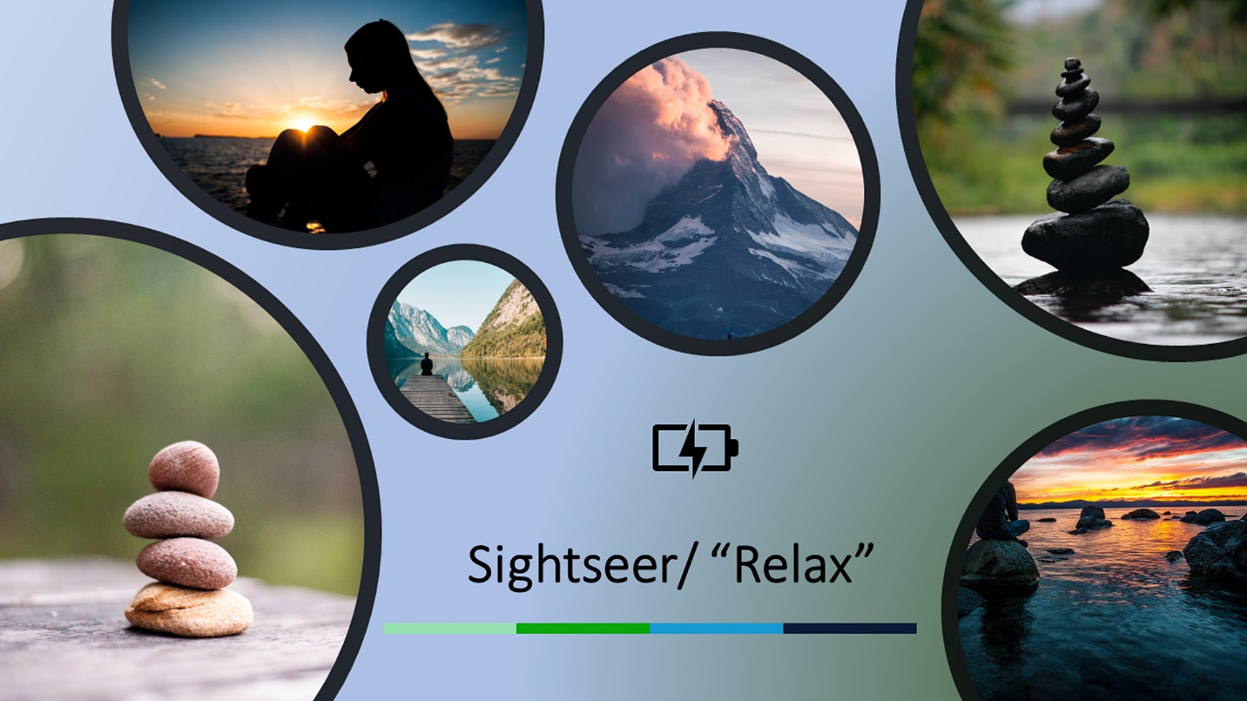

**Reflection:**

The Colors I am using are between green and blue since these two colors, with proper modifications, can make people feel tranquility. Also, I put those pictures in circles because circles can bring more comfort to people rather than rectangles. The edges are smoother. By adding a charging symbol, users will know the target of this trip is to relax and recharge themselves. For the background, the gradients color changes by the main color of each image in the circle. That make the whole picture looks gentler.