AI-Powered Dark Store Demand Intelligence System

1. Introduction
Quick commerce companies rely on dark stores to deliver products rapidly to customers. Managing inventory efficiently is important to reduce stock outs, improve delivery performance, and increase customer satisfaction.
This project analyzes dark store order data to identify demand patterns, stock availability issues, and operational inefficiencies using SQL and Power BI. AI-generated business insights and recommendations were also included to improve decision-making.

2. Problem Statement
Quick commerce businesses often face challenges such as:
- stock shortages
- delayed deliveries
- uneven product demand across areas
- inefficient inventory allocation
The objective of this project is to analyze order and delivery data to optimize inventory planning and operational performance.

3. Tools & Technologies Used
- SQL (MySQL)
- Power BI
- Excel
- AI-generated business insights using ChatGPT

4. Dataset Description
The dataset contains dark store operational data with the following fields:
- Order ID
- Date
- Time
- Area
- Product
- Category
- Quantity
- Price
- Delivery Time
- Stock Availability
The dataset was created to simulate real-world quick commerce operations across multiple delivery zones.

5. SQL Analysis Performed
The following business analyses were performed using SQL:
- Total order analysis
- Top-selling product analysis
- High-demand area identification
- Stock out frequency analysis
- Average delivery time analysis
- Peak order hour analysis

6. Dashboard Features
The Power BI dashboard includes:
- Total Orders KPI
- Top Selling Products Chart
- Highest Demand Areas Chart
- Stock Availability Analysis
- Delivery Performance Analysis
- AI Insights & Recommendations Section

7. Key Insights
- Dairy products such as milk and bread showed high morning demand
- Snack products showed increased evening sales activity
- Certain areas experienced higher stock out frequency
- Delivery delays were higher in high-demand regions

8. AI-Based Recommendations
- Increase dairy inventory during morning hours
- Improve delivery staffing during peak evening demand
- Optimize inventory allocation in stock out-prone areas
- Monitor delivery delays in high-order zones

9. Business Impact
This project demonstrates how operational analytics and AI-generated insights can improve:
- inventory management
- delivery efficiency
- customer satisfaction
- demand forecasting
- operational decision-making

10. Conclusion
The project successfully demonstrates the use of SQL, Power BI and AI-assisted analytics to solve real-world quick commerce operational challenges. The dashboard provides actionable insights that can help businesses optimize inventory and delivery operations efficiently.
11. Dashboard
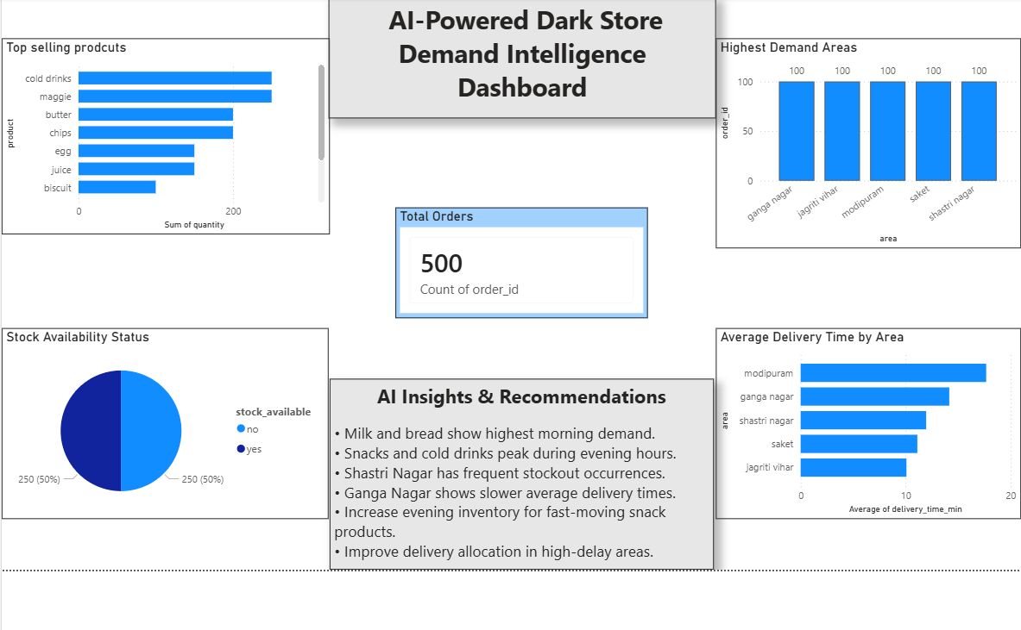
12. Charts Created
