# Machine Learning TP1

Félix HENAFF & Alfred DEDUYER, FIPA25

## 3 Linear regression with one variable

### 3. 1 Plotting the Data

**How many features are involved in this problem?**

There is 1 feature involved in the problem: the population in a city.

**How much data is involved in this problem?**

There are 97 data because there are 97 cities.

**What is the problem from a machine learning point-of-view?**

– Supervised/Unsupervised? Supervised because we give a y value.

– Regression/Classification? Regression because y is continuous

– Linear/non-linear problem?

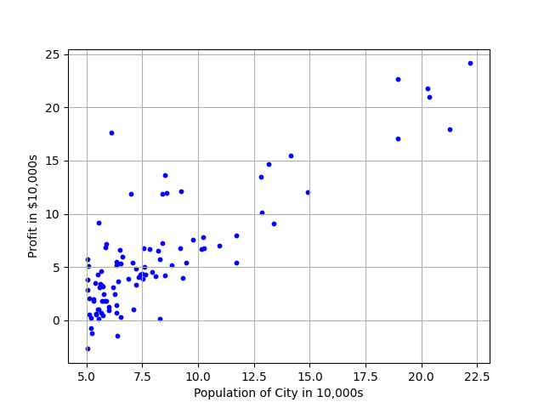

Figure 1 Scatter plot of training data

### 3.2 Gradient Descent

### 3.2.3 Computing the cost J(θ)

def computeCost(X, y, theta):   
 *"""  
 computes the cost of using theta as the parameter for linear   
 regression to fit the data points in X and y  
 """* # m = number of training examples  
 m = y.size  
  
 # Hypothesis (predicted values)  
 h = X.dot(theta)  
  
 # Compute the squared errors  
 squared_errors = (h - y) ** 2  
  
 # Calculate the cost function  
 J = (1 / (2 * m)) * np.sum(squared_errors)  
  
 return J

### 3.2.4 Gradient descent

import numpy as np  
from computeCost import computeCost  
  
def gradientDescent(X, y, theta, alpha, num_iters):  
 *"""*  
 *Performs gradient descent to learn theta.*  
 *theta, cost_history, theta_history = gradientDescent(X, y, theta, alpha, num_iters)*  
 *Updates theta by taking num_iters gradient steps with learning rate alpha.*  
 *"""*  
# Initialize some useful values  
 m = y.size # number of training examples  
 n = theta.size # number of parameters  
 cost_history = np.zeros(num_iters) # cost over iterations  
 theta_history = np.zeros((n, num_iters)) # theta over iterations  
  
 for i in range(num_iters):  
 # Compute the prediction error  
 error = X.dot(theta) - y  
  
 # Perform the gradient step for each theta parameter  
 gradient = (1 / m) * X.T.dot(error)  
  
 # Update theta  
 theta = theta - alpha * gradient  
  
 # Save the cost J in every iteration  
 cost_history[i] = computeCost(X, y, theta)  
  
 # Save the values of theta in every iteration  
 theta_history[:, i] = theta.flatten()  
  
 return theta, cost_history, theta_history

--------------------------

Theta found by gradient descent:

-3.6302914394043593 1.1663623503355818

Expected theta values (approx)

-3.6303 1.1664

--------------------------

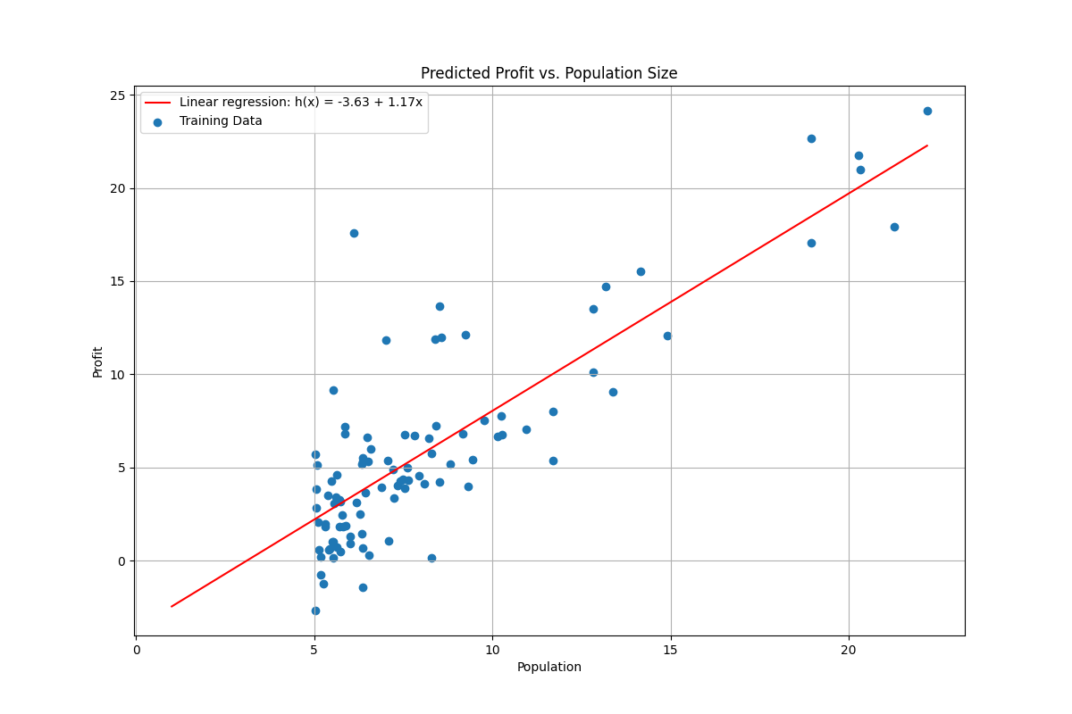

Figure 2 Training data with linear regression fit

## 3.3 Visualizing J(θ)

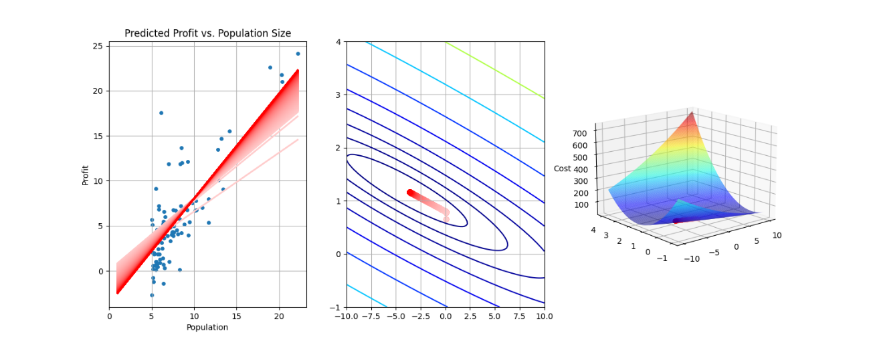

Figure 3 Cost function J(θ)

# 4 Linear regression with multiple features

4.1 Feature Normalization

def featureNormalize(X):  
 *"""  
 Returns a normalized version of X where  
 the mean value of each feature is 0 and the standard deviation  
 is 1. This is often a good preprocessing step to do when  
 working with learning algorithms.  
 """* # Compute the mean and standard deviation of each feature  
 mu = np.mean(X, axis=0)  
 sigma = np.std(X, axis=0)  
  
 # Normalize each feature in X  
 X_norm = (X - mu) / sigma  
  
 return X_norm, mu, sigma

## 4.2 Learning with gradient decent

### 4.2.1 Compute cost and gradients

def computeCostMulti(X, y, theta):   
 *"""  
 Computes the cost of using theta as the parameter for linear  
 regression to fit the data points in X and y.  
 """* m = y.size # Number of training examples  
  
 # Hypothesis (predicted values)  
 h = X.dot(theta)  
  
 # Compute the squared errors  
 squared_errors = (h - y) ** 2  
  
 # Calculate the cost function  
 J = (1 / (2 * m)) * np.sum(squared_errors)  
  
 return J

def gradientDescentMulti(X, y, theta, alpha, num_iters):  
 *"""  
 Performs gradient descent to learn theta.  
 theta, cost_history, theta_history = gradientDescentMulti(X, y, theta, alpha, num_iters)  
 Updates theta by taking num_iters gradient steps with learning rate alpha.  
 """* m = y.size # Number of training examples  
 n = theta.size # Number of parameters  
 cost_history = np.zeros(num_iters)  
 theta_history = np.zeros((n, num_iters))  
  
 for i in range(num_iters):  
 # Compute the error (difference between prediction and actual values)  
 error = X.dot(theta) - y  
  
 # Update each parameter theta_j  
 gradient = (1 / m) * X.T.dot(error)  
 theta = theta - alpha * gradient  
  
 # Save the cost J in every iteration  
 cost_history[i] = computeCostMulti(X, y, theta)  
 theta_history[:, i] = theta.flatten()  
  
 return theta, cost_history, theta_history

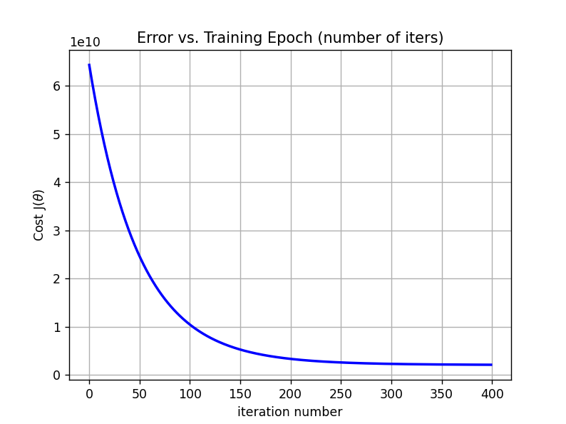

Figure 4 Convergence of gradient descent with an appropriate learning rate

### 4.2.3 Predict the price for a new house

we used a learning rate (αα) of 0.05 and 600 iterations to adjust the model's parameters during gradient descent.

Predicted price of a 1650 sq-ft, 3 br house

(using gradient descent):

[[293081.48469249]]

In this case, after 600 iterations and with an alpha of 0.05, the model predicted a price of approximately $293,081 for a 1650 sq-ft, 3-bedroom house.

## 4.3 Normal equations

def normalEqn(X,y):  
 *""" Computes the closed-form solution to linear regression  
 normalEqn(X,y) computes the closed-form solution to linear  
 regression using the normal equations.  
 """* theta = np.linalg.inv(X.T @ X) @ X.T @ y  
 return theta

Predicted price of a 1650 sq-ft, 3 br house

(using normal equations):

[[293081.4643349]]

Figure 5 : Error vs training

## Some questions, you have to answer

**Define terms:**

Supervised/Unsupervised:

* Supervised: The algorithm learns from labeled data (with known responses).
* Unsupervised: The algorithm learns from unlabeled data to identify hidden structures.

Regression/Classification:

* Regression: Prediction of continuous values (e.g., house price).
* Classification: Prediction of categories or classes (e.g., spam/non-spam).

Descriptors/Features: Input variables that explain the data (e.g., surface area, number of bedrooms for a house).

Targets: Output values to be predicted (e.g., house price, object class).

Linear regression model: A model that predicts a linear relationship between the features and a continuous target, in the form of an equation.

$$h_{θ}\left(x\right)= θ_{0}+θ_{1}x_{1}+…+θ_{n}x_{n}$$

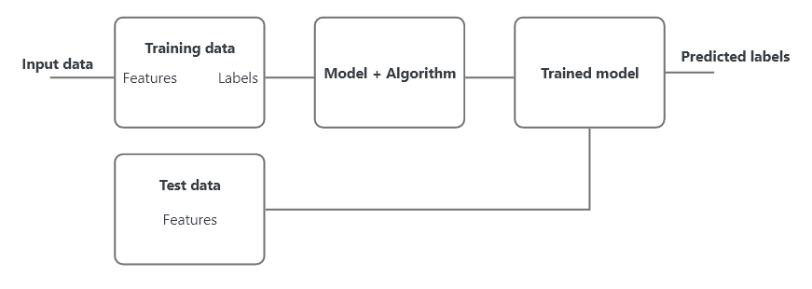

Figure 6 Schematic learning and prediction

**How does learning work? By what means? What is the purpose of the cost function? How**

is the problem solved? Do you know of other ways of solving it?

Learning works by adjusting model parameters to minimize the difference between predictions and actual values, using a process called optimization.

* How: Through algorithms like gradient descent, which iteratively updates parameters based on the error.
* Cost function: Measures the error between predictions and actual values; its minimization guides the learning process.
* How it's solved: By adjusting model parameters to minimize the cost function, usually with gradient descent.

**Why do we sometimes need to standardize features?**

Normalization of features is important to ensure that all features have a similar scale. This prevents features with larger ranges from dominating the learning process and helps optimization algorithms like gradient descent converge faster and more efficiently.