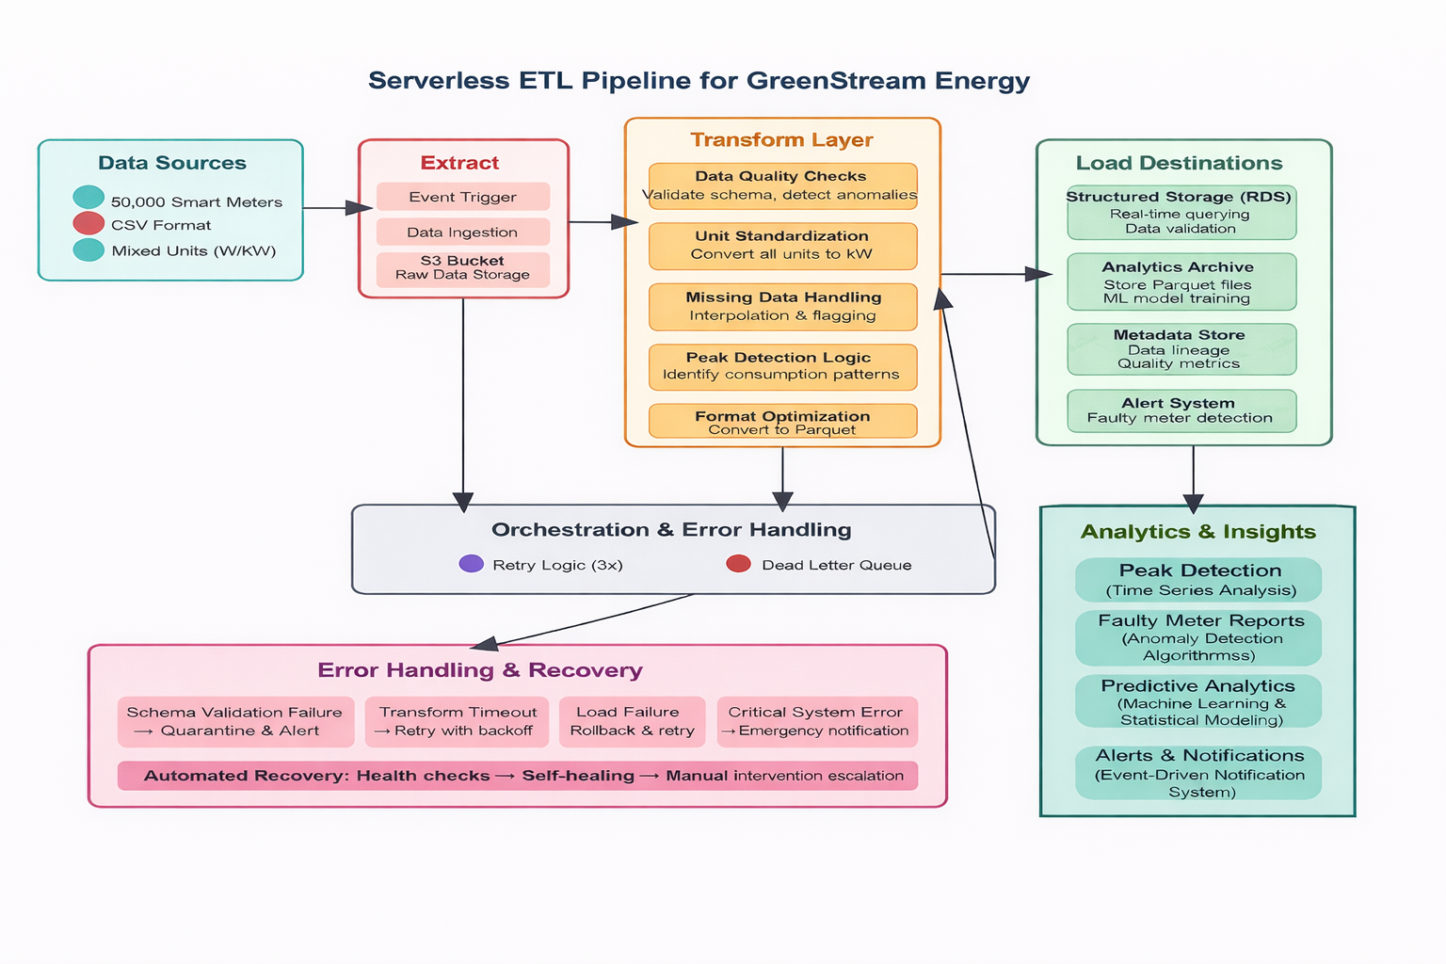

Task B:

Unit Standardization Rules
• the energy unit is "W", divide the value by 1000 and convert the unit to "kW".
• If the energy unit is "kW", keep the value unchanged.
• If the unit is neither "W" nor "kW", flag the record as invalid and exclude it from analytical processing while logging it in the metadata store.

- Missing Data Handling Rules
• If an energy reading is NULL, flag the record as missing.
• If the missing interval is short (e.g., a single timestamp), apply interpolation using neighboring values.
• If the missing interval is long, exclude the record from peak-usage calculations and predictive analytics.
• All interpolated values must be labeled as estimated in the metadata.

- Data Validation Rules
• If the energy value is negative, mark the record as invalid and quarantine it.
• If the energy value exceeds a realistic household consumption threshold, flag it as an outlier.
• If timestamps are duplicated, missing, or outside the expected time range, reject the record.
• All validation failures are routed through the error-handling workflow and logged for auditability.
- Faulty Smart Meter Detection Rules
• If a meter reports zero consumption for an unusually long continuous period, flag it as potentially faulty.
• If a meter reports the same constant value over extended intervals, mark it as suspicious.
• If sudden, extreme deviations occur compared to historical patterns, classify the reading as anomalous.
• Flagged meters are excluded from peak-usage calculations and forwarded to the alert system.
- • Data Format Optimization Rules
• Convert all validated and standardized data into columnar Parquet format.
• Partition data by time (e.g., date) and meter identifier to optimize querying.
• If conversion fails, retry automatically; unresolved failures are sent to a dead-letter queue.

Task C:

