<https://portal.vision.cognitive.azure.com/demo/extract-text-from-images>

Y7H1JR_RFVIN

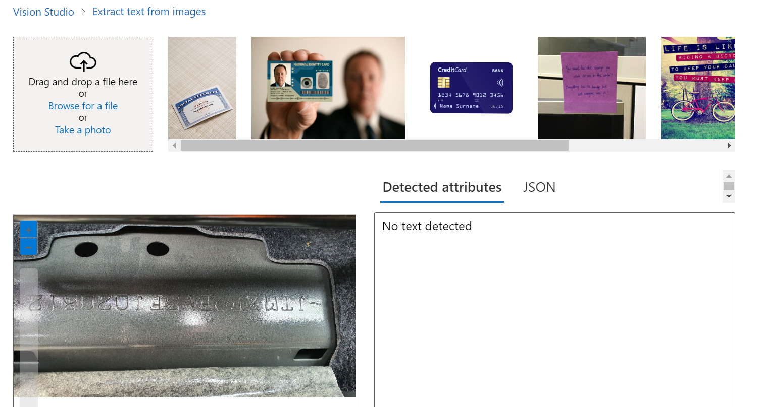

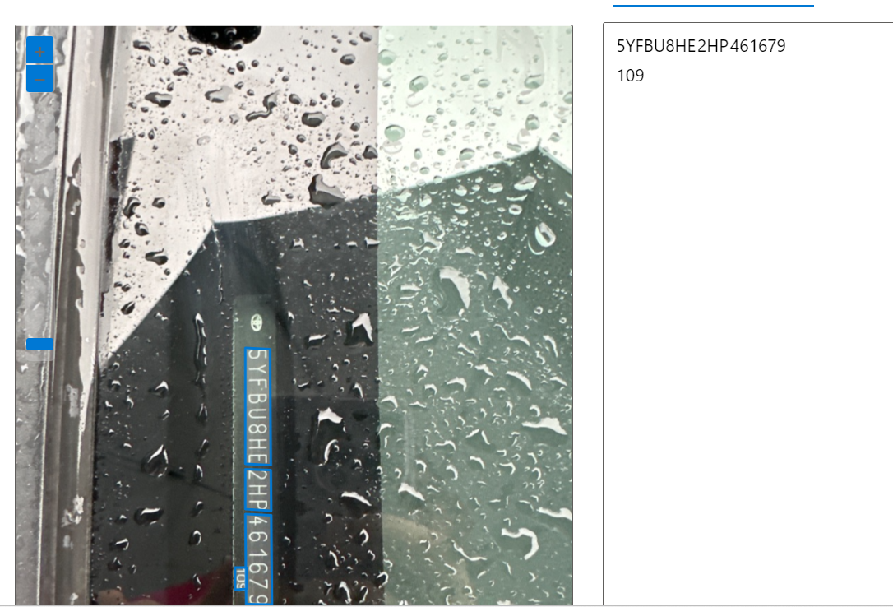

Insumos – cadena de abastecimiento

Intermedio – transformación

Output – distribución

Y9SFQH_RFRTV

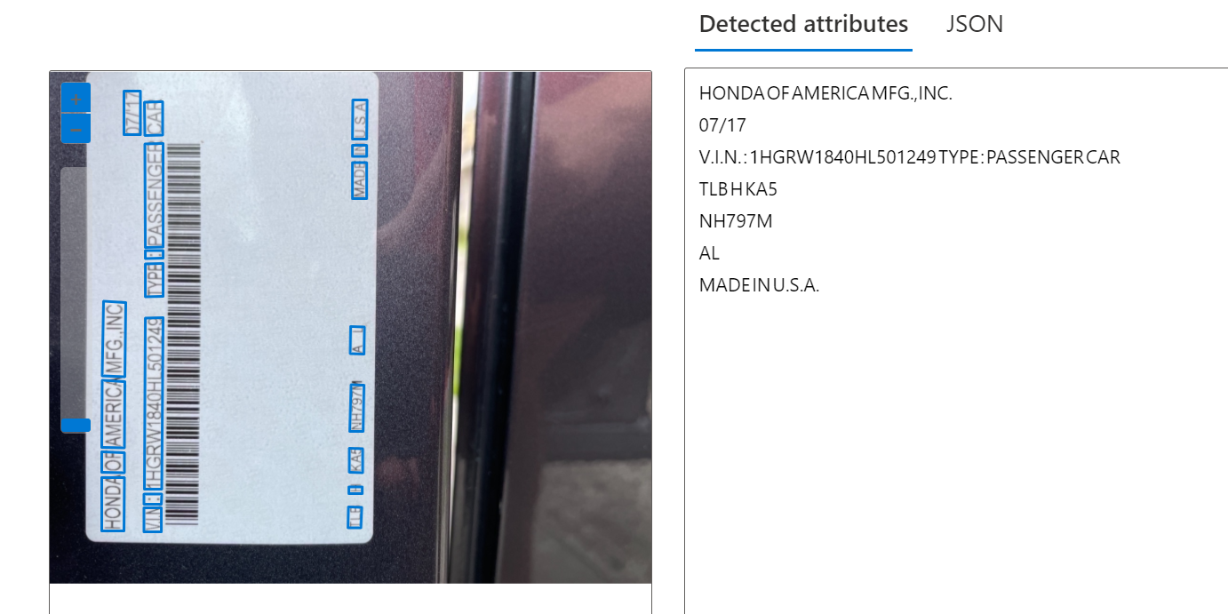

<https://learn.microsoft.com/en-us/azure/ai-services/custom-vision-service/getting-started-improving-your-classifier>

* Prevent overfitting
  + provide images with different angles, backgrounds, object size, groups, and other variations
* Data quantity
  + at least 50 images per label as a starting point
* Data balance
  + You're likely to see better results if you maintain at least a 1:2 ratio between the label with the fewest images and the label with the most images.
* Data variety
  + Be sure to use images that are representative of what will be submitted to the classifier during normal use.
* Negative images (classifiers only)
  + If you're using an image classifier, you may need to add negative samples to help make your classifier more accurate.
* Occlusion and truncation (object detectors only)
  + If you want your object detector to detect truncated objects, you'll need to include training images that cover those cases.
* Use prediction images for further training
* Visually inspect predictions
* Next steps