**WEEK 2 HOMEWORK**

**STUDENT NAME: Botirbek Tolipov**

**UNIVERSITY NAME: La Roche University**

**COURSE NAME: Object Oriented Sytems**

**INSTRUCTOR NAME: Dustin Updyke**

**DATE OF SUBMISSION: 04/01/2025**

**Design Phase**

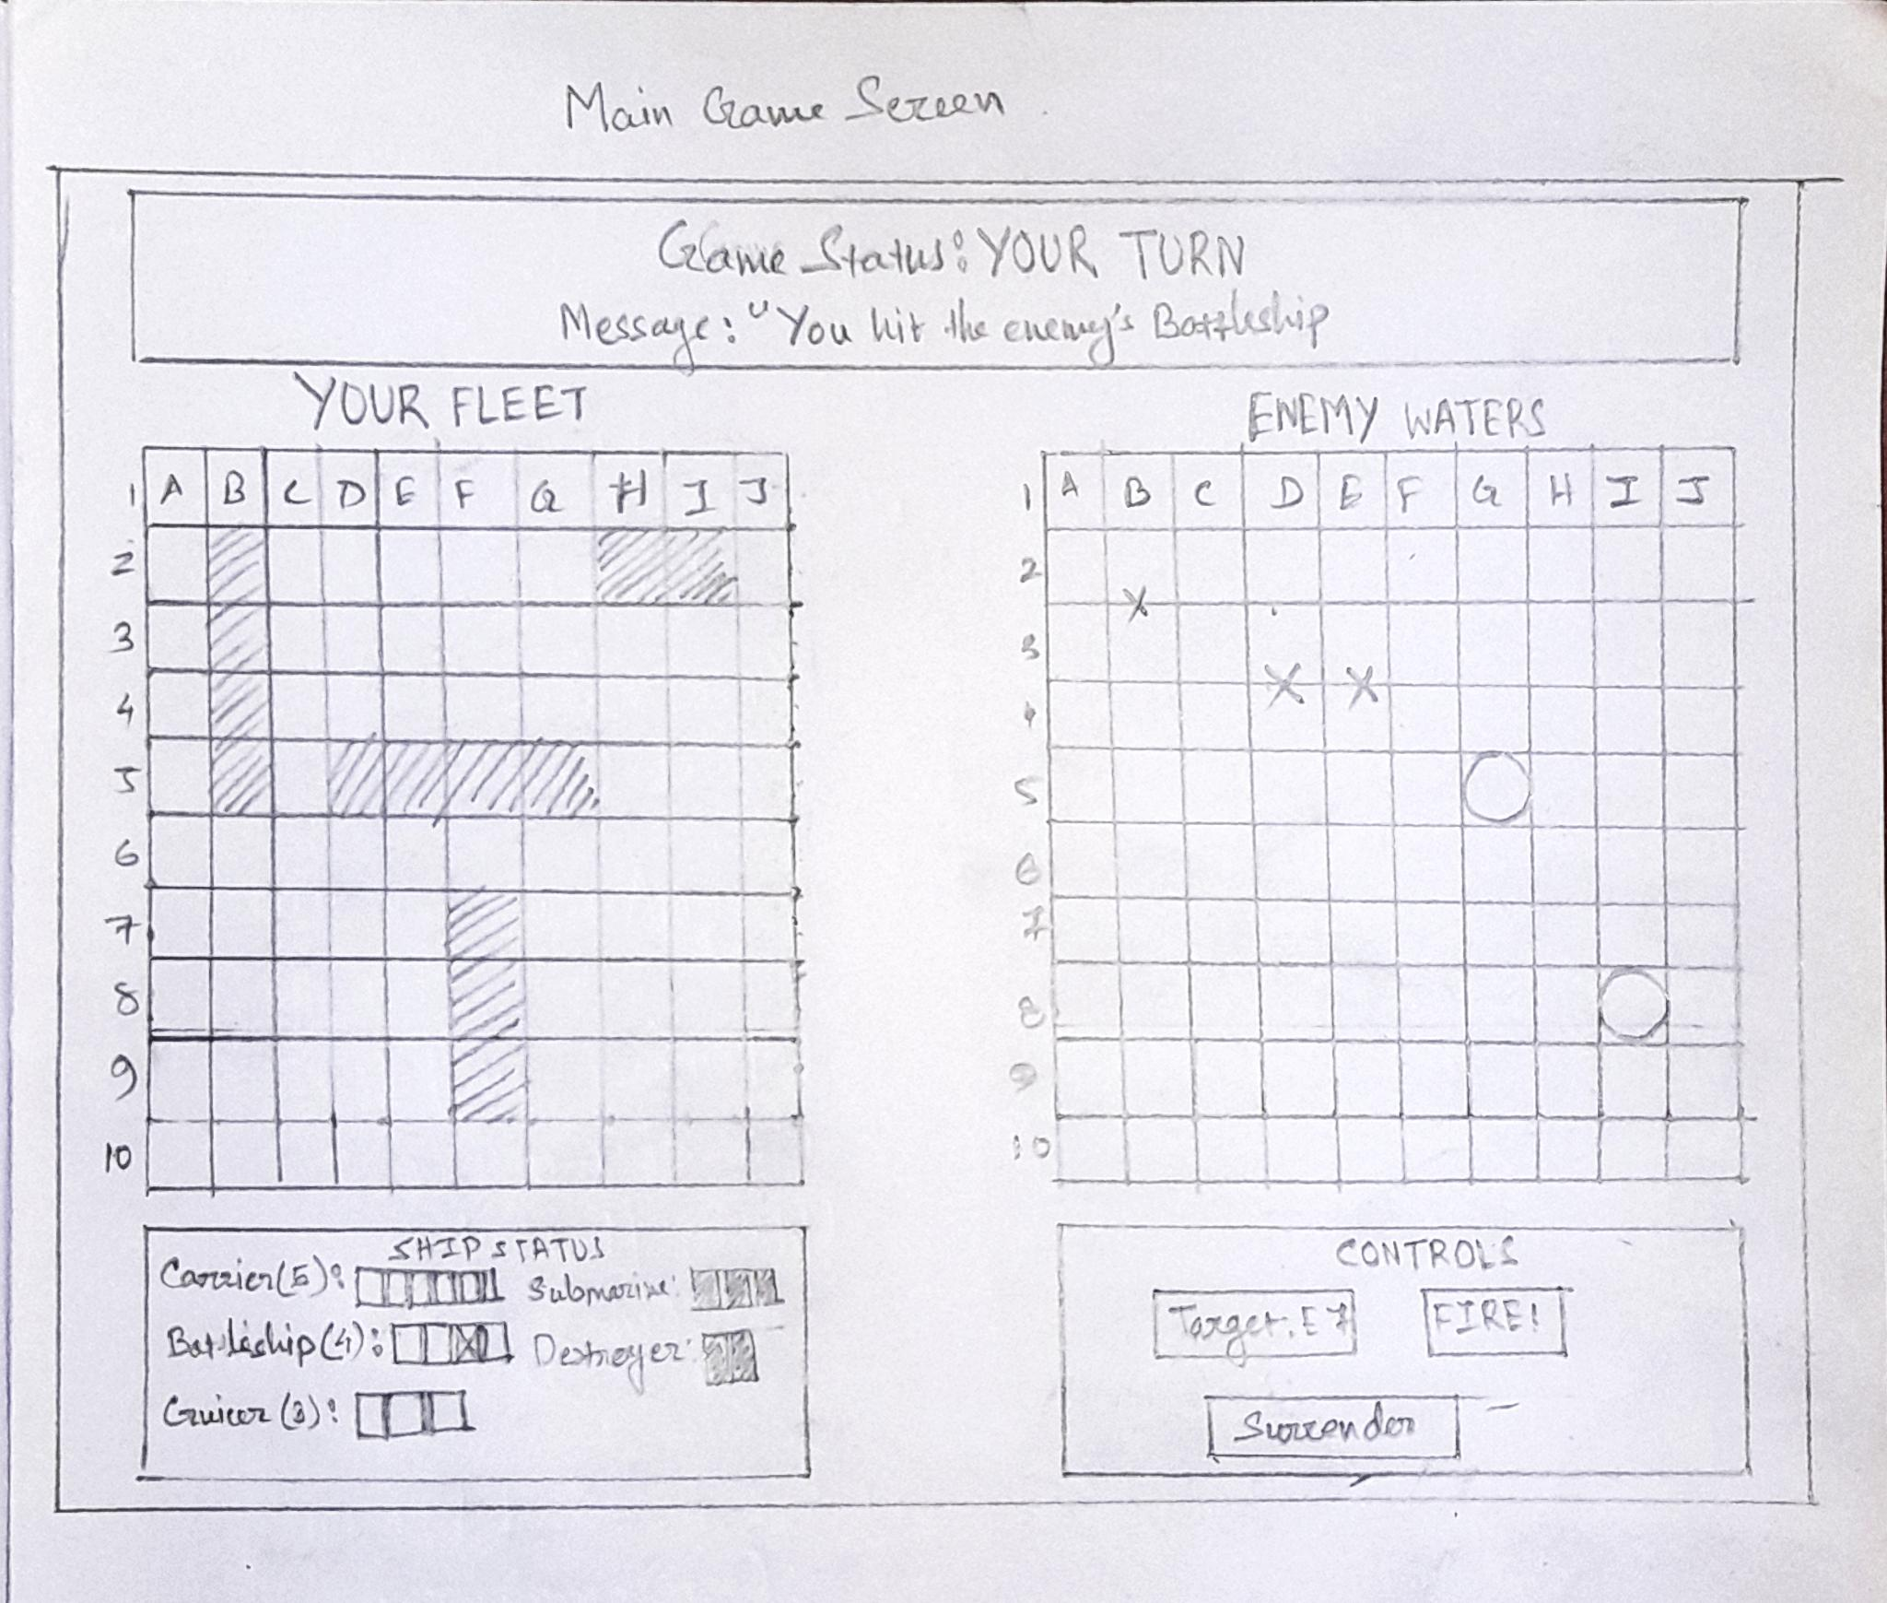Fig 1: Main Game Screen

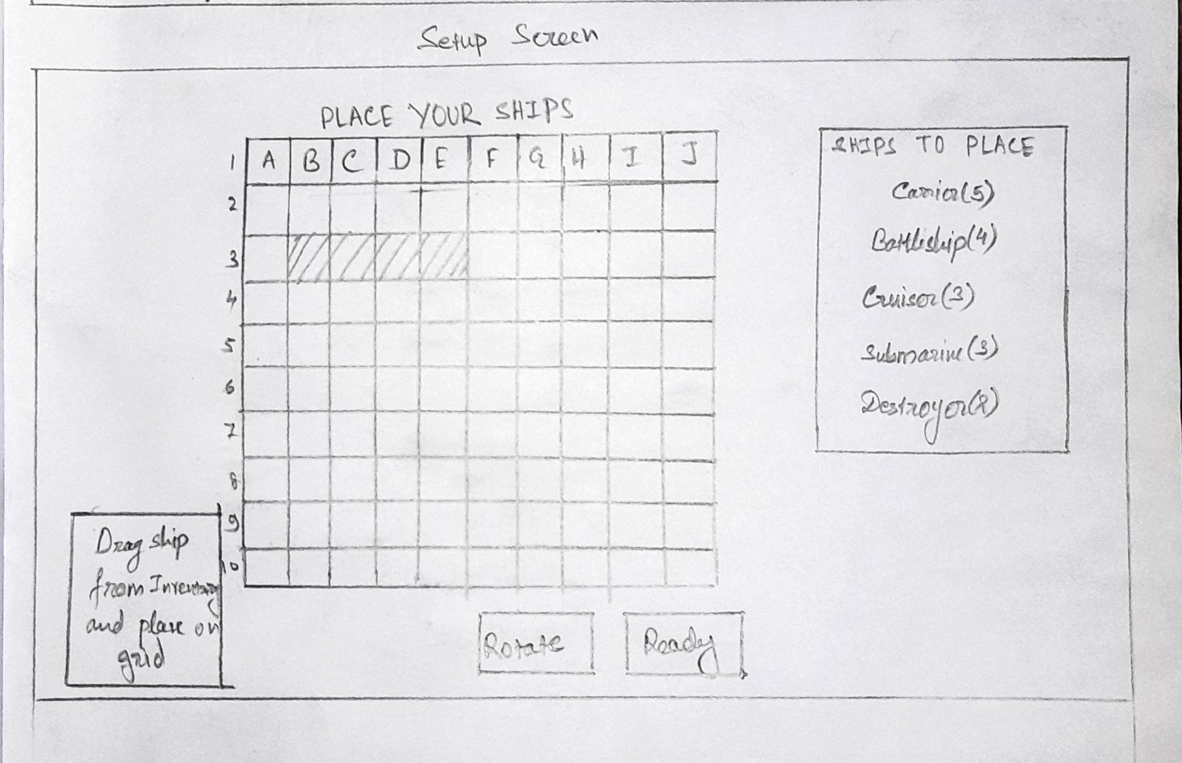Fig 2: Setup Screen

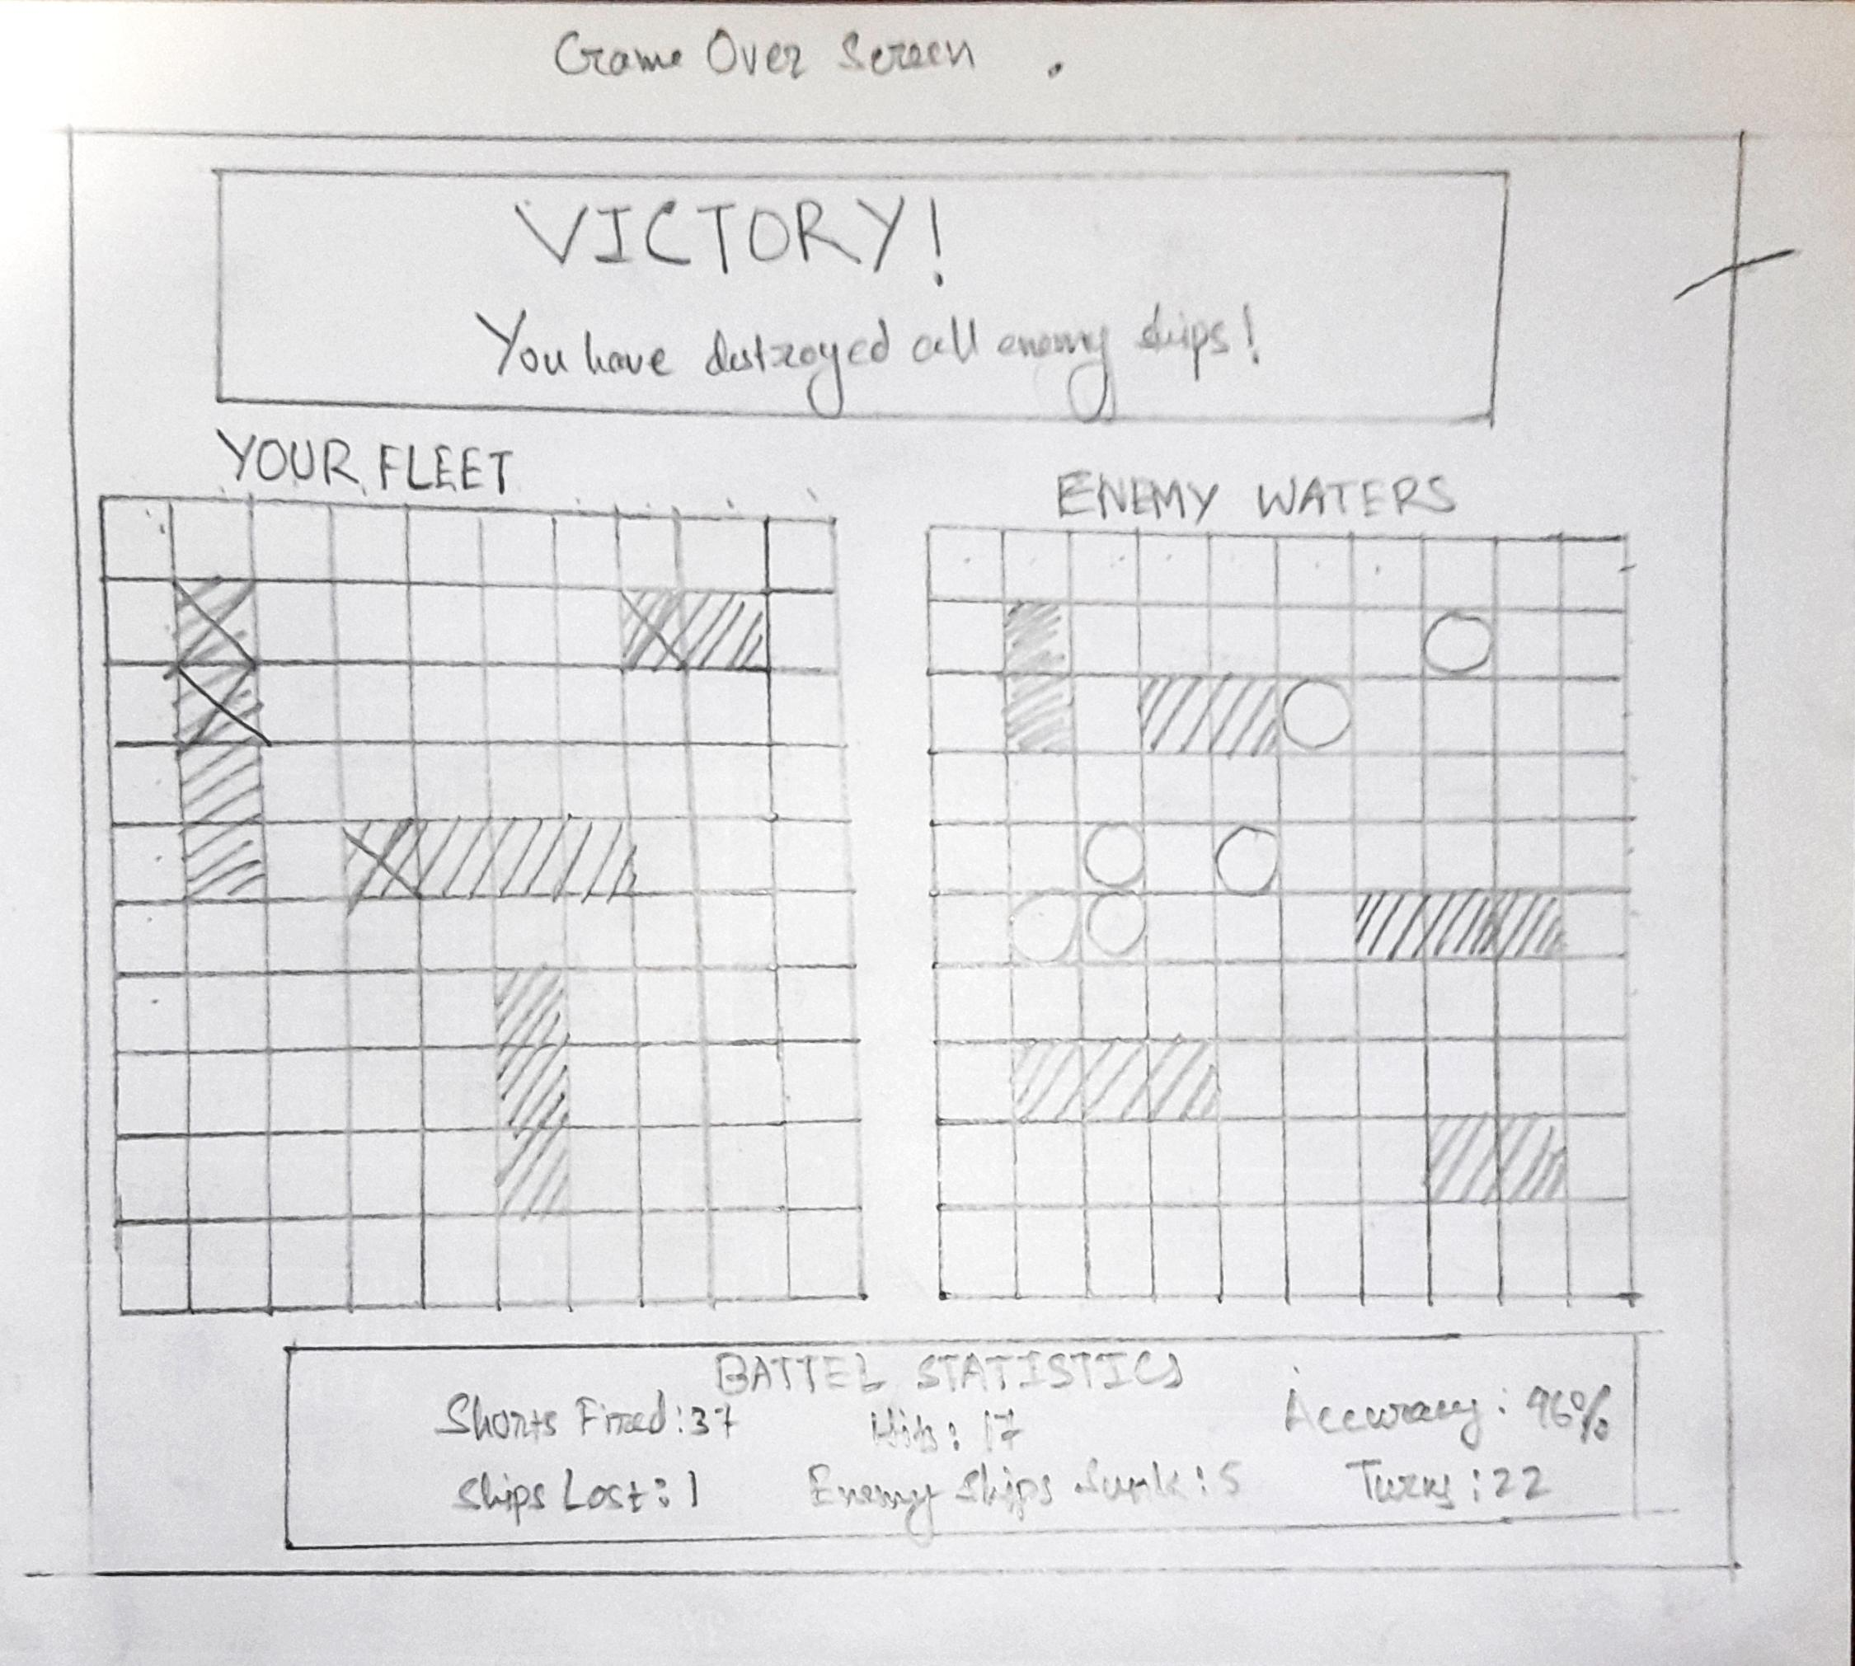Fig 3: Game Over Screen

**Review Session**

The usability evaluation was performed on hand-drawn prototype interfaces that encouraged participants to interact as if they were playing the game. Their feedback centered around issues of clarity, usability, scalability, and other such considerations. Information collected from this round of usability testing will serve to inform the refinement of the final digital realization.

Clarity: The hand-drawn layout effectively communicates gameplay elements. Visible sections help players recognize different areas, while hit/miss indicators appear clear and easily distinguishable.

Completeness: The wireframes cover all the needed components of the game state updates, tracking of ships, and inputs for control (Madandola et al., 2024). Players will be able to follow the flow of gameplay without any confusion or hardship. It will be very helpful for them.

Consistency: Uniform design of elements is maintained throughout all grids, buttons, as well as labels is kept within one theme. The order of layout provides smooth transitions from one game phase to another.

Scalability: Future implementations of AI opponents and different ranks will have to respect the core mechanics of the game. The designs lend themselves to scalability. Yet it still being user-friendly.

Usability: The logical structure of the interface allows intuitive interaction. Players could easily place ships, select targets, and check on game status with little instruction.

Adherence to Requirements: All functional requirements have been catered to, providing a solid interface to digital implementation. The layout, while adhering to the mechanics of classic Battleship, lends itself to the modernization of the user interface.

Technical Feasibility: The transition from hand drawings to digital renderings will be powered by HTML, CSS, and JavaScript, thus feasible (Nurpalah et al., 2021). The design leaves scope for the credible realization of core functionality.

Optimizing Opportunities: Clearer definitions of the attack selection operation and cutting down the other UI elements will amplify the clarity. This will totally optimize the user experience.

Security Consideration: Target validation as well as input validation for the selection of targets is important to restrict any unwanted happenings. Proper inputs shall guarantee fair and error-free gameplay.

Innovation and Creativity: The design combinations work, mixing classic Battleship mechanics with an accessible, modern UI. It enhances player engagement while remaining intuitive, preserving the essence of the game.

**References:**

Madandola, O. O., Bjarnadottir, R. I., Yao, Y., Ansell, M., Dos Santos, F., Cho, H., ... & Keenan, G. M. (2024). The relationship between electronic health records user interface features and data quality of patient clinical information: an integrative review. *Journal of the American Medical Informatics Association*, *31*(1), 240-255. <https://pmc.ncbi.nlm.nih.gov/articles/PMC10746323/pdf/ocad188.pdf>

Nurpalah, A., Pasha, M. S., Rhamdhan, D. D., Maulana, H., & Rafdhi, A. A. (2021). Effect of UI/UX designer on front end. *International Journal of Research and Applied Technology (INJURATECH)*, *1*(2), 335-341. <http://ojs.unikom.ac.id/index.php/injuratech/article/download/6759/2931>