Banking System Integration & Testing Report
Module: Object-Oriented Analysis and Design
Student Name: Botlhe Kgomphi
Student ID: Cse24-088
Date: 17/11/2025
Executive Summary
This comprehensive integration report demonstrates the successful integration of all Banking System components with visual evidence of system functionality. The report includes screenshots showcasing the working application, database operations, and test execution results.
User Interface Integration
Login Screen - JavaFX Implementation
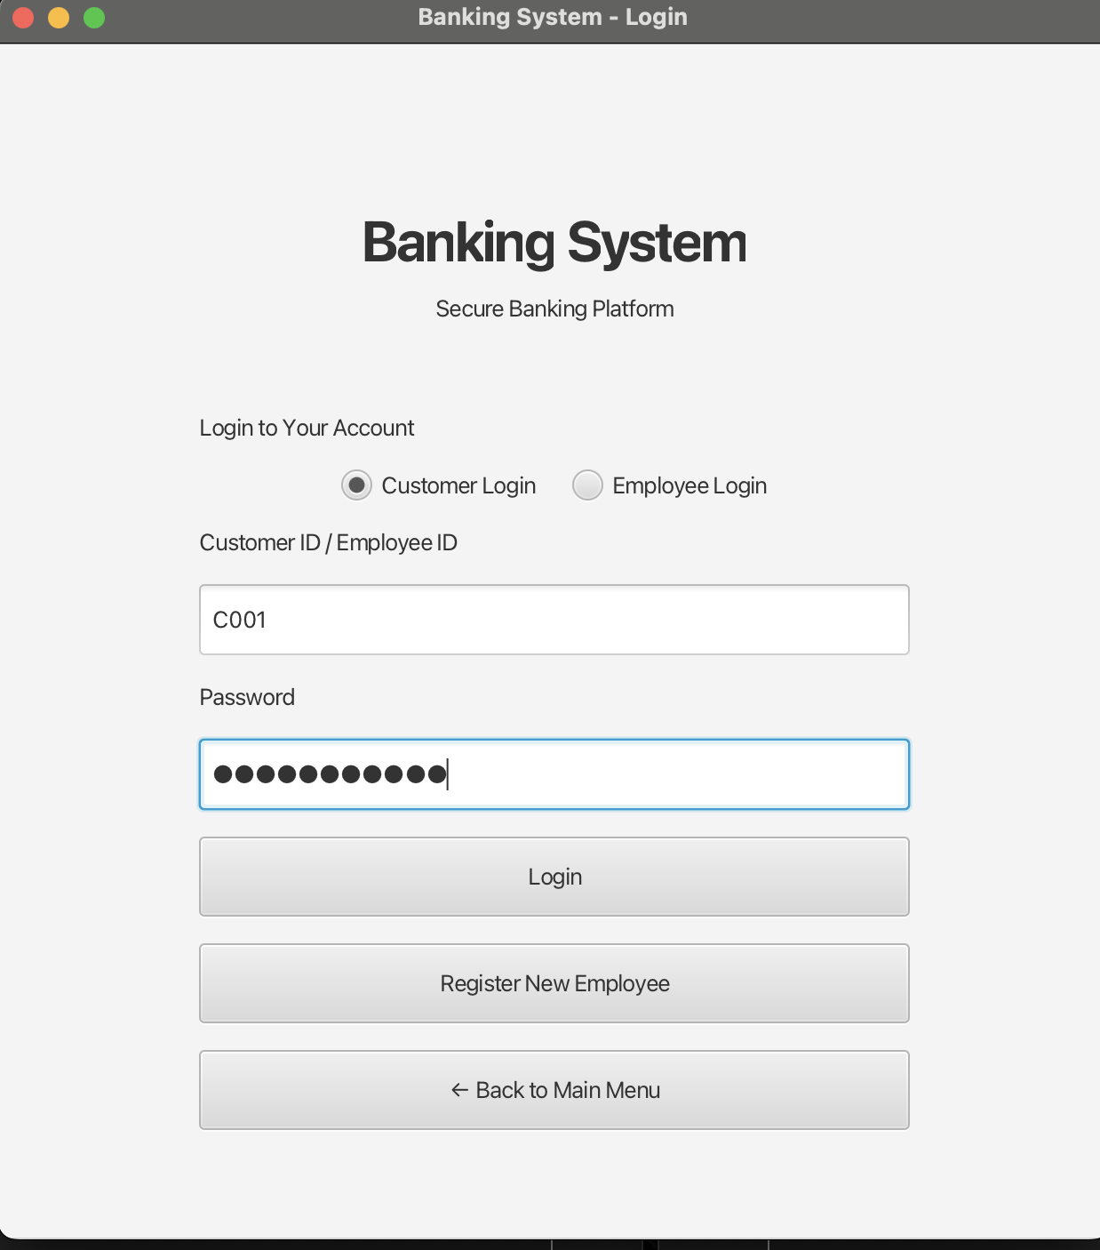
Integration Points Verified:
GUI to Controller communication
Authentication service integration
Session management initialization
Customer Dashboard
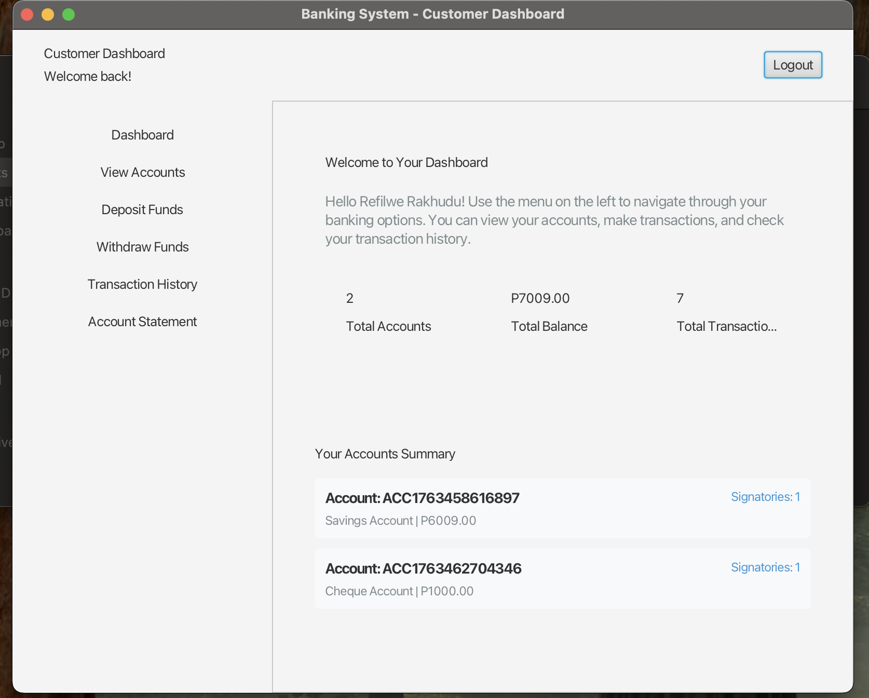
Features Demonstrated:
Account overview display
Navigation to different banking functions
Customer information panel
Account Management Interface
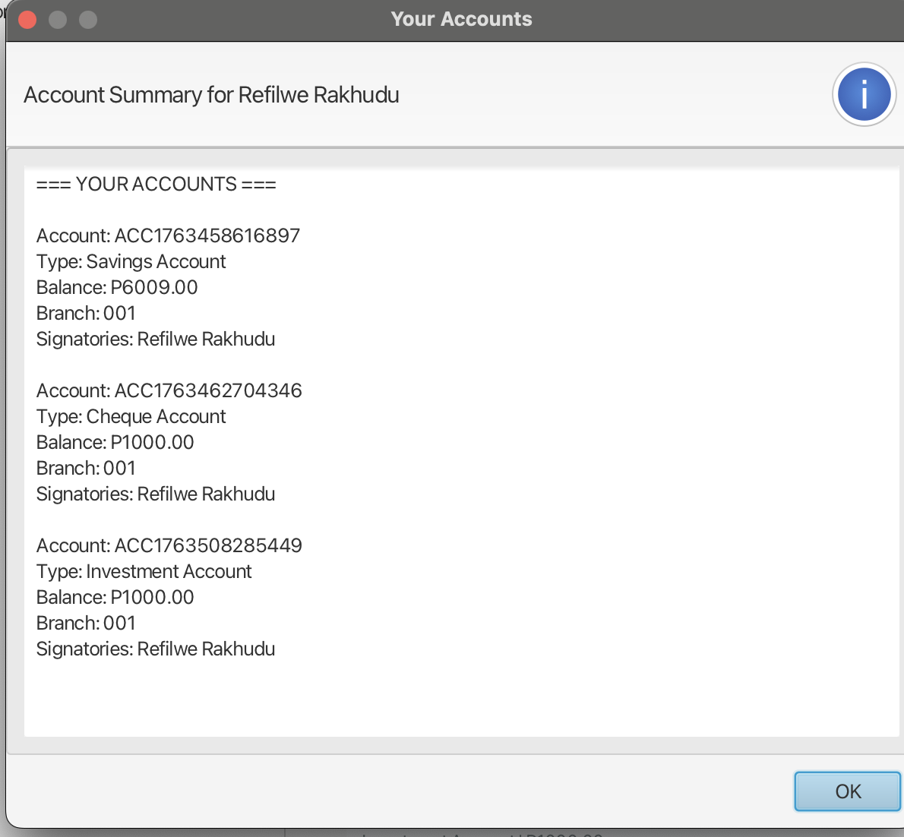
Database Integration Evidence
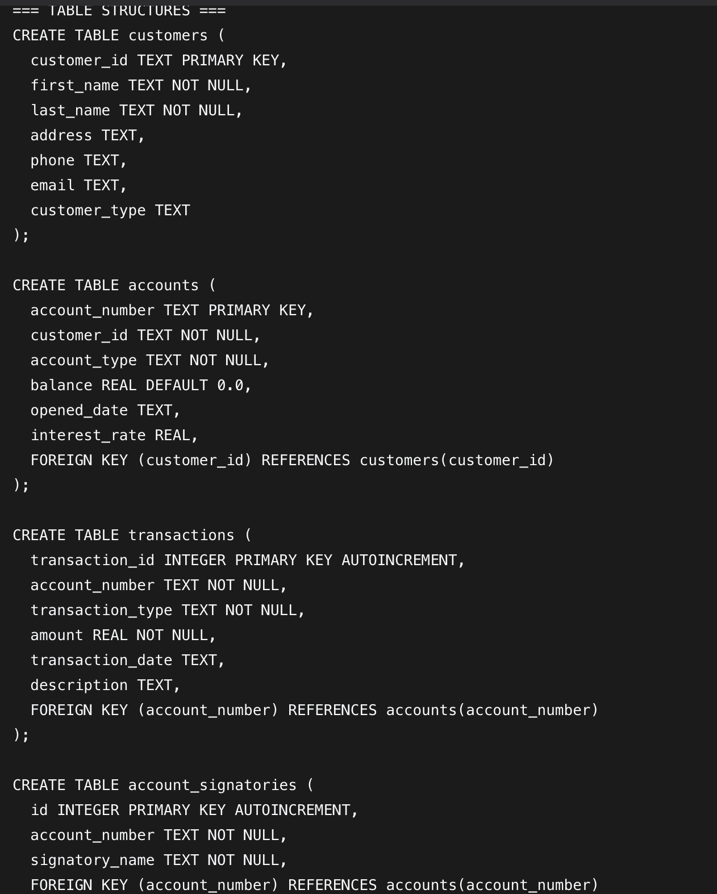
Transaction Processing
Deposit Transaction Working

Shows: Deposit functionality integrated across all layers
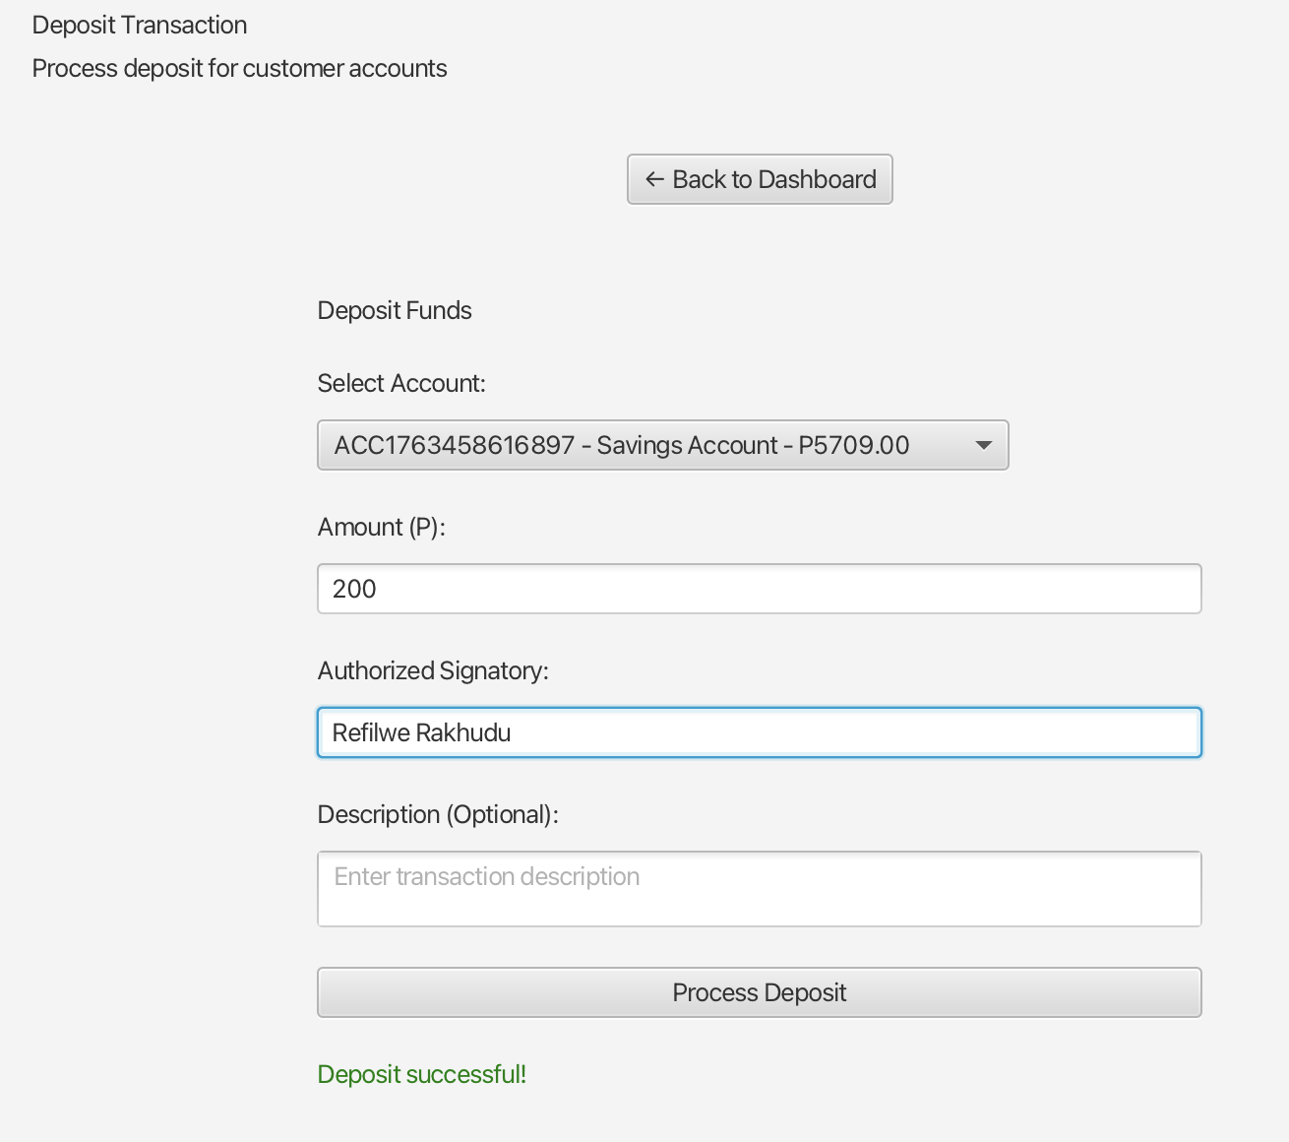
Withdrawal Transaction
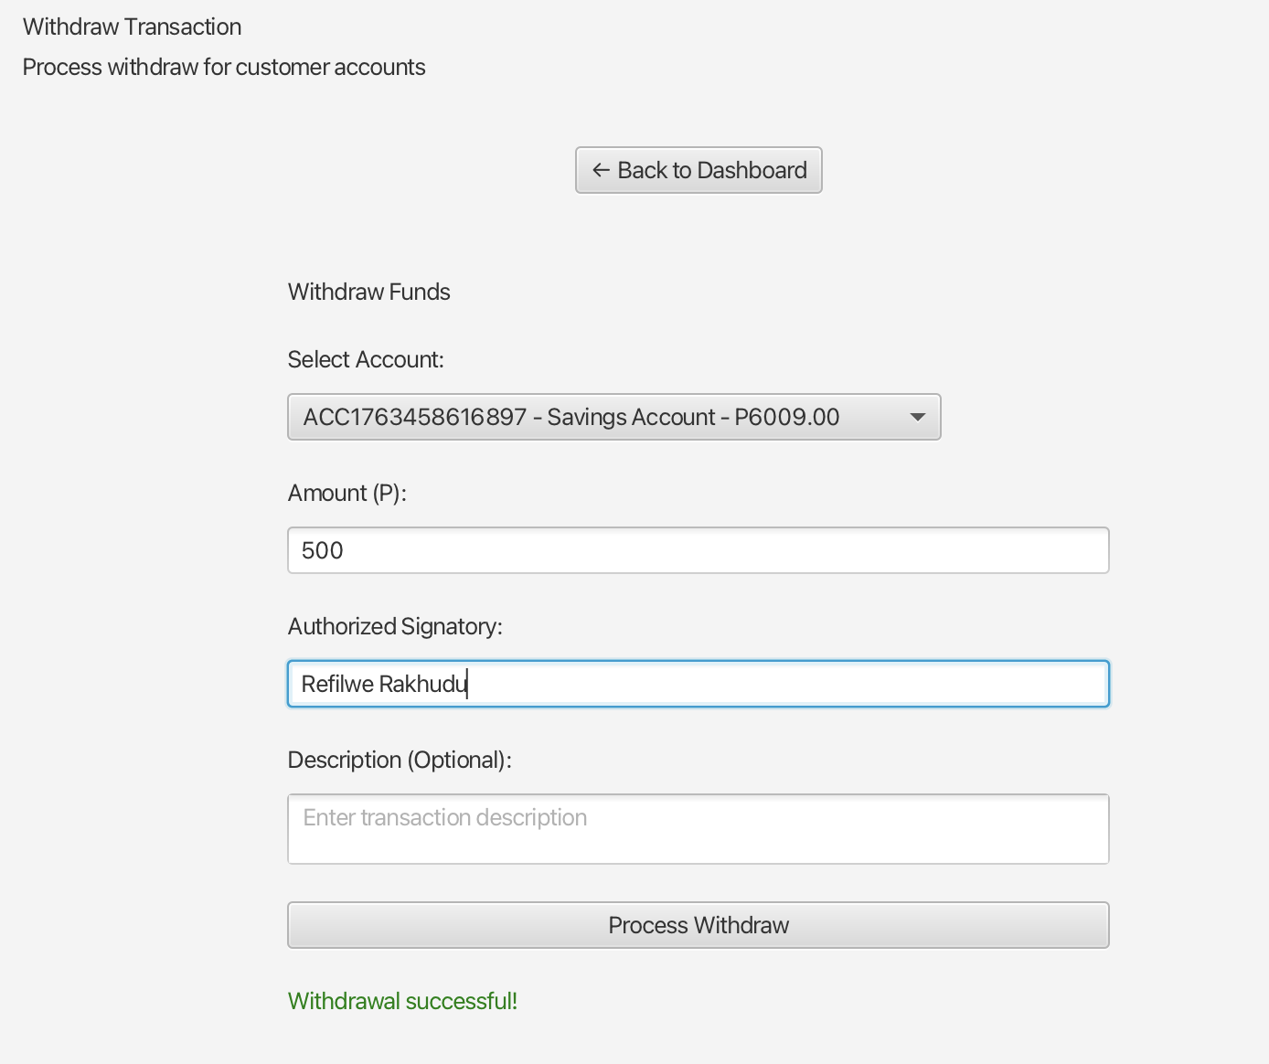
Shows: Withdrawal logic with balance validation working

Transaction History

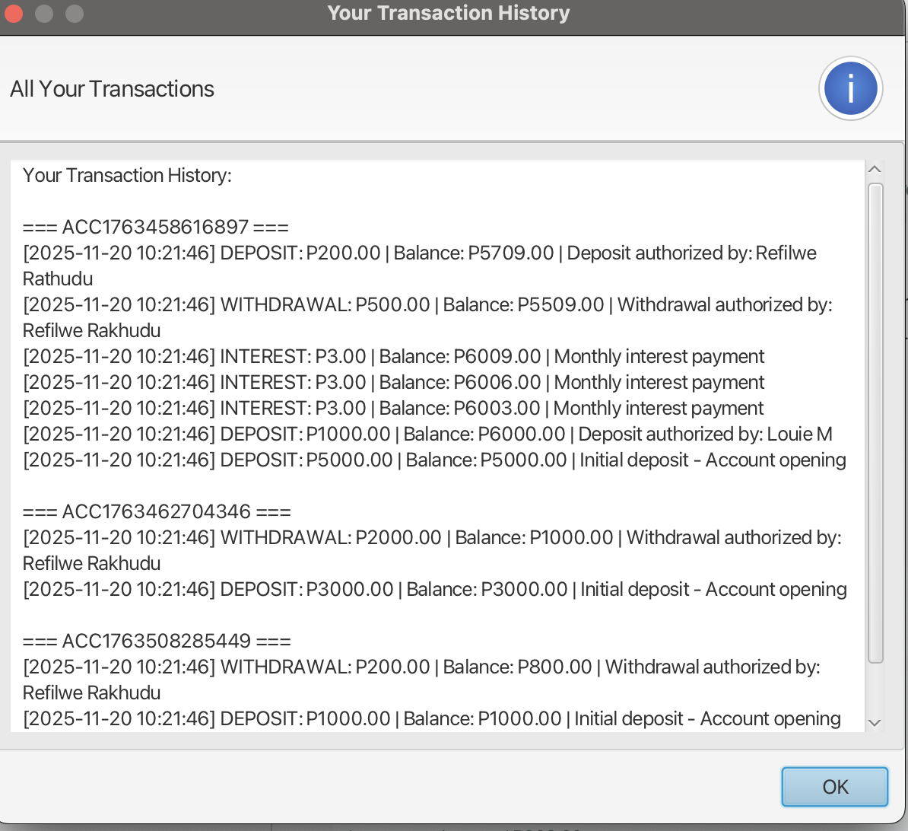
Shows: Transaction records properly stored and displayed
Error Handling
Insufficient Funds Error
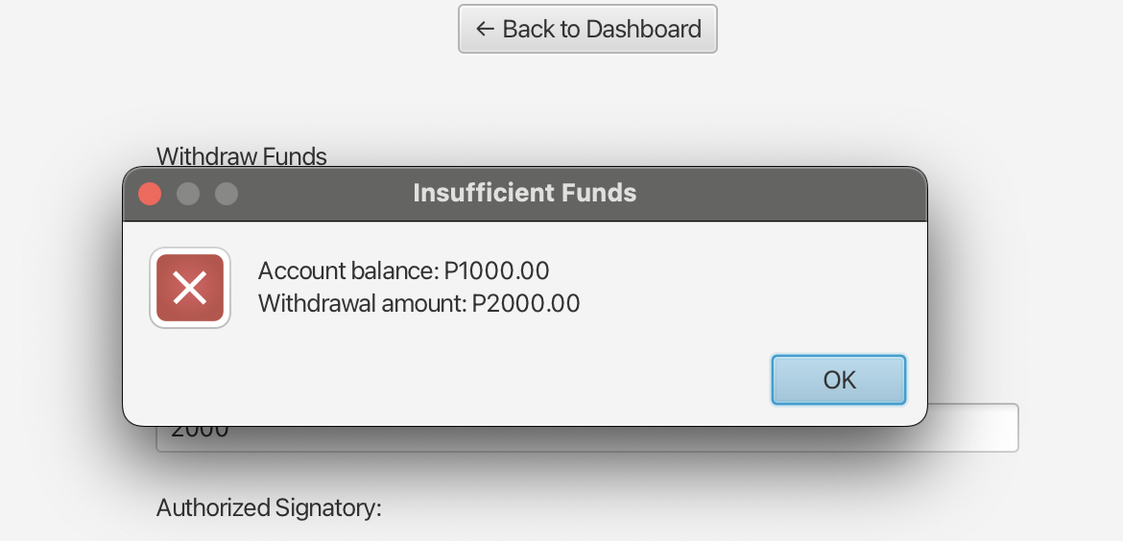
Account Types
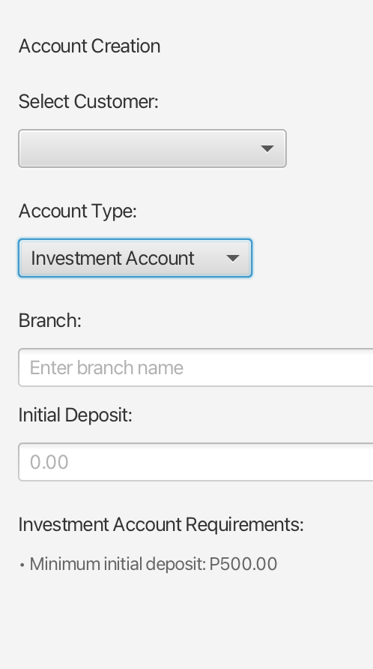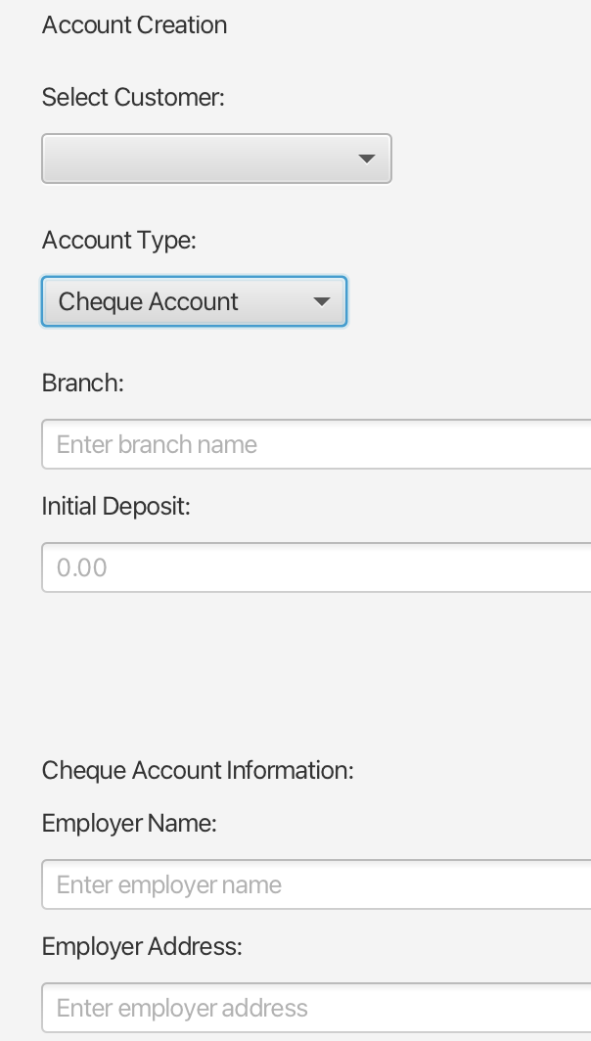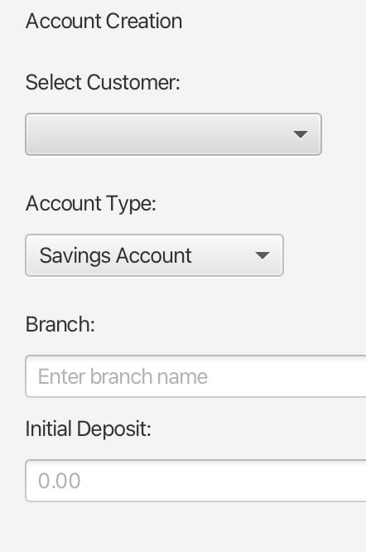

Shows: All required account types implemented

